Full Stack Development

Introduction
  - Project Title: TalentSync Works – Freelance Platform
  - Team Members: Akula Nagababu
Geddada Renuka Sai
Narkidimilli M S S Praharshitha
Mahammad Muzammil

Project Overview
Purpose: TalentSync Works is a comprehensive freelancing platform that connects clients with skilled freelancers. It enables clients to post projects, freelancers to bid based on their expertise, and admins to manage platform activities. The platform ensures seamless collaboration, secure communication, and efficient project completion, empowering users to build strong professional relationships and successful freelance careers.
Goals:
- Simplify project posting and freelancer bidding process
- Enable efficient freelancer selection by clients
- Provide real-time communication and collaboration
- Improve transparency and workflow management
- Offer a secure and centralized freelancing environment

Features

User Registration & Login:
Users (clients, freelancers, admins) create secure accounts with role-based access.
Project Posting:
Clients can submit detailed projects including description, budget, and required skills.
Dashboard:
- Clients: Post projects, review proposals, hire freelancers
- Freelancers: Browse projects, submit bids, track applications
- Admins: Monitor users, projects, and maintain platform integrity
Proposal Submission:
Freelancers submit proposals with portfolio, pricing, and timeline.
Client–Freelancer Communication:
Integrated chat system enables real-time communication and collaboration.
Notifications:
Users receive real-time updates on project status, proposals, and messages.
Security & Compliance:
JWT-based authentication, role-based authorization, and secure data handling ensure platform reliability.

Architecture
- Frontend: Developed with React.js using Bootstrap and Material UI for responsive and interactive UI. Axios is used to communicate with backend APIs and fetch projects, proposal, and user data dynamically.
- Backend: Built using Node.js and Express.js. RESTful APIs handle authentication, project posting, proposal management, and chat communication between clients and freelancers.
- Database: MongoDB is used to store users, freelancer profiles, projects, proposals, and chat history. Schema-based interaction is implemented using Mongoose ORM.

4. Setup Instructions
Step 1: Install Prerequisites
Make sure the following are installed on your machine:
  - Node.js – Download
  - MongoDB (local or Atlas) – Download MongoDB Community Server
  - Git – Download Git

Step 2: Clone the Project Repository
👉 REPLACE THE PROJECT LINK TEXT

Step 3: Setup Backend
  - Navigate to server folder
  - Install dependencies
  - Create .env file
  - Start backend server

Step 4: Setup Frontend
- Navigate to client folder
- Install frontend dependencies
- Start frontend server

Step 5: Use the Application
- Register as Client, Freelancer, or Admin
- Start posting projects and bidding

Folder Structure

freelancer-app-MERN/

├── server/

├── client/

│ ├── node_modules/

│ ├── public/

│ ├── src/

│ │ ├── components/

│ │ │ ├── admin/

│ │ │ ├── client/

│ │ │ ├── freelancer/

│ │ │ └── common/

│ │ ├── pages/

│ │ ├── assets/

│ │ ├── App.js

│ │ └── index.js

├── .gitignore

Running the Application
1. Start the Backend Server
cd server
npm install
Create .env
npm start
Server → http://localhost:8080
MongoDB connected successfully

2. Start Frontend
cd client
npm install
npm start
App → http://localhost:5173

3. Test Application
Register as:
Client → Post and manage projects
Freelancer → Browse projects and submit bids
Admin → Monitor users and projects

- API Documentation

Authentication APIs
  - Register API → Create account
  - Login API → JWT authentication

Project Management APIs
  - Create Project (Client)
  - Get All Projects
  - Get Project Details
  - Update/Delete Project

Proposal APIs

Submit Proposal (Freelancer)

Get Project Proposals

Accept Freelancer

Chat APIs
  - Send Message
  - Get Chat History

Authentication

User Registration

Purpose: Create account (Client/Freelancer/Admin)
Required Data: Name, Email, Password, Role
Response: Success message + JWT token

User Login

Purpose: Authenticate user
Required Data: Email, Password
Response: User details + JWT token

User Interface

User Interface (For Freelancers & Clients)

Sign Up / Login Page: Users (Clients and Freelancers) can create an account or log in securely using email and password with role-based authentication.

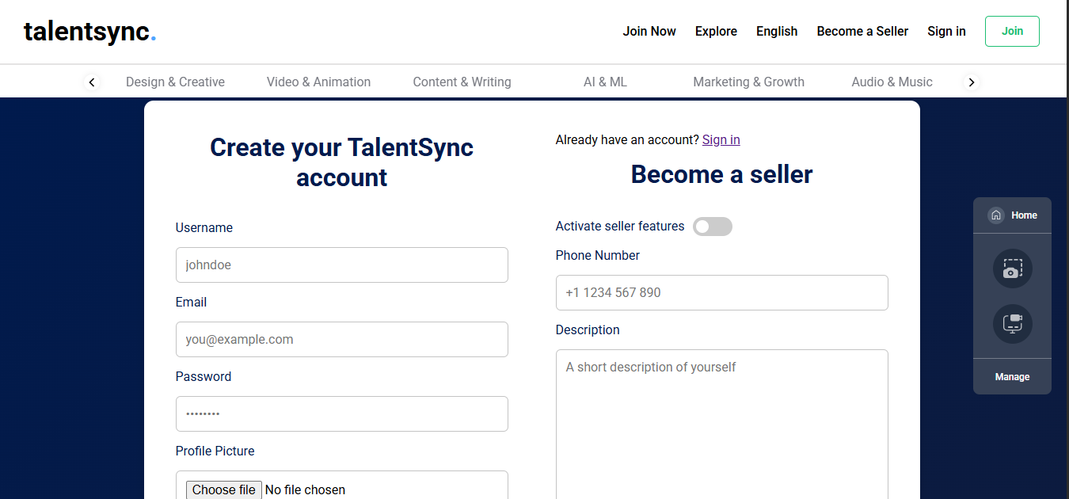

User Dashboard: After logging in, users land on a personalized dashboard with the following options:

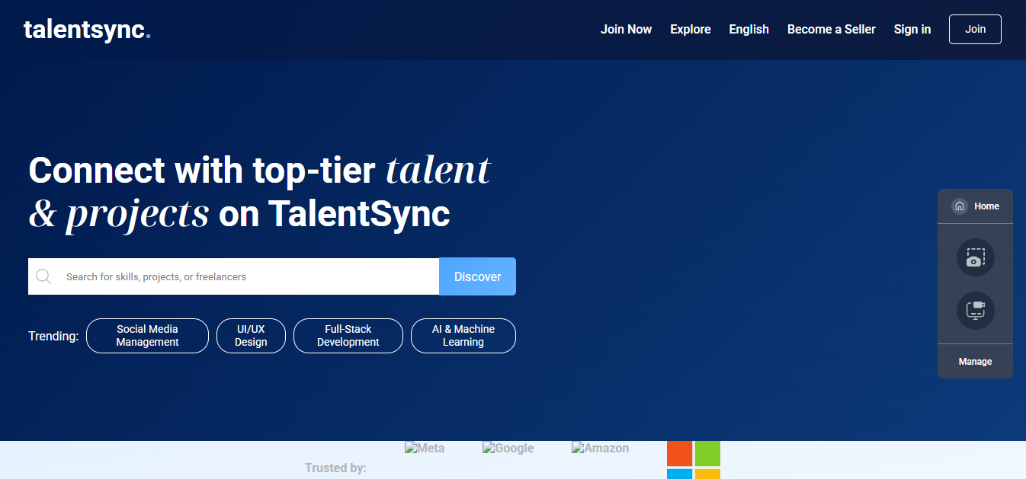

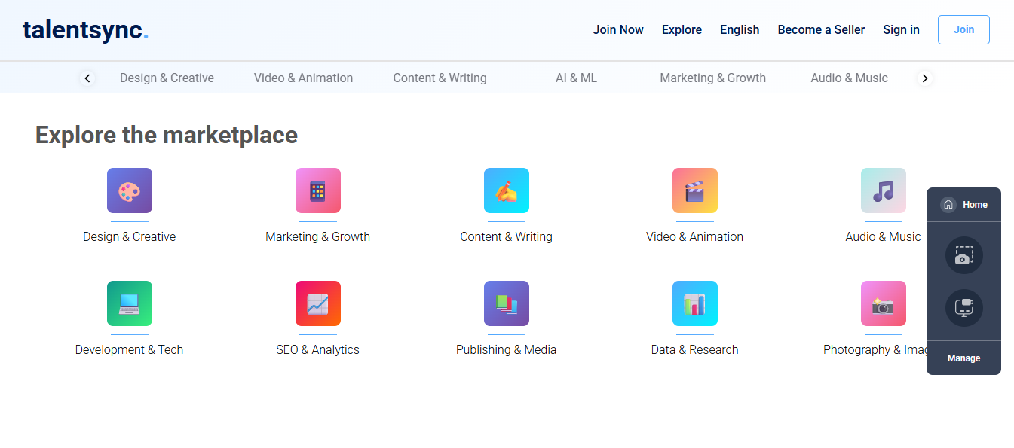

For Clients

Post Project: A form to enter project title, description, required skills, budget, and deadline.

My Projects: View and manage all posted projects.

View Proposals: Review of freelancer bids and portfolios.

Chat with Freelancer: Communicate directly with selected freelancers.

Logout Button: Ends session securely.

For Freelancers

Browse Projects: View available projects based on skills and interests.

Submit Proposal: Apply to projects with pricing, timeline, and portfolio.

My applications: Track submitted proposals and project status.

Chat with Client: Communicate with clients for project discussion.

Logout Button: Ends session securely.

- Admin Interface

Admin Dashboard:
Designed for system administrators with features including:
- View All Users: Manage client and freelancer accounts.
- Monitor Projects: Track posted projects and proposals.
- Manage Disputes: Handle conflicts between clients and freelancers.
- Search/Filter Options: Filter users and projects efficiently.
- Logout Button: Ends session securely.

Testing

TalentSync Works was tested using both manual and API testing methods. Manual testing covered user registration, project posting, proposal submission, freelancer hiring, and chat functionality. API endpoints were tested using Postman to ensure proper request handling and role-based access. Authentication, project workflows, and UI responsiveness were validated across multiple devices.

- Screenshots or Demo
👉 REPLACE THE PROJECT LINK TEXT
- Knowing Issues
- Payment gateway integration has not been implemented yet.
- Mobile responsiveness can be improved on smaller screens.
- Real-time notifications are limited.
- Analytics dashboard is basic and needs enhancement.
- Multi-language support is not available yet.

Future Enhancements

  - Payment gateway integration for secure transactions
  - AI-based freelancer recommendation system
  - Real-time admin analytics dashboard
  - Mobile application using React Native
  - Advanced notification and tracking system

