
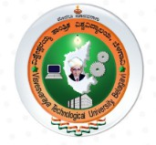
INDUSTRY INTERNSHIP(BINT803B)
2025-26

TABLE OF CONTENTS

Body report structure starting from Chapter 1
This v2 report body starts after the separately prepared front matter. The left gutter is reduced enough for spiral binding while still keeping the pages readable and clean.

Contents | i
List of Figures | ii
Chapter 1: About the Organization | 1-3
Chapter 2: Introduction | 4
Chapter 3: Internship Planning and Methodology | 5-6
Chapter 4: Objectives of Internship | 7
Chapter 5: Internship Execution and Project Delivery | 8-10
Chapter 6: Learning Experience | 11-12
Chapter 7: Learning Outcomes | 13
Chapter 8: Snapshots | 14-15
Chapter 9: Future Scope | 16
Chapter 10: Conclusion | 17
References | 18
Attachments | 19

Front matter such as certificate, declaration, acknowledgement, and abstract can be bound before this body copy if needed.

Dept. of CSE-DS, MITM NYERAS | Maharaja Institute of Technology Mysore | VTU Page | i

LIST OF FIGURES
INDUSTRY INTERNSHIP(BINT803B)
2025-26



Figure map for the body section
The figures below are arranged to remain inside the reduced content width so that nothing spills into the spiral binding margin.

Figure 1.1: NYERAS Edutech & Innovations | 1
Figure 1.2: Project Components | 2
Figure 1.3: Organizational Ecosystem | 3
Figure 3.1: Internship Timeline & Milestones | 5
Figure 3.2: Internship Learning Path | 6
Figure 5.1: Manual Learning vs Structured Project Execution | 8
Figure 5.2: Technology Stack Engineered | 9
Figure 5.3: Internship Execution Workflow | 10
Figure 6.1: Monthly Workload Chart | 11
Figure 6.2: Learning Experience Theme Map | 12
Figure 8.1: Portfolio Snapshot Gallery | 14
Figure 8.2: Portfolio Visualizations and Summary Cards | 15

Dept. of CSE-DS, MITM NYERAS | Maharaja Institute of Technology Mysore | VTU Page | ii

CHAPTER 1
INDUSTRY INTERNSHIP(BINT803B)
2025-26

ABOUT THE ORGANIZATION
NYERAS Edutech & Innovations is the organization where the internship was carried out. The phase 1 material shows a practical, industry-oriented environment with AICTE recognition, VTU collaboration, and a clear focus on hands-on learning and mentorship.

Company Name | NYERA EDUTECH & INNOVATIONS PRIVATE LIMITED
Location | 1161, AECS Layout Main Rd, AECS Layout - A Block, AECS Layout, Singasandra, Bengaluru, Karnataka 560068
Company Focus | AICTE verified company in collaboration with VTU that provides training and internships.
Core Mission | Providing real industrial knowledge and experience through structured internship programs.

AICTE Verified Institution
Recognized for quality and credibility in training.
Practical, Hands-On Learning
Emphasis on real-world exposure and applied skills.
VTU Collaboration Partner
Supports academic and industry learning.
Professional Development & Mentorship
Guidance from experienced professionals throughout the program.




Dept. of CSE-DS, MITM NYERAS | Maharaja Institute of Technology Mysore | VTU Page | 1

CHAPTER 1
INDUSTRY INTERNSHIP(BINT803B)
2025-26

Project components and application architecture
The internship work can be viewed as a set of connected project components: analytics automation, machine learning, deep learning, dashboards, and deployment-oriented packaging. The structure is intentionally modular so each project can be studied, demonstrated, and reused.

Data Analytics
Cleaning, querying, visualizing, and reporting data.

Application architecture
Machine Learning
Model training, evaluation, and prediction workflows.
Deployment and Documentation Packaging, version control, and report readiness.




Raw Data  Inputs | > | Cleaning  Preprocess | > | Analysis  EDA + SQL | > | Modeling  ML / DL | > | Reporting  Dashboards

Tools | Role
Excel / SQL | Foundational analytics and tabular analysis
Python / Pandas | Data manipulation and automation
Power BI / Tkinter | Interactive outputs and user-facing systems
PyTorch / scikit-learn | Machine learning and deep learning models

Dept. of CSE-DS, MITM NYERAS | Maharaja Institute of Technology Mysore | VTU Page | 2

CHAPTER 1
INDUSTRY INTERNSHIP(BINT803B)
2025-26

Organizational ecosystem and internship progression
NYERAS is best understood as an ecosystem rather than a single project site. The internship connected multiple technical streams, which made the learning path broader and more realistic.

AI/ML | Model building, analysis, and automation-ready intelligence
Data Science | Cleaning, EDA, visualization, and reporting
Automation Testing | Workflow reliability and quality checks
Web Development | Dashboards and browser-based interfaces
AWS DevOps | Deployment and environment management
Human Resource | Operational support and internship coordination
Cyber Security | Safety, integrity, and access awareness
VLSI Design | Broader technical exposure and skill expansion
Java Full Stack | Application logic and structured engineering
The summary below shows the workload trend from the diary data that fed the later chapters.

108
Diary Entries
All months combined
777.7
Logged Hours
Approximate total recorded work

5
Months
January through May

Month | Entries | Hours | Representative focus
January | 10 | 80.0 | On my first day at NYERAS Edutech & Innovations, I was introduced to the organizational structure, workflow, and the exp
February | 28 | 196.7 | Focused on strengthening Excel skills by working on real datasets involving sales and customer information.
March | 31 | 215.5 | Initiated the Retail Store Sales Insights project by identifying the problem statement and understanding dataset require
April | 30 | 231.2 | Continued ML/AI Portfolio dashboard refinement.
May | 9 | 54.3 | Final internship completion review.



Dept. of CSE-DS, MITM NYERAS | Maharaja Institute of Technology Mysore | VTU Page | 3

CHAPTER 2

INTRODUCTION
INDUSTRY INTERNSHIP(BINT803B)
2025-26

This internship report documents the work completed across the NYERAS journey, starting from the organizational context and moving through planning, methodology, execution, learning, and final outcomes. The body begins at Chapter 1 because the front matter is handled separately in the bound copy.
The internship evolved from foundation analytics into advanced ML/AI delivery. The later projects included an interactive portfolio dashboard and a medical imaging system for brain tumor detection, both of which demonstrate the shift from support work to independent technical delivery.

108
Diary Entries
Used as evidence across the report

3
Major Systems
Retail, portfolio, and medical AI

10
Portfolio Projects
Shown in the dashboard section
99.03%
Medical Accuracy
Validation result for tumor detection

Focus | What the report captures
Technical growth | From data handling to modular AI system delivery
Presentation quality | Tables, figures, screenshots, and clean chapter spacing
Professional readiness | Documentation, communication, and portfolio development



Dept. of CSE-DS, MITM NYERAS | Maharaja Institute of Technology Mysore | VTU Page | 4

CHAPTER 3
INDUSTRY INTERNSHIP(BINT803B)
2025-26



INTERNSHIP PLANNING AND METHODOLOGY
The internship was not a loose set of tasks. It followed a sequence of planning, execution, review, and completion. That structure is important because it shows how the work moved from orientation to repeatable delivery.

Onboarding  Plan | > | Task Setup  Assign | > | Execution  Build | > | Review  Verify | > | Final Delivery  Submit

Stage | Outcome
Orientation and setup | Environment ready and internship expectations understood
Guided project work | Individual modules and analyses delivered
Milestone reviews | Progress checked and improvements applied
Final compilation | Report and project assets prepared for evaluation

Dept. of CSE-DS, MITM NYERAS | Maharaja Institute of Technology Mysore | VTU Page | 5

CHAPTER 3
INDUSTRY INTERNSHIP(BINT803B)
2025-26



Learning path and workflow selection
The learning path moved from manual understanding to structured project execution. This is visible in the phase 1 slides, which show onboarding, project execution, learning, and delivery as a single storyline.

Traditional Manual EDA | Automated Pipeline
Write scripts from scratch | Reuse structured modules and routines
Handle missing values manually | Automate cleaning and validation steps
Create isolated charts | Generate repeatable reports and dashboards
Slow and hard to scale | Faster, traceable, and easier to maintain

Learning path

Onboarding  Tools | > | Project Execution  Build | > | Learning  Reflect | > | Delivery  Handover

Method | Reason
Incremental implementation | Keeps the system testable at each stage
Repeated verification | Reduces errors before final delivery
Documentation while building | Makes the project easier to explain and review

Dept. of CSE-DS, MITM NYERAS | Maharaja Institute of Technology Mysore | VTU Page | 6

CHAPTER 4
INDUSTRY INTERNSHIP(BINT803B)
2025-26



OBJECTIVES OF INTERNSHIP
The objectives were practical, not only academic. They focused on learning by building, testing, documenting, and presenting systems that could actually be demonstrated during evaluation.
- Develop practical experience in data analytics tools and real-world project workflows.
- Learn to move from raw data to structured, explainable, and useful outputs.
- Build strong foundations in Python-based analysis and machine learning implementation.
- Understand deep learning and medical imaging as applied advanced use cases.
- Improve documentation, communication, and professional project presentation.

Objective | Evidence in the report
Data handling | Diary entries, analytics tables, and summary charts
ML implementation | Portfolio projects and brain tumor ensemble system
Professional communication | TOC, list of figures, and structured chapter layout
Deployment thinking | Workflow diagrams and tool stack summaries

Dept. of CSE-DS, MITM NYERAS | Maharaja Institute of Technology Mysore | VTU Page | 7

CHAPTER 5
INDUSTRY INTERNSHIP(BINT803B)
2025-26



INTERNSHIP EXECUTION AND PROJECT DELIVERY
This chapter combines the phase 1 learning material with the phase 2 delivery work. It shows how the internship moved from foundation-level manual work to reusable, automated, and presentation-ready project delivery.

 | Project | Timeline | Stack | Delivery note
 | NYERAS Retail Analytics System | Jan-Feb 2026 | Python, Pandas, SQL, Power BI | Retail data analysis, automation, and dashboarding.
 | ML/AI Portfolio Dashboard | Feb-Apr 2026 | Python, Tkinter, PyTorch, scikit-learn | Interactive launcher for 10 ML/AI projects.
 | Brain Tumor Detection System | Apr 2026 | PyTorch, medical imaging, ensemble learning | Ensemble deep learning with 99.03% validation accuracy.

Phase 1 Foundation | Phase 2 Growth
Retail analytics automation and workflow discipline | Interactive ML/AI dashboard and portfolio presentation
Data cleaning, SQL, and reporting habits | Medical imaging, ensemble learning, and advanced model work
Manual understanding of process | Structured delivery and reusable modules

Dept. of CSE-DS, MITM NYERAS | Maharaja Institute of Technology Mysore | VTU Page | 8

CHAPTER 5
INDUSTRY INTERNSHIP(BINT803B)
2025-26

Technology stack engineered

Core Engine
Python, Pandas, and scikit-learn for data manipulation, cleaning, and model training.
UI Layer
Tkinter-based dashboard and browser-style presentation for non-technical users.
Deployment
Windows batch setup and reproducible environment preparation.



Key Libraries & Frameworks | System Components
Miniconda, Pandas, Matplotlib, scikit-learn | START_APP.bat launcher
PyTorch, Tkinter, ReportLab, Pillow | retail_ui_server.py dashboard
SQL, Power BI, NumPy, GitHub | phase1 and phase2 workflow files

The point of the stack is not only to list technologies. It is to show that the internship work was built in a real engineering environment where the UI, analysis, reporting, and deployment concerns were all handled together.

Dept. of CSE-DS, MITM NYERAS | Maharaja Institute of Technology Mysore | VTU Page | 9

CHAPTER 5
INDUSTRY INTERNSHIP(BINT803B)
2025-26



Workflow and execution pipeline

En ng
vironment Bootstra  Setup | p Da  > | ta Auto-Detection  Read | > | Intelligent Cleaning  Fix | > | Model Training  Learn | Visu  > | alization & Reporti  Deliver

Step | Result
Bootstrap | Environment checks and dependency setup
Data detection | Relevant columns and patterns identified
Cleaning | Noise and missing values reduced
Training | Model performance compared and improved
Reporting | Outputs prepared for presentation and review

Dept. of CSE-DS, MITM NYERAS | Maharaja Institute of Technology Mysore | VTU Page | 10

CHAPTER 6

LEARNING EXPERIENCE
INDUSTRY INTERNSHIP(BINT803B)
2025-26



The diary shows steady accumulation of technical work across five months. The chart and summary below compress that record into a form that is easier to evaluate in a report.
Monthly Workload Chart
Month | Entries | Hours
January | 10 | 80.0
February | 28 | 196.7
March | 31 | 215.5
April | 30 | 231.2
May | 9 | 54.3

232
216
231
197
80
54

174

116

58

0
Jan Feb Mar Apr May

Key monthly summary
January | On my first day at NYERAS Edutech & Innovations, I was introduced to the organizational structure, workflow, and the exp
February | Focused on strengthening Excel skills by working on real datasets involving sales and customer information.
March | Initiated the Retail Store Sales Insights project by identifying the problem statement and understanding dataset require
April | Continued ML/AI Portfolio dashboard refinement.
May | Final internship completion review.

Dept. of CSE-DS, MITM NYERAS | Maharaja Institute of Technology Mysore | VTU Page | 11

CHAPTER 6
INDUSTRY INTERNSHIP(BINT803B)
2025-26



Learning experience subsections
The subsections below condense the longer diary narrative into the main learning themes that repeated through the internship.

6.1 Overview of Learning Experiences 6.2 Artificial Intelligence and Machine Learning Experience The internship combined analytics, automation, dashboarding, Worked with classification, regression, neural networks, and and AI/ML project delivery into one continuous learning path. ensemble methods across multiple projects.
6.3 Data Collection and Preprocessing 6.4 AI Workflow and System Integration
Handled raw datasets, cleaned values, normalized inputs, and Connected preprocessing, model execution, UI feedback, and prepared structured training data. output reporting into one pipeline.
6.5 Database Handling and Data Management 6.6 Intelligent Analytics and AI-Based Decision Support
Used structured data handling, query logic, and project files for Systems
repeatable analysis. Built systems that transformed data into decisions, dashboards, or predictions.
6.7 Debugging and Problem Solving 6.8 Testing Experience
Improved troubleshooting discipline while fixing interface, logic, Verified outputs, confirmed accuracy, and re-ran modules to and model integration issues. ensure consistency.
6.9 Domain Knowledge and Practical Analytical 6.10 UI/UX Enhancements
Understanding Improved the appearance and usability of launchers, dashboards, Strengthened understanding of business-style analytics and and report pages.
medical AI use cases.
6.11 Learning Modern Tools and Technologies 6.12 Team Collaboration and Communication
Used Python, Tkinter, PyTorch, Pandas, ReportLab, and version Practiced project explanation, mentoring interactions, and control tools together. documentation sharing.
6.13 Real-Time Project Workflow
Worked in a stepwise manner from idea to implementation, testing, and final delivery.

Dept. of CSE-DS, MITM NYERAS | Maharaja Institute of Technology Mysore | VTU Page | 12

CHAPTER 7

LEARNING OUTCOMES
INDUSTRY INTERNSHIP(BINT803B)
2025-26

The internship outcome is a combination of technical capability and professional readiness. The report therefore separates the skills into what was built and how it changes future work.

Technical Mastery | Professional Growth
Ensemble learning and deep learning architectures | Better communication and documentation discipline
Medical AI applications and model evaluation | Stronger confidence in presenting technical work
GUI development and deployment planning | Improved workflow organization and task ownership

Ensemble Learning
Combined multiple models for stronger and more stable predictions.
Medical AI Applications
Applied ML to MRI scan analysis and brain tumor classification.
Deployment Readiness
Considered environment setup, packaging, and workflow reproducibility.
Deep Learning Architectures
Worked with CNNs and Transformer-style ideas in medical and portfolio projects.
GUI Development
Built interactive interfaces with Tkinter and responsive layouts.
Documentation Standards
Kept report and code structure organized for evaluation and reuse.




Dept. of CSE-DS, MITM NYERAS | Maharaja Institute of Technology Mysore | VTU Page | 13

CHAPTER 8

SNAPSHOTS
INDUSTRY INTERNSHIP(BINT803B)
2025-26



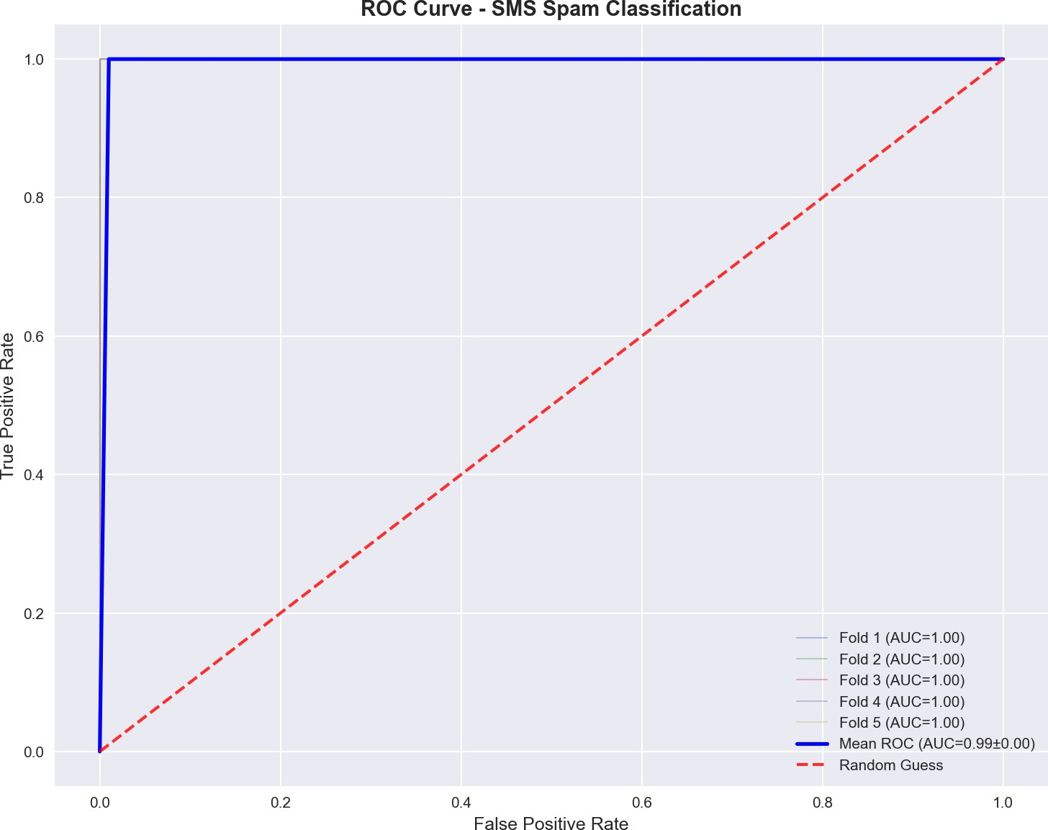
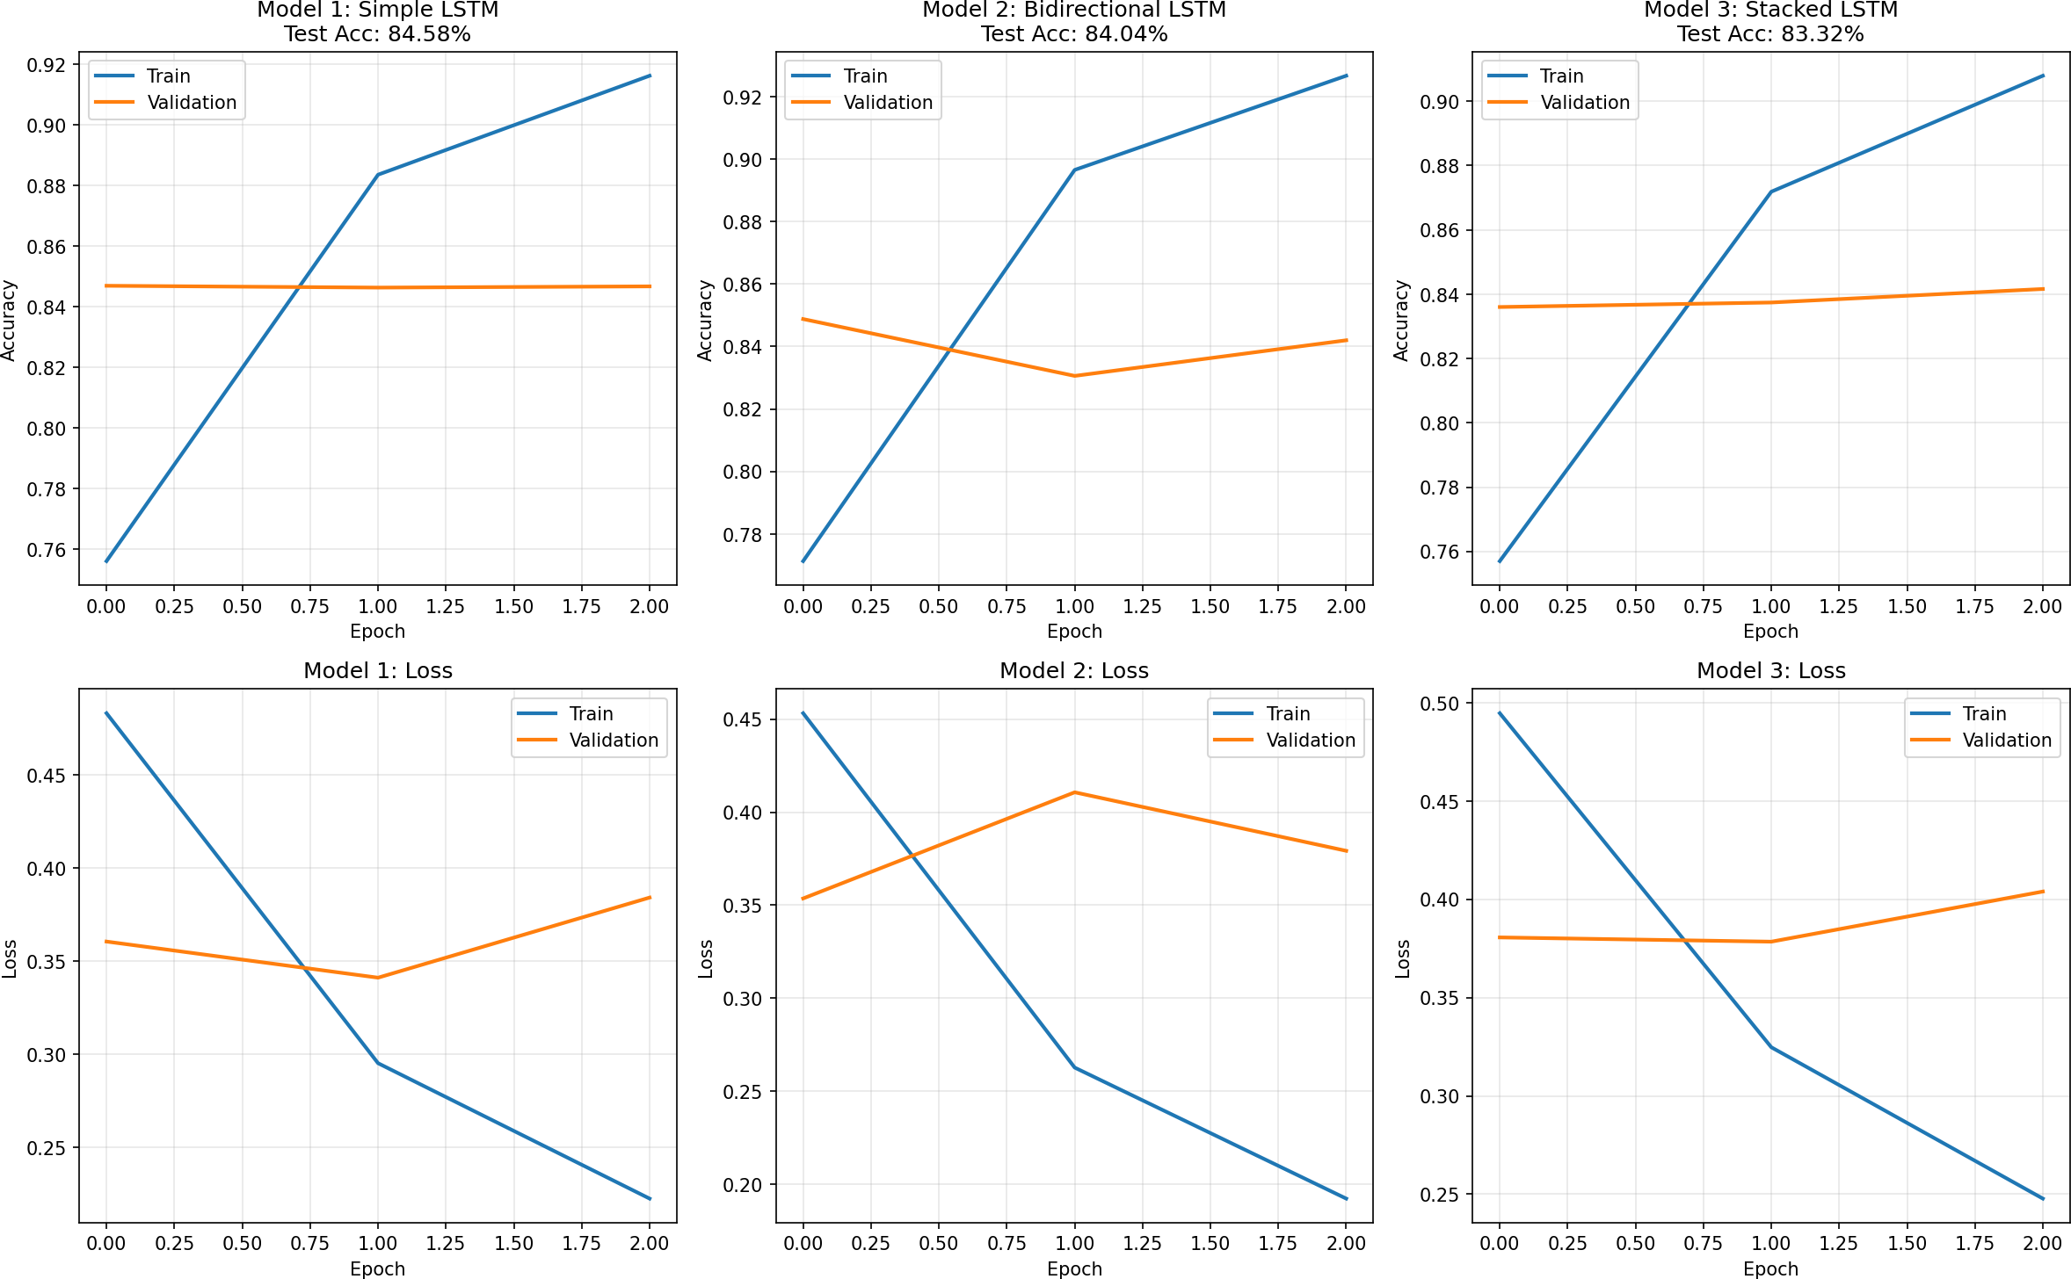
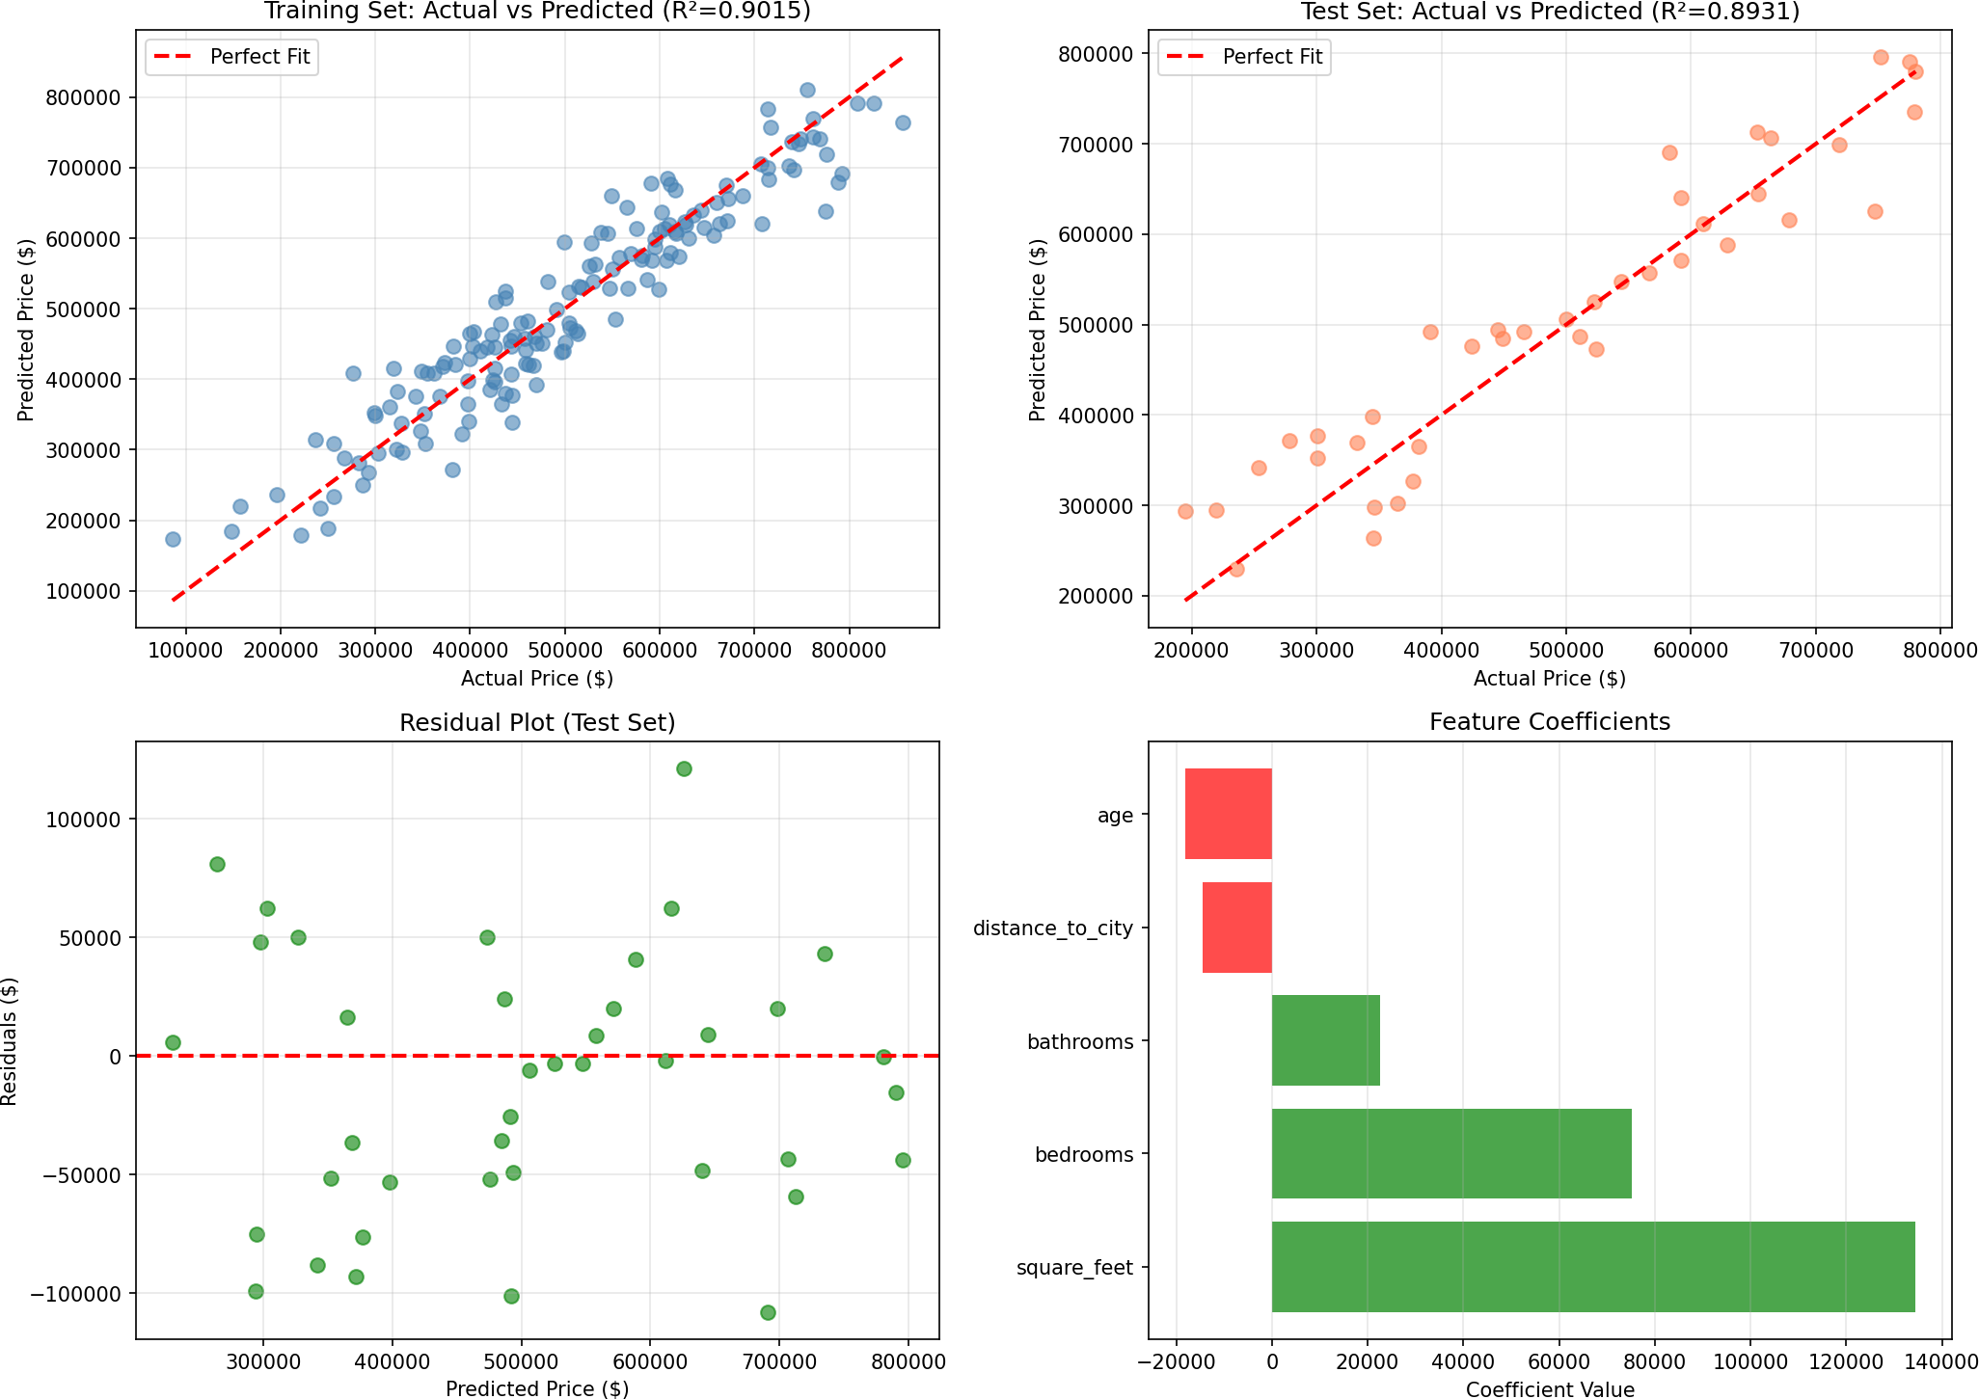
The snapshot section arranges the project visuals so they stay inside the spiral-bound margin. The images are scaled to the available column width instead of floating beyond the page frame.
SMS Classification ROC Curve

Sentiment Analysis LSTM

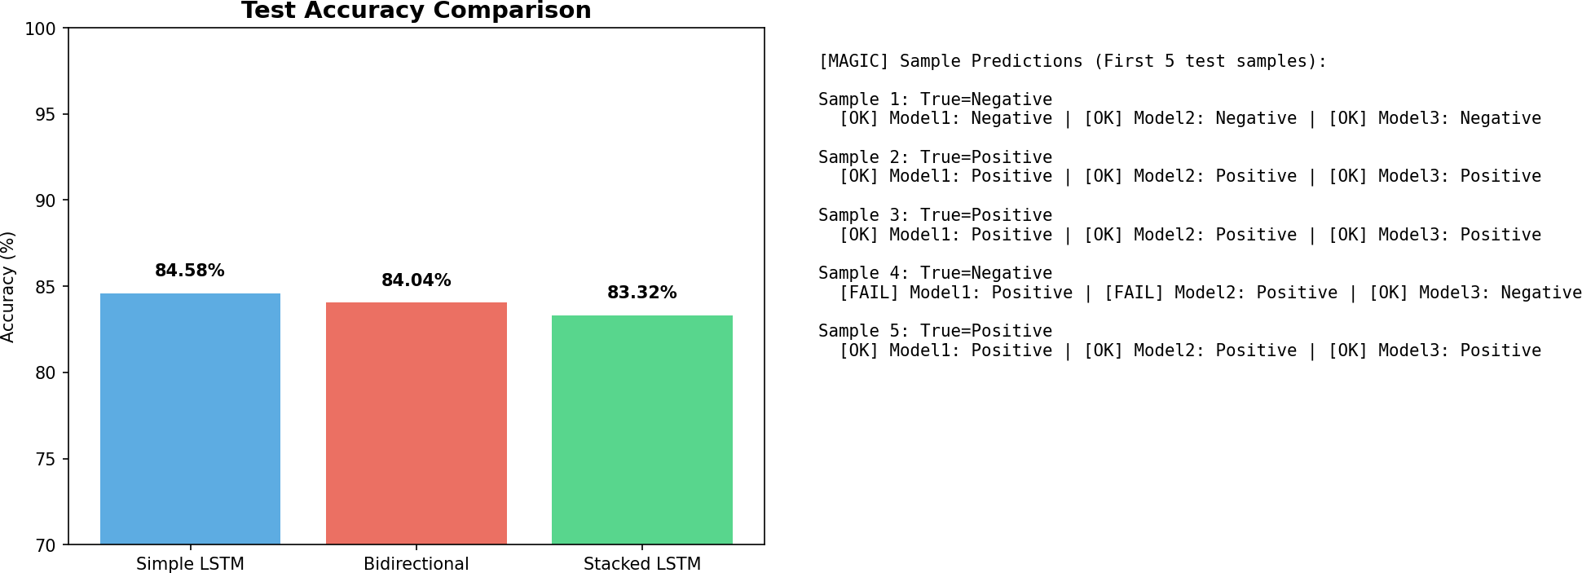
Sentiment Analysis Comparison

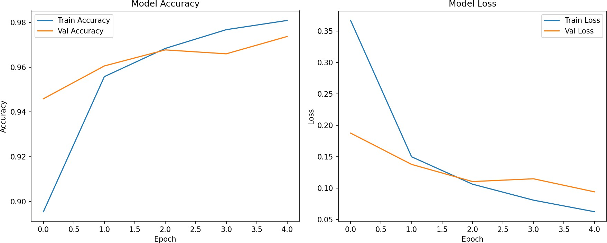
MNIST Training History

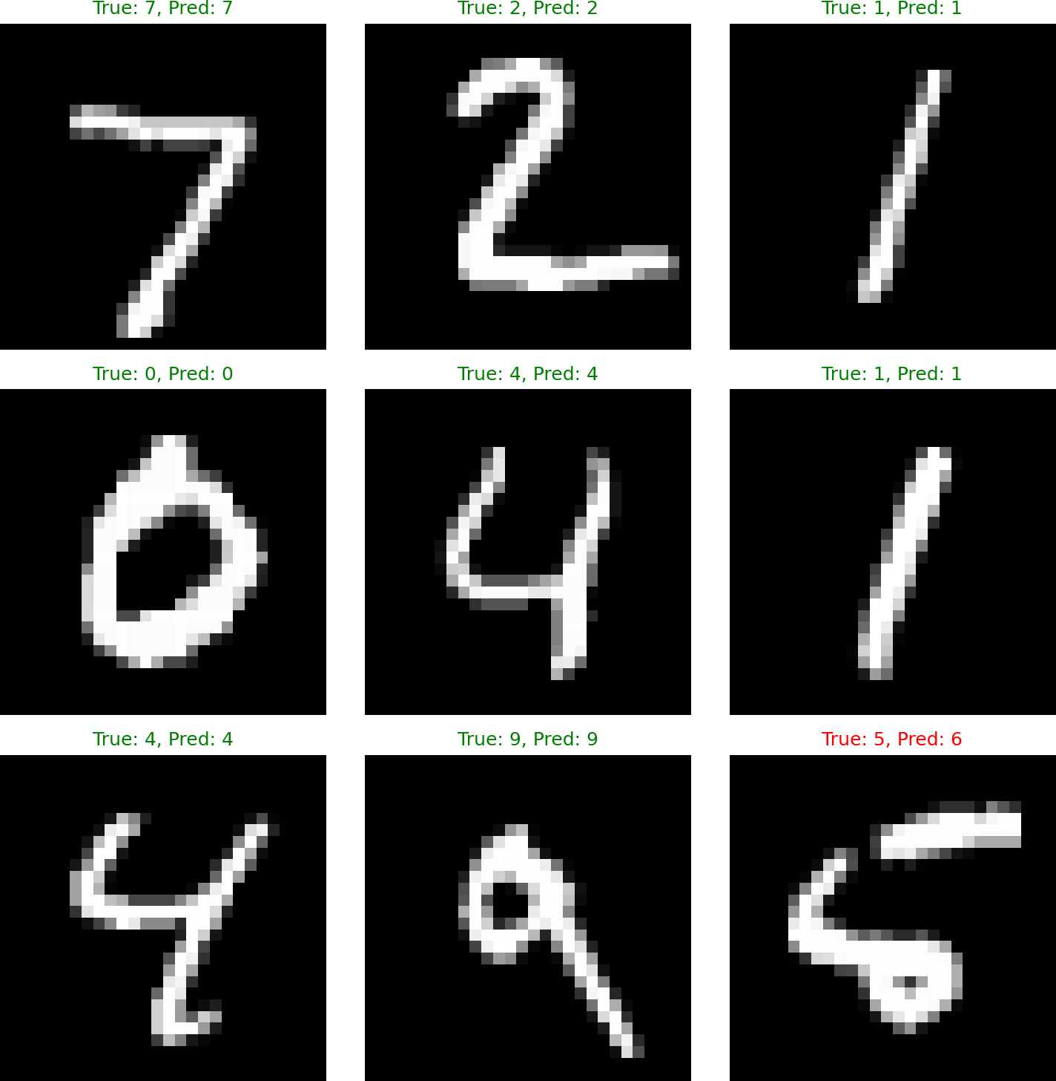
MNIST Predictions

Housing Prediction

Dept. of CSE-DS, MITM NYERAS | Maharaja Institute of Technology Mysore | VTU Page | 14

CHAPTER 8

Snapshots continued
INDUSTRY INTERNSHIP(BINT803B)
2025-26



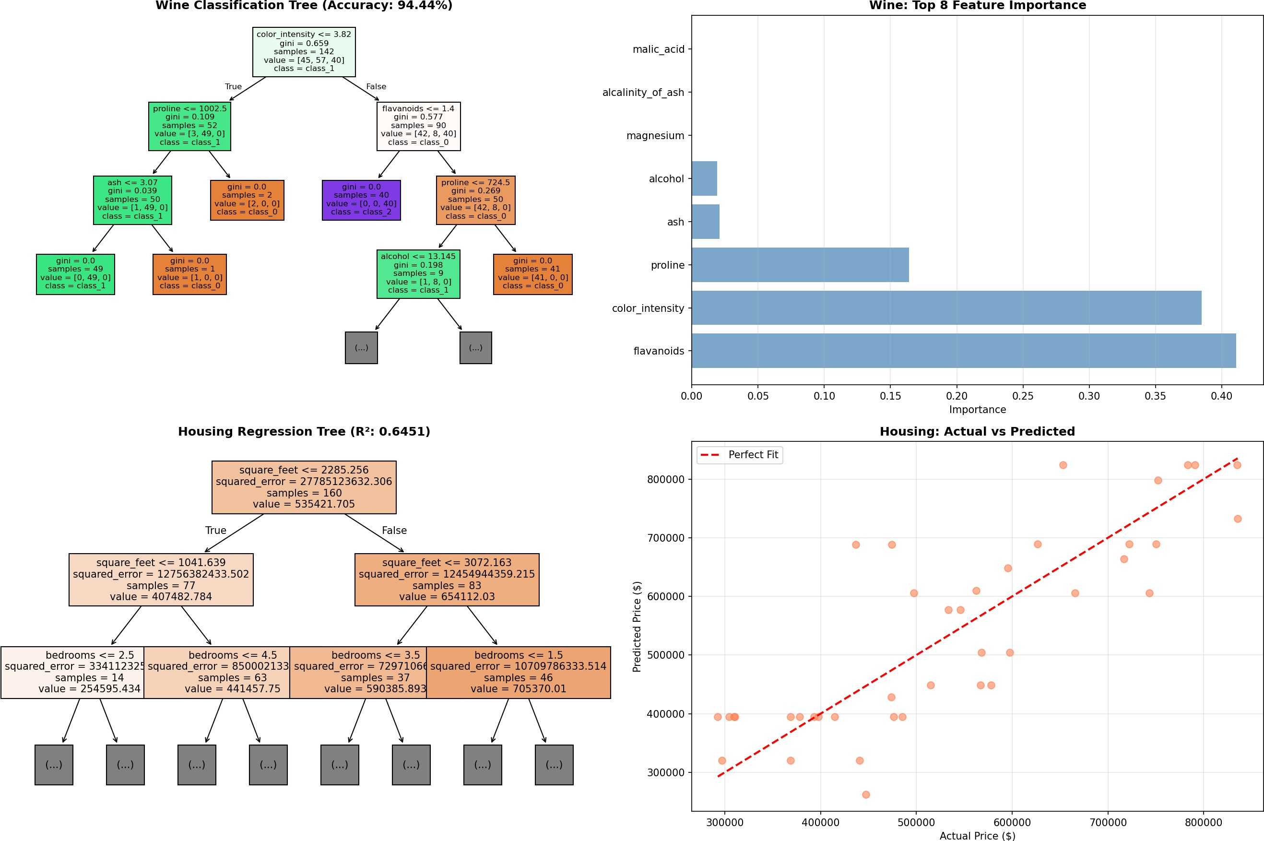
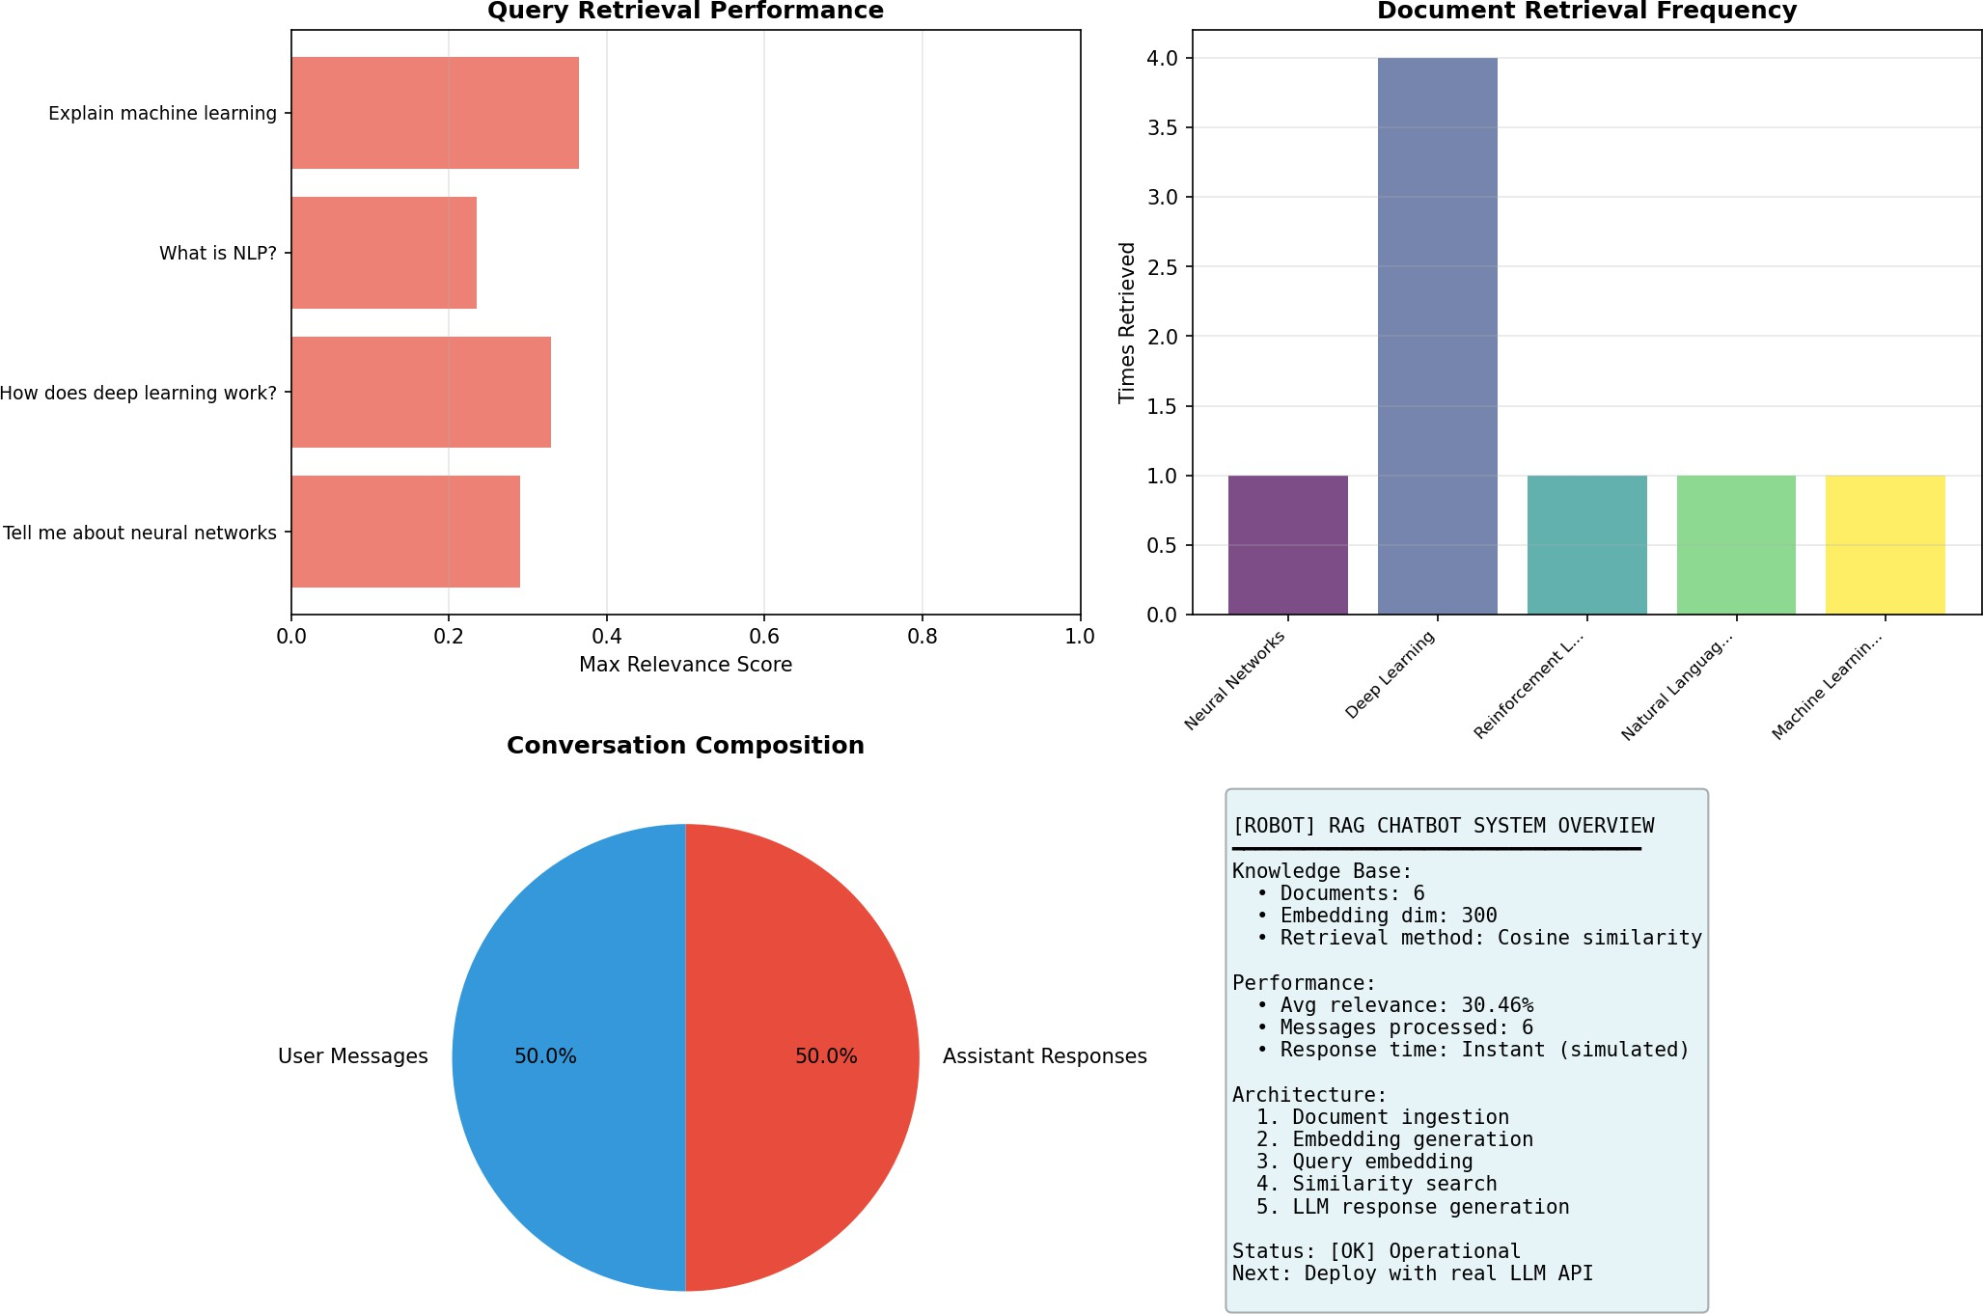
The second snapshot page continues with the remaining portfolio visuals and a compact figure summary used for presentation or viva support.
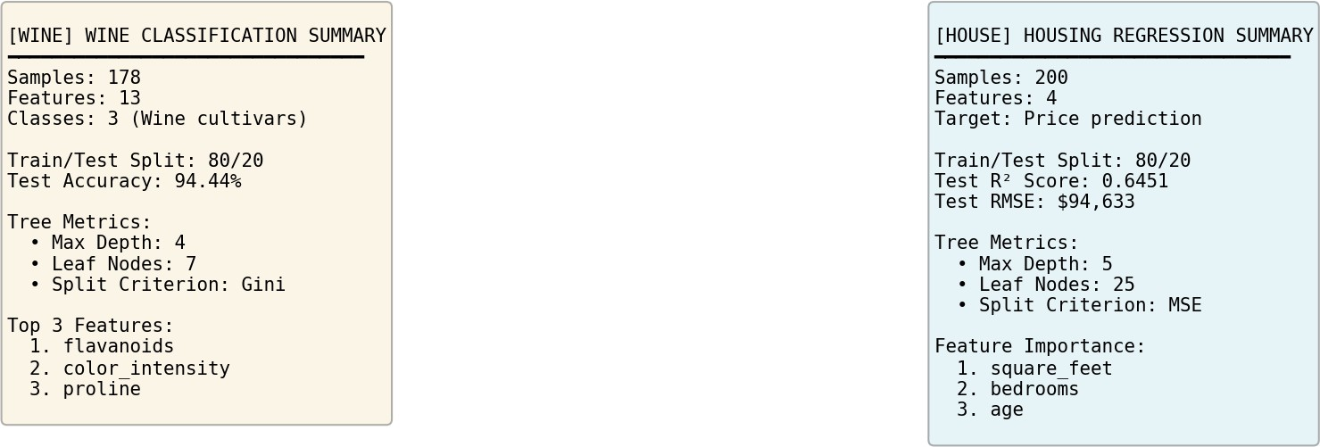
Decision Trees Summary

Decision Trees Analysis

RAG Chatbot Analysis

Figure | Caption
8.1 | Portfolio Snapshot Gallery
8.2 | Portfolio Visualizations and Summary Cards
8.3 | Dataset and dashboard evidence from the internship

Dept. of CSE-DS, MITM NYERAS | Maharaja Institute of Technology Mysore | VTU Page | 15

CHAPTER 9

FUTURE SCOPE
INDUSTRY INTERNSHIP(BINT803B)
2025-26



The internship projects are already useful, but they can be pushed further in three directions: more automation, broader deployment, and deeper model experimentation.
Automation Expansion
Extend the current workflow with deeper automation, richer dashboards, and smoother one-click execution.
Medical AI Growth
Add more imaging datasets, compare more models, and improve explainability for clinical use.
Portfolio Deployment
Move the dashboard and project demos into a web-hosted or containerized presentation layer.

Future work can include a browser-hosted dashboard, better model explainability, and a larger shared repository for demo and evaluation use.

Dept. of CSE-DS, MITM NYERAS | Maharaja Institute of Technology Mysore | VTU Page | 16

CHAPTER 10

CONCLUSION
INDUSTRY INTERNSHIP(BINT803B)
2025-26

The internship at NYERAS Edutech & Innovations gave a clear progression from foundation analytics to advanced AI delivery. The phase 1 material explains the organization, planning, and learning path, while the phase 2 work demonstrates that the intern could deliver production-aware technical systems.
This v2 body is designed for spiral binding, with a reduced left gutter and compact figures that remain inside the usable page area. That makes the report easier to bind, print, and evaluate without losing content to the margin.

108
Diary Entries
Used to shape the report
777.7
Logged Hours
Approximate total work span

3
Major Systems
Retail, portfolio, and medical AI
99.03%
Medical Accuracy
Brain tumor model result




Dept. of CSE-DS, MITM NYERAS | Maharaja Institute of Technology Mysore | VTU Page | 17

REFERENCES
INDUSTRY INTERNSHIP(BINT803B)
2025-26



Source material and supporting tools

Primary Project Repository | https://github.com/Mr-nagabhushana-at-Git-hub/NYERAS
Dashboard Project Folder | NYERAS_PROJECTS/ML_AI_Portfolio/projects
Internship Diary JSON | content/jan.json to content/may.json
Report Generation Stack | Python 3.11, ReportLab, Pillow, pypdf
Institutional Context | NYERAS internship material and phase 1 presentation slides shared by the user
The report body was written from the diary JSON files, the portfolio project images, and the phase 1 presentation screenshots shared by the user.

Dept. of CSE-DS, MITM NYERAS | Maharaja Institute of Technology Mysore | VTU Page | 18

ATTACHMENTS
INDUSTRY INTERNSHIP(BINT803B)
2025-26



Files and folders associated with the report

Source Diary Files | content/jan.json, content/feb.json, content/march.json, content/apr.json, content/may.json
Project Screenshots | NYERAS_PROJECTS/ML_AI_Portfolio/projects/*.png
Generated Report | output/Nagabhushana_Internship_Report_v2.pdf
Organization Branding | logos/nyeras.png and logos/vtu.png
If you later want this body merged with a front matter PDF, the page structure here can be appended directly after your certificate, declaration, acknowledgement, abstract, and official title pages.

Dept. of CSE-DS, MITM NYERAS | Maharaja Institute of Technology Mysore | VTU Page | 19

