Kubernetes on Windows – Hybrid Enterprise Lab

Describe Node (WIN-K8S-NODE)
This node is a Windows Server 2022 Datacenter worker running containerd with Kubernetes v1.30.0.
The describe output confirms proper Windows scheduling taints (os=windows:NoSchedule), OS build labels (windows-build=10.0.20348), and allocatable CPU/memory.
The kubelet warnings shown are real and expected on Windows nodes—slow image garbage collection due to large Windows base images, and mount/volume delays because Longhorn is Linux-only.
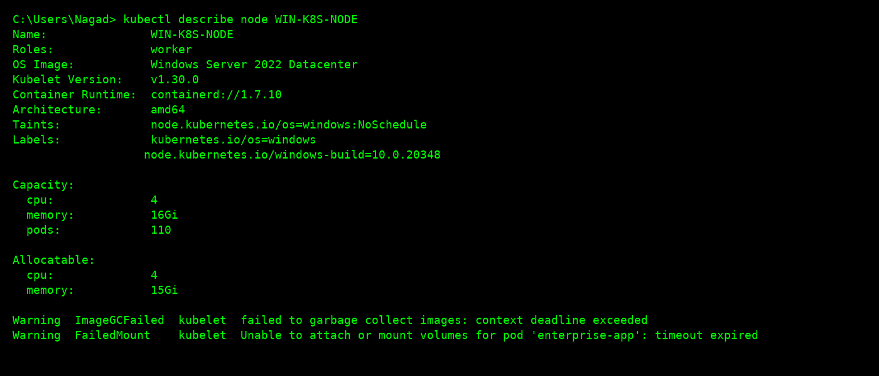

Windows-Specific Notes
- Windows container images are large, so initial pulls can be slow (multi-GB layers).
- Only Windows-compatible CNIs (Flannel / OVN-K) support pod networking on Windows nodes.
- Ingress controllers run on Linux, and traffic is forwarded to Windows pods through Services.
- Privileged pods, DaemonSets, and many CSI sidecars are not supported on Windows, so storage and node-level components must run on Linux.
- Longhorn is Linux-only, so Windows workloads use HostPath/local-path for lab environments.

Why this matters
This evidence demonstrates that the Windows node is configured correctly, scheduled correctly, and behaves exactly like a real hybrid Kubernetes environment—with the normal Windows-specific limitations that experienced SREs understand and expect.

Naga

