K.L.N. COLLEGE OF ENGINEERING
(An Autonomous Institution, Approved by AICTE, Affiliated to Anna University)
Pottapalayam, Sivagangai District – 630 612.

Department of InformationTechnology
20IT6L1 – INTERNET OFTHINGS LABORATORY
(MINIPROJECT)
MOTION DETECTION ALARM SYSTEM USING ARDUINO
A PROJECT REPORT
Submitted by
ILAKKIYA.S(910623105027)
NAGAHARINE.M(910623105043)
MAHALAKSHMI.M(910623105039)
Submitted to:
Mrs.M.MEENA.,ME.,(PHD)
Assistant Professor/IT
Academic Year: 2025–2026

CERTIFICATE

This is to certify that the Mini Project titled “MOTION DETECTION ALARM SYSTEM
USING ARDUINO”has been carried out by ILAKKIYA.S(910623105027) ,
NAGAHARINE.M (910623105043) , MAHALAKSHMI.M(910623105039)under the
guidance of Mrs.M.MEENA,M.E,(PHD)., Assistant Professor /IT, in partial fulfillment of the
requirements for the IoT Laboratory during the Sixth Semester of B.Tech (Information
Technology),K L N College Of Engineering,Pottapalayam

Date:_______
Place: POTTAPALAYAM

SIGNATURE SIGNATURE
Dr.P.GANESHKUMARM.,M.E.,Ph.D MRS.M .MEENA,M.E.,Ph.D
HEAD OF THE DEPARTMENT, SUPERVISOR,
PROFESSOR, ASSISTANT PROFESSOR,
INFORMATION TECHNOLOGY INFORMATION TECHNOLOGY

INTERNAL EXAMINER EXTERNAL EXAMINER

ACKNOWLEDGEMENT

We would like to express our sincere gratitude to the Management and Principal of K. L. N.
College of Engineering for providing us with the opportunity to carry out this mini project as
part of the IoT Laboratory.

We are deeply thankful to our respected Head of the Department, Dr. P. Ganesh Kumar, M.E.,
Ph.D., Head of the Department & Professor of IT, for his constant encouragement, valuable
support, and for providing us with all the facilities required to complete this project successfully

We express our heartfelt thanks to our guide, Mrs.M.Meena, M.E.,(PHD) Assistant Professor,
Department of IT, for her valuable guidance, continuous motivation, and insightful
suggestions throughout the course of the project.

We also extend our sincere thanks to all the faculty members and technical staff of the IT
Department for their assistance and cooperation.

Finally, we thank our parents and friends for their constant support and encouragement
throughout this mini project.

ABSTRACT
This project presents the implementation and demonstration of a Motion Detection Alarm
System using the Arduino microcontroller and PIR (Passive Infrared) sensor. Arduino is a low-
cost, user-friendly microcontroller platform widely used in embedded systems and Internet of
Things (IoT) applications. The PIR sensor is capable of detecting infrared radiation emitted by t
he human body, making it suitable for motion detection and security-based applications.
In this system, the PIR sensor continuously monitors the surrounding environment for any
movement. When motion is detected, the sensor sends a signal to the Arduino, which processes
the input and activates a buzzer to provide an alert. The buzzer serves as an immediate
notification mechanism, indicating the presence of an intruder or movement in the monitored
area. The project emphasizes simplicity, cost-effectiveness, and ease of implementation using
basic electronic components and Arduino programming. It demonstrates the fundamental
concepts of sensor interfacing, digital signal processing, and real-time response in embedded
systems. The system operates efficiently with minimal power consumption and can be easily
extended for advanced applications.The objectives of this project include establishing proper
interfacing between the PIR sensor and Arduino, implementing a reliable motion detection
mechanism, and designing an effective alert system. The implementation showcases sensor
signal reading, conditional decision-making, and output control through the buzzer. This project
can be further enhanced by integrating IoT notifications output control through the buzzer.

CHAPTER TITLE PAGE NO
ABSTRACT i

1 INTRODUCTION 1
1.1.Background 2
1.2.Problem Statement 2
1.3.Objectives 3

2 LITERATURE REVIEW 4
2.1.Prior works 5
2.2.How your project differs 5

3 SYSTEM REQUIREMENTS 7
3.1.Hardware Requirements 8
3.2.Software Requirements 8

4 SYSTEM DESIGN 9
4.1.Block Diagram 10
4.2.Circuit Diagram 10
4.3.Algorithm 10

5 IMPLEMENTATION 11
5.1.Description of each Module 12
5.2.Code snippets 12
5.3.Integration steps 14

6 RESULTS AND DISCUSSION 15
6.1.Output details 16
6.2.Screenshots 16
6.3.Tables 17

7 CONCLUSION 18
7.1.Summary of achievements 19
7.2.Limitations 19

8 REFERENCES 20

9 APPENDIX 22

1.INTRODUCTION

1. INTRODUCTION

1.1. BACKGROUND:

The increasing need for safety and security in residential, commercial, and industrial environments has led to the development of efficient and cost-effective motion detection systems. With the advancement of embedded systems and microcontroller technologies, it has become easier to design compact, low-power, and reliable security solutions. Arduino, a widely used open-source microcontroller platform, provides a simple and flexible environment for developing such applications.
The integration of sensors with microcontrollers has enabled real-time monitoring and automation in various fields. Among these sensors, the Passive Infrared (PIR) sensor plays a crucial role in motion detection systems. The PIR sensor detects infrared radiation emitted by living beings, especially humans, and identifies changes in the surrounding environment. This makes it highly suitable for applications such as intruder detection, automatic lighting systems, and surveillance systems.
The combination of Arduino and PIR sensor creates a simple yet powerful platform for implementing motion-based alert systems. Arduino offers ease of programming, low cost, and compatibility with various input and output devices, making it ideal for beginners and developers. The buzzer, used as an output device in this project, provides an immediate audible alert when motion is detected, ensuring quick response to potential security threats.
This system emphasizes simplicity, reliability, and efficiency by utilizing minimal hardware components while achieving effective motion detection. The Arduino microcontroller processes the input signal from the PIR sensor and controls the buzzer accordingly. The system operates in real-time and consumes low power, making it suitable for continuous monitoring applications.
Furthermore, this project serves as a foundation for developing advanced IoT-based security systems. It can be extended by integrating wireless communication modules, mobile notifications, or camera systems for remote monitoring and enhanced functionality. Thus, the Motion Detection Alarm System demonstrates a practical and scalable approach to modern security solutions using embedded system technology.

1.2. PROBLEM STATEMENT:
Ensuring safety and security in homes, offices, and restricted areas is a growing concern in today’s world. Traditional security systems are often expensive, complex, and require continuous human monitoring, making them less accessible for small-scale or low-cost applications. Additionally, many existing systems lack real-time response and are not efficient in detecting unauthorized human movement.
Detecting motion using sensors such as the Passive Infrared (PIR) sensor requires proper interfacing with microcontrollers like Arduino and accurate processing of sensor signals. However, challenges arise in designing a reliable system that can effectively differentiate between motion and no-motion conditions while minimizing false alarms caused by environmental factors such as temperature variations or noise.
Moreover, developing a simple and cost-effective motion detection system that provides immediate alerts without requiring advanced hardware or complex programming remains a challenge for beginners and students. Therefore, there is a need for an efficient, easy-to-implement solution that can detect motion accurately and provide instant notification using basic components and simple embedded programming techniques.

1.3. OBJECTIVES :
- To develop a motion detection system using Arduino
- To interface the PIR sensor with the Arduino microcontroller
- To detect human movement using infrared sensing
- To design an alert system using a buzzer
- To process sensor input and control output effectively
- To demonstrate real-time motion detection
- To ensure the system is simple, reliable, and cost-effective

2.LITERATURE SURVEY

2. LITERATURE SURVEY:

2.1. PRIOR WORKS:
Several previous efforts have been made to develop motion detection systems using sensors and microcontrollers for security applications. Many systems utilize Passive Infrared (PIR) sensors interfaced with microcontrollers such as Arduino, Raspberry Pi, and other embedded platforms. These systems are widely used in automatic lighting, intrusion detection, and surveillance systems.
In earlier implementations, motion detection systems were developed using complex hardware setups and high-cost components. Some systems also integrated cameras and wireless modules for enhanced monitoring, but required advanced programming knowledge and higher power consumption. Basic Arduino-based projects have demonstrated motion detection using PIR sensors and simple output devices like LEDs and buzzers, providing a foundation for low-cost security systems.

Limitations of Prior Works:
- High cost and complex hardware design
- Requires continuous monitoring in some systems
- Limited accuracy due to environmental disturbances
- Higher power consumption in advanced systems
- Minimal user-friendly and low-cost implementations

2.2. OUR PROJECT IMPROVES:
Our project focuses on developing a simple, cost-effective, and reliable motion detection system using Arduino and PIR sensor. The system is designed to be easy to implement, making it suitable for beginners as well as practical security applications. It utilizes minimal hardware components while providing efficient real-time motion detection.
By using Arduino, the project simplifies the process of interfacing sensors and controlling output devices. The PIR sensor is effectively used to detect human motion based on infrared radiation, and the Arduino processes this input to trigger an alert through the buzzer. This ensures quick response and accurate detection with minimal delay.
The system improves upon earlier approaches by reducing complexity and cost while maintaining functionality. It provides a real-time alert mechanism without requiring continuous human monitoring. Additionally, the design is flexible and can be easily extended to include advanced features such as IoT-based notifications, wireless communication, or integration with other sensors.
Overall, the project demonstrates an efficient and scalable solution for motion detection, making it suitable for security applications in homes, offices, and restricted areas.
2.3. BENEFITS :
• Promotes hands-on learning of Arduino and embedded system development
• Demonstrates real-time motion detection using PIR sensor
• Provides a simple and cost-effective security solution
• Enables immediate alert using buzzer for quick response
• Supports easy integration with additional sensors and IoT modules

2.4. SUMMARY :
Traditional motion detection systems are often complex, expensive, and require continuous monitoring, making them less suitable for simple and low-cost applications. Many existing systems focus on advanced features with higher hardware requirements, which increases cost and complexity while reducing accessibility for beginners and small-scale implementations.
The proposed Motion Detection Alarm System overcomes these limitations by using Arduino and a PIR sensor to create a simple, efficient, and real-time motion detection solution. The system provides immediate alerts through a buzzer when motion is detected, ensuring quick response without the need for constant human supervision. This project offers a cost-effective and easy-to-implement approach, making it suitable for learning embedded systems and developing basic security applications.

3.SYSTEM REQUIREMENTS

3. SYSTEM REQUIREMENTS:

3.1. HARDWARE REQUIREMENTS:
• Arduino UNO: The main microcontroller used to process sensor input and control the output.
• PIR Sensor: Used to detect human motion based on infrared radiation.
• Buzzer: Provides an audible alert when motion is detected.
• IoT Trainer Kit: Used for easy interfacing and built-in connections.
• Jumper Wires: For connecting Arduino with sensor and buzzer.
• USB Cable: To power the Arduino and upload the program.
• Power Supply (5V USB): Provides power to the Arduino board.
• Breadboard (optional): For external connections if required.

3.2. SOFTWARE REQUIREMENTS:
• Arduino IDE: For writing, compiling, and uploading code to the Arduino board.
• Embedded C (Arduino Programming): Used to develop the logic for motion detection and buzzer control.
• Arduino Drivers: Required for proper communication between the computer and Arduino board.
• Serial Monitor (Arduino IDE): Used to display sensor output and debug the system.
• USB Drivers: To establish connection between Arduino and computer.

4.SYSTEM DESIGN

4. SYSTEM DESIGN:
4.1. BLOCK DIAGRAM:
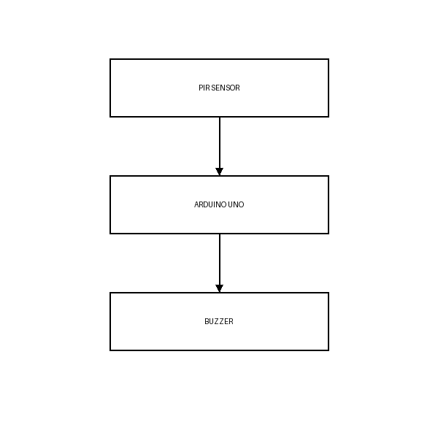
:
Figure 4.1 Block Diagram

4.3. ALGORITHM:
- Start
- Initialize the Arduino UNO board and connect it to the system via USB
- Define the PIR sensor pin and buzzer pin in the program
- Set PIR sensor pin as INPUT
- Set buzzer pin as OUTPUT
- Open Arduino IDE
- Write the program to read PIR sensor data
- Upload the code to Arduino board
- Initialize serial communication (optional for monitoring)
- Read the input signal from PIR sensor continuously
- If motion is detected (signal HIGH):
- → Turn ON the buzzer
- → Display "Motion Detected" in Serial Monitor
- Else (no motion detected):
- → Turn OFF the buzzer
- → Display "No Motion" in Serial Monitor
- Repeat the process continuously (loop)
- End

5.IMPLEMENTATION

5. IMPLEMENTATION:

5.1. DESCRIPTION OF EACH COMPONENTS:
Component | Description | Qty
Arduino UNO | Microcontroller used to process input and control output | 1
PIR Sensor | Detects human motion using infrared radiation | 1
Buzzer | Provides audible alert when motion is detected | 1
Arduino IDE | Software used to write and upload code | 1
Jumper Wires | Used for connecting components | 2–4
IoT Trainer Kit | Provides built-in connections and modules | 1
USB Cable | Used to power Arduino and upload code | 1
Power Supply (5V) | Provides required power to the system | 1

5.2. CODE SNIPPETS:
int pirPin = 2; // PIR sensor connected to D2
int buzzer = 8; // Buzzer connected to D8
int motion = 0; // Variable to store PIR value

void setup() {
pinMode(pirPin, INPUT); // Set PIR as input
pinMode(buzzer, OUTPUT); // Set buzzer as output
Serial.begin(9600); // Start serial communication
}

void loop() {
motion = digitalRead(pirPin); // Read PIR sensor

if (motion == HIGH) {
digitalWrite(buzzer, HIGH); // Turn ON buzzer
Serial.println("Motion Detected!");
}
else {
digitalWrite(buzzer, LOW); // Turn OFF buzzer
Serial.println("No Motion");
}

delay(500); // Small delay
}

5.3. INTEGRATION STEPS:
Connect all hardware components (PIR sensor and buzzer) to the Arduino UNO using proper digital pins.
- Connect all hardware components (PIR sensor and buzzer) to the Arduino UNO
- Connect PIR sensor output pin to Arduino digital pin D2
- Connect buzzer to Arduino digital pin D8
- Connect Arduino to the system using USB cable for power and programming
- Open Arduino IDE and write the program for motion detection and buzzer control
- Upload the code to the Arduino board
- Test individual components such as PIR sensor and buzzer
- Integrate the complete system and verify real-time motion detection

6.RESULTS & DISCUSSIONS

.

6. RESULTS AND DISCUSSION:

6.1. OUTPUT DETAILS:
- The Arduino UNO successfully runs the program and monitors the PIR sensor continuously
- The PIR sensor detects human motion using infrared radiation
- When motion is detected, the PIR sensor sends a HIGH signal to Arduino
- The Arduino processes the signal and turns ON the buzzer
- The buzzer produces an audible alert indicating motion detection
- When no motion is detected, the PIR sensor sends a LOW signal
- The Arduino turns OFF the buzzer
- The system works in real-time with minimal delay
- Serial Monitor displays messages like “Motion Detected” and “No Motion” (optional)
- The PIR sensor stabilizes after initial calibration (20–30 seconds)
- The system accurately detects movement within its range
- Continuous monitoring is achieved using the loop function

SCREENSHOTS :

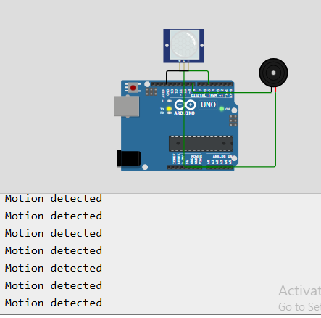
Fig 6.2 OUTPUT

7.CONCLUSION

7. CONCLUSION:

7.1. SUMMARY OF ACHIEVEMENTS:
The Motion Detection Alarm System using Arduino effectively demonstrates real-time motion detection using a PIR sensor. The system successfully integrates hardware components such as the Arduino microcontroller, PIR sensor, and buzzer to create a simple and reliable security solution. It detects human movement based on infrared radiation and provides an immediate audible alert, ensuring quick response to potential intrusions.
This project serves as an excellent platform for understanding basic concepts of embedded systems, including sensor interfacing, digital input processing, and output control. The use of Arduino simplifies development and makes the system easy to implement and modify. Overall, the project provides a practical and cost-effective approach to motion detection and can be extended for advanced IoT-based security applications.

7.2. LIMITATIONS AND FUTURE ENHANCEMENTS:

LIMITATIONS:
• Limited to basic motion detection using PIR sensor only
• Cannot detect stationary objects or very slow movements
• Possibility of false detection due to environmental factors (heat, noise)
• No wireless communication for remote monitoring or alerts

FUTURE ENHANCEMENTS:
• Integrate IoT modules (Wi-Fi/GSM) for remote notifications
• Add camera module for image/video capture on motion detection
• Improve accuracy using multiple sensors
• Develop mobile application for real-time monitoring

8.REFERENCE

8. REFERENCES:
- Arduino. (n.d.). Arduino UNO Documentation. Retrieved from
https://www.arduino.cc/en/Guide/ArduinoUno
- Arduino. (n.d.). Arduino IDE Documentation. Retrieved from
https://www.arduino.cc/en/software
- Random Nerd Tutorials. (2021). PIR Motion Sensor with Arduino. Retrieved from
https://randomnerdtutorials.com
- Adafruit Industries. (n.d.). PIR Motion Sensor Guide. Retrieved from
https://learn.adafruit.com
- Electronics Hub. (2020). Arduino Motion Sensor Alarm Project. Retrieved from
https://www.electronicshub.org
- Circuit Digest. (2021). Motion Detector using Arduino and PIR Sensor. Retrieved from
https://circuitdigest.com
- Components101. (n.d.). PIR Sensor Working and Specifications. Retrieved from
https://components101.com
- Microchip Technology Inc. (2020). Introduction to Embedded Systems. Retrieved from
https://www.microchip.com
- Maker Advisor. (2021). Arduino Motion Detection Projects. Retrieved from
https://makeradvisor.com
- Tutorials Point. (n.d.). Arduino Programming Basics. Retrieved from
https://www.tutorialspoint.com

9.APPENDIX

9. APPENDIX:

9.1. FULL SOURCE CODE:

// Motion Detection Alarm System using Arduino

int pirPin = 2; // PIR sensor connected to digital pin D2
int buzzer = 8; // Buzzer connected to digital pin D8
int motion = 0; // Variable to store PIR sensor value

void setup() {
pinMode(pirPin, INPUT); // Set PIR sensor as input
pinMode(buzzer, OUTPUT); // Set buzzer as output
Serial.begin(9600); // Initialize serial communication
}

void loop() {
motion = digitalRead(pirPin); // Read PIR sensor value

if (motion == HIGH) {
digitalWrite(buzzer, HIGH); // Turn ON buzzer
Serial.println("Motion Detected!");
}
else {
digitalWrite(buzzer, LOW); // Turn OFF buzzer
Serial.println("No Motion");
}

delay(500); // Delay for stability
}

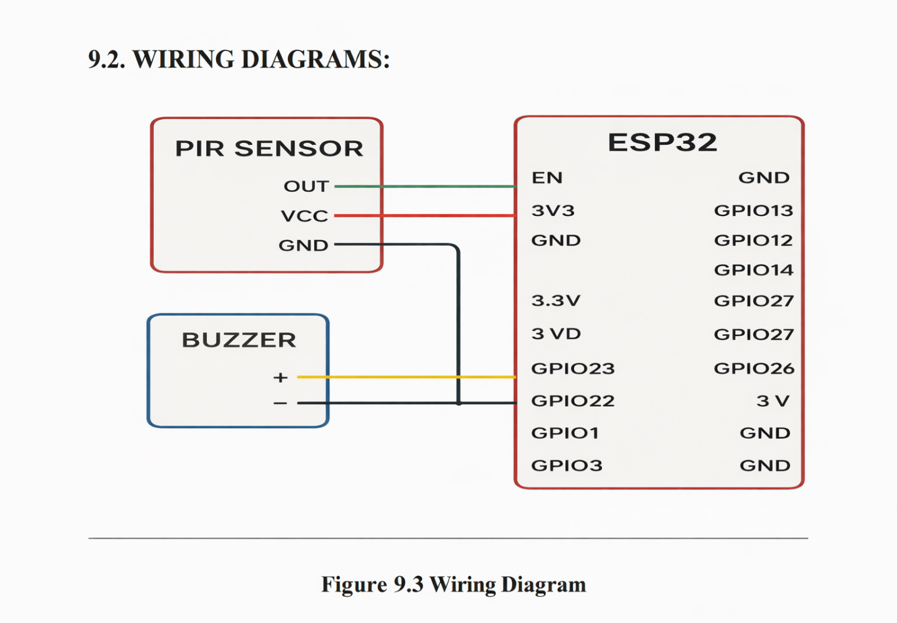

9.3 PHOTOS OF WORKING MODEL:
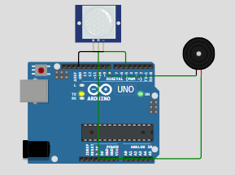
Figure 9.3.1.MOTION SENSING USING ARDUINO

Figure 9.3.2 MOTION DETECTED USING ARDUINO AND PR SENSOR

