* 1. 3333 records are present in the dataset.
  2. 21 features are there in the dataset.  
     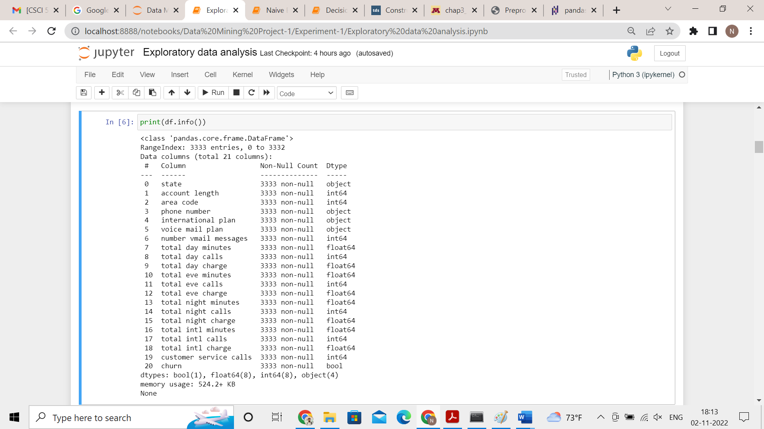  
     In the above picture, the datatypes with object and int64 are discrete; columns with Dtype float 64 are continuous, churn has bool Dtype which is binary.
  3. Features such as State, Account length, area code, phone number are irrelevant because the churn status is not linked with any kind of pattern with these features.
  4. There are no missing values in the data.
  5. The continuous numeric features are total day minutes, total day charge, total eve minutes, total eve charge, total night minutes, total night charge, total int minutes and total int charge.  
     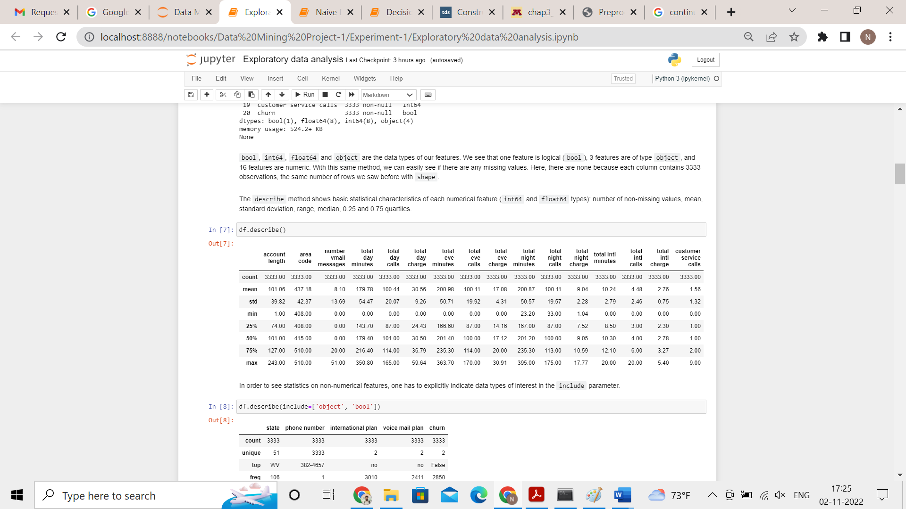

|  |  |  |  |  |  |
| --- | --- | --- | --- | --- | --- |
| **Feature** | **average** | **median** | **maximum** | **minimum** | **Std dev** |
| total day minutes | 179.78 | 179.40 | 350.80 | 0.0 | 54.47 |
| total day charge | 30.56 | 30.5 | 59.64 | 0.0 | 9.26 |
| total eve minutes | 200.98 | 201.4 | 363.70 | 0.0 | 50.71 |
| total eve charge | 17.08 | 17.12 | 30.91 | 0.0 | 4.31 |
| total night minutes | 200.87 | 201.20 | 395.00 | 23.20 | 50.57 |
| total night charge | 9.04 | 9.05 | 17.77 | 1.04 | 2.28 |
| total int minutes | 10.24 | 10.30 | 20.00 | 0.0 | 2.79 |
| total int charge | 2.76 | 2.78 | 5.40 | 0.0 | 0.75 |

* 1. A customer makes 1.56 calls on an average to the company
  2. There are total 51 states in the data  
     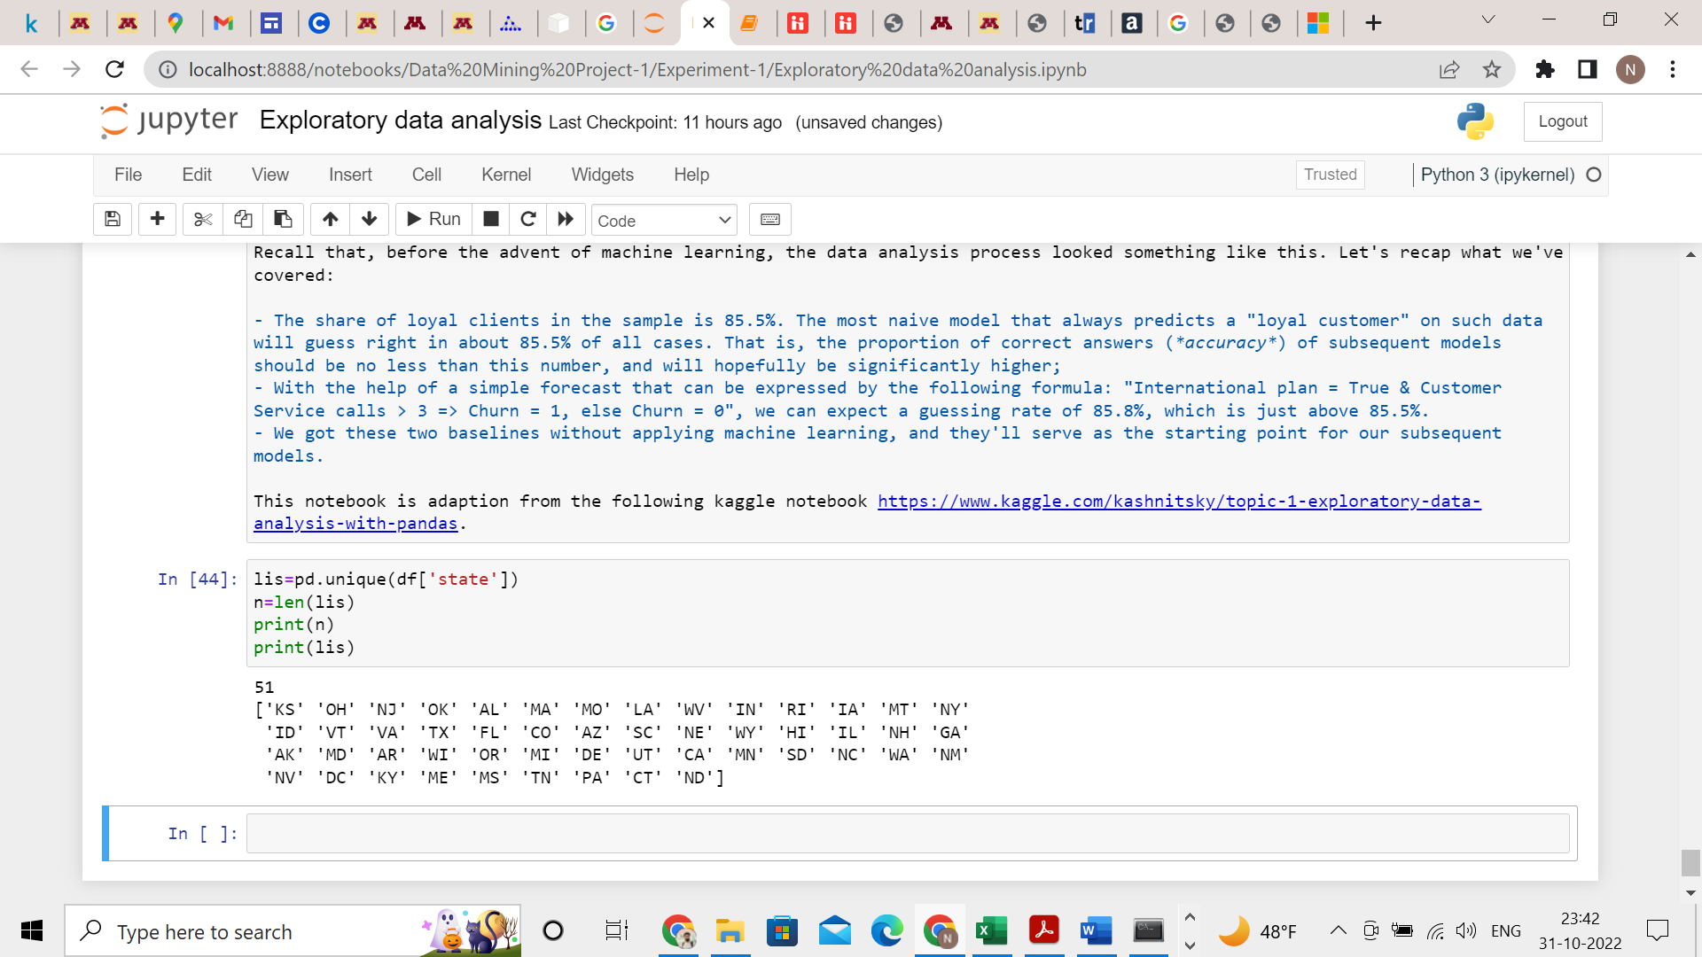
  3. The following is the distribution of the “Churn” and it is skewed because True count is very less compared to False count.  
     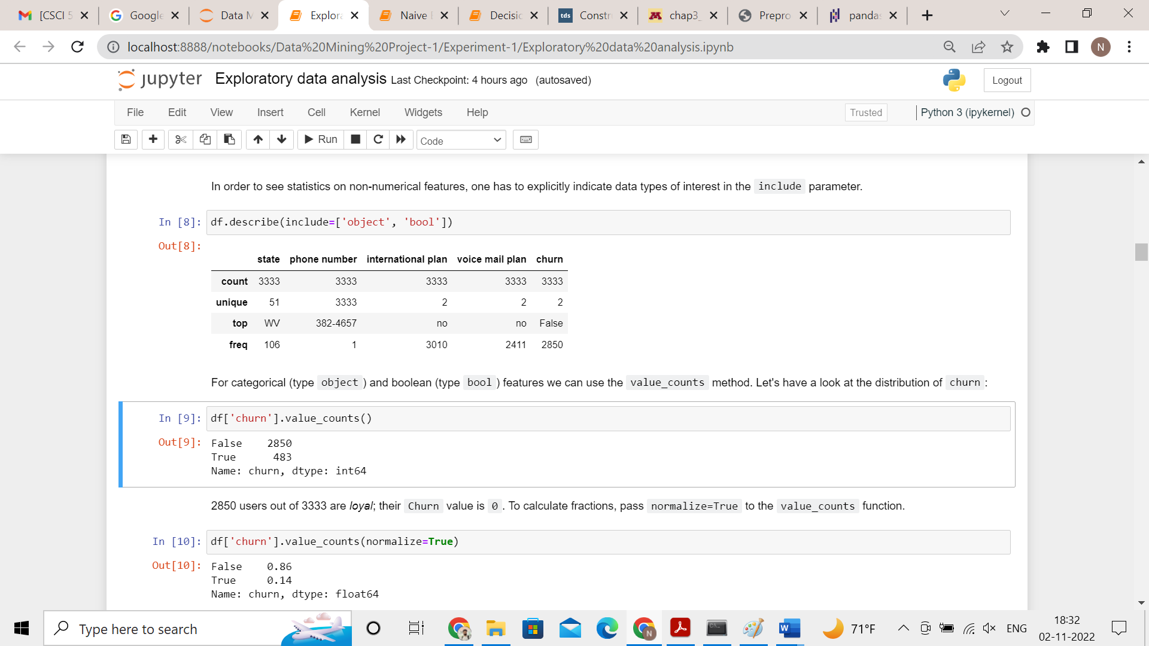  
     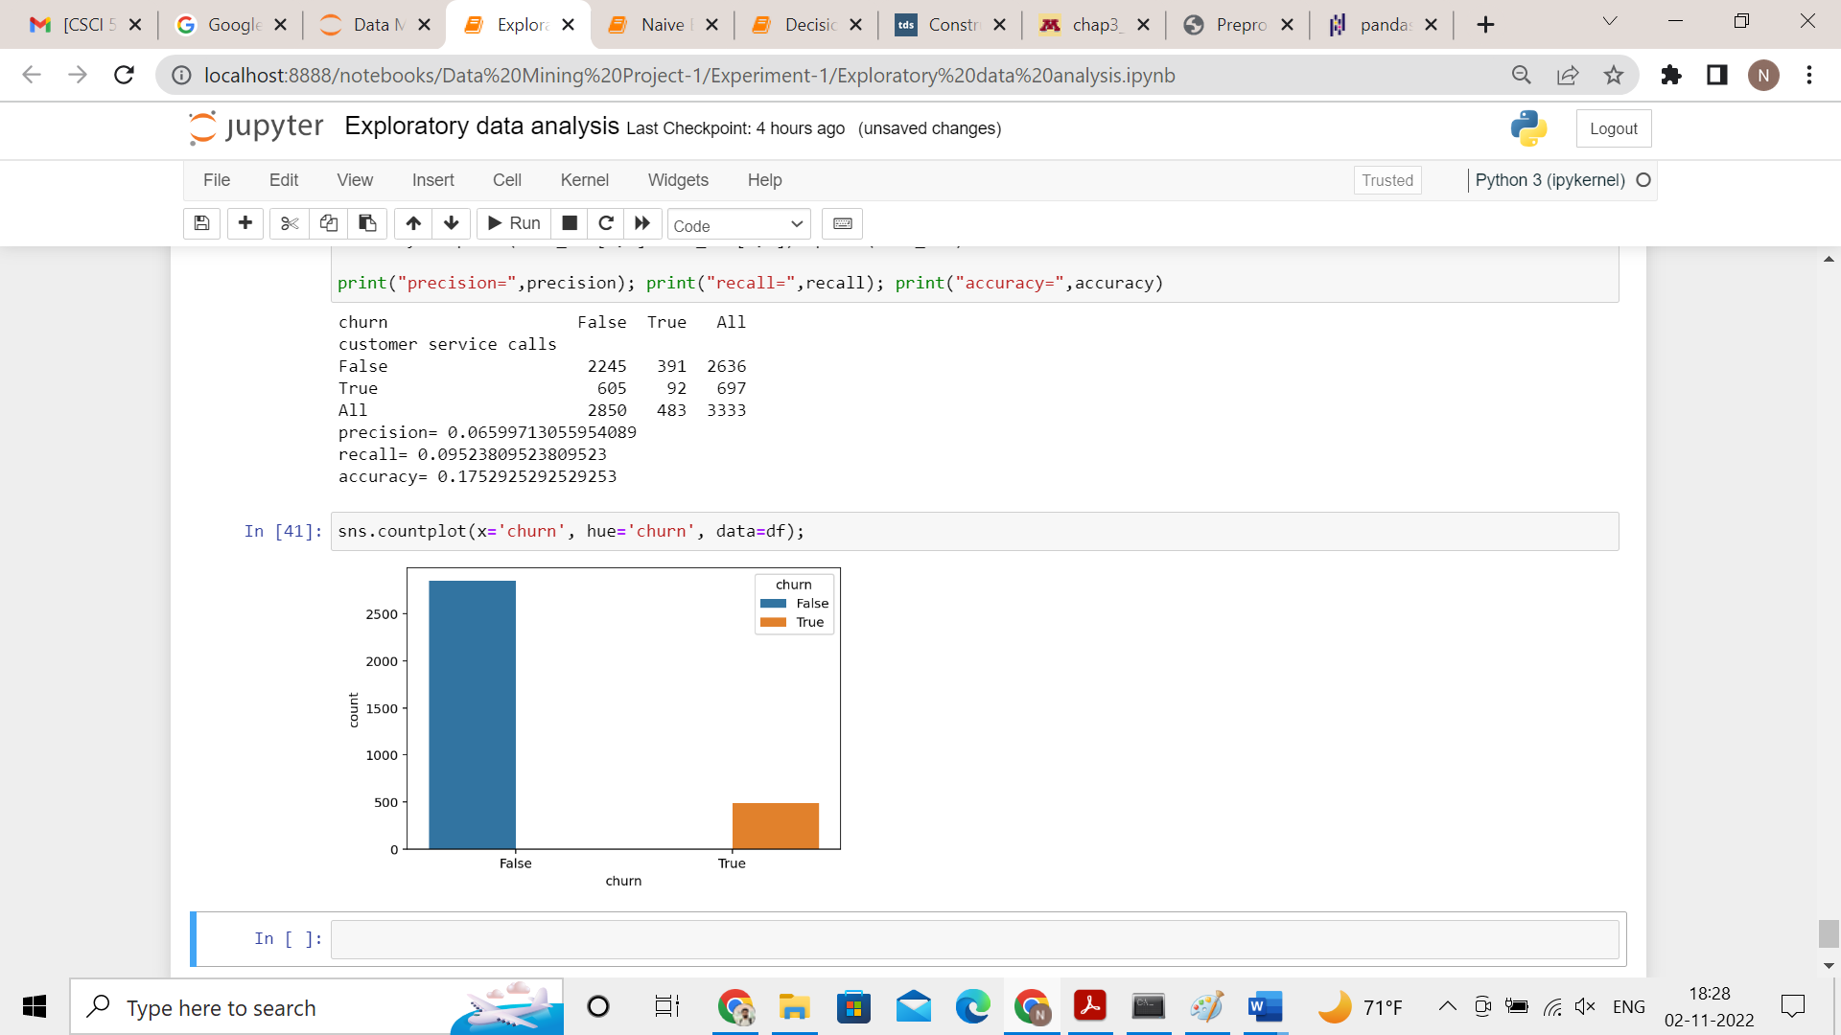
  4. Min is 0 and max is 59.64  
     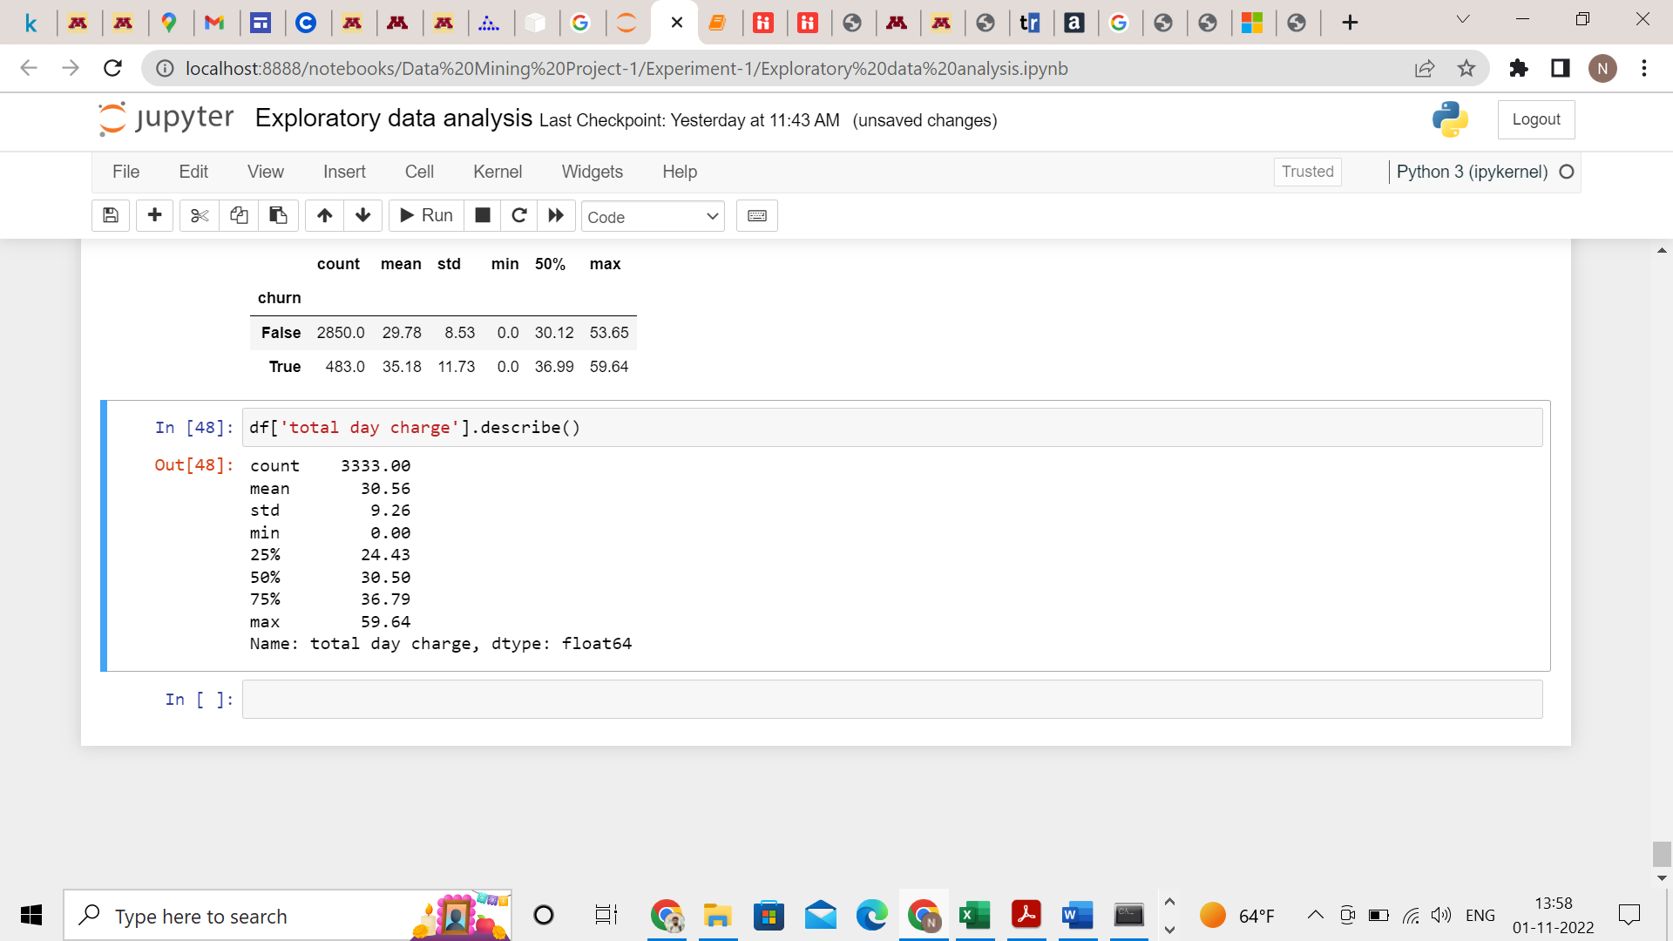

For higher total day charge the churn is True and lesser the total day charge the churn is False.

* 1. The average customer service calls made by the user who has churned out of the company is 2.23 and average customer service calls made by the users who did not churn out is 1.45. This shows that the users who have churn out have more customer service calls and the users who didn’t churn out have lesser customer service calls. This shows that there might be a problem with the customer service.  
     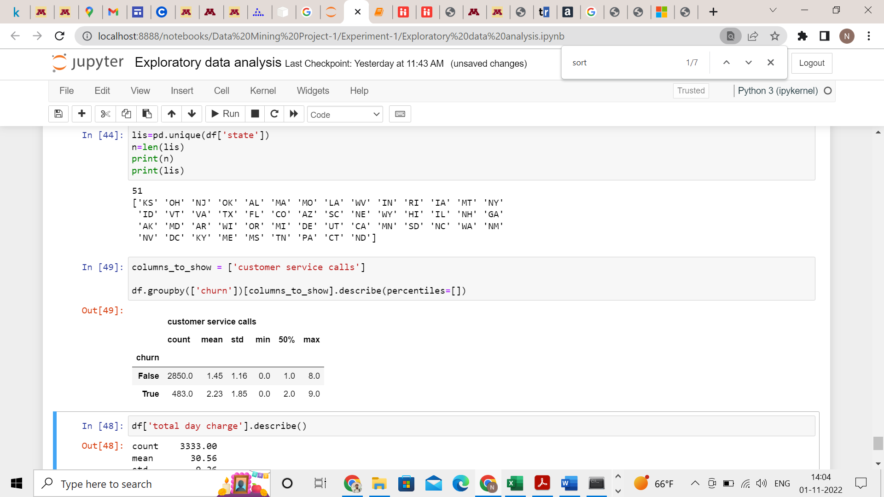
  2. For Churn=True  
     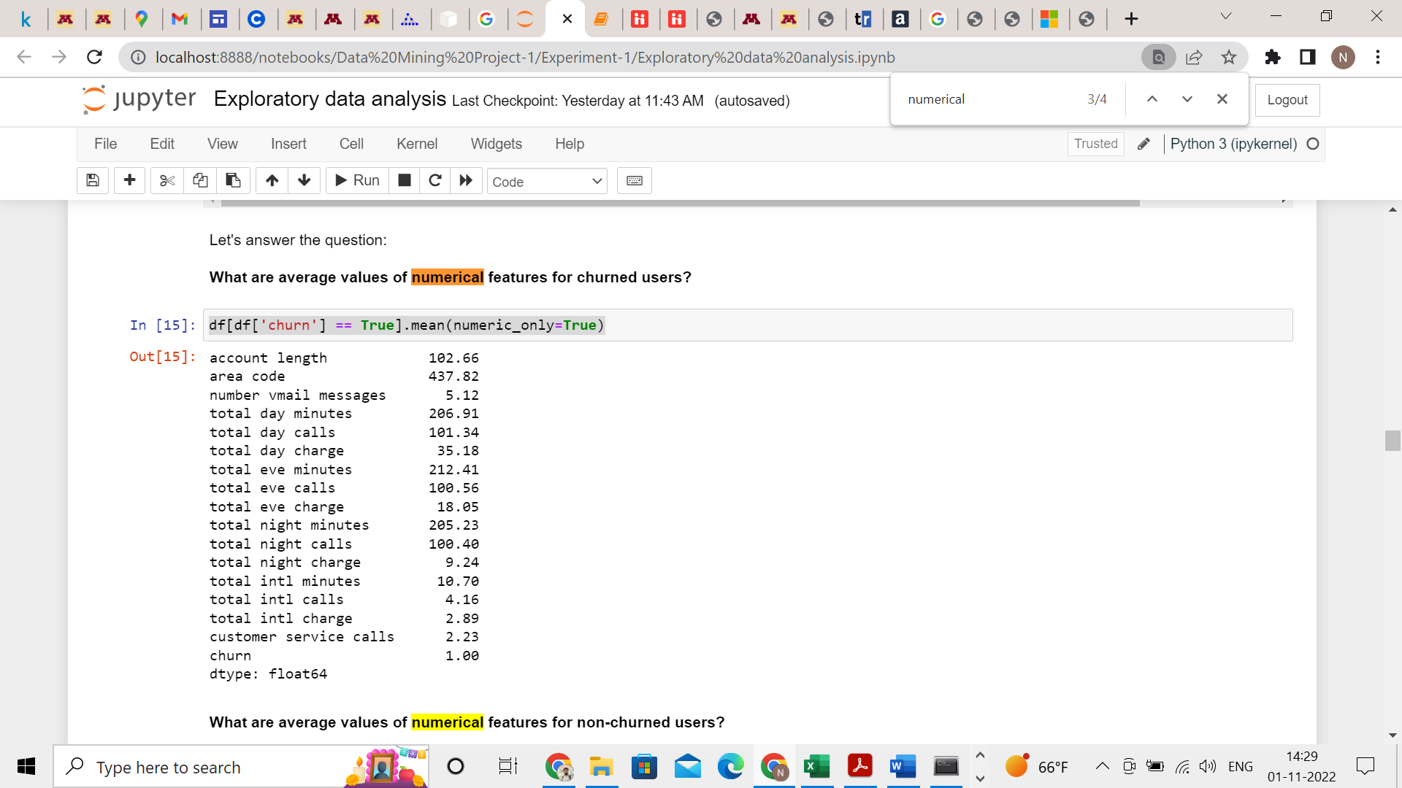  
     For Churn=False  
     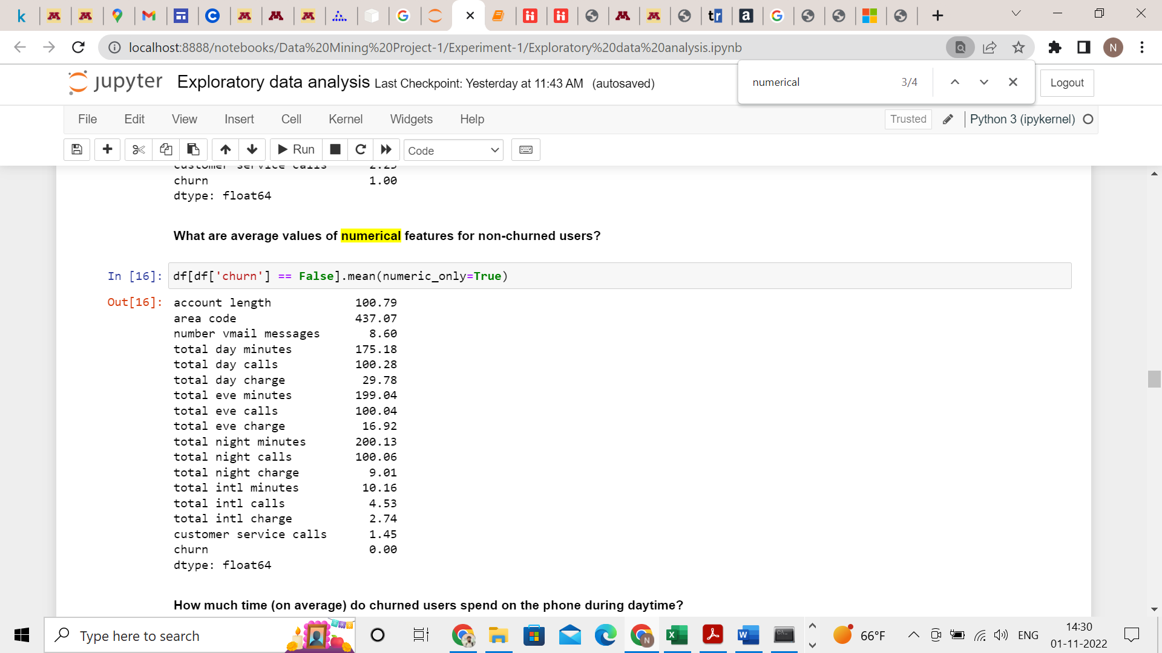  
     Comparing  
     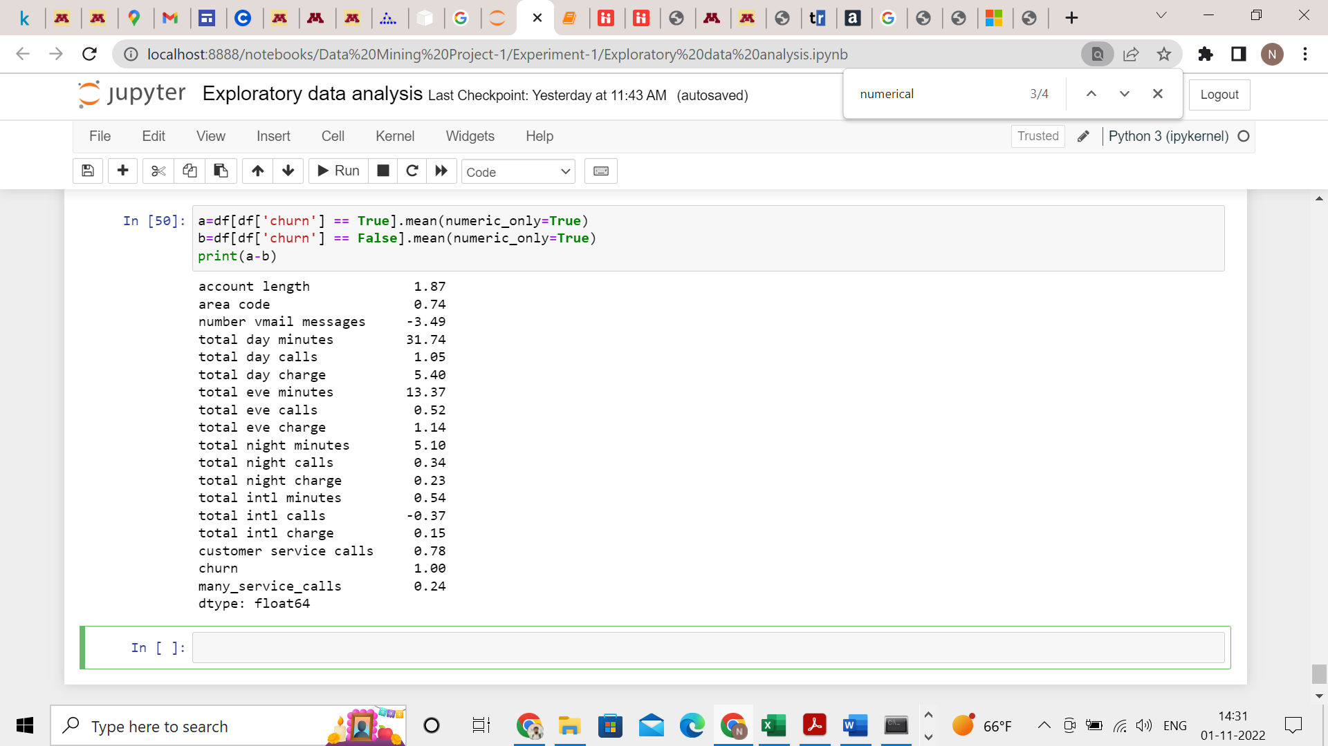  
     From the above images, it should be noted the customer service calls are almost 1.5 times more from the churned-out users than the users who stayed with the company, so there may be an issue with the customer care like delays, no resolution, not able to understand the customer’s problems etc. It should also be noted that the churned-out users have lesser number of voice mail messages and lesser number of international calls but more calls especially the day time and evening compared to the users who didn’t churn out. So, the company could come up with a subscription focusing on local calls (not international plan) with more talk time and reasonable price to retain the users who are churning out.
  3. When international call = no and churn = False  
     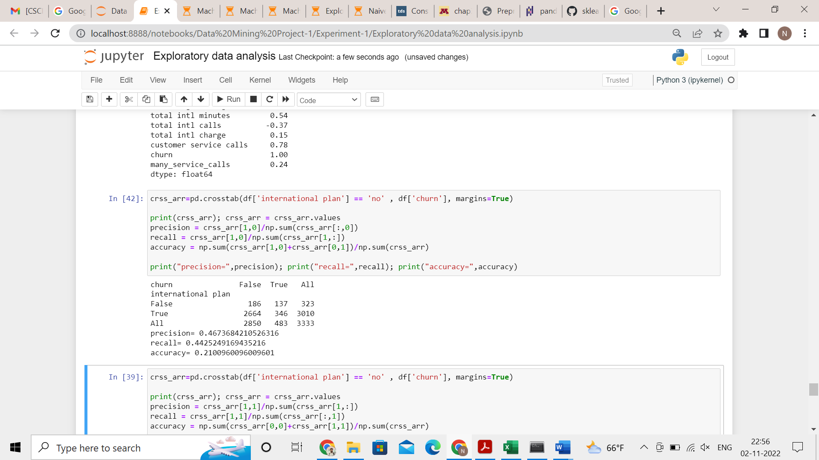

Precision = 0.467  
recall = 0.443  
accuracy = 0.21

* 1. P(churn = yes| international plan = no) = 346/3333 = 0.104  
     P(churn = no| international plan = no) = 2664/3333 = 0.799  
     P(churn = yes| international plan = yes) = 137/3333 = 0.041  
     P(churn = no| international plan = yes) = 186/3333 = 0.056  
     P(churn=yes) = 483/3333 = 0.145  
     P(churn=no) = 2850/3333 = 0.855  
     P(international plan = yes) = 323/3333 = 0.097  
     P(international plan = no) = 3010/3333 = 0.903  
     P(international plan = yes| churn = yes) =   
     P(international plan = no| churn = yes) =   
     P(international plan = yes| churn = no) =   
     P(international plan = no| churn = no) =
  2. P(Churn=True| customer service call=0 )  
       
     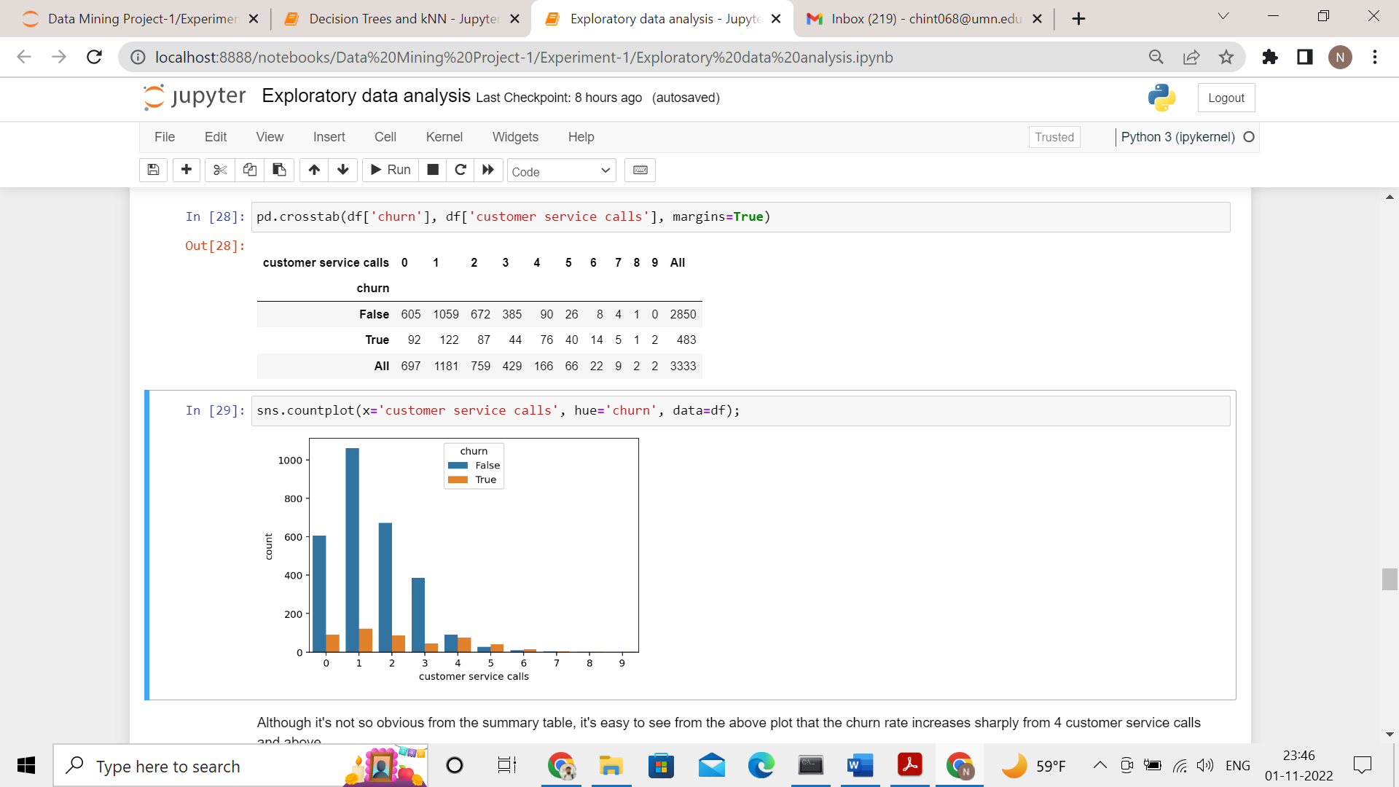  
       
     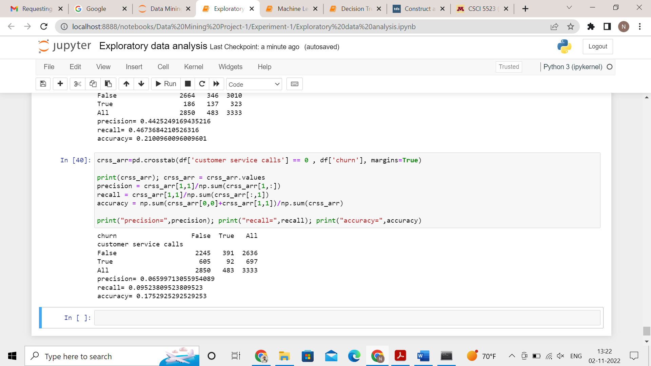  
       
     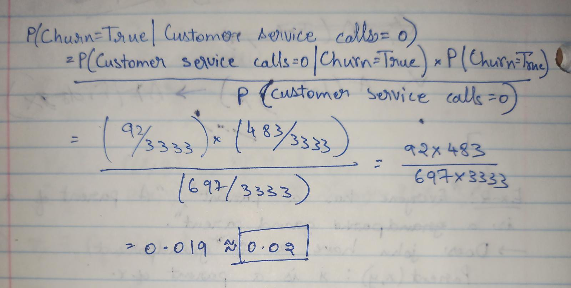
  3. 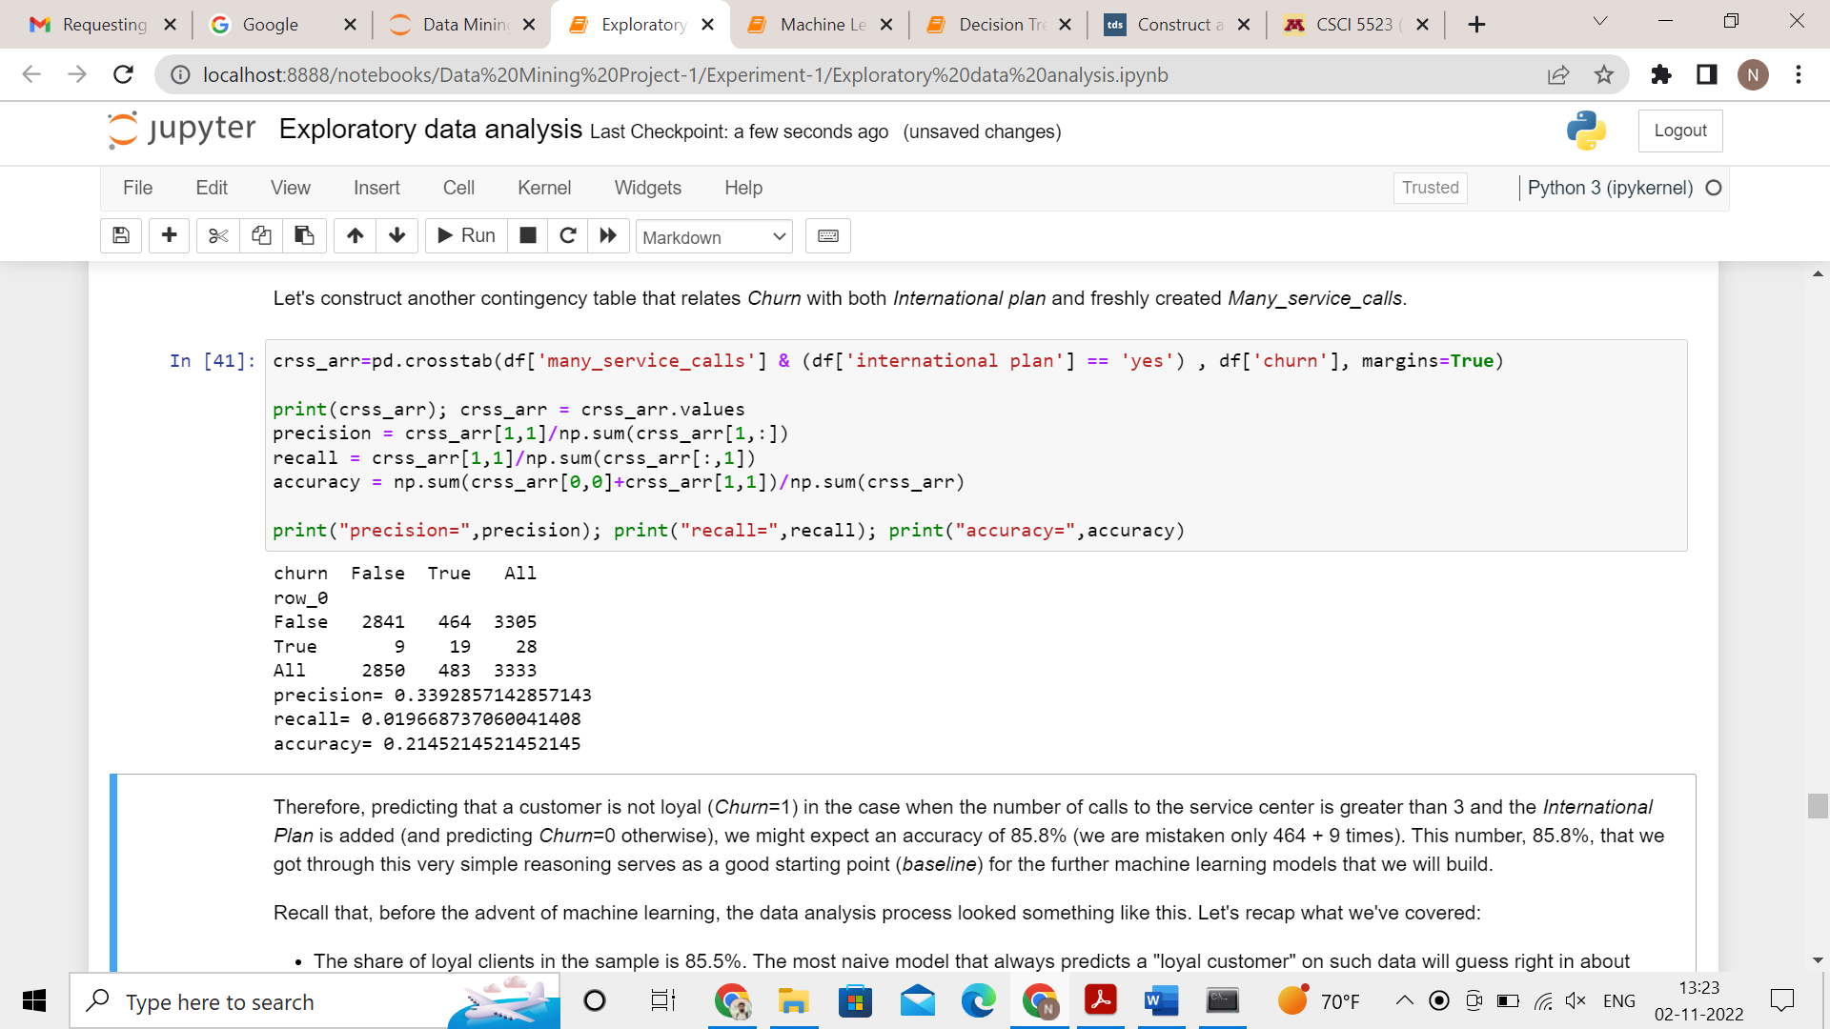  
     precision = 0.339  
     recall = 0.019  
     accuracy = 0.214