4, 5 - Practicing DDL Commands (Data Definition Language)

1. Create table command

2. Table command

3. Truncate table command

4. Drop table command

-> create table Bus(Bus_No varchar(5), source varchar(20), destination varchar(20),CouchType varchar2(10),fare number)

desc bus;

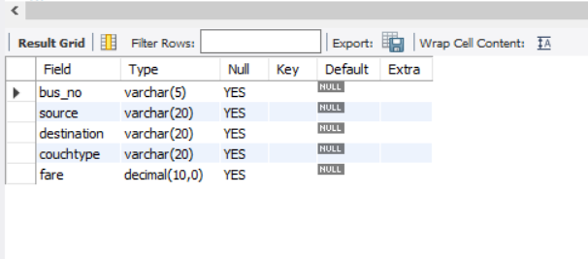

* create table passenger(PPNo varchar(15),name varchar(20) not null,age numeric(4),sex char(10) not null,address varchar(30));

desc passenger;

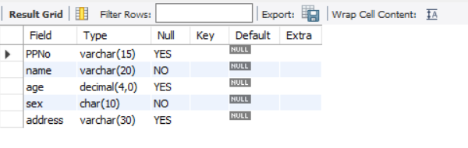

* create table ticket(ticket_no numeric(9) primary key,age numeric(4),sex char(4) not null,source varchar(20),destination varchar(20),dep_time varchar(4));

desc ticket;

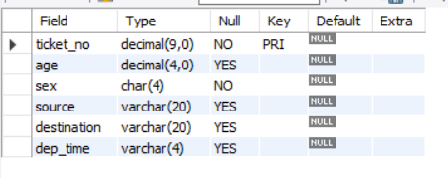

* create table reservation(PNRNo numeric(9), no_of_seats numeric(8), address varchar(50),contact_no numeric(10),status char(3));

desc reservation;

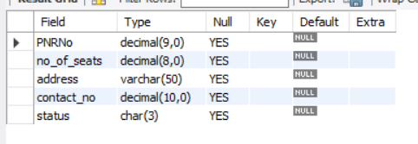

* create table cancellation(PNRNo numeric(9),no_of_seats numeric(8),address varchar(50),contact_no numeric(10),status char(3));

desc cancellation;

