**Exp No: 6 Applying DML commands on Road Way Travels Tables. Data Manipulation Command.**

**1. Insert**

**2. Update**

**3. Delete**

**4. Select**

**-> insert into student_details values(586 , 'Thirunhari','Nagajyothi','CSE');**

**insert into student_details values(585 , 'Katipally','Srija','CSE');**

**insert into student_details values(129 , 'Ponnam','Mahija','ECE');**

**insert into student_details values(345 , 'Uppala','Shivani','IT');**

**insert into student_details values(367 , 'Maharaj','NagaSushma','EEE');**

**select * from student_details;**

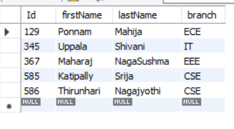

* update student_details set First_Name='Gajula',Last_Name='Manaswi' where Id=585;



* delete from student_details where Id = 345;
* select *from student_details;
* 