1. **Write a program to implement k-mediods clustering algorithm**

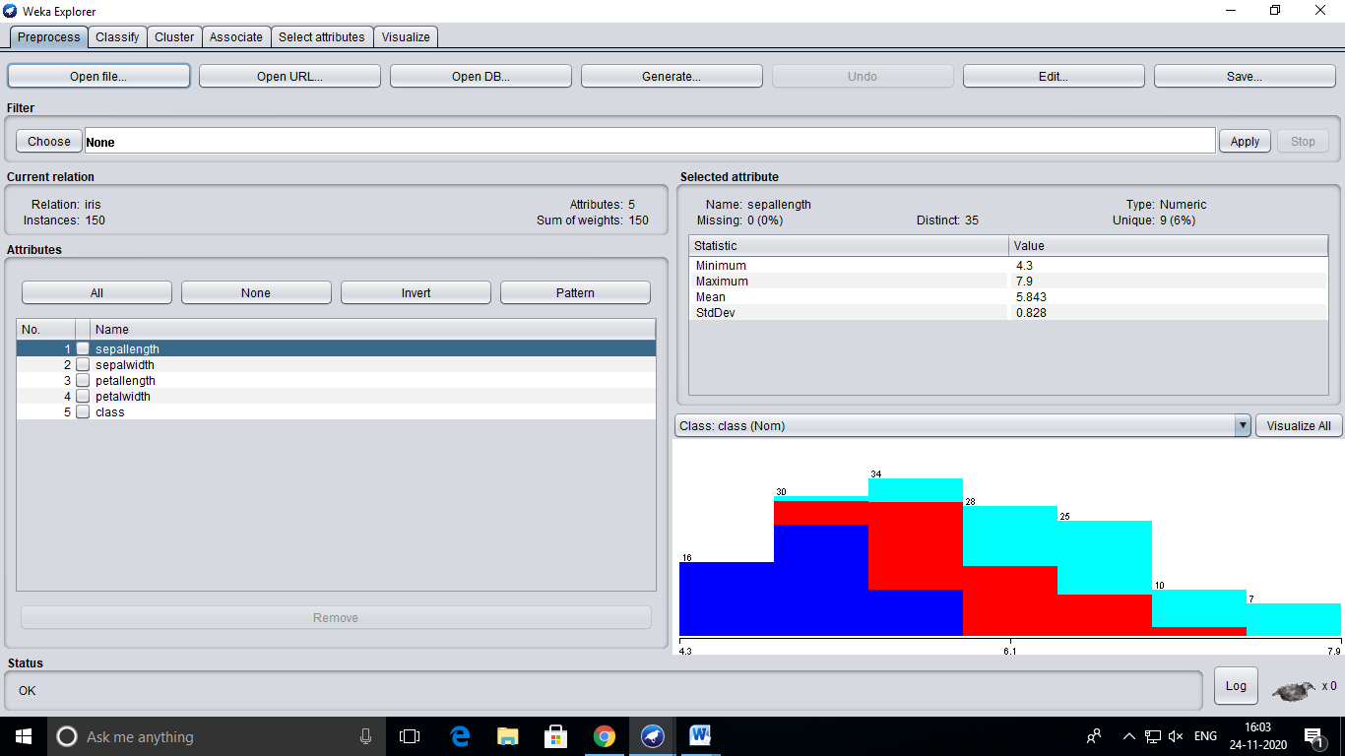

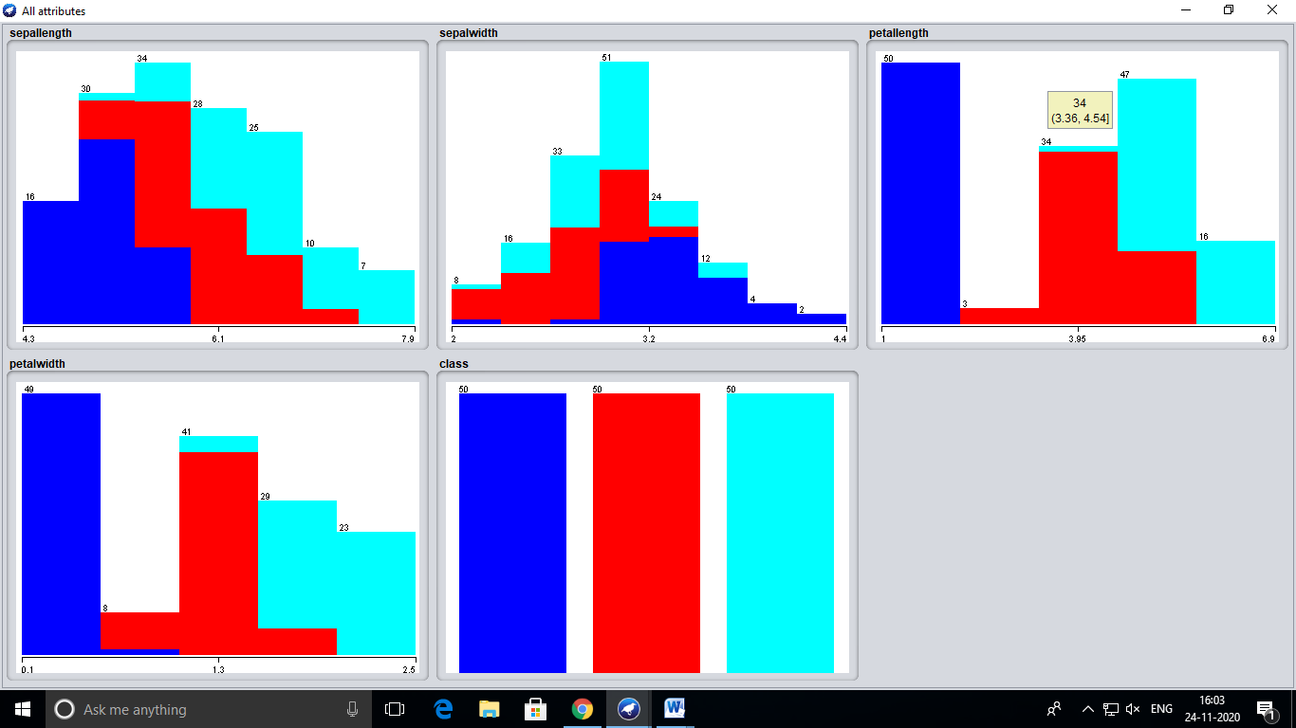

=== Run information ===

Scheme: weka.clusterers.SimpleKMeans -init 0 -max-candidates 100 -periodic-pruning 10000 -min-density 2.0 -t1 -1.25 -t2 -1.0 -N 2 -A "weka.core.EuclideanDistance -R first-last" -I 500 -num-slots 1 -S 10

Relation: iris

Instances: 150

Attributes: 5

sepallength

sepalwidth

petallength

petalwidth

class

Test mode: evaluate on training data

=== Clustering model (full training set) ===

kMeans

======

Number of iterations: 7

Within cluster sum of squared errors: 62.1436882815797

Initial starting points (random):

Cluster 0: 6.1,2.9,4.7,1.4,Iris-versicolor

Cluster 1: 6.2,2.9,4.3,1.3,Iris-versicolor

Missing values globally replaced with mean/mode

Final cluster centroids:

Cluster#

Attribute Full Data 0 1

(150.0) (100.0) (50.0)

==================================================================

sepallength 5.8433 6.262 5.006

sepalwidth 3.054 2.872 3.418

petallength 3.7587 4.906 1.464

petalwidth 1.1987 1.676 0.244

class Iris-setosa Iris-versicolor Iris-setosa

Time taken to build model (full training data) : 0 seconds

=== Model and evaluation on training set ===

Clustered Instances

0 100 ( 67%)

1 50 ( 33%)