Code For Machine Learning Algorithm
- Import Required Libraries
import zipfile
import os
from tensorflow.keras.preprocessing.image import ImageDataGenerator
from tensorflow.keras.applications import MobileNetV2
from tensorflow.keras.models import Model
from tensorflow.keras.layers import Dense, GlobalAveragePooling2D
from tensorflow.keras.optimizers import Adam
import matplotlib.pyplot as plt
from tensorflow.keras.preprocessing import image
import numpy as np
- Extract Dataset from Zip File
zip_path = '/content/archive.zip'
extract_path = '/content/e-waste-dataset'
if not os.path.exists(extract_path):
with zipfile.ZipFile(zip_path, 'r') as zip_ref:
zip_ref.extractall(extract_path)
- Prepare Data Generators for Training, Validation, and Testing
train_generator = train_datagen.flow_from_directory(
'/content/e-waste-dataset/modified-dataset/train',
target_size=IMG_SIZE,
batch_size=BATCH_SIZE,
class_mode='categorical'
)

validation_generator = val_datagen.flow_from_directory(
'/content/e-waste-dataset/modified-dataset/val',
target_size=IMG_SIZE,
batch_size=BATCH_SIZE,
class_mode='categorical'
)
test_generator = val_datagen.flow_from_directory(
'/content/e-waste-dataset/modified-dataset/test',
target_size=IMG_SIZE,
batch_size=BATCH_SIZE,
class_mode='categorical',
shuffle=False
)
- Build the Model Using Transfer Learning (MobileNetV2)
base_model=MobileNetV2(input_shape=(224,224, 3), include_top=False, weights='imagenet')
base_model.trainable = False
x = base_model.output
x = GlobalAveragePooling2D()(x)
x = Dense(128, activation='relu')(x)
output = Dense(train_generator.num_classes, activation='softmax')(x)
model = Model(inputs=base_model.input, outputs=output)
- Compile the Model
model.compile(optimizer=Adam(learning_rate=0.0001),
loss='categorical_crossentropy',
metrics=['accuracy'])
- Train the Model
EPOCHS_INITIAL = 10
history = model.fit(
train_generator,
epochs=EPOCHS_INITIAL,
validation_data=validation_generator
)
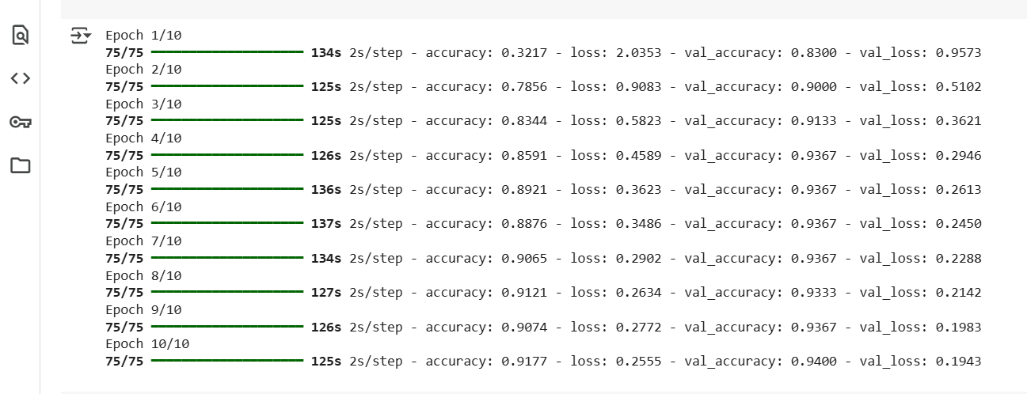

- Save the Trained Model
model.save('/content/mobilenetv2_e_waste_model.h5')
- Visualize Training Performance (Accuracy and Loss)
# Accuracy plot
plt.plot(history.history['accuracy'], label='Train Accuracy')
plt.plot(history.history['val_accuracy'], label='Validation Accuracy')
plt.title('Model Accuracy')
plt.xlabel('Epoch')
plt.ylabel('Accuracy')
plt.legend()
plt.show()
plt.plot(history.history['loss'], label='Train Loss')
plt.plot(history.history['val_loss'], label='Validation Loss')
plt.title('Model Loss')
plt.xlabel('Epoch')
plt.ylabel('Loss')
plt.legend()
plt.show()
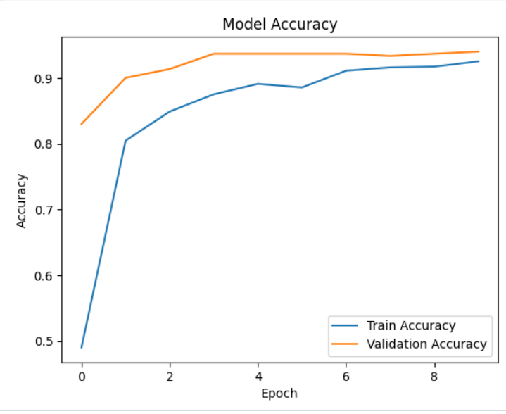
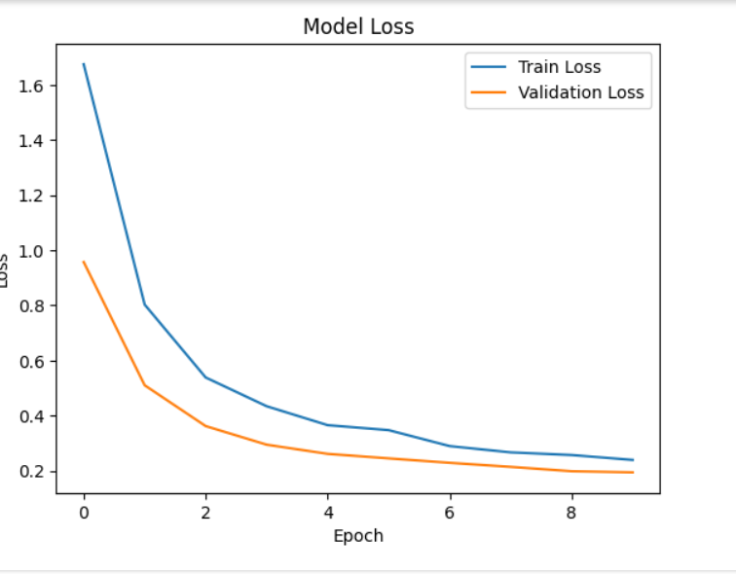
- Predict E-Waste Class for a Sample Image
img_path = '/content/sample.jpg' # Replace with your image path
img = image.load_img(img_path, target_size=IMG_SIZE)
img_array = image.img_to_array(img) / 255.0
img_array = np.expand_dims(img_array, axis=0)
predictions = model.predict(img_array)
predicted_class = np.argmax(predictions[0])
class_labels = list(train_generator.class_indices.keys())
print(f"Predicted Class: {class_labels[predicted_class]}")
APP DASHBOARD:
<!DOCTYPE html>
<html lang="en">
<head>
<meta charset="UTF-8">
<title>EcoScan – E-Waste Identifier</title>
<style>
* {
box-sizing: border-box;
} body {
font-family: 'Segoe UI', sans-serif;
background: linear-gradient(to right, #e8f5e9, #f1f8e9);
padding: 0;
margin: 0;
}header {
background-color: #2e7d32;
color: white;
padding: 20px 0;
text-align: center;
font-size: 24px;
font-weight: bold;
letter-spacing: 1px;
}
.container {
max-width: 600px;
background: white;
margin: 40px auto;
padding: 30px;
border-radius: 12px;
box-shadow: 0 0 15px rgba(0,0,0,0.1);
} h2 {
color: #388e3c;
margin-bottom: 10px;
}
label {
font-weight: bold;
display: block;
margin-top: 20px;
}input[type="text"],
textarea,
input[type="file"] {
width: 100%;
padding: 10px;
border-radius: 8px;
border: 1px solid #ccc;
font-size: 14px;
margin-top: 5px;
} textarea {
resize: vertical;
}
button {
width: 100%;
margin-top: 30px;
background-color: #2e7d32;
color: white;
padding: 12px;
font-size: 16px;
border: none;
border-radius: 10px;
cursor: pointer;
}

button:hover {
background-color: #1b5e20;
}
.preview {
margin-top: 20px;
text-align: center;
}

.preview img {
max-width: 100%;
border-radius: 10px;
margin-top: 10px;
}
footer {
text-align: center;
padding: 20px;
color: #666;
font-size: 14px;
}
</style>
</head>
<body><header>♻️ E WASTE MANAGEMENT AND RECYCLING APP</header> <div class="container">
<h2>🔐 User Details</h2>
<form id="ewasteForm">
<label for="name">Full Name:</label>
<input type="text" id="name" name="name" placeholder="Enter your name" required>
<label for="address">Address:</label>
<textarea id="address" name="address" rows="3" placeholder="Enter your address" required></textarea>
<label for="imageUpload">Upload Object Image:</label>
<input type="file" id="imageUpload" name="imageUpload" accept="image/*" required>
<div class="preview" id="preview"></div>
<button type="button">Upload and Check</button>
</form>
</div> <footer>
&copy; 2025 EcoScan | Designed for E-Waste Awareness
</footer> <script>
// Preview uploaded image
document.getElementById("imageUpload").addEventListener("change", function(event) {
const preview = document.getElementById("preview");
preview.innerHTML = "";
const file = event.target.files[0];
if (file) {
const img = document.createElement("img");
img.src = URL.createObjectURL(file);
img.onload = () => URL.revokeObjectURL(img.src);
preview.appendChild(img);
}
});
</script></body>
</html>
