**Hackathon Project Phases Template** for the **CareWise: AI Symptom Checker and Treatment Advisor using Palm's chat-bison-001** project.

Hackathon Project Phases Template

# Project Title:

 CareWise: AI Symptom Checker and Treatment Advisor using Palm's chat-bison-001

# Team Name:

Team Code

# Team Members:

* Merugu Nagalakshmi
* Shaik Ayesha Parveen
* Nagulagari Sai Harshini
* Nelluri Meghana

# Phase-1: Brainstorming & Ideation

## Objective:

## Develop an AI-powered symptom checker and treatment advisor that assists users in identifying potential health conditions and providing basic treatment recommendations

## Key Points:

1. **Problem Statement:**
   * Many  individuals lack immediate access to medical professionals for minor health concerns.
   * Misinformation from unreliable sources can lead to poor self-diagnosis and incorrect treatment decisions.
2. **Proposed Solution:**
   * An AI-powered application utilizing Palm's chat-bison-001 to provide symptom analysis and preliminary treatment recommendations.
   * The app helps users understand when to seek professional medical advice.
3. **Target Users:**
   * Individuals seeking preliminary health insights.
   * Users needing guidance on whether to consult a doctor.
   * Remote areas with limited access to medical professionals.
4. **Expected Outcome:**
   * A functional AI-powered healthcare assistant that provides symptom analysis and treatment guidance based on user queries.

# Phase-2: Requirement Analysis

## Objective:

Define the technical and functional requirements for the CareWise.

## Key Points:

1. **Technical Requirements:**
   * Programming Language: **Python**
   * Backend: **Google Palm chat-bison-001 API**
   * Frontend: **Streamlit Web Framework**
   * Database: **Not required initially (API-based queries)**
2. **Functional Requirements:**
   * Ability to analyze symptoms using chat-bison-001.
   * Provide general treatment advice based on medical guidelines.
   * Offer a user-friendly chatbot interface for seamless interaction.
3. **Constraints & Challenges:**
   * Ensuring accurate and reliable health advice.
   * Handling API response limitations and optimization**.**
   * Complying with medical data privacy regulations.

# Phase-3: Project Design

## Objective:

Develop the architecture and user flow of the application.

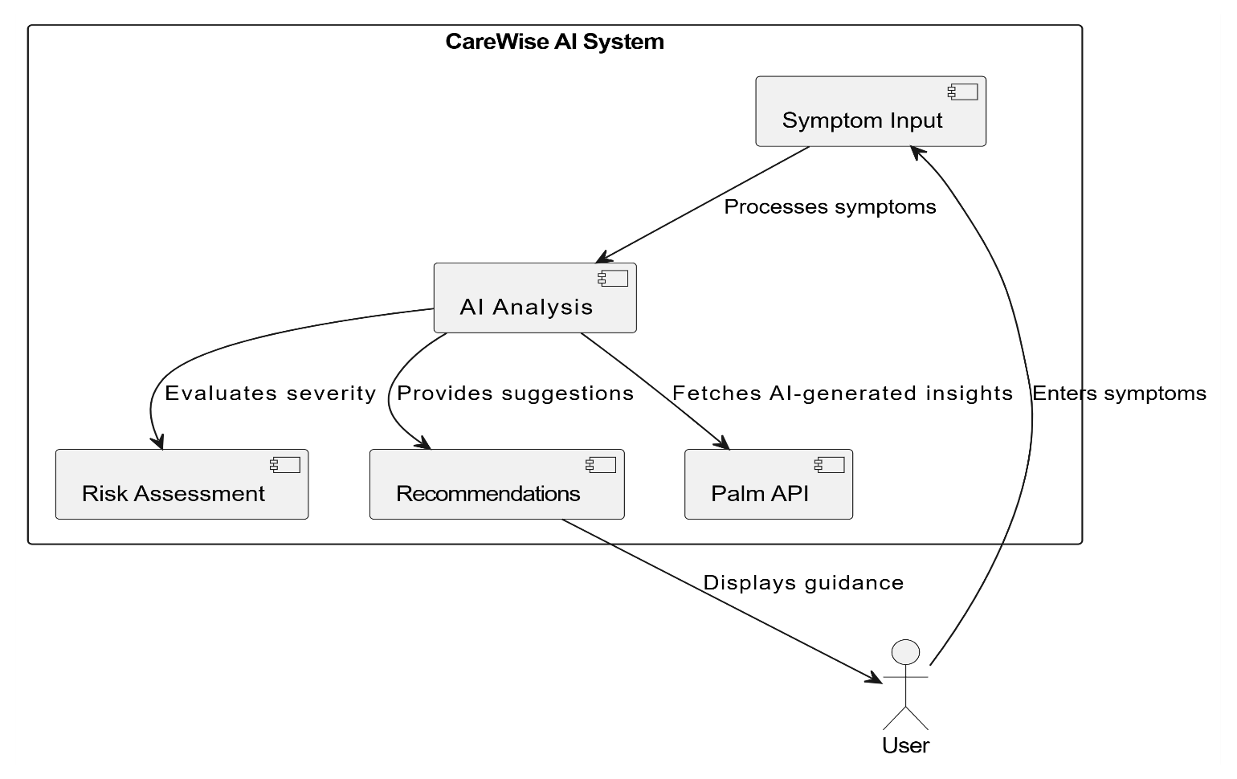

## Key Points:

1. **System Architecture:**
   * User enters symptoms via UI.
   * Query is processed using **Palm's chat-bison-001 API.**
   * AI model analyzes symptoms and provides potential conditions and treatment options.
   * Frontend displays the results in an intuitive manner.
2. **User Flow:**
   * Step 1: User enters symptoms (e.g., "fever and headache").
   * Step 2: The backend queries chat-bison-001 API for analysis.
   * Step 3:The app processes and displays results with recommendations.
   * Step 4: If symptoms are severe, the app advises consulting a doctor.
3. **UI/UX Considerations:**
   * Simple and accessible chatbot-style interface.
   * Clear and concise medical guidance.
   * Light and dark mode for better usability.

# Phase-4: Project Planning (Agile Methodologies)

## Objective:

Break down development tasks for efficient completion.

|  |  |  |  |  |  |  |  |
| --- | --- | --- | --- | --- | --- | --- | --- |
| **Sprint** | **Task** | **Priority** | **Duration** | **Deadline** | **Assigned To** | **Dependencies** | **Expected Outcome** |
| Sprint 1 | Environment Setup & API Integration | 🔴 High | 6 hours  (Day 1) | End of Day 1 | Shanawaz | Google API Key, Python, Streamlit setup,Palm ApI | API connection established & working |
| Sprint 1 | Frontend UI Development | 🟡  Medium | 2 hours  (Day 1) | End of Day 1 | Member 2 | API response format finalized | Basic chatbot UI |
| Sprint 2 | Symptom Analysis & Response Generation | 🔴 High | 3 hours  (Day 2) | Mid-Day 2 | anwar | API response, UI elements ready | AI-powered symptom analysis |
| Sprint 2 | Error Handling & Debugging | 🔴 High | 1.5 hours  (Day 2) | Mid-Day 2 | Member 1&4 | API logs, UI inputs | Improved API stability |
| Sprint 3 | Testing & UI Enhancements | 🟡  Medium | 1.5 hours  (Day 2) | Mid-Day 2 | mohammad | API response, UI layout completed | Responsive UI, better user experience |
| Sprint 3 | Final Presentation & Deployment | 🟢 Low | 1 hour  (Day 2) | End of Day 2 | Entire Team | Working prototype | Demo-ready project |

## Sprint Planning with Priorities

**Sprint 1 – Setup & Integration (Day 1)**

**(**🔴 **High Priority)** Set up the **environment** & install dependencies.

**(**🔴 **High Priority)** Integrate **Google API**.

**(**🟡 **Medium Priority)** Build a **basic UI with input fields**.

## Sprint 2 – Core Features & Debugging (Day 2)

**(**🔴 **High Priority)** Implement **search & comparison functionalities**. **(**🔴 **High Priority)** Debug API issues & handle **errors in queries**.

## Sprint 3 – Testing, Enhancements & Submission (Day 2)

**(**🟡 **Medium Priority)** Test API responses, refine UI, & fix UI bugs.

**(**🟢 **Low Priority)** Final **demo preparation & deployment**.

# Phase-5: Project Development

## Objective:

Implement core features of the CareWise

## Key Points:

1. **Technology Stack Used:**
   * **Frontend:** Streamlit
   * **Backend: Google Palm chat-bison-001**
   * **Programming Language:** Python
2. **Development Process:**
   * Implement **API key authentication** and **Palm API Integration**.
   * Develop **symptom analysis and treatment logic.**
   * Optimize **search queries for performance and relevance**.
3. **Challenges & Fixes:**
   * **Challenge:** Delayed API response times.

**Fix:** Implement **caching** to store frequently queried results.

* + **Challenge:** Limited API calls per minute.

**Fix:** Optimize queries to fetch **only necessary data**.

# Phase-6: Functional & Performance Testing

## Objective:

Ensure that the CareWise App works as expected.

|  |  |  |  |  |  |
| --- | --- | --- | --- | --- | --- |
| **Test Case ID** | **Category** | **Test Scenario** | **Expected Outcome** | **Status** | **Tester** |
| TC-001 | Functional Testing | Query "What should I do for fever" | Relevant treatment suggestions should be displayed. | ✅ Passed | Tester 1 |
| TC-002 | Functional Testing | Query "Symptoms of flu " | Flue symptoms should be listed | ✅ Passed | Tester 2 |

|  |  |  |  |  |  |
| --- | --- | --- | --- | --- | --- |
| TC-003 | Performance Testing | API response time under 500ms | API should return results quickly. | ⚠ Needs Optimization | Tester 3 |
| TC-004 | Bug Fixes & Improvements | Fixed incorrect API responses. | Data accuracy should be improved. | ✅ Fixed | Develop er |
| TC-005 | Final Validation | Ensure UI is responsive across devices. | UI should work on mobile & desktop. | ❌ Failed - UI broken on mobile | Tester 4 |
| TC-006 | Deployment Testing | Host the app using Streamlit Sharing | App should be accessible online. | 🚀 Deployed | DevOps |

# Final Submission

1. **Project Report Based on the templates**
2. **Demo Video (3-5 Minutes)**
3. **GitHub/Code Repository Link**

|  |
| --- |
|  |

<https://github.com/Nagalakshmi292004/TEAMCODE/blob/main/.gitignore>

1. **Presentation**