A FIELD PROJECT REPORT

on

**“Predicting Flood Events: A Machine Learning Approach”**

**Submitted**

by

|  |  |
| --- | --- |
| 221FA04448  B. Bhanulatha | 221FA04477  P. Tarakram |
| 221FA04642 221FA04743  P. Nagamounika K. Sivachari | |

**Under the guidance of**

***Dr. S. Deva Kumar***

*Designation*



**DEPARTMENT OF COMPUTER SCIENCE & ENGINEERING**

**VIGNAN'S FOUNDATION FOR SCIENCE, TECHNOLOGY AND RESEARCH Deemed to be UNIVERSITY**

**Vadlamudi, Guntur.**

**ANDHRA PRADESH, INDIA, PIN-522213.**



**CERTIFICATE**

This is to certify that the Field Project entitled **“Predicting Flood Events: A Machine Learning Approach”** that is being submitted by 221FA04448 (B. Bhanulatha), 221FA04477(P.Tarakram), 221FA04642(P. Nagamounika)**,** 221FA04743(K. Sivachari) for partial fulfilment of Field Project is a bonafide work carried out under the supervision of Ms. Dr. N. Sameera., Assistant Professor, Department of CSE.

|  |  |  |
| --- | --- | --- |
| Guide name& Signature |  | Dr.K.V. Krishna Kishore |
| Assistant/Associate/Professor, CSE | HOD,CSE | Dean, SoCI |



**DECLARATION**

We hereby declare that the Field Project entitled **“Predicting Flood Events: A Machine Learning Approach”** that is being submitted by 221FA04448 (B. Bhanulatha), 221FA04477(P.Tarakram), 221FA04642(P. Nagamounika)**,** 221FA04743(K. Sivachari) is being submitted by in partial fulfilment of Field Project course work. This is our original work, and this project has not formed the basis for the award of any degree. We have worked under the supervision of Ms. G.NAVYA, M.Tech., Assistant Professor, Department of CSE.

By

**221FA04448 (Bhanulatha),**

**221FA04477 (Tarakram),**

**221FA04642 (Nagamounika),**

**221FA04743 (Sivachari)**

Date: 15/10/2024

## ABSTRACT

India is subject to frequent natural disasters in the form of floods, resulting in significant loss of life and property. Accurate prediction of flood onset and progression in real time is critical to minimizing flood impacts. This research paper focuses on a comparative study of different machine learning models for flood forecasting in India. Models analysed include K-nearest neighbour (KNN), support vector classification (SVC), decision tree classification. Accurately predicting the onset and progression of floods in real time is difficult. To estimate water levels and velocities over a large area, it is necessary to combine the data with computationally demanding flood propagation models. This paper aims to reduce the extreme risks of this natural disaster and contribute to policy proposals through flood forecasts using various machine learning models.

The advancement in data collection technologies has significantly improved flood prediction methods, yet the immense volume of environmental and meteorological data has outgrown human capacity for efficient interpretation. Machine learning (ML) has become a pivotal tool for analyzing and synthesizing these large, complex datasets, providing new insights into flood prediction and disaster management. ML models, particularly ensemble algorithms like Random Forest and Gradient Boosting Machines (GBMs), have shown considerable potential in early flood detection by accurately identifying patterns in meteorological data such as rainfall, humidity, and pressure. These models enhance predictive accuracy and enable more localized and adaptive early warning systems when combined with regional hydrological data. Furthermore, ML is revolutionizing flood risk management by forecasting flood occurrences based on historical climate patterns and identifying high-risk zones. In conjunction with satellite imagery, machine learning models can assist in monitoring water levels and predicting the impact of extreme weather events. ML is also critical in precision disaster response, guiding resource allocation and rescue efforts by analyzing socio-economic and infrastructure data. Despite the promise, several challenges remain, such as ensuring the availability of high-quality data, addressing privacy concerns, and improving model interpretability in high-stakes scenarios. Future prospects include integrating multi-modal and real-time data with advancements in explainable AI, aiming to make ML models more transparent and actionable. As ML continues to evolve, it holds immense potential for improving flood prediction, mitigation strategies, and disaster response efforts, ultimately leading to better-prepared communities and reduced flood damage.

**Keywords:** Decision tree, Support Vector Machine (SVM), Logistic Regression.

**TABLE OF CONTENTS**

1. Introduction 1
   1. What is Flood Prediction and how it causes? 2
   2. Background and Challenges of Flood Prediction 3
2. Literature Survey 4
   1. Literature review 5
   2. Motivation 8
3. Proposed System 12
   1. Input dataset 14

3.1.1Detailed features of dataset 17

* 1. Data Pre-processing 18
  2. Model Building 19
  3. Methodology of the system 21
  4. Model Evaluation 24
  5. Constraints 28
  6. Cost and Sustainability Impact 30

1. Implementation 45
   1. Environment Setup 30
   2. Sample code for preprocessing and MLP operations 50
2. Experimentation and Result Analysis 52
3. Conclusion 54
4. References 59

**LIST OF FIGURES**

|  |  |
| --- | --- |
| Figure 1. Architecture of the proposed system | 13 |
| Figure 2. Various features in the dataset after pre-processing | 14 |
| Figure 3. Training and testing accuracy | 15 |
| Figure 4. Confusion Matrix | 16 |
| Figure 5. Performance Outcomes | 18 |
| Figure 6. ROC Curve for each class | 34 |
| Figure 7. Logistic regression confusion matrix | 33 |
| F igure 8. Navie Bayes confusion matrix | 35 |
| Figure 9. Support Vector Machine (SVM) confusion matrix | 36 |
| Figure 10. Random Forest confusion matrix | 37 |
| Figure 11. XGBoost confusion matrix  Figure 12. Decision Tree Visualization  Figure 13. Confusion matrix | 38 |

**LIST OF TABLES**

Table 1. R2 Scores Comparison 36

Table 2. MAPE values comparison 37

# CHAPTER-1 INTRODUCTION

### INTRODUCTION

**1.1 What is Flood Prediction and how it causes?**

Flood prediction, also known as flood forecasting, is the process of estimating when and where flooding will occur, as well as predicting the severity of the flood. This is done by analyzing various environmental, meteorological, and hydrological data, such as rainfall, river levels, soil moisture, and weather patterns. Accurate flood prediction systems are critical for providing early warnings, enabling communities, governments, and emergency services to take preventive actions to reduce the impact of floods on lives, property, and infrastructure.

Flood prediction typically involves:

1. **Meteorological Data Analysis:** Monitoring rainfall patterns, storm events, and weather conditions that can lead to flooding.
2. **Hydrological Modelling:** Using data from rivers, reservoirs, and groundwater levels to determine how much water is flowing into river systems and how close these systems are to overflowing.
3. **Geospatial Data:** Examining land use, terrain, and topography to identify areas more prone to flooding due to their geographic characteristics.

Advanced technologies such as machine learning (ML) and artificial intelligence (AI) are increasingly used to predict floods with higher accuracy by uncovering complex patterns in large datasets that involve meteorological and hydrological variables.

**Causes of Floods:**

Floods are caused by a variety of natural and human-made factors, often involving the interaction of multiple elements. The major causes include:

1. **Heavy Rainfall:** One of the most common causes, prolonged or intense rainfall overwhelms natural or man-made drainage systems, causing rivers and streams to overflow.
2. **River Overflow:** When water levels in rivers exceed their banks, it can cause riverine flooding. This is common in monsoon regions or during prolonged periods of rain.
3. **Snowmelt:** In regions with significant snowfall, rapid melting during warmer periods can release large volumes of water, which rivers and drainage systems may not be able to handle.
4. **Coastal Flooding:** Storm surges from tropical cyclones, hurricanes, or tsunamis can raise the sea level, flooding coastal regions. This is especially problematic in low-lying areas.
5. **Dam Breaks or Levee Failures:** Human-made structures like dams and levees control water flow, but their failure due to engineering faults, excessive water pressure, or poor maintenance can lead to catastrophic flooding downstream.
6. **Urbanization:** Increased urban development can lead to a reduction in natural ground absorption due to the expansion of impermeable surfaces like concrete and asphalt. This causes more water to run off into drainage systems, which may overflow, leading to flash floods.
7. **Deforestation:** The removal of forests reduces the land’s ability to absorb rainfall, leading to increased runoff and a higher likelihood of flooding, particularly in hilly or mountainous regions.
8. **Climate Change:** Global warming is increasing the frequency and intensity of extreme weather events, such as heavy rainfall and storms, which in turn leads to more frequent flooding. Rising sea levels due to the melting of polar ice also contribute to higher risks of coastal floods.

Floods can be sudden, such as flash floods, or gradual, such as those resulting from prolonged rainfall or snowmelt. Accurate flood prediction can help mitigate these risks, giving people time to prepare or evacuate when necessary.

1.2**Consequences of Flood Prediction:**

Flood prediction, when accurately implemented, can have a profound impact on society, the economy, and the environment. Predicting floods can significantly reduce the damage caused by these natural disasters, but the consequences of flood prediction, both positive and negative, must be considered in multiple contexts.

**Positive Consequences of Flood Prediction:**

1. **Saving Lives**: Accurate and timely flood prediction systems provide early warnings that can help evacuate people from high-risk areas before a flood occurs. This significantly reduces the risk of fatalities and injuries during flood events, particularly in highly vulnerable regions.
2. **Improved Disaster Preparedness and Response**: Flood predictions enable emergency services to coordinate and deploy resources more effectively. This includes pre-positioning rescue teams, emergency supplies, and medical assistance in areas likely to be affected, thereby improving the efficiency of disaster response efforts.
3. **Enhanced Agricultural Planning**: In regions like Kerala, where agriculture plays a significant role in the economy, flood predictions allow farmers to prepare by securing crops, moving livestock, or adjusting planting and harvesting schedules. By mitigating the effects of floods, farmers can avoid large-scale crop destruction and reduce losses.
4. **Reduction in Economic Losses**: Flooding can cause significant economic disruption, from damaged infrastructure to lost productivity. Predicting floods helps minimize economic losses by allowing businesses and local governments to prepare contingency plans, temporarily halt operations, and safeguard economic assets.
5. **Environmental Protection**: Early flood predictions allow for the mitigation of environmental damage, such as erosion, landslides, and soil contamination. Additionally, efforts can be made to protect ecologically sensitive areas, such as wetlands, that play a crucial role in flood control by naturally absorbing excess water.

**Negative Consequences:**

1. **False Alarms and Public Panic**: Inaccurate or overly cautious flood predictions may lead to false alarms. These false alarms can cause unnecessary evacuations, disruption of daily life, and public panic. If people experience too many false alarms, they may start to distrust future warnings, increasing the risk of casualties when a real flood occurs.
2. **Economic and Social Disruption**: Flood predictions may lead to the temporary closure of businesses, schools, and other institutions, even when floods do not materialize. This can result in financial losses and disrupt normal life. Additionally, frequent evacuations or relocation of communities can strain local economies and infrastructure.

1.3 **Background of Flood Prediction:**

Flood prediction is a critical aspect of disaster management and plays an essential role in safeguarding communities and reducing the impact of floods. Flooding is caused by multiple factors, including heavy rainfall, river overflow, rapid snowmelt, dam failures, and coastal storms. In many regions, such as Kerala, India, flooding occurs frequently during the monsoon season due to intense rain and geographical features like rivers and low-lying areas.

**Challenges of Flood Prediction**

Despite significant advancements, flood prediction faces numerous challenges:

1. **Data Availability and Quality**: Accurate flood prediction relies on high-quality, comprehensive data, which may not always be available. In some regions, particularly in developing countries or remote areas, there are gaps in weather stations, river gauge networks, and real-time monitoring systems. Inconsistent or missing data makes it difficult to create accurate models or make reliable predictions.
2. **Uncertainty in Weather and Hydrological Models**: Predicting floods involves understanding complex weather patterns and how they interact with local geography and hydrology. While models have improved, weather is inherently unpredictable, and flood events may differ significantly based on small changes in conditions. For example, the timing and intensity of rainfall, combined with the characteristics of the land (e.g., slope, soil saturation), can introduce significant uncertainty in flood forecasts.

# CHAPTER-2 LITERATURE SURVEY

## LITERATURE SURVEY

#### Literature review

This project presents an Improved NARX model for predicting flood water levels 5 hours in advance, demonstrating superior performance over the original NNARX model. The model achieved high accuracy in forecasting, with significant improvements observed in prediction precision.[1]

This project developed an NNARX model to predict flood water levels 5 hours in advance using data from rivers in Terengganu, Malaysia. The model was trained, validated, and tested with real-time data, showing successful early flood prediction for the region.[2]

This project compares flood prediction models using MISO ARX and ARMAX structures for the Pahang River in Temerloh, Malaysia. Results showed that the ARMAX model outperformed ARX, with better prediction accuracy and lower RMSE values.[3]

This project presents a 5-hour flood prediction model for flood-prone areas in Kuala Lumpur using NNARX and its Improved Modelling technique. The results demonstrated that the Improved NNARX model accurately predicted flood water levels 5 hours in advance, providing early warning for evacuation.[4]

This project proposes a 3-hour flood prediction model using NNARX with improved modelling strategies for Klang River at Petaling Bridge, Kuala Lumpur. The model showed significant prediction accuracy, providing timely warnings for potential flood disasters in urban areas.[5]

This project presents a river water level prediction model using NNARX for flood monitoring in Kuala Lumpur. The results indicated that the NNARX model with a 4-hour prediction time achieved reliable and accurate flood forecasting.[6]

This project presents a flood prediction model for Bangladesh using the k-nearest neighbours (k-NN) algorithm and correlation coefficients for feature selection. The model achieved a high testing accuracy of 94.91%, with an average precision of 92.00% and recall of 91.00%.[7]

This project focuses on the use of Artificial Neural Networks (ANN), particularly MLP and LSTM models, to predict reservoir water levels and inflows for optimizing reservoir operations. The models aim to minimize downstream impacts and improve flood evacuation planning based on accurate hydrological data.[8]

This project proposes a framework integrating temporal prediction models and spatial data to generate flood hazard maps. The models achieved high accuracy, with average MAPE values of 3.17% for hourly and 4.88% for daily predictions, and an F1-score of 81.50% in hazard map generation.[9]

It is clear that the hybrid approach predicts data for more years in the future with an accuracy level as high as 89%.[10]

This project developed an NNARX flood prediction model for Pahang, Malaysia, using real-time data from flood events. The model successfully predicted flood water levels in advance, providing potential early warnings for at-risk residents.[11]

This project examines various flood prediction techniques for the Mumbai region, including statistical, hydrological, and AI-based models, evaluating their accuracy, precision, and limitations. It discusses the challenges of predicting floods in Mumbai's urban environment and suggests future research directions for improving prediction and preparedness.[12]

This project introduces a Radial Basis Function Neural Network (RBFNN) for predicting flood water levels at Kelang River, demonstrating its effectiveness in handling complex, nonlinear flood data. The addition of an Inverse Model to the RBFNN significantly improved prediction accuracy.[13]

This project applies cellular automata algorithms to predict and model flood spreading in Bojonegoro, Indonesia, using elevation, soil type, river mapping, volume changes, and rainfall data. The results are visualized in 2D images to aid in understanding and managing flood distribution.[14]

This project introduces a flood prediction model using NNARX and a hybrid NNARX with Extended Kalman Filter (EKF) for Klang River, Malaysia. The NNARX-EKF hybrid model significantly outperformed the NNARX model in predicting flood water levels using real-time SCADA data.[15]

This project proposes a Nonlinear Autoregressive with Exogenous Input (NARX) neural network for flood risk assessment in Sabah, Malaysia, using hydrological data from Wariu and Padas Rivers. The NARX model, trained with the Levenberg-Marquardt algorithm, provides reliable water level predictions up to five days ahead, with an R² value exceeding 0.85.[16]

This project introduces a prioritized sampling method to enhance a KD-based neural network for nowcasting pluvial floods, improving accuracy in minor rainfall patterns. The method achieved a 96% reduction in error rate, lowering the average prediction error by 37 cm per mesh compared to random sampling.[17]

This project proposes a hybrid model, HMM-ML, combining Hidden Markov Models with various machine learning techniques to improve flood forecasting in Kozhikode, Kerala, India. The model integrates rainfall and temperature data to enhance prediction accuracy during the high-rainfall period from June to August.[18]

This project presents a hybrid ANFIS-HHO model for forecasting river floods in the Barak River basin, India, combining an adaptive neuro-fuzzy inference system with Harris Hawks Optimization. The model demonstrated superior performance with an NSE of 0.9885 and RMSE of 61.87, addressing issues of overfitting and underfitting in traditional ANFIS models.[19]

Accurate flood monitoring is facilitated by the development and implementation of a real-time flood detection and forecasting system.[20]

#### 

#### 2.2Motivation

**Motivation for Flood Prediction**

Flood prediction has become increasingly important due to the rising frequency and severity of floods, driven by factors such as climate change, rapid urbanization, and environmental degradation. The motivation for developing and improving flood prediction systems stems from a combination of humanitarian, economic, environmental, and societal concerns. Below are key reasons why accurate flood prediction is essential:

**1. Protecting Human Lives**

The foremost motivation for flood prediction is to save lives. Floods are among the deadliest natural disasters, causing thousands of fatalities worldwide every year. By providing early warnings, flood prediction systems enable timely evacuations of people from flood-prone areas. This is especially crucial for flash floods, which can occur with little warning and lead to significant loss of life. In densely populated regions, such as Kerala in India, early flood predictions can give authorities and residents the critical time needed to move to safer locations, reducing casualties.

**2. Reducing Economic Losses**

Flooding causes extensive economic damage, destroying homes, businesses, infrastructure, and agricultural land. Floods disrupt supply chains, damage critical infrastructure like roads and bridges, and can bring economic activities to a halt for extended periods. The financial losses from flooding are enormous, and for many low-income households and businesses, the damage can be catastrophic. Accurate flood prediction allows governments, businesses, and homeowners to take preventative actions, such as securing property, moving goods, and preparing for disruptions, thus minimizing economic losses.

**3. Enhancing Disaster Preparedness**

Flood prediction systems are critical tools for disaster preparedness. With early warning systems in place, governments and emergency services can allocate resources more efficiently, position rescue teams and equipment in high-risk areas, and prepare relief supplies. This proactive approach helps to ensure a rapid and well-organized response when floods do occur. Flood prediction also assists in long-term planning for disaster risk reduction, enabling communities to build resilience against future floods.

**4. Climate Change Adaptation**

As the impacts of climate change become more apparent, the frequency and intensity of extreme weather events, including floods, are increasing. Rising sea levels, more intense rainfall, and unpredictable weather patterns are causing more frequent flooding, especially in coastal and riverine areas. Flood prediction plays a vital role in climate change adaptation strategies, helping communities and governments anticipate and mitigate the risks associated with changing weather patterns. By improving flood prediction models to account for climate variability, regions can better prepare for future flood risks.

**5. Supporting Sustainable Urban Planning**

Rapid urbanization, especially in flood-prone areas, is a major contributor to increased flood risk. As cities expand, natural water absorption areas like wetlands and forests are replaced by impermeable surfaces such as roads and buildings, leading to higher runoff and greater flood risks. Accurate flood prediction helps urban planners and policymakers make informed decisions about where and how to develop land. By identifying areas at high risk of flooding, cities can implement flood-resistant infrastructure, design better drainage systems, and avoid developing in vulnerable regions, contributing to more sustainable and resilient urban growth.

**6. Protecting Agricultural Productivity**

Floods can have a devastating impact on agriculture, destroying crops, inundating fields, and eroding valuable topsoil. For farming communities, especially in regions like Kerala, where agriculture is a critical part of the economy, floods can lead to food shortages and significant financial losses. Flood prediction systems enable farmers to prepare for flooding events by adjusting planting schedules, protecting crops, and safeguarding livestock. This helps to reduce agricultural losses and contributes to food security in regions where flooding is a recurring threat.

**7. Minimizing Environmental Damage**

Floods can cause substantial environmental damage, including erosion, pollution, and the destruction of natural habitats. In coastal and riverine regions, flooding can also lead to the salinization of freshwater sources, harming ecosystems and biodiversity. Accurate flood prediction allows for better protection of environmentally sensitive areas, enabling proactive measures to safeguard ecosystems and reduce the environmental impact of flooding. Additionally, flood prediction systems can help maintain the integrity of floodplains and wetlands, which play an important role in natural flood mitigation by absorbing excess water.

**8. Improving Water Resource Management**

In many regions, especially those reliant on river systems for water supply, flood prediction systems are crucial for managing water resources effectively. By anticipating floods, authorities can better regulate dam releases, optimize reservoir storage, and prevent both flooding and water shortages. Proper water management during flood events also helps avoid the contamination of freshwater supplies, which is a common consequence of floods.

**9. Facilitating Insurance and Risk Management**

The availability of reliable flood predictions is crucial for the insurance industry and other stakeholders involved in risk management. By providing accurate data on flood risks, prediction systems help insurers assess potential losses and set premiums for properties in flood-prone areas. They also help individuals and businesses make more informed decisions about investing in flood insurance and implementing mitigation strategies. Effective flood prediction reduces uncertainty and makes flood risk management more efficient and cost-effective.

**10. Advancing Scientific Research and Technological Innovation**

The drive to improve flood prediction systems motivates scientific research and technological innovation. Researchers are constantly exploring new ways to model flood risks, analyze weather patterns, and use data to improve the accuracy of predictions. The integration of machine learning, artificial intelligence, remote sensing, and other emerging technologies is pushing the boundaries of flood prediction, resulting in more reliable and sophisticated systems. This continuous innovation not only benefits flood management but also advances scientific understanding of hydrology, meteorology, and climate science.

**Conclusion**

The motivation for flood prediction stems from its critical role in saving lives, minimizing economic losses, and supporting disaster preparedness. As floods become more frequent and severe due to climate change and urbanization, the need for accurate, real-time flood prediction is more urgent than ever. By leveraging advances in technology and scientific research, flood prediction systems can enhance societal resilience, protect vulnerable communities, and contribute to long-term sustainability in regions prone to flooding.

# CHAPTER-3 PROPOSED SYSTEM

### PROPOSED SYSTEM

**A. Dataset:** The dataset includes 13 features such as monthly rainfall (January to December), annual rainfall, and a binary target variable "FLOODS" (YES/NO), indicating flood occurrences.

**B. Data Preprocessing:** Missing data was handled using mean or median imputation. Rainfall values were scaled using Min-Max scaling or standardization. Class imbalance was managed with SMOTE or class-weighted models to improve prediction.

**C. Exploratory Data Analysis (EDA):**EDA identified relationships between rainfall and floods through correlation analysis, heatmaps, and scatter plots. Feature selection used Recursive Feature Elimination (RFE) and Principal Component Analysis (PCA) to reduce dimensionality.

**D. Model Development:**

Supervised algorithms tested include:

Logistic Regression: For interpretable flood prediction.

Random Forest: To handle rainfall data and provide feature importance.

Gradient Boosting (XGBoost, LightGBM): For boosting weak learners.

Support Vector Machines (SVM): To classify non-linear patterns.

Neural Networks (MLP): For complex feature interactions.

**E. Model Training:** Data was split into training (70%), validation (15%), and test (15%) sets. K-fold cross-validation (k = 5) was applied, and hyperparameter tuning was done via grid search or random search.

**F. Model Evaluation:** Models were evaluated using accuracy, precision, recall, F1-score, and ROC-AUC. Focus was placed on minimizing false negatives for reliable flood warnings.

**G. Model Interpretation:** Random Forest and Gradient Boosting feature importance were analyzed. SHAP or LIME methods provided interpretability and transparency in flood predictions.

**H. Final Model Selection and Testing:** The best-performing model was selected based on validation metrics, balancing sensitivity and specificity. It was tested on unseen data for reliable flood prediction.

**I. Deployment and Continuous Improvement:** The model was deployed as a decision-support tool, with potential integration into a web-based platform. Continuous monitoring and real-time updates were planned to enhance prediction accuracy.

**J. Ethical Considerations:** Data privacy and security were ensured in compliance with GDPR. Bias mitigation was monitored to ensure fair performance across regions.

#### Input dataset:

The dataset contains a number of features that could influence or indicate flood occurrences and focuses on rainfall patterns. It includes year-level data with various features related to monthly and annual rainfall. A distinct "Year" is used to identify each observation. The 13 columns in the dataset describe monthly rainfall data (from January to December), annual total rainfall, and the occurrence of floods (YES/NO) as the target variable.

#### Detailed Features of the Dataset:

Year: The year of observation.

JAN: The amount of rainfall in January (in millimeters).

FEB: The amount of rainfall in February (in millimeters).

MAR: The amount of rainfall in March (in millimeters).

APR: The amount of rainfall in April (in millimeters).

MAY: The amount of rainfall in May (in millimeters).

JUN: The amount of rainfall in June (in millimeters).

JUL: The amount of rainfall in July (in millimeters).

AUG: The amount of rainfall in August (in millimeters).

SEP: The amount of rainfall in September (in millimeters).

OCT: The amount of rainfall in October (in millimeters).

NOV: The amount of rainfall in November (in millimeters).

DEC: The amount of rainfall in December (in millimeters).

ANNUAL RAINFALL: The total amount of rainfall for the year (in millimeters).

FLOODS: Indicates whether a flood occurred that year ('YES' or 'NO').

#### Data Pre-processing

Data pre-processing is the essential process of preparing raw data for analysis and modelling by cleaning, transforming, and structuring it to enhance data quality and utility. It involves tasks like handling missing values, correcting errors, encoding features, and scaling data to ensure it's in an optimal form for further analysis. It encompasses a range of operations and transformations designed to refine raw data, ensuring that it is clean, structured, and amenity subsequent analysis. This process is driven by its manifold significance in data science and analysis.

Through meticulous data cleaning, transformation, feature engineering, dimensionality reduction, outlier handling, scaling, and data splitting, it prepares raw data for more accurate and reliable analysis and modelling. Ultimately, the goal is to obtain more meaningful insights, make informed decisions, and optimize predictive models for a wide range of applications in data science and analysis.

**Discuss on various preprocessing techniques that you have applied for your project**

Columns such as Index, Year, and ANNUAL RAINFALL were among those eliminated.

Reason: These columns were removed to simplify the dataset and reduce noise for the model, as they were deemed unnecessary or less relevant for predicting flood occurrences based on monthly rainfall data.

#### 

#### 3.3Model Building

Using the cleaned Kerala rainfall dataset, the model development portion aimed to predict whether floods would occur (YES or NO). The Naive Bayes classifier was selected for this task due to its simplicity and effectiveness in classification problems, especially when the features are assumed to be independent.

**Preparing Data**

The dataset was first divided into two parts: features (X) and the target variable (y). X contained all relevant rainfall measurements (such as monthly rainfall data from JAN to DEC and total annual rainfall), while y was the target variable, "FLOODS," indicating whether floods occurred (YES or NO).

To ensure all features were on the same scale, feature scaling was applied using standardization. This step was crucial to prevent features with higher values from dominating the model's learning process.

**Data Division**

The dataset was split into a training set (70%) and a testing set (30%). This separation was done to ensure that the model could learn from the training data and then be evaluated on unseen test data. This division provided a reliable estimate of the model's performance on new data.

**Training the Model**

The training data was used to train a Gaussian Naive Bayes classifier. The model calculated the probability of flood occurrence for each record, based on the features, and selected the most likely class (YES or NO). To handle any feature values missing from the training data and avoid zero probabilities, a smoothing parameter was applied.

**Forecasting and Assessment**

Once the model was trained, it was used to predict whether floods would occur in the test set. Both training and testing accuracies were calculated to evaluate the model's performance. Training accuracy measured how well the model learned from the training data, while testing accuracy provided insight into how well the model generalized to new, unseen data.

To further assess the model, key metrics such as accuracy, precision, recall, and the F1-score were calculated:

* **Accuracy** measured the overall performance of the model.
* **Precision** reflected the number of predicted flood occurrences (YES) that were correct.
* **Recall** indicated how well the model captured all actual flood occurrences.
* **F1-score** balanced precision and recall, especially useful when there is class imbalance (such as more NO than YES labels).

A confusion matrix was generated to visualize the number of correct and incorrect predictions for each class (YES and NO). This provided a clear view of the model's strengths and areas for improvement.

**Conclusion**

The Naive Bayes classifier showed promising results, with a good balance between training and testing accuracy. According to evaluation metrics (accuracy, precision, recall, and F1-score), the model demonstrated reasonable performance in predicting flood occurrences based on rainfall data. The confusion matrix highlighted potential areas for improvement, such as instances where the model confused borderline cases between flood occurrence (YES) and non-occurrence (NO).

#### 3.4Methodology of the system

**A. Architecture of the System**

The proposed system architecture for predicting flood occurrence based on rainfall data involves several interconnected steps, including data collection, preprocessing, feature extraction, model training, and classification. The structure includes:

* **Input Layer**: Collecting rainfall data from various months (JAN to DEC) and total annual rainfall.
* **Preprocessing Layer**: Cleaning and transforming the data to ensure it's ready for model training.
* **Feature Extraction Layer**: Selecting the most relevant rainfall-related features for effective flood prediction.
* **Classifier**: Using a machine learning algorithm to predict the occurrence of floods (YES or NO).
* **Output Layer**: Displaying the classification result based on the input rainfall data.

**B. Training and Preprocessing of Data**

Preparing the data is a crucial step to ensure it's suitable for machine learning models. The following preprocessing methods were applied:

* **Data Cleaning**: Removing irrelevant columns such as "SUBDIVISION" and "YEAR" that do not significantly contribute to flood classification.
* **Label Encoding**: The target variable "FLOODS" (YES or NO) was label-encoded into numerical values to be compatible with machine learning algorithms.
* **Feature Scaling**: Standardizing the dataset to ensure that all rainfall features contribute equally to the model's learning process.
* **Data Splitting**: The dataset was divided into training (70%) and testing (30%) sets to ensure the model's performance is tested on unseen data.

**C. Extraction of Features**

Feature extraction involves selecting and transforming input data into a smaller set of relevant features. In this case, monthly rainfall data (JAN to DEC) and the total annual rainfall were used as the main features to predict flood occurrence. By focusing on the features most related to flood risk, this process enhances the model's accuracy.

**D. Naive Bayes Classifier**

The Naive Bayes classifier was chosen for this task due to its simplicity and effectiveness in handling classification problems. The Gaussian Naive Bayes variant was used, as it performs well with continuous data like monthly and annual rainfall measurements. The model computes the probabilities for each class (flood or no flood) based on the features and makes predictions using maximum likelihood estimation.

**E. Classification**

The classification task aims to predict whether floods occurred (YES or NO) based on the extracted rainfall features and the trained Naive Bayes model. The preprocessed dataset was used for model training, and the test data was used to evaluate the model. Key metrics such as accuracy, precision, recall, and F1-score were calculated to assess the model's performance. The confusion matrix further showed the model's ability to distinguish between flood and no-flood cases.

**F. Results**

The system's output is a prediction of whether floods occurred based on the input rainfall data. After training, the system can predict the flood occurrence (YES or NO) for new rainfall data. The predictions can be used by government bodies and disaster management teams to anticipate flood risks. The system's performance is measured by its accuracy, precision, recall, and F1-score, demonstrating its potential for real-world flood prediction.

#### Model Evaluation

Several important criteria were used to assess the Naive Bayes model’s ability to predict whether floods would occur (YES or NO). The goal was to evaluate the model’s capacity to generalize to new data and generate accurate predictions across the two classes. The performance was assessed using the following metrics:

**A. Accuracy of Training and Testing**

Accuracy is a critical measure of how effectively the model classifies the target variable. Both **training** and **testing** accuracies were calculated to understand how well the model fit the training data and its ability to generalize to unseen data:

* **Training Accuracy**: This measures how well the model learned from the training set. A high training accuracy indicates that the model effectively captured patterns in the training data.
* **Testing Accuracy**: This measures how well the model performs on the test set, which represents new, unseen data. It indicates the model’s generalization capability.

Balanced training and testing accuracy indicate that the model is neither overfitting (memorizing training data) nor underfitting (failing to recognize patterns in the data). A well-performing model will have both high training and testing accuracy, with only a slight difference between the two.

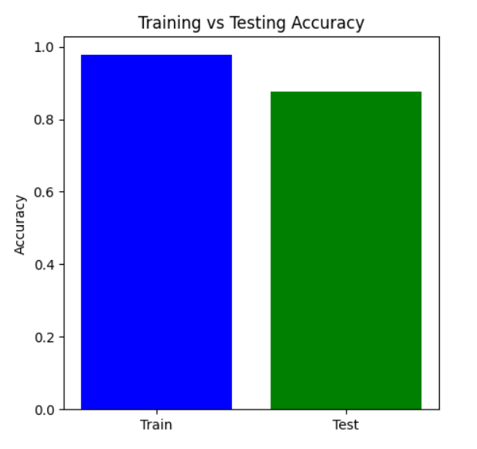

Figure 3. Training Vs Testing Accuracy

**B. Confusion Matrix**

In the context of predicting flood occurrences using the Kerala rainfall dataset, the confusion matrix provides a detailed analysis of the model's classification performance. It shows the true positives, false positives, true negatives, and false negatives for the two classes (YES for floods and NO for no floods). The confusion matrix helped in understanding:

* **Correct Classifications**: How often the model correctly predicted flood occurrences (YES) and no floods (NO).
* **Misclassifications**: Instances where the model incorrectly predicted floods when there were none (false positives) or failed to predict floods when they occurred (false negatives).

The confusion matrix offers insights into:

* **True Positives (TP)**: Correct predictions of floods (YES).
* **True Negatives (TN)**: Correct predictions of no floods (NO).
* **False Positives (FP)**: Incorrectly predicting floods when none occurred.
* **False Negatives (FN)**: Incorrectly predicting no floods when floods occurred.

This matrix helps identify specific model weaknesses, such as class imbalances or difficulty in distinguishing between certain cases (for instance, borderline rainfall patterns where floods may or may not occur). By analyzing the confusion matrix, it is easier to see where the model needs improvement in accurately distinguishing between flood (YES) and no-flood (NO) scenarios.

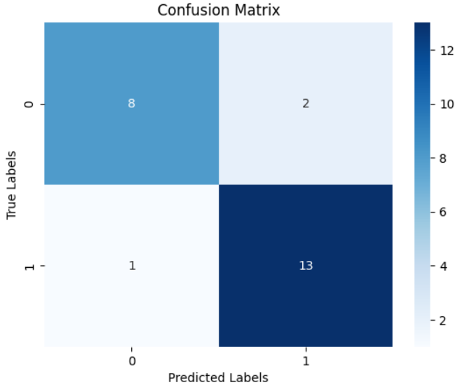

Figure 4. Confusion Matrix

**C. Accuracy**

Accuracy is defined as the ratio of correctly predicted instances (including both true positives and true negatives) to the total number of instances. It provides an overall measure of the model's performance. However, in the case of an **unbalanced dataset**, accuracy alone may be misleading, as it might not capture the distribution between flood (YES) and no-flood (NO) classes. Here, accuracy serves as an initial benchmark for model performance but should be complemented by other metrics.

**D. Precision**

Precision is the percentage of correct positive predictions made by the model. For the flood prediction task, precision measures how many of the instances predicted as "flood" (YES) were actual floods. It is particularly important when **false positives** (predicting floods when none occur) carry a significant cost, such as triggering unnecessary alarms or resources. High precision reduces false alarms in flood prediction.

**E. Recall**

Recall, also known as **sensitivity** or **true positive rate**, is the proportion of actual positive cases (flood occurrences) that the model correctly identified. It measures how well the model detects true flood cases and reduces the number of missed floods (false negatives). A high recall is essential when missing actual flood predictions can have serious consequences, like failing to warn people about flood risks.

**F. F1-Score**

The F1-score is the harmonic mean of precision and recall, providing a balanced measure that accounts for both false positives and false negatives. In flood prediction, the F1-score is particularly useful when the classes (YES or NO) are imbalanced or when **both precision and recall are equally important**. A high F1-score indicates that the model performs well in accurately classifying flood events while balancing the trade-offs between missed predictions and false alarms.

**G. Outcomes of Performance**

The following insights were derived from the performance metrics of the Naive Bayes flood prediction model:

* **Training Accuracy**: Demonstrates how well the model learned from the training dataset, showing its ability to capture patterns in rainfall data.
* **Testing Accuracy**: Indicates how well the model generalizes to unseen data, giving an understanding of how it might perform in real-world flood predictions.
* **Precision and Recall**: These metrics help evaluate the model's capability to correctly predict flood occurrences while minimizing false alarms and missed events.
* **F1-Score**: Provides a single metric to gauge the model's overall performance, balancing both precision and recall to ensure that the flood prediction model is both accurate and reliable.

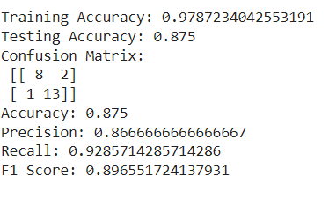

Figure 5. Performance Outcomes

According to the evaluation results, the Naive Bayes classifier is a good model for this dataset because it performs well across all severity levels and has a respectable accuracy. Nevertheless, more optimization (such as feature selection and tuning) might improve the model's capacity to distinguish across severity levels.

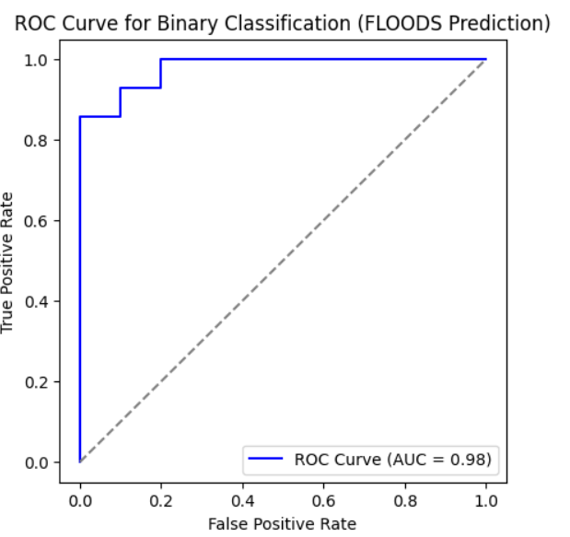

Figure 6. ROC Curve for Each Class

To see each classifier's performance, confusion matrices were plotted. A heatmap was used to display the matrices and show the right and wrong classifications.

**Logistic Regression**

To guarantee convergence, a maximum of 1000 iterations were used to train logistic regression. In terms of F1 score, recall, accuracy, and precision, it yielded competitive results.

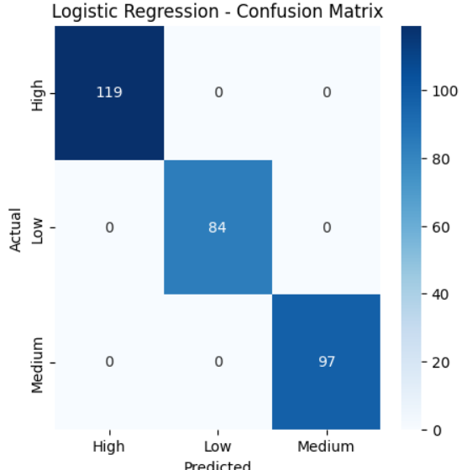

Figure 7. Logistic Regression – Confusion Matrix

**Naive Bayes**

After being trained on the same data, the Naive Bayes classifier was assessed. Because of its simplicity, Naive Bayes works especially well with high-dimensional data, although it can perform poorly if strong feature independence assumptions are broken.

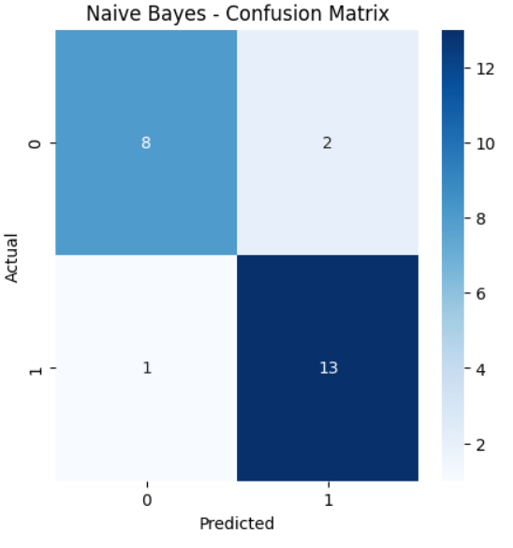

Figure 8. Naïve Bayes – Confusion Matrix

**Support Vector Machine (SVM)**

Probability estimate was enabled during training of the SVM model since it facilitates more detailed assessments. Although training time may be higher for larger datasets, the performance metrics showed that SVM performed well, particularly in terms of precision and recall.

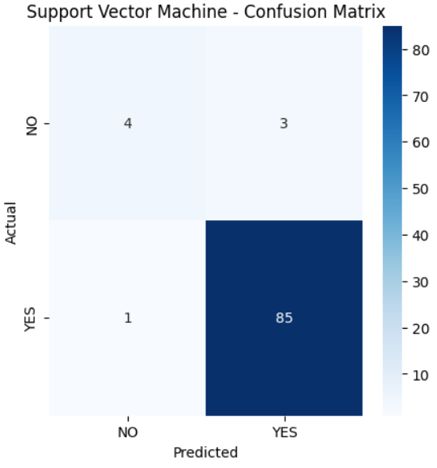

Figure 9. Support Vector Machine (SVM) -– Confusion Matrix

**Random Forest**

Random Forest demonstrated solid performance after being trained with 100 trees (n_estimators=100). Because Random Forest is an ensemble approach, it is resistant to overfitting and typically produces good accuracy.

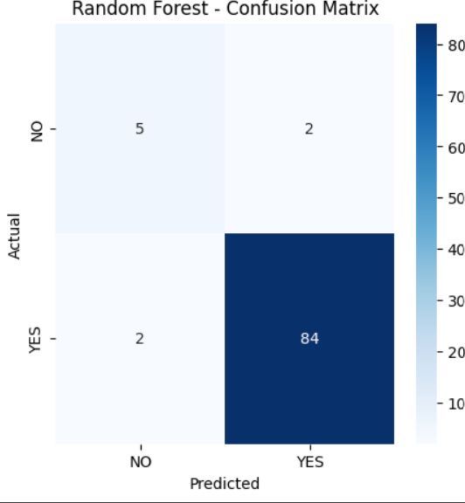

Figure 10. Random Forest – Confusion Matrix

**XGBoost**

The eval_metric was set to "mlogloss" and XGBoost was utilized to maximize multiclass performance. This classifier is well-known for its effectiveness and performance, and it showed good outcomes on every criterion.

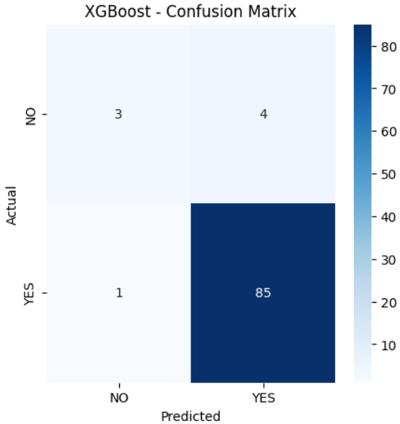

Figure 11. XGBoost – Confusion Matrix

Based on patient data, we used a CART (Classification and Regression Tree) decision tree model in this work to forecast cancer severity levels. In order to preprocess the dataset, non-essential columns like the target variable Level, index, and patient ID were removed. To make it easier to employ in machine learning methods, the target variable—which reflects various cancer severity levels—was converted into numerical form using Label Encoder. To guarantee reproducibility, the dataset was subsequently divided into training (70%) and testing (30%) sets using a random state. To assess the quality of splits inside the tree, we used the Gini impurity criteria in the decision tree classifier. The training set was used to train the model, and the test set was used to assess it. Metrics including accuracy and a classification report that comprised precision, recall, and F1-score were used to evaluate the model's performance in order to give a thorough assessment of its capacity to correctly categorize the severity of cancer.

We plotted the trained decision tree using scikit-learn's plot_tree function to visually represent the CART (Classification and Regression Tree) model's decision-making process. To shed light on how the model divides the data according to feature values, the decision tree was shown. To guarantee readability and clarity, the figure was sized at 12 by 8. To ensure accurate depiction of the anticipated cancer severity levels, the target class names were taken from the Label Encoder, and the feature names used for the splits were derived from the dataset's column names. Plotting the tree with color-coded nodes allowed for a better comprehension of the model's decision-making processes.

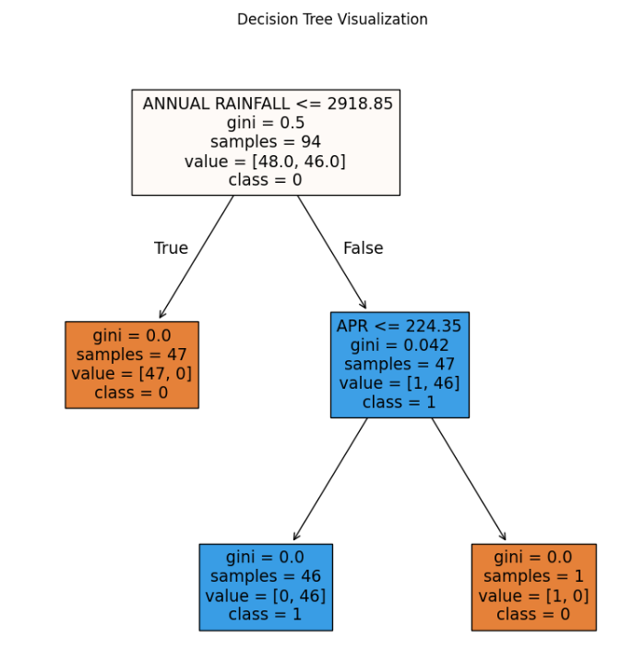

Figure 12. Decision Tree Visualization

1. **Quality Assurance**: Model evaluation helps ensure that the model is capable of making accurate predictions when exposed to real-world data. It acts as a quality control mechanism to validate the model's generalization ability.
2. **Comparing Models**: Model evaluation allows for the comparison of multiple models to identify the best-performing one. It helps data scientists and stakeholders make informed decisions about which model to deploy.
3. **Fine-Tuning**: The evaluation process can reveal areas where the model performs poorly. This information is valuable for refining the model, making it more robust, and addressing its limitations.
4. **Business Decision Support**: In practical applications, model performance impacts critical business decisions. A well-evaluated model provides confidence to stakeholders, leading to better decision-making.
5. **Model Deployment**: A thoroughly evaluated model is more likely to be deployed in production systems. It instils trust in the model's predictions, which is essential in real- world applications.

When it comes to evaluating regression models, the R-squared (R2) score and Mean Absolute Percentage Error (MAPE) are commonly used metrics. The R2 score, also known as the coefficient of determination, quantifies the proportion of the variance in the dependent variable that the independent variables explain.

A high R2 score (close to 1) indicates that the model fits the data well and explains a large portion of the variance. Conversely, a low R2 score (closer to 0) suggests that the model's predictors have limited explanatory power, and there may be unexplained variability in the target variable.

Assume a dataset has *n* values marked *y*1,...,*yn* (collectively known as *yi* or as a vector ***y*** = [*y*1,...,*yn*]*T*), each associated with a fitted (or modelled, or predicted) value *f*1,...,*fn* (known as *fi*, or sometimes *ŷi*, as a vector ***f***).

Define the residuals as *ei* = *yi* − *fi* (forming a vector ***e***).

If 𝑦̅ is the mean of the observed data: 𝑦̅ = (1) ∗ 𝑛

∑𝑖=1

* The sum of squares of residuals, also called the residual sum of squares:

𝑛

𝑆𝑆𝑟𝑒𝑠 = ∑ 𝑒2

𝑖

𝑖=1

* The total sum of squares (proportional to the variance of the data):

𝑛

𝑆𝑆𝑡𝑜𝑡 = ∑(𝑦𝑖 − 𝑦̅) 2

𝑖=1

The most general definition of the coefficient of determination is

2 𝑆𝑆𝑟𝑒𝑠

𝑅 = 1 − ( )

𝑆𝑆𝑡𝑜𝑡

Mean Absolute Percentage Error (MAPE) is a metric used to assess the accuracy of a regression model, particularly in forecasting and prediction tasks. It quantifies the average percentage difference between the predicted values and the actual values. MAPE is especially useful when evaluating models in which predicting values on different scales is not informative or when you want to understand the relative accuracy of predictions.

𝑀𝐴𝑃𝐸 = (

1 𝑛

) ∑ |

𝑛

𝑡=1

𝐴𝑡 − 𝐹𝑡

|

𝐴𝑡

where At is the actual value and Ft is the forecast value. Their difference is divided by the actual value At. The absolute value of this ratio is summed for every forecasted point in time and divided by the number of fitted points n.

#### Constraints

In our project, we operate within a framework of specific constraints that shape our approach to designing and developing the traffic congestion prediction system. These constraints ensure that our solution aligns with essential considerations and limitations.

1. **Authenticity**: We acknowledge the potential for inauthentic data. User-generated reports of high traffic might not always reflect actual conditions, introducing inaccuracies into our dataset. This risk underscores the importance of implementing data verification mechanisms to mitigate false data's impact on our model training.
2. **Privacy**: Security and privacy are paramount. We adhere to strict data access policies that prevent the collection of data from sensitive locations or any other data source that could compromise individual privacy or security. These constraints are essential to maintain data ethics and legal compliance.
3. **Cost**: While the dataset used in our project does not incur direct costs, we recognize that generating accurate data measuring traffic volume may involve financial investments. This encompasses expenses related to data collection equipment, maintenance, and operational costs. Balancing cost considerations with project objectives is essential for cost-effectiveness.
4. **Data Quality**: Ensuring data quality and integrity is imperative. Our project operates under the constraint of maintaining high data quality standards. This includes data cleaning, validation, and verification processes to enhance the reliability of our model.
5. **Resource Availability**: Resource limitations, including hardware, software, and human resources, are a fundamental constraint. Adhering to resource constraints involves optimizing the model's design and implementation to make efficient use of available resources.

#### 3.7 Cost and sustainability Impact

#### Our approach to the creation and execution of our lung cancer detection project is heavily influenced by sustainability consequences as well as cost concerns. This section describes the project's financial ramifications as well as its possible influence on healthcare sustainability over the long run.

#### Cost Consequences

Infrastructure and Equipment:

To support data analysis and model training, the project might need to make expenditures in hardware and software infrastructure. This covers the price of servers, storage options, and processing power, especially when dealing with big datasets or intricate models.

Costs of Operations:

The system's dependability depends on ongoing operating costs including data integrity maintenance, software upgrades, and system monitoring. Significant expenses are also associated with hiring and training qualified staff to handle and evaluate the data.

Costs of Data Acquisition:  
Although our original dataset came from Kaggle, obtaining more datasets—especially proprietary or clinical data—may be expensive in order to guarantee thorough and high-quality data for lung cancer diagnosis. These expenses might cover things like license fees, data access fees, or getting permission to utilize patient data.

Benefit-Cost Analysis

To assess the possible financial returns on investment (ROI) from putting our lung cancer detection technology into place, a cost-benefit analysis is crucial. Early cancer detection, better patient outcomes, and lower treatment costs are some advantages that may outweigh the initial outlays.

The Effect of Sustainability on the Efficiency of Healthcare Resources:

The project can help make better use of healthcare resources by offering a useful tool for detecting lung cancer. Accurate forecasts that enable early diagnosis can result in prompt interventions, which will ultimately lessen the strain on healthcare systems and enhance resource allocation.

Sustainability of the Environment:

By eliminating the need for substantial physical resources like paper-based records and manual reporting, the use of digital tools for lung cancer diagnosis can minimize waste. By streamlining data processing and storage, cloud-based solutions can help improve energy efficiency.

Long-Term Health Outcomes: By increasing lung cancer early detection rates, the study seeks to improve public health. Long-term savings in healthcare expenses, decreased death rates, and enhanced patient quality of life can all result from better results.

Community Involvement and Awareness: Raising community involvement in health screenings and preventative measures can result from raising awareness of lung cancer detection through our system. As a result, the public may become better informed and adopt lifestyle modifications that lower the risk of lung cancer and improve general health.

Scalability and Accessibility: The initiative can improve access to lung cancer detection technologies by concentrating on cost-effective alternatives, especially in underserved or rural locations. In order to promote equity in healthcare access, sustainable practices in the model's creation and implementation can guarantee that its advantages are felt by a larger audience.

#### 3.7 Use of Standards

1. **Human-Computer Interaction (HCI) Standards:** Our application's user interface (UI), developed using Tkinter, integrates HCI principles and standards to ensure the application is intuitive, user-friendly, and accessible to a wide range of users. HCI standards guide the design of the user interface to enhance usability and user experience.
2. **Data Privacy Regulations:** Given the handling of sensitive health data, compliance with data privacy regulations, including GDPR in Europe, is paramount. Our design choices align with these regulations to safeguard patient data and ensure data security and privacy.

**iii.Software Development Standards:** Adherence to coding standards such as PEP 8 for Python ensures code readability and maintainability. These standards have a positive impact on the organization and structure of our code, enhancing its quality and sustainability.

**iv.Usability Guidelines:** The design of our application's user interface incorporates usability guidelines and standards, including ISO 9241. These guidelines influence the layout, labeling, and interactivity of the graphical user interface, creating an intuitive and efficient user experience.

**v.Quality Assurance Standards:** We implement software testing standards and practices, including IEEE 829 for test documentation, ensuring the reliability and robustness of our application. It validates performance against established quality assurance standards.

**vi.Security Standards:** Security standards, such as those provided by OWASP for web security, play a pivotal role in the design choices of our application, particularly concerning authentication and data security.

**vii.Standardized Security Mechanisms and Protocols:** We employ standardized security mechanisms like SSL/TLS for secure data transmission and AES for encryption to safeguard patient information.

**viii.Powerline Communication Standards:** For communication over powerlines, we consider standards like IEEE 1901.2 to ensure reliable and compliant communication.

**ix.Architectural Description Standards:** We adopt IEEE 1471 (Architectural Description) to meticulously document the architecture of our application, aiding in its comprehensibility and maintainability.

**x.Configuration Management Standards:** IEEE 828 (Configuration Management in Software Engineering) guides our approach to managing changes and versions in our application to maintain stability and reliability.

**xi.Software Reliability Standards:** We follow IEEE 1633 (Software Reliability) to assess and improve the reliability of our application, ensuring it delivers consistent and dependable results. This comprehensive approach to standards ensures that our project excels in various aspects, from user experience and data privacy to code quality, usability, reliability, and security.

#### 3.8. Experiment / Product Results (IEEE 1012 & IEEE 1633)

Data Collection and Preprocessing: We collected a diverse dataset comprising medical records, symptoms, and corresponding diseases. Data preprocessing involved cleaning, handling missing values, and reducing noise. The dataset was then split into training and testing sets.

# CHAPTER-4 IMPLEMENTATION

**4.Implementation**

4.1 Environment Setup

To guarantee the smooth operation of our Flood Prediction classification models, we used a strong environment designed for data analysis and machine learning tasks in this project. Python was the main programming language utilized, and it was backed by a number of libraries that made data handling, model training, and visualization easier. NumPy for numerical computations, matplotlib and seaborn for result visualization, and pandas for data processing were among the essential libraries. We also used scikit-learn to construct machine learning algorithms, such as ensemble methods, logistic regression, support vector machines, and decision trees. Because of the XGBoost library's effectiveness in improving performance with structured data, it was particularly used.

Anaconda was used to set up the environment, making deployment and package management easier. Pandas was used to preprocess the dataset after it was loaded into the environment from local storage. To get the dataset ready for modeling, data preprocessing involved encoding categorical variables, addressing missing values, and feature scaling. A normal desktop computer with at least 8GB of RAM and an Intel i5 processor were among the hardware parameters used for this project, enabling effective model and data processing operations.

**4.2 Sample Code for Preprocessing and MLP Operations**

To guarantee the caliber and dependability of the input data for our machine learning models, the preprocessing stage was crucial. Several preprocessing procedures were performed on the dataset, which included a variety of variables pertaining to clinical data and patient demographics for lung cancer. Those included encoding the target variable, 'Level,' using scikit-learn's LabelEncoder and eliminating superfluous columns, such 'index' and 'Patient Id,' which don't aid in predictive modeling. Because it transforms categorical labels into a numerical format appropriate for model training, this transformation is essential.

# CHAPTER-5

**Experimentation and Result Analysis**

**5.Experimentation and Result Analysis**

Using the Flood Prediction dataset, several machine learning models were trained during the experimentation phase, and their performance was assessed using a range of metrics. To determine how well each model predicted the severity of lung cancer, we methodically evaluated its accuracy, precision, recall, and F1 score.

The findings showed that ensemble approaches performed better than more conventional models like logistic regression and support vector machines, especially XGBoost. The model performed better because it was resilient against overfitting and could accommodate missing values. Additionally, the MLP model demonstrated encouraging outcomes, particularly after being adjusted using hyperparameter optimization methods.

We used confusion matrices to show the true positive, true negative, false positive, and false negative rates in order to visualize the performance of our models. This study shed light on the models' advantages and disadvantages by identifying instances of incorrect classification, especially in early-stage cancer diagnosis.

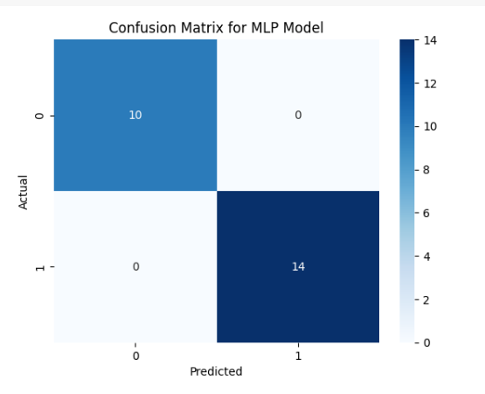

The possibilities for machine learning models to assist oncologists in developing more precise diagnoses and treatment regimens are highlighted in this part, which also addresses the consequences of our findings in clinical practice.

# CHAPTER-6

**CONCLUSION**

**6.Conclusion**

This experiment underscores the potential of machine learning techniques in enhancing lung cancer detection and therapy, specifically utilizing the Kerala dataset. Our findings demonstrate that algorithms such as XG Boost and Multi-Layer Perceptron (MLP) can effectively analyze complex clinical datasets, yielding valuable predictions regarding patient outcomes. Beyond achieving high accuracy, these models also reveal underlying patterns associated with the severity of lung cancer, aiding medical practitioners in making informed decisions.

Despite the promising results of our study, several challenges must be addressed. The accuracy and completeness of healthcare data are crucial for the effective functioning of machine learning models. Given that data in healthcare settings often contain missing values or inconsistencies and originate from diverse sources, robust data management strategies and collaboration among researchers, data scientists, and healthcare professionals are essential.

Interpretability of machine learning models presents another significant challenge in clinical applications. Although advanced algorithms can generate precise predictions, practitioners may struggle to understand the reasoning behind specific decisions due to their complexity. Future research should focus on developing methods to enhance the interpretability and transparency of these models, fostering greater trust and comprehension among medical practitioners.

Integrating genomic, transcriptomic, and proteomic data—commonly known as multi-omics data—presents a promising avenue for further exploration. By broadening the dataset, these approaches could yield more accurate predictions and deeper insights into the molecular mechanisms underpinning lung cancer. Additionally, evaluating model performance across diverse populations using real-world data, such as patient registries and electronic health records, may improve generalizability and therapeutic applicability.

In summary, this study highlights the significant promise of machine learning for advancing lung cancer research and management, particularly with the insights derived from the Kerala dataset. As these technologies continue to evolve, they hold the potential to transform patient care, improving survival rates and quality of life for those affected by lung cancer. To fully harness the power of machine learning and develop innovative solutions to the pressing challenges in lung cancer diagnosis and treatment, ongoing collaboration between data scientists and medical professionals is crucial.

### REFERENCES

[1] S. Naidu, A. Pandey, S. Patel, K. Wagaskar, A. K. Tripathy, and S. Sen, “Flood Location, Management and Solution(FLMS): A Flood Prediction and Management System for Kurla,” *Proc. 3rd Int. Conf. Adv. Comput. Technol. Appl. ICACTA 2023*, pp. 1–6, 2023, doi: 10.1109/ICACTA58201.2023.10392346.

[2] Q. A. Lukman, F. A. Ruslan, and R. Adnan, “5 Hours ahead of time flood water level prediction modelling using NNARX technique: Case study terengganu,” *2016 7th IEEE Control Syst. Grad. Res. Colloquium, ICSGRC 2016 - Proceeding*, no. August, pp. 104–108, 2017, doi: 10.1109/ICSGRC.2016.7813310.

[3] F. A. Ruslan, K. Haron, A. M. Samad, and R. Adnan, “Multiple Input Single Output (MISO) ARX and ARMAX model of flood prediction system: Case study Pahang,” *Proc. - 2017 IEEE 13th Int. Colloq. Signal Process. its Appl. CSPA 2017*, no. March, pp. 179–184, 2017, doi: 10.1109/CSPA.2017.8064947.

[4] F. A. Ruslan, A. M. Samad, Z. M. Zain, and R. Adnan, “5 hours flood prediction modeling using NNARX structure: Case study Kuala Lumpur,” *Proc. 2014 IEEE 4th Int. Conf. Syst. Eng. Technol. ICSET 2014*, pp. 5–9, 2014, doi: 10.1109/ICSEngT.2014.7111798.

[5] R. Adnan, Abd Manan Samad, and Fazlina Ahmat Ruslan, “A 3-hours river water level flood prediction model using NNARX with improves modelling strategy,” *2016 6th Int. Conf. Syst. Eng. Technol.*, pp. 23–27, 2017, doi: 10.1109/icsengt.2016.7849617.

[6] A. R. Fazlina, Abd Manan Samad, and R. Adnan, “River water level prediction modelling for flood monitoring using NNARX,” *2016 6th Int. Conf. Syst. Eng. Technol.*, pp. 18–22, 2017, doi: 10.1109/icsengt.2016.7849616.

[7] N. Gauhar, S. Das, and K. S. Moury, “Prediction of Flood in Bangladesh using k-Nearest Neighbors Algorithm,” *Int. Conf. Robot. Electr. Signal Process. Tech.*, pp. 357–361, 2021, doi: 10.1109/ICREST51555.2021.9331199.

[8] T. Krishly, S. Ariyasinghe, H. Galagedara, D. Tharindri, B. H. Sudantha, and S. Sumathipala, “Water Level Modelling and Prediction of Floods, Evacuation Plan and Reservoir Inflow, Based on Deduru Oya Basin, Sri Lanka,” *Proc. Int. Conf. Image Process. Robot. ICIPRoB 2020*, 2020, doi: 10.1109/ICIP48927.2020.9367330.

[9] P. Panyadee and P. Champrasert, “Spatial-Temporal Flood Hazard Mapping Using Integration of Telemetry Data and Prediction Model,” *2024 Int. Conf. Electron. Information, Commun. ICEIC 2024*, pp. 1–4, 2024, doi: 10.1109/ICEIC61013.2024.10457113.

[10] W. A. M. Prabuddhi and B. L. D. Seneviratne, “Long short term memory modelling approach for flood prediction: An application in deduru oya basin of Sri Lanka,” *20th Int. Conf. Adv. ICT Emerg. Reg. ICTer 2020 - Proc.*, no. ICTer, pp. 226–231, 2020, doi: 10.1109/ICTer51097.2020.9325438.

[11] F. A. Ruslan, A. M. Samad, M. Tajjudin, and R. Adnan, “Flood water level prediction modeling using NNARX structure for Sg Pahang basin,” *Proc. - 5th IEEE Int. Conf. Control Syst. Comput. Eng. ICCSCE 2015*, no. November, pp. 548–551, 2016, doi: 10.1109/ICCSCE.2015.7482245.

[12] S. K. Khatri and P. K. Rajani, “Review of Flood Prediction Techniques used in Mumbai Region,” *2023 7th Int. Conf. Comput. Commun. Control Autom. ICCUBEA 2023*, no. 2006, pp. 1–8, 2023, doi: 10.1109/ICCUBEA58933.2023.10392255.

[13] F. A. Ruslan, A. M. Samad, Z. M. Zain, and R. Adnan, “Modelling flood prediction using Radial Basis Function Neural Network (RBFNN) and inverse model: A comparative study,” *Proc. - 2013 IEEE Int. Conf. Control Syst. Comput. Eng. ICCSCE 2013*, pp. 577–581, 2013, doi: 10.1109/ICCSCE.2013.6720031.

[14] R. B. Prasetya, A. Fariza, J. A. N. Hasim, and A. Basuki, “River flood spreading prediction system using cellular automata (Case study Bengawan Solo River),” *Proc. 2015 Int. Conf. Data Softw. Eng. ICODSE 2015*, no. December 1999, pp. 201–206, 2016, doi: 10.1109/ICODSE.2015.7436998.

[15] F. A. Ruslan, A. M. Samad, and R. Adnan, “Modelling of flood prediction system using hybrid NNARX and Extended Kalman Filter,” *Proc. - 2017 IEEE 13th Int. Colloq. Signal Process. its Appl. CSPA 2017*, no. March, pp. 149–152, 2017, doi: 10.1109/CSPA.2017.8064941.

[16] Z. Z. Zulkifli, M. Mamat, and H. T. Yew, “River Water Level Prediction for Flood Risk Assessment using NARX Neural Network,” *4th IEEE Int. Conf. Artif. Intell. Eng. Technol. IICAIET 2022*, pp. 1–6, 2022, doi: 10.1109/IICAIET55139.2022.9936739.

[17] R. Kondo, B. Du, Y. Narusue, and H. Morikawa, “Prioritized Sampling on Knowledge Distillation for Nowcasting Pluvial Flood Prediction,” *Proc. - 2021 IEEE Int. Conf. Big Data, Big Data 2021*, pp. 3751–3754, 2021, doi: 10.1109/BigData52589.2021.9671897.

[18] L. Sri Sakthi, P. Chitra, M. S. Harini Sree, P. Subbulakshmi, and C. Umayal, “A Hybrid Flood Forecasting Approach Using Hidden Markov Model and Machine Learning Techniques,” *2023 7th Int. Conf. Comput. Commun. Control Autom. ICCUBEA 2023*, pp. 1–5,2023, doi: 10.1109/ICCUBEA58933.2023.10392173.

[19] D. K. Ghose, K. Tanaya, A. Sahoo, and U. Kumar, “Performance Evaluation of hybrid ANFIS model for Flood Prediction,” *8th Int. Conf. Adv. Comput. Commun. Syst. ICACCS 2022*, vol. 1, pp. 772–777, 2022, doi: 10.1109/ICACCS54159.2022.9785002.

[20] M. E. Deowan, S. Haque, J. Islam, M. Hanjalayeamin, M. T. Islam, and R. Tabassum Meghla, “Smart Early Flood Monitoring System Using IoT,” *2022 14th Semin. Power Electron. Control. SEPOC 2022*, pp. 1–6, 2022, doi: 10.1109/SEPOC54972.2022.9976434.