Project Report: Consumer Financial Complaints End to End Pipeline

Prepared by: Naganandhini R
Tools: Python (Pandas/NumPy/Matplotlib/Seaborn), MySQL, Power BI
Dataset: Consumer Financial Protection Bureau (CFPB) Complaints

Phase I: Data Engineering & Preprocessing (Python)
Using two specialized notebooks, I transformed raw, inconsistent data into a high quality analytical dataset.

Step 1: Data Cleaning & Integrity
- Missing Value Strategy: I identified high null columns (like Consumer complaint narrative) and handled them strategically to maintain dataset volume while ensuring accuracy in the Sub issue and State fields.
- Inconsistency Resolution: I cleaned and standardized categorical values to prevent duplicate groupings (e.g., ensuring "Credit card" and "credit card" were merged).
- Date Normalization: I converted the Date submitted and Date received columns into standard datetime formats to allow for accurate time series analysis.
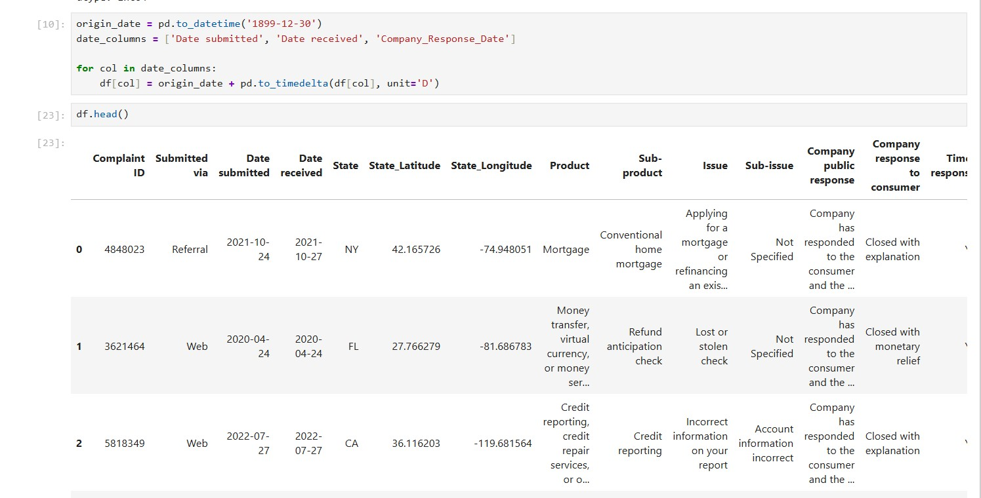

Step 2: Feature Engineering & EDA
- Visual Exploration: I used Matplotlib and Seaborn to create heatmaps and distribution plots to identify outliers before moving the data to SQL.
- Geographic Mapping: I created a custom mapping function to group 50+ states into Census Regions (Northeast, Midwest, South, West). This allowed for higher level geographic insights.
- Time Features: I extracted Year and Month features to analyze seasonal trends.

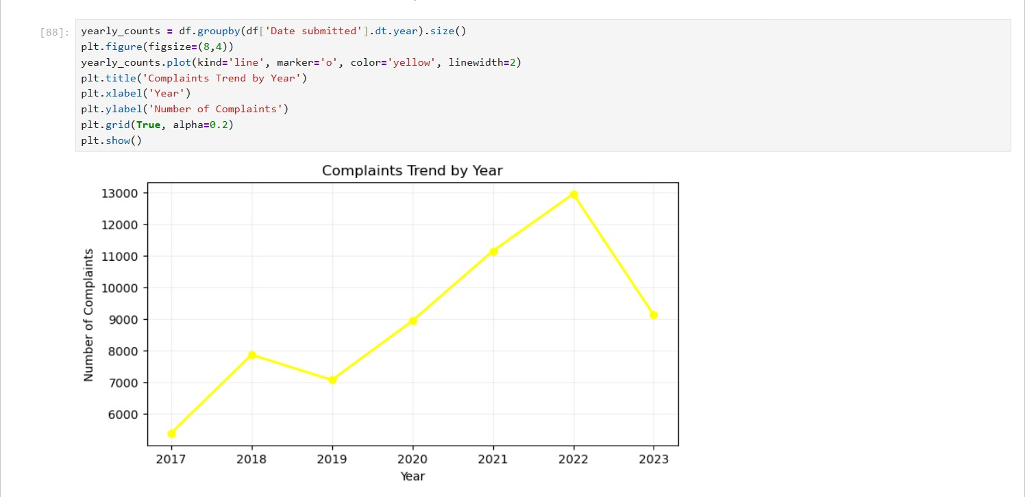

Phase II: Deep Dive Analysis (MySQL)
Once the data was structured, I migrated it to a MySQL environment to perform complex relational queries and performance benchmarking.
Step 1: Advanced Window Functions
• The "Top 3 Issues" Challenge: I implemented DENSE_RANK() OVER (PARTITION BY Product ORDER BY COUNT(*) DESC) to solve a complex business problem: identifying the top 3 pain points for every unique financial product simultaneously.

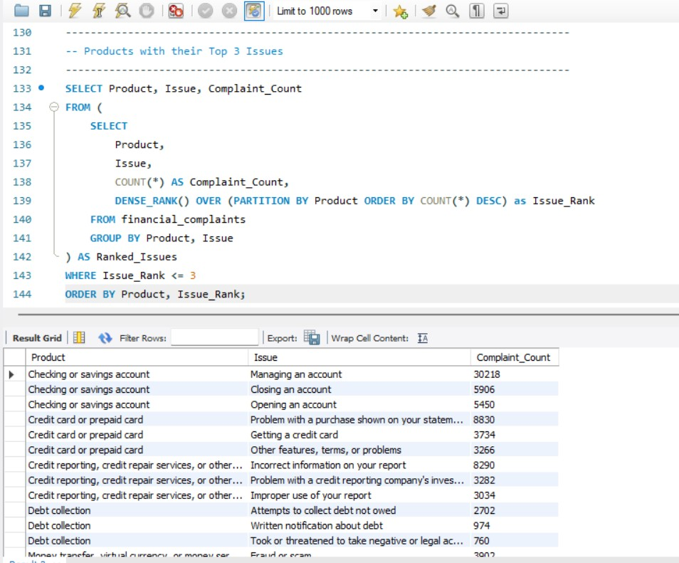

Step 2: Operational Analytics
- Response Benchmarking: I built queries to segment companies into "Timely" vs. "Late" responders, specifically targeting the 3.94% of non compliant cases.
- Drill Down Logic: I wrote multi level GROUP BY queries to analyze complaints at the Product > Sub product > Issue level, which served as the logical backbone for the Power BI hierarchy.
- Monthly Trend Calculation: I performed aggregations to identify the "July Spike," confirming a consistent 15% increase in volume during the mid year period.

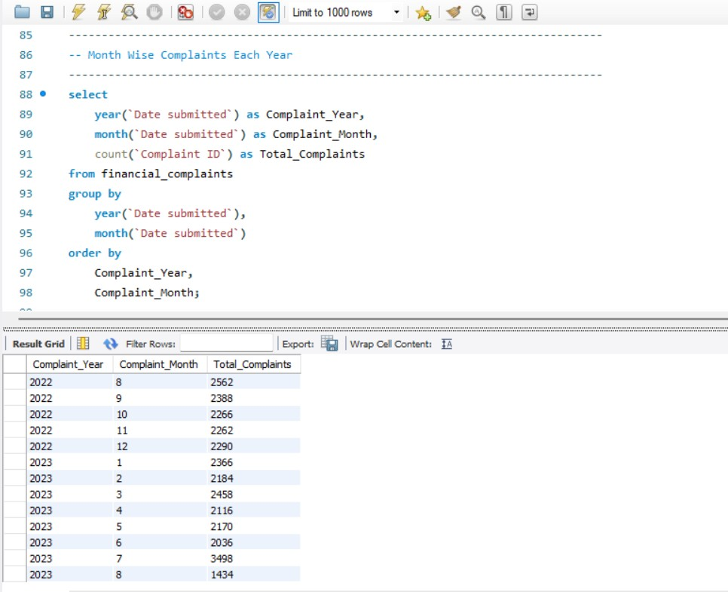

Phase III: Strategic Visualization (Power BI)
I developed a 3 page, interactive dashboard using a modern "Midnight Green" dark mode theme to communicate findings to stakeholders.

Page 1: Executive Overview
- Visuals: KPI cards (63K Complaints, 15.09 Avg Response Days), Line Chart for Monthly Trends, and a State wise Bar Chart.
- Goal: Provide an "at a glance" health check of consumer sentiment.
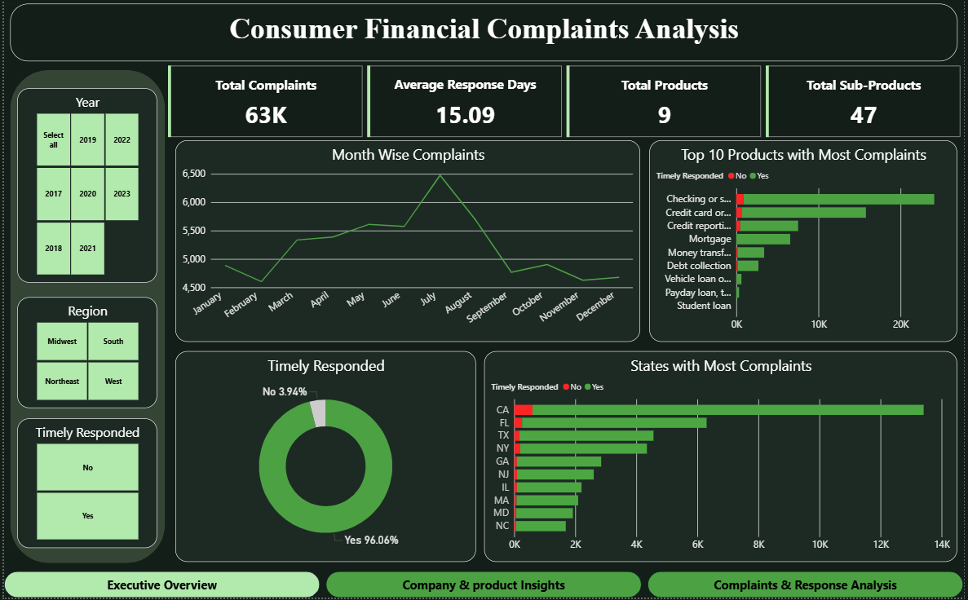

Page 2: Company & Product Insights
- Visuals: Horizontal bar charts for Top 10 Sub products and Companies, plus a "Company Tier" Pie Chart (Small, Medium, Large).
- Goal: Identify which specific institutions and product lines are driving the most friction.

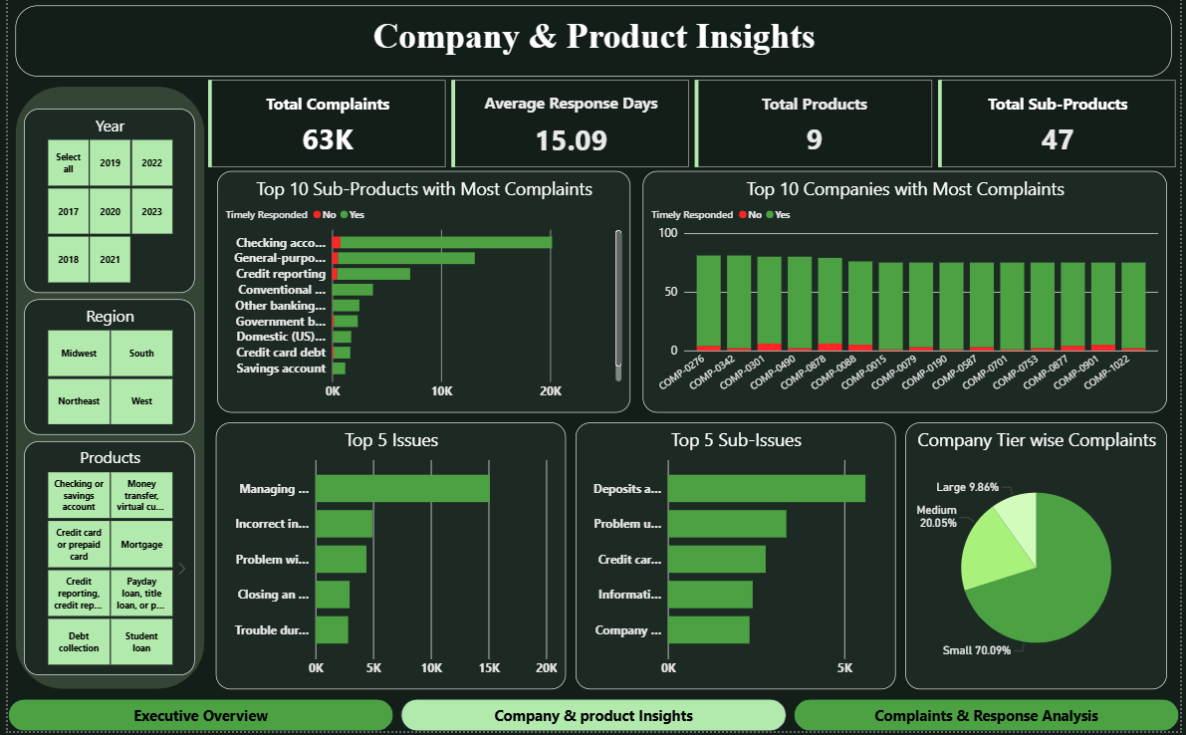

Page 3: Regional & Response Analysis
- Visuals: Regional Donut Chart, Submission Channel Bar Chart, and a Response Type breakdown.
- Goal: Analyze how complaints are submitted and how well they are being resolved geographically.

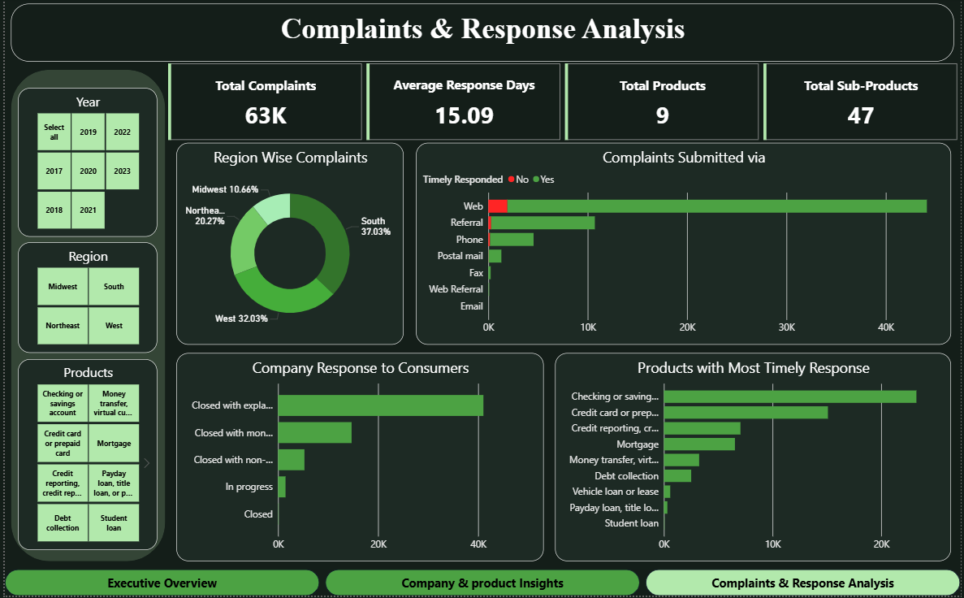

Key Business Findings
- Product Friction: Checking/Savings accounts and Credit Reporting represent the highest risk areas for financial institutions.
- Seasonal Trend: A recurring surge in July suggests a need for increased support staffing during the summer months.
- Efficiency Gap: While the 96% timely response rate is strong, the "Company Tier" analysis shows that smaller firms struggle more with response latency than larger MNCs.

Project Conclusion
The analysis of the Consumer Financial Complaints dataset successfully demonstrates a complete end to end data pipeline. By integrating Python, SQL, and Power BI, I was able to transform a high volume, unstructured dataset into a suite of actionable insights.
The technical workflow proved that Python is essential for creating a "clean room" for data, especially when handling complex feature engineering like the Census Region mapping. The subsequent deep dive in MySQL enabled the extraction of high level rankings and seasonal trends most notably the July volume surge that would be difficult to pinpoint with basic analysis tools. Finally, the Power BI dashboard provides a professional interface for stakeholders to interact with these findings in real time.
Overall, this project highlights the importance of a structured analytical approach. The insights discovered regarding product friction points and geographic complaint density provide a clear roadmap for improving operational efficiency and customer response strategies. This project stands as a verified proof of concept for managing large scale financial data to drive informed business decisions.

