Django Project

For Different User authentication(Normal Users, Employees and Admin )

**Overview:**

In this project , I used Django framework which is really useful for how the database works and the connection to database.

I created this project how the normal users ,Employee and Manager admin are different while accessing the website and the database and also the how the permissions are managed by the admin member.

This project reflects registration for normal users ,registration for employee and how the admin create the employee and give permissions to the employees.

**Roles and Responsibilities:**

**Normal Users :**

These users only can access the website displayed static pages and any forms regarding their queries. Some other pages are not accessible by these users because these normal users are not authorized to access those pages.

**Employee User:**

Employee users are different from normal users. Employee users may have different permissions and also some other different pages are displayed because employee has more permissions than normal users .

In this project I have given admin panel access to the employee and with limited permissions .

**Admin:**

Admin have all the permission to add ,delete and manage permissions to the Employee user

**The Admin Panel:**

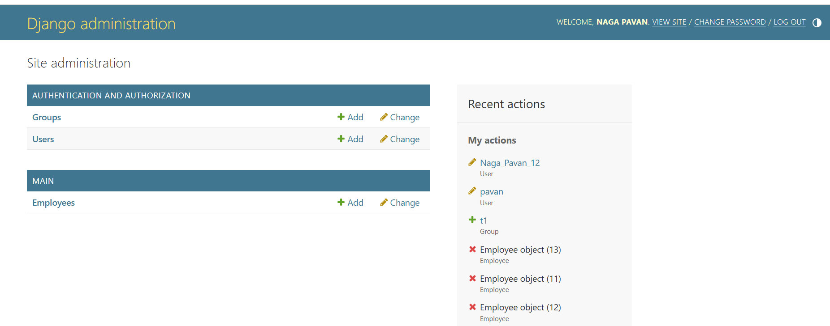

**Groups:**

The Admin Can create different groups with different permission and then admin add the users to the group which user may access those permissions.

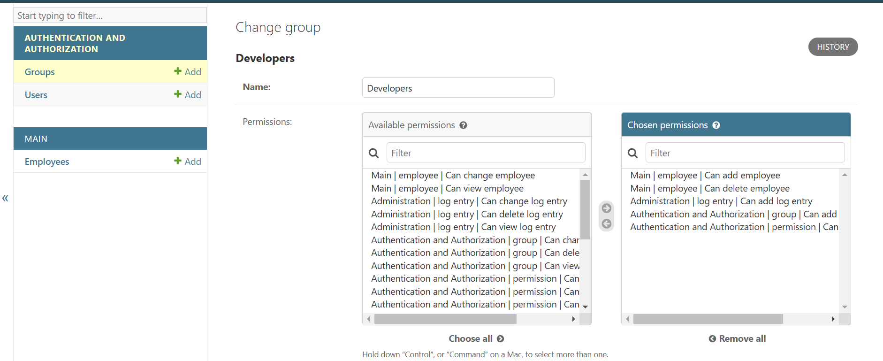

The Admin can only have that permissions to create and manage the permission .

**Users:**

Users are who can access the admin panel . In this project I have made the employees to access the admin panel with limited permissions.

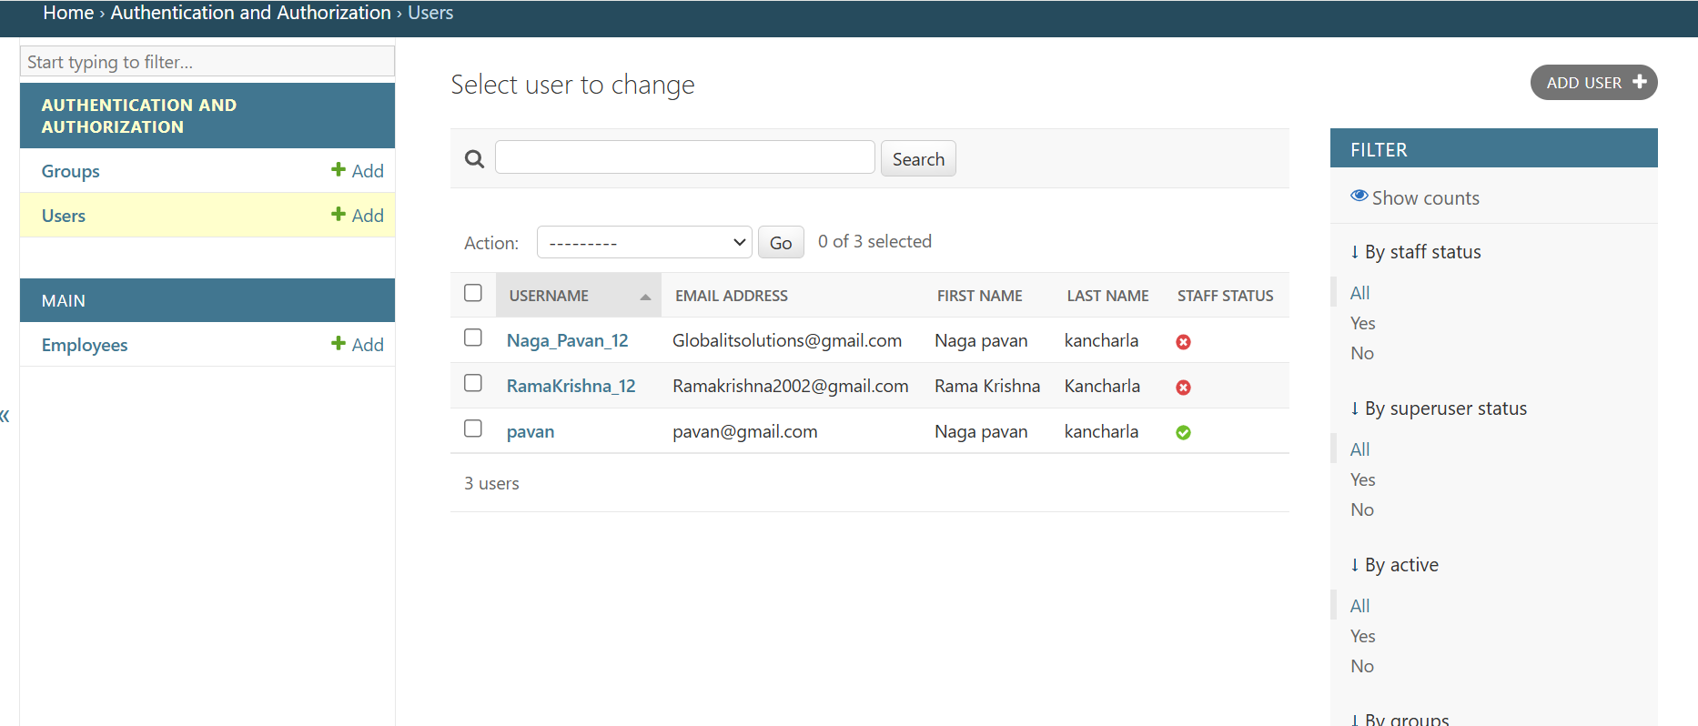

As you see , Pavan is the Admin and the remaining are Employees I have created

Here, The staff status of pavan is active so, pavan is admin

These admin are created when the project is created to access the database.

Command: python manage.py createsuperuser

Username:

Email id :

Password:

Re enter password:

And the Remaining Employees and Normal Users will be created by admin or else they self register through Registration page provided in the website.

These other will register with the required fields like

First name, Last Name, Email id(normal users, web mail for employees)

Passwords (must to be remember)

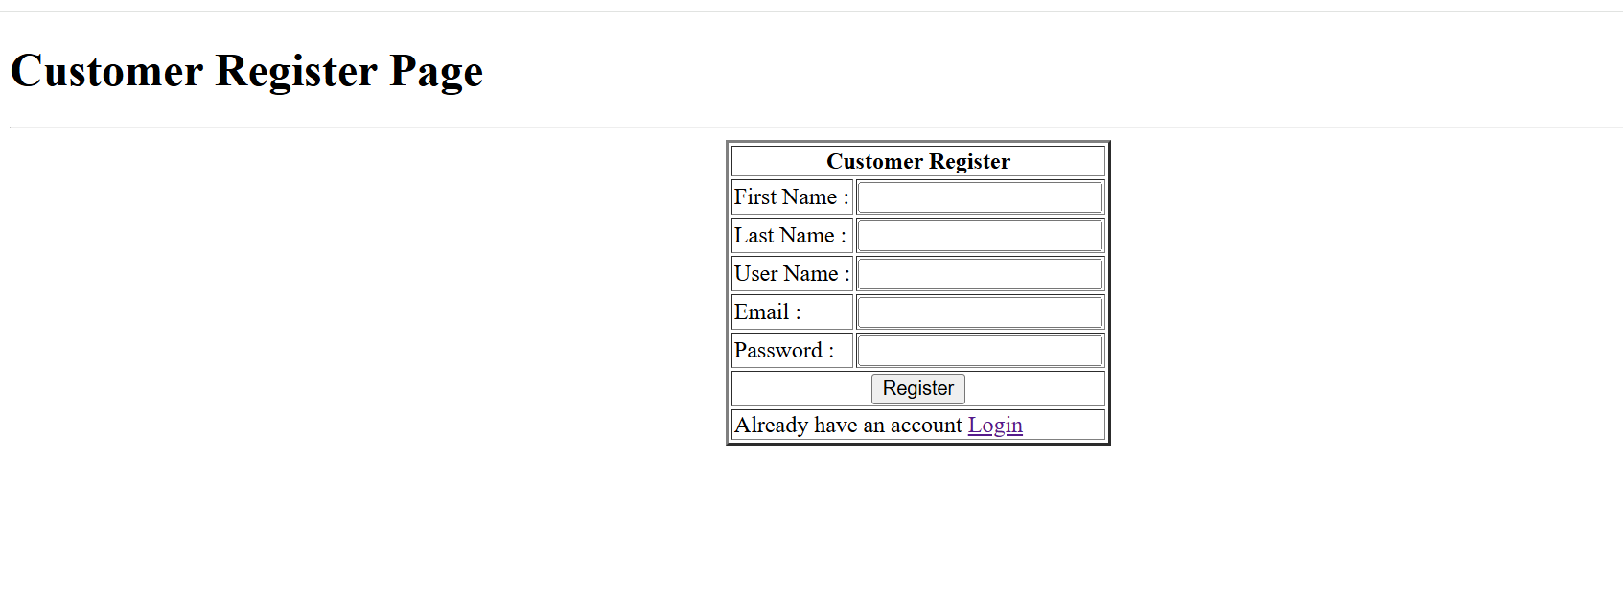

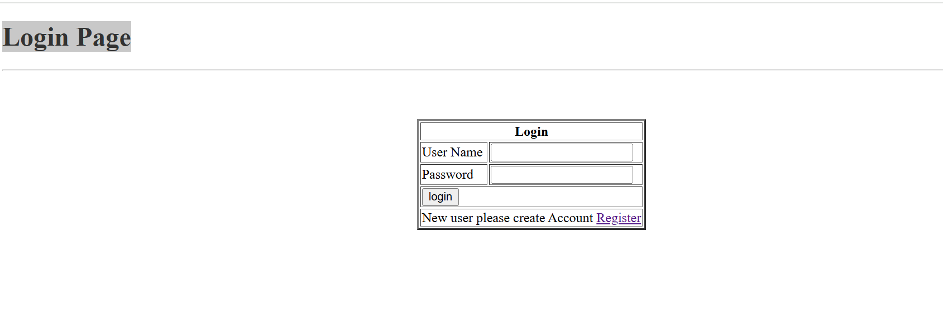

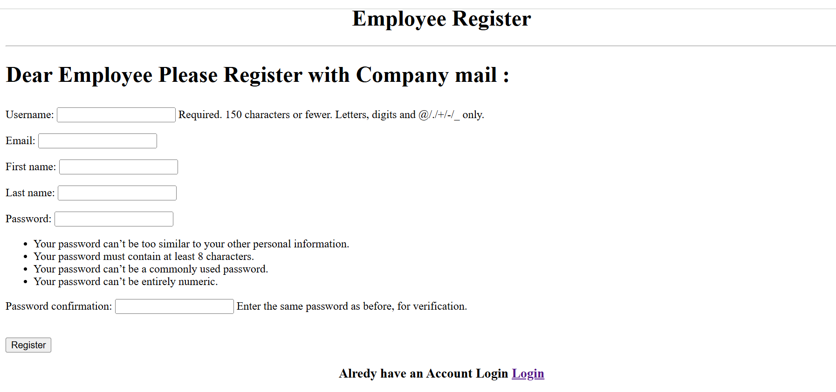

**from django.contrib.auth.decorators import login_required**

**from django.contrib.auth import authenticate,logout,login**

**@login_required(login_url ='login')**

These are inbuilt Functionalities provided by the Django Framework

**Login_Required pages** is only accessible for authorized persons like

Admin and Employee

**from django.contrib.auth.hashers import make_password,check_password**

**make_password** method provided by Django which hash map the password given by normal users this hashed password is stored in the database.