Download Javafx from

<https://gluonhq.com/products/javafx/>

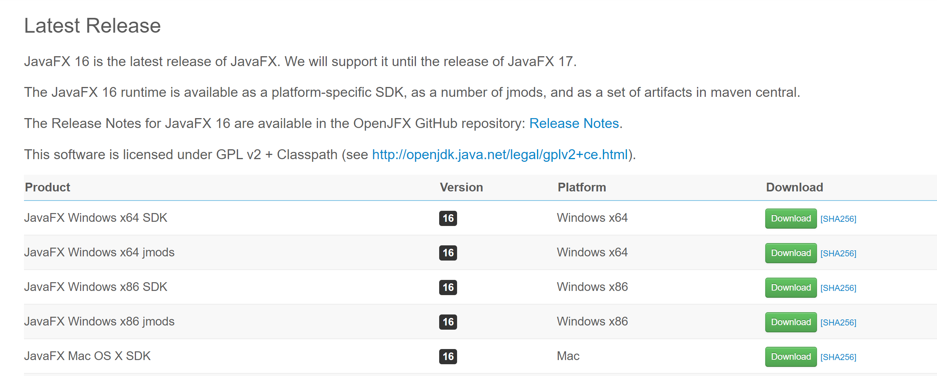

Once you installed include that in Intelij

Go go File->project structure ->lib

When you right click on the lib and add to modules

Later Edit the configuration

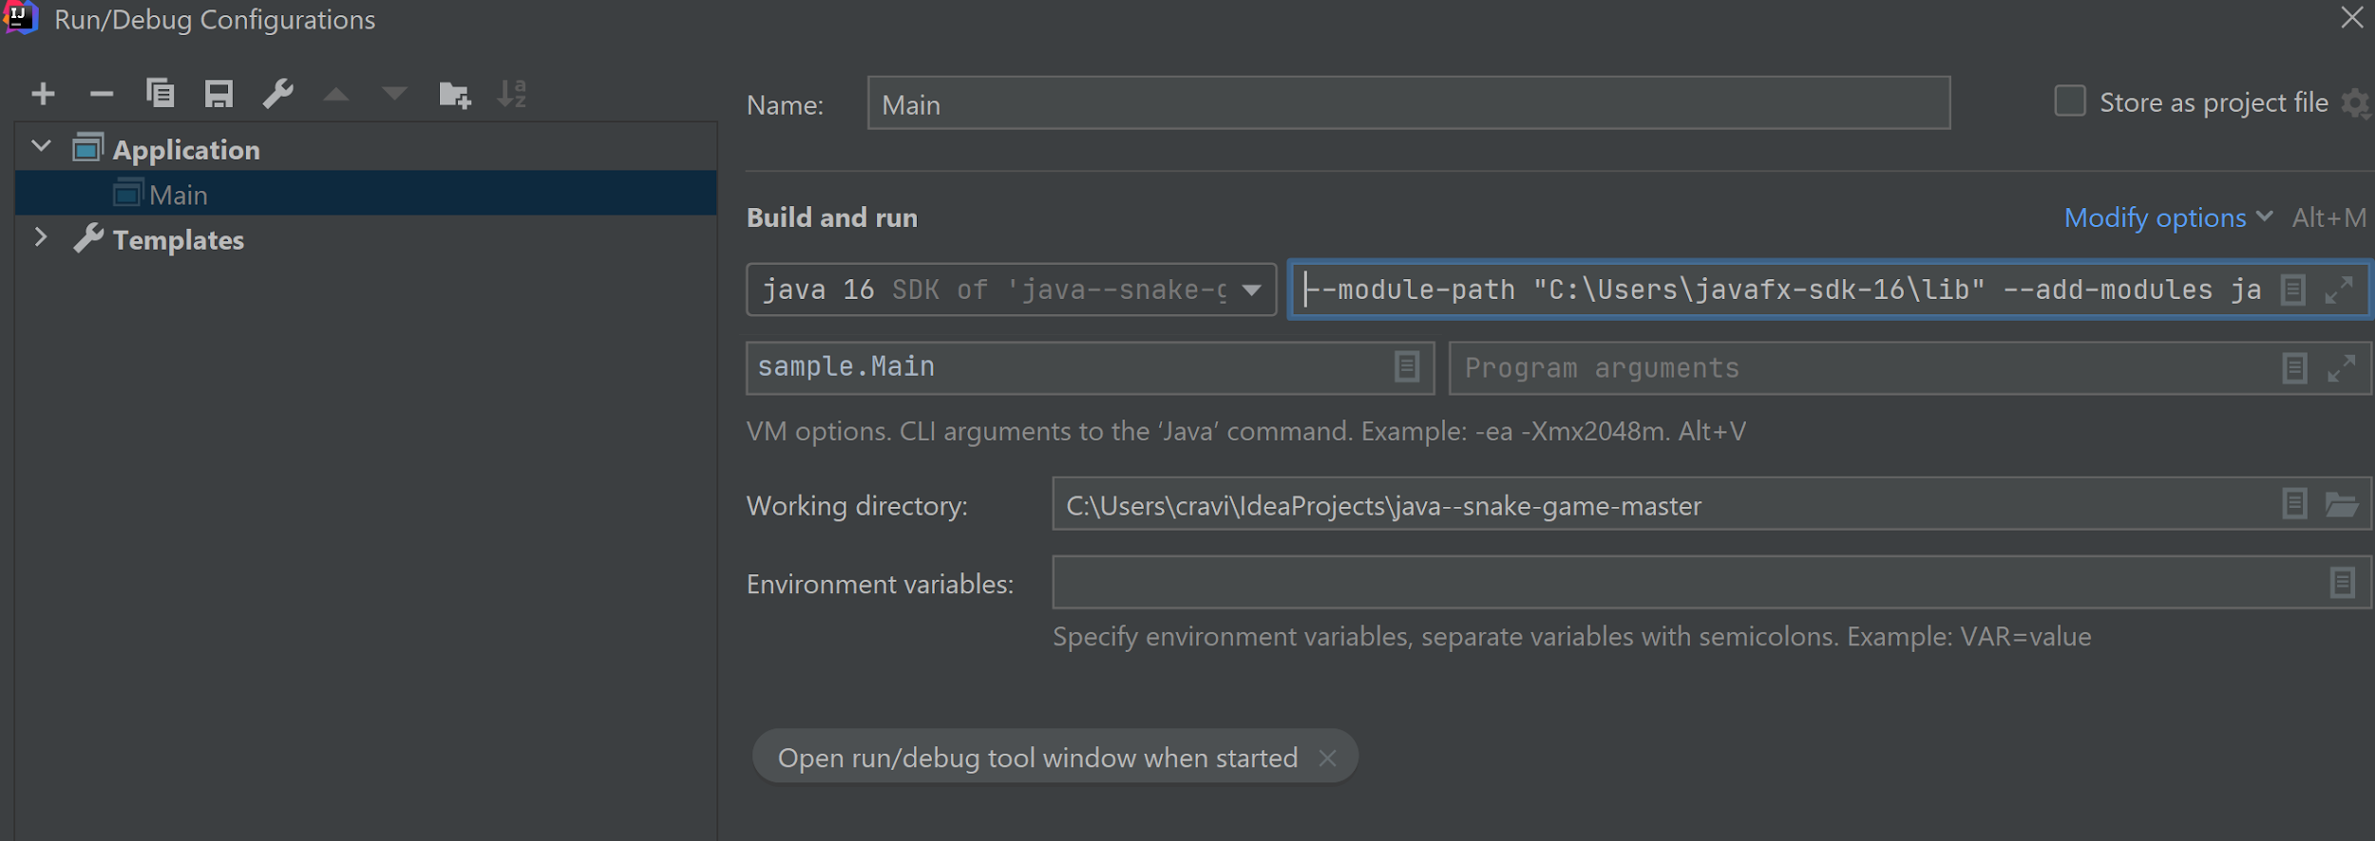

Add

--module-path "C:\Users\javafx-sdk-16\lib" --add-modules javafx.controls,javafx.fxml,,javafx.media