The Dark web
What is Darkweb?
We all might have heard that dark-web is a place where bad or illegal things happen but it is not entirely true. Dark-web is also a kind of normal web which is hidden in the internet from public access, it requires a network called Tor to access the dark web . This tor network makes dark-web more secure and anonymous on the internet.
Note: This blog is made only for educational purposes
How do we understand Tor?
https://www.sciencified.org/post/the-tor-network
Check this blog to clearly understand how “The Onion Router” network works.
As the name suggests Dark web has been embedded in the internet using tor protocols and we require a Tor browser and connection to access any website which is present in the dark web.
Dark websites doesn’t have domain names like google.com instead a domain name like http://juhanurmihxlp77nkq76byazcldy2hlmovfu2epvl5ankdibsot4csyd.onion/ this .onion URL routes to a famous search engine called Ahmia in the dark web.
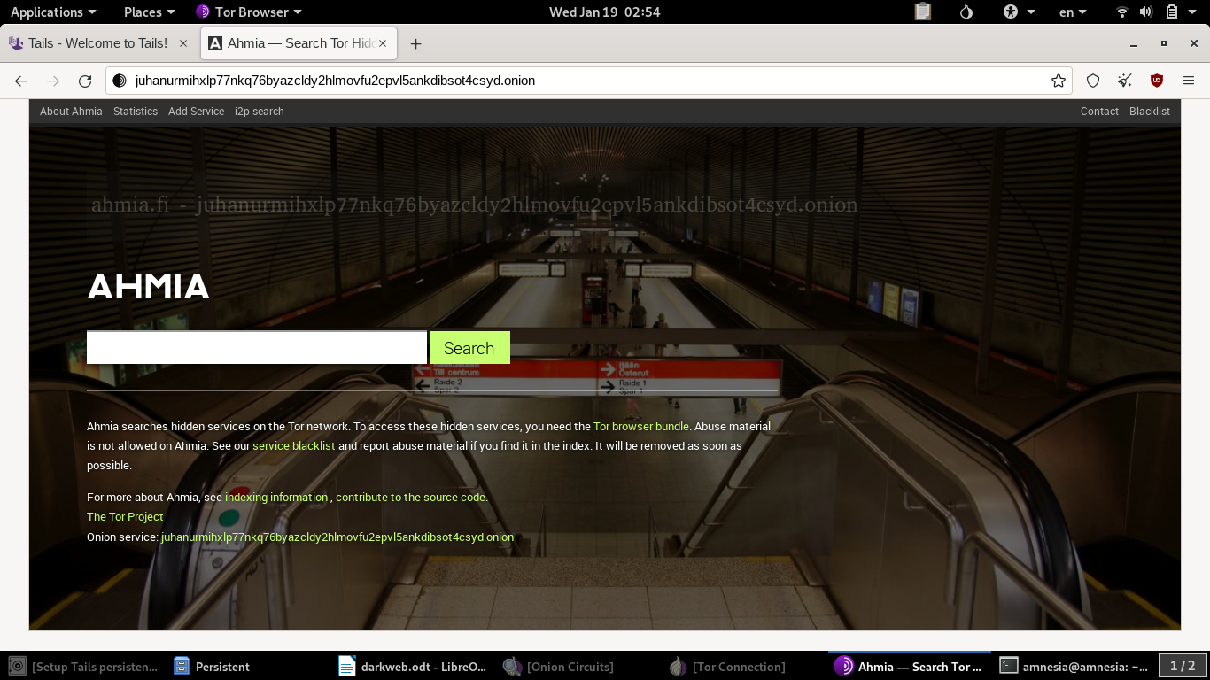
Dark-web is like a ocean of both good and bad things . The only advantage being on tor is the anonymity of the user being in the network .It is also secure in a way but one should be knowing how to work with tor networks and avoid being attacked by any hacker.
Dark-web has become a place for all kind of hackers who are available to be hired.
Hackers can attack any organization and then they leak all their data through blogs in the dark web. All kinds of attacks are performed like Ransomware,Trojan horse, phishing , denial of service , man in middle attacks or compromising a computer. Upon client requirements they can send the entire data to them or they can give access to the victims system through any reverse shell or SSH service.
These images are from a dark web site
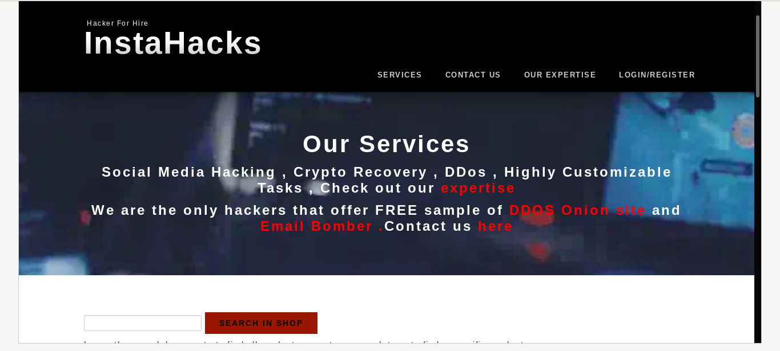
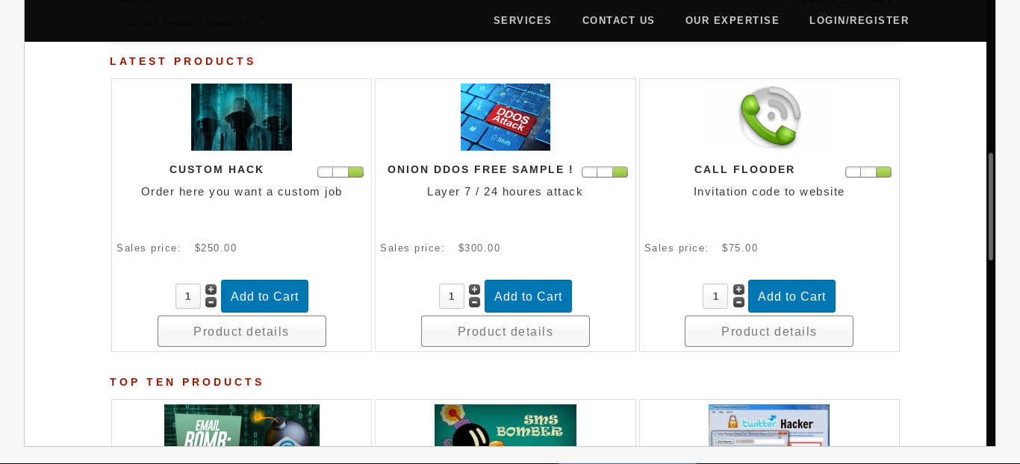
I won’t be sharing the onion address of these sites, because these sites could be dangerous to access without any proper knowledge about the dark web.
The other part of dark web involves selling illegal things like cocaine, morphine and other drugs which are illegal in many part of the world.
Weapons , machines,technology is also sold on dark web, weapons like machine guns, different rifles, shotguns even rocket launcher and bazooka is sold.
Payments are done through cryptocurrency like bitcoin, ethereum, solana etc..
they don’t allow credit cards,or other type of digital bank transfers as these are vulnerable towards identity and anonymity. Cryptocurrencies are perfect as transactions are more secured and completely anonymous with Block-chain technology.
The good things of using dark web can be surfing the internet anonymously without being tracked or identified by ISP providers, government agencies or any other organization. There are also some good people in the dark web where education content, software and various services are made free and open source .Some people are even working towards exposing various scams and illegal things done by any powerful people in the world.
Tails : An integrated Linux operating system or a workspace which is more secured and anonymity is maintained effectively. Visit - https://tails.boum.org/
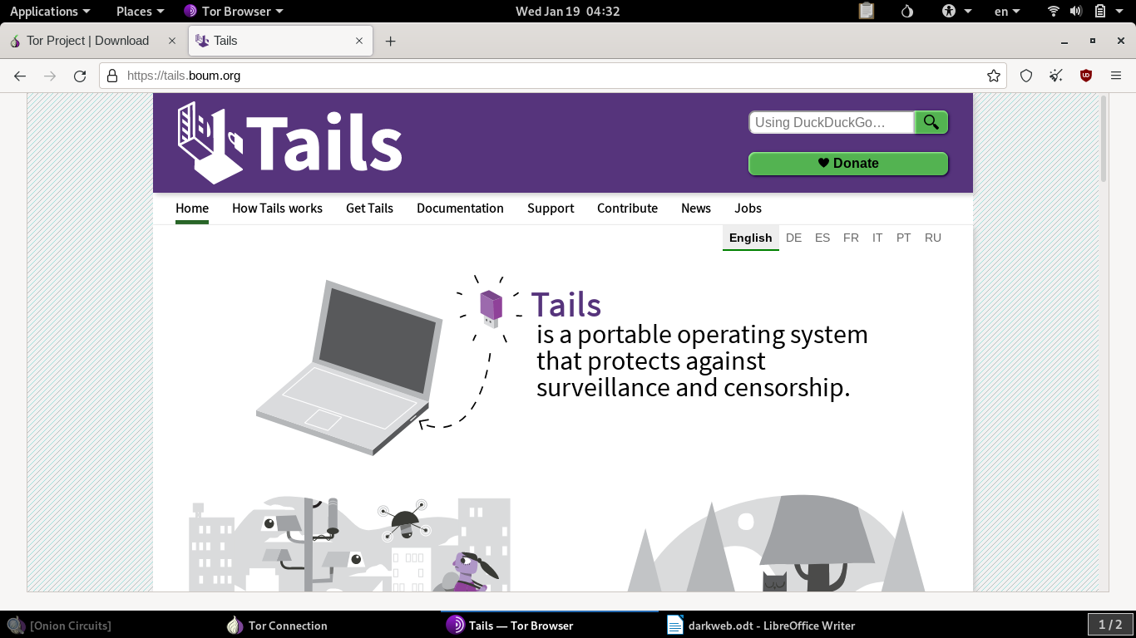
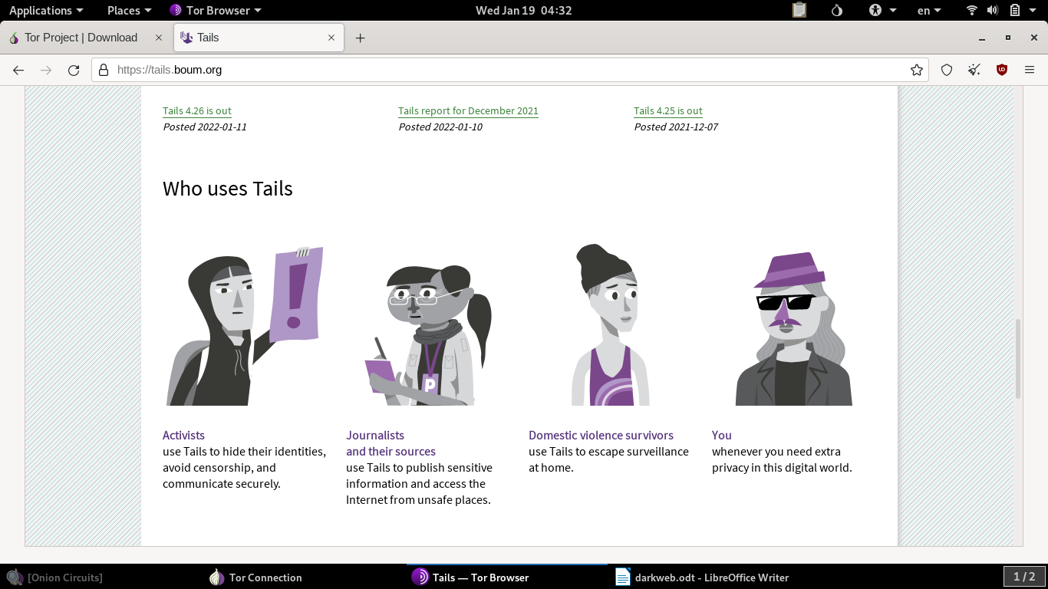
Note : you should never install Tails on a hard-disk(standalone or dual boot), virtual machine but instead it can be downloaded into a USB stick , external hard-drive. Tails can be loaded and booted into the ram of the computer through this portable devices and then tails OS can be used, this is the best way to use in order to avoid external attacks, tracking and to maintain anonymity and be secured.
Steps to configure and install tails:
- Download tails here : https://tails.boum.org/install/index.en.html
- After downloading the tails USB image you can use a tool called Rufus to flash the image to the USB device : https://rufus.ie/en/
- Now tails is loaded into the USB
- Power off the existing OS
- Insert the USB to the system
- On starting enter the boot menu and boot from USB
- Tails will be started and ready to function.

Steps to configure Tor :
- Connect to the internet either Ethernet , WiFi..
- On the navigation bar there is an icon with onion symbol, click on that..
- next step is to start tor connection , it will be prompted..
- Onion circuit will be established
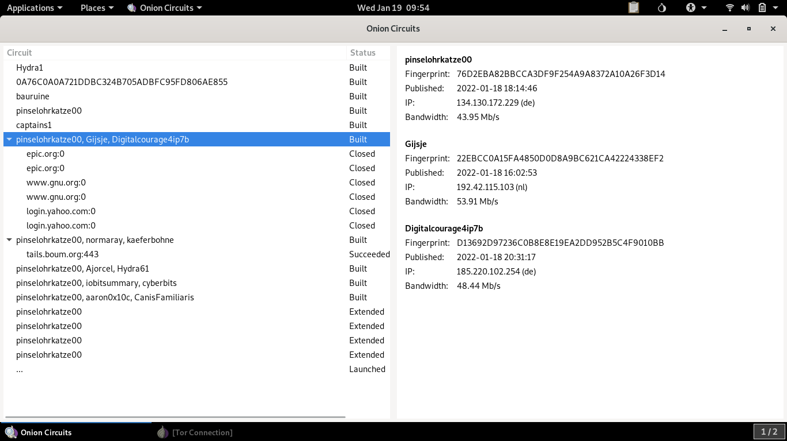
- IT will prompt to open the Tor browser .. you are good to go ...

