S.D.M College of Engineering &TechnologyDharwad

**580002**



Project Synopsis on

**“Student Placement Rating System”**

---------------------------------------------------------------------------------------------------------

Submitted by

**Name USN**

1. **ANAND 2SD12CS402**
2. **MANTESH .H 2SD12CS410**
3. **NAGARAJ G.K 2SD12CS412**
4. **PRAKASH S 2SD12CS415**

**Under the guidance of**

AssistantProf: Mayur Patil.

Semester: 7th B.E Academic Year: 2014-15

-----------------------------------------------------------------------------------------------------------

Department of Computer Science & Engineering

**1.1 Problem definition**

In today’s world rating places an important role in our life, like Standard &Poor and Moody’s give credit rating to all the countries, based on that the investor will choice which country to invest his money, on the same premises the student placement rating system is proposed to give the rating to the students based on their subjects and Google history.

**1.2 Scope of the project**

If student palcement rating system is implemented successfully the company will get to known students ability, students are interrsted to learn new technology and solve their difficulties realted to subjectes and projects. At persent there is no such system exist.

**1.3 Objectives**

1. The company knows the student learning ability.
2. Company may prefer rating of the site to select the students.

**1.4 Project Modules:**

1. Administrator
2. Student

**1.5 Sub-Modules:**

1. Login with Facebook,Gmail
2. Fetch google history
3. Fetch live stock price
4. Algorithm Design
5. Implementation of algorithm
6. Design of Home-page(Interface)
7. Interface Intigration(Sub-Module Intigration)
8. Other-Pages(How-it-works,About-us etc)

**1.6 Project Outcomes**

* Skills in using tools.
* Report writing skills.
* Writing industry standard code.
* Learning new technologies.

**1.7 How it works:**

Send for computation

Fetch stock price and google history

Input Grade

WEB-Client

Google Services

i.e.

Fetch History and stock price

Main-System-Algorithm for computing the rating

Http-Servlet-Request

Placement Rating

Response

Http-Servlet-Response

Fig:- Working of student-placementraing-system

**Google App Engine Architecture:**

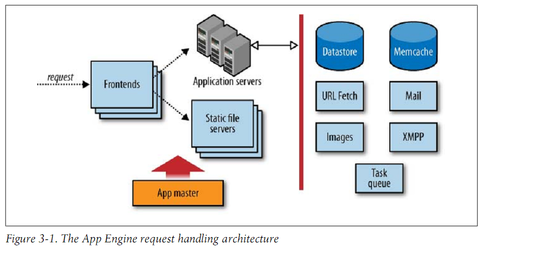

**1.8 Hardware& Software Requirements**

**Tools:**

1. Rational rose-7 (Design Tool).
2. Dreemweaver-8(Front End Design).
3. Eclipse-Kepler-64bit(Google-App-Engine).
4. Codenvy (Cloud-tool)

**Database:** Google app engine database (Big-Table).

**Hardware:**

* + - * Pentium IV & above
      * 512 MB RAM & above
      * HDD 80 GB & above

**References**:

[www.codnvy.com](http://www.codnvy.com)

[www.w3schools.com](http://www.w3schools.com)

[www.javatpoint.com](http://www.javatpoint.com)

**Books:**

Programming Google App Engine by Dan Sanderson

Using Google App Engine by Charles Severance