JeshlaAutoAI Workstream Roadmap
Progress and completion checklist | 17 October 2026
Core AI agent roadmap updated 18 October 2026. Workstreams 5, 6 and 7 have Y for their stated scoped acceptance. Workstreams 2, 3 and 4 retain parked quality gaps. Full offline regression: 343 tests passed. Next is Workstream 8 release acceptance, followed by a proposed UI milestone before Workstream 9 framework integration.
Learning phases remain Phase 1 Y, Phase 2 implementation Y and Phase 3 I. Workstreams track completion without restarting learning.
Completion flow Foundation Y → Conversations P → Memory P → Knowledge I → Reasoning P → Actions P → Reliability P → Release X → Framework P

Status key
Y Verified scope X Not completed or not started
I In progress P Pending verification or parked

Workstream overview
Current status as of 18 October 2026. Y means completed within stated scope; P means unfinished or parked, not failed. Next is Workstream 8 (X). Proposed UI work is X and does not change the existing workstream numbering.
Status | Workstream | Acceptance focus
Y | 1 Foundation | Four provider adapters are supported: Groq, OpenRouter, Ollama and Gemini. Earlier three-provider direct/tool acceptance is retained; Gemini direct use was user verified. Full four-provider live release acceptance is not claimed.
P | 2 Conversations and context | Chats, shared facts, transcript download and observed browser-to-console restart recall work. Actual-history summary quality, Ollama summary acceptance and broader summary isolation remain parked.
P | 3 Long term memory | Fact storage, provenance, timestamps, revisions, scoped archive search and user-approved memory suggestions are implemented and tested. Broader semantic recall and conflict quality remain parked.
P | 4 Knowledge and evidence | Scoped citation guards, page deadlines, structured tables and mixed-source grounding acceptance are verified. One broader relevance/entailment/hybrid quality gate remains parked.
Y | 5 Reasoning and task completion | Bounded tool selection, clarification, real-file planning/recovery and complete/partial/blocked outcomes verified. Universal reasoning or semantic correctness is not claimed.
Y | 6 Controlled actions | Exact console/browser approval, decline, durable receipts and restart/replay protection verified for trusted local-user scope. OS sandboxing and public multi-user authentication are outside this scope.
Y | 7 Reliability | Scoped crash/save recovery, simulated provider-failure presentation/recovery and configurable context budgets verified. Full offline regression: 343 tests passed on 18 October 2026. Live provider fault injection and exact token fit are not claimed.
I | 8 Core agent release | Local development preview accepted. Fresh core installation/startup and 71 selected offline checks passed; synthetic recovery verified. Full/RAG setup and broad quality/release gates remain pending.
P | 9 Automation framework integration | Deferred until core release acceptance and user decision. Requested project-structure milestone and proposed UI work precede framework integration.

Workstream 1 Foundation
Status Y. Direct answer and real tool/result cycle verified for the three selected models; safe configuration errors shown in both interfaces.
Live acceptance passed for OpenRouter nvidia/nemotron-3-super-120b-a12b:free, Groq openai/gpt-oss-20b and Ollama qwen2.5-coder:7b. Ollama uses a narrow registered-JSON compatibility path; existing tool validation and action approvals remain.
Status | Completion checklist
Y | Groq connection works with the configured open-weight model (live execution).
Y | Native model/tool/result loop works with public web search (live execution).
Y | Ollama/OpenRouter/Groq adapters exist; alternate native adapters have offline transport tests.
Y | The three selected provider/model combinations pass live direct-answer and real tool/result acceptance: OpenRouter, Groq and Ollama. Ollama JSON-text proposals are narrowly normalized to the shared tool-call format; caller validation and approvals remain. See foundation-acceptance.md.
Y | Actionable, secret-safe provider configuration errors in console and browser: missing hosted keys/model settings, invalid numeric settings and unknown provider; shared presentation and headless UI regressions pass (181 offline tests).

Workstream 2 Conversations and context
Status P. Console recall/switching and browser create/chat/reopen/memory/download are verified for observed scope. Actual-history summary accuracy and full live summary isolation remain parked.
Status | Completion checklist
Y | Create, list and reopen named chats (user execution and offline tests).
Y | Case-insensitive startup Y/N and 80-character titles work (offline tests and user execution).
Y | Editable console multiline input works without END (user execution).
Y | Save full newly successful turns in a transcript archive (offline persistence tests).
Y | Streamlit supports chat creation, multiline submission and memory viewing in headless tests; real startup passed.
Y | Summary failures pause retries, including across restarts (user output and offline checks).
Y | Implement and validate the registered summary path: 189 offline tests pass; synthetic long-chat summaries pass on Groq and OpenRouter. The exact cause of the historical HTTP 400 is unconfirmed.
Y | Verify summary persistence, restart, chat switching and complete transcript preservation with real SQLite storage and mocked models.

Workstream 2 continued
Status | Completion checklist
P | Actual-history summary accuracy: Groq format rejection and exhausted quota block live diagnosis; Ollama completed 6/7 grounding checks but failed source attribution. Resume later; see workstream-2-summaries.md.
Y | User verified console restart recall and session switching; browser screenshots, separate transcript exports and live event logs verify sampled chat separation.
P | Complete live summary-content isolation across restart/switch after actual-history summarization is reliable. Existing SQLite/model-mocked summary isolation tests pass.
Y | Browser create/chat/reopen/shared-memory/download acceptance passed for the observed scope: separate browser/default transcript exports and user screenshots confirm distinct chats and shared saved facts. Page-jump usability remains separate.

Parked gaps: Groq actual-history summary-format reliability and Ollama source attribution. Do not spend further quota on these until resumed by user decision.

Workstream 3 Long term memory
Status P. Provenance, timestamps, explicit revision history, lexical archive search and controlled suggestions are verified. Semantic relevance and broad contradiction accuracy remain parked after the bounded local retry.
Status | Completion checklist
Y | Save, update, show and forget explicit facts (offline tests; save/show/forget also user verified).
Y | Deleted seed facts are not automatically reinserted (offline regression).
Y | Memory persists across store reopen and is scoped by user/namespace (offline tests).
Y | Saved facts reach normal LLM conversation (user execution).
Y | Optional local-only MiniLM semantic retrieval is integrated with scoped SQLite facts and search_memory; lexical default preserved.
P | Real semantic relevance calibration: bounded local retry loaded the model but returned no paraphrase match. Mocked scope/update/delete tests pass. No downloads or API calls.
Y | Bounded lexical archived-conversation search is connected to the shared agent, scoped to user/memory-space and current or explicitly selected chats, with chat/turn/time references. 210 offline tests and an actual local archive lookup pass; hosted tool-choice acceptance remains P.
Y | Fact provenance, existing timestamps and verification labels are stored and exposed in memory context/commands. Backward-compatible migration preserves all 5 existing database rows; 203 offline tests pass. See workstream-3-memory.md.

Workstream 3 continued
Status | Completion checklist
Y | Explicit same-key corrections preserve scoped revision history; normal retrieval uses current values only. MEMORY HISTORY key reviews revisions; FORGET deletes associated history. 206 offline tests pass.
Y | Advisory related-fact conflict candidates and configurable storage-age review are implemented; no automatic merge, deletion or truth claims.
P | Broader semantic contradiction quality across keys/projects/timeframes: real HTML/PDF advisory smoke case passed, but general accuracy remains unverified.
Y | Scoped suggestions require explicit ID-bound accept/reject; no automatic saved facts or existing-key overwrite. 214 offline tests and temporary command integration pass; live model suggestion selection remains unverified.

Workstream 4 Knowledge and evidence
Status P and parked. Scoped citation guards, page deadlines, table integration, 64/64 local excerpt consistency, live mixed-source acceptance and six representative grounding behaviors are verified. Broader relevance, entailment and hybrid quality remain P after bounded local timeouts. Remaining: 1 P, 0 I, 0 X. Workstream 5 scoped acceptance is now Y; next: Workstream 6 controlled actions.
Status | Completion checklist
Y | Implement document ingestion, metadata and recursive chunking in rag/ingest.py; artifacts are present.
Y | Implement FAISS/BM25 hybrid retrieval and BGE reranking in rag/retrieval.py and rag/query.py.
Y | Implement query rewriting and PDF answer export in rag/query.py.
Y | Implement CSV/Excel search, header detection and dataset routing in the rag modules.
Y | Implement RAG tool-calling/web agents and evaluation variants; saved reports document prior runs.
Y | Legacy RAG launch commands and working-directory-sensitive data/index paths consolidated; canonical conversation loop preserved.
Y | Public web search returns real snippets and links (live execution).
Y | A response can combine saved project facts with web results (user execution).

Workstream 4 continued
Status | Completion checklist
Y | Web reference traceability guard rejects unseen URLs and invented internal markers, permits one correction, and safely fails empty required searches. 225 offline tests pass.
Y | Six representative grounding behaviors passed across Groq/Gemini runs: supported/missing facts, injection rejection, natural conflict clarification, unofficial-source refusal and failed-page disclosure. Broader quality remains P.
Y | Bounded static public-page reader is connected to search results with DNS pinning/public-address validation, redirect checks, excerpt limits and final-URL citation registration. 232 offline tests pass.
Y | Sampled official Playwright search/read/cited-title acceptance passed. Production page reads use a killable worker with a 30-second communication budget and bounded cleanup; broader claim quality remains P.
Y | Re-evaluated existing keyword indexes locally: baseline 1/8 expected source/location/keyword cases; report document-keyword-baseline.json.
Y | Normalized/source-aware keyword ranking and bounded same-page context pass 8/8 audited source/location/keyword cases (6/8 original labels; two page errors independently checked against PDF). 240 offline tests pass.
P | Broader document relevance, answer entailment, fresh-source coverage and hybrid quality remain unverified beyond this small keyword benchmark.
Y | Structured indexed source IDs, bounded excerpts and document-citation validation are integrated while legacy text/hybrid entry points remain compatible. 237 offline tests pass.

Workstream 4 continued
Status | Completion checklist
Y | Structured CSV/Excel retrieval integrated; temporary row/sheet/header selection, truncation and failed/empty-read checks passed.
Y | Real-tool mixed memory/document/web acceptance passed on Gemini: eight sample checks, returned DOC/URL references and unrelated-user exclusion. General entailment remains pending.

Workstream 5 Reasoning and task completion
Status Y for the current bounded core. Groq clarification and Gemini temporary-file planning/recovery passed; 287 full offline tests pass. Completed/partial/blocked execution outcomes preserve existing incomplete status compatibility. Conservative recovery and structural-source limitations remain documented. Remaining: 0 P, 0 I, 0 X.
Status | Completion checklist
Y | Read-only loop validates tool arguments and limits rounds/calls (offline tests).
Y | Unclear ordinary input receives clarification (user execution).
Y | Representative clarification passed on Groq: three missing-detail questions, reuse of supplied facts, and JSON conflict values/references/question after one bounded correction.
Y | Sampled list/read and failed-read/discover/read planning passed live on Gemini with real temporary files. Seven recovery regressions pass. Groq tool rejection and OpenRouter quota failures remain recorded.
Y | Completed, partial and blocked execution outcomes verified; incomplete compatibility retained for failures. Same-workbook sheet resolution preserved. Execution completion does not certify semantic truth. Full offline suite: 287 tests passed.

Workstream 6 Controlled actions
Status Y for the current trusted local-user core. Exact console/browser approvals, live browser create/decline/refresh, all-five-action receipt replay/cancellation checks, fresh-process and hard-exit checks, and the classified tool permission matrix are verified. Commands retain normal OS permissions. Remaining: 0 P, 0 I, 0 X. Broader reliability and release gates remain pending.
Status | Completion checklist
Y | Console exact-action approval has regression coverage.
Y | Browser action proposals wait for exact UI approval; no hidden console confirmation or immediate execution. Scoped policy and UI tests pass.
Y | All five controlled action kinds verified for decline, cancellation, receipt replay and fresh-process/hard-exit protection. Browser completed/declined and hard-exit states also verified across new processes; receipt-write failures preserve the running claim.
Y | All five controlled action kinds verified for decline, cancellation, receipt replay and fresh-process/hard-exit protection. Browser completed/declined and hard-exit states also verified across new processes; receipt-write failures preserve the running claim.
Y | Current local-core tool permission matrix documented and tested. Shared project classification and conversation-registry checks fail closed on unclassified/duplicate tools. Approved commands use normal OS permissions; no OS sandbox or multi-user authentication is claimed.

Workstream 7 Reliability
Status Y for scoped local reliability acceptance. 343 offline tests pass. Recovery, simulated provider failure/recovery and bounded context checks are verified within the limits recorded below. Workstream 8 release gate is next.
Status | Completion checklist
Y | Timings and bounded tool execution are implemented and exercised.
Y | Same-chat concurrency locks block overlapping turns and release normally (offline tests).
Y | Scoped offline provider-failure acceptance: console error presentation and browser failure/recovery exercised for all four provider labels across authentication, rate limit, quota, response timeout, tool-output and output-limit categories. Existing transport/retry/classification checks also pass (32 focused tests). These are simulations, not live fault injection into every provider.
Y | Scoped crash/save recovery verified: caught archive/checkpoint failures preserve the answer; kernel locks release after process exit; a real LangGraph SQLite fixture rolls back an uncommitted checkpoint mutation after process exit and reopens the prior state with its committed transcript intact. Seven focused runtime/recovery tests pass. Legacy locks still require inspection; archive/checkpoint transactions are not atomic together.
Y | Scoped bounded context acceptance: configurable AI_CHAT_MAX_CONVERSATION_CHARS (default 36,000), existing project-task/evidence limits and scoped lexical memory retrieval, plus four-provider preflight checks for oversized Unicode/schema input. Oversized tasks stop honestly before model calls; exact question is not silently shortened. Provider token estimates remain approximate and configured hosted context is required for fit preflight; broader relevance quality remains parked under Workstream 4.
Y | Scoped broad-suite fixture/isolation acceptance verified: the 331-test full offline run passed. Earlier 116-test/six-error results are historical; broader reliability and live-provider fault coverage remain pending.

Budget note: project input defaults to 32000 characters; chat input defaults to 36000 and is configurable with AI_CHAT_MAX_CONVERSATION_CHARS. Provider preflight uses token estimates; configured context is required and account quotas remain independent.

Workstream 8 Core agent release
Status I. Local development preview accepted by the user. Fresh core installation/startup and 71 selected offline checks passed; synthetic core-store backup/recovery verified. Full release, full/RAG setup and parked quality gates remain pending.
Status | Completion checklist
P | Full core acceptance remains pending because Workstreams 2, 3 and 4 retain parked quality gates. Evidence review is prepared in core-release-review.md.
P | Fresh core-only installation, dependency check, console/browser startup and 71 selected offline end-to-end tests passed. Full/RAG installation timed out; broader fresh-environment acceptance remains pending.
Y | README and setup instructions updated; missing direct dependencies declared; core/RAG/full/optional-integration profiles documented.
Y | Stopped-writer synthetic copy restores facts, chats, real checkpoint history/summary and receipt protection. Actual user-state and optional RAG-index restoration are not claimed.
P | User accepted the trusted local-user development preview. Full-release scope/acceptance remains pending; no public deployment or publication approval is implied.
X | General full AI-agent release not declared.

Do not mark the whole agent complete until the core acceptance checklist, setup and recovery checks pass and release limitations are agreed.

Workstream 9 Automation framework integration
Status P. Start only after core release acceptance and the user chooses framework work.
Status | Completion checklist
P | Begin only after the core-agent release gate passes and the user chooses to proceed.
P | Create a separate framework-integration roadmap at that time.

Existing Jira and QA modules are preserved. New framework development remains parked until core release acceptance.

Evidence and document maintenance
Updated snapshot of agentic-ai-roadmap.md through the keyword ranking milestone and 241-test mixed-source offline check. Detailed evidence: workstream-2-summaries.md, workstream-3-memory.md, workstream-4-grounding.md and browser-logging.md. Small benchmark coverage does not prove universal answer accuracy.
Update both the roadmap and this Word snapshot after each completed workstream. Keep the Y X I P codes, state the tested scope and preserve pending release gates.

Restored roadmap explanations and diagrams
The current workstream checklists above remain the status authority. These restored sections preserve the learning phases, architecture, completion diagrams and release criteria. Historical milestones retain their original dates and test counts.

Your actual development position
You are not still in Phase 1. Your current original learning phase is Phase 3: memory, stateful agents and integration hardening.
Original development phase | Build status | Readiness
Phase 1 — LLM foundations and basic agents | Y | Foundation implemented and real model use demonstrated; some release checks remain
Phase 2 — RAG and knowledge implementation | Y | Ingestion, hybrid retrieval, reranking, structured search and evaluation exist; quality/runtime integration is P
Phase 3 — State, persistent memory and conversational agents | I | Core components work; summaries, advanced recall and broader acceptance remain P

The numbered sections later in this document are completion workstreams, not a claim that you must restart Phase 1. A built module can have pending integration or acceptance without losing credit for its implementation.
The full-project audit read/parsed 94 Python files, with no syntax errors. See project-progress-audit.md (project-progress-audit.md) for folder evidence, RAG details, prototype distinctions and the current full-suite test limitations.
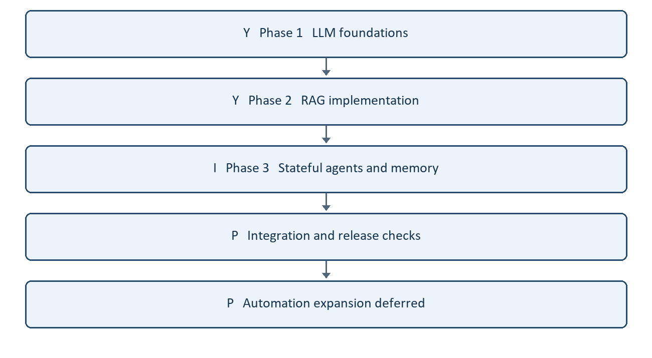

Target and scope
Build JeshlaAutoAI as a reliable, local-first AI agent with a configurable hosted or local model, conversation, persistent memory, evidence retrieval, validated tools, and user-controlled actions.
AI agent is the application we are building. Agentic AI describes the approach: the model selects tools, observes results, adjusts its next step, and answers or asks for clarification. Agentic by itself is an adjective, not a separate product target. Recommended project description: JeshlaAutoAI — an AI agent built with agentic AI capabilities.
Automation-framework development is deferred until the core-agent acceptance gates below pass. Preserve existing Jira/QA modules, but do not make new framework integration the next milestone. Completion means the agreed core scope is verified, not that every possible AI capability exists or that the project matches proprietary products.

Memory development details
- Separate chat history, session summaries and reusable facts; never use a summary as approval.
- Select relevant memories instead of injecting every fact into each prompt.
- Keep source, timestamp and scope for facts; distinguish user assertions from tool evidence.
- Search archived conversations only within the intended scope and cite the originating chat/turn.
- Propose useful new memories or corrections; define explicit user control before automatic storage.
- Handle conflicts, stale facts, deletion and optional expiry. Document that deleting a fact does not erase archived messages or provider records.
- Start with a measured retrieval baseline; add embeddings/semantic retrieval only when it improves the project's evaluation set without reintroducing the previous local inference bottleneck.

Implementation principles
- Do not hardcode project names, framework choices, answers or fixed clarification scripts in model reasoning.
- Store editable project facts in memory/configuration. Keep credentials outside source and logs.
- Use deterministic code for command parsing, argument validation, permission checks, isolation, budgets and storage.
- Prefer documented configurable defaults for limits; not every internal invariant needs a user-facing option.
- Use model reasoning for interpreting ordinary requests, choosing read tools, synthesizing evidence and asking focused questions.
- Add tools with schemas and clear failure behavior. Native model tool calls do not themselves authorize execution.
- Keep a shared backend for console and Streamlit. UI changes should not change approval rules.
- Use the simplest architecture that passes the required tasks; multiple agents, autonomous background work and additional providers are optional future capabilities, not prerequisites.

Core-agent acceptance checklist
Release gates receive Y only when the complete acceptance scenario passes. A working component alone does not complete a broad gate. P means related work exists but full acceptance is pending.
- P — General conversation and clarification use supplied context without inventing missing facts.
- P — Named chats survive restart and have isolated history/summary; shared memory is scoped deliberately.
- P — Memory save/update/forget and relevant search pass both ordinary and conflicting-fact cases.
- P — Long chats preserve full newly archived transcripts; summaries carry key details without becoming instructions or permissions.
- P — Local source, indexed documents, structured data and public web searches work independently and together.
- P — Citations correspond to retrieved evidence; current facts are not claimed after search failure.
- P — Multi-step tasks stop at a clear result or ask for essential missing details.
- P — Tool arguments, source paths and action permissions are validated in code.
- P — Write/execute approvals work in both supported interfaces, or a documented interface limitation is explicitly accepted for the release.
- P — Failed/uncertain actions are not silently retried; restart and cancellation do not duplicate side effects.
- P — Provider, network, quota and context-limit failures are understandable and recoverable.
- P — Repeatable setup, data backup/recovery and the acceptance/regression suite pass in the supported environment.

Immediate next milestone
Finish package/interface verification and synchronize completion evidence. No further code moves planned for this scope. Full Workstream 8 release and optional RAG/quality checks remain pending; development preview remains accepted.

Evidence labels
- Implemented: code exists; does not imply full live acceptance.
- Live verified: supported by an observed real execution.
- Pending: not implemented or not yet verified sufficiently.
- Deferred: deliberately outside the current development scope.
Existing root README installation/END/history notes predate several changes. Reconcile documentation during release preparation; prefer newer topic guides until then. Existing Jira uncertainty remains a tracked framework-integration issue, not something to bypass or delete while focusing on the general agent.

AI agent versus agentic AI
These terms overlap, and terminology varies. They do not describe two mutually exclusive technologies.
Term | Meaning | Example in JeshlaAutoAI
AI agent | A concrete software system that uses a model to pursue a task through available tools and context | Your application reads saved facts, chooses web search, receives results and answers
Agentic AI | An approach or capability in which a system chooses and adapts its actions toward a goal within defined boundaries | The agent notices missing evidence, searches another source, checks the result and decides whether to answer or ask you
Agentic | An adjective describing that behavior | An agentic assistant or agentic workflow
Fixed workflow | A predefined sequence of steps and conditions; useful when the process should be predictable | Command parsing, exact-action approval and database validation

An AI agent can be more or less agentic. Agentic behavior does not require multiple agents, unlimited autonomy, a particular model, or automatic self-training. Fixed workflows can form part of a reliable agentic system.

Which is better for this project?
Build one reliable AI agent with bounded agentic behavior. Let the model interpret requests, select read tools, evaluate results and ask for missing details. Keep permissions, validation, storage, command handling and execution limits deterministic. More autonomy is useful only when its results can be checked; it is not automatically better.
For example, answering a saved fact needs no elaborate plan. Research across several sources benefits from adaptive tool use. A write or command still needs the applicable approval regardless of how the model planned it.

Architecture diagram
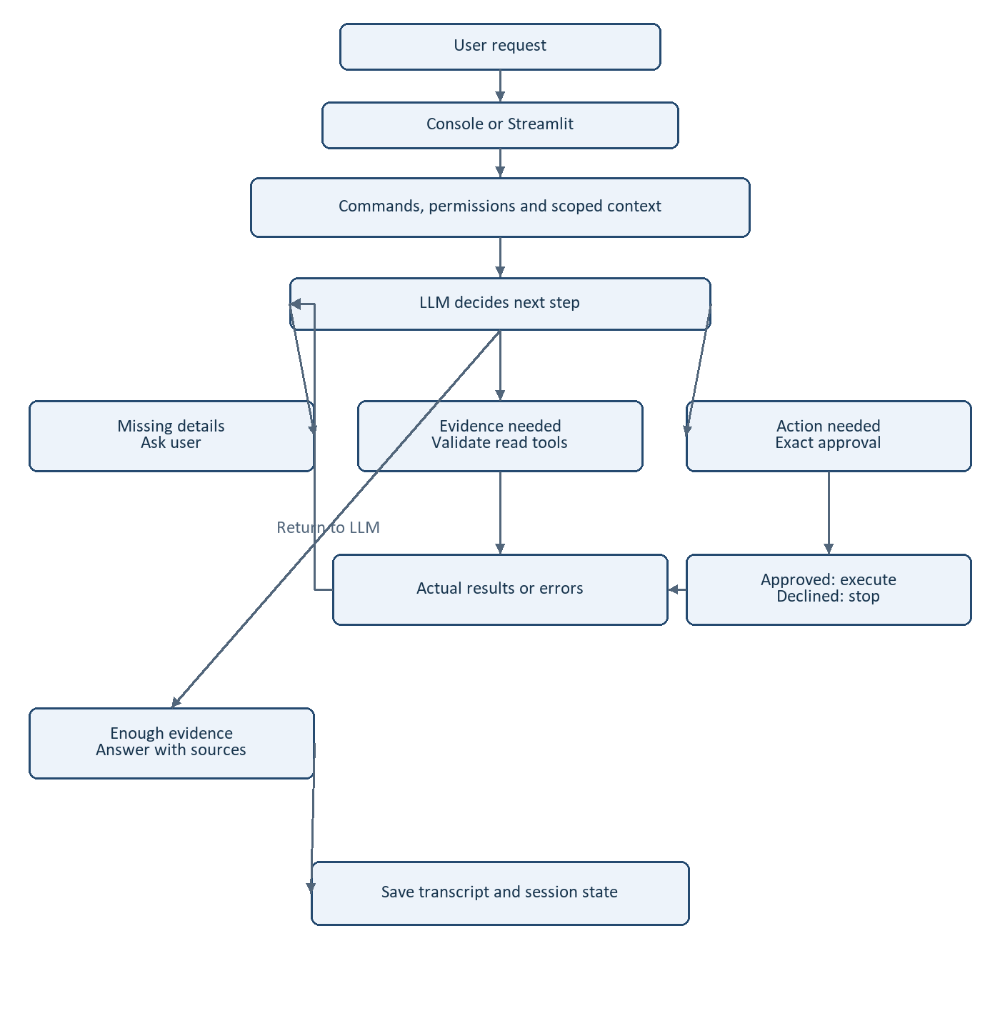
Tool results feed back into the model for another decision. Clarification returns to the user; declined approval stops the action. This is the intended flow, not a claim that all release gates have passed.
This diagram is the intended architecture. The read-only LLM/tool loop is working. Browser action approval, advanced memory retrieval and several reliability gates remain incomplete; the diagram does not claim every box is fully implemented.

Roadmap and completion flow
Status codes: Y = completed within the stated acceptance scope; X = not started/incomplete; I = in progress; P = pending/parked. Embedded roadmap diagrams are earlier snapshots retained for history. Current status: Workstreams 4 P, 5 Y, 6 Y, 7 Y; next Workstream 8.
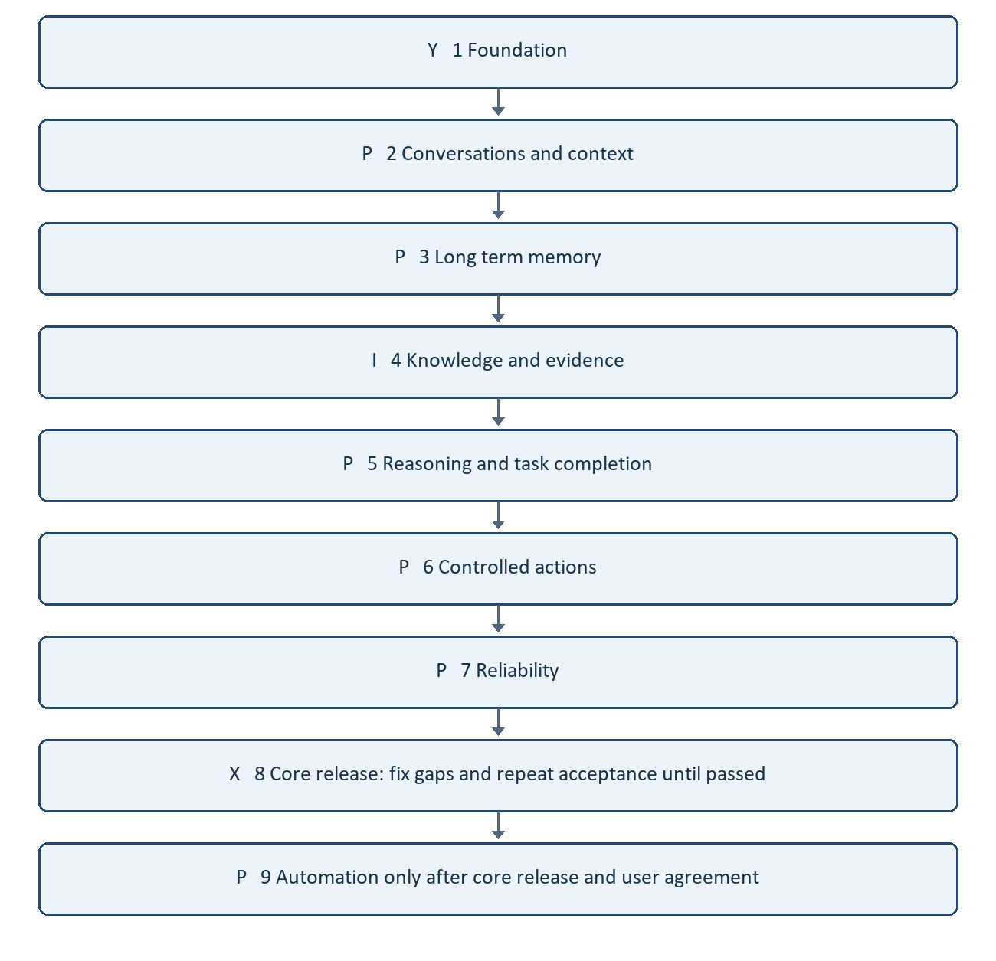
The recommended target is therefore not AI agent *or* agentic AI: JeshlaAutoAI is the AI agent; agentic AI is the behavior and design approach it uses.

Free and open-source stack priorities
The workbook comparison and project-specific P1/P2/P3 checklist are saved in free-open-source-module-audit.md (free-open-source-module-audit.md). These priorities complement the Y/X/I/P completion statuses above.
- P1: retain the working stack; repair dependency reproducibility, isolated tests, relevant memory/structured retrieval, citations, summary recovery and acceptance evaluation.
- P2: add tracing, evaluation tooling or improved parsing only for a measured gap.
- P3: park alternative orchestration/vector frameworks, fine-tuning, multimedia and automation-framework expansion until the agreed core is accepted.
Free API access is quota-limited and separate from software/model licensing. Installed alternatives do not imply active use or completed integration.

Historical milestone record
Historical milestone record. Earlier active labels and test totals below describe their stated stage. Current status on 18 October 2026: Workstreams 2, 3 and 4 retain parked gaps; Workstreams 5, 6 and 7 have scoped acceptance Y. Next Workstream 8. Latest full offline run: 343 tests passed in 45.360 seconds.

Offline test baseline completed - 17 October 2026
Y - scoped completion: repaired stale test fixtures and verified 120 tests passing in 3.704 seconds using the offline guard. This supersedes the earlier 116-test/six-error baseline for these fixtures; it does not establish live API, RAG answer-quality or production acceptance.
Run from the project root:
python tests/run_offline.py
Changes:
- tests/test_jira_creation.py: enable creation only within fake-gateway test fixtures; add a regression proving disabled creation blocks writes.
- tests/test_prompt_workflow.py: mock proposal discussion instead of calling the real model; explicitly enable the fake approval workflow in its test scope.
- tests/run_offline.py: guard discovery and execution against external sockets, unmocked requests HTTP calls and browser launches. Loopback sockets remain for asyncio/framework internals. This is a process-level test guard, not a subprocess sandbox.
- tests/test_offline_runner.py: verify socket/HTTP/browser blocking and loopback classification.
The verified run used the project's virtual environment and required Windows file permissions. Real Jira permission gates, provider settings and runtime agent behavior were not changed. Full agent reliability remains P; next is memory and structured retrieval integration.

Shared table and memory tool integration - 17 October 2026
Y - implementation and offline integration: CSV/XLSX discovery/filtering with source rows and scoped lexical saved-memory search are connected to the shared conversation. 129 guarded offline tests pass. See table-memory-tools.md (table-memory-tools.md) for files, limits and trial prompts. P - broader acceptance: live model behavior, semantic-memory retrieval, complex-table queries and grounding remain pending.

Task outcome logging - 17 October 2026
Y - scoped completion: project reports include task_status (completed/incomplete); timer decorators and the console's outer workflow observe that explicit status. Returned incomplete results log INCOMPLETE instead of SUCCESS. Exceptions still propagate and log FAILED / INTERRUPTED. New turns reset task_status so an earlier incomplete checkpoint does not contaminate the next result. Shared conversation budget/invalid-ID/step-limit exits also mark incomplete.
165 guarded offline tests passed in 28.822 seconds. Added tests/test_task_timing.py and updated runtime reset coverage. Files: agent/timing.py, agent/chat_runtime.py, agent/conversation.py, agent/langgraph/langgraph_agent.py. Runtime tools, approvals, provider selection and saved facts were not changed. This covers explicit task outcomes; route-specific blocked/waiting states without task_status still need separate acceptance coverage. No live API call was required.
The user's previous successful settings.gradle/build.gradle run confirmed PayWrightWorkSpaceGradle correctly and inspected all requested lines. Next priority remains provider/model-aware token budgeting, followed by grounded document workflows and overall core-agent acceptance.

Provider-budget preflight - 17 October 2026
Y - configured/estimated preflight: Ollama request context, configurable hosted context/output caps, model binding and explicit unknown-limit diagnostics are implemented. Public OpenRouter model metadata was verified and stored for the selected model. 174 offline tests pass. See model-budgeting.md (model-budgeting.md). P - exact tokenizer/model discovery, quota scheduling, metadata refresh and adaptive compaction remain. This supersedes the earlier entirely-pending provider-budget item without claiming full token accuracy.

Workstream 2 summary reliability started - 17 October 2026
I overall. Registered, data-only summary generation replaces the old JSON-only client path. Validation, one bounded format correction and category-safe failures preserve context/archives. 189 offline tests pass, including real SQLite summary restart/session isolation with model mocks. Live synthetic long-chat summaries pass on Groq (2.11s) and OpenRouter (11.11s), retaining a correction and unanswered question. Full user-chat/live-browser acceptance remains pending; Ollama summary generation was not live-tested. See workstream-2-summaries.md (workstream-2-summaries.md). The Word workstream snapshot is docs/agentic-ai-roadmap.docx.

Workstream 2 status review - 17 October 2026
I — In progress overall. Summary implementation and scoped persistence checks are Y, supported by 189 offline tests and live synthetic Groq/OpenRouter summary reports. Actual user-history quality, full live restart/switch verification and complete browser create/chat/reopen/memory/download acceptance are P. Mark the overall workstream Y only after those remaining acceptance checks pass. See workstream-2-summaries.md (workstream-2-summaries.md).

Workstream 2 item 1 grounding fix — 17 October 2026
Y for scoped archive-supported question retention and source-attribution retest: 194 offline tests and seven live synthetic OpenRouter checks passed. Item 1 remains P for broader actual-history accuracy and Ollama context acceptance. See workstream-2-summaries.md (workstream-2-summaries.md).

Workstream 2 sequencing decision — 17 October 2026
At the user's request, park item 1 (P): actual-history summary format/accuracy and Ollama attribution. Do not spend further API quota on this blocker now. Move next to item 2: complete live restart/chat-switch isolation acceptance; then item 3 browser acceptance. Overall Workstream 2 remains I; parking is not completion.

Browser logging — 17 October 2026
Added local privacy-safe rotating browser event logs; 199 guarded offline tests pass. See browser-logging.md (browser-logging.md). Live event inspection is pending after the user reloads the app. Workstream 2 remains I because summary accuracy is parked P and full live summary isolation remains pending.

Current handoff — Workstream 3 active, 17 October 2026
This update supersedes earlier progress snapshots: Workstream 2 is P overall (parked, not completed). Console recall/switching, sampled browser chat separation, shared-memory display, transcript downloads and live browser event logging are Y for observed scope. Actual-history summary generation/accuracy, Ollama source attribution and full live summary isolation remain P—parked. Latest regression baseline: 199 offline tests passed. Workstream 3 is I as the selected active workstream; provenance/timestamp/verification implementation is the first planned task, not claimed completed. See workstream-2-summaries.md (workstream-2-summaries.md) and browser-logging.md (browser-logging.md).

Workstream 3 first milestone — 17 October 2026
Y for provenance/timestamp/verification metadata, safe legacy migration and current memory integration. Existing facts backed up and preserved. 203 guarded offline tests passed; no API calls. Workstream 3 remains I. Next: correction/conflict policy and revision handling; advanced retrieval and archived-chat search remain pending. See workstream-3-memory.md (workstream-3-memory.md).

Workstream 3 correction milestone — 17 October 2026
Y for atomic same-key correction/revision handling, scope isolation and forget cleanup; 206 offline tests plus temporary command integration passed. Broader semantic conflicts, stale facts, archive search and memory suggestions remain pending. Workstream 3 remains I.

Workstream 3 archive-search milestone — 17 October 2026
Y for scoped lexical archive lookup and shared tool integration. 210 offline tests pass; actual default-chat local lookup confirms source references. No model calls or downloads. Semantic retrieval, broader conflict/staleness policy and controlled suggestions remain pending; Workstream 3 is I.

Workstream 3 suggestions milestone — 17 October 2026
Y for explicit user-controlled proposal/review/accept/reject lifecycle and existing-key conflict refusal. 214 offline tests pass. Workstream 3 remains I: semantic retrieval and broader contradictions/staleness remain pending.

Workstream 3 remaining-P review — 17 October 2026
Both pending areas now have implementation: optional semantic retrieval and advisory conflict/age review. 220 offline tests pass. Real cached-model quality/latency and broader semantic contradiction evaluation remain P. The slow local test was interrupted intentionally; no completion is claimed for those acceptance gaps.

Historical handoff Workstream 4 active at that earlier stage
Historical snapshot; superseded by the current status table. Supersedes earlier active-focus snapshots: Workstream 3 is P overall after its one bounded real-model retry failed paraphrase relevance. Local loading succeeded; advisory HTML/PDF candidate detection/no mutation passed. Semantic calibration and broader conflict accuracy remain parked, not completed. Workstream 4 remains I and is now the next active scope. 220 offline tests remain the regression baseline.

Workstream 4 started — 17 October 2026
Y for web citation traceability and failed-required-search protection in the shared conversation loop. 225 offline tests pass; no live API calls. Workstream 4 remains I. Full-page retrieval, local document/source citation validation, indexed retrieval quality and mixed-source acceptance remain pending. See workstream-4-grounding.md (workstream-4-grounding.md).

Workstream 4 source-page milestone — 17 October 2026
Y for public-page reader and search/read/citation offline integration; 232 tests pass. No live network/provider calls. Workstream 4 remains I; local-document citations, real retrieval quality, mixed-source acceptance and live page compatibility are pending. See workstream-4-grounding.md (workstream-4-grounding.md).

Workstream 4 document-source milestone — 17 October 2026
Y for structured indexed-source references and citation guard integration; 237 offline tests pass. P for retrieval quality: actual keyword baseline 1/8, resume pages present but other documents rank ahead. No model calls or downloads. Next: generic tokenization/ranking improvements and repeatable re-evaluation, then mixed-source grounding.

Workstream 4 keyword ranking verified — 17 October 2026
Keyword baseline now 8/8 with audited page labels, versus 6/8 unchanged original labels (two incorrect page-1 labels verified as page 2 in the actual PDF). Initial baseline was 1/8. 240 offline tests pass; no provider quota or embeddings used. Legacy hybrid defaults remain. W4 I: mixed-source and live citation/entailment acceptance next.

Mixed-source grounding in progress — 17 October 2026
241 offline tests pass, including scoped memory/document/web/page integration. Live Groq synthetic-fixture tool selection executed all four tools; final-answer request hit QUOTA_EXHAUSTED HTTP 429. Live combined-answer/citation acceptance remains P; no further retry or silent provider change. Word roadmap snapshot updated. Workstream 4 remains I.

Module usage reference
Restored classifications from the 17 October audit. Usage, optional additions and alternatives are distinguished. Historical acceptance notes do not override the current checklists.

Complete module list: usage first
Usage reflects the inspected application paths, not just installed packages. NOT USED means no integration was identified in the audited project, not proof that the package is absent from the environment. OPTIONAL means add only for a demonstrated need; ALTERNATIVE means it overlaps an existing choice. These usage labels are separate from the Y/X/I/P completion checklist.
Usage / decision | Module | Priority | Purpose or evidence
USED | LangChain | P1 | Existing agent/RAG integrations.
NOT USED - ALTERNATIVE | LlamaIndex | P3 | Alternative RAG framework; retain current implementation.
NOT USED - OPTIONAL | LiteLLM | P2 | Provider gateway; existing adapters already cover three providers.
USED - DEPENDENCY | Transformers (Hugging Face) | P1 | Supports local sentence-transformers models.
USED - SUPPORTED FALLBACK | Ollama | P2 | Provider implemented and previously run; Groq is currently selected.
USED | sentence-transformers | P1 | Local embeddings and reranking.
PARTIAL - ALTERNATIVE | ChromaDB | P3 | Installed with stored artifacts; inspected active hybrid path uses FAISS.
USED - DEPENDENCY | PyTorch | P1 | Local embedding/reranking model execution.
NOT USED - ALTERNATIVE | Haystack | P3 | Alternative pipeline framework.

Reference table continued
Usage / decision | Module | Priority | Purpose or evidence
MIXED - DEPENDENCY / OPTIONAL | Tokenizers / Datasets (HF) | P1 / P3 | Tokenization through the model stack; no application dataset-library workflow established.
NOT USED - OPTIONAL | PEFT / TRL (HF) | P3 | Fine-tuning is outside current acceptance scope.
INDIRECT / OPTIONAL | llama.cpp | P3 | Earlier Ollama logs show its llamacpp runner; no separate direct integration required.
NOT USED - OPTIONAL | Google Gemini SDK | P3 | SDK not required: Gemini provider now works through the existing HTTP adapter; separate SDK remains optional.
USED | FAISS | P1 | Vector retrieval in the existing hybrid RAG pipeline.
USED | LangGraph | P1 | Agent graph, state and checkpoint flow.
NOT USED - ALTERNATIVE | Gradio | P3 | Streamlit already supplies browser UI.
NOT USED - OPTIONAL | DSPy | P3 | Prompt/program optimization if later justified.
NOT USED - OPTIONAL | bitsandbytes | P3 | Quantization tooling not part of the current app path.

Reference table continued
Usage / decision | Module | Priority | Purpose or evidence
NOT USED - OPTIONAL | Unsloth | P3 | Fine-tuning tooling.
NOT USED - ALTERNATIVE | vLLM | P3 | Separate model-serving runtime.
NOT USED - ALTERNATIVE | CrewAI | P3 | Alternative agent orchestration.
NOT USED - ALTERNATIVE | AutoGen | P3 | Alternative agent orchestration.
NOT USED - ALTERNATIVE | smolagents (HF) | P3 | Alternative agent framework.
NOT USED - ALTERNATIVE | TensorFlow / Keras | P3 | Current model stack uses PyTorch.
USED | Streamlit | P1 | Browser chat implemented alongside console; live acceptance remains pending.
NOT USED - OPTIONAL | Diffusers (Hugging Face) | P3 | Image/video generation outside text-agent target.
NOT USED - OPTIONAL | ComfyUI | P3 | Multimedia workflow UI outside current target.

Reference table continued
Usage / decision | Module | Priority | Purpose or evidence
NOT USED - OPTIONAL | MarkItDown | P2 | Consider only for a demonstrated document-loader gap.
NOT USED - OPTIONAL | Docling | P2 | Consider for complex layout extraction.
NOT USED - OPTIONAL | Unstructured | P2 | Alternative document parsing/chunking.
NOT USED - OPTIONAL | PyMuPDF | P2 | Alternative PDF parser; license review required before adoption.
NOT USED AS EMBEDDINGS - ALTERNATIVE | BGE / E5 / Nomic embed models | P2 | Current embedding model is MiniLM; BGE reranker below is a different role.
NOT USED - ALTERNATIVE | Qdrant (self-hosted) | P3 | Storage replacement/extension only if requirements justify it.
NOT USED - ALTERNATIVE | LanceDB | P3 | Alternative vector storage.
NOT USED - ALTERNATIVE | pgvector | P3 | Alternative Postgres-backed vector storage.
NOT USED - ALTERNATIVE | Milvus | P3 | Alternative vector storage for larger deployments.

Reference table continued
Usage / decision | Module | Priority | Purpose or evidence
NOT USED - ALTERNATIVE | Weaviate | P3 | Alternative vector database.
USED | bge-reranker | P1 | BAAI/bge-reranker-base in existing RAG retrieval.
NOT USED - OPTIONAL | RAGAS | P2 | Possible addition to existing custom evaluation.
NOT USED - OPTIONAL | DeepEval | P2 | Evaluation alternative; choose based on measured gaps.
NOT USED - OPTIONAL | promptfoo | P2 | Prompt/provider regression evaluation option.

Integration update - 17 October 2026
Y: bounded CSV/XLSX conversation tools and scoped lexical-memory tool integration are implemented and covered by the 129-test offline suite. This supersedes the earlier not-connected finding for the shared conversation path. P: broader semantic retrieval, complex-table processing and live acceptance remain. Details: table-memory-tools.md (table-memory-tools.md).

UI plan and current practice
Updated 18 October 2026. This plan records the screenshot-inspired navigation options and the development checks we are practicing. It authorizes no UI implementation yet. Preserve the working console and browser flows while adding useful controls later.

Current work and sequence
Y Workstream 7 scoped reliability: OS-owned locks recover after process exit; caught save failures preserve the answer; simulated provider failures display safely and allow the next browser request; oversized context stops before network calls.
Y Verification: 343 full offline tests passed. The user also verified browser-to-console recall after restart on OpenRouter in 5.13 seconds without web search.
X Workstream 8 release gate: core acceptance, clean setup, installation documentation, backup/recovery and release-scope review. Parked Workstream 2, 3 and 4 gaps must be explicitly reviewed.
X Proposed UI milestone after Workstream 8 and before Workstream 9. This is an additional milestone, not a renumbering of the existing workstreams.
P Workstream 9 automation framework integration remains deferred until the release gate passes and the user chooses to proceed.

Screenshot options and meaningful equivalents
Option | Icon | Meaning for JeshlaAutoAI | Plan
Sidebar toggle | Panel icon | Collapse navigation | Useful later
New | Plus | Start chat | Existing; improve placement
Projects | Folder or container | Select project root and organize work | Useful later
Artifacts | Shapes | Generated documents and downloads | Useful later
Code | Angle brackets and slash | Coding workspace | Later framework scope
Customize | Briefcase | Settings for providers and preferences | Useful later
Chats and tasks | Text section | Visible saved chat titles | Existing; improve navigation
List controls | Sliders | Sort and filter chats | Useful later
View all | Text link | Full history list | Useful later
Profile menu | Avatar and chevron | User preferences | Optional local-user scope
Apps or integrations | Grid and plus | Possible integrations menu | Meaning uncertain; later
Search | Magnifying glass | Search saved conversations | Useful later
Greeting | Logo or sunburst | Welcome screen | Optional
Message composer | Text area | Editable multiline message | Existing
Attachments | Plus | Upload documents | Useful later
Chat and Cowork | Mode tabs | Potential Chat and Tasks modes | Later after task behavior
Model and Low | Model text | Provider/model; supported effort setting | Useful; capability dependent
Voice input | Microphone and chevron | Speech input options | Optional later
Voice conversation | Waveform | Likely live voice | Meaning inferred; optional
Plan and Upgrade | Text link | Subscription controls | Unnecessary locally
Memory | Suggested book icon | Inspect/manage saved facts | Existing; improve access
Pending approvals | Suggested shield/check | Review exact proposed actions | Existing; improve access
Provider status | Suggested status dot | Active provider and error status | Useful later
Icon meanings are inferred from the supplied screenshot. Final icons should be consistent outlined symbols with text labels; unavailable capabilities should not appear as working features.

Practices to keep
Use configurable providers, project roots and budgets; keep rules explicit instead of hardcoding user-specific values.
Reuse saved chat context and scoped memory; select tools from the current request and avoid public search for private chat-history questions.
Test offline with synthetic data first, then perform bounded live acceptance. Record the evidence and limits behind each Y status.
Show exact actions before approval, store execution receipts and block uncertain replay. A save warning must not encourage repeating an action.
Preserve saved chats, facts, existing working code and diagrams. Park blocked quality checks with clear reasons rather than spending repeated quota.
Keep Y, X, I and P status meanings consistent. Passing scoped checks does not imply every possible behavior or live provider fault has been verified.

Limits still visible at release
Token counts are approximate; unknown hosted context limits cannot guarantee fit. Archive and checkpoint saves are separate transactions. Legacy chat locks require inspection. Broad retrieval/semantic and summary-quality gaps remain parked. The UI list is a proposal, not completed functionality.

Project structure milestone after Workstream 8
Status I for closing acceptance. Package moves and console separation are implemented with legacy compatibility. Latest completed full code baseline: 359 tests before console extraction; 31 focused console checks passed. Final bounded full/interface verification is pending. Original private backup retained.
I Inventory source modules, imports, entry points, dependency directions and import-time side effects.
X Verify a dated full backup outside the active project after stopping writers; preserve credentials privately, databases, indexes and receipts. Rehearse recovery before migration.
X Agree package boundaries for interfaces, runtime, providers, memory/storage, knowledge/retrieval, tools/actions, integrations and configuration. Final names follow the audit.
X Migrate one coherent group at a time with compatibility wrappers. Preserve python -m agent.langgraph.langgraph_agent and streamlit_app.py startup.
X Run affected tests after each step and final regression/clean core setup; verify saved facts/chats/checkpoints and approval/replay behavior.
X Update developer guides and diagrams. Retain backup through successful acceptance before removing only its verified directory.
Current sequence: finish scoped release preparation, project structure, UI improvements, then Workstream 9. Full release and parked quality checks remain visible; preview agreement does not mark them completed.

Current package structure and verification
Updated 18 October 2026. Code moves are complete for the current scope; final acceptance is still being recorded. Full Workstream 8 release and parked RAG/summary/semantic quality are separate. Compatibility wrappers preserve existing import paths and launch commands.
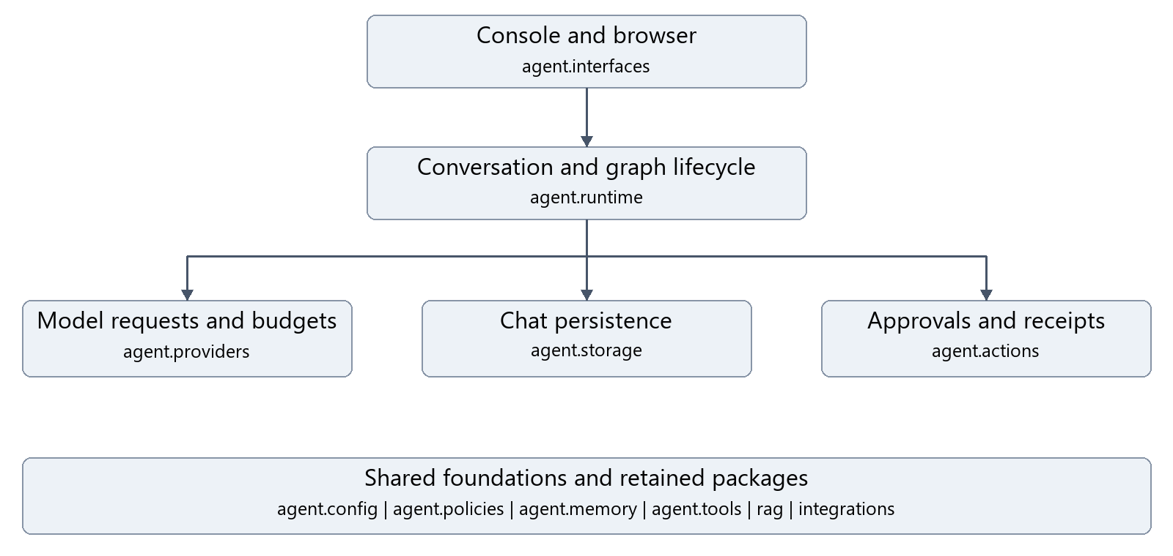
Current responsibility groups. Foundation row lists shared or retained packages; arrows summarize main flow, not every import. Workflow node assembly remains in agent/langgraph and is supplied to the lazy runtime factory.
Package | Responsibility
agent.interfaces | Console interaction and browser backend
agent.runtime | Turn execution, summaries, conversation and lazy graph lifecycle
agent.providers | Text/tools, Gemini settings, errors and context budgets
agent.storage | Conversation catalog and transcripts
agent.actions | Durable receipts and scoped browser proposals
agent.config | Stable application-root anchor
agent.policies | Deterministic history routing and classified tools
agent.memory and agent.tools | Existing scoped fact storage/retrieval and tool implementations
rag and integrations | Retained optional knowledge and integration packages
Verification: 359 full tests passed before console separation; 31 focused console checks passed afterward. Earlier isolated editable core acceptance passed startup and 86 selected tests. Latest full/interface retries have time limits and are not counted as passes until their final reports say passed. See project-structure-audit.md and outputs/acceptance.
Backup: D:/JeshlaAutoAI_Backups/before-structure-20261018-175619. 928 backup/restore hashes and six copied SQLite integrity checks verified. Retain this private backup through final acceptance. Current database paths, schemas, provider settings and receipt identities are preserved.

AI agent workflow and current status
Status snapshot 23 October 2026. The directed flow connects the accepted agent foundation to the planned manual API web and mobile testing workflow. This current snapshot takes precedence over earlier dated status diagrams; earlier roadmap content is retained.
Y = verified within the stated scope or plan complete. P = pending blocked or parked. X = not started. I = in progress; no stage is currently I.
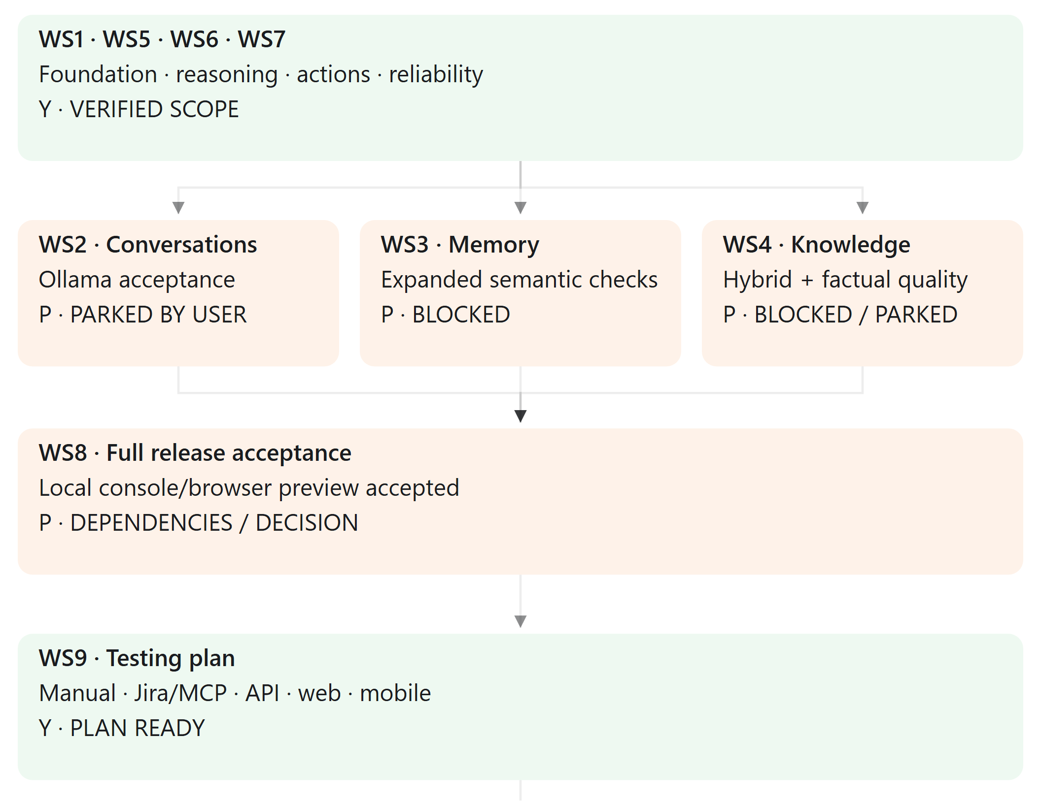
WS1 to WS8 retain seven P checklist rows and one X release completion row. WS8 umbrella checks overlap earlier gates. WS9 planning is Y; implementation and execution remain P until the pilot scope is selected.

Requirements and testing platform workflow
First pilot: select one local project and one real feature requirement. Clarify missing details and review a source linked manual test pack before choosing an automation track.
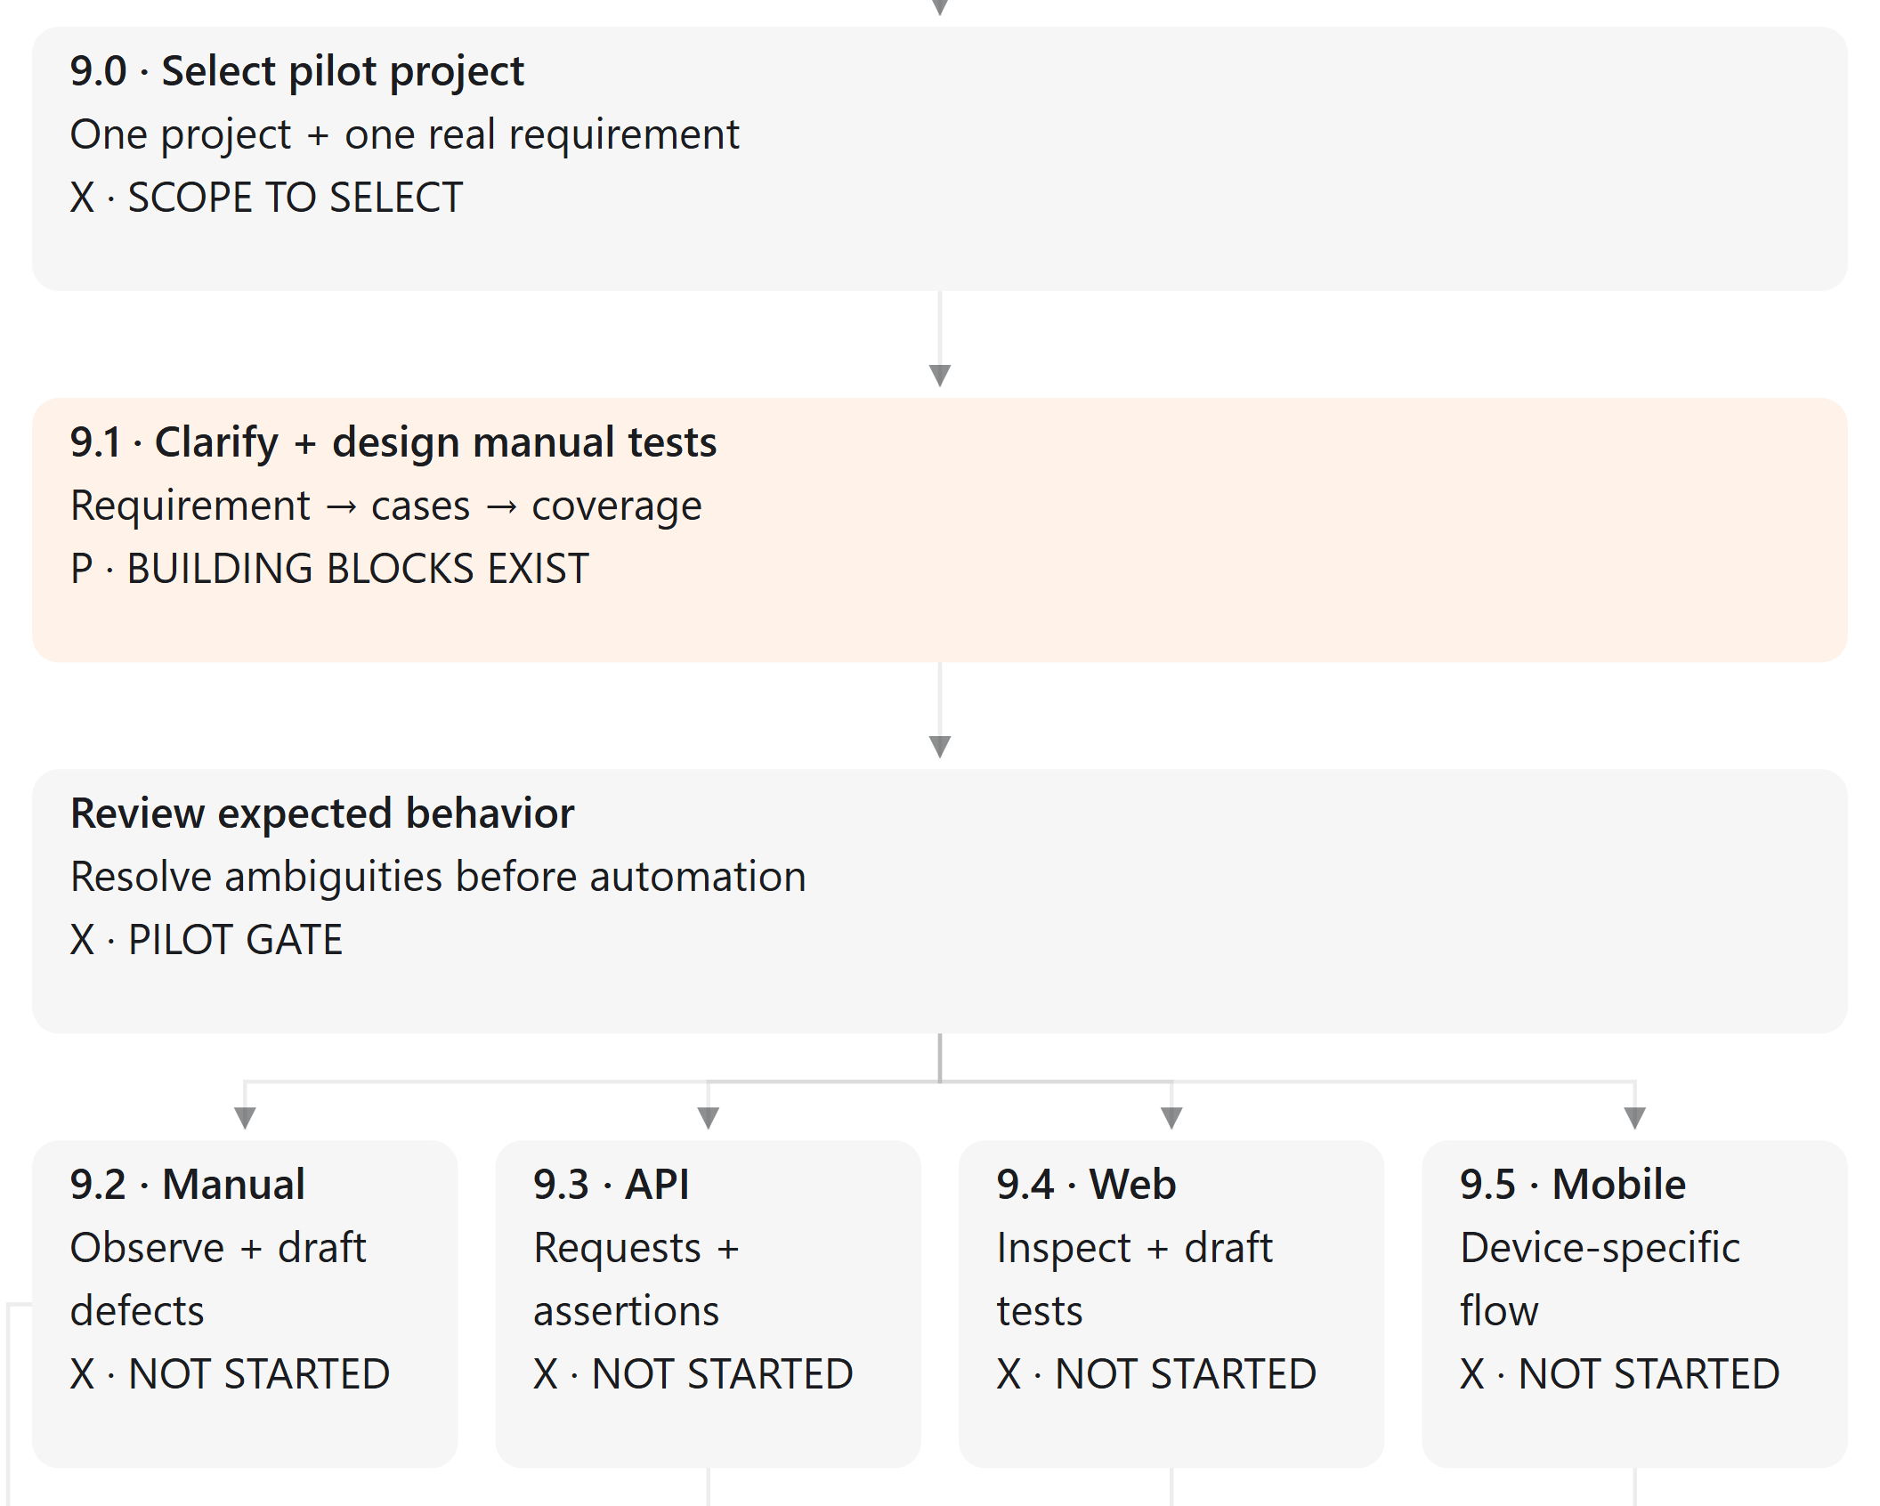
Jira through Atlassian MCP is optional for requirements and traceability. Existing Java Gradle and framework conventions must be inspected and reused where appropriate. Manual observations feed reporting directly; API web and mobile tracks continue to reviewed code generation.

Controlled execution and reporting workflow
Review proposed code changes before selected execution. Actual run evidence determines results; failures or uncertain outcomes require investigation and a reviewed next proposal.
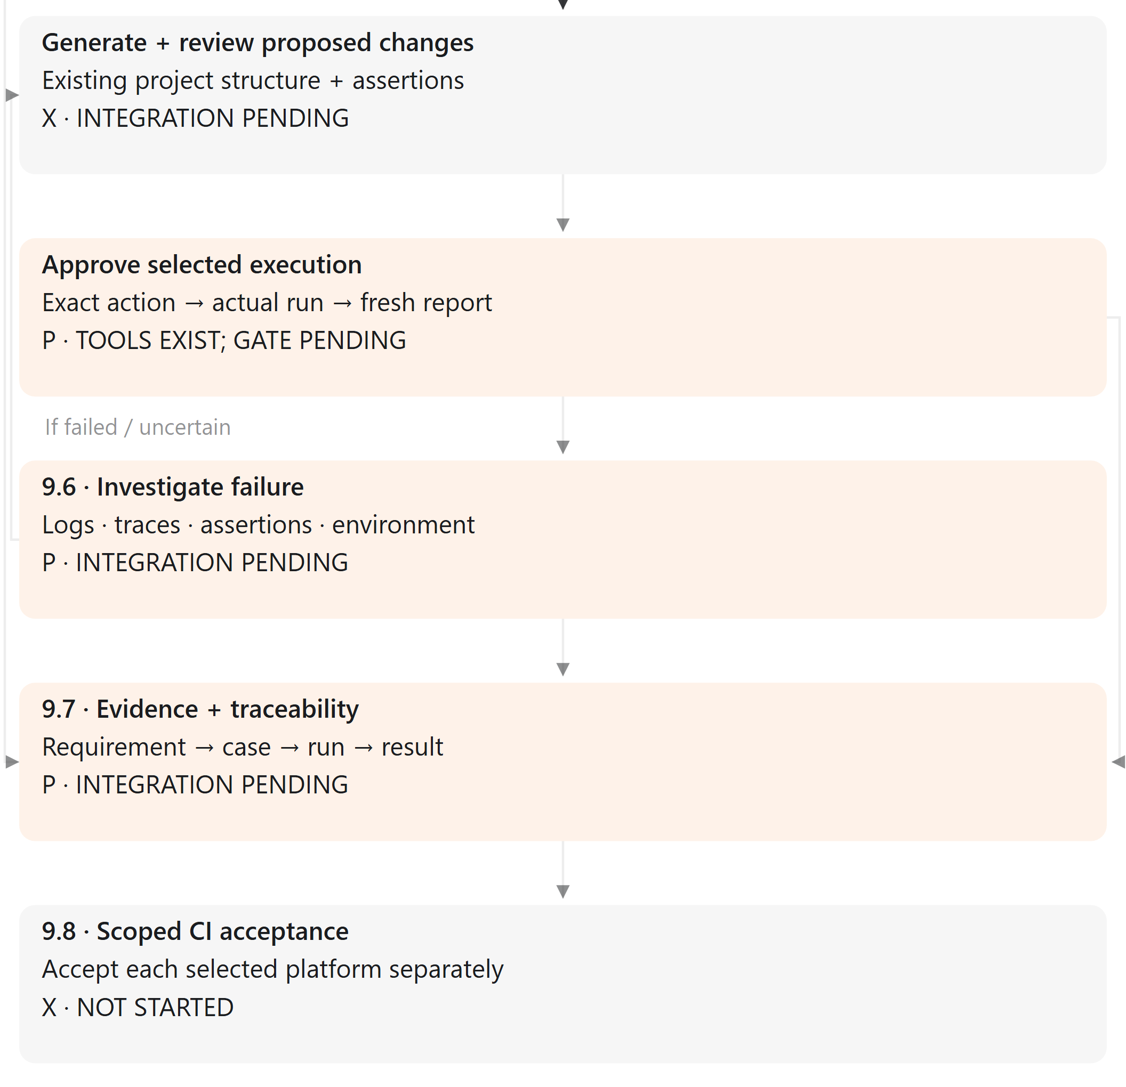
The static Word diagram preserves the same status labels and directed paths as the animated flow in the chat. Animation illustrates direction only; it does not execute the agent or change any project status.

