**A REPORT OF INTERNSHIP AT PARLE BISCUIT FACTORY – PATWARI BAKERS PRIVATE LIMITED**

**A PROJECT SUBMITTED TO P.K.N ARTS AND SCIENCE COLLEGE**

**IN PARTIAL FULFILLMENT OF THE REQUIREMENT FOR THE DEGREE OF THE BACHELOR OF COMMERCE**

**SUBMITTED BY**

**KING**

**REGISTRATION NO: C3E13306**

**UNDER THE GUIDANCE OF**

**PRANIKA PETCHI**



**DEPARTMENT OF COMMERCE**

**PKN ART AND SCIENCE COLLEGE**

**THIRUMANGALAM**

**AFFILIATED TO MADURAI KAMARAJ UNIVERSITY**

**MADURAI**

**May - 2025**

**CONTENTS**

|  |  |  |
| --- | --- | --- |
| **Chapter**  **Number** | **CONTENT** | **Page No** |
| **1** | **INTRODUCTION ABOUT THE TRAINING** | **1** |
|  | 1.1 TRANING MEANING | **1** |
|  | 1.2 DEFINITION | **1** |
|  | 1.3 TYPES OF THE TRAINING | **1** |
|  | 1.4 OBJECTIVES OF THE TRAINING | **2** |
|  | 1.5 ADVANTAGES OF THE JOB TRAINING | **2** |
|  | 1.6 NEED FOR TRAINING | **2** |
|  | 1.7 SCOPE OF TRAINING | **2** |
|  | 1.8 PERIOD OF TRAINING | **2** |
| **2** | **OBSERVATION ABOUT ORGANISATION** | **3** |
|  | 2.1 OVERVIEW OF THE COMPANY | **3** |
|  | 2.2 ORGANIZATION STRUCTURE | **4** |
|  | 2.3 COMPANY LAYOUT | **7** |
| **3** | **VARIOUS DEPARTMENTS** | **8** |
|  | 3.1 PURCHASE DEPARTMENT | **8** |
|  | 3.2 PRODUCTION DEPARTMENT | **9** |
|  | 3.3 SALES DEPARTMENT | **13** |
|  | 3.4 HUMAN RESOURCES DEPARTMENT | **15** |
| **4** | **FINDING & SUGGESTION** | **17** |
|  | 4.1 FINDINGS | **17** |
|  | 4.2 SUGGESSTIONS | **17** |
| **5** | **CONCLUSION** | **18** |

**CHAPTER - 1**

**INTRODUCTION ABOUT THE TRANING**

* 1. **TRAINING - MEANING**

Training is concerned with imparting developing specific skills for a particular purpose. Training is a purpose of learning a sequence of programmed behaviour. It is the act of increasing the knowledge and skills of an employee for doing a particular job.

* 1. **TRAINING –DEFINITION**

According to Edwin Flippo, ‘training is the act of increasing the skills of an employee for doing a particular job’.

* 1. **TYPES OF TRAINING**
* Institutional training
* On-the job training

**INSTITUTIONAL TRAINING**

Institutional training is process by which the aptitude, skill and abilities of the student business activities are increased. Institutional training is arranged to understand the real business environment as well as gain particular knowledge about various business function.

**ON- THE JOB TRAINING**

On – the job training is the most common form of training for any person in the organization. The basic theme of on-the job training is “TO LEARN BY DOING ITSELF”. The trainee learns while is engaged in doing a job.

* 1. **OBJECTIVES OF THE TRAINING**

The objectives of the training are as follows:

* To increase job satisfaction and moral among employees.
* To increase efficiencies in processes, resulting in financial gain.
* To increase innovation in strategies and products.
* To know the organization structure.
* To know the various welfare measures provided to their employees.
  1. **ADVANTAGES OF THE TRAINING**
* On the job training is an inexpensive professional development tool.
* On the job training provides a favourable environmental for quick learning.
* Contributed to company growth.
* This way they gain confidence in their work.
* Everyone knows each other.
  1. **NEED OF THE TRAINING**

The training program is designed with a view to enable the student to have an at exposure on the practical field. “MADURAI KAMARAJ UNIVERSITY” incorporated on the job training as a component of commerce with computer application degree course fora period of “10 DAYS”. It helps to increase the self-confidence of the student.

* 1. **SCOPE OF TRAINING**

The scope the training depends upon the categories of employees to be trained. As we all know that training is continuous process and only needed for newly selected personal at all levels of the organization.

* 1. **PERIOD OF TRAINING**

I did my job training at “**PARLE BISCUIT FACTORY – PATWARI BAKERS PRIVATE LIMITED**” Madurai District in Tamil Nadu. I have undergone training from “2/6/2025 To 11/6/2025”.

**CHAPTER-2**

**OBSERVATION ABOUT THE COMPANY**

**2.1 OVERVIEW OF THE COMPANY**

**PARLE-G** is a brand of biscuits manufactured by Parle Products in INDIA. A 2011 Nielsen survey reported that it is the best-selling brand of biscuits in the world.

Owner : Parle products

Country : India

Introduced : 1939

Markets : Worldwide

Tagline : G for Genius

Website : Parleproducts.com

**HISTORY**

Parle products was established as a confectionary maker in the **Vile Parle** suburb of Mumbai in 1929. Parle Products began manufacturing biscuits in 1939. In 1947, when India became independent, the company launched and an ad campaign showcasing its Gluco brand of biscuits as an Indian alternative to British-branded biscuits.

Parle-G biscuits were called “Parle Gloco Biscuits” until 1980s. The “G” in the name of Parle-G originally stood for “**Glucose”,** througha later brand slogan also stated “G” for “**Genius”.**

In 2013, parle-G became India’s first fast-moving consumer goods brand to cross the Rs 50 billion mark in retail sales.

**LOGO**



**PROFILE OF THE BRANCH**

|  |  |
| --- | --- |
| BRANCH NAME | : **PARLE BISCUIT FACTORY – PATWARI BAKERS PRIVATE LIMITED** |
| ADDRESS OF THE BRANCH | : Plot No B-2, SIDCO INDUSTRIAL ESTATE, Kappalur, Madurai 625008 |

**2.2 ORGANIZATIONAL STRUCTURE**

Organizational structure is explained as the patterns of relationship among the components of a structure.

**IMPORTANCE**

* It facilitates proper administration.
* It avoids delay in decision making.
* It also helps in taking correct decision.
* It helps in controlling the quality of output.
* It simulates initiative and creative thinking of the employee.
* It helps for the growth of a company.

**Need of employees**

**1. Job-Related Needs**

* Production – roles like production technicians and quality control specialists are common in biscuit factories.
* Operations – Positions in operation management, Particularly in food repacking and export/import can be found
* Training and skill development
* Clear job roles and responsibilities – to avoid confusion and improve productivity.
* Safe working conditions – especially important in environments with heavy machinery
* Overtime pay – when extra hours are required.

**2. Financial Needs**

* Employees work to earn a livelihood, so they need:
* Fair and timely wages – competitive with industry standards.
* Overtime pay – when extra hours are required.
* Bonuses or incentives – for good performance or meeting targets**.**

**3. Workplace Benefits**

* To attract and retain skilled workers:
* Health insurance – for themselves and their families.
* Paid leave – including vacation, sick days, and holidays.
* Retirement plans – such as pensions or provident funds.

**4. Career Growth Opportunities**

* To keep employees motivated:
* Promotion paths – from worker to supervisor, for example.
* Skill upgrades – through company-sponsored training or certifications.
* Recognition – rewards for good work or long service.

**5. Supportive Work Environment**

* A healthy company culture encourages:
* Respect from management and peers
* Open communication – ability to give suggestions or report problems
* Job security – not fearing sudden layoffs
* Teamwork – collaboration between departments

**6. Personal Needs**

* Sometimes overlooked, but important:
* Work-life balance – reasonable work hours
* Transportation support – company buses or allowances
* Canteen or food facilities – especially in remote work locations

**ORGANIZATIONAL STRUCTURE**

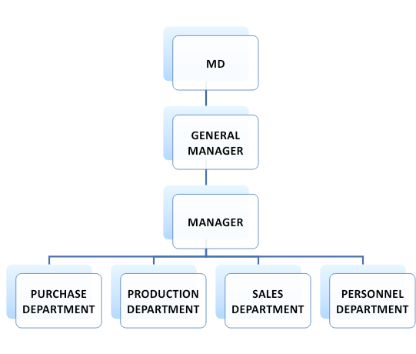

**2.3 COMPANY LAYOUT**

Company layout refers to the detail’s allocation of an available area for various purpose.















**CHAPTER-3**

**VARIOUS DEPARTMENTS**

**3.1 PURCHASE DEPARTMENT**

STRUCTURE OF PURCHASE DEPARTMENT



**RAW MATERIALS**

* Wheat flours
* Sugar
* Partially hydrogenated edible vegetable oils
* Invert syrup
* Leaving agents (503 baking powder)
* Milk solids
* Salt
* Emulsifiers
* Dough conditioners and contains added flavours

**PRODUCTS:**

* Biscuits
* Confectionery
* Snacks
* Cakes
* Rusk
* Atta
* Breakfast Cereals

**FUNCTIONS OF PURCHASE DEPARTMENT**

* The purchase department in Parle G company, like in any organization, handles the acquisition of materials and services necessary for production and operations
* Its key functions include source reliable suppliers, negotiating favourable prices and terms, managing contracts, ensuring timely delivery and quality, and maintain good relationships with suppliers

**KEY FUNCTIONS**

* Supplier selection and management
* Negotiation and contract management
* Order purchasing and follow-up
* Inventory management
* Cost management
* Market Research and Analysis

**3.2 PRODUCTION DEPARTMENT**

Production department in Parle Products is responsible for “Manufacturing Biscuits, Including the well known Parle G.

**FUNCTIONS OF PRODUCTION DEPARTMENT**

The Department follows a structured process Followed by

* Raw Material mixing
* Dough molding
* Baking
* Cooking and conveying
* Assorting and packing
* Storing and Dispatching

**1. RAW MATERIAL MIXING**

Parle G biscuits begin with the mixing of raw materials, including **“Wheat flour, Sugar, Oils, and other ingredients”**.

**2. DOUGH MOLDING**

The mixed ingredients are then molded into biscuits shapes using machinery.

**3. BAKING**

The biscuits are backed in the long ovens, typically around 260 feet in length. The temperature of the oven varies, with propane gas often used for baking.

**4. COOLING AND CONVEYING**

After backing, the biscuits are cooled on conveyer belts, which can be several hundred feet long.

**5. ASSORTING AND PACKING**

The cooled biscuits are then assorted and the metal detector ensures the removal of any metal particles. They are then packed using machinery and workers.

**6. STORING AND DISPATCHING**

Finally the packed biscuits are stored and then dispatched to various locations for distribution.

Parle aims to minimize wastage and ensure quality through various measures, including HACCP(Hazard Analysis and Critical Control Points), regular staff training, and the use of modern technology in its factories. The production capacity of parle has significantly increased over the year.

***PRODUCTION PROCESS***

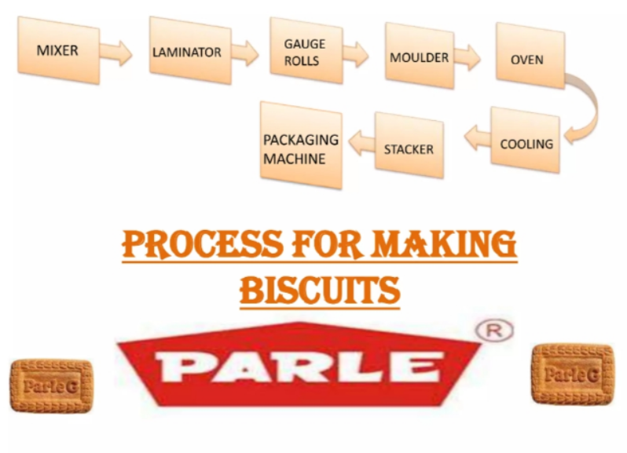

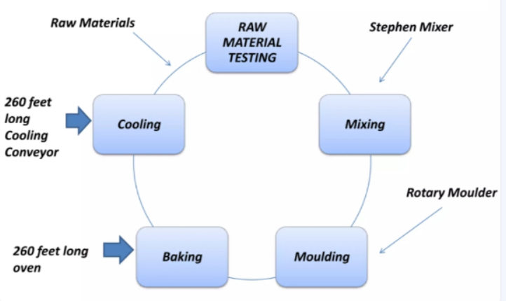

**3.3 SALES DEPARTMENT**

Parle Products is an Indian multinational food corporation known for its biscuits and confectionery products, particularly the Parle- G brand. Their sales department is the responsible for distributing and selling these products across the india.

Parle-G’s success is attributed to a strong distribution network, competitive pricing, and a focus on rural markets.

STRUCTURE OF SALES DEPARTMENT

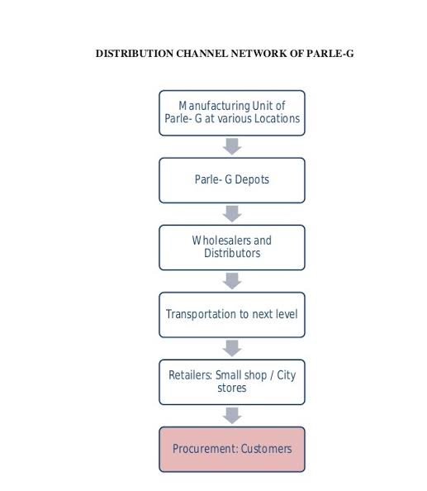

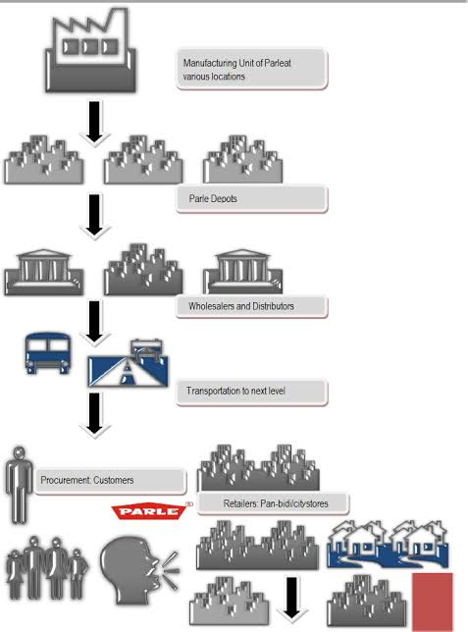

**3.4 HUMAN RESOURCES DEPARTMENT**

Parle Products, a major Indian food corporation, has a Human Resource(HR) department that handles personnel management, Including recruitment, training and development. This department is responsible for managing the company’s workface and ensure employee well-being.

**KEY FUNCTIONS OF HR DEPARTMENT**

* Recruitment
* Training and development
* Performance Appraisal
* Welfare Activities
* Industrial Relations
* Wage and Salary Administration
* Employee Relations

**Recruitment**

Finding and hiring suitable candidates for various positions within the company

**Training and Development**

Providing opportunities for employee to enhance their skills and knowledge

**Performance Appraisal**

Evaluating employee performance and providing feedback for improvement

**Welfare Activities**

Implementing programs to support employee well-being, including health and safety initiatives.

**Industrial Relations**

Managing employee relationships and ensuring a positive work environment.

**Wage and Salary Administration:**

Managing employee compensation and benefits.

**Employee Relations**

Building and maintaining positive relationships with employees, including addressing grievance and concerns.

**PARLE PRODUCTS HR PHILOSOPHY**

* Parle products value its human resources as its most valuable asset
* The company is committed to providing opportunities for employee development and growth.
* Parle products believes in creating a positive and supportive work environment
* The company emphasizes teamwork, responsibility, and integrity in its workplace culture.

**SHIFT TIMING**

Shift systems are vary by position and department, but generally fall within a range of **“8 hours to 12 hours “** a day.

Some positions, like those in sales and marketing may have a fixed shifts like **“10 AM to 6 PM”.**

Other roles may have more flexible or rotating shifts, potentially including morning and evening shifts. Additionally, some positions may involve working weekends.

**CHAPTER-4**

**FINDINGS AND SUGGESTIONS**

* 1. **FINDINGS**
* The company maintains a positive and collaborative work environment.
* There is poor communication between employer and labours.
* Inadequate water facility.
* Lack of transport facility
* Credits are allowed to buyers.
* The company adheres strictly to safety standards, with regular safety drills and clear safety signage throughout the facility.
* There is no canteen facility.
* 81 %respondents are excellent for the work load.
* 80% respondents are agreeing in the company recognizes avaluable.
  1. **SUGGESTIONS**
* Diversity product portfolio
* Health focused products
* Leverage brand recognition
* Expand export markets
* Maintain affordable pricing
* Innovation and new products
* Target school- going students
* Explore partnerships

These could ensure continued success and growth for the company

**CHAPTER-5**

**CONCLUSION**

Employee- employer relationship refers to degree off readiness of an organism to pursue some designated goal and implies the determination of the nature and locus of the forces, including the degree of readiness employee – employer relationship is a general inspirational process, which gets the members of the team to pull their weight effectively, to give loyalty to the group, to carry out properly the tasks that they have accepted and generally to pay an effective part in the job that the group.

**MOLDING MACHINE**

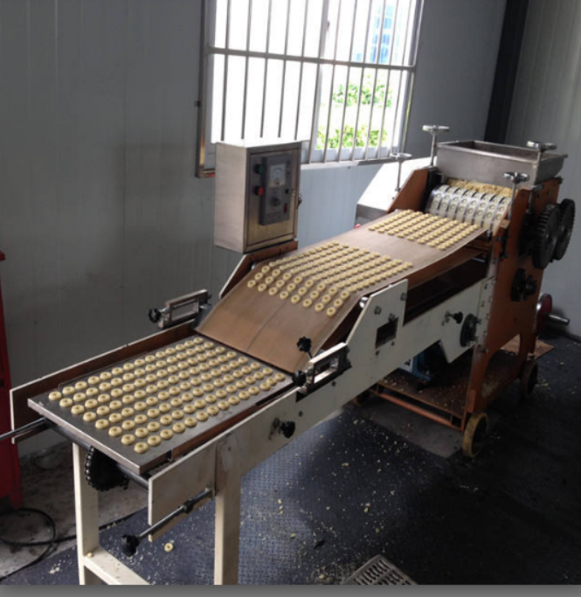

**PRODUCTION AREA**

