**A REPORT OF INTERNSHIP AT ADR PLASTICS PRIVATE LIMITED**

**A PROJECT SUBMITTED TO P.K.N ARTS AND SCIENCE COLLEGE**

**IN PARTIAL FULFILLMENT OF THE REQUIREMENT FOR THE DEGREE OF THE BACHELOR OF COMMERCE**

**SUBMITTED BY**

**KING**

**REGISTRATION NO: C3E13306**

**UNDER THE GUIDANCE OF**

**MYTHILI**



**DEPARTMENT OF COMMERCE**

**PKN ART AND SCIENCE COLLEGE**

**THIRUMANGALAM**

**AFFILIATED TO MADURAI KAMARAJ UNIVERSITY**

**MADURAI**

**May - 2025**

**CONTENTS**

|  |  |  |
| --- | --- | --- |
| **Chapter**  **Number** | **CONTENT** | **Page No** |
| **1** | **INTRODUCTION ABOUT THE TRAINING** |  |
|  | 1.1 INTRODUCTION OF INTERNSHIP TRAINING | **1** |
|  | 1.2 DEFINITION OF INTERNSHIP TRAINING | **1** |
|  | 1.3 MEANING OF INTERNSHIP TRAINING | **2** |
|  | 1.4 OBJECTIVES INTERNSHIP TRAINING | **2** |
|  | 1.5 SCOPE OF INTERNSHIP TRAINING | **4** |
|  | 1.6 LIMITATIONS OF INTERNSHIP TRAINING | **4** |
| **2** | **OBSERVATION ABOUT ORGANISATION** |  |
|  | 2.1 INDUSTRY PROFILE | **5** |
|  | 2.2 RAW MATERIAL SUPPLY & DEMAND | **5** |
|  | 2.3 AUTOMOTIVE MARKET | **7** |
|  | 2.4 OPPORTUNITIES FOR UK PLASTICS COMPANIESIN INDIA | **8** |
| **3** | **COMPANY PROFILE** |  |
|  | 3.1 COMPAY PROFILE | **9** |
|  | 3.2 A.D.R PLASTICS | **9** |
|  | 3.3 OBJECTIVEES OF THE COMPANY | **10** |
|  | 3.4 VISION & MISSION | **10** |
|  | 3.5 ORGANIZATION CHART | **11** |
|  | 3.6 MANAGEMENT CONTROL | **11** |
| **3** | **VARIOUS DEPARTMENTS** |  |
|  | 4.1 DEPARTMENTATION | **12** |
|  | 4.2 PURCHASE DEPARTMENT | **12** |
|  | 4.3 PRODUCTION DEPARTMENT | **14** |
|  | 4.4 MARKETING DEPARTMENT | **16** |
|  | 4.5 FINANCE DEPARTMENT | **17** |
|  | 4.6 HUMAN RESORCE MANAGEMENT DEPARTMENT | **18** |
| **5** | **CONCLUSION** |  |
|  | 5.1 SWOT ANALYIS | **22** |
|  | 5.2 CONCULSION | **23** |
|  | 5.3 REFERENCE | **23** |

**CHAPTER - 1**

**INTRODUCTION ABOUT THE TRANING**

**1.1 INTRODUCTION OF INTERNSHIP TRAINING**

* The internship program is designed to provide students engaged in a field experience with an opportunity to share their insights, to explore the links between students' academic preparation and their field work, and to assist participants in developing and carrying out the major research project which will serve to culminate their internship experience.
* Internship are individualized and tailored to the needs and interests of each student in the program as part of the internship experience to take an active role in finding an appropriate internship for themselves.
* Many students pursue their own contacts however, information is available on locating internship sites.
* Students selected for internships with companies that don't have formal programs for interns might ask that the student formulate a basic introduction letter.
* An intern may also demonstrate initiative and create an introduction that she emails to office mates before she personally introduces herself to the company's employees.
* If you've been hired as an intern, ask about the orientation process and whether you can pen your own introduction or if the company will include your introduction as part of your on- boarding process.

**1.2 DEFINITION OF INTERNSHIP TRAINING**

An internship is a temporary position with an emphasis on on-the-job training rather than merely employment, and a can bepaid or unpaid. To intern means "to pass inside something and when you have an internship, it's like you've temporarily gotten permission to be inside a workplace

An internship is a period of work experience offered by an organization for limited period of time. Once confined to medical graduates, internship is used for a wide range of placements in businesses, non-profit organizations and government agencies. They are typically undertaken by students and graduates looking to gain relevant skills and experience in a particular field. Employers benefit from these placements because they often recruit employees from their best interns, who have known capabilities, thus saving time and money in the long run.

Internships are usually arranged by third-party organizations that recruit interns on behalf of industry groups. Rules vary from country to country about when interns should be regarded as employees. The system can be open to exploitation by unscrupulous employers.

**1.3 Meaning of Internship Training**

* Internship is a job Oriented process which aim to develop special skills related to the job. Through internship process effort is made to increase practical skill with the theoretical knowledge which student got in formal educational institute,Under internship, business organization or technical institute and college or university jointly impar training for students during his bachelor or master degree.
* The objective of such programmeis to strike a balance between theoretical and practical knowledge. Educational institute impart theoretical knowledge to their students but for practicalknowledge they are sent to business organization.
* The period of internship varies depending upon the nature of the job, size of the organization etc. For instance, fresh engineering graduates or diploma holders are moved from workshop to workshop to work with the seniors, before they are placed on a particular job. This period varies from six months to one year.
* An internship is an agreement between intern and organization for a fixed period of time, whereinterns agree to work for them and they agree to mentor and teach them many companies go on to hire their successful intern's for full time employment
* An internship is a pre-professional work experience that provides students, recent graduates, and career changers with a chance to find out more about a certain career. For students, internships provide a way to gain work experience, supplement academic classes and, in some cases, and may be earn college credit points. Internships could be paid or unpaid. Even when it's paid, remuneration is modest.
* Internships usually go on for six to twelve weeks and are the time that coincides with the holidays, to gain the relevant knowledge and skills required in the field as well as add weight tothe resume.
* Gaining relevant experience through internships would help making professional contacts, two of the best things a student can do to prepare themselves for getting a job in their field after college.

**1.4 OBJECTIVES OF TRAINING**

To provide me the opportunity to test their interest in a particular career before permanent commitments. are made.

1. To develop skills in the application of theory to practical work situations.
2. To develop skills and techniques directly applicable to their careers.
3. Internships will increase my sense of responsibility and good work habits.
4. Internship me will have higher levels of academic performance. Internship programs will increase my earning potential upon graduation.

* To enlarge Knowledge

Training is provided especially for middle and lower level of employees. Training provides all information relating to various aspects of the organization hence, they can develop required skill and ability to perform the assigned task successfully. It increases the level of knowledge possessed by individuals.

* To enlarge skilfulness

Training provides the opportunity for employees to impart new skills systematically so that they can perform the task successfully. The ever-changing environmental forces require new and innovative skills and ideas to perform the task. Training helps employees to get acquainted with new skills and knowledge.

* To modify the approach of Workers

Another objective of training is to bring about change in the attitude of the workers towards co- workers, supervisors and the organization. Furthermore, training helps to develop healthy attitudes in them so that the good working relationship can be developed in the organization.

* To develop executive Performance

Training imparts new skills, knowledge, and attitudes in employees so that they can perform organizational activities better than before. By such training, they can do the job more effectively and efficiently, thereby improving the overall performance of the organization.

* To Make Workers for proficient use of assets

When employees are trained, they get additional skills, knowledge, and techniques of handling resources. This helps them to utilize machines, tools, equipments and other organizational resources efficiently and effectively.

* To decrease accidents

Employees can be provided with safety training measures to reduce sudden accidents. When the workers are known with the technique of handling new and sophisticated technologies the chances of occurring accidents will be minimized.

* To offer enhanced prospect for workers

Training is a learning process, which provides various opportunities to employees to develop the existing level of skills, knowledge, attitudes and behavioral relations. The improvement in job performanceprovides an opportunity for growth and advancement. Due to such training, employees get an opportunity for doing challenging work, work experience, and promotion.

* To enlarge efficiency and earnings

Productivity measures an efficient relationship between input and output. The training aims to increase organizational productivity by increasing output with the limited input. Training increases the efficiency and effectiveness of employees which reduce the absenteeism, labor turnover, operating costand wastage. This ultimately leads to high productivity thereby earning more profit.

**1.5. SCOPE OF TRAINING**

To understand the functioning and working conditions of a non- governmental organization; to see what is like to work in a professional environment to see if this kind of work is a possibility for my future career:

* To use my gained skills and knowledge:
* To is see what skills and knowledge I still need to work in a professional environment;
* To learn about the organizing of a research project (planning, preparation, permissions)
* To learn about research methodologies (field methods/methods to analyze data).
* To get fieldwork experience/collect data in an environment unknown for me.
* To get experience in working in another country with persons from another culture; To enhancemy communication skills;

This internship report contains my activities that have contributed to achieve a number of my stated goals. In the following chapter a description of the organization and the activities is given. After these are flexion on my functioning, the unexpected circumstances and the learning goals achieved during the internship are described. Finally I give a conclusion on the internship experience according to my learn in goals.

**1.6 LIMITATION OF TRAINING**

In attempt to make this project authentic and reliable, every possible aspect of the topic was kept in mind. Nevertheless, despite of fact constraints were at play during the formulation of this project. The main limitations are as follows

* Due to limitation of time only few people were selected for the study. So the sample of commers was not enough to generalize the findings of the study.
* The main source of data for the study was primary data with the help of self-administered
* questionnaires Hence, the chances of unbiased information are less People were hesitant to disclose the true facts
* The chance of biased response can't be eliminated though all necessary steps were taken to avoid the same.
* Training is a costly affair and expensive process
* Sometimes, it is difficult to obtain good training

**CHAPTER –II**

**2.1 INDUSTRY PROFILE**

The plastics industry in India has been written by the British Plastics Federation. The Indian plastics market is comprised of around 25,000 companies and employs 3 million people. The domestic capacity for polymer production was 5.72m tonnes in 2009. The State of Gujurat in Western India is the leading plastics processing hub and accounts for the largest number of plastics manufacturers, with over 5,000 plastics firms.

The growth rate of the Indian plastics industry is one of the highest in the world, with plasticsconsumption growing at 16% per annum (compared to 10% p.a. in China and around 2.5% p.a. in the UK). With a growing middle class (currently estimated at 50 million) and a low per capita consumption of plastics, currently 8kg per head, this trend is likely to continue. The Plastindia Foundation estimate that plastics consumption is likely to reach 16kg per headby 2015.

Despite India having a population of 1.15 billion and a work force of 467 milion, plasticscompanies have reported problems with labour shortages. This has led to increased investment in technology such as automation and conveyor belt systems.

Apart from the shortage of a skilled labour, the plastics industry is also facing the problem of a nationwide power deficit. The electricity demand deficit is 12-13 per cent.This provides excellent opportunities for firms offering energy saving solutions, power saving machines andancillary equipment.

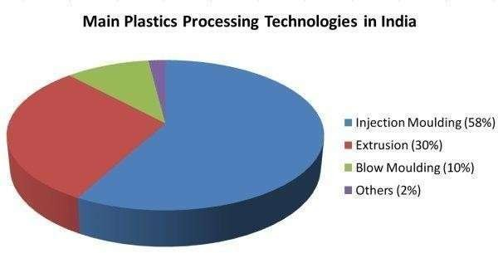

**2.2 RAW MATERIAL SUPPLY AND DEMAND**

Reliance Industries, India’s largest private sector conglomerate company, stated in January that India’s polyolefins market is expected to grow 12 percent to about 7.5 million metric tonsin 2011 with double-digit growth in consumption of both polypropylene and polyethylene. Polypropelene will account for the largest growth at 18% (with consumption growing from 2.2million metric tonnes to 2.6 million metric tonnes).

It is estimated that between 75-80% of Polypropylene demand in India is met by Reliance Industries with around 20% coming from four Government run companies Indian Oil Corporation Ltd (IOCL), Haldia Petrochemicals, Bharat Petroleum Corporation LTD (BPCL)and the Gas Authority of India Ltd (GAIL).

Partially due to the growth of the Indian construction industry (which is growing at approx. 20% p.a.) the demand for PVC is exceptionally high with domestic production barely meeting50% of the demand. Again, of the domestic suppliers, Reliance is the largest followed by Chemplast and Finoflex (with the latter two accounting for about 5% of demand).

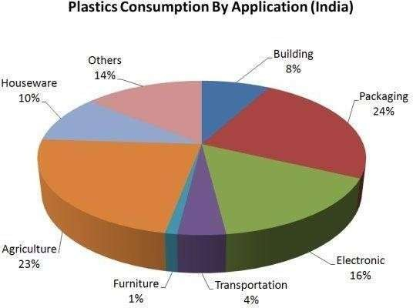

EVA is also in high demand, with barely 10% of the demand being met bydomestic supply, inthis case by Relene (a division of Reliance).

Despite the fact that India has one of the highest plastics recycling rates in theworld (an estimated 47% of all plastics is recycled) the demand for recycled plastics is huge, especiallyfor commodity plastics such as PP, PET, PS, LDPEand HDPE.

**2.3 AUTOMOTIVE MARKET**

India is the second fasted growing consumer market for Automobiles in theworld (afterChina) and the seventh largest producer, with over 2.6 million motor vehicles being manufactured in India in 2009.

According to forecasts, automobile manufacturing in India is set to raise 7% year on year until 2015. Car manufacturers in India have reported significant increases in output over the last 12 months, specifically Tata Motors reporting a32% increase in sales, Toyota Kirloska Motor at 26% and Ford India, a staggering 220% - due, in large part to the highly successfulFord Figo model.

**Packaging Industry**

Packaging currently accounts for the largest consumption of plastics in India, at24%of overall consumption.

In January 2011 India’s Corporate Affairs Minister indicated that the country was set to lift foreign direct investment (FDI) restrictions for supermarket giantssuch asTesco and Walmart (which currently has just six stores in India).

The Indian Government has highlighted the need for foreign investment to bringinnew technology such as cold chain logistics systems, warehousing facilities and packaging technology. This will assist in in improving the rate at which food perishes before it reaches market – currently at around 40% per annum.

This issues offer huge opportunities for plastics packaging manufacturers wishing toenter the market.

**2.4 Opportunities for UK Plastics Companies in India**

**Plastindia 2012**

The BPF recognises the potential for UK plastics manufacturers and service providers and together with support from UK Trade & Investment is encouragingBritish firms to explore the Indian market through Plastindia 2012. Plastindia 2012 will take place between 1st and 6th February 2012 in New Delhi,India. The show is the largest plastics trade fair in India and the s econdlargest plastics event anywhere in the world.

The show takes place once every three years and the previous edition attracted 1,518 exhibitors and 130,000 visitors. The BPF have secured a key location atthe show for the British Pavilion however space is in great demand and the deadline forcompanies wishing to securea a stand booking is 2nd September 2011.

**CHAPTER – III**

**3.1 COMPANY PROFILE**

ADR Plastics is a manufacturer based in Madurai, specializing in a range of plastic products. Their offerings include various household and commercial items like storage barrels, stools, dustbins, and containers. The company is located at Shed No.- 144, SIDCO Industrial Estate, Kappalur, Madurai, Tamil Nadu - 625008.

ADR Plastics focuses on producing high-quality, durable, and elegant plastic products that cater to residential, office, and commercial uses. They have a strong reputation For affordability, timely delivery, and customer satisfaction.

**3.2 A. D. R. Plastics :-**

Registered in 2008 , A. D. R. Plastics has made a name for itself in the list oftop suppliersof in India. The supplier company is located in Madurai, Tamil Nadu and is one of the leading sellers of listed products.

A. D. R. Plastics is listed in Trade India's list of verified sellers offering supremequality of etc.Buy in bulk from us for the best quality products and service.

**A.D.R. PRODUCTS**

**A.D.R. LOGO**

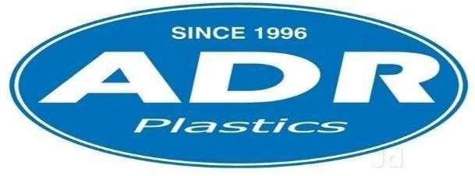

**3.3 Objectives of the company**

* To earn more profit.
* To expand their business.
* To provide better quality product to their customers.
* To increase the production through improved technologies.
* To gain the satisfaction of customers.
* 7BTo promote the employment opportunity for the village people.
* To retain their dealers, agents and extend their business to Chennai and south side.

**3.4 Vision & Mission**

The vision of our manufacturing is to continue the heritage of our company and be a manufacturer of top quality products. The vision will be accomplished by sharing the responsibilities of planning and decision making with all of our employees

**Mission**

Our mission is to produce and continually develop quality products at a competitive price while fostering a climate where there is an environmental technologies can thrive. It is our goal to ensure our mission by continuous self- improvement, growth in our operations and employees, while maintaining profitability to benefit of our customers, employees and community. All employees will work together in combining their efforts and skills to ensure our mission and goals are fulfilled in a courteous manner

**3.5 ORGANIZATION CHART**

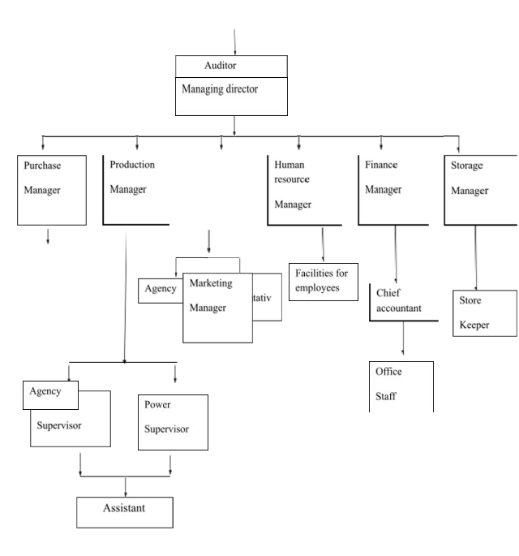

**3.6 MANAGEMENT CONTROL**

Management has direct control over their sub-ordinates. They have accepted the Sub-ordinate suggestion for achieving their objectives, because the staff members have Direct relationship in production process and give ideas for controlling manpower wastage of future plan.

**Duties of directors**

* To verify all accounts of the company.
* To check the duties of all directors.
* He has to bear the loss of the directors.
* His main duty is right decision at the right time.
* Overall organization activities are handled by him.
* Their duty is to enquire when the production is low.

**CHAPTER – IV**

**4.1 DEPARTMENTS**

A.D.R. PLASTICS has classified their overall functions Under 5 department and each department has its own manager to look after its activities.

The departments are

* Purchase department
* Production department
* Marketing department
* Finance department
* Human Resource department



**PURCHASE DEPARTMENT**

**4.2 PURCHASE DEPARTMENT**

Purchase is the basic function of production. Under this department purchase or buying of raw material and material for packing and is made. This function therefore has assumed as a technical aspect and calls for higher degree of skills, experience and intelligence.

Their 3 main factors are.

* Low price
* More quality
* Right time

Raw material they used for their production:

* P.P. Material (Poly propylene)
* Master batches (used for colors)

**P.P. Material**



**Master batches**

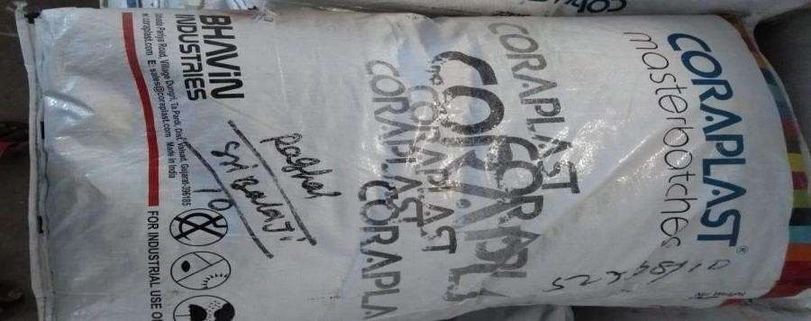

**Hierarchy of purchase department**

Purchase manager



Agents

**Objectives of purchase department**

The objectives of purchase department is not so much to procure The raw materials at the lowest price but to reduce the cost of final product Forensuring that there is a large number of well- known parameters.

**PURCHASE MANAGER**

Purchase department is headed over by Mr. V.P.M. Sathish in an efficient Manner. He does his job with great care most important is given by him during Purchase.

**Functions of purchase manager**

* Quality raw material has to be purchased
* Purchasing price should be reasonable
* Adequate raw materials should be purchased
* To meet critical situation
* Smooth relationship should be maintained with purchasing agents
* Amount settlement and credit period with seller should be properly made.

**4.3 PRODUCTION DEPARTMENT**

Production refers to the conversion of raw materials into finished product. In productive enterprises it is essential that production is carried on in the Best manner at the lowest cost, and the goods are of right quality and are Produced at the proper time. This can be ensured only through proper planning of production. To achieve the object of the management, the company plans exact Production necessary for order also and for the smooth functioning of the Industry.

**PRODUCTION DEPARTMENT CHART**

Manager



Supervisor

Labours

**Production Manager**

Production department is under the control of Mr. Jaya Singh. Who is acting as Manager.

**Function of production manager**

* He has entire control over the department
* Supervisor and labours has to work as what production manager says.
* Production order is deal by him.
* When to produce? How much to produce? Is said by production.
* When and how to deliver? Is also said by him.

**PRODUCTION PROCESS**

* Heating
* Melting
* Machine work
* Out come

Name of the machine : INJECTION MOULD

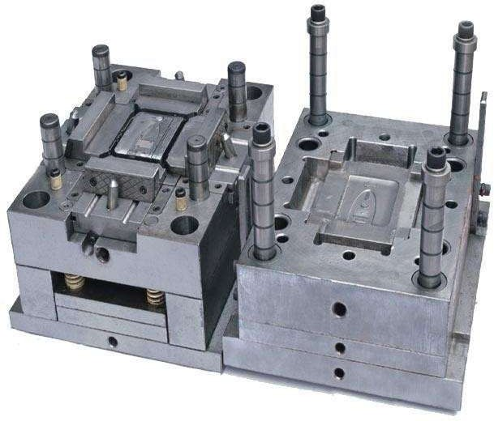**INJECTION MOULD:**

* This machine used for production of all plastic chairs in A.D.R
* The same machine used for all plastic products but in different shapessuitable forplastic cups, pipes, short tables, bucket etc.,

**4.4 MARKETING DEPARTMENT**

Marketing department play a vital role in achieving the objectives of our business. Researches competitive products by identifying and evaluating product characteristics, market share and pricing. Monitors budgets by comparing and analyzing actual results with plans and forecasts. Support sales staff by providing sales data, market trends, forecasts, account analyses, new product information; relaying customer services requests. Prepares marketing reports by collecting, analyzing, and summarizing sales data.

**Direct Selling**

For the wholesaler and retailer , the company has been doing directselling In andaround Madurai. Direct selling is done.

**Sales Agent**

The sales of product in Chennai, Mumbai, Kanyakumari, Ramnad,Calcutta,Bangalore, Pondicherry, Andhra are done through sales agents.

**Pricing**

The company sell its products to the retailers directly. The company gives its product in different sizes to the retailers at the following costs.

**4.5 FINANCE DEPARTMENT**

**4.1 Finance department**

**Finance manager**

**Chief accountant**

**Assistant**

**Function of finance manager**

* He should take decision regarding finance only in consultationwith allpartners.
* He deals with amount – collection from purchase and paysamount toseller.
* Transaction of money is done only through banks which iseasy andsafe.

**Books maintained:-**

The finance department maintain these following books in the company:-

* Issue control
* Credit note
* Bank accounts
* Files maintained like expense file and purchase file.
* 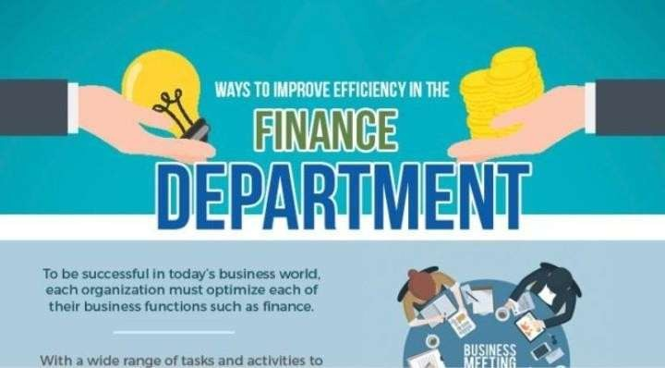

**Issues control**

The stores department is in charge of issue control. Issues are based on production function. The work order provides details on quantity of materials to be issued and the corresponding quantity of components to be manufactured.

**Credit note**

The credit note is maintained to record the due amount collected and the remaining due if any has to recover. It records the details about the collection of amount due and the balance to be collection from debtors. It will have the following details viz., bills collection and the balance amount to pay.

**Bank account**

The company had received credit facilities from various bank viz., Canara bank , SBOT,TMB, TKVB. These banks help this company by rendering credit facilities to it.

**FILES MAINTAINED:**

**Expense file**

The company maintains expenses file separately to maintain the expenses incurred for packaging its products and transporting its product and advertising expenses. This book enters the following above expenditure.

**Purchase file**

The company again maintains a separate file for purchasing and enters all thedetails regarding purchase in this file.

**OBJECTIVES OF A FINANCE MANAGER**

* To minimize financial cost
* To effectively manage funds
* To coordinate between operational and marketing department
* To increase the return on investment
* To follow standard operating procedures
* To comply with various reporting standards
* To create an effective internal control of funds and operations

**4.5 HUMAN RESOURCE MANAGEMENT DEPARTMENT**

The name of the department itself defines its work. Personnel department promotes and motivates the employee for their development and also to contribute to the company.

The personnel relationship with the individual working in the factory and individual details is recorded. This department is handled by Mr. P.C.Rajashekar as a manager and he has one assistant.



**Functions of personnel Manager**

* To maintain good relationship with workers in the factory.
* Individual record should be maintained.
* Welfare facilities are provided by him.
* Fringe benefits, compensation plans are made by him.
* Workers should be motivated and promoted.

**Employees state insurance (ESI)**

* ESI have been provided by the company according to the factories act for every employees.
* The employees registered under the scheme are entitled to medical treatment for themselves, and their dependents, unemployment cash benefit in certain contingencies and maternity benefit in case of women employees.

**Employees provident fund (EPF)**

* For the contribution of EPF both labours and management contribute equally according to the factories Act.
* EPF act of 1991, intended to help employees save a portion of their salary in event of retirement, disability, sickness or unemployment. 12% of wages in both employers and employees contribute in their contribution accounts

**BONUS:**

* Bonus is also provided by the company to workers without failevery year.
* The minimum bonus will be provided 8.33 % of the salary during theyear
* The maximum bonus is 20% of the salary during the accounting year

**LEAVE**

According to the factories act employees are provided with leave. Every Sunday the company will be closed. Then according to government holiday 9 days will be left for a year. The local holiday (election) will also be granted.

**OTHER BENEFIT**

* Medical expenses will be provided by the company up to acertain limit.
* During emergency period advance will be provided to employerandemployees.
* During occasions such as marriage also amount will be given.
* For education of employee and employee’s child will be given upto certainlimit.

**Fringe benefits**

Traveling allowances, dearness allowances are giver to the workers i.e., labourers, sales representative, drivers etc.,

**Welfare facilities**

Welfare schemes are important area where organization has to concentrate even if satisfying amount of salary is given to employees. The management of A.D.R.POLYMERS had provided many welfare schemes which listed below

* Death relief fund
* Iong service award

**First aid facility**

To prevent the employees from any cause , first aid facilities are applicable. Therefore, health care are taken on employees.

**Water facility**

Facilities have been made in such a way the employees can get sufficient water for their use.

**Safety measures**

Safety measures have been taken such as to protect from fire accidents and other theft. There are two exit doors.

**Preventive measure**

* The nature of raw material may cause irritation to eyes. To protect the employees by special type of glass, hand glouses are provided. While dough making the workers have to wear leg glouse.
* During production the employee in production department wear hair glouse toprotect their hair falling and better quality of product.

**Generator**

Generator is also in the company will be helpful to workers. when current is switched off. Italso leads to non-stop production.

**RECRUITMENT**

* A.D.R. PLASTICS follows a policy in recruitment. It select right person for the right joband in the right time. The recruitment is done only approval of managing directors.
* The recruitment process includes analyzing the requirements of a job, attracting employees to that job.

They follows some methods in recruitment process

**METHODS**

* Direct method
* Indirect method

**DIRECT METHOD**

In this method, the representatives of the company are sent to the potential candidates in the educational and training institutes. They establish contacts with the candidates seeking jobs. These representatives work in cooperation with placement cells in institutions persons pursuing management; medical etc.

**INDIRECT METHOD**

Indirect method include advertisement in newspapers, on radio and televisions etc.

**CHAPTER V**

**5.1 SWOT ANALYSIS:**

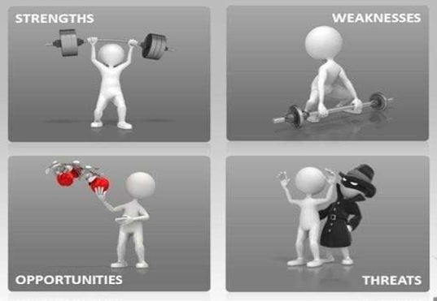

* + - Strength
    - Weakness
    - Opportunities
    - Threats

**STRENGTH**

* They begins their business just few years ago and they were producing their productwith branded quality.
* They produce the product to satisfy the customer.
* We are import Raw material from the northern side of Indian countries.
* Production process are only in machine. In production Department no manual workscarried by a workers .Only a machine works are running there for production purpose.
* Customers and labour satisfaction is very important for our company.

**WEAKNESS**

* The company is located in outer area.
* There is no upgrade in technologies .They did not upgrade the technologies.
* Our product is Unreachable. Because of no advertisement.

**OPPORTUNITY**

* We will export our products to all over countries.
* We will advertised our product in online facilities like amazon, flipkart etc.,

**THREATS**

* More competition of our product. So the company name cannot reach the customer.
* Upcoming new industries with latest technology.
* Some immediate rules and regulations by government are affecting the

**5.2 CONCLUSION**

The training period at “ A.D.R PLASTIC ” had helped me a lot. This training helped me to learn various new things. I have gained theoretical and practical knowledge about the functioning of the company. I gained lots of experience at various departments. This training is a milestone for me in my academic career. I really enjoyed very much doing this project, which would be helpful for me in future enhancement. I am thankful to my faculty members for their support and encouragement throughout the project. I thank the institution for giving this opportunity.

**5.3 REFERENCE**

* [www.justdial.com](http://www.justdial.com/)
* [www.adrplastics.com](http://www.adrplastics.com/)