What is Ansible?
Ansible is an open-source IT engine that automates application deployment, cloud provisioning, intra service orchestration, and other IT tools.
Ansible is easy to deploy because it does not use any agents or custom security infrastructure on the client-side, and by pushing modules to the clients
It can easily connect to clients using SSH-Keys, simplifying though the whole process. Client details, such as hostnames or IP addresses and SSH ports, are stored in the files, which are called inventory files. If you created an inventory file and populated it, then Ansible can use it.
Ansible uses the playbook to describe automation jobs, and playbook, which uses simple language, i.e., YAML. YAML is a human-readable data serialization language & commonly used for configuration files, but it can be used in many applications where data is being stored.

Why Use Ansible
- Ansible is free to use by everyone.
- Ansible is very consistent and lightweight, and no constraints regarding the operating system or underlying hardware are present.
- It is very secure due to its agentless capabilities and open SSH security features.
- Ansible does not need any special system administrator skills to install and use it.
- Ansible has a smooth learning curve determined by the comprehensive documentation and easy to learn structure and configuration.
- Its modularity regarding plugins, inventories, modules, and playbooks make Ansible perfect companion orchestrate large environments.

Ansible Workflow
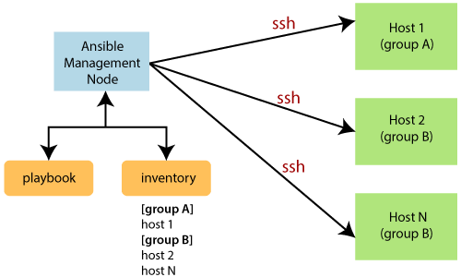

Ansible Architecture
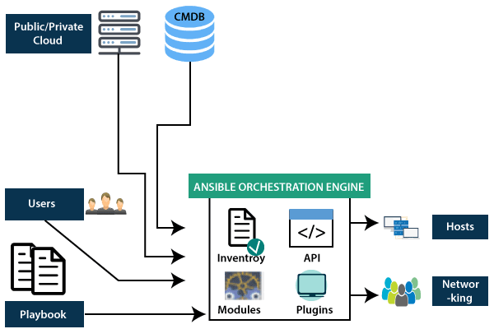

Inventory
Inventory is lists of nodes or hosts having their IP addresses, databases, servers, etc. which are need to be managed.

API's
The Ansible API's works as the transport for the public or private cloud services.

Modules
Ansible connected the nodes and spread out the Ansible modules programs. Ansible executes the modules and removed after finished. These modules can reside on any machine; no database or servers are required here. You can work with the chose text editor or a terminal or version control system to keep track of the changes in the content.

Plugins
Plugins is a piece of code that expends the core functionality of Ansible. There are many useful plugins, and you also can write your own.

Playbooks
Playbooks consist of your written code, and they are written in YAML format, which describes the tasks and executes through the Ansible. Also, you can launch the tasks synchronously and asynchronously with playbooks.

Hosts
In the Ansible architecture, hosts are the node systems, which are automated by Ansible, and any machine such as RedHat, Linux, Windows, etc.

Networking
Ansible is used to automate different networks, and it uses the simple, secure, and powerful agentless automation framework for IT operations and development. It uses a type of data model which separated from the Ansible automation engine that spans the different hardware quite easily.

Cloud
A cloud is a network of remote servers on which you can store, manage, and process the data. These servers are hosted on the internet and storing the data remotely rather than the local server. It just launches the resources and instances on the cloud, connect them to the servers, and you have good knowledge of operating your tasks remotely.

CMDB
CMDB is a type of repository which acts as a data warehouse for the IT installations.

Install Ansible on Debian/Ubuntu systems
Step 1: First perform an update to the packages
$ sudo apt update
Step 2: Then install the software properties common package.
$ sudo apt install software-properties-common
Step 3: And install the Ansible personal package archive.
$ sudo apt-add-repository ppa:ansible/ansible
Step 4: Install the Ansible.
$ sudo apt update
$ sudo apt install ansible

Ansible Playbooks
Playbooks are the files where the Ansible code is written. Playbooks are written in YAML format. YAML means "Yet Another Markup Language," so there is not much syntax needed. Playbooks are one of the core features of Ansible and tell Ansible what to execute, and it is used in complex scenarios. They offer increased flexibility.
Playbooks contain the steps which the user wants to execute on a particular machine. And playbooks are run sequentially. Playbooks are the building blocks for all the use cases of Ansible.

Create a Playbook
---
name: install and configure DB
hosts: testServer
become: yes

vars:
oracle_db_port_value : 1521

tasks:
-name: Install the Oracle DB
yum: <code to install the DB>

-name: Ensure the installed service is enabled and running
service:
name: <your service name>
Tags:-
Name
It specifies the name of the Ansible Playbooks.
Hosts
It specifies the lists of the hosts against which you want to run the task. And the host's Tag is mandatory. It tells Ansible that on which hosts to run the listed tasks. These tasks can be run on the same machine or the remote machine. One can run the tasks on the multiple machines, and the host's tag can have a group of host's entry as well.
Vars
Vars tag defines the variables which you can use in your playbook. Its usage is similar to the variables in any programming language.
Tasks
Tasks are the lists of the actions which need to perform in the playbooks. All the playbooks should contain the tasks to be executed. A task field includes the name of the task. It is not mandatory but useful for debugging the playbook. Internally each task links to a piece of code called a module. A module should be executed, and arguments that are required for the module you want to run.

