**Assignment 12.2**

Perform the below given activities:

a. Take a sample data set of your choice

|  |
| --- |
| > data(mtcars)  > library(randomForest)  > mtcars.rf <- randomForest(mpg ~ ., data=mtcars, ntree=1000, keep.forest=FALSE,  + importance=TRUE)  > plot(mtcars.rf, log="y")  > varImpPlot(mtcars.rf) |
|  |
| |  | | --- | |  | |

b. Apply random forest, logistic regression using Spark R

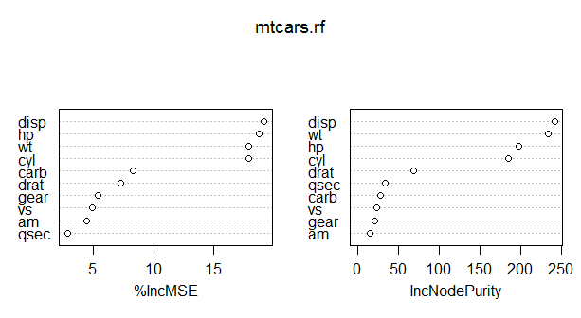

c. Predict for new dataset