Project Design Phase-II
Technology Stack (Architecture & Stack)
Date | 05 September 2026
Team ID | ServiceNow
Project Name | Medical Diagnosis Center Service Portal
Maximum Marks | 4 Marks
Technical Architecture:
The architecture below represents the implemented Medical Diagnosis Center Service Portal using ServiceNow components, custom application tables, automation, notifications and role-based administration.
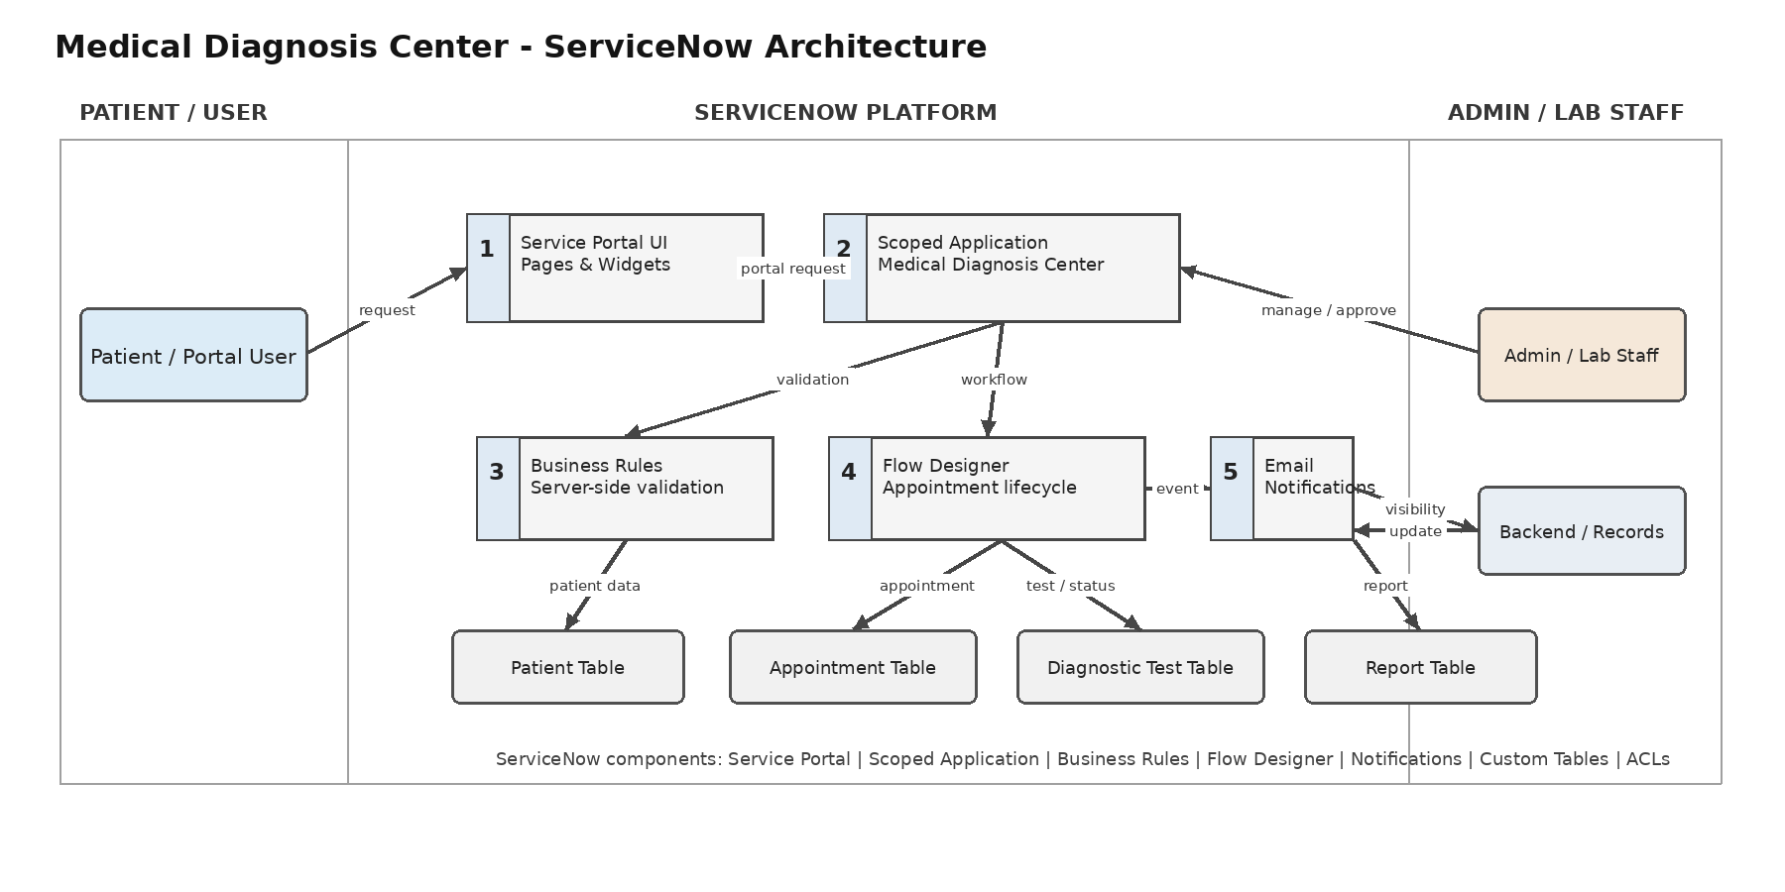
Table-1: Components & Technologies
S.No | Component | Description | Technology
1 | User Interface | Patient-facing interface for diagnostic test browsing, booking, appointment tracking and report access. | ServiceNow Service Portal, Pages & Widgets, HTML/CSS/JavaScript
2 | Application Logic-1 | Server-side validation, automatic field/status updates, cancellation/refund calculation and report creation. | ServiceNow Business Rules, Server-side JavaScript
3 | Application Logic-2 | Appointment approval and status lifecycle automation. | ServiceNow Flow Designer
4 | Application Logic-3 | Client-side interaction and validation on forms and portal inputs. | ServiceNow Client Scripts / UI Policies
5 | Database | Stores patient, appointment, diagnostic test and report records. | ServiceNow Platform Database / Custom Tables
6 | Cloud Database | No separate external cloud database is configured; the application uses the ServiceNow platform data layer. | ServiceNow Platform
7 | File Storage | Handles report file attachments associated with application records when applicable. | ServiceNow Attachments / Platform Storage
8 | External API-1 | No external API is required for the implemented core solution. | Not implemented
9 | External API-2 | No second external API is required for the implemented core solution. | Not implemented
10 | Machine Learning Model | No machine-learning model is used in the implemented application. | Not applicable
11 | Infrastructure (Server / Cloud) | Developed and demonstrated on a ServiceNow Personal Developer Instance / ServiceNow cloud platform. | ServiceNow Cloud Platform / PDI

Project Design Phase-II
Technology Stack (Architecture & Stack)
Table-1: Components & Technologies - Continued
S.No | Component | Description | Technology
11 | Infrastructure (Server / Cloud) | Developed and demonstrated on a ServiceNow Personal Developer Instance / ServiceNow cloud platform. | ServiceNow Cloud Platform / PDI
Table-2: Application Characteristics
S.No | Characteristics | Description | Technology
1 | Open-Source Frameworks | No separate open-source application framework is used; the project is built with native ServiceNow capabilities. | ServiceNow platform APIs / native capabilities
2 | Security Implementations | Authenticated access, application scope, roles and ACLs are used to restrict access to application data and backend records. | ServiceNow ACLs, Roles, Application Scope, Authentication
3 | Scalable Architecture | Portal UI, application logic/workflow and data are separated into platform components, allowing additional users, tables, pages and workflows to be added. | Service Portal, Business Rules, Flow Designer, Platform Database
4 | Availability | The application is hosted on the ServiceNow cloud platform / PDI and is available according to the configured instance. | ServiceNow Cloud Platform
5 | Performance | Server-side validation and automated workflows reduce manual processing; portal operations use ServiceNow records and server-side logic. | Business Rules, GlideRecord, Service Portal, Flow Designer
Implementation Note: External APIs and machine-learning components are marked as not implemented because they are not part of the implemented core solution.

