Project Design Phase-II
Data Flow Diagrams & User Stories
Date | 05 September 2026
Team ID | ServiceNow
Project Name | Medical Diagnosis Center Service Portal
Maximum Marks | 4 Marks
Data Flow Diagrams
A Data Flow Diagram (DFD) shows how data enters, moves through, is processed by, and is stored in the Medical Diagnosis Center ServiceNow application.
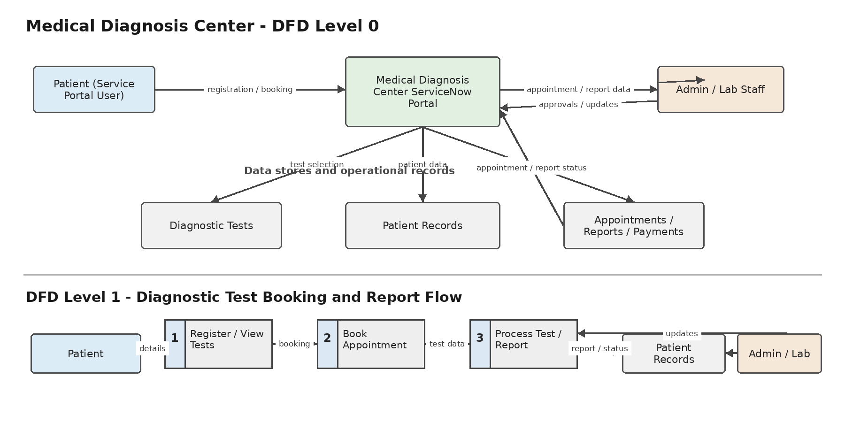

User Stories
Use the following table to list the user stories for the Medical Diagnosis Center Service Portal.
User Type | Functional Requirement  (Epic) | User Story  Number | User Story / Task | Acceptance criteria | Priority | Release
Patient  (Service Portal user) | Registration | US-1 | As a patient, I can register or provide my details so that I can use the diagnostic center portal. | Patient details are captured and the patient can access the portal journey. | High | Sprint-1
 |  | US-2 | As a patient, I can view available diagnostic tests and their details before booking. | Available tests and relevant test details are displayed. | High | Sprint-1
 | Test Booking | US-3 | As a patient, I can select a diagnostic test, date and available time slot and submit a booking request. | A valid slot can be selected and an appointment record is created. | High | Sprint-1
 |  | US-4 | As a patient, I can receive confirmation when my appointment is approved or confirmed. | Confirmation details are available and the patient is notified. | High | Sprint-1
 | Appointment Tracking | US-5 | As a patient, I can view my appointments and their current status. | The patient can see appointment details and status. | High | Sprint-1
 |  | US-6 | As a patient, I can cancel or reschedule an eligible appointment. | Eligible appointments can be cancelled/rescheduled and the status is updated. | Medium | Sprint-2
 | Payment | US-7 | As a patient, I can view the payment status and complete payment for a diagnostic service. | Payment status is stored as Pending, Paid, Failed or Refunded. | High | Sprint-1
 | Reports | US-8 | As a patient, I can receive a notification when my diagnostic report is available. | A report-availability notification is sent when the report is created. | High | Sprint-2
 |  | US-9 | As a patient, I can view and download my diagnostic reports from the portal. | Only the patient's available reports are displayed and can be downloaded. | High | Sprint-2
Lab Technician | Test Processing | US-10 | As a lab technician, I can update the appointment status from Sample Collected to Processing and Completed. | Status changes are recorded against the appointment. | High | Sprint-2
 |  | US-11 | As a lab technician, I can create or attach the diagnostic report when testing is completed. | A report record is created and linked to the correct appointment/patient. | High | Sprint-2
Administrator | Test Management | US-12 | As an administrator, I can manage diagnostic test records and their availability. | Test records can be maintained for portal booking. | High | Sprint-1
 | Administration & Monitoring | US-13 | As an administrator, I can review appointments, approvals, payments and reports from the application backend. | Authorized staff can review required records and operational status. | High | Sprint-2
 |  | US-14 | As an administrator, I can view dashboard information for monitoring diagnostic center operations. | Dashboard information reflects the available application data. | Medium | Sprint-2

