**Cycle#2: Working With Private Methods**

Private methods defined in the class to modularize the logic inside the class. Private method can be called with in the other methods of the Class. Private methods cannot be called from Outside.

**Following examples demonstrates how to**

* How to define and Implement Private Methods
* How to call Private Methods from other Method of the Class

**Example: Display list of Sales orders for the Customer**

**Selection Screen:**

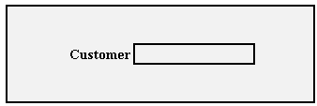

**Output:**

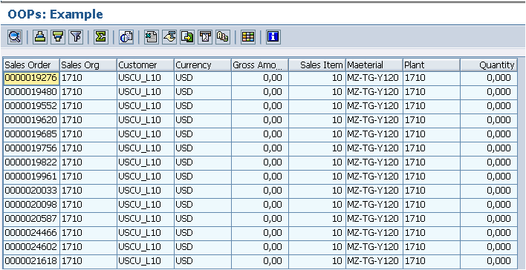

**Steps to be done Class**

* 1. **Class Definition**
     1. Private Section
        1. Declare Variable G_KUNNR of Type KUNNR
        2. Declare Internal table IT_ORDERS to hold Sales Order Details
        3. Declare Method GET_ORDERS without any parameters
     2. Public Section
        1. Declare Constructor with Importing Parameter KUNNR
        2. Declare Method DISPLAY without any parameters
  2. **Class Implementation**
     1. CONSTRUCTOR Method

Set the G_KUNNR with importing value

* + 1. GET_ORDERS Method

Get Data from VBAK and VBAP Using Inner Join

* + 1. DISPLAY

Select the Sales Order details by calling the Private Method GET_ORDERS

Either use LOOP … END LOOP to Print the Sales Order or use ALV

In the following Example ALV Used

**Consume Class from the Report**

1. Declare Parameter for the Customer
2. Declare reference to Class
3. Create Instance for the Class and pass the Customer Number
4. Call DISPLAY Method using Instance

**Logic:**

*\*&---------------------------------------------------------------------\**  
*\*& Report ZRTEST_EXAMPLE_04*  
*\*&---------------------------------------------------------------------\**  
*\*&*  
*\*&---------------------------------------------------------------------\**  
REPORT zrtest_example_06.  
TYPES:  
  BEGIN OF ty_sales,  
    vbeln TYPE vbeln,  
    vkorg TYPE vkorg,  
    kunnr TYPE kunnr,  
    waerk TYPE waerk,  
    netwr TYPE netwr,  
    posnr TYPE posnr,  
    matnr TYPE matnr,  
    werks TYPE werks_d,  
    zmeng TYPE dzmeng,  
  END OF ty_sales,  
  ty_sales_tab TYPE TABLE OF ty_sales.  
  
CLASS lcl_example_01 DEFINITION.  
  PUBLIC SECTION.  
    METHODS:  
      constructor IMPORTING iv_kunnr TYPE kunnr,  
      display.  
  PROTECTED SECTION.  
  PRIVATE SECTION.  
    DATA:  
      g_kunnr  TYPE kunnr,  
      it_sales TYPE ty_sales_tab.  
    *" Private method can be called other method of the class only*  
    *" We can't call from outside using Object reference*  
    METHODS get_orders.  
ENDCLASS.  
  
CLASS lcl_example_01 IMPLEMENTATION.  
*\*--------------------------------------------------------------------\**  
*\*  Constructor*  
*\*--------------------------------------------------------------------\**  
  METHOD constructor.  
    g_kunnr = iv_kunnr.  
  ENDMETHOD.  
*\*--------------------------------------------------------------------\**  
*\*  Get Sales Orders for the Given Customer*  
*\*--------------------------------------------------------------------\**  
  METHOD get_orders.  
    SELECT  
      vbak~vbeln  
      vkorg  
      kunnr  
      vbak~waerk  
      vbak~netwr  
      posnr  
      matnr  
      werks  
      zmeng  
      INTO TABLE it_sales  
      FROM vbak INNER JOIN vbap  
      ON vbak~vbeln = vbap~vbeln  
      WHERE kunnr = g_kunnr.  
  ENDMETHOD.  
*\*--------------------------------------------------------------------\**  
*\*  Display Sales Orders*  
*\*---------------- ----------------------------------------------------\**  
  METHOD display.  
    *" Call Get Data method*  
    CALL METHOD get_orders.  
    *" Fill Field Catalog*  
    DATA(lt_fcat) = VALUE slis_t_fieldcat_alv(  
      ( fieldname = 'VBELN' tabname = 'VBAK' seltext_m = 'Sales Order' )  
      ( fieldname = 'VKORG' tabname = 'VBAK' seltext_m = 'Sales Org' )  
      ( fieldname = 'KUNNR' tabname = 'VBAK' seltext_m = 'Customer' )  
      ( fieldname = 'WAERK' tabname = 'VBAK' seltext_m = 'Currency' )  
      ( fieldname = 'NETWR' tabname = 'VBAK' seltext_m = 'Gross Amount' )  
      ( fieldname = 'POSNR' tabname = 'VBAP' seltext_m = 'Sales Item' )  
      ( fieldname = 'MATNR' tabname = 'VBAP' seltext_m = 'Maeterial' )  
      ( fieldname = 'WERKS' tabname = 'VBAP' seltext_m = 'Plant' )  
      ( fieldname = 'ZMENG' tabname = 'VBAP' seltext_m = 'Quantity' ) ).  
    CALL FUNCTION 'REUSE_ALV_GRID_DISPLAY'  
      EXPORTING  
        i_callback_program = sy-repid  
        it_fieldcat        = lt_fcat  
      TABLES  
        t_outtab           = it_sales  
      EXCEPTIONS  
        program_error      = 1  
        OTHERS             = 2.  
    IF sy-subrc <> 0.  
*\* Implement suitable error handling here*  
    ENDIF.  
  
  ENDMETHOD.  
ENDCLASS.  
  
PARAMETERS : p_kunnr TYPE kunnr.  
  
START-OF-SELECTION.  
  DATA: o_ref TYPE REF TO lcl_example_01.  
  CREATE OBJECT o_ref EXPORTING iv_kunnr = p_kunnr.  
  CALL METHOD o_ref->display.