**Cycle#1: Understanding the Consume Class by creating the Instance**

Following examples demonstrates how to

* Create Instance
* Working with Attributes
* Working with Methods
* Working with Constructor Methods

**Attributes**

* Create Single Instance and Access Public Attributes
* Create Multiple Instances and Access Public Attributes
* Create Instance and try to access private attribute

**Example#1 Create Single Instance and Access Public Attributes**

Following example contains declaring class with single public attributes and creating instance and set and gets the public attribute of the class via instance

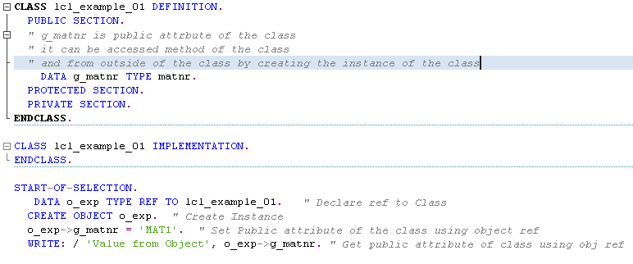

**Example#2: Create Multiple Instances and Access Public Attributes**

In the following example, we don’t have any changes in the Class. Only change is we created multiple instances for the same class

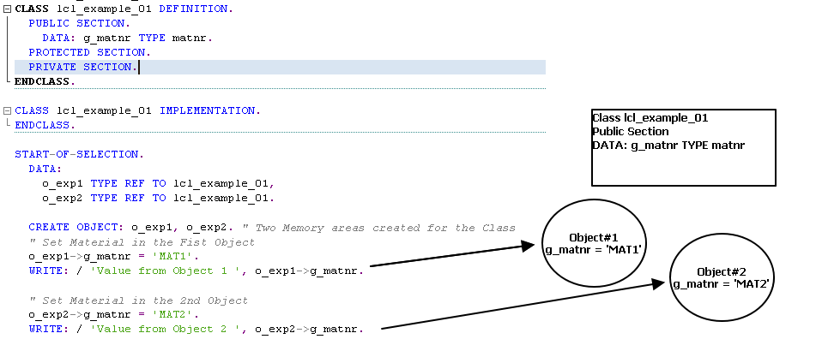

**Example#3: Create Instance and try to access private attribute**

Following example demonstrates what will happen if we try to access private attribute of the Class via instance

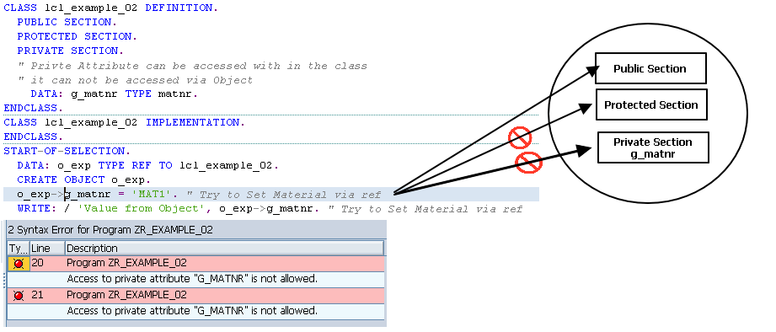

**Methods**

* Access Public Method without Parameters
* Access Public Methods with Parameters

**Example#1: Access Public Method without Parameters**

Methods are having definition section and implementation section.

In the definition section, importing, exporting, changing and returning methods specified.

In the Implementation sections, actual logic implemented

Following example shows how to Public methods from the Outside using instance

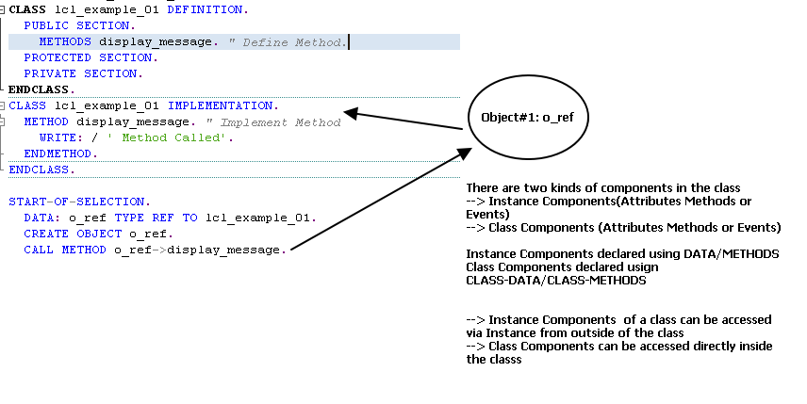

**Example#1: Access Public Method with Parameters**

**Defining the Method and Implementing the Method in the Class** 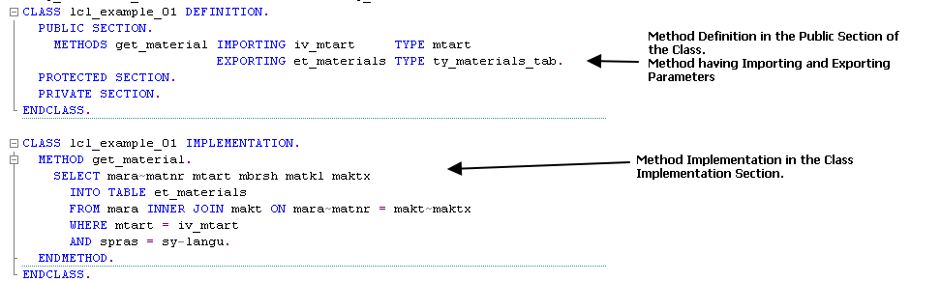

**Calling the Method**

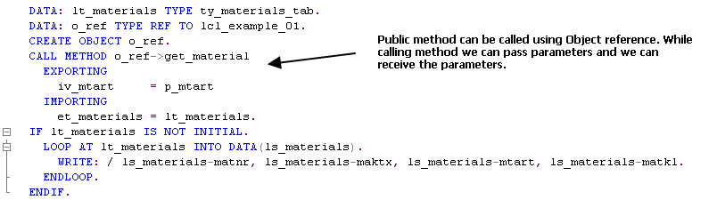

**Type Definition**

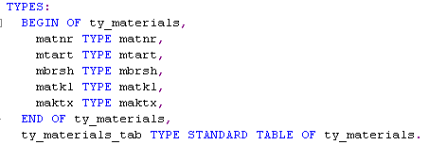

**Constructor**

Constructors are special methods which will be called when creating the Object of the class. We can have constructor with or without parameters

We are going to re write the previous example, by adding the Material as Private attribute and set the values during object creation. Following are the steps to work with constructors

1. Declare Private Variable in the Class
2. Define the Constructor
3. Implement the Constructor
4. While creating the Instance for the Class, pass the parameter

