Features of OOPs

What are the advantages/Features of OOPs?

* Multiple copies or Multiple Instances
* Encapsulation
* Abstraction
* Inheritance
* Events
* Polymorphism

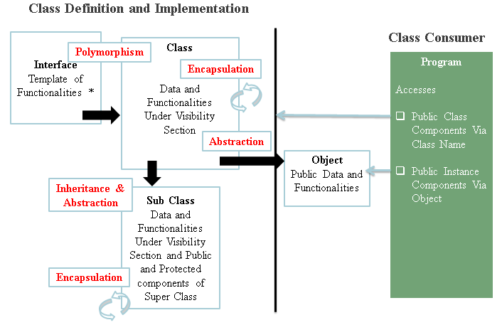

**Recommended:**

Basic knowledge on syntaxes of how to define and implement the class and calling methods of the class

Contents

Multiple Instances/Copies 3

Encapsulation: Binding Logic with Data 4

Program: 5

Abstraction 9

Inheritance 11

Adding New Functionality 11

Program 12

Redefine Existing Functionality 14

Program 16

Events 19

Program 20

Class: Customer 20

Class: Lazy Department 20

Class: Active Department 21

Polymorphism 23

Program 23

# Multiple Instances/Copies

When it is needed to maintain multiple copies of same field then we will bind the data in the class, create instance and will use

**Program with Without Object Orientation**

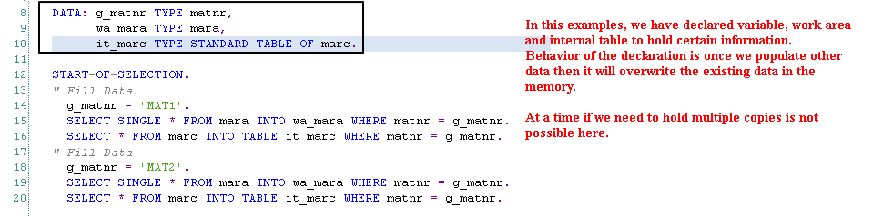

**Program with Object Oriented Features**

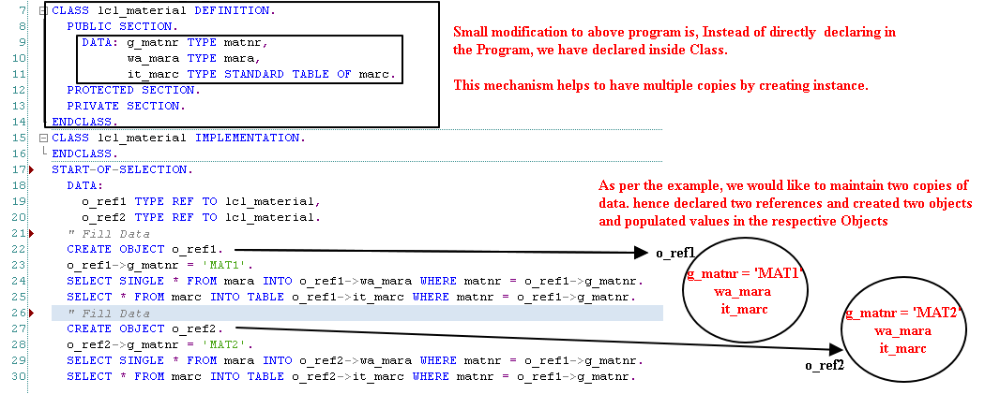

In the debugging, we can observe that memory is live for both the instances.

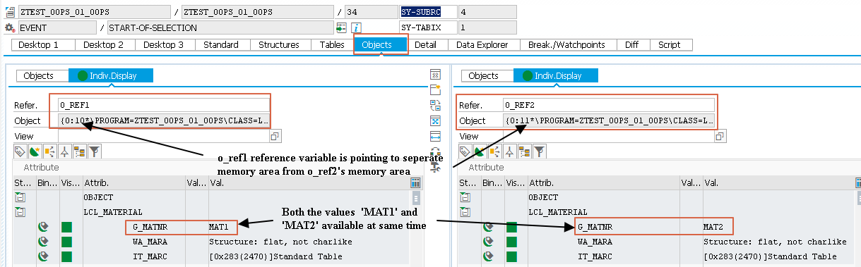

# Encapsulation: Binding Logic with Data

Encapsulation allows to bind the logic with related data only.

Let assume that, application program is going to deal with Customer Master and Sales Order details and corresponding operations

**Data**: Customer Master and Sales Order Data

**Operations**: Create Customer Master, Change Customer Master, Display Customer Master, Block Customer, Release Customer, Create Sales Order, Change Sales Order, Display Sales Order, Deliver Sales Order, Bill Sales Order

In Procedure Oriented Programming, we will define all the data (There is not separation) in one location (Ideally TOP Include in the ABAP Program) and all the operations defined inform of routines one by one.

In the Object Orientation, We can separate the data and corresponding logic and group them in separate classes

**Class#1: Customer Class**

Data: Customer Master Data

Operations: Create Customer, Change Customer, Display Customer, Block Customer, Release Customer

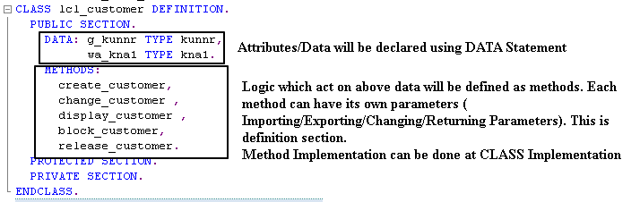

**Class#2: Sales Class**

Operations: Create Sales Order, Changes Sales Order, Display Sales Order, Deliver Sales Order, Bill Sales Order

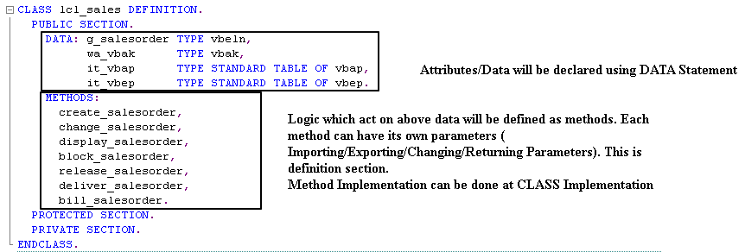

As per the above example, based on the data and corresponding operation, we are able to separate the data and logic into two different units.

*Note: Below example is used for Abstraction example also as we have used on Method Next_Action in the protected section.*

## Program:

*&---------------------------------------------------------------------*  
*& Report ZTEST_OOPS_02  
*&---------------------------------------------------------------------*  
*&  
*&---------------------------------------------------------------------*  
REPORT ztest_oops_02.  
CLASS lcl_customer DEFINITION.  
  PUBLIC SECTION.  
    DATA:  
      g_kunnr TYPE kunnr,  
      wa_kna1 TYPE kna1.  
    METHODS:  
      create_customer,  
      change_customer,  
      display_customer,  
      block_customer,  
      release_customer.  
  PROTECTED SECTION.  
    METHODS next_action.  
  PRIVATE SECTION.  
    METHODS:  
      send_cust_sts_to_recovery_team,  
      send_cust_sts_to_legal_team,  
      send_cust_sts_to_sales_team,  
      send_cust_sts_to_local_rowdies.  
ENDCLASS.  
  
CLASS lcl_sales DEFINITION.  
  PUBLIC SECTION.  
    DATA:  
      g_salesorder TYPE vbeln,  
      wa_vbak      TYPE vbak,  
      it_vbap      TYPE STANDARD TABLE OF vbap,  
      it_vbep      TYPE STANDARD TABLE OF vbep.  
    METHODS:  
      create_salesorder,  
      change_salesorder,  
      display_salesorder,  
      block_salesorder,  
      release_salesorder,  
      deliver_salesorder,  
      bill_salesorder.  
  PROTECTED SECTION.  
    METHODS next_action.  
  PRIVATE SECTION.  
    METHODS:  
      inform_ord_sts_to_warehse_dept,  
      inform_ord_sts_to_supervisor,  
      inform_ord_sts_to_market_team.  
ENDCLASS.  
  
CLASS lcl_customer IMPLEMENTATION.  
  METHOD create_customer.  
    WRITE / 'Sales order Created'.  
  ENDMETHOD.  
  METHOD change_customer.  
    WRITE / 'Sales Order Changed'.  
  ENDMETHOD.  
  METHOD display_customer.  
    WRITE / 'Display Sales Order'.  
  ENDMETHOD.  
  METHOD next_action.  
    CALL METHOD:  
      send_cust_sts_to_recovery_team,  
      send_cust_sts_to_legal_team,  
      send_cust_sts_to_sales_team.  
  ENDMETHOD.  
  METHOD block_customer.  
    WRITE / 'Block Sales Order'.  
    CALL METHOD next_action.  
  ENDMETHOD.  
  METHOD release_customer.  
    WRITE / 'Release Customer'.  
  ENDMETHOD.  
  METHOD send_cust_sts_to_recovery_team.  
    WRITE / 'Will inform local rowdiesys'.  
  ENDMETHOD.  
  METHOD send_cust_sts_to_legal_team.  
    WRITE / 'Proceeding legally takes long time. Customer can fly other countries'.  
    WRITE / 'Better take help of local solution'.  
    WRITE / 'I have amicable solution'.  
  ENDMETHOD.  
  METHOD send_cust_sts_to_sales_team.  
    WRITE / 'No more sales.. its fixed..Contact legal team for further action'.  
  ENDMETHOD.  
  METHOD send_cust_sts_to_local_rowdies.  
    WRITE / 'Tomorrow morning deadly warning. Recovery money 50-50'.  
  ENDMETHOD.  
ENDCLASS.  
  
CLASS lcl_sales IMPLEMENTATION.  
  METHOD create_salesorder.  
    WRITE / 'Sales Order Created'.  
  ENDMETHOD.  
  METHOD change_salesorder.  
    WRITE / 'Sales Order chaged'.  
  ENDMETHOD.  
  METHOD display_salesorder.  
    WRITE / 'Sales Order displayed'.  
  ENDMETHOD.  
  METHOD next_action.  
    CALL METHOD inform_ord_sts_to_warehse_dept.  
    CALL METHOD inform_ord_sts_to_supervisor.  
    CALL METHOD inform_ord_sts_to_market_team.  
  ENDMETHOD.  
  METHOD block_salesorder.  
    WRITE / 'Sales Order Blocked'.  
    CALL METHOD next_action.  
  ENDMETHOD.  
  METHOD release_salesorder.  
    WRITE / 'Sales Order released'.  
  ENDMETHOD.  
  METHOD deliver_salesorder.  
    WRITE / 'Sales Order Delivered'.  
  ENDMETHOD.  
  METHOD bill_salesorder.  
    WRITE / 'Billing done'.  
  ENDMETHOD.  
  METHOD  inform_ord_sts_to_warehse_dept.  
    WRITE /  'Got information from Sales team for fuurther action'.  
  ENDMETHOD.  
  METHOD inform_ord_sts_to_supervisor.  
    WRITE / 'Got information from Sales team for fuurther action'.  
  ENDMETHOD.  
  METHOD inform_ord_sts_to_market_team.  
    WRITE / 'Got information from Sales team for fuurther action'.  
    WRITE / 'As usal we will nothing. that matter sales team dont know'.  
  ENDMETHOD.  
ENDCLASS.  
  
  
START-OF-SELECTION.  
  " Work with Customer  
  DATA:  
     o_customer TYPE REF TO lcl_customer.  
  CREATE OBJECT o_customer.  
  CALL METHOD:  
  o_customer->create_customer,  
  o_customer->change_customer,  
  o_customer->display_customer,  
  o_customer->block_customer,  
  o_customer->release_customer.  
  
  " Work with Sales Order  
  DATA:  
    o_salesorder TYPE REF TO lcl_sales.  
  CREATE OBJECT o_salesorder.  
  CALL METHOD:  
      o_salesorder->create_salesorder,  
      o_salesorder->change_salesorder,  
      o_salesorder->display_salesorder,  
      o_salesorder->block_salesorder,  
      o_salesorder->release_salesorder,  
      o_salesorder->deliver_salesorder,  
      o_salesorder->bill_salesorder.

Output:

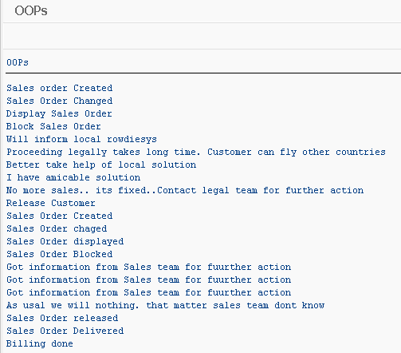

# Abstraction

Abstraction allows controlling access to class features i.e. on Data and Methods. Class contains 3 visibility sections.

* Public Section
* Protected Section
* Private Section

**Public Section:** Whatever the components (Data or Methods) declared in this section can be accessed with in the Class as well as outside the class (From the consumer) by declaring the reference and creating instance

**Protected Section:** This section basically for extending features of the existing class. Whatever the class components which can be extended/re-implemented in the future can be specified

**Private Section**: this section contains only those components which can be used only with in the class

**Customer Class:**

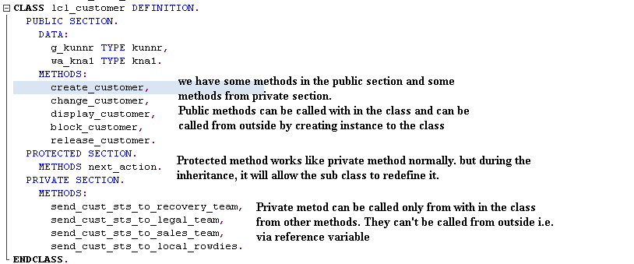

**Sales Class:**

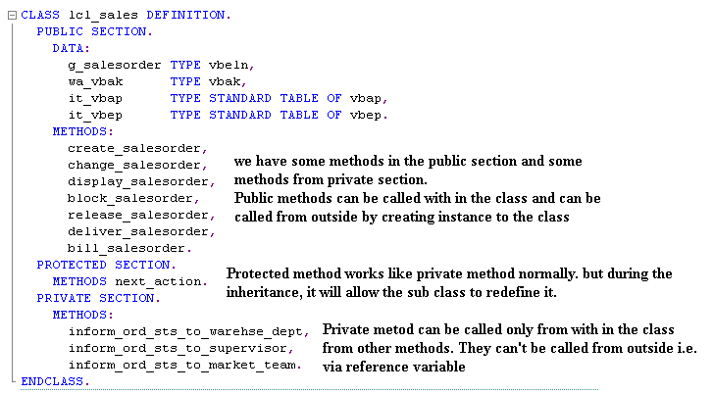

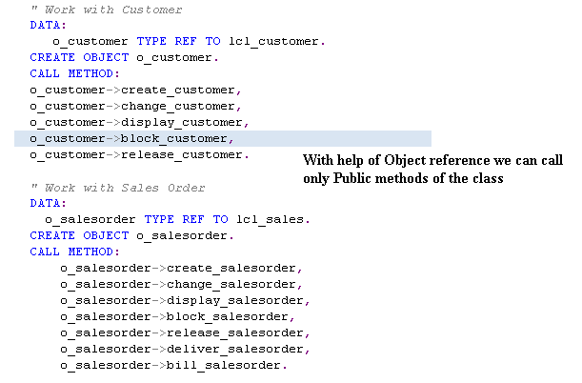

# Inheritance

Inheritance allows to extend the existing functionality of class.

We can

* Add new elements data, events and methods in the sub class
* Redefine existing Functionality

## Adding New Functionality

Add new Functionality **“Send_Order_status_to_the_Customer”** to the Sales Class by extending the class

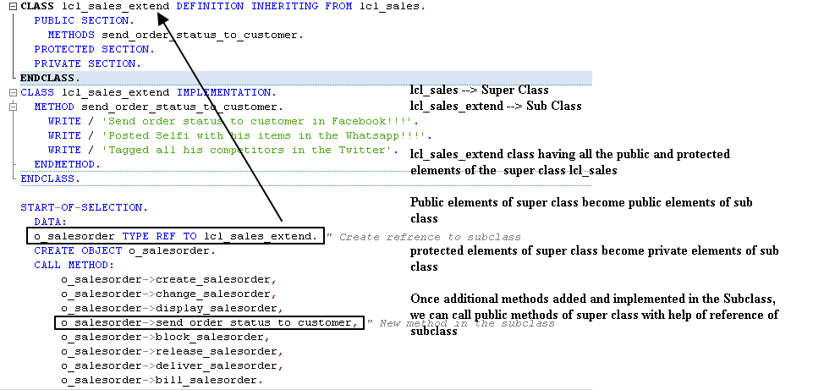

### Program

CLASS lcl_sales DEFINITION.  
  PUBLIC SECTION.  
    DATA:  
      g_salesorder TYPE vbeln,  
      wa_vbak      TYPE vbak,  
      it_vbap      TYPE STANDARD TABLE OF vbap,  
      it_vbep      TYPE STANDARD TABLE OF vbep.  
    METHODS:  
      create_salesorder,  
      change_salesorder,  
      display_salesorder,  
      block_salesorder,  
      release_salesorder,  
      deliver_salesorder,  
      bill_salesorder.  
  PROTECTED SECTION.  
    METHODS next_action.  
  PRIVATE SECTION.  
    METHODS:  
      inform_ord_sts_to_warehse_dept,  
      inform_ord_sts_to_supervisor,  
      inform_ord_sts_to_market_team.  
ENDCLASS.  
  
CLASS lcl_sales IMPLEMENTATION.  
  METHOD create_salesorder.  
    WRITE / 'Sales Order Created'.  
  ENDMETHOD.  
  METHOD change_salesorder.  
    WRITE / 'Sales Order chaged'.  
  ENDMETHOD.  
  METHOD display_salesorder.  
    WRITE / 'Sales Order displayed'.  
  ENDMETHOD.  
  METHOD next_action.  
    CALL METHOD inform_ord_sts_to_warehse_dept.  
    CALL METHOD inform_ord_sts_to_supervisor.  
    CALL METHOD inform_ord_sts_to_market_team.  
  ENDMETHOD.  
  METHOD block_salesorder.  
    WRITE / 'Sales Order Blocked'.  
    CALL METHOD next_action.  
  ENDMETHOD.  
  METHOD release_salesorder.  
    WRITE / 'Sales Order released'.  
  ENDMETHOD.  
  METHOD deliver_salesorder.  
    WRITE / 'Sales Order Delivered'.  
  ENDMETHOD.  
  METHOD bill_salesorder.  
    WRITE / 'Billing done'.  
  ENDMETHOD.  
  METHOD  inform_ord_sts_to_warehse_dept.  
    WRITE /  'Got information from Sales team for fuurther action'.  
  ENDMETHOD.  
  METHOD inform_ord_sts_to_supervisor.  
    WRITE / 'Got information from Sales team for fuurther action'.  
  ENDMETHOD.  
  METHOD inform_ord_sts_to_market_team.  
    WRITE / 'Got information from Sales team for fuurther action'.  
    WRITE / 'As usal we will nothing. that matter sales team dont know'.  
  ENDMETHOD.  
ENDCLASS.  
  
CLASS lcl_sales_extend DEFINITION INHERITING FROM lcl_sales.  
  PUBLIC SECTION.  
    METHODS send_order_status_to_customer.  
  PROTECTED SECTION.  
  PRIVATE SECTION.  
ENDCLASS.  
CLASS lcl_sales_extend IMPLEMENTATION.  
  METHOD send_order_status_to_customer.  
    WRITE / 'Send order status to customer in Facebook!!!'.  
    WRITE / 'Posted Selfi with his items in the Whatsapp!!!'.  
    WRITE / 'Tagged all his competitors in the Twitter'.  
  ENDMETHOD.  
ENDCLASS.  
  
START-OF-SELECTION.  
  DATA:  
  o_salesorder TYPE REF TO lcl_sales_extend. " Create refrence to subclass  
  CREATE OBJECT o_salesorder.  
  CALL METHOD:  
      o_salesorder->create_salesorder,  
      o_salesorder->change_salesorder,  
      o_salesorder->display_salesorder,  
      o_salesorder->send_order_status_to_customer, " New method in the subclass  
      o_salesorder->block_salesorder,  
      o_salesorder->release_salesorder,  
      o_salesorder->deliver_salesorder,  
      o_salesorder->bill_salesorder.

Output

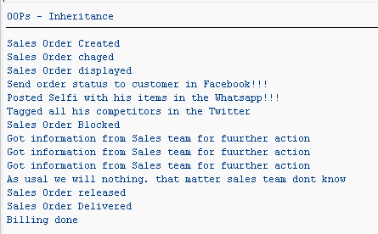

## Redefine Existing Functionality

Redefine allows subclass to have its own implementation instead of Super class implementation

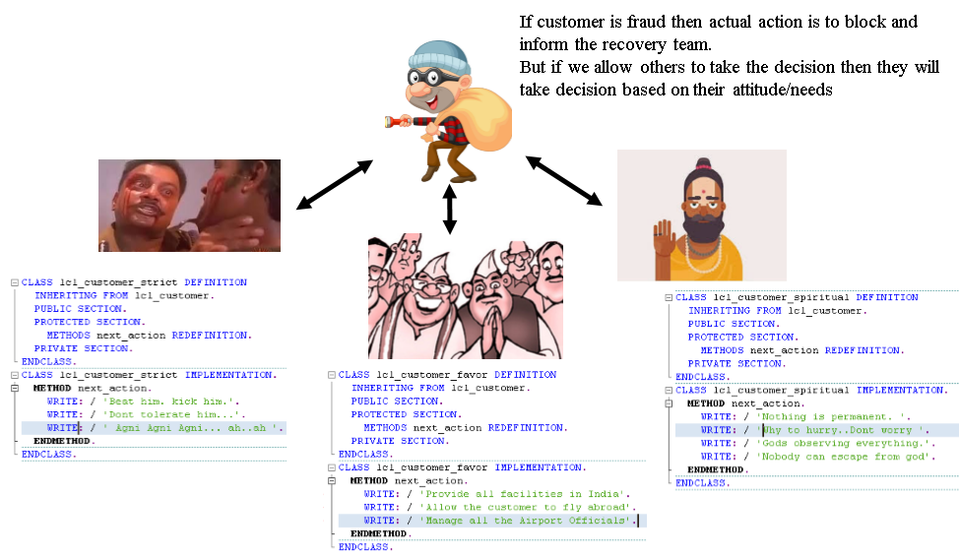

**Creating instances and Calling Block Customer Statement**

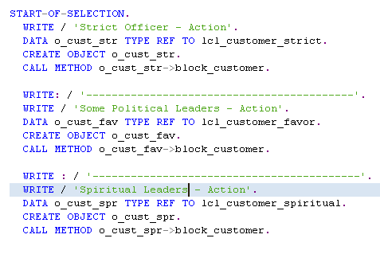

In the all the above cases, we have not called the NEXT_ACTION Method directly. We have called only BLOCK_CUSTOMER.

BLOCK_METHOD calling the NEXT_ACTION Method.

System giving priority to Implementation of Subclass instead of Super class when Method redefined.

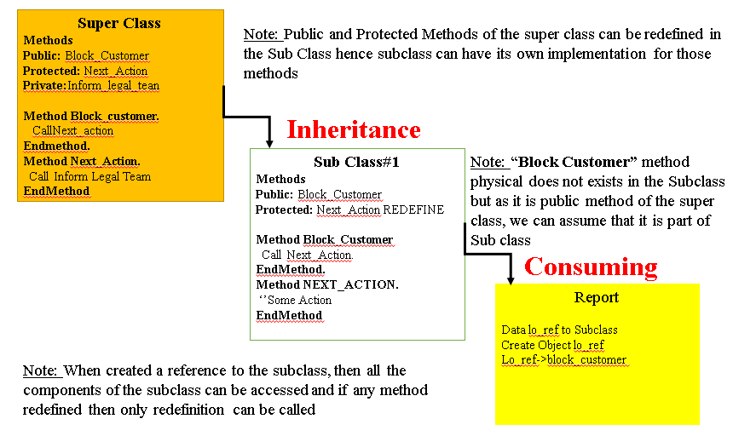

### Program

*&---------------------------------------------------------------------*  
*& Report ZTEST_OOPS_04  
*&---------------------------------------------------------------------*  
*&  
*&---------------------------------------------------------------------*  
REPORT ztest_oops_04.  
CLASS lcl_customer DEFINITION.  
  PUBLIC SECTION.  
    DATA:  
      g_kunnr TYPE kunnr,  
      wa_kna1 TYPE kna1.  
    METHODS:  
      create_customer,  
      change_customer,  
      display_customer,  
      block_customer,  
      release_customer.  
  PROTECTED SECTION.  
    METHODS next_action.  
  PRIVATE SECTION.  
    METHODS:  
      send_cust_sts_to_recovery_team,  
      send_cust_sts_to_legal_team,  
      send_cust_sts_to_sales_team,  
      send_cust_sts_to_local_rowdies.  
ENDCLASS.  
CLASS lcl_customer IMPLEMENTATION.  
  METHOD create_customer.  
    WRITE / 'Sales order Created'.  
  ENDMETHOD.  
  METHOD change_customer.  
    WRITE / 'Sales Order Changed'.  
  ENDMETHOD.  
  METHOD display_customer.  
    WRITE / 'Display Sales Order'.  
  ENDMETHOD.  
  METHOD next_action.  
    CALL METHOD:  
      send_cust_sts_to_recovery_team,  
      send_cust_sts_to_legal_team,  
      send_cust_sts_to_sales_team.  
  ENDMETHOD.  
  METHOD block_customer.  
    WRITE / 'Block Sales Order'.  
    CALL METHOD next_action.  
  ENDMETHOD.  
  METHOD release_customer.  
    WRITE / 'Release Customer'.  
  ENDMETHOD.  
  METHOD send_cust_sts_to_recovery_team.  
    WRITE / 'Will inform local rowdiesys'.  
  ENDMETHOD.  
  METHOD send_cust_sts_to_legal_team.  
    WRITE / 'Proceeding legally takes long time. Customer can fly other countries'.  
    WRITE / 'Better take help of local solution'.  
    WRITE / 'I have amicable solution'.  
  ENDMETHOD.  
  METHOD send_cust_sts_to_sales_team.  
    WRITE / 'No more sales.. its fixed..Contact legal team for further action'.  
  ENDMETHOD.  
  METHOD send_cust_sts_to_local_rowdies.  
    WRITE / 'Tomorrow morning deadly warning. Recovery money 50-50'.  
  ENDMETHOD.  
ENDCLASS.  
  
CLASS lcl_customer_strict DEFINITION  
  INHERITING FROM lcl_customer.  
  PUBLIC SECTION.  
  PROTECTED SECTION.  
    METHODS next_action REDEFINITION.  
  PRIVATE SECTION.  
ENDCLASS.  
CLASS lcl_customer_strict IMPLEMENTATION.  
  METHOD next_action.  
    WRITE: / 'Beat him. kick him.'.  
    WRITE: / 'Dont tolerate him...'.  
    WRITE: / ' Agni Agni Agni... ah..ah '.  
  ENDMETHOD.  
ENDCLASS.  
  
CLASS lcl_customer_favor DEFINITION  
  INHERITING FROM lcl_customer.  
  PUBLIC SECTION.  
  PROTECTED SECTION.  
    METHODS next_action REDEFINITION.  
  PRIVATE SECTION.  
ENDCLASS.  
CLASS lcl_customer_favor IMPLEMENTATION.  
  METHOD next_action.  
    WRITE: / 'Provide all facilities in India'.  
    WRITE: / 'Allow the customer to fly abroad'.  
    WRITE: / 'Manage all the Airport Officials'.  
  ENDMETHOD.  
ENDCLASS.  
CLASS lcl_customer_spiritual DEFINITION  
  INHERITING FROM lcl_customer.  
  PUBLIC SECTION.  
  PROTECTED SECTION.  
    METHODS next_action REDEFINITION.  
  PRIVATE SECTION.  
ENDCLASS.  
CLASS lcl_customer_spiritual IMPLEMENTATION.  
  METHOD next_action.  
    WRITE: / 'Nothing is permanent. '.  
    WRITE: / 'Why to hurry..Dont worry '.  
    WRITE: / 'Gods observing everything.'.  
    WRITE: / 'Nobody can escape from god'.  
  ENDMETHOD.  
ENDCLASS.  
  
START-OF-SELECTION.  
  WRITE / 'Strict Officer - Action'.  
  DATA o_cust_str TYPE REF TO lcl_customer_strict.  
  CREATE OBJECT o_cust_str.  
  CALL METHOD o_cust_str->block_customer.  
  
  WRITE: / '------------------------------------------'.  
  WRITE / 'Some Political Leaders - Action'.  
  DATA o_cust_fav TYPE REF TO lcl_customer_favor.  
  CREATE OBJECT o_cust_fav.  
  CALL METHOD o_cust_fav->block_customer.  
  
  WRITE : / '------------------------------------------'.  
  WRITE / 'Spiritual Leaders - Action'.  
  DATA o_cust_spr TYPE REF TO lcl_customer_spiritual.  
  CREATE OBJECT o_cust_spr.  
  CALL METHOD o_cust_spr->block_customer.

# Events

Events allows to cast current status to outside. Other classes can use the information to perform certain action.

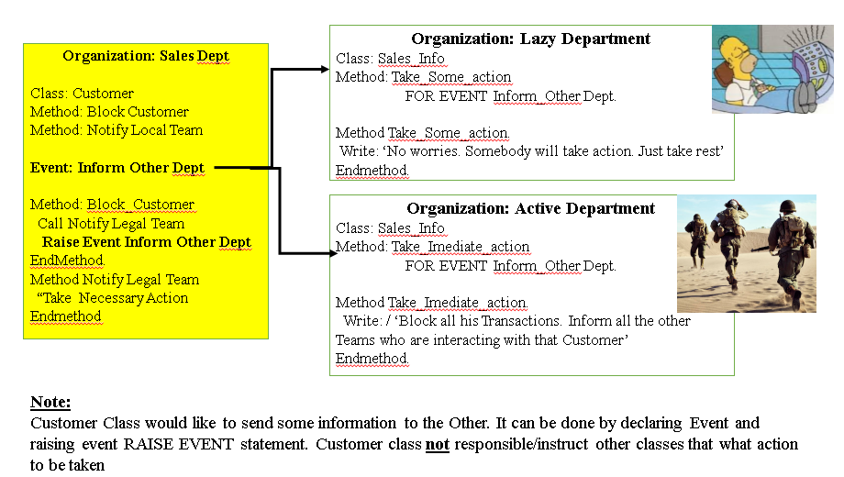

For implementing the Events we have certain steps

1. Declare Event in the Class 1
2. Raise Event in the Class 2
3. Implement Event Handler Method in Class 2
4. Link the Event Handler method of the Class 2 with Object of Class 1 while Consuming the Class1

## Program

### Class: Customer

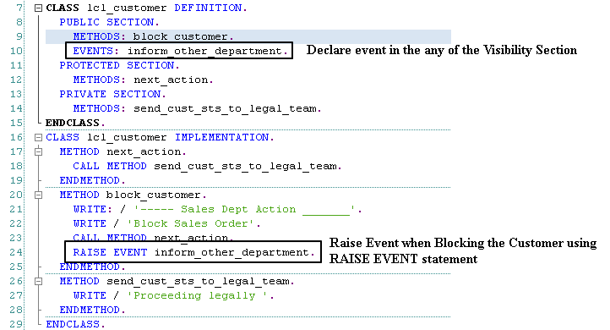

### Class: Lazy Department

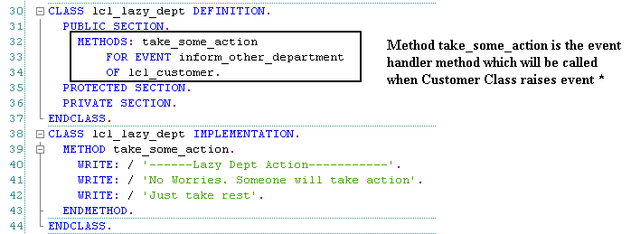

### Class: Active Department

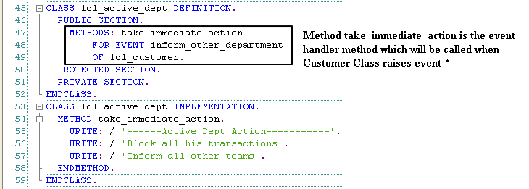

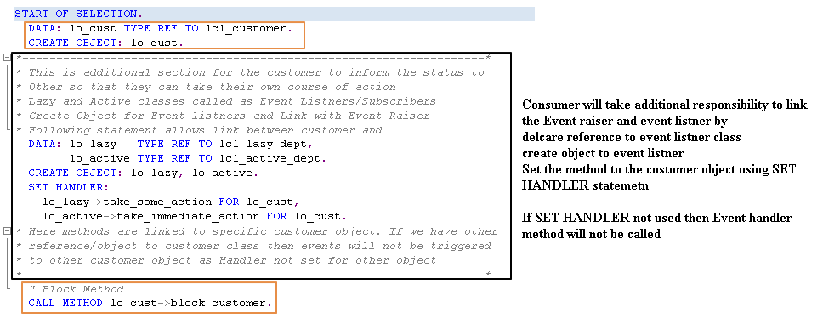

#### Complete Program

*&---------------------------------------------------------------------*  
*& Report ZTEST_OOPS_05  
*&---------------------------------------------------------------------*  
*&  
*&---------------------------------------------------------------------*  
REPORT ztest_oops_05.  
CLASS lcl_customer DEFINITION.  
  PUBLIC SECTION.  
    METHODS: block_customer.  
    EVENTS: inform_other_department.  
  PROTECTED SECTION.  
    METHODS: next_action.  
  PRIVATE SECTION.  
    METHODS: send_cust_sts_to_legal_team.  
ENDCLASS.  
CLASS lcl_customer IMPLEMENTATION.  
  METHOD next_action.  
    CALL METHOD send_cust_sts_to_legal_team.  
  ENDMETHOD.  
  METHOD block_customer.  
    WRITE: / '----- Sales Dept Action _______'.  
    WRITE / 'Block Sales Order'.  
    CALL METHOD next_action.  
    RAISE EVENT inform_other_department.  
  ENDMETHOD.  
  METHOD send_cust_sts_to_legal_team.  
    WRITE / 'Proceeding legally '.  
  ENDMETHOD.  
ENDCLASS.  
CLASS lcl_lazy_dept DEFINITION.  
  PUBLIC SECTION.  
    METHODS: take_some_action  
        FOR EVENT inform_other_department  
        OF lcl_customer.  
  PROTECTED SECTION.  
  PRIVATE SECTION.  
ENDCLASS.  
CLASS lcl_lazy_dept IMPLEMENTATION.  
  METHOD take_some_action.  
    WRITE: / '------Lazy Dept Action-----------'.  
    WRITE: / 'No Worries. Someone will take action'.  
    WRITE: / 'Just take rest'.  
  ENDMETHOD.  
ENDCLASS.  
CLASS lcl_active_dept DEFINITION.  
  PUBLIC SECTION.  
    METHODS: take_immediate_action  
        FOR EVENT inform_other_department  
        OF lcl_customer.  
  PROTECTED SECTION.  
  PRIVATE SECTION.  
ENDCLASS.  
CLASS lcl_active_dept IMPLEMENTATION.  
  METHOD take_immediate_action.  
    WRITE: / '------Active Dept Action-----------'.  
    WRITE: / 'Block all his transactions'.  
    WRITE: / 'Inform all other teams'.  
  ENDMETHOD.  
ENDCLASS.

START-OF-SELECTION.  
  DATA: lo_cust TYPE REF TO lcl_customer.  
  CREATE OBJECT: lo_cust.  
*--------------------------------------------------------------------*  
* This is additional section for the customer to inform the status to  
* Other so that they can take their own course of action  
* Lazy and Active classes called as Event Listners/Subscribers  
* Create Object for Event listners and Link with Event Raiser  
*   Following statement allows link between customer and  
  DATA: lo_lazy   TYPE REF TO lcl_lazy_dept,  
        lo_active TYPE REF TO lcl_active_dept.  
  CREATE OBJECT: lo_lazy, lo_active.  
  SET HANDLER:  
    lo_lazy->take_some_action FOR lo_cust,  
    lo_active->take_immediate_action FOR lo_cust.  
*--------------------------------------------------------------------*  
  " Block Method  
  CALL METHOD lo_cust->block_customer.

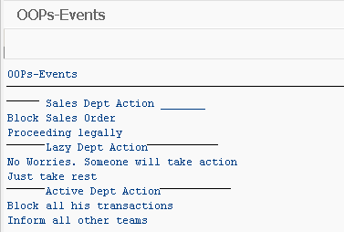

# Polymorphism

Polymorphism allows consumer to call several implementations with same name and interface parameters with same reference variable

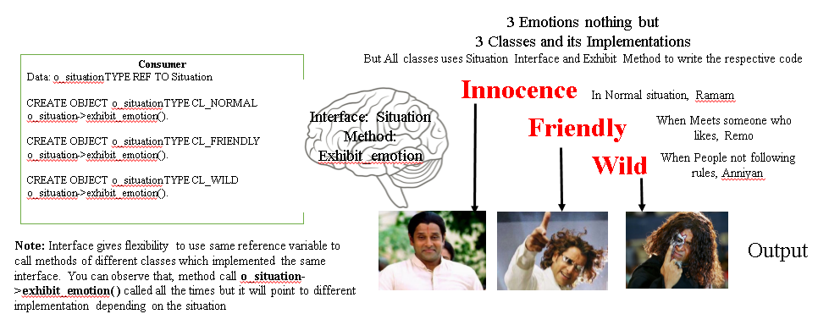

## Program

Interface Definition

Interface Implementation

Using Interface in the Consumer section

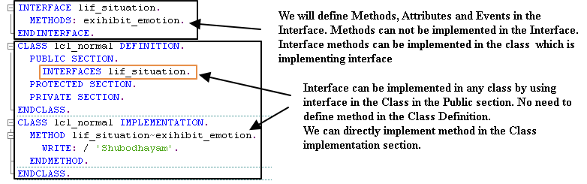

Other Classes implemented the Interface

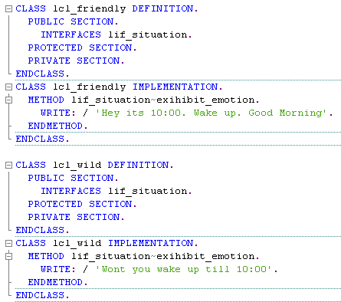

**Consuming the Classes**

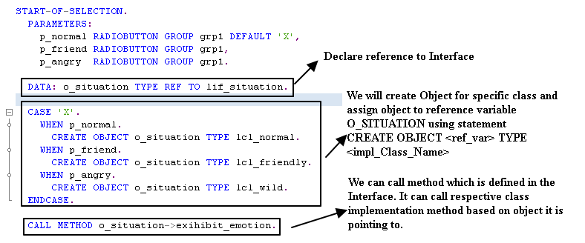

**Complete Program**

*&---------------------------------------------------------------------*  
*& Report ZTEST_OOPS_06  
*&---------------------------------------------------------------------*  
*&  
*&---------------------------------------------------------------------*  
REPORT ztest_oops_06.  
  
INTERFACE lif_situation.  
  METHODS: exihibit_emotion.  
ENDINTERFACE.  
CLASS lcl_normal DEFINITION.  
  PUBLIC SECTION.  
    INTERFACES lif_situation.  
  PROTECTED SECTION.  
  PRIVATE SECTION.  
ENDCLASS.  
CLASS lcl_normal IMPLEMENTATION.  
  METHOD lif_situation~exihibit_emotion.  
    WRITE: / 'Shubodhayam'.  
  ENDMETHOD.  
ENDCLASS.  
  
CLASS lcl_friendly DEFINITION.  
  PUBLIC SECTION.  
    INTERFACES lif_situation.  
  PROTECTED SECTION.  
  PRIVATE SECTION.  
ENDCLASS.  
CLASS lcl_friendly IMPLEMENTATION.  
  METHOD lif_situation~exihibit_emotion.  
    WRITE: / 'Hey its 10:00. Wake up. Good Morning'.  
  ENDMETHOD.  
ENDCLASS.  
  
CLASS lcl_wild DEFINITION.  
  PUBLIC SECTION.  
    INTERFACES lif_situation.  
  PROTECTED SECTION.  
  PRIVATE SECTION.  
ENDCLASS.  
CLASS lcl_wild IMPLEMENTATION.  
  METHOD lif_situation~exihibit_emotion.  
    WRITE: / 'Wont you wake up till 10:00'.  
  ENDMETHOD.  
ENDCLASS.  
  
START-OF-SELECTION.  
  PARAMETERS:  
    p_normal RADIOBUTTON GROUP grp1 DEFAULT 'X',  
    p_friend RADIOBUTTON GROUP grp1,  
    p_angry  RADIOBUTTON GROUP grp1.  
  
  DATA: o_situation TYPE REF TO lif_situation.  
  CASE 'X'.  
    WHEN p_normal.  
      CREATE OBJECT o_situation TYPE lcl_normal.  
    WHEN p_friend.  
      CREATE OBJECT o_situation TYPE lcl_friendly.  
    WHEN p_angry.  
      CREATE OBJECT o_situation TYPE lcl_wild.  
  ENDCASE.  
  
  CALL METHOD o_situation->exihibit_emotion.

Output:

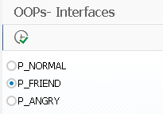

Execute

