Name: Nagaraju Emp.ID: 213495

# Assessment: Connect to your Azure SQL Database server

Contents

Assessment: Connect to your Azure SQL Database server 1

Steps: 1

1) Creating SQL Data Base 1

2) Connecting Database to Azure Data Studio 6

3) Create the tutorial database 8

4) Create a table 10

5) Insert rows into the table 11

6) View the result 12

Figure 1: Azure Storage account Dashboard 2

Figure 2: SQL database creation 2

Figure 3: Creating SQL Database in Azure 3

Figure 4: Creating SQL Database Server 4

Figure 5: SQL database ready to create 5

Figure 6: Create SQL Database in AZURE 6

Figure 7: Added the network firewall rules 6

Figure 8: Azure Database studio opened 7

Figure 9: Creating connection to the SQL database server 7

Figure 10: Azure SQL database server connected 8

Figure 11: Creating new query in connected DB server 8

Figure 12: Created a TutorialDB in Azure database server 9

Figure 13: TutorialDB got crated after running the SQL query 10

Figure 14: Creating table in TutorialDB database 11

Figure 15: Creating content in the table 12

Figure 16: Checking the Created table with select command 12

## Steps:

## Creating SQL Data Base

* Created Azure storage account using azure portal

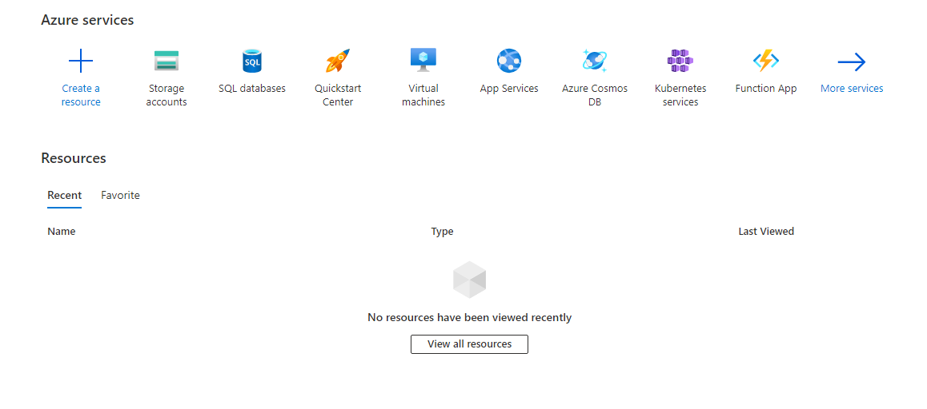

Figure 1: Azure Storage account Dashboard

* Open SQL Database dashboard to create database

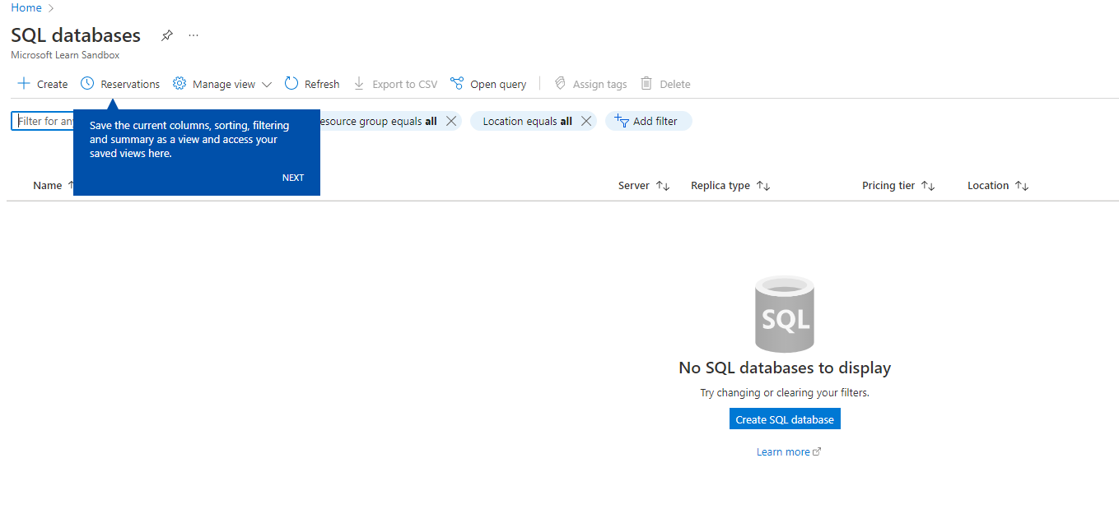

Figure 2: SQL database creation

* Create sample SQL Database

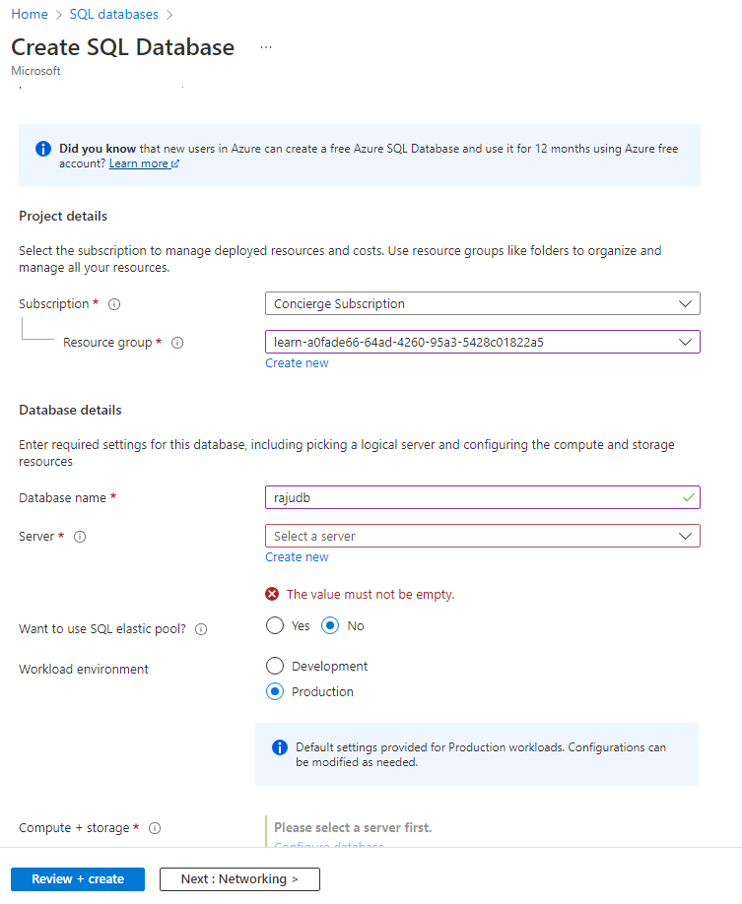

Figure 3: Creating SQL Database in Azure

* Created sample SQL Database sever

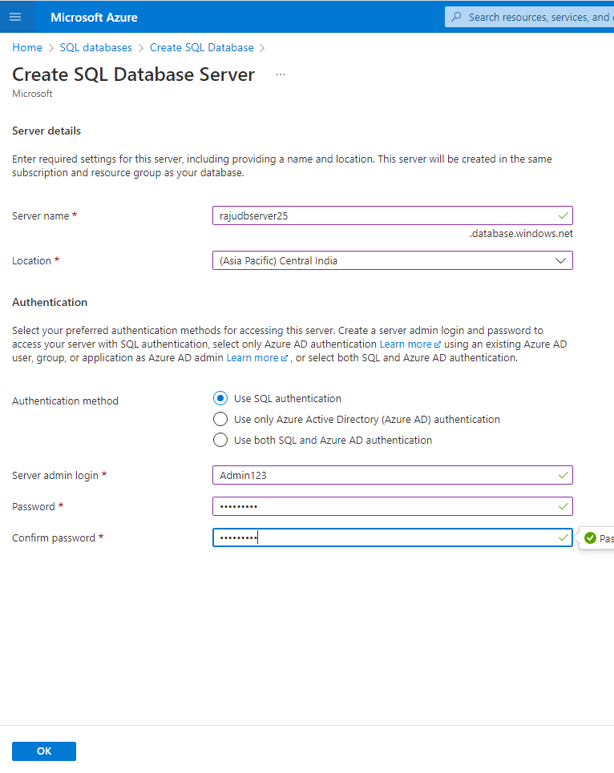

Figure 4: Creating SQL Database Server

* Validated Database inputs and tap on Create sample SQL Database

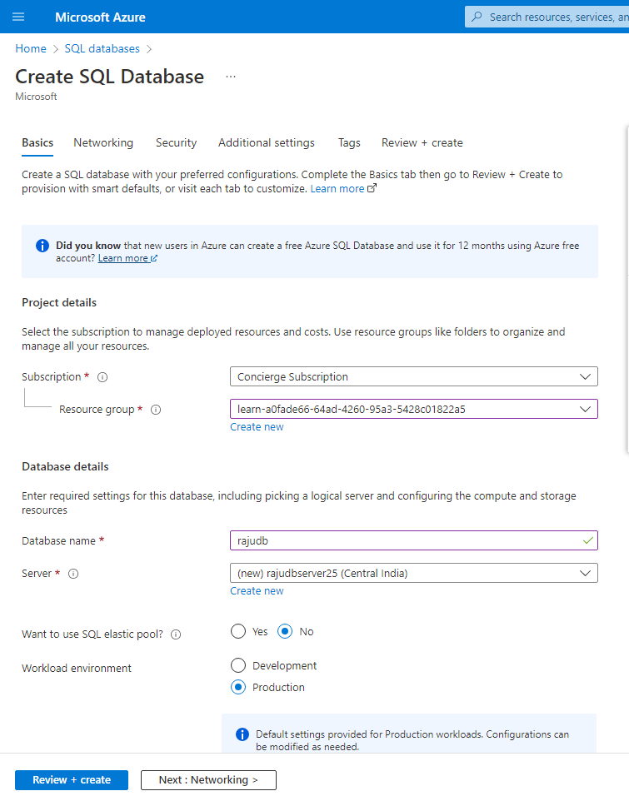

Figure 5: SQL database ready to create

* Database Got Created

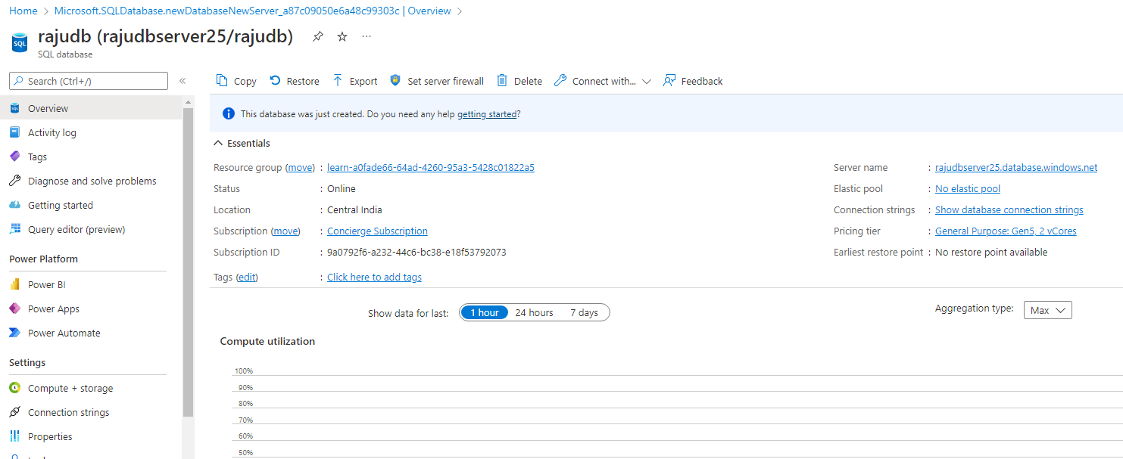

Figure 6: Create SQL Database in AZURE

* Added Network firewall rules to connect the server

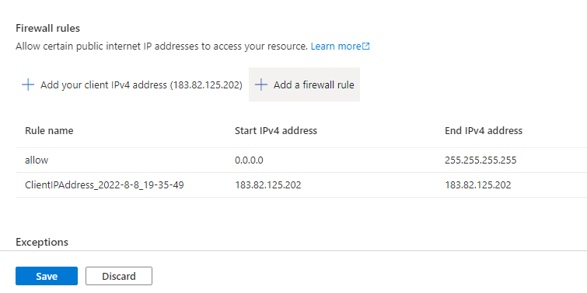

Figure 7: Added the network firewall rules

## Connecting Database to Azure Data Studio

* Opened **Azure Data Studio** to establish a connection to your Azure SQL Database server.
* Tap on **Create a connection** to connect to Azure Database

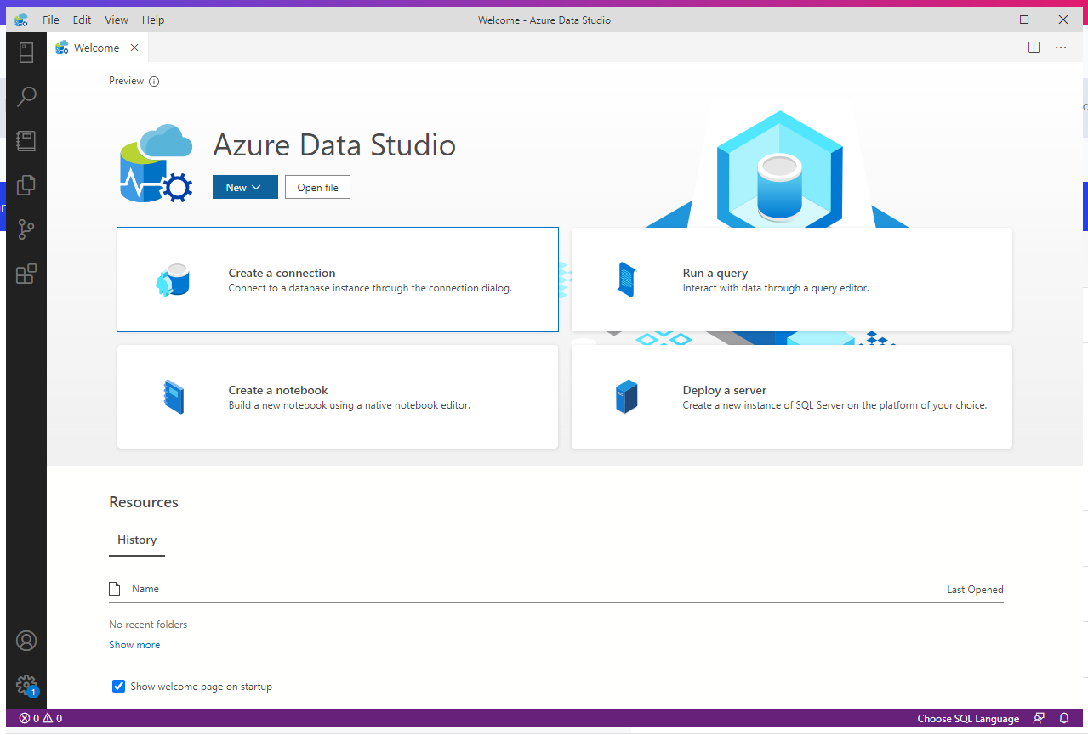

Figure 8: Azure Database studio opened

* Connect to Azure Database with server authentication details

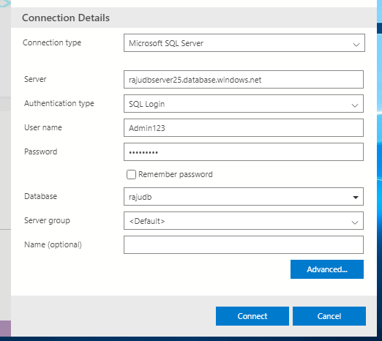

Figure 9: Creating connection to the SQL database server

* Azure Database server is connected successfully with Azure Data Studio.

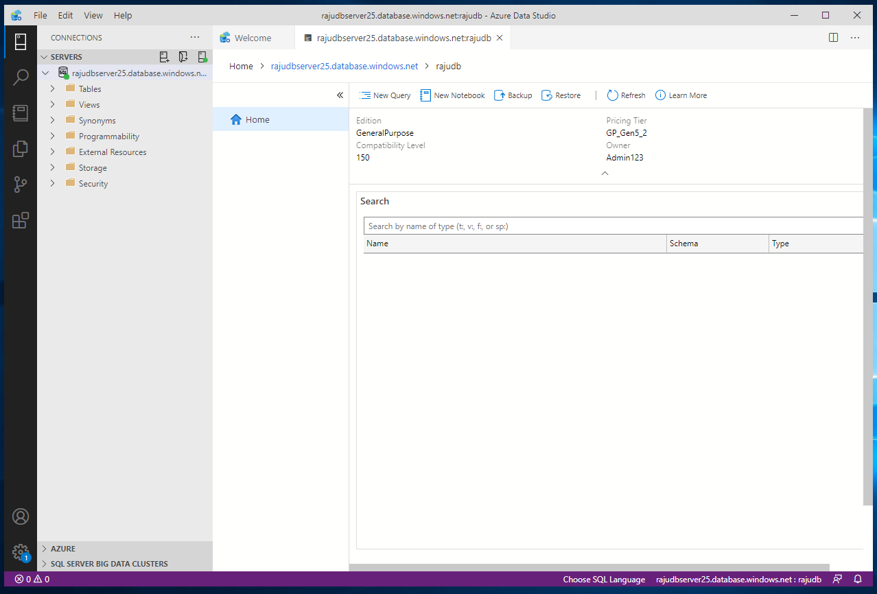

Figure 10: Azure SQL database server connected

## Create the tutorial database

* Right-click on your Azure SQL server in the SERVERS sidebar and select New Query.

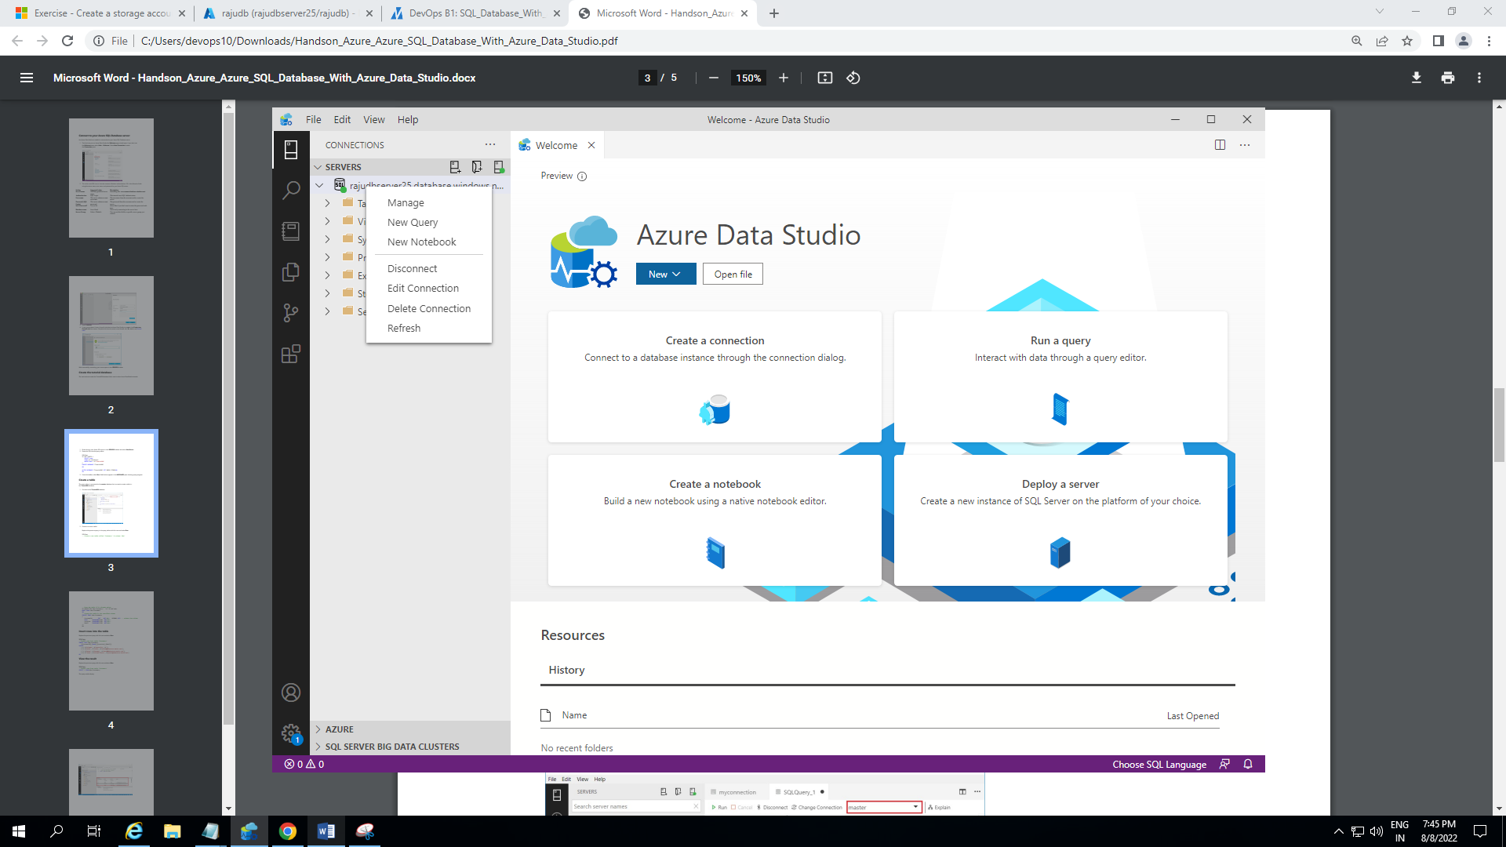

Figure 11: Creating new query in connected DB server

* Pasted below SQL into the query editor.

IF NOT EXISTS (

SELECT name

FROM sys.databases

WHERE name = N'TutorialDB'

)

CREATE DATABASE [TutorialDB]

GO

ALTER DATABASE [TutorialDB] SET QUERY_STORE=ON

GO

* From the toolbar, selected Run. Notifications appear in the MESSAGES pane showing query progress.

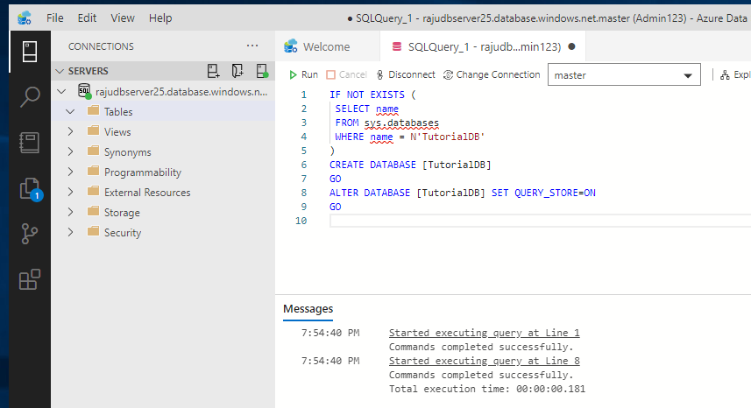

Figure 12: Created a TutorialDB in Azure database server

* **TutorialDB** database created in Azure database server

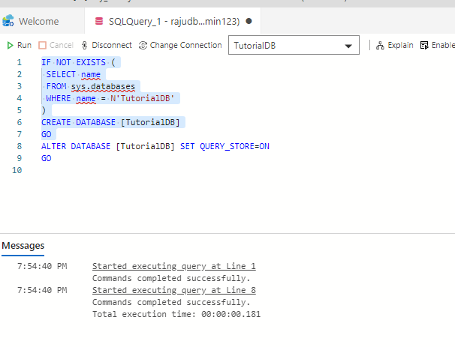

Figure 13: TutorialDB got crated after running the SQL query

## Create a table

* The query editor is connected to the master database, changed to the **TutorialDB** database.
* Created a *Customers* table with following SQL query.

-- Create a new table called 'Customers' in schema 'dbo'

-- Drop the table if it already exists

IF OBJECT_ID('dbo.Customers', 'U') IS NOT NULL

DROP TABLE dbo.Customers

GO

-- Create the table in the specified schema

CREATE TABLE dbo.Customers

(

 CustomerId INT NOT NULL PRIMARY KEY, -- primary key column

 Name [NVARCHAR](50) NOT NULL,

 Location [NVARCHAR](50) NOT NULL,

 Email [NVARCHAR](50) NOT NULL

);

GO

* Run the Query and table got created in **TutorialDB** database

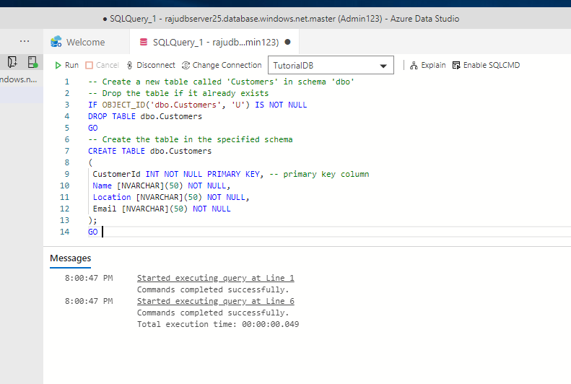

Figure 14: Creating table in TutorialDB database

## Insert rows into the table

* **Run** below query which is the table content is inserted in table.

INSERT INTO dbo.Customers

 ([CustomerId],[Name],[Location],[Email])

VALUES

 ( 1, N'Orlando', N'Australia', N''),

 ( 2, N'Keith', N'India', N'keith0@adventure-works.com'),

 ( 3, N'Donna', N'Germany', N'donna0@adventure-works.com'),

 ( 4, N'Janet', N'United States', N'janet1@adventure-works.com')

GO

* Content in the table got created after run the query

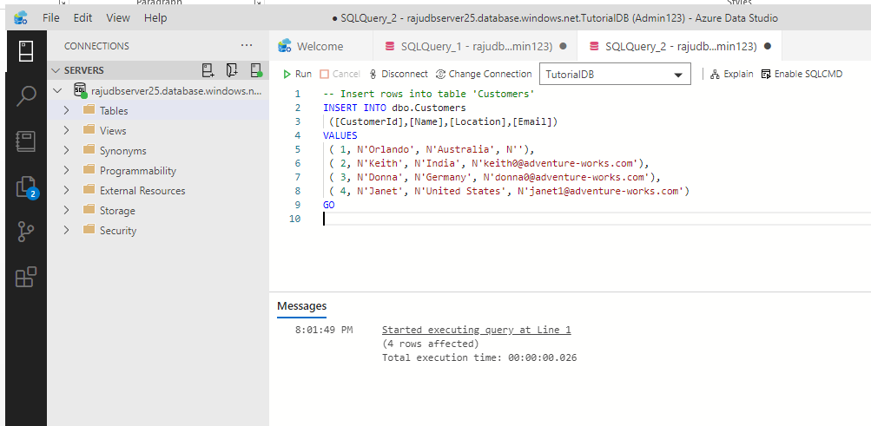

Figure 15: Creating content in the table

## View the result

* Run the below query to check the result

-- Select rows from table 'Customers'

SELECT * FROM dbo.Customers;

* Which results the created table with content

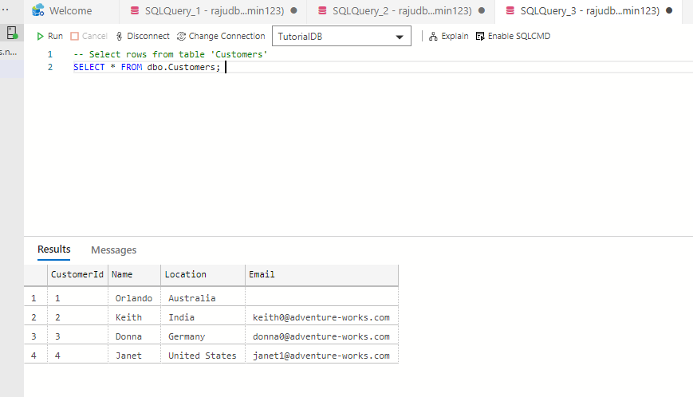

Figure 16: Checking the Created table with select command

* Created **TutoriaDB** database reflected in Azure SQL data base which is created through **Azure Data Studio.**

