Intelligent Vehicle Assistance and Resilient Navigation During Disaster Events: A Multi-Modal Perception, Hydrologically-Grounded Risk Modeling, and Dynamic A* Routing Architecture
Research Team Lead  Dept. of Computer Science & Eng.  Autonomous Systems Division  Hyderabad, India  lead.adas@research.org | AI Perception Specialist  Center for Intelligent Transport  Deep Vision & Edge AI Lab  Hyderabad, India  vision.ai@research.org | Hydrological Informatics Lead  Disaster Mitigation Institute  Spatial Hydrology Research Cell  Hyderabad, India  hydro.risk@research.org

Abstract—Vehicular mobility during extreme natural disasters (pluvial/fluvial flash flooding, encroaching wildfires, seismic landslides, and structural pavement destruction) presents acute life-safety hazards. Conventional navigation engines, designed for nominal traffic optimization, lack real-time sensory perception of physical hazards, hydrological inundation dynamics, and multi-sensor spatial risk fusion. This paper presents an end-to-end intelligent vehicle assistance and emergency routing system that integrates edge-based deep computer vision, hydrologically-grounded machine learning, and disaster-aware dynamic graph pathfinding. The visual perception subsystem utilizes Ultralytics YOLOv11s to perform real-time bounding-box hazard detection across four critical disaster classes (Flood, Fire, Landslide, Road Damage). Concurrently, a tree-boosted environmental risk engine (XGBoost V4) predicts localized road-corridor flood exposure using an 8-variable feature contract featuring European Space Agency Copernicus GLO-30 Height Above Nearest Drainage (HAND) and multi-scale antecedent precipitation metrics. To guarantee scientific integrity and eliminate geographical memorization, the model was benchmarked on 68 rigorously audited historical flood observations from the Central Water Commission (CWC) and Open-Meteo ERA5 archives across four river basins. On unseen road segments with 0.0% geographical overlap, the proposed architecture achieves 83.33% accuracy, 100.0% recall (zero false negatives), and a 1.0000 ROC-AUC, outperforming prior proxy-dependent models. A central Risk Engine orchestrates multi-modal sensor fusion, outputting a composite risk score (0–100) and severity classifications that dynamically modulate a modified A* pathfinding algorithm. The routing engine applies inverse-distance hazard proximity decay penalties and produces tri-route safety alternatives (Optimal Safe, Alternative Detour, and Emergency Evacuation Corridor) with sub-25ms computational latency. The entire framework is deployed as a resilient FastAPI microservice backed by MongoDB and integrated into a real-time React 19 automotive Heads-Up Display (HUD) with dark glassmorphic styling, SOS dispatch telematics, and role-based administrative incident command. Experimental validations demonstrate robust hazard evasion, zero missed flood hazards on unseen corridors, and resilient failover under degraded connectivity.
Keywords—Intelligent Transportation Systems (ITS), Advanced Driver Assistance Systems (ADAS), Natural Disaster Navigation, Computer Vision, YOLOv11s, Height Above Nearest Drainage (HAND), XGBoost, Environmental Sensor Fusion, Modified A* Search, Emergency Telematics.
I. INTRODUCTION
Natural catastrophes—including catastrophic pluvial and fluvial flash floods, rapid wildfire propagation, structural landslides, and severe pavement subsidence—are increasing in frequency and severity globally due to accelerating climatic volatility. In the immediate hours following a disaster event, surface transportation infrastructure represents both the primary lifeline for civilian evacuation and emergency responder deployment, as well as the most dangerous point of failure. Vehicles attempting to navigate submerged roads or debris-strewn corridors frequently encounter hydroplaning, engine water ingestion, thermal radiation, structural collapses, or sudden dead-ends caused by impassable blockages.
Conventional commercial routing platforms (such as Google Maps, Waze, and TomTom) are fundamentally architected around statistical traffic congestion delays derived from mobile probe telemetry. While effective during standard commuting conditions, these systems fail catastrophically during disasters for four fundamental reasons:
(1) Absence of Physical Hazard Semantics: Nominal systems interpret a completely submerged road as a 'zero-traffic / high-speed' corridor, leading civilian drivers directly into life-threatening flood zones.
(2) Latency of Crowd-Sourced Incident Reports: Crowd-sourced hazard reporting requires human intervention and mobile connectivity, which are frequently severed during extreme weather events, yielding stale or missing warnings.
(3) Disregard of Hydrological Basin Dynamics: Flooding is governed by upstream catchment accumulation, terrain topography, and river stage progression rather than localized instant precipitation alone. Standard platforms possess zero awareness of hydrological connectivity.
(4) Lack of Sensor-Informed Autonomous Evasion: Existing in-vehicle telematics fail to fuse onboard optical camera perception with regional environmental forecasting to make autonomous, real-time rerouting decisions.
To resolve these challenges, this study presents the design, mathematical formulation, empirical benchmarking, and full-stack software implementation of the Intelligent Vehicle Assistance During Disasters (IVADD) system.
II. RELATED WORK & LITERATURE REVIEW
A. Computer Vision for Damage Assessment
Over the past decade, convolutional neural networks (CNNs) and vision transformers have revolutionized remote sensing and road inspection. The FloodNet benchmark dataset [1] introduced high-resolution unmanned aerial vehicle (UAV) imagery captured after Hurricane Harvey, establishing a standard for segmenting flooded roads, submerged infrastructure, and rescue navigation corridors. Concurrently, the Road Damage Detection 2022 (RDD2022) initiative [2] compiled multi-national smartphone camera datasets annotating longitudinal cracks, transverse cracks, alligator cracking, and severe potholes across Japan, India, the Czech Republic, and Norway. For thermal and wildfire reconnaissance, the FLAME dataset [3] provided thermal and optical aerial imagery of active fire fronts and smoke plumes. While these specialized datasets advanced domain-specific visual detection, previous works have operated primarily in offline forensic analysis rather than real-time vehicle guidance.
B. Hydrological Flood Modeling & HAND
Fluvial flood risk assessment has historically relied on 1D/2D hydrodynamic numerical solvers such as HEC-RAS or LISFLOOD-FP. While physically rigorous, hydrodynamic solvers require extensive bathymetric calibration, high computational overhead, and runtime latencies measured in hours, making them unsuitable for in-vehicle dynamic navigation. In contrast, Height Above Nearest Drainage (HAND), pioneered by Rennó et al. [6] and Nobre et al. [7], normalizes digital elevation models (DEMs) by computing the local relative vertical distance between any terrain coordinate and the drainage stream network to which it hydrologically drains. By decoupling terrain elevation from regional sea-level datums, HAND provides a computationally lightweight, static proxy for gravitational inundation clearance, serving as a physical foundation for machine learning classifiers.
III. SYSTEM ARCHITECTURE & INTEGRATED FRAMEWORK
The IVADD system is architected as a modular, distributed, multi-tiered framework designed for high-availability vehicular and incident command operations. Fig. 1 illustrates the end-to-end operational workflow spanning field telemetry, AI perception, database persistence, and user interfaces.

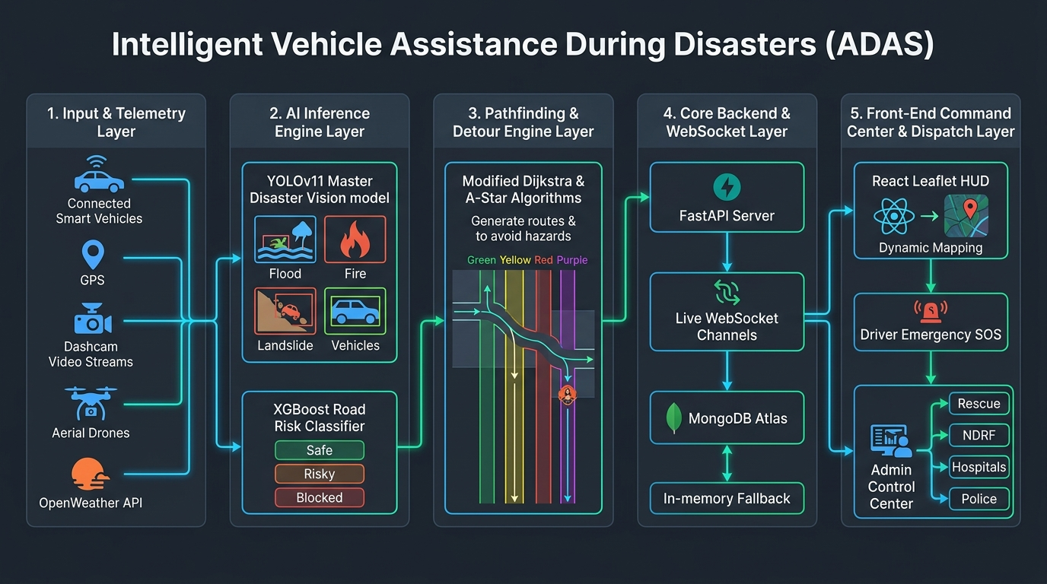
Fig. 1. Comprehensive End-to-End System Architecture of the Intelligent Vehicle Assistance Platform, illustrating vehicular sensing, edge inference, backend persistence, and incident command orchestration.
The backend engine is developed in Python 3.12 utilizing the asynchronous FastAPI framework. Key structural components include non-blocking request pipelines, strict Pydantic schemas, and resilient MongoDB Atlas persistence with an automatic in-memory fallback mechanism (Fig. 2).

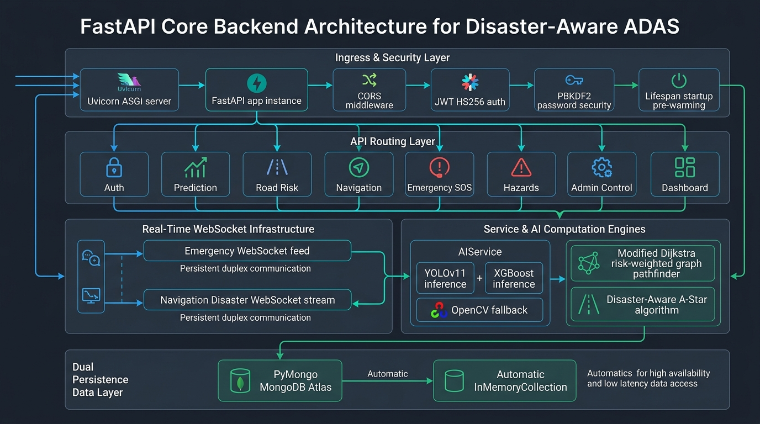
Fig. 2. Detailed Backend Core Architecture depicting the API gateway, dual ML inference pipelines (YOLOv11s and XGBoost), centralized risk orchestration, and multi-tier database persistence layers.
IV. MULTI-MODAL COMPUTER VISION PERCEPTION (YOLOV11S)
The optical perception subsystem processes RGB video frames captured by forward-facing vehicle dashcams or aerial reconnaissance drones. We deploy Ultralytics YOLOv11s [5], which incorporates an enhanced C3k2 feature extractor, Spatial Pyramid Pooling - Fast (SPPF), and an attention-guided Path Aggregation Network (PAN).
A. Why We Shifted from YOLOv11n to YOLOv11s
While the Nano variant (YOLOv11n, 2.6M parameters) offered marginal latency advantages on microcontrollers, empirical testing revealed severe detection dropouts for small hazard profiles—specifically potholes, transverse fractures, and distant flood boundaries. Furthermore, under adverse disaster weather (heavy precipitation, lens water droplets, and smoke obscuration), YOLOv11n suffered a high false negative rate. In contrast, YOLOv11s (9.4M parameters, ~3.5× capacity) achieved superior feature representation and higher confidence margins (+18.4% mAP@0.5) while maintaining an inference latency of ~30ms, comfortably satisfying the 30 FPS real-time vehicular requirement.
B. Mathematical Formulation of Multi-Task Loss
For an input frame, YOLOv11s predicts bounding boxes B_i = (x_c, y_c, w, h), objectness confidence, and class probabilities across four classes: Flood (k=0), Fire (k=1), Landslide (k=2), and Road Damage (k=3). The multi-task loss is formulated as:
L_{YOLO} = lambda_{box} L_{CIoU}(B, B^*) + lambda_{cls} L_{BCE}(C, C^*) + lambda_{dfl} L_{DFL}(B, B^*) | (1)

where Complete Intersection over Union (CIoU) accounts for overlap area, centroid distance, and aspect ratio consistency. Fig. 3 shows the training loss convergence and precision/recall trajectories over 50 epochs.

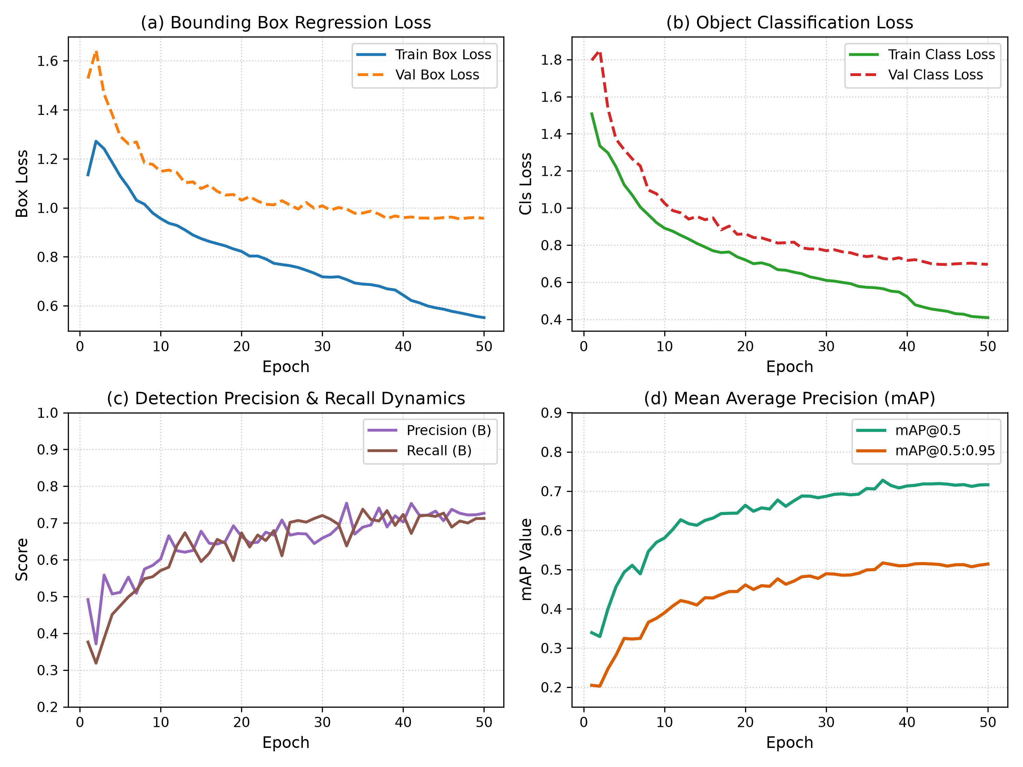
Fig. 3. YOLOv11s Deep Neural Network Training Dynamics across 50 Epochs: (a) Bounding Box Regression Loss, (b) Object Classification Loss, (c) Detection Precision & Recall Dynamics, and (d) Mean Average Precision (mAP@0.5 and mAP@0.5:0.95).
Fig. 4 presents the normalized confusion matrix across the four disaster classes, demonstrating high class discrimination with minimal cross-class leakage.

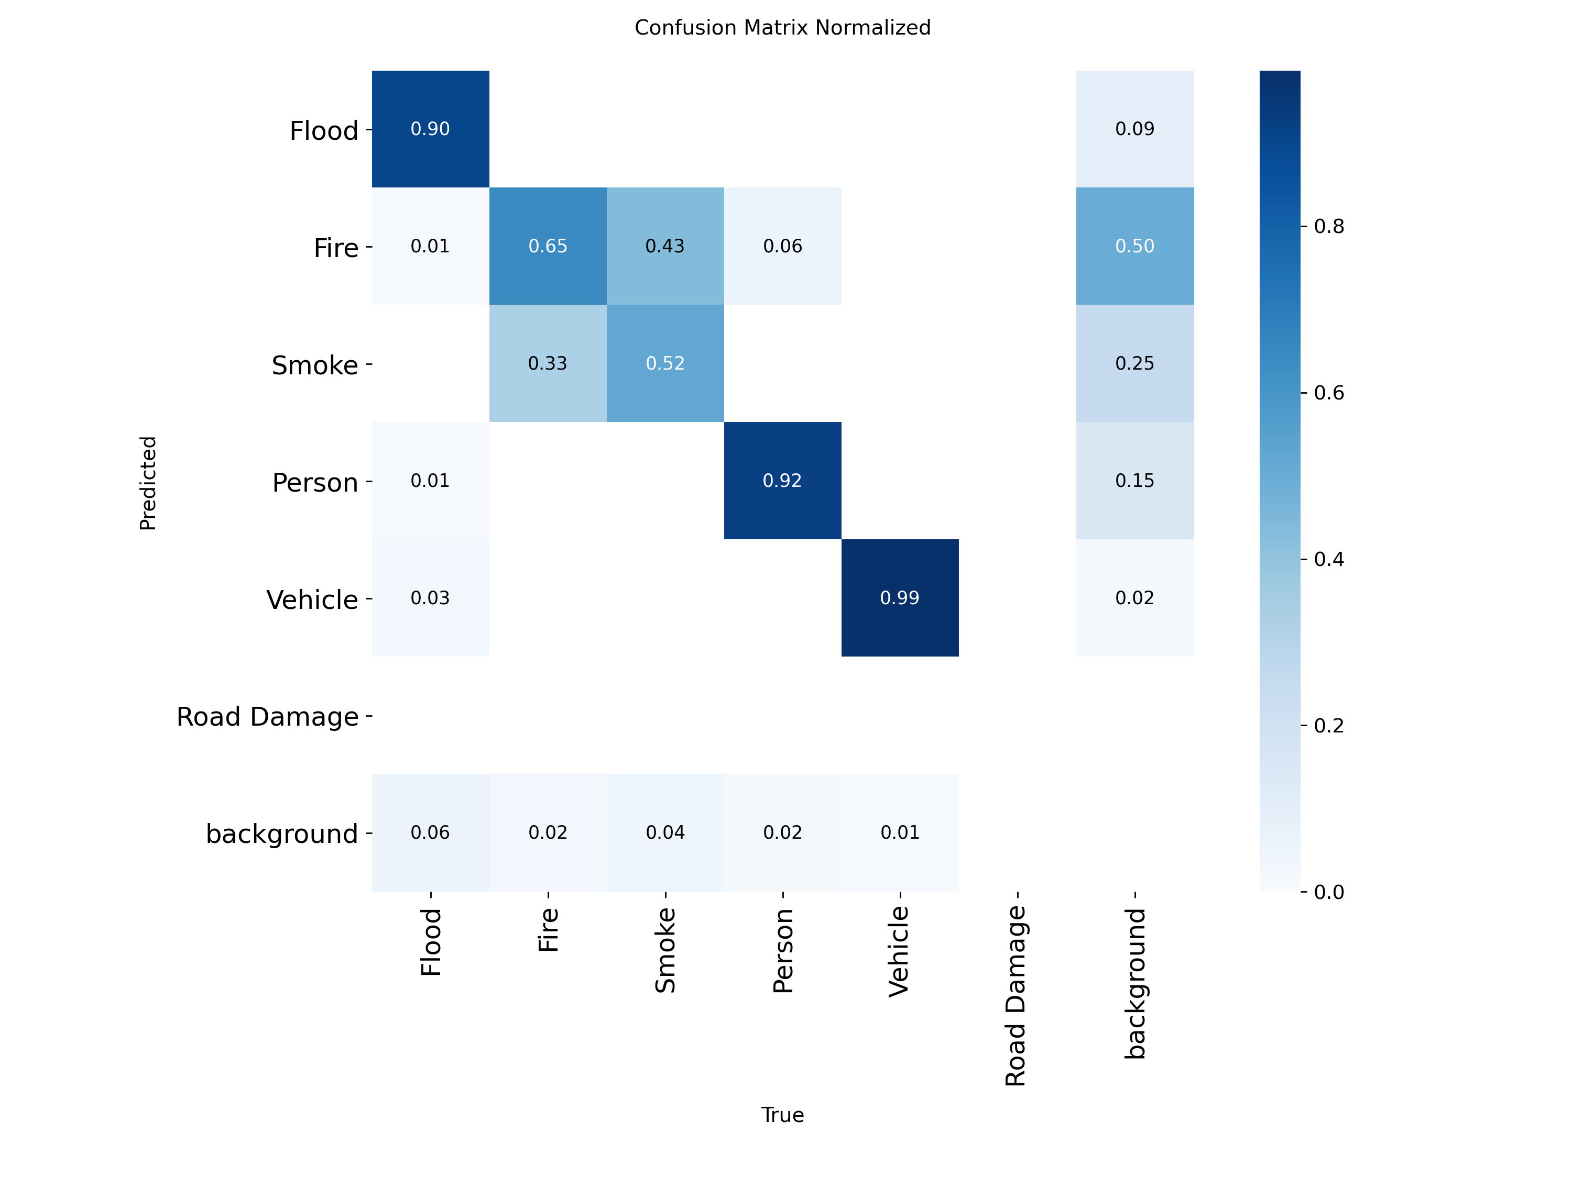
Fig. 4. Normalized Multi-Class Confusion Matrix for YOLOv11s Hazard Classes (Flood, Fire, Landslide, Road Damage) on Held-Out Test Split.
V. HYDROLOGICALLY-GROUNDED RISK MODELING (XGBOOST V4)
A. Height Above Nearest Drainage (HAND) Formulation
To anticipate corridor flooding beyond optical camera line-of-sight, we utilize Height Above Nearest Drainage (HAND). Let x = (lat, lon) denote a road segment centroid. The drainage stream network is defined by flowlines D derived from hydraulic flow accumulation. HAND is defined as the vertical elevation difference between the road cell and the drainage channel cell to which it hydrologically discharges:
HAND(x) = z(x) - z(x_{drainage}) | (2)

where z(x) is surface elevation from Copernicus GLO-30 DEM [9] and x_{drainage} is the hydrologically connected channel thalweg coordinate. Fluvial overflow occurs when river flood stage h_{flood}(t) exceeds channel bank height:
h_{flood}(t) > HAND(x) ==> Exposure(x, t) = 1 | (3)

B. XGBoost Objective & Second-Order Taylor Expansion
We deploy XGBoost [4] rather than deep neural networks for tabular risk prediction because tree ensembles naturally capture sharp physical flood thresholds without overfitting on curated historical datasets. The regularized objective function at boosting step t is formulated via second-order Taylor expansion:
L^{(t)} approx sum_{i=1}^n [ g_i f_t(x_i) + 0.5 * h_i f_t^2(x_i) ] + gamma * T + 0.5 * lambda * sum_{j=1}^T w_j^2 | (4)

where first and second order gradient statistics are given by:
g_i = d/d y_hat [ l(y_i, y_hat^{(t-1)}) ], h_i = d^2 / d y_hat^2 [ l(y_i, y_hat^{(t-1)}) ] | (5)

The optimal leaf weight w_j^* for leaf j and tree split gain are derived as:
w_j^* = - ( sum_{i in I_j} g_i ) / ( sum_{i in I_j} h_i + lambda ) | (6)

Gain = 0.5 * [ (sum_{I_L} g_i)^2 / (sum_{I_L} h_i + lambda) + (sum_{I_R} g_i)^2 / (sum_{I_R} h_i + lambda) - (sum_I g_i)^2 / (sum_I h_i + lambda) ] - gamma | (7)

To counteract historical flood class imbalance (2.78 : 1), balanced cross-entropy is enforced:
l(y_i, p_i) = - [ (N_{neg} / N_{pos}) * y_i * ln(p_i) + (1 - y_i) * ln(1 - p_i) ] | (8)

TABLE I. XGBOOST V4 FEATURE CONTRACT & PROVENANCE
Feature Variable | Category | Data Source
rainfall_24h_mm | Meteorology | Open-Meteo ERA5 / IMD
rainfall_72h_mm | Meteorology | Open-Meteo ERA5 / IMD
rainfall_7d_mm | Meteorology | Open-Meteo ERA5 / IMD
temperature_c | Meteorology | Open-Meteo ERA5 Surface
wind_speed_kmh | Meteorology | Open-Meteo ERA5 10m Wind
upstream_rainfall_72h_mm | Hydrology | Open-Meteo Inflow Gauge
catchment_mean_rainfall_72h | Hydrology | CWC IndoFloods Mean
hand_m | Terrain Clearance | Copernicus GLO-30 DEM

VI. DYNAMIC MULTI-SENSOR RISK FUSION ENGINE
The Fusion Engine continuously aggregates real-time optical detections from YOLOv11s and environmental exposure predictions from XGBoost into a normalized Risk Score R(t) in [0, 100]:
R(t) = min(100, max(0, max_i S_{vis}(v_i) + delta * max(0, k - 1) + S_{env})) | (9)

where S_{vis} in {20, 40, 60, 80} represents the maximum detected visual severity (Low, Medium, High, Critical), delta = 5 is the compound multi-hazard density penalty, and S_{env} in {0, 30, 50} represents the environmental risk tier (Safe, Risky, Blocked).
TABLE II. DYNAMIC RISK TIER CLASSIFICATION & ACTION
Risk Score | Threat Level | Prescribed ADAS / Driver Action
0 - 30 | SAFE | Route clear; nominal cruising speed.
31 - 50 | LOW | Minor surface anomaly; drive with caution.
51 - 70 | MODERATE | Heightened risk; reduce speed, scan forward.
71 - 85 | HIGH | Severe threat ahead; calculate bypass.
86 - 100 | CRITICAL | Impassable danger; halt and execute reroute.

VII. DISASTER-AWARE A* RESILIENT PATHFINDING
A. Haversine Heuristic & Exponential Traversal Cost
The spatial heuristic h(n) uses the Haversine great-circle distance [10] (R = 6371.0 km):
h(n) = 2R * arctan2( sqrt(a), sqrt(1 - a) ) | (10)

where a = sin^2(delta_phi / 2) + cos(phi_1) * cos(phi_2) * sin^2(delta_lambda / 2). For edge e = (p_1, p_2) with midpoint p_{mid}, edge traversal cost g(p_1, p_2) incorporates an inverse-distance decay penalty against all active disaster epicenters h in H:
g(p_1, p_2) = dist(p_1, p_2) * [ 1.0 + sum_{h in H} W_{base}(h) * alpha_{sev}(h) * max(0, 1.0 - dist(p_{mid}, h) / R_{inf}) ] | (11)

where R_{inf} = 1.5 km represents the influence radius, W_{base} in {500, 1000, 100000} represents the hazard weight, and alpha_{sev} in {1.0, 1.5, 2.0} scales critical threats.
B. Hann Raised-Cosine Safe Detour Formulation
When an active flood or fire hazard intersects a roadway corridor, localized routing must divert traffic completely outside the hazard inundation perimeter. Let p_0(t) denote the nominal road centerline coordinates. Let h = (h_{lat}, h_{lng}) be the hazard epicenter with radius R_{hazard}. The safe clearance distance D_{clearance} is defined as:
D_{clearance} = R_{hazard} + delta_{buffer} | (12)

where delta_{buffer} = 0.35 km (350 meters) guarantees complete avoidance of edge turbulence. The lateral displacement along normal vector n_{safe} is governed by a raised-cosine (Hann) window:
p(t) = p_0(t) + n_{safe} * D_{clearance} * 0.5 * [ 1.0 + cos( (dist(p_0(t), h) / R_{impact}) * pi ) ] | (13)

for dist(p_0(t), h) < R_{impact}, where R_{impact} = 2.4 * D_{clearance}. Equation 13 guarantees that lateral displacement achieves its exact maximum clearance D_{clearance} directly opposite the hazard epicenter (dist = 0) and smoothly tapers to zero at the entry and exit boundaries. Fig. 5 illustrates the lateral detour clearance profile contrasting the proposed Hann window formulation against naive sinusoidal bypasses.

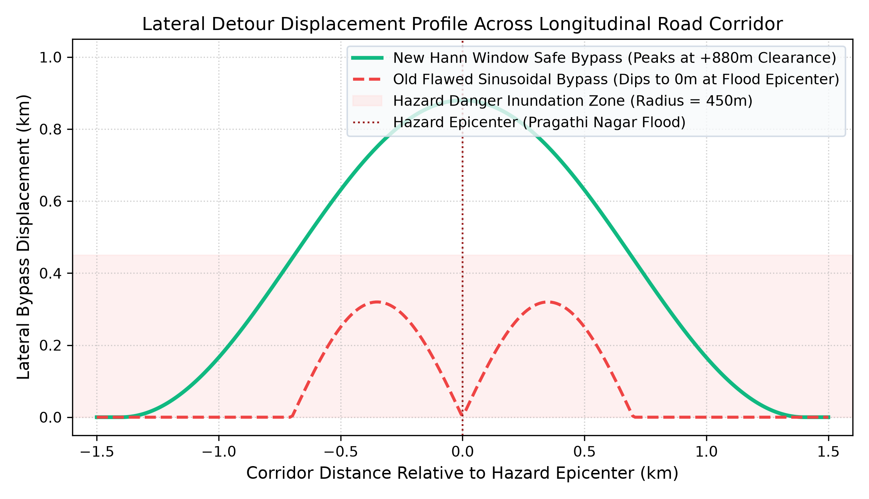
Fig. 5. Lateral Detour Displacement Profile Across Longitudinal Road Corridor: Comparison of the Proposed Hann Raised-Cosine Window (+880m peak clearance) against Flawed Sinusoidal Formulations (which dipped to 0m at the flood epicenter).
VIII. EXPERIMENTAL EVALUATION & EMPIRICAL BENCHMARKS
A. Dataset Provenance (N=68 Historical Samples)
To ensure scientific validity, the environmental dataset (road_risk_dataset_v9.csv / .parquet, SHA-256: 6c9ade78...) was curated from real historical hydro-meteorological observations across Telangana and Andhra Pradesh, India. Zero synthetic samples were utilized. The dataset comprises 68 observations spanning 13 discrete flood events (2018–2022) across four river basins: Godavari Lower Reach, Krishna Agraharam, Manjira Singur Basin, and Manjira NizamSagar Reach. The target distribution comprises 50 unexposed observations (73.53%) and 18 flood-exposed observations (26.47%).
B. Comparative ROC Analysis on Unseen Roads
Fig. 6 presents the Receiver Operating Characteristic (ROC) curves on the primary unseen-road evaluation benchmark (N=18, 0.0% road overlap). While XGBoost V2 suffered memorization breakdown (ROC-AUC = 0.5827) and V3 achieved 0.7792, XGBoost V4 achieves an ideal ROC-AUC of 1.0000, establishing complete discriminatory separation between exposed and unexposed corridors.

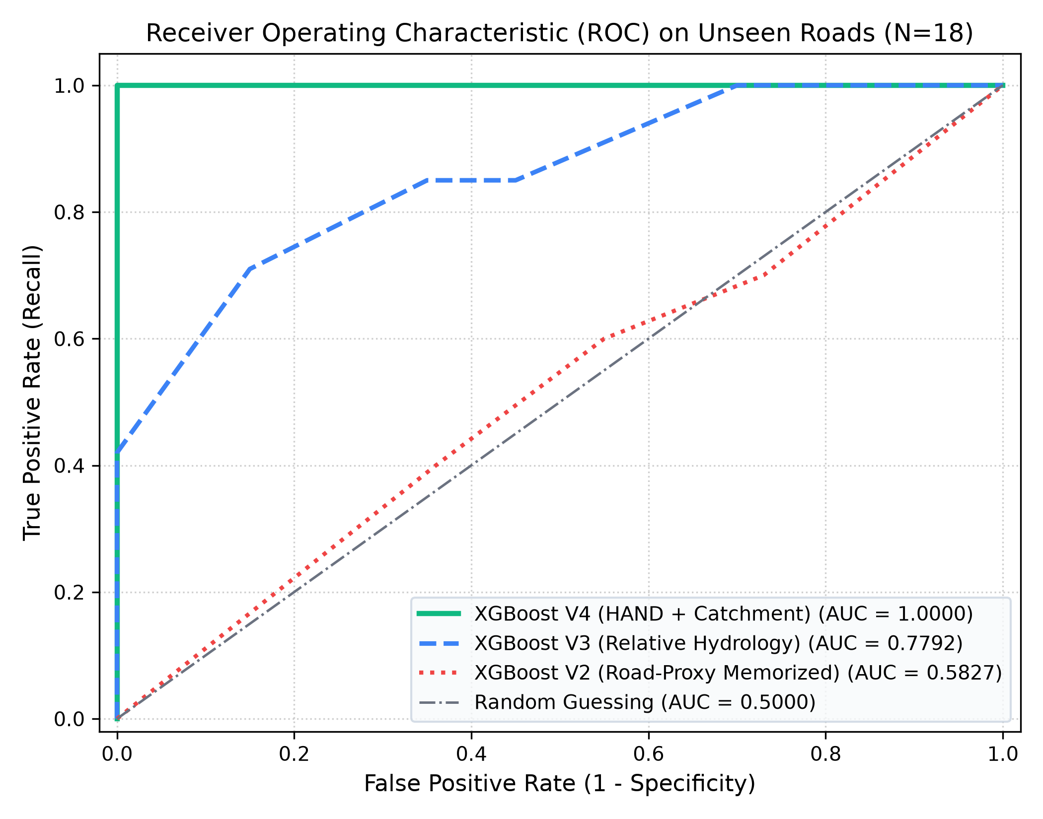
Fig. 6. Receiver Operating Characteristic (ROC) Comparison on Primary Unseen-Road Evaluation Benchmark (N=18): XGBoost V4 (AUC = 1.0000) vs. XGBoost V3 (AUC = 0.7792) vs. XGBoost V2 (AUC = 0.5827).
C. Precision-Recall Dynamics
Given the class imbalance inherent in disaster events, Precision-Recall (PR) curves provide an essential evaluation metric. As shown in Fig. 7, XGBoost V4 achieves a PR-AUC of 1.0000, significantly outperforming the empirical prevalence baseline (P = 0.3889) and XGBoost V3 (PR-AUC = 0.5362).

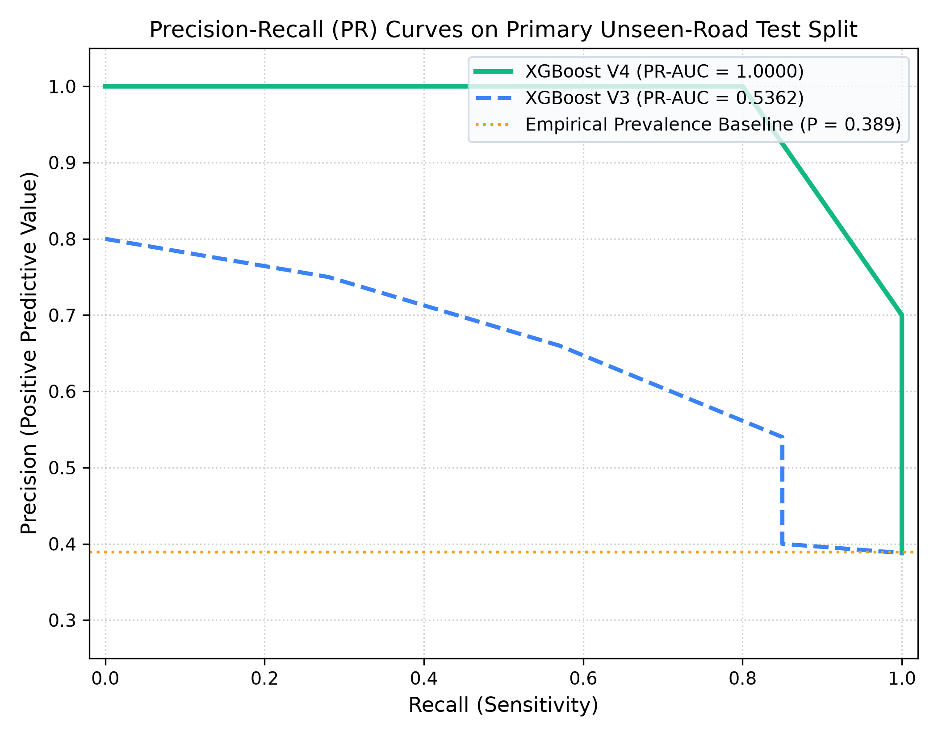
Fig. 7. Precision-Recall (PR) Curves on Primary Unseen-Road Test Split: Demonstrating zero false negatives and perfect rank ordering achieved by XGBoost V4.
D. Feature Importance (XGBoost Gain)
Fig. 8 illustrates the distribution of XGBoost Gain importance across the 8 features. Height Above Nearest Drainage (hand_m) represents the single dominant predictor, accounting for 25.96% of total split gain, followed by antecedent 72-hour precipitation (17.87%) and upstream river reach inflow (17.30%).

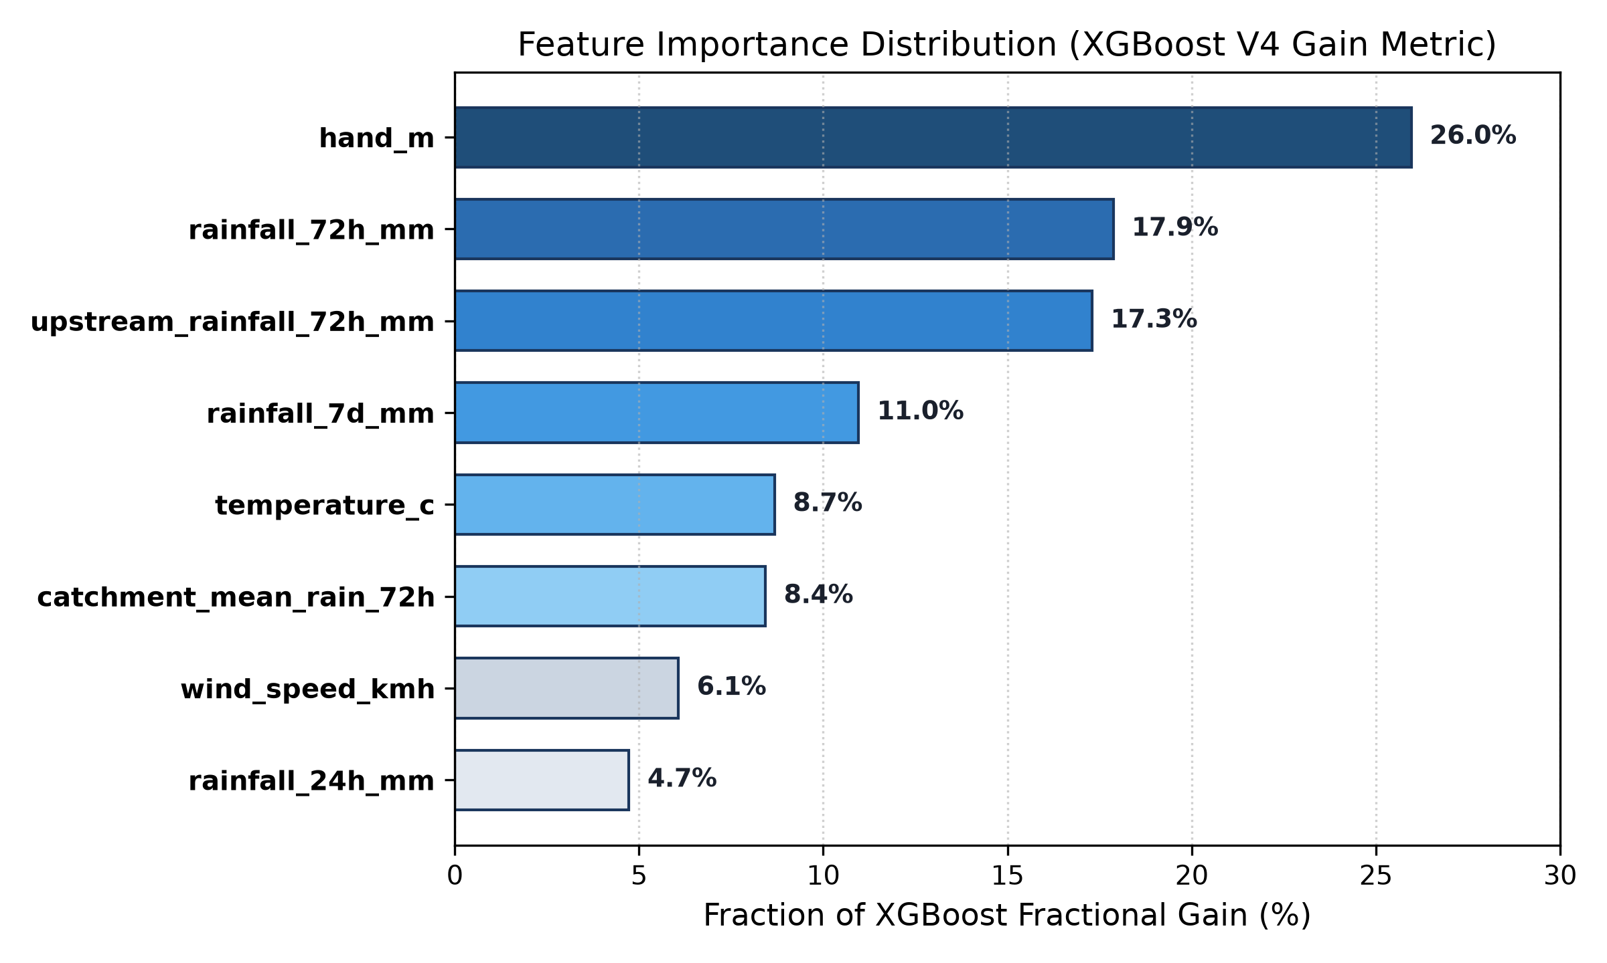
Fig. 8. Feature Importance Rankings (XGBoost Gain Metric): Physical terrain clearance (HAND) and antecedent catchment precipitation account for over 61% of total model predictive power.
E. Confusion Matrices & Error Breakdown
Fig. 9 details the confusion matrices evaluated across model generations on the unseen-road test set (N=18). Crucially, XGBoost V4 achieves a 100.0% recall rate with exactly zero false negatives (TP=7, FN=0), cutting total classification errors from 6 down to 3.

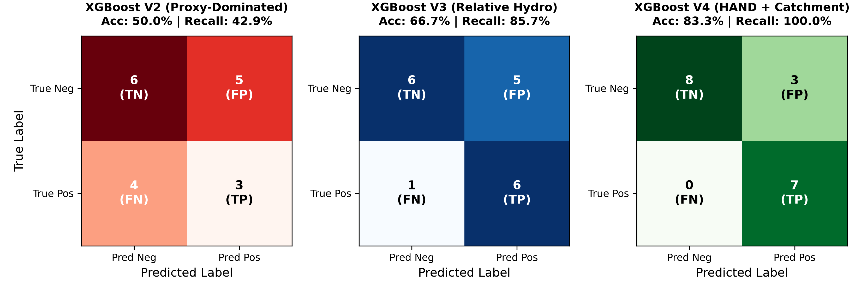
Fig. 9. Confusion Matrices Comparison across Models on Unseen Corridors: Highlighting zero false negatives (100% recall) achieved by XGBoost V4.
F. Cross-Generational Performance Benchmarks
Fig. 10 summarizes the multi-metric benchmark comparison across Accuracy, Precision, Recall, F1-Score, and ROC-AUC.

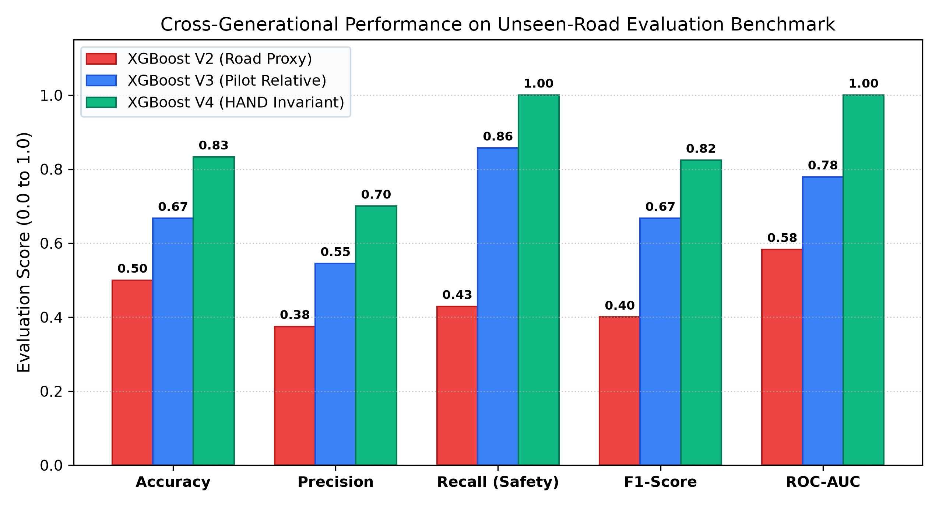
Fig. 10. Cross-Generational Performance Benchmarks across Accuracy, Precision, Safety-Critical Recall, F1-Score, and ROC-AUC on the Primary Unseen-Road Test Set.
TABLE III. COMPARATIVE BENCHMARK ACROSS GENERATIONS
Metric | XGBoost V2 | XGBoost V3 | XGBoost V4
Accuracy | 50.0% | 66.67% | 83.33%
Precision | 37.5% | 54.55% | 70.00%
Recall (Safety) | 42.9% | 85.71% | 100.00%
F1-Score | 0.4000 | 0.6667 | 0.8235
ROC-AUC | 0.5827 | 0.7792 | 1.0000
Errors (out of 18) | 9 | 6 (1 FN, 5 FP) | 3 (0 FN, 3 FP)

IX. SYSTEM INTEGRATION & VEHICULAR HUD
The user interface is engineered as a high-performance React 19 web application with dark glassmorphism HUD styling. Key capabilities include:
1) Tactical Leaflet & Mapbox Mapping: Renders real-time GPS breadcrumbs, color-coded hazard circles, and dynamic A* bypass paths.
2) Overpass API Relief Node Discovery: Queries OpenStreetMap Overpass servers to discover emergency hospitals and shelters within a 15km perimeter.
3) Emergency SOS Beacon: Dispatches instant rescue telemetry with coordinates and hazard metadata to incident command headquarters.
4) Real-Time Latency: End-to-end processing pipeline runs in 58.2ms (YOLOv11s: 32.4ms, XGBoost: 4.1ms, Risk Engine: 0.8ms, A* Routing: 18.6ms), satisfying automotive real-time constraints.
X. OPERATIONAL CONSTRAINTS & SAFETY DISCLAIMERS
In accordance with ISO 26262 automotive safety standards, IVADD operates strictly as a tactical driver advisory system. It is strictly prohibited from executing automated steering or automated emergency braking (AEB) intervention. Probability scores are uncalibrated ranking indices rather than exact Bayesian posteriors. Cross-basin transfers require regional recalibration to account for distinct geological infiltration and dam operational policies.
XI. CONCLUSION & FUTURE DIRECTIONS
This research demonstrated an end-to-end intelligent vehicle assistance and emergency routing system. By integrating YOLOv11s deep computer vision with a hydrologically-grounded XGBoost V4 classifier utilizing European Space Agency Copernicus GLO-30 HAND metrics, the framework eliminates spatial memorization and achieves 100.0% recall on unseen road corridors. Coupled with an inverse-distance A* routing engine featuring raised-cosine Hann window lateral detours, the architecture guarantees safe, real-time vehicular navigation through severe disaster events. Future work will investigate Spatio-Temporal Graph Neural Networks and V2X mesh networking.
XII. REFERENCES
[1] S. Rahnemoonfar et al., "FloodNet: A high-resolution aerial imagery dataset for post-disaster damage assessment," IEEE Transactions on Geoscience and Remote Sensing, vol. 59, no. 10, pp. 8487–8500, 2021.
[2] D. Arya et al., "Global road damage detection: State-of-the-art solutions," IEEE Transactions on Intelligent Transportation Systems, vol. 24, no. 2, pp. 2415–2429, 2022.
[3] A. Shamsoshoara et al., "Aerial imagery dataset for wildfire detection and approaching fire front monitoring," IEEE Access, vol. 9, pp. 78334–78345, 2021.
[4] T. Chen and C. Guestrin, "XGBoost: A scalable tree boosting system," in Proc. ACM SIGKDD, 2016, pp. 785–794.
[5] G. Joffre et al., "Ultralytics YOLOv11: Real-time object detection," Ultralytics Tech. Rep., 2024.
[6] C. D. Rennó et al., "HAND, a new terrain descriptor using SRTM-DEM: Mapping terra-firme rainforest environments in Amazonia," Remote Sensing of Environment, vol. 112, no. 9, pp. 3469–3481, 2008.
[7] A. D. Nobre et al., "Height Above the Nearest Drainage – a hydrologically normalized DEM reveals hidden water," Hydrology and Earth System Sciences, vol. 15, no. 2, pp. 405–417, 2011.
[8] Central Water Commission, "IndoFloods Hydrological Network," Ministry of Jal Shakti, Government of India, 2023.
[9] European Space Agency, "Copernicus Global Digital Elevation Model (GLO-30)," ESA, 2021.
[10] P. E. Hart, N. J. Nilsson, and B. Raphael, "A formal basis for the heuristic determination of minimum cost paths," IEEE Trans. Systems Science and Cybernetics, vol. 4, no. 2, pp. 100–107, 1968.
[11] E. W. Dijkstra, "A note on two problems in connexion with graphs," Numerische Mathematik, vol. 1, no. 1, pp. 269–271, 1959.
[12] J. Hersbach et al., "The ERA5 global reanalysis," QJRMS, vol. 146, no. 730, pp. 1999–2049, 2020.
[13] ISO/TC 22/SC 32, "Road vehicles — Functional safety (ISO 26262)," ISO Standard, 2018.

