CloudWatch (31)
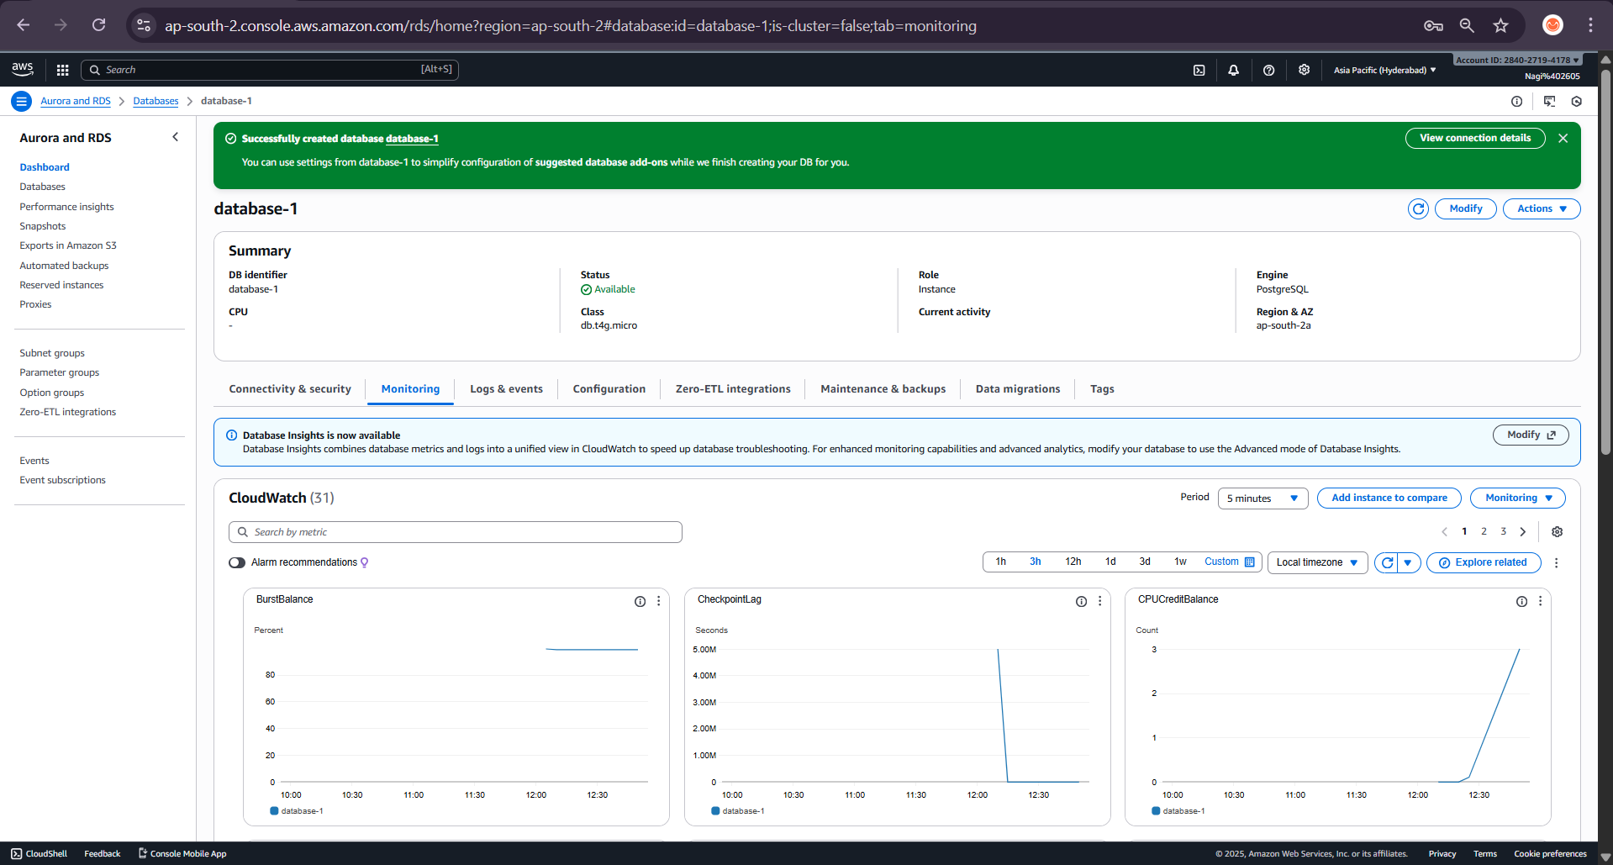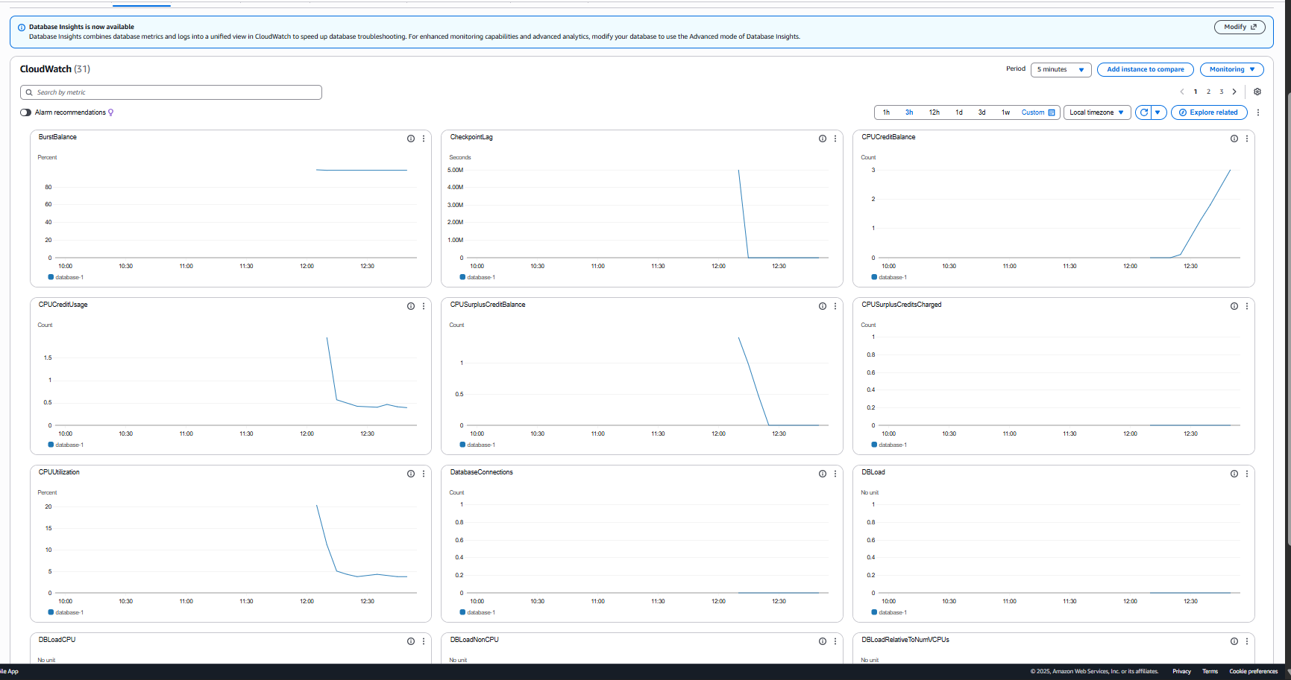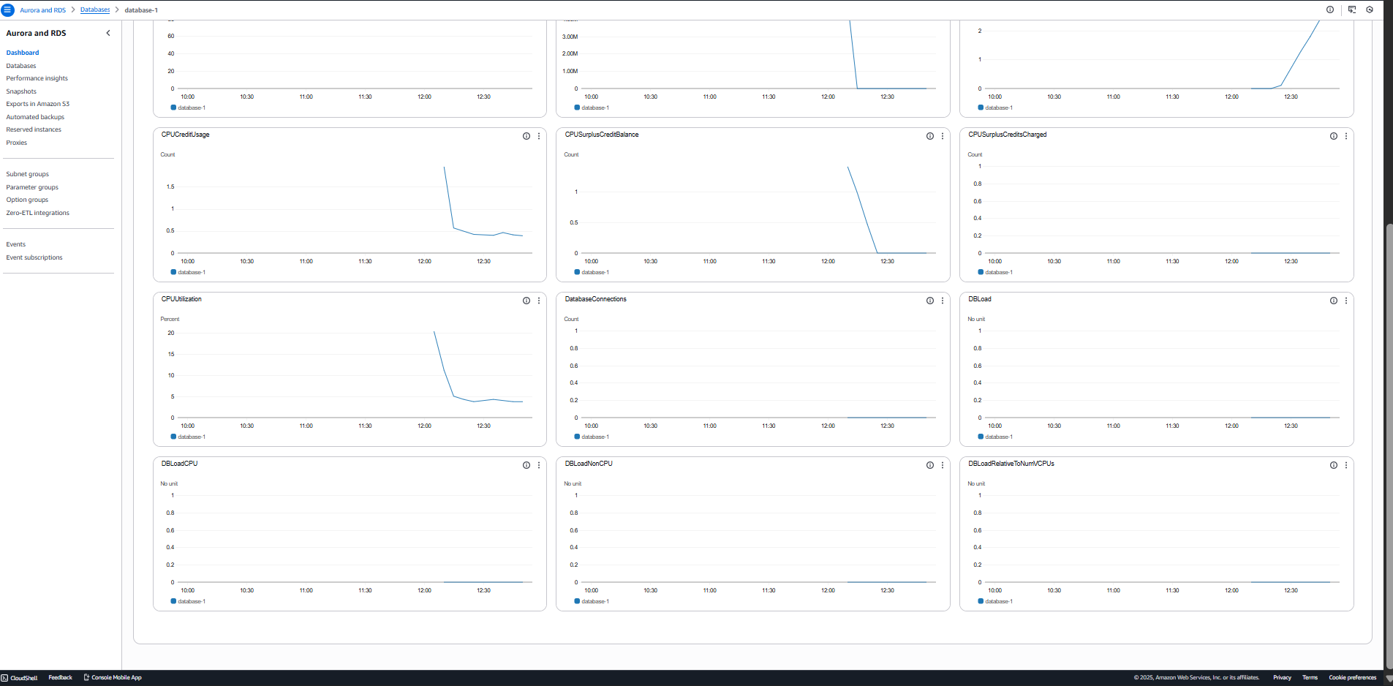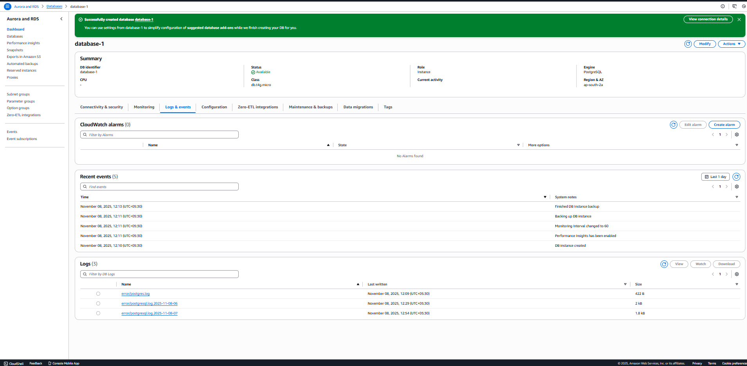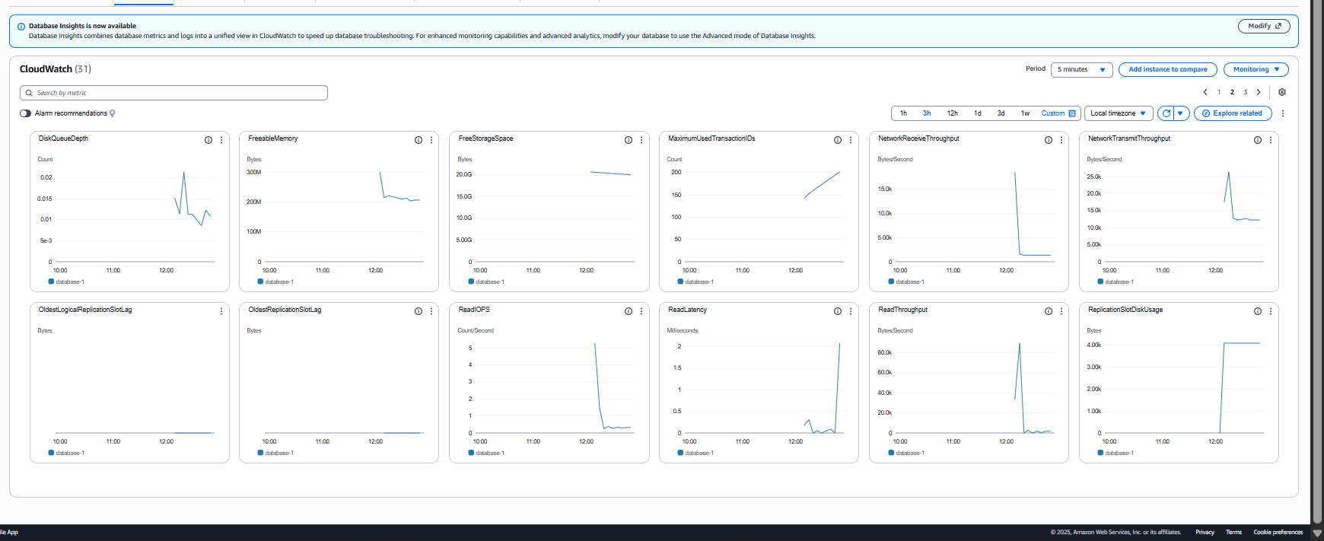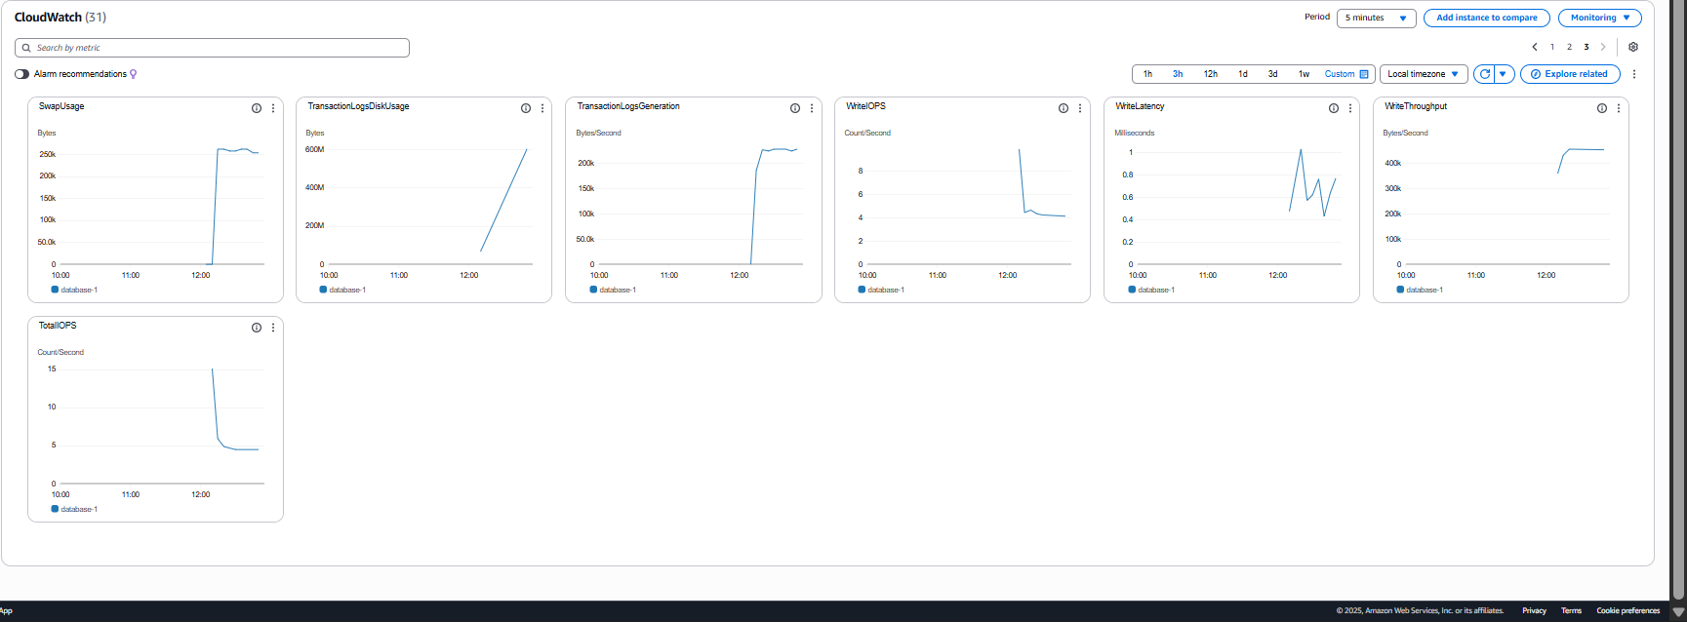

🔹 CPU Metrics

Metric | Description | Usage | Priority
CPUUtilization (%) | Percentage of CPU used by the DB instance. | Indicates database load; high sustained CPU (>80%) = performance issue. | ⭐ Primary
CPUCreditBalance (Count) | For burstable instance types (like t4g/t3), shows remaining CPU credits. | If it goes to zero, the CPU will throttle. | ⭐ Primary (for burstable)
CPUCreditUsage (Count) | Number of credits consumed during the period. | Helps track how much CPU is being used. | Medium
CPUSurplusCreditBalance (Count) | CPU credits accrued when usage is above baseline (temporary burst). | Indicates short-term burst usage. | Low
CPUSurplusCreditsCharged (Count) | Credits charged when you use more CPU than allowed. | Cost-related metric. | Low

🔹 Memory Metrics
Metric | Description | Usage | Priority
FreeableMemory (Bytes) | Available RAM for database operations. | If it drops too low, your DB can slow down or crash due to swapping. | ⭐ Primary
SwapUsage (Bytes) | Amount of disk space used as virtual memory. | High swap means memory pressure → tune DB memory parameters or scale up. | ⭐ Primary (for performance)
🔹 Storage Metrics

Metric | Description | Usage | Priority
FreeStorageSpace (Bytes) | Remaining disk space. | Alerts when space runs low (e.g., < 20% free). | ⭐ Primary
DiskQueueDepth (Count) | Number of pending read/write operations. | High queue = I/O bottleneck. | ⭐ Primary (for I/O)
TransactionLogsDiskUsage (Bytes) | Space used by WAL (transaction logs). | Helps monitor replication or transaction-heavy workloads. | Medium
TransactionLogsGeneration (Bytes/Second) | Rate of WAL log creation. | Used to estimate replication lag and backup size growth. | Medium
ReplicationSlotDiskUsage (Bytes) | Disk space used by replication slots. | If not cleared, can fill up storage. | Medium

🔹 I/O Performance Metrics
Metric | Description | Usage | Priority
ReadIOPS (Count/Second) | Disk read operations per second. | Indicates read workload intensity. | Medium
WriteIOPS (Count/Second) | Disk write operations per second. | Indicates write workload intensity. | Medium
TotalIOPS (Count/Second) | Combined read + write IOPS. | Quick overview of total disk activity. | ⭐ Primary
ReadLatency (Milliseconds) | Time to complete read operations. | High latency = storage bottleneck. | ⭐ Primary (performance)
WriteLatency (Milliseconds) | Time to complete write operations. | High latency = poor storage or overloaded DB. | ⭐ Primary (performance)
ReadThroughput (Bytes/Second) | Data read rate. | Monitor read-heavy workloads. | Medium
WriteThroughput (Bytes/Second) | Data write rate. | Monitor write-heavy workloads. | Medium

🔹 Connection & Load Metrics
Metric | Description | Usage | Priority
DatabaseConnections (Count) | Active client connections. | Compare with DB instance max connections limit. | ⭐ Primary
DBLoad (No unit) | Overall DB load (sessions * average active time). | Used to measure overall pressure. | ⭐ Primary (performance)
DBLoadCPU (No unit) | Portion of load attributed to CPU processing. | Identifies CPU-bound workloads. | Medium
DBLoadNonCPU (No unit) | Portion of load waiting on I/O or locks. | Identifies bottlenecks. | Medium
DBLoadRelativeToNumVCPUs (No unit) | Normalized DB load compared to CPU cores. | Load > 1 means overutilization. | ⭐ Primary

🔹 Replication & Transaction Metrics
Metric | Description | Usage | Priority
CheckpointLag (Seconds) | Time delay for writing dirty pages to disk. | High lag → increased crash recovery time. | Medium
OldestReplicationSlotLag (Bytes) | Lag for the oldest replication slot. | Important for replication health. | ⭐ Primary (replication)
OldestLogicalReplicationSlotLag (Bytes) | Lag for logical replication slots. | For logical replication setups. | Medium
MaximumUsedTransactionIDs (Count) | Number of transactions used. | Avoid transaction ID wraparound (Postgres-specific). | Medium

🔹 Network Metrics
Metric | Description | Usage | Priority
NetworkReceiveThroughput (Bytes/Second) | Incoming network traffic. | Measures client query volume. | Medium
NetworkTransmitThroughput (Bytes/Second) | Outgoing network traffic. | Measures result data sent to clients. | Medium

🔹 Key Summary: Most Important (Primary) Metrics

Category | Primary Metrics | Why Important
CPU | CPUUtilization, CPUCreditBalance | Detect CPU saturation or throttling
Memory | FreeableMemory, SwapUsage | Prevent crashes due to low memory
Storage | FreeStorageSpace, DiskQueueDepth | Avoid out-of-storage and I/O lag
I/O Performance | ReadLatency, WriteLatency, TotalIOPS | Core indicators of DB health
Connections/Load | DatabaseConnections, DBLoad, DBLoadRelativeToNumVCPUs | Understand traffic & load
Replication | OldestReplicationSlotLag | Ensure replication health

1️ .Overview Section (High-Level Health)
- CPUUtilization
- FreeableMemory
- FreeStorageSpace
- DatabaseConnections

2️.Performance Section
- DBLoad, DBLoadCPU, DBLoadNonCPU
- ReadLatency, WriteLatency, DiskQueueDepth
- TotalIOPS

3️ .Resource Section
- CPUCreditBalance (for burst instances)
- SwapUsage, TransactionLogsDiskUsage

4️.Replication & Backup Section
- OldestReplicationSlotLag
- TransactionLogsGeneration

5️ Network Section
- NetworkReceiveThroughput
- NetworkTransmitThroughput

