AI Tooling & Licensing Framework — Copilot vs. Claude
Oct 9, 2026 · @Nag

Summary
Default every request to the Microsoft 365 Copilot licenses we already pay for, and spend money on Claude only where Copilot measurably falls short. Claude Enterprise seats go to a small group of heavy daily users. The Claude API is for automations built into systems, and every API workload gets its own budget and owner.
We need this because AI requests now arrive faster than the Central AI Team can judge them one by one. The framework gives reviewers and the AI Intake Portal a fixed set of questions that route each request to one of four answers:
- Use what you have. Microsoft 365 Copilot (flat per-seat cost, no usage bill).
- Premium seat. A Claude Enterprise seat or Copilot add-on, for heavy individual use.
- Build it. The Claude API or Copilot Studio, for automations and agents (pay per use).
- Not approved. The data, risk or business case doesn't support it.
"Flat license means no consumption worry" is only partly true. Copilot chat inside Microsoft 365 apps is flat. Copilot Studio agents and Azure/Foundry models bill by usage, the same way the Claude API does. The real choice is not Copilot vs. Claude. It's seat-based individual productivity vs. metered automation, and both vendors sell both.

The cost models
Only two options are truly flat: Copilot inside Microsoft 365 apps, and Claude Team seats. Claude Enterprise is not one of them. Its $20 seat buys access, and all usage is billed on top at API rates.
Option | What you pay (USD) | Usage billing | Best for
Microsoft 365 Copilot | $30 per user/month, annual, on top of an E3/E5 base license | Flat. Includes Copilot Chat and internal agents built in Copilot Studio | Everyday work in Outlook, Teams, Word, Excel and PowerPoint
Copilot Chat | $0 with eligible Microsoft 365 plans | Free for web chat. Custom agents are metered | Users without a Copilot seat
Copilot Studio credits | $200/month per 25,000 credits, or pay-as-you-go | Metered per agent action | Customer-facing or high-volume agents
Claude Team | Standard $20, Premium $100 per seat/month (annual); 150 seats max | Flat, with 5-hour and weekly limits | Predictable power users, if SCIM and audit logs aren't required
Claude Enterprise | $20 per seat/month, annual | Metered at API rates; admins set user and org spend caps | Governed company rollout: SSO, SCIM, audit logs, custom retention
Claude API | Per million tokens: Haiku 5.5 $0.10 in / $0.50 out · Sonnet 5.5 $2 / $10 · Opus 5.5 $4 / $20 | Metered; batch jobs 50% off | Automations built into systems, such as the intake portal
Three things this table changes:
- "Use Copilot so we don't worry about consumption" holds only for chat inside Microsoft 365. Agents for unlicensed users, customer-facing bots and Foundry models are all metered.
- Claude Enterprise needs spend caps from day one. Third-party estimates put light users at about $25–30/month in total and heavy research or Claude Code users at $150–500+ (tl;dv). Those numbers are not Anthropic's. Measure our own usage in a pilot.
- Claude is already partly inside Copilot. Microsoft 365 Copilot customers can use Claude models in Excel and PowerPoint (Anthropic, May 2026). Claude has also been a model option in Researcher and Copilot Studio since September 2025, once an admin enables it (Anthropic). Some "I need Claude" requests can be met with no new license.
Sources disagree on the pay-as-you-go rate per Copilot Credit, and Microsoft's pricing page doesn't state it. Confirm it with our Microsoft account team before budgeting any Copilot Studio agent.

Decision framework
Every request answers five questions in order, and the first match decides the route. Data risk is checked first, so a cheap route never skips Security review.
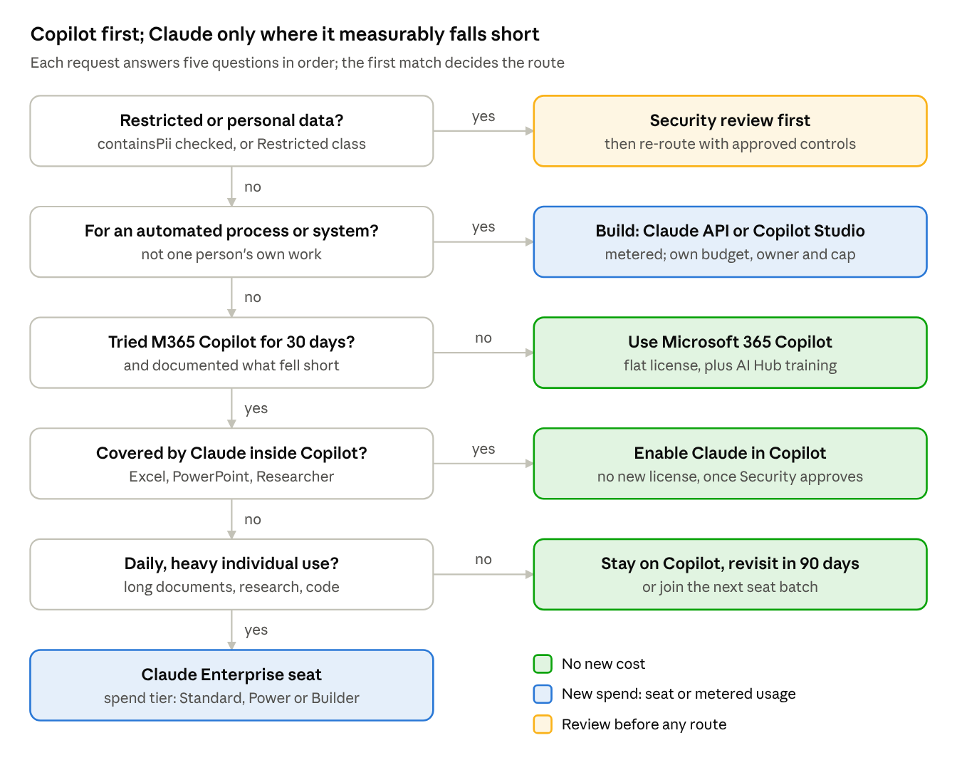
request routing · 5 questions, 6 routes
Three of the six routes cost nothing new. New spend happens only for automations (metered) and for heavy individual users who have already shown that Copilot falls short.

Using Claude Enterprise seats well
On Claude Enterprise, usage drives the bill and the $20 seat fee barely matters. So the levers are who gets a seat, how much each person can spend, and which model they use by default. Seat count matters less.
Who qualifies for a seat. Approve a seat only when all three of these hold:
- The person has used Microsoft 365 Copilot for at least 30 days, and can name a specific task where it fell short.
- The work is daily and substantial: long-document analysis, coding with Claude Code, or multi-step research.
- The data involved is allowed in Claude under our data rules (see Governance).
Spend tiers. Starting caps, proposed for tuning after the pilot:
Tier | Who | Monthly cap per user (USD) | Default model
Standard | Analysts, writers, managers | $50 | Sonnet 5.5
Power | Researchers, finance and legal analysts | $200 | Sonnet 5.5; Opus 5.5 for hard tasks
Builder | Engineers using Claude Code | $500 | Opus 5.5
A user who hits their cap requests a raise through the intake portal. Two raises in a quarter moves them up a tier.
Monthly hygiene.
- Pull per-user activity from the admin analytics, and reclaim any seat unused for 30 days.
- Review the top 10 spenders each month. High spend with clear output is fine. High spend from someone pasting whole SharePoint folders gets a coaching session.
- Publish five short guides in the AI Hub: Projects instead of re-pasting files, starting new chats, picking the right model, Claude in Excel/PowerPoint, and Claude Code basics.
Team vs. Enterprise. Claude Team gives flat-priced seats with usage included, but it has no SCIM or audit logs and tops out at 150 seats. For a governed company rollout, Enterprise with caps is the right choice. Team only fits a small, contained pilot, if Security accepts the missing controls.

Using the Claude API well
Use the API for automations, not for people chatting. Built carefully, a typical internal automation costs a few dollars a month, not thousands. Model choice, caching and batching usually decide the bill more than volume does.
Pick the smallest model that holds quality. API prices per million tokens, from claude.com/pricing:
Model | Input / output (USD) | Use for
Haiku 5.5 | $0.10 / $0.50 | Classifying, routing, extracting fields, short summaries
Sonnet 5.5 | $2 / $10 | The default: drafting, analysis, most agents
Opus 5.5 | $4 / $20 | Hard reasoning, long agent runs, code generation
Worked example: triage in the intake portal. Assume 1,000 requests a month, each about 3,000 tokens in and 500 out. That's roughly $0.55 a month on Haiku 5.5 or $11 on Sonnet 5.5. At this scale, model choice matters more than the number of requests. The real risk is an agent that loops, not a busy form.
Free savings to require in every build:
- Prompt caching. Reusing a fixed instruction block or reference document costs about 5% of the normal input price (Sonnet 5.5: $0.10 vs. $2 per million tokens).
- Batch processing. Anything that can wait a few hours, such as nightly summaries or backfills, runs at 50% off.
- Effort setting. Simple routes run at low effort. Raise it only where tests show better results.
Guardrails for every API workload:
- One workspace per project, with its own API key, owner and monthly spend limit.
- Keys live server-side only. In Fabric, that means a User Data Function or Data Agent, never the browser (the portal's rule 5).
- Usage is logged per workload, and every project reviews its cost against its budget monthly.
- Agents get a hard cap on steps or tokens per run.
Anthropic directly or through Microsoft Foundry. Claude on Microsoft Foundry is billed through Microsoft at standard API rates. Calling Anthropic directly gets new features first. Going through Foundry keeps billing and access control in Azure. Ask the Microsoft account team whether Foundry spend counts toward our Azure commitment; if it does, Foundry is the better default.

Governance and data rules
What kind of data is involved decides which tool can be used, before cost is even considered. This is a proposed mapping, and Security and Legal must confirm it before it goes into the intake portal.
Data class | Examples | M365 Copilot | Claude Enterprise | Claude API workload | Personal AI accounts
Public | Published marketing, press releases | Yes | Yes | Yes | Yes
Internal | Process docs, meeting notes | Yes | Yes | Yes | No
Confidential | Pricing, contracts, recipes, financials | Yes | Yes, with custom retention set | After security review | No
Restricted | Employee or customer personal data, HR, legal holds | Only where an approved policy covers it | Case-by-case approval | Only with an approved design and containsPii review | Never
Rules that go with this table:
- The containsPii flag on every intake request is the gate. If it's checked, the request goes to Security review before approval, whichever tool is requested.
- Claude inside Copilot is a separate decision. Microsoft states that Anthropic models are "hosted outside Microsoft-managed environments" and covered by Anthropic's terms (Anthropic). Security should review that before an admin turns it on.
- Personal AI accounts get one sentence of policy, owned by Security and Legal, and published in one place. Response emails link to it rather than restating it. This replaces the "personal accounts are permitted" line in the current deferral template.
- Every paid AI tool is approved through the intake portal. No department buys its own seats or API keys on a corporate card.

How it plugs into the AI Intake Portal
The portal asks six questions and suggests a route before a reviewer opens the request. The reviewer still decides, but most decisions become a confirmation rather than research.
Six questions added to the intake form:
- What task do you want AI for? (pick from a list, plus free text)
- Have you tried Microsoft 365 Copilot for it? What fell short?
- How often: daily, weekly, or occasionally?
- Is this for you, or for an automated process or system?
- What's the most sensitive data involved? (the data classes above)
- Does it involve personal data? (containsPii)
Suggested routes from the answers:
Answers | Suggested route | Response sent
Copilot not tried, or occasional use | Use Microsoft 365 Copilot, with a training link | "Not approved, use Copilot" (reason code OVERLAP_M365)
Needs Claude specifically for Excel or PowerPoint work | Enable Claude inside Copilot, if Security has approved it | New template: "Available in your current tools"
Daily heavy individual use, Copilot gaps documented | Claude Enterprise seat, Standard tier | Approved now, or deferred to the next seat batch
Automated process or system | Build request: Claude API or Copilot Studio | Moves into the AI Solution workflow
Restricted data or containsPii | Security review first | "More information needed", with Security copied
What changes in Matt's templates: add a reason code for "available in your current tools", and fill in the tool name from the request (Copilot Premium, Claude Enterprise seat, and so on) instead of hardcoding it. The workflow and outbox design in AI_INTAKE_WORKFLOW_AND_RESPONSES.md already supports both.

Rollout plan
The framework can be running in 13 weeks: four weeks to agree the rules, four weeks for a capped pilot, then scaling based on what the pilot measures.
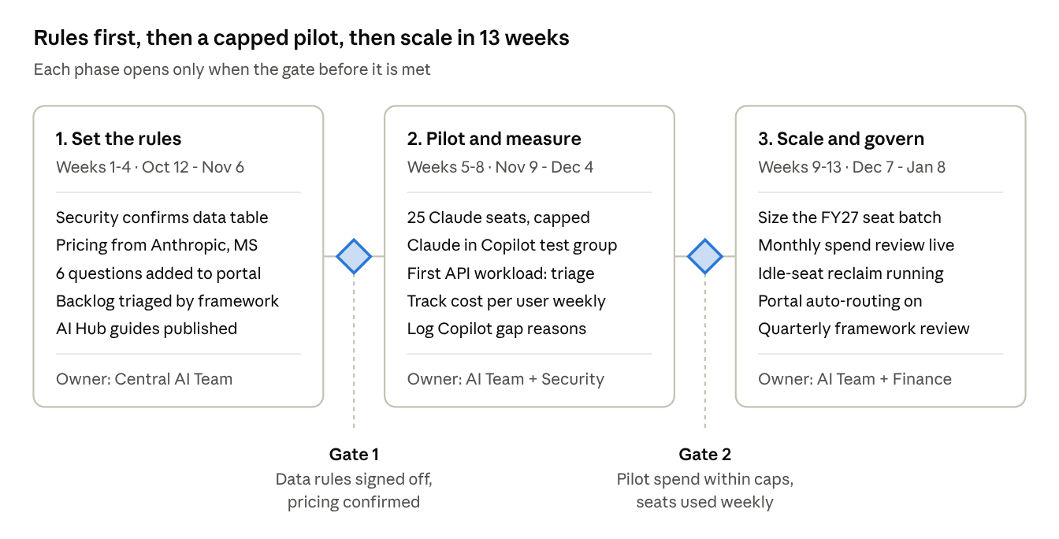
rollout · 3 phases, 2 gates, 13 weeks
The pilot exists to replace the third-party cost estimates with our own numbers. At Gate 2 we'll know the actual monthly cost per Claude user and which Copilot gaps come up most. Those two figures size the FY27 seat batch.

Open decisions
- ☐ Security and Legal: confirm the data-class table, decide whether to enable Claude inside Copilot, and write the one-sentence personal-AI policy.
- ☐ Procurement: get the Claude Enterprise seat minimum and our negotiated rate; the pay-as-you-go rate per Copilot Credit; and whether Foundry spend counts toward our Azure commitment.
- ☐ Finance: set the FY27 AI budget split between flat seats and metered usage.
- ☐ Central AI Team: confirm the spend tiers and caps, and name the 25 pilot users.
- ☐ Matt: agree the license-versus-build request split and the new "available in your current tools" response.

Sources
Prices checked against vendor pages on Oct 9, 2026. Confirm them with account teams before committing budget.
- Claude pricing: plans and API
- Microsoft 365 Copilot pricing
- Copilot Studio pricing
- Claude now available in Microsoft 365 Copilot (Anthropic, Sep 2025)
- Claude across Excel, PowerPoint, Word and Outlook (Anthropic, May 2026)
- Claude Enterprise pricing estimates (tl;dv, third party)

