Create database with scripts else use .bak up file to restore database

Please Use provided excel sheet for schema and don’t change sheet names and column names

There are 2 sheets in excel sheets

1 for Customer with item details

2 Only Item details(Name,Price)

Login Screen :

MVP-R-001:

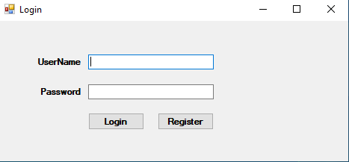

1)If First Time to login screen click register button to create user

User/Login Registration

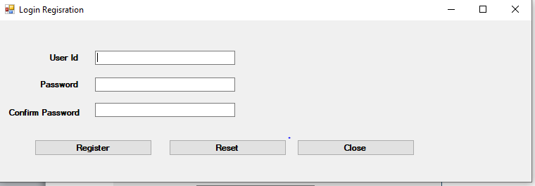

2)After Login with credentials and it will go to dashboard or mdi screen

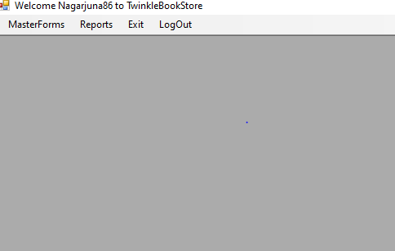

3) create roles for New User either admin or sales man

MasterForms->Roles

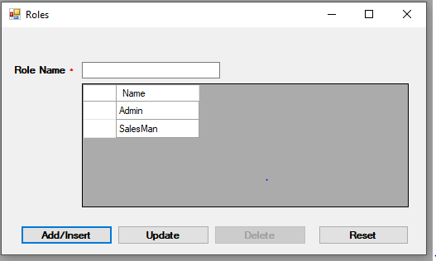

4)Go to UserRole screen and map login user with corresponding role

MasterForms->LoginRolesMapping

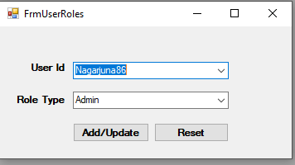

5)Go to Items screen

MasterForms->Items

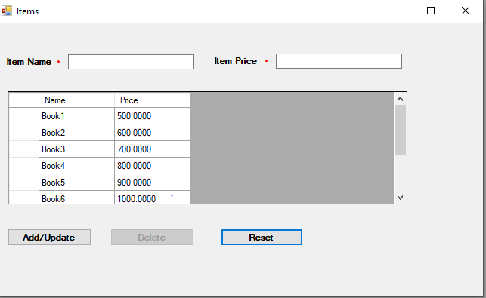

6)Customer Enrollment

MasterForm->Customer

MVP-R-001:

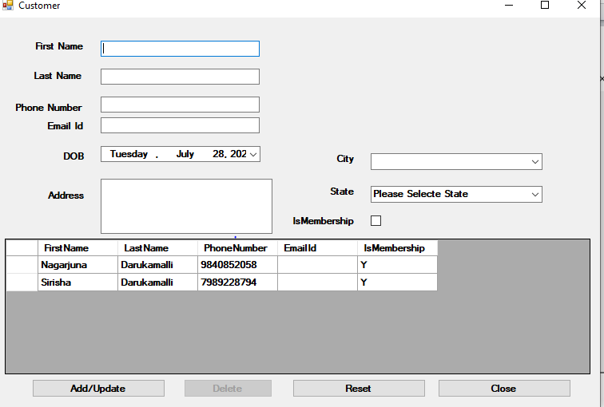

7)MasterForm->CustomerItemDetail

To add new items /update items to existing or new customer

MVP-R-005:

*MVP-R-003:*

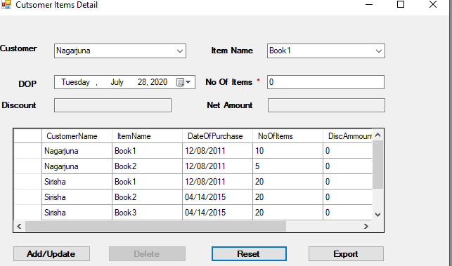

8)

MasterForm->Import Customer Data

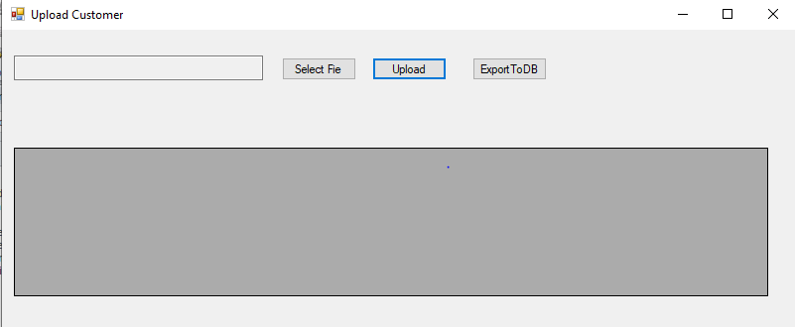

9)Reports->CustomerSearch

MVP-R-002:

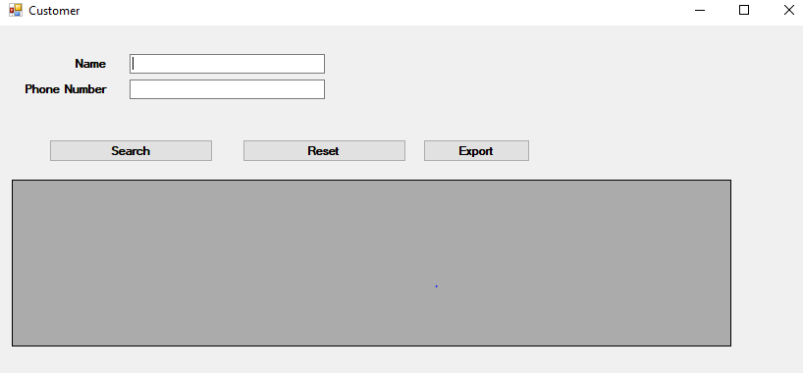

10)Qualified 20% discount

*MVP-R-007:*

MVP-R-006:

Reports-> Qualified 20% discount

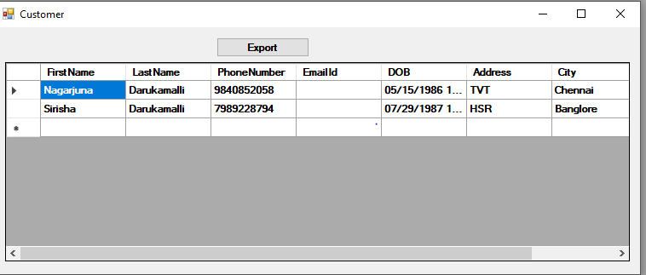

11)Customer Upcoming BDay

*MVP-R-008:*

MVP-R-006:

Reports->

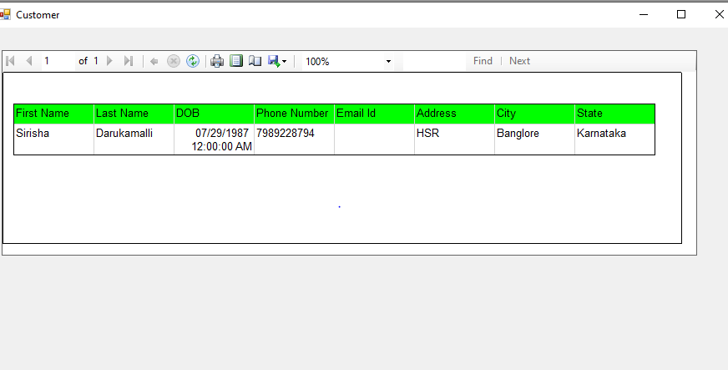

12)Annual Billing

*MVP-R-009:*

MVP-R-006:

Reports-> Annual Billing

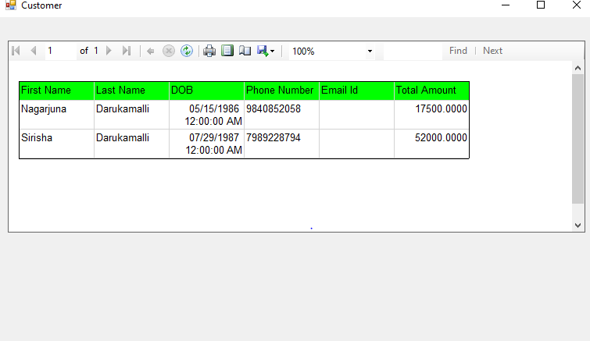

Technology stack**:**

Sql Server

ORM(Entity) and ADO.net

C#

WinForms

Reports->Microsoft Report Viewer and ITextSharp

Architecture

N-Tier Architecture

Dependency injection->Unity Container

Oops

Collections

Generic Collections