While running npm install commands

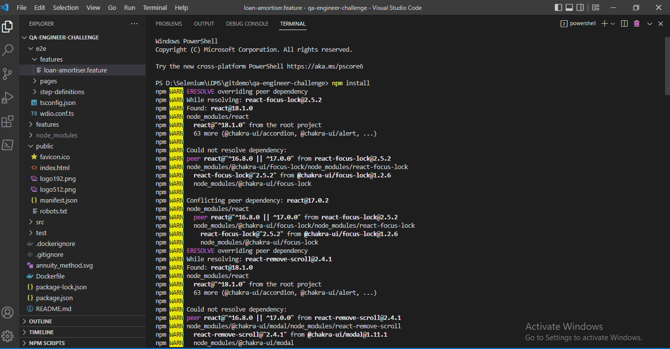

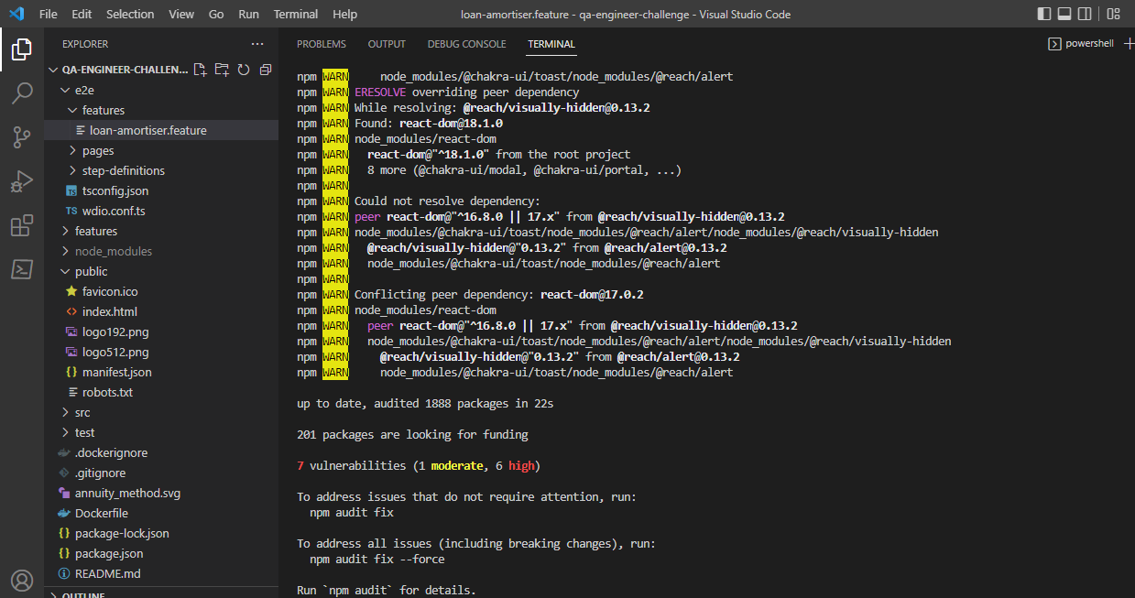

I tried the below solutions but it didn't work for me.

1) go to C:\Program Files\nodejs

you have to edit 4 files named npm, npm.cmd, npx, npx.cmd

open files in vs code

replace prefix -g with prefix --location=global in all four files

2) Tried npm-windows-upgrade when on Windows. npm updates itself in the "wrong" directory and not in the node installation path. npm-windows-upgrade will fix the issue

npm-windows-upgrade --npm-version latest

3) Uninstall Nodejs and tried using 16.15.1 and 18.3.0 version

While running npm run e2e commands

