Document Repository Configuration

**Prerequisite for module –**

1. Mendix Version – 9.18.4 or higher.

**How to configure Document Repository module?**

Step 1:

For configuring document repository module, we need these following modules to be downloaded from the mendix marketplace.

-> community commons module.

-> Email Template.

-> Email connector.

-> DeepLink (version: 10.0.2).

-> Audit trail.

-> MxModelReflection.

-> Encryption.

-> ZipHandling.

Step 2:

Navigation should be configured to access document repository Module.

- Homepage

- File Explorer

- Project Set

Image1: Navigation Menu for Document Repository.

Step 3:

Authentication should be added.

aImage2: Authentication for Document Repository.

Step 4:

After step 2 we can directly add CSS file provided from SharePoint and add in styling>web and import that file as shown in below image in main.scss.

Image3: Import scss file name in main.scss.

Step 5:

To Access document repository, we need to create a project set first it important to create a project set before using document repository.

-To create a project set just click on add set and name the project set as required.

Image3: Add Project Set.

Step 6:

For Emails we need to configure email as shown in below image. We need to create template for each.

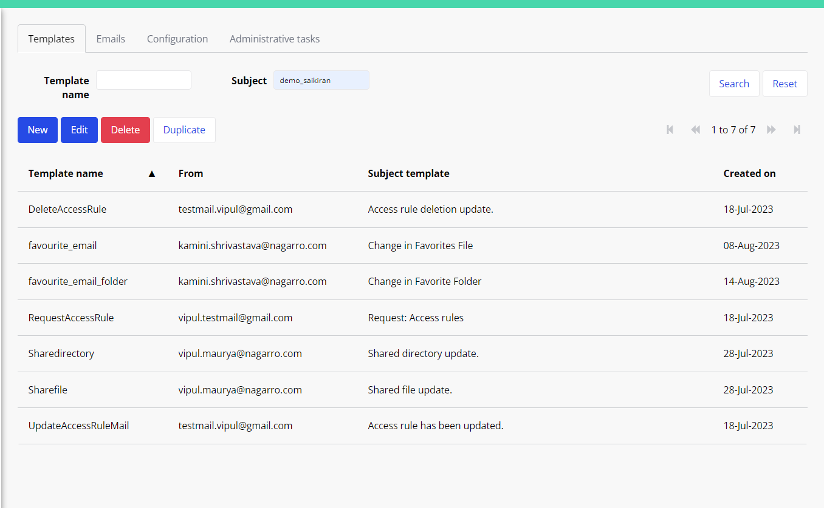

Image4: Email configuration.

1. Delete Access Email Template

Tokens: {%1%} = DocumentRepository.AccessRuleHelper/UserName

Tokens: {%2%} = DocumentRepository.Directory/Title

Tokens: {%3%} = DocumentRepository.Directory/DirectoryID

Image5: Delete Email Access Template.

1. Favourite Email Template – for Documents/files. Etc

Tokens: {%1%} = DocumentRepository.DocumentMetadata/Name

Tokens: {%2%} = DocumentRepository.DocumentMetadata/ FileURL

image6: Favourites Email Template for documents.

1. Favourite Email template for Folders

Tokens: {%1%} = DocumentRepository.Directory/Title

Tokens: {%2%} = DocumentRepository.Directory/DirectoryURL

Image7: Favourites Email Template Folders.

1. Request Access Rule Template

Tokens: {%1%} = DocumentRepository.Directory/Title

Tokens: {%2%} = DocumentRepository.AccessRuleHelper/Read

Tokens: {%3%} = DocumentRepository.AccessRuleHelper/Edit

Tokens: {%4%} = DocumentRepository.AccessRuleHelper/Create

Tokens: {%5%} = DocumentRepository.AccessRuleHelper/Delete

Tokens: {%6%} = DocumentRepository.AccessRuleHelper/UserName

Tokens: {%7%} = DocumentRepository.Directory/DirectoryID

Image8: Request Access Rule Template.

1. Share Directory Template

Tokens: {%1%} = DocumentRepository.ShareFile/UserName

Tokens: {%2%} = DocumentRepository.Directory/Title

Tokens: {%3%} = DocumentRepository.Directory/DirectoryID

Image9: Share Directory Template.

1. Share files Template

Tokens: {%1%} = DocumentRepository.ShareFile/UserName

Tokens: {%2%} = DocumentRepository.ShareFile/DocFileName

Tokens: {%3%} = DocumentRepository.Directory/Title

Tokens: {%4%} = DocumentRepository.ShareFile/DocID

image10: Share Documents Template.

1. Update Access Rule Mail Template

Tokens: {%1%} = DocumentRepository.AccessRuleHelper/UserName

Tokens: {%2%} = DocumentRepository.Directory/Title

Tokens: {%3%} = DocumentRepository.AccessRuleHelper/Read

Tokens: {%4%} = DocumentRepository.AccessRuleHelper/Edit

Tokens: {%5%} = DocumentRepository.AccessRuleHelper/Create

Tokens: {%6%} = DocumentRepository.AccessRuleHelper/Delete

Tokens: {%7%} = DocumentRepository.Directory/DirectoryID

Image11: Update Access Rule Mail Template.

Step 7:

In step 7 we need to configure deep link to share documents with others.

So, we need to configure deep link.

1. Deep link Image – view directory configuration

Image12: View Directory Configuration – For Deep Link.

1. Deep link Image - view shared directory configuration

Image13: View Shared Directory Configuration – For Deep Link.

1. deep link image - view shared file

Image14: View Shared Documents Configuration – For Deep Link.