PretextGuard
Project Master Document
Payload-free pretexting detection through claim verification
Problem statement: No. 37, Pretexting Pattern Classifier from Email Metadata
Course: BCSE410L Cyber Security, VIT Vellore
Student: Marupaka Naga Sai Dattu (Nagasai), Reg. No. 23BCE0757
Faculty: Dr. Arun Prasath G
Version: 3.2, 2 October 2026

This is the single source of truth for the project. Version 3.2 supersedes version 3.1 and every earlier version, PretextGuard_Project_Plan_v2.md, the novelty and architecture slides in both Review-I decks, and every earlier plan discussed in chat. If anything else disagrees with this document, this document wins.
Contents
1. How to use this document
2. Project snapshot
3. Problem and threat model
4. Novelty (final, locked 21 September 2026)
5. Prior work and how PretextGuard differs
6. System architecture
7. Tactic taxonomy
8. Data plan
9. Technology stack
10. Security design
11. Evaluation plan
12. Build plan
13. Viva preparation
14. Decisions log
15. Open items and next actions
16. Glossary
17. References

1. How to use this document
This document is written so that a person or an AI assistant can pick up PretextGuard with no other context: what the project is, what is novel, how it is built, what data it uses, what has been decided, and what happens next.

1.1 Rules for anyone picking this up
- This document wins conflicts. Stale sources: PretextGuard_Project_Plan_v2.md (still lists SemEval transfer and the severity model as novelty claims; both were struck), the 16-slide and 11-slide Review-I decks (old novelty lineup), and older chat plans.
- Suggested read order for a new assistant: docs/PretextGuard_Context.md first (working agreement, environment, current state and the exact next task), then Section 2 (snapshot), Section 4 (novelty), Section 6 (architecture), Section 12 (build plan) and Section 15 (open items). A new chat has no memory of earlier chats; these two documents are all it needs.
- Section 4.7 lists dead ideas. Do not propose them again as novelty.
- Keep it current. When a decision changes, update the relevant section, bump the version number, and add a row to the decisions log (Section 14).
- The project-files copy may be text only. The claude.ai project can store this document as extracted text, so the figures do not come through. Every figure therefore has a text description directly below its caption.

1.2 Working agreement
- Claude writes all the code and all the explanations, one phase at a time. Nagasai places the files with the commands Claude provides, runs them in VS Code, and reports results or errors back. Claude never runs Git itself; Nagasai commits and pushes.
- Every file and every function gets a plain-language explanation before moving on, including the background theory. The rubric deducts 20 marks if the student cannot explain his own implementation.
- No code copied from GitHub repositories (30-mark penalty). Use well-known libraries; write the project logic fresh.
- Assume little background outside the MERN stack and basic ML/NLP. Explain Python tooling, FastAPI, DistilBERT and similar from the ground up.
- Prefer the easiest path that still scores well. Established libraries over custom implementations.
- Plan first. Before any large deliverable, share a short plan and wait for Nagasai's go-ahead.
- Style for anything delivered to Nagasai: direct and honest, no em dashes, no filler words such as "showcase" or "testament". Documents as .docx or PDF, not HTML.
- Commit after each working step, not once per phase. Small, frequent commits to the GitHub repo are the evidence of original, incremental work; one large commit per phase looks like a paste.
- File workflow on macOS. The project lives at ~/Desktop/pretextguard (iCloud Desktop sync is off). Files arrive either as downloads in ~/Downloads, with one block of mv commands per phase that puts each file in its exact place, or as paste blocks that create each file in place (cat > path << 'PG_EOF' ... PG_EOF, preceded by setopt NO_BANG_HIST) when the interface cannot hand over files. Dotfiles and small config files are created in the terminal, and files that share a name (such as __init__.py) are created with touch, so no two downloads collide.
- Change list at the end of every phase. Claude lists what changed so this document can be kept current.
- No unit tests per phase. Each phase is verified by running its scripts and checking their printed output; tests/test_environment.py is the one setup check.
- Fresh chats. Any new chat, including Claude Code on the web, starts from docs/PretextGuard_Context.md and this document. Nothing carries over from earlier chats, so both files must stay current.
- Harvest security marks. When a design choice also improves security (for example, no database), say so explicitly.

2. Project snapshot
Item | Details
Project name | PretextGuard
Course | BCSE410L Cyber Security, VIT Vellore (final-year B.Tech CSE)
Problem statement | No. 37: Pretexting Pattern Classifier from Email Metadata (picked from a faculty list of 60)
Type | Individual project. The student must present and explain the work independently.
One-line pitch | Pretexting emails carry no link or attachment, so scanners miss them. PretextGuard extracts what an email claims about itself and verifies each claim against the email's headers and its own conversation history. A claim that the evidence contradicts is the detection.
What gets built | A web app: paste a raw email, or upload a .eml file or a whole thread, optionally give the organisation's domain, and get a 0-100 Pretext Risk Score, highlighted manipulation phrases, a findings table, and plain-English contradictions.
Novelty (locked 21 Sep 2026) | N1 payload-free evaluation protocol  N2 thread consistency verification  N3 claim-evidence contradiction engine (core)  Architecture contribution: claim-routed verification pipeline
Current status | Phase 0 complete: Python 3.12 venv, repository, environment check and pip-audit all clean. Version 3.2 (2 Oct 2026) fixed stale sections and folded in the beginner walkthrough. Phase 1 (data acquisition) is next.
Repository | github.com/Nagasai-Datta/PretextGuard (public); local folder ~/Desktop/pretextguard
Next deadline | Not a planning constraint. Scope is fixed and will not be cut (decision, 22 Sep 2026).

2.1 Grading rubric (100 marks)
Criterion | Marks | Where PretextGuard earns it
Novelty and innovation | 30 | N1, N2, N3 and the claim-routed architecture (Section 4)
Implementation quality | 25 | End-to-end pipeline, model, verifiers, API, UI (Sections 6, 12)
Security features | 15 | Ten controls mapped to OWASP (Section 10)
Literature survey | 10 | Twelve works, closest competitors cited first (Section 5)
System design | 10 | Claim-routed architecture, no-persistence design (Section 6)
Testing and performance | 5 | One ablation per claim, claim-extraction accuracy, robustness tests (Section 11)
Presentation and viva | 5 | Live demo and prepared answers (Section 13)

Penalties: minus 30 for copied or unoriginal work (for example GitHub code); minus 20 for being unable to explain the implementation; minus 20 for fake or manipulated experimental results.
Faculty rule on novelty: merely changing the user interface, programming language, framework, or database does not count as innovation. Stack choices are argued under System Design and Security Features, never under Novelty.

2.2 Review-I (completed)
Review-I ran from 29 July 2026: 20 marks, about 10 minutes per student, no code required. Marks: problem understanding 4, literature and existing work 4, novelty and research gap 6, proposed solution 4, planning 2. Delivered: a 16-slide deck with speaker notes, a prep-notes file, and a slide spec for AI design tools. Nagasai also presented his own edited 11-slide deck (review_1.pptx), with the annotated-email diagram on slide 7.
Outcome: the faculty struck the old N2 (SemEval cross-domain label transfer) and the old N4 (tactic-stacking severity model) and asked for at least one more core claim. N1 and N3 survived. Section 4 is the response.

3. Problem and threat model

3.1 What pretexting is
Pretexting is social engineering built on a made-up identity or scenario. The attacker pretends to be someone trusted ("this is the CFO", "this is your vendor") and the story itself is the attack. The victim does the damage personally: wires the money, changes the bank details, shares the data. Business Email Compromise (BEC) is pretexting aimed at company money.
Running example used throughout the project:
From: "David Chen - Finance Director" <d.chen.finance@gmail.com>
Reply-To: finance.dept.acme@protonmail.com
Date: Tue, 14 Jul 2026 02:47 AM
Authentication-Results: spf=pass dkim=pass dmarc=pass (all for gmail.com)

Hi Priya, this is David from Finance. I need you to process a wire
transfer before 3 PM today. I'm in meetings all day and can't take
calls. Please don't loop in anyone else - just get it done.
Priya works at acmecorp.com. The real David is her company's Finance Director. Note the authentication line: the attacker sent from a real Gmail account, so SPF, DKIM and DMARC all pass. They prove the message came from gmail.com. They say nothing about whether the sender is David from Acme. Catching that gap is N3's job.

3.2 Payload versus payload-free
A payload is the part of an email that does technical damage: a malicious link or attachment. Email security scanners are built around payloads: URL blacklists, link sandboxes, attachment detonation. A payload-free email has no link and no attachment, so those scanners find nothing. The example above has no link, no attachment, no malware and no typos. The entire attack is three phrases: authority ("this is David from Finance"), urgency ("before 3 PM today") and secrecy ("don't loop in anyone else").

3.3 Two attacker positions
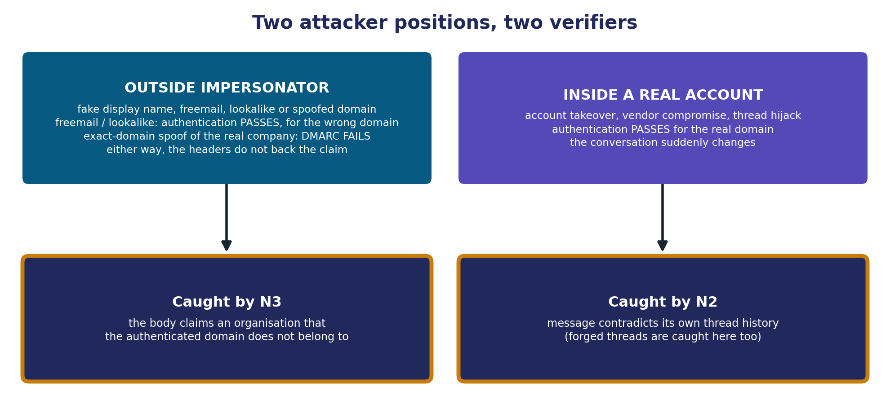
Figure 1. Which verifier catches which attacker
Text description: two columns. Left: the outside impersonator uses a fake display name and a freemail, lookalike or spoofed domain. Freemail and lookalike senders pass authentication, but for the wrong domain; an exact-domain spoof of the real company fails DMARC. Either way the headers do not back the claim, and N3 catches it because the body claims an organisation that the authenticated domain does not belong to. Right: the attacker inside a real account (account takeover, vendor compromise, thread hijack) passes authentication for the real domain, but the conversation suddenly changes; N2 catches it because the message contradicts its own thread history, and forged threads are caught there too.
- Outside impersonator: fake display name, freemail account, lookalike domain, Reply-To redirection, or a spoof of the company's exact domain. A freemail or lookalike sender usually passes SPF, DKIM and DMARC for its own domain, so the giveaway is that the authenticated domain does not match the organisation the body claims. An exact-domain spoof fails DMARC when the real company publishes a DMARC policy. Either way the headers do not back the claim. Caught by N3.
- Inside a real account: account takeover, vendor email compromise, thread hijacking (the Emotet and Qakbot reply-chain style). Mail comes from the real account, so SPF, DKIM and DMARC pass and N3 has nothing to contradict. What changes is the conversation: new urgency, new bank details, a different sending path. Caught by N2.
- Forged thread: the attacker invents a quoted "previous conversation" that never happened. N2's thread-integrity check catches it, and N3 often fires too because the sender is external.

3.4 Why it matters
Figure | Source | Status
21,489 BEC complaints; about $2.9 billion adjusted losses (2023) | FBI IC3 2023 report | Used in Review-I
About $2.77 billion BEC losses (2024) | FBI IC3 2024, as reported by Abnormal AI | Check the primary IC3 report before citing
Pretexting volume more than doubled across recent reporting cycles | Verizon DBIR | Used in Review-I
2026 DBIR classifies thread-based attackers building trust as pretexting | Verizon DBIR 2026, as quoted by IRONSCALES | Check the primary DBIR before citing
Under 8% of BEC incidents are found by technical controls | Industry reporting (earlier plan) | Source must be re-verified before the report

3.5 Target users and deployment
Corporate email security teams, secure email gateway vendors, and finance or accounts-payable staff (the people BEC targets). Realistic deployment: an extra check at the mail gateway, or an analyst triage tool that explains why a message is suspicious.

3.6 Email and authentication basics (for beginners)
An email is a plain text file: headers (the envelope: who sent it, to whom, how it travelled), a blank line, then the body (the letter). The From line has a display name, which is free text anyone can type, and an address whose part after @ is the domain. Most mail apps show only the display name, which is exactly what pretexting exploits.
Header | What it is | Analogy
From | Display name and address shown to the reader | The name printed on the letter
Reply-To | Where replies actually go, if different from From | "Please reply to this other address"
Return-Path | Where bounces go; the true envelope sender | The return address on the envelope
Received | One line added by every mail server on the way | Postmarks from each post office
Authentication-Results | The receiving server's SPF, DKIM and DMARC verdicts | The post office's inspection stamp
Message-ID | Unique ID of this email | A tracking number
In-Reply-To, References | IDs of the earlier emails in the conversation | "Re: your letter no. 123"
SPF: the domain publishes the list of mail servers allowed to send for it, and the receiver checks the sending server against that list. DKIM: the sending server signs the message with a private key whose public half the domain publishes; a valid signature proves the domain signed it and nobody altered it. DMARC: passes when SPF or DKIM passed for a domain that matches the visible From domain, and tells receivers what to do on failure. The receiving server writes all three verdicts into Authentication-Results; PretextGuard reads them.
The key idea: authentication proves which domain sent an email, not who the person is. A real Gmail account passes all three checks, so an email claiming to be Acme's Finance Director that authenticates as gmail.com passed authentication for the wrong domain. Spotting that mismatch is N3's job.

4. Novelty (final, locked 21 September 2026)

4.1 Summary
ID | Name | What it does | How we prove it
N1 | Payload-free evaluation protocol | Removes URLs, domains and attachment file names from email bodies before any model sees them. | Ablation on binary attack-vs-benign detection: model A (raw bodies) vs model B (redacted bodies), each tested on the raw, redacted and naturally link-free views of the same held-out set. A's drop from raw to redacted measures how much prior accuracy was link-reading.
N2 | Thread consistency verification | Checks a message against its own thread history (tactic onset, request drift, sending-path drift, thread integrity) and points to the message where the thread flipped. | Detection with vs without the thread verifier on the thread-hijack benchmark, plus hijack-point localisation accuracy. Content signals on real Enron threads, header signals on real Apache mailing-list threads.
N3 (core) | Claim-evidence contradiction engine | Checks affiliation, identity and authority claims in the body against what the headers can prove. The header check is conditioned on the claim. | Full system vs text-only vs headers-only vs parallel score fusion (BEC-Guard style). Real positives from affiliation claims in Nazario and Nigerian Fraud; colleague impersonation from synthetic BEC, reported separately.
Architecture | Claim-routed verification pipeline | Claims are typed and routed to the verifier that can check them. Output is a ledger of claim, evidence and contradiction. | Same signals wired as a flat classifier vs claim-routed: accuracy, false positives, share of findings with a traceable reason.

Viva line: "N3 catches the impersonator. N2 catches the attacker who does not need to impersonate, because he is already inside the account." Design principle: PretextGuard never trusts what an email says about itself, and authentication proves which domain sent a message, not who the person is.

4.2 N1: payload-free evaluation protocol
What: before training or inference, the body is redacted. URLs become [URL], bare domains become [DOMAIN], attachment file names become [FILE]. Words such as "see attached" stay, because they are language, not payload.
Why: machine learning models take the cheapest shortcut to a correct answer. In phishing datasets, a suspicious link predicts the label, so a model can reach 97 to 99% by reading links instead of manipulation. Real pretexting has no link, so the shortcut does not exist in the real attack.
Experiment: the task is binary attack-vs-benign detection, because the shortcut claim is about phishing detectors. Train model A on raw bodies (prior-work style) and model B on redacted bodies, both DistilBERT; a TF-IDF plus logistic regression pair is a cheap second check. Test both on three views of the same held-out set: raw, redacted, and the naturally link-free subset (emails that had no URL before redaction). The hypothesis is that A drops sharply from raw to redacted and B holds. Report the measured numbers whatever they are.

4.3 N2: thread consistency verification
What: when an email arrives inside a thread, it is compared with the earlier messages in that same thread. A legitimate thread changes gradually; a hijacked one flips at one message.
Signal | What is compared | Attack example
Tactic onset | Tactic probabilities of the new message vs the average of earlier messages in the thread | Three weeks of calm invoice emails, then urgency and secrecy appear
Request drift | Payment details, account numbers and credential requests vs everything earlier in the thread | "We changed banks, please use this new account"
Sending-path drift | First Received hop, mail client (X-Mailer), sender domain vs the same sender's earlier messages | Same address but a different origin server and client; or a lookalike domain swapped in mid-thread
Thread integrity | In-Reply-To and References must point to real earlier Message-IDs; quoted history must match the real earlier text | A fabricated "previous conversation" with no matching Message-IDs
Style drift (optional, dropped first) | Greeting, sign-off and function-word profile vs the sender's earlier messages | The reply is suddenly written in a different voice

Output: the index of the message where the thread flipped, and the signals that fired.
Input modes: thread mode needs the earlier messages (several .eml files or one .mbox). In single-email mode N2's history checks are skipped, but In-Reply-To and quoted-text integrity checks still run when that data is present.
Evaluation data: raw Enron is expected to lack In-Reply-To, References, Received and X-Mailer (Phase 1 confirms), so its threads can only test the content signals (tactic onset, request drift). The header signals (sending-path drift, thread integrity) are tested on public Apache project mailing-list archives, which keep those headers. Both are real threads, and the report states the split.
Why it is novel: academic detectors classify single emails. The closest work on compromised accounts (Ho et al., USENIX Security 2019) is URL-based and needs organisation-wide mailbox data. Conversation-level social-engineering detection exists for chat (ConvoSentinel) but uses no email headers. Commercial tools (Abnormal AI, IRONSCALES) do behavioural thread analysis but are closed and depend on login telemetry. An open, explainable, payload-free detector that works at email-thread level with thread headers was not found.

4.4 N3: claim-evidence contradiction engine (core)
What: the body makes claims; the headers provide evidence. N3 checks each affiliation, identity or authority claim against the evidence that could confirm or contradict it. An affiliation claim is any statement that the sender represents an organisation: the recipient's own company (internal) or an outside one such as a bank, a vendor or a government office (external).
Claim in the body | Example | Evidence checked | Contradiction when
Internal affiliation | "This is David from Finance"; signature says Acme | Authenticated From domain vs organisation domain; SPF, DKIM, DMARC; freemail list; lookalike distance | Claims to be internal but the authenticated domain is external, freemail or a lookalike; or the From shows the organisation's own domain but DMARC fails (exact-domain spoof)
External affiliation | "Director of Foreign Operations, Central Bank"; "PayPal Security Team" | Claimed organisation name vs sending domain (rapidfuzz); a small list of known brand domains; authentication | The sending domain does not belong to the claimed organisation
Authority or rank | "As CFO I need this today" | Display name vs address; lookalike distance to organisation domains | Rank claimed from a freemail, lookalike or unauthenticated sender
Reply direction | "Reply to me directly" | Reply-To vs From | Reply-To points to a different domain
Contact details in signature | Signature email or phone | Signature email vs From address | The signature address differs from the sending address
Prior relationship | "As we discussed on the call" | Handed to the thread verifier (N2) | No such conversation exists

Tactics without verifiers: urgency, secrecy, scarcity, reciprocity, social proof and liking cannot be proven or disproven by headers. They act as modifiers: they raise the weight of any contradiction that is found.
Conditioning, in two examples: spf=fail on a newsletter is low risk. spf=fail on a message claiming to be the CFO and ordering a payment is high risk. The reverse also holds: dmarc=pass on a Gmail message is normal, but dmarc=pass on a Gmail message claiming to be Acme's Finance Director is a contradiction, because authentication passed for the wrong domain. Same header values, different meaning, and the only thing that changed is the claim. BEC-Guard runs a header classifier and a body classifier in parallel and combines their scores. Adding two scores cannot express "the body claims X and the headers disprove X", because the scores do not know they are about the same claim.
Organisation domain: internal-affiliation checks need the organisation's own domain(s). The UI and API take them as an optional field that defaults to the recipient's domain from the To header; datasets use the To domain. When it is missing or anonymised, internal-affiliation checks are recorded as not checkable instead of guessed. External-affiliation checks do not need it.

4.5 Architecture contribution: claim-routed verification pipeline
Most detectors, including the old v1 plan, work as email to features to classifier to score, with an explanation added afterwards. PretextGuard works like a fact-checking pipeline (claim detection, evidence retrieval, verdict), applied to email, where the evidence is protocol metadata and conversation history instead of documents.
- Claim-first evidence. The body decides which evidence gets checked. Evidence is gathered per claim, not all at once and blended. This is the general form of N3's conditioning.
- Explanation by construction. The output is the reason: "claims to be Acme Finance; authenticates only as gmail.com". LIME is reduced to one job, highlighting which words triggered each tactic.
- Extensible. A new attack pattern means adding one verifier function. The NLP model does not need retraining.
Architecture style | Example | Weakness
End-to-end classifier | Two-Stage Framework (MDPI Computers, 2025) | Score first, explanation bolted on afterwards
Parallel fusion | BEC-Guard (USENIX Security 2019) | Two scores added; a claim cannot be linked to the evidence against it
Claim annotation only | Mithun et al. (2024) | Marks claims but leaves verification to a future algorithm
Claim-routed verification | PretextGuard | (this project)

It is presented on the architecture slide as the system design the three claims live inside, not as a fourth numbered claim, so it cannot be dismissed as padding.

4.6 Plain components (kept, not claimed as novelty)
- Pretext Risk Score 0-100: the old N4 idea, kept as the output the UI needs.
- SemEval-2023 Task 3 pretraining: the old N2 idea, optional; run only if time allows.
- Isolation/Secrecy as a seventh tactic (not a Cialdini principle; see Section 7): a design choice worth mentioning in the report, not a numbered claim.
- LIME word highlights and the keyword baseline.

4.7 Dead ideas: do not propose again
Idea | Status | Why
v1: DistilBERT on LLM-generated emails labelled with Cialdini principles | Scrapped, July 2026 | Near-duplicate of the Two-Stage Framework paper (MDPI Computers 14(12):523, 2025)
Old N2: SemEval-2023 cross-domain label transfer as novelty | Struck by faculty after Review-I | Kept only as optional pretraining
Old N4: tactic-stacking severity model as novelty | Struck by faculty after Review-I | Kept only as the plain 0-100 score
Stack choices as novelty (FastAPI, React, no database) | Never valid | Excluded by the faculty rule
"Dual-reference verification" as a separate numbered claim | Merged | Became the architecture contribution
Tactic co-occurrence analysis as novelty | Not valid | Already done by Pan et al. (2026) and Ferreira and Teles (PPSE)

5. Prior work and how PretextGuard differs
Gap statement: existing persuasion-based detectors score single emails that usually carry payloads, and none verifies what an email claims against its own metadata or conversation history. The attacks that most need this, payload-free pretexting from spoofed senders and from hijacked accounts, are exactly the ones they do not isolate.
Work | What it does | Where PretextGuard differs
Karki, Abri, Siami Namin, Jones (2022). IEEE Big Data, pp. 2841-2848 | BERT, RoBERTa and DistilBERT classify Cialdini principles in phishing emails | Payload-bearing phishing, body only; no metadata, no verification
Two-Stage Deep Learning Framework (2025). MDPI Computers 14(12):523 | 2,995 GPT-generated phishing emails labelled with Cialdini principles; DistilBERT then a dense network | Emails and labels both LLM-made; payload-bearing; body only. Closest competitor to the old v1
Pan, Yang, Cole, Wilson, Woodard (2026). Expert Systems with Applications | 340,912 emails annotated by 4 LLMs under 3 prompting strategies; persuasion cue interactions | Analysis study, not a detector; no header or thread verification. Our precedent for LLM-assisted annotation
Valecha, Mandaokar, Rao (2022). IEEE TDSC 19(2):747-756 | Phishing email detection using persuasion cues | Content cues only; no claim verification against metadata
Aggarwal, Kumar, Sudarsan (2014). SIN '14, ACM, pp. 217-222 | Detects link-free phishing that baits the victim into replying with sensitive data, using content features such as no recipient name, a money offer and a reply prompt | Scores scam content only; does not check who the sender claims to be against headers or thread history; no colleague impersonation or hijacked threads. Closest prior work on the payload-free angle
Mithun, Bartlett, Mirkovic, Freedman (2024). arXiv:2405.12494 (USC ISI) | 940 emails annotated with 32 weak explainable phishing indicators, including sender affiliation claims; argues mismatches are stronger signals than content | Annotates claims but explicitly leaves verification to a future downstream algorithm and does not propose a detector. PretextGuard builds that verifier. Must be cited.
Cidon et al. (2019). BEC-Guard, USENIX Security | Header classifier and body classifier in parallel, scores combined | Additive fusion; no claim-conditioned checks; no thread consistency
Ho et al. (2019). Detecting and Characterizing Lateral Phishing at Scale, USENIX Security | Phishing sent from compromised enterprise accounts; 113M emails, 92 organisations | URL-based only and needs organisation-wide mailbox data; the authors state it misses narrow, stealthy content-level attacks
Ai et al. (2024). ConvoSentinel, arXiv:2406.12263 | Message-level and conversation-level social-engineering detection | Chat, not email; no header or thread-integrity evidence
Piskorski et al. (2023). SemEval-2023 Task 3 | 23 persuasion techniques, human span annotation, news | News domain; used only as optional pretraining data
Al-Subaiey et al. (2024). Computers and Electrical Engineering 120:109625 | Web platform on about 82.5k merged emails, interpretable phishing detection | Binary phishing vs legitimate; no tactics, no claim verification. Source of our merged corpus
Commercial tools (Abnormal AI, IRONSCALES, Darktrace) | Behavioural AI for thread hijacking and account takeover | Closed methods relying on login and device telemetry; not inspectable or reproducible

Background references for the report: Cialdini, Influence (taxonomy); Stajano and Wilson (2011), principles of scam victims (source of the urgency tactic); Ferreira and Teles, PPSE framework; Lumen (2021), influence cues in text; Da San Martino et al. (2019), propaganda technique taxonomy; Stringhini and Thonnard (2015), IdentityMailer; Duman et al. (2016), EmailProfiler; SoK re-examination of phishing research (dataset quality).

6. System architecture

6.1 Architecture diagram
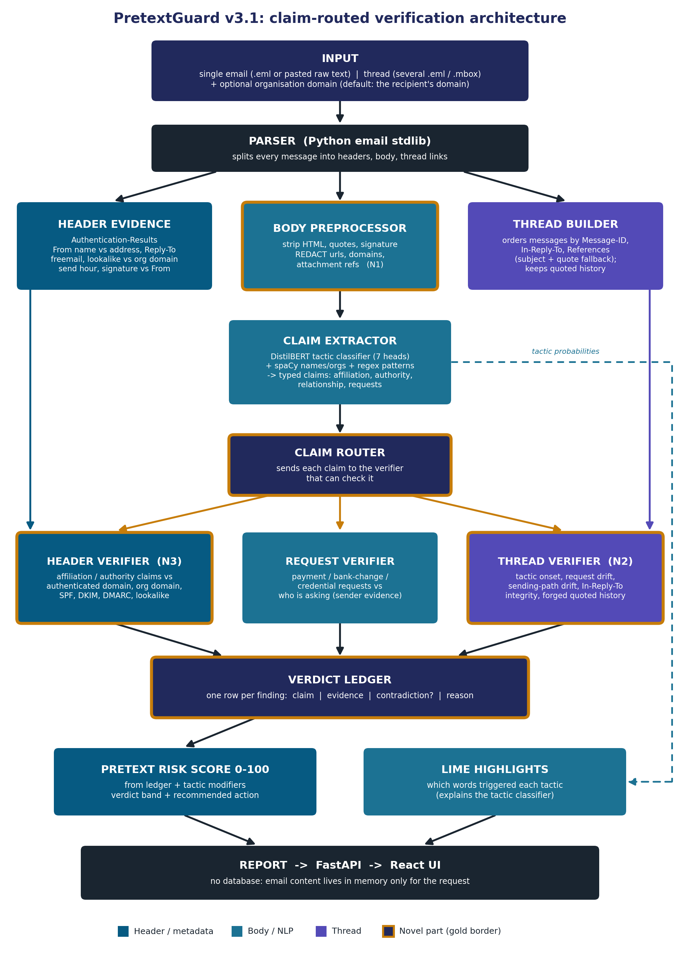
Figure 2. Claim-routed verification architecture (gold border = novel part)
Text description: input (single email, thread, optional organisation domain) goes to the parser, which feeds three branches: header evidence, the body preprocessor (N1 redaction) and the thread builder. The claim extractor reads the redacted body and produces typed claims (affiliation, authority, relationship, requests) plus tactic probabilities. The claim router sends each claim to the header verifier (N3), the request verifier or the thread verifier (N2); header evidence feeds the header verifier and the thread builder feeds the thread verifier. All verifiers write rows to the verdict ledger, which drives the 0-100 risk score. LIME highlights explain the tactic classifier. Both outputs form the report returned through FastAPI to the React UI, with no database. Gold borders mark the novel parts: body preprocessor, claim router, both verifiers and the ledger.

6.2 Components
Component | Input | Output | Implementation | Module
Parser | Raw .eml bytes, pasted text, or a thread | Headers, body, thread links | Python email stdlib (email.parser with policy.default); mailbox for .mbox files | src/headers
Header evidence extractor | Headers + organisation domain(s) | Evidence dict: auth results (or unknown), From name/address/domain, Reply-To, Return-Path, Received chain, send hour, freemail flag, lookalike score vs organisation and claimed domains | email.utils, tldextract, rapidfuzz, freemail domain list | src/headers
Body preprocessor | Body | Clean text and redacted text (N1) | Regex, HTML stripping, quote and signature splitting | src/preprocess
Thread builder | Several messages | Ordered thread, per-message evidence, quoted history | Message-ID, In-Reply-To, References; fallback for Enron: normalised subject, participants and quote matching | src/thread
Claim extractor | Redacted body and signature block | Typed claims (affiliation_internal, affiliation_external, authority, relationship, request types) with text span, claimed organisation and confidence | DistilBERT 7-head tactic classifier + spaCy NER + regex patterns | src/claims
Claim router | Claims | Claim-to-verifier assignments | Rule table (Section 6.4) | src/router
Header verifier (N3) | Affiliation, authority, reply and signature claims + header evidence + organisation domain | Ledger rows | Python rules with weights | src/verifiers
Thread verifier (N2) | Relationship and request claims + thread | Ledger rows + hijack index | Tactic deltas, request drift (set differences on payment details), sending-path comparison, Message-ID and quote matching | src/verifiers
Request verifier | Request claims + sender evidence | Ledger rows | Regex for account numbers and IBANs, keyword patterns; checks who is asking. Request drift against the thread belongs to the thread verifier (N2) | src/verifiers
Ledger + risk score | Ledger rows + tactic probabilities | Score 0-100, verdict band, recommended action | Weighted formula calibrated on validation data | src/router
LIME highlights | Body + classifier | Word weights per tactic | lime library | src/explain
API | HTTP request (email or thread, optional organisation domain) | JSON report | FastAPI, Pydantic, slowapi | src/api
UI | JSON report | Analyzer page and evaluation dashboard | React + Vite + Tailwind | frontend

6.3 Data contracts
Claim object produced by the claim extractor:
{
"claim_id": "c1",
"type": "affiliation_internal",
"text": "this is David from Finance",
"span": [10, 36],
"attributes": {"person": "David", "organisation": "Acme", "department": "Finance"},
"confidence": 0.91
}
Ledger row produced by a verifier:
{
"claim_id": "c1",
"verifier": "header",
"evidence": {"from_domain": "gmail.com", "org_domain": "acmecorp.com", "freemail": true,
"spf": "pass", "dkim": "pass", "dmarc": "pass"},
"contradiction": true,
"severity": "high",
"reason": "Claims to be internal Acme Finance, but the message authenticates as gmail.com, an external freemail domain."
}
Report returned by the API (shape): score, verdict, action, org_domain (as used, or null), tactics (name, probability, highlighted spans), ledger (rows as above, including checks marked not checkable), header_findings, thread (hijack index and signals, or null), request_id. Email content is never stored after the response.

6.4 Routing table
Claim type | Routed to | Notes
affiliation_internal, affiliation_external, authority | Header verifier | Core N3 checks; internal checks need the organisation domain
reply_direction, signature_contact | Header verifier | Reply-To and signature vs From
prior_relationship | Thread verifier | Does the claimed conversation exist?
payment_request, payment_change, credential_request, gift_card, data_request | Request verifier; plus thread verifier when a thread is present | The request verifier checks who is asking; the thread verifier checks request drift against earlier messages (N2)
urgency, secrecy, scarcity, reciprocity, social_proof, liking | No verifier | Modifiers that raise the weight of contradictions

6.5 Header signals
Signal | Comes from | Normal | Attack | Meaning
SPF | Authentication-Results | pass | fail on an exact-domain spoof; pass for freemail or lookalike senders | Did it come from a server the domain allows? Pass proves the domain, not the person
DKIM | Authentication-Results | pass | none / fail on a spoof; pass for freemail or lookalike senders | Is there a valid signature proving it was not forged?
DMARC | Authentication-Results | pass | fail on an exact-domain spoof; pass for freemail or lookalike senders | Final verdict aligning SPF and DKIM with the visible From domain. It shows which domain sent the message, not whether that domain matches the claim
Name vs address | From | Name and domain agree | "Finance Director" <x@gmail.com> | The display name is free text anyone can type
Freemail | From domain | Company domain | gmail, yahoo, proton | Executives do not send from personal accounts
Lookalike distance | From domain vs organisation domains | Exact match | acme-corp.co | Very similar but not equal (rapidfuzz)
Reply-To divergence | Reply-To vs From | Empty or same | Different domain | Replies are silently routed to the attacker
Envelope mismatch | Return-Path, Received | Consistent with From | Unrelated server | The envelope and the letterhead disagree
Send-hour anomaly | Date | Business hours | 02:47 | Weak alone; meaningful when stacked
Signature vs From | Body signature block | Same address | Different address | Insight from Mithun et al. (2024)

PretextGuard reads the SPF, DKIM and DMARC verdicts written by the receiving mail server into the Authentication-Results header. It does not recompute them. When that header is missing (common in old corpora), the signal is recorded as unknown, never as pass, and the verifiers rely on the other evidence. Which sources carry which headers is measured in Phase 1 (the header coverage table, Section 8.1), and authentication signals are scored only where the header exists.

6.6 Pretext Risk Score (plain component)
The score is computed from the ledger: each contradiction adds points by severity (affiliation and payment contradictions weigh most), manipulation tactics add smaller points, and urgency or secrecy multiply the weight of contradictions found alongside them. The result is capped at 100. Weights are calibrated on the validation split, never on the test split.
Initial verdict bands, to be tuned in Phase 10: 0-34 Benign, 35-69 Suspicious, 70-100 High risk. Each band maps to a recommended action (for example: verify through a known phone number before acting).

6.7 Worked example
Claims extracted from the David email
c1 affiliation_internal "this is David from Finance"
c2 payment_request "process a wire transfer"
modifiers: urgency ("before 3 PM today"), secrecy ("don't loop in anyone else")

Ledger
c1 -> header verifier : claims Acme Finance; From gmail.com (freemail),
authenticated as gmail.com (spf, dkim, dmarc pass),
org acmecorp.com -> CONTRADICTION (high)
c1 -> header verifier : Reply-To protonmail.com != From -> CONTRADICTION (medium)
c2 -> request verifier: payment request from an external
freemail sender -> CONTRADICTION (high)

Score: high-severity contradictions x urgency and secrecy -> High risk band
Action: do not pay; call David on a number from the company directory.
Variant, exact-domain spoof: if the attacker had instead forged From: "David Chen" <d.chen@acmecorp.com> from his own server, the From would look internal, but Acme's DMARC policy would fail the message (dmarc=fail). The header verifier then records: claims internal, uses Acme's own domain, fails Acme's authentication, CONTRADICTION (high). Either way, N3 compares the claim with what authentication actually proved.

6.8 Runtime workflow
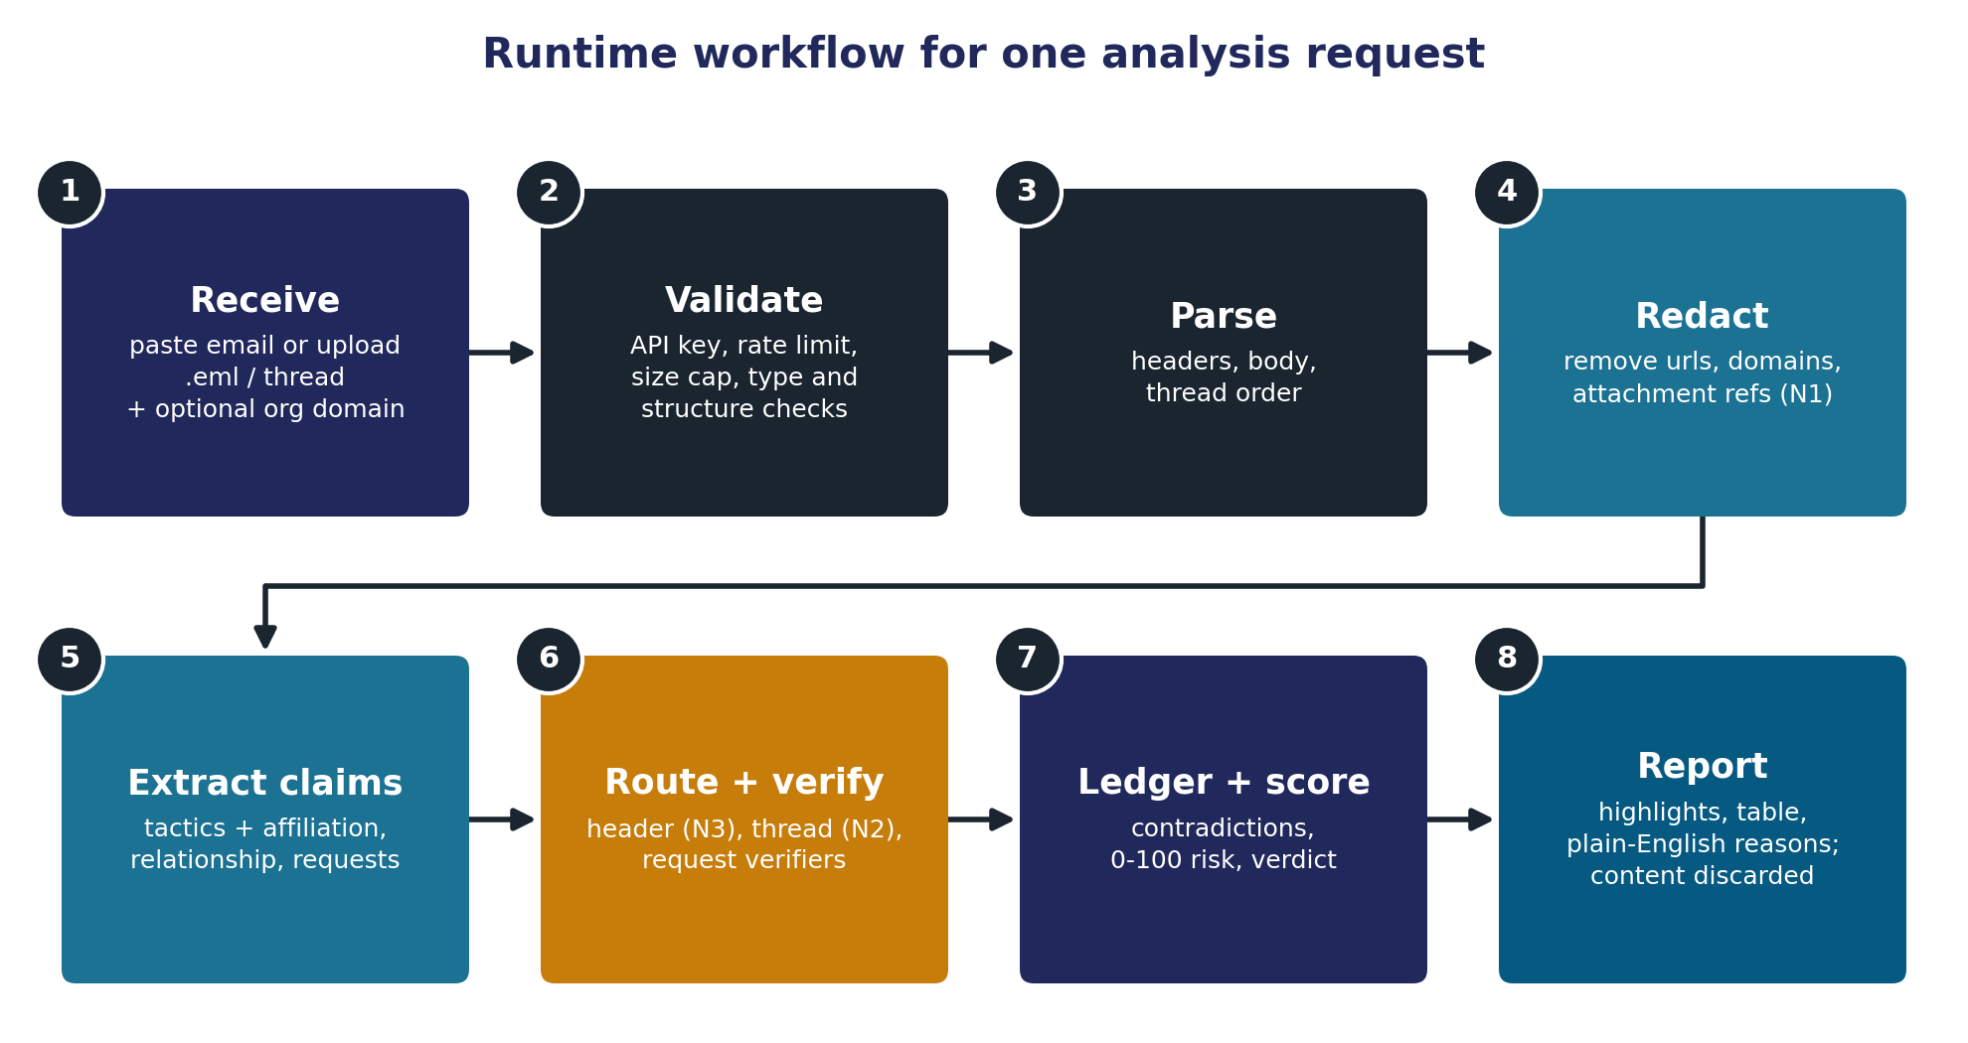
Figure 3. Eight steps for one analysis request
Text description: eight steps in two rows. 1 Receive (paste an email or upload a .eml or thread, plus an optional organisation domain); 2 Validate (API key, rate limit, size cap, type and structure checks); 3 Parse (headers, body, thread order); 4 Redact (remove URLs, domains and attachment references, N1); 5 Extract claims (tactics plus affiliation, relationship and request claims); 6 Route and verify (header verifier N3, thread verifier N2, request verifier); 7 Ledger and score (contradictions, 0-100 risk, verdict); 8 Report (highlights, findings table, plain-English reasons; the email content is then discarded).

6.9 Module map
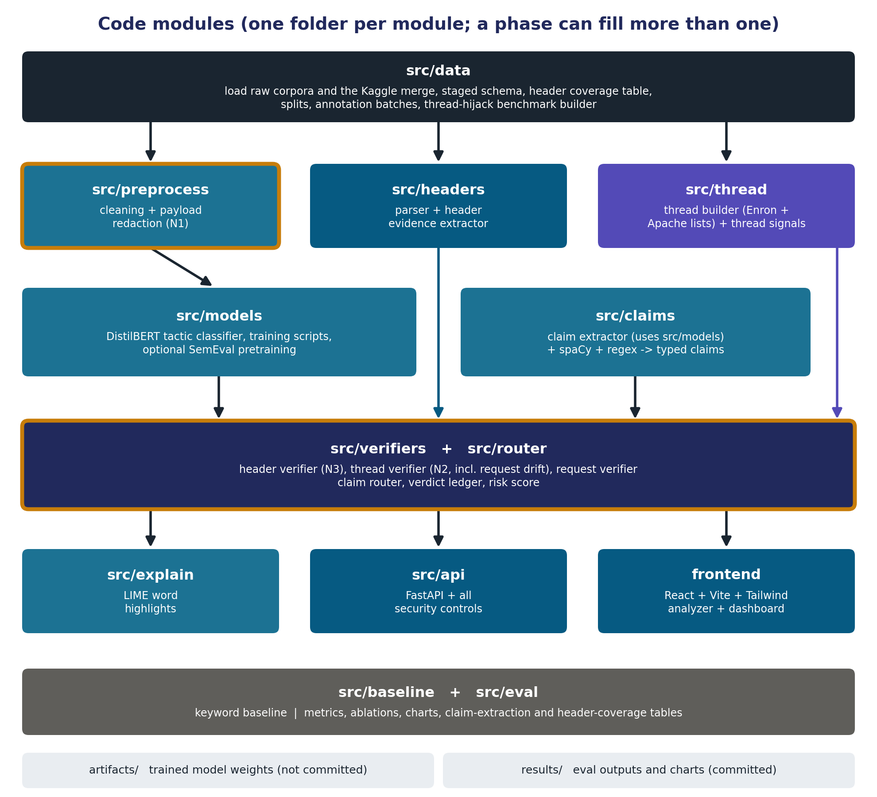
Figure 4. Code modules; a build phase can fill more than one folder
Text description: src/data (raw corpora, Kaggle merge, staged schema, header coverage table, splits, annotation batches, thread-hijack benchmark) feeds src/preprocess (cleaning and N1 redaction), src/headers (parser and header evidence) and src/thread (thread builder for Enron and Apache threads, thread signals). src/preprocess feeds src/models (DistilBERT classifier), which src/claims uses. Models, headers, claims and thread all feed src/verifiers plus src/router (header verifier N3, thread verifier N2 including request drift, request verifier, claim router, ledger, risk score). These feed src/explain (LIME), src/api (FastAPI and security controls) and the React frontend. src/baseline and src/eval sit alongside. artifacts/ holds trained weights (not committed); results/ holds evaluation outputs (committed).

6.10 Build time and run time
The project has two halves. Build time happens once, on the Mac and on Colab, during Phases 1 to 13: collect and clean the data, label it, train the tactic classifier and run the experiments. Run time is the web app: it analyses one email at a time and stores nothing. The only thing that crosses from build time to run time is the trained model in artifacts/; the experiment numbers feed the report and the dashboard.
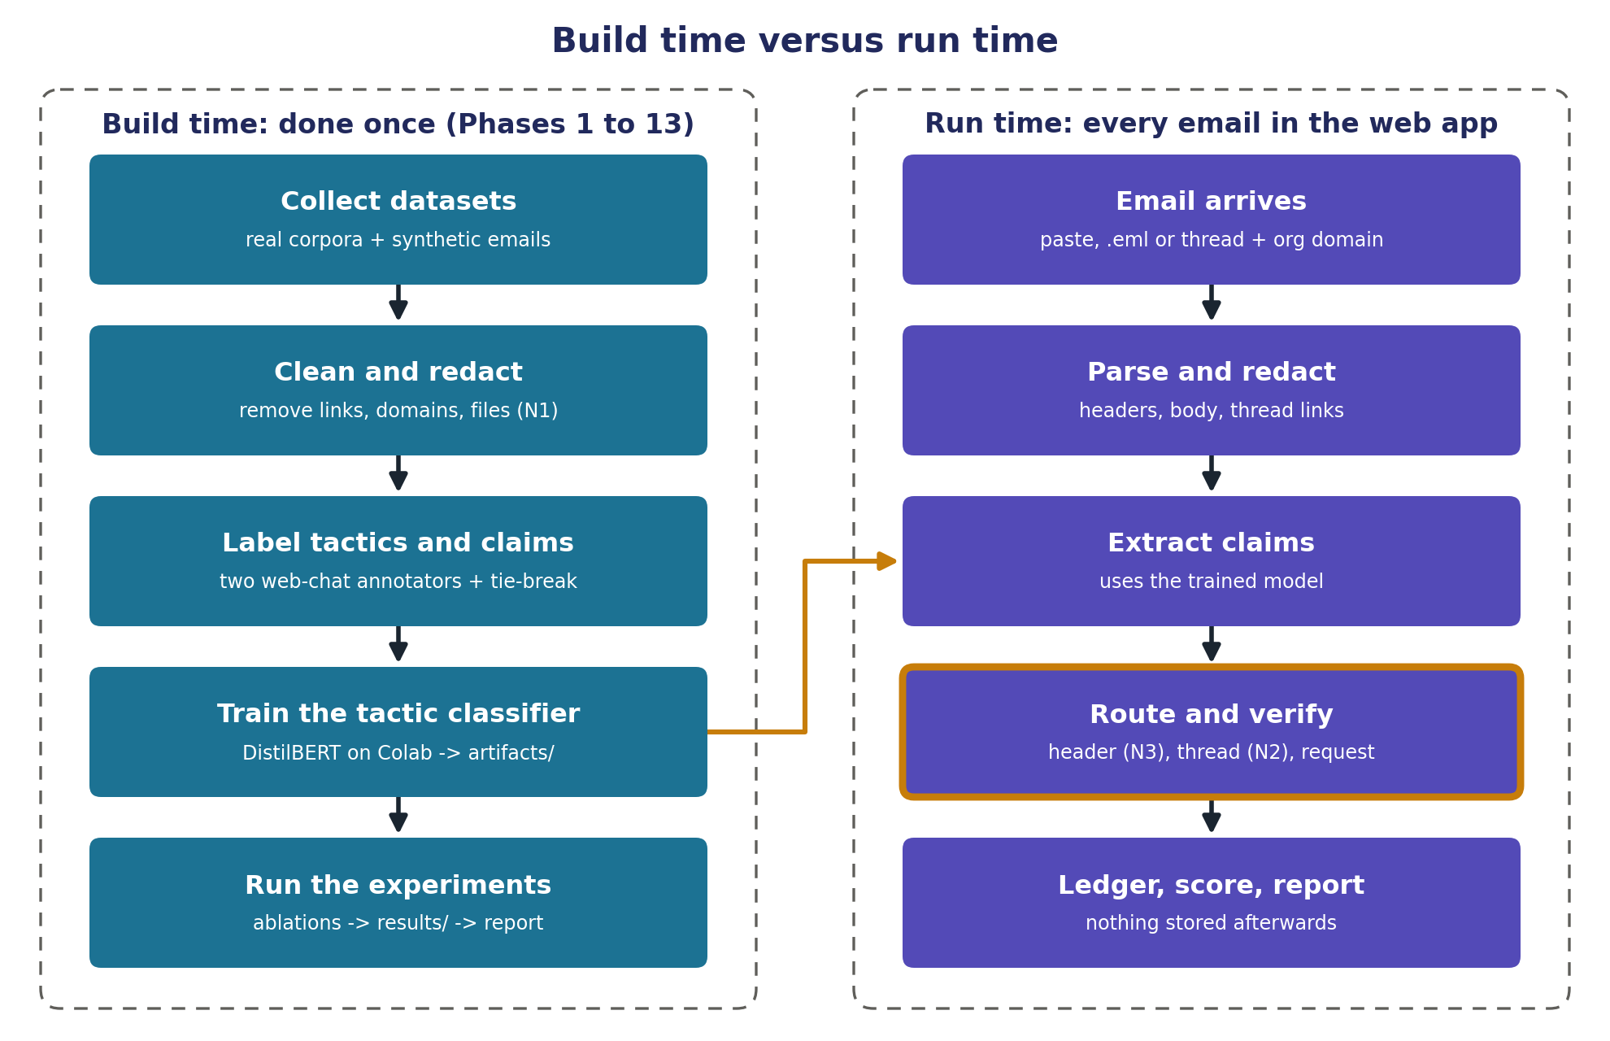
Figure 5. Build time versus run time
Text description: two dashed columns. Left, build time, done once in Phases 1 to 13: collect datasets (real corpora plus synthetic emails), clean and redact (N1), label tactics and claims (two web-chat annotators plus a tie-break), train the tactic classifier (DistilBERT on Colab, saved to artifacts/), run the experiments (ablations to results/ and the report). Right, run time, every email in the web app: email arrives (paste, .eml or thread plus organisation domain), parse and redact, extract claims (using the trained model), route and verify (header N3, thread N2, request; gold border = novel), ledger, score and report, with nothing stored afterwards. A gold arrow carries the trained model from the training step to claim extraction.
Run-time steps, mapped to the code that performs them:
Step | What happens | David example | Code lives in
1. Receive | The browser sends the email and the optional organisation domain | Raw text of the David email | frontend/, src/api/
2. Validate | API key, rate limit, size cap, type and structure checks | Passes | src/api/
3. Parse | Headers, body and thread links; headers become an evidence dict | from_domain gmail.com, freemail, dmarc pass, Reply-To protonmail.com | src/headers/, src/thread/
4. Redact (N1) | Links, domains and file names become placeholders | No links, body unchanged | src/preprocess/
5. Extract claims | Tactic probabilities plus typed claims from patterns and name detection | c1 affiliation_internal, c2 payment_request; urgency 0.94, secrecy 0.91 | src/models/, src/claims/
6. Route and verify | Each claim goes to the verifier that can check it | Header and request verifiers both find contradictions | src/router/, src/verifiers/
7. Ledger and score | Contradictions add points; urgency and secrecy multiply them | High risk band | src/router/
8. Report | JSON back to the browser; the email is discarded from memory | Highlights, findings table, recommended action | src/api/, src/explain/, frontend/
API endpoints (Phase 11): POST /analyze (one email, optional organisation domain), POST /analyze/thread (several emails), GET /results (evaluation numbers for the dashboard), GET /health.

6.11 Machine learning parts in plain words
- Classifier: a program that learns patterns from labelled examples. Shown thousands of emails marked with the tactics they use, it learns what each tactic sounds like.
- DistilBERT and fine-tuning: DistilBERT is a smaller, faster version of BERT that has already read a huge amount of English. Fine-tuning shows it our labelled emails so it learns the seven tactics on top of what it knows. It outputs seven independent probabilities (multi-label), for example urgency 0.94 and liking 0.03.
- Weights and Colab: training needs a GPU, so it runs on Google Colab's free GPU. The result is a set of weight files (the learned numbers), downloaded into artifacts/ and used on the Mac's CPU, which is fast enough for one email at a time.
- spaCy and regex: spaCy finds people and organisation names; regex patterns catch phrases such as "this is X from Y", account numbers and signature blocks. The claim extractor combines them with the classifier into typed claims.
- LIME: removes words one at a time, watches how a tactic probability changes, and highlights the words that mattered most.
- Keyword baseline: fixed word lists per tactic; it exists to show that DistilBERT beats simple rules.

7. Tactic taxonomy
Seven labels, multi-label (one email can carry several). Five come from Cialdini's principles: authority, scarcity, reciprocity, social proof and liking. Urgency is not a Cialdini principle; it comes from Stajano and Wilson's time principle (2011), which phishing research treats separately from scarcity. The seventh, isolation/secrecy, comes from the BEC literature.
# | Tactic | What it looks like | Example phrase
1 | Authority | Asserted rank, role or institutional power | "This is the CFO"; "IT Security requires"
2 | Urgency | Manufactured deadline or time pressure (Stajano and Wilson's time principle, not Cialdini) | "Before 3 PM today"; "immediately"
3 | Scarcity | Loss or finality framing | "Last chance"; "your account will be deleted"
4 | Reciprocity | Debt framing | "I covered for you last month, now I need..."
5 | Social proof | Everyone else has already done it | "The whole team has already signed off"
6 | Liking / rapport | Manufactured warmth, flattery, false familiarity | "Great seeing you at the offsite, quick favour..."
7 | Isolation / secrecy | Cut the victim off from verification (not in Cialdini) | "Keep this between us"; "don't loop in your manager"

Dropped: commitment/consistency (rare in single emails, hard to annotate, would be a sparse label). Urgency vs scarcity: urgency is a deadline or time pressure; scarcity is loss or finality framing. An email can carry both ("reply by 5 PM or the account is deleted"), and then both labels apply. Why secrecy matters most: a legitimate business request almost never asks you to avoid verification.

8. Data plan
Principle: real data first; synthetic data only to fill gaps that are measured and documented.

8.1 Datasets
Dataset | Email? | Size (approx.) | Fields | Role
Phish No More (Kaggle): Enron, Ling, CEAS-08, Nazario, Nigerian Fraud, SpamAssassin | Yes | 82,500 (42,891 phishing/spam, 39,595 legitimate) | CEAS, Nazario, Nigerian, SpamAssassin: sender, receiver, date, subject, body, urls. Enron, Ling: subject, body | Main single-email corpus for body-level work
Enron raw (CMU maildir) | Yes | About 500k | Message-ID (internal JavaMail IDs), Date, From, To, Subject, X-From, X-To, X-Folder; expected to lack In-Reply-To, References, Received and X-Mailer (Phase 1 confirms) | Benign baseline; real threads for N2 content signals
Nazario + Nigerian Fraud (inside the merge) | Yes | About 15k | As above | Primary real attack positives (body level); Nigerian Fraud also gives real external affiliation claims for N3
CEAS-08 + SpamAssassin (inside the merge) | Yes | About 45k | sender, receiver, date, subject, body, urls only; no Reply-To, Received or Authentication-Results | Body-level work only; header evidence comes from the raw sources below
SpamAssassin public corpus (raw) | Yes | About 6,000 | Full raw headers (2002 to 2005, mostly before DMARC) | Header evidence extractor development; benign and spam headers
Nazario phishing corpus (raw yearly mbox files) | Yes | A few thousand, counted in Phase 1 | Full raw headers; newer years may carry Authentication-Results | Real attack positives with headers; external affiliation claims for N3
phishing_pot (GitHub dataset of honeypot .eml files; data only, no code) | Yes | Counted in Phase 1 | Full raw headers, recent (still updated in 2026); recipient addresses anonymised | Modern attack positives with real authentication headers; licence checked in Phase 1
Apache project mailing-list archives (monthly mbox export) | Yes | A few lists over a few years, chosen in Phase 1 | Full headers including Message-ID, In-Reply-To, References and Received | Real threads for N2 header signals (sending-path drift, thread integrity)
SemEval-2023 Task 3, Subtask 3 | No (news) | 26,663 paragraphs, 23 techniques | Human span labels, multi-label | Optional pretraining (plain component)
Synthetic | Yes | About 500 emails + injected thread replies | Full | Modern BEC gap-fill; thread-hijack injections; matched benign continuations. Generated through free web chats from fixed prompt templates and stored in data/synthetic/ (committed)
Header coverage table (Phase 1): for every source, Phase 1 counts how many messages carry Reply-To, Return-Path, Received, Authentication-Results, In-Reply-To and References. The table goes into the report. Authentication signals are scored only where the header exists; synthetic headers fill only the gaps this table shows, and that is disclosed.

8.2 Why several datasets
The project needs five things and no single dataset has them all: examples of normal and attack email (Enron; Nazario and Nigerian Fraud), real header evidence (raw SpamAssassin, raw Nazario, phishing_pot; the Kaggle merge keeps only sender and date), tactic and claim labels (none of the email corpora have them; SemEval has human tactic labels but is news), threads for content signals (raw Enron), and threads with full headers for header signals (Apache mailing lists). Each source fills one gap.

8.3 Thread-hijack benchmark (for N2)
- Rebuild real threads from raw Enron using normalised "RE:" subjects, participants and quoted text, because Enron is expected to lack In-Reply-To and References (the first Phase 1 script confirms which thread headers exist). Rebuild Apache mailing-list threads from Message-ID, In-Reply-To and References.
- Keep threads with at least three messages.
- Pick an injection point and generate an attacker reply in one of three variants: account-takeover reply (same sender, content drift; on Apache threads the sending details are copied from that sender's real messages), mid-thread lookalike domain swap, or forged thread (a new email with fabricated quoted history and no matching Message-IDs).
- Negatives: the real next reply from the same thread (Enron or Apache), plus a synthetic benign continuation generated with the same generator and prompt template (style-confound control).
- Labels: hijacked or not (thread level) and the hijack message index.
- Evaluation split: content signals (tactic onset, request drift) are scored on Enron threads; header signals (sending-path drift, thread integrity) on Apache threads.
- Disclose in the report that the injected replies are synthetic while the base threads are real.

8.4 Tactic labels and annotation
- SemEval: human labels, mapped from 23 techniques to our 7 with a documented mapping table (Phase 5).
- Synthetic emails: a script in src/data writes fixed prompt templates; Nagasai pastes them into a free web chat and saves the JSON replies in data/synthetic/. Labels are known from the prompt, and every synthetic attack has a benign twin from the same template.
- Real attack emails: a stratified sample of about 600 to 800 is labelled for the seven tactics and for claim types with text spans (affiliation, authority, relationship, request types), so the claim extractor can be evaluated too. Labelling uses the free web chat interfaces of two different model families, Gemini (annotator 1) and DeepSeek (annotator 2); z.ai (GLM) breaks ties where they disagree. No paid APIs. Method follows Pan et al. (2026).
- Procedure: a script in src/data writes batch prompt files of about 20 redacted emails with fixed instructions and a fixed JSON output schema. Nagasai pastes each batch into a fresh chat, saves the reply as a JSON file in data/labelled/<annotator>/, and records the model name and date. A validation script checks every reply against the schema and lists items to re-ask.
- Agreement: Cohen's kappa per label (each tactic and each claim type), reported with the mean. Final labels: agreed labels stand; disagreements take the tie-breaker's label.
- Limitations to state: web chats give no temperature control and their models change over time, so labels are not exactly reproducible. Mitigations: one model per annotator for the whole run, fixed prompts, and every raw reply saved in the repo.
- Decision recorded: Nagasai chose not to hand-label, including a small human validation sample. Validation therefore rests on agreement between two LLM annotators; the report should state this as a limitation and describe the annotation method as it actually happened.

8.5 Style-confound control
If attacks are written by an LLM and legitimate emails are human-written from 2001, a model can learn "LLM vs 2001 human" instead of manipulation. Controls: real attack emails are the primary positives; every synthetic attack has a matched synthetic benign twin from the same generator and template; a source classifier (LLM vs Enron vs Nazario) is trained and its AUC is reported as a threat to validity.

8.6 Splits
The single-email table is split 70% train, 15% validation and 15% test in Phase 1, stratified by source and category with a fixed random seed, after duplicates are removed. The test split stays untouched until final evaluation in Phase 13; weights and thresholds are tuned on validation only. The thread benchmark is split by thread in Phase 9, so no thread appears in both training and test.

8.7 Unified schema
The schema is filled in stages, so no phase depends on a later one. The phase that fills each group is shown on the right.
id, source, category, is_attack, has_full_headers,
raw_ref, raw_headers, body_raw, split (Phase 1)
body_clean, body_redacted, has_url (Phase 2)
from_name, from_addr, from_domain, reply_to,
return_path, date, subject, org_domain,
auth_results (spf, dkim, dmarc or unknown),
message_id, in_reply_to, references (Phase 3)
tactic_authority, tactic_urgency, tactic_scarcity,
tactic_reciprocity, tactic_social_proof, tactic_liking,
tactic_secrecy, claims (type, span, organisation),
label_source (semeval | synthetic | llm_annotated | none) (Phase 5)
thread_id, thread_position (Phase 9)

8.8 Phase 1 staging decisions
- Category and is_attack: every email gets a category (ham, spam, phishing or fraud); is_attack is true only for phishing and fraud, so the attack-vs-benign task is not padded with ordinary spam.
- Deduplication: the Kaggle merge repeats Enron, Nazario and SpamAssassin emails that the raw downloads also contain. Duplicates are found by hashing normalised body text and removed before splitting; when two copies exist, the one with full headers is kept. The same email in train and test would inflate every score.
- Kaggle header block: Kaggle rows get a minimal header block built from their sender, receiver, date and subject columns, so Phase 3 parses every source the same way. has_full_headers is false for them, and the coverage table shows it.
- Raw Enron stays out of the single-email table. The Kaggle merge already holds Enron bodies; raw Enron is used for the header check now and for threads in Phase 9.
- Apache lists: two user-support lists over twelve months, chosen after checking that they are mostly human threads (developer lists are flooded with bot notifications).
- Storage: Parquet files (a compressed, typed table format) in data/processed/; raw downloads stay untouched in data/raw/<source>/. raw_ref points every row back to its original file.
- Scripts and libraries: src/data/paths.py, download.py, loaders.py, stage.py, coverage.py and split.py; new libraries pandas, pyarrow, requests and tqdm, pinned when installed.
- Checks before writing download code: current URLs and file names for Nazario, SpamAssassin, Enron (CMU), the Apache archive API and the chosen lists; the phishing_pot licence and folder layout; the exact Kaggle file names. About 1 GB is downloaded and about 3 GB used after unpacking.
- READMEs: a root README with the complete end-to-end idea, plus one README each for src/, data/, results/, notebooks/, docs/ and artifacts/. .gitignore changes artifacts/ to artifacts/* with an exception for artifacts/README.md.

8.9 Where data lives
Stage | Location | In Git? | Phase
Downloads, never modified | data/raw/<source>/ | No (large, separately licensed) | 1
One table of every email | data/processed/staged.parquet | No | 1
Plus clean and redacted bodies | data/processed/ | No | 2
Plus header evidence columns | data/processed/ | No | 3
Annotation batches, raw chatbot replies, final labels | data/labelled/ | Yes (small; proof of method) | 5
Synthetic emails | data/synthetic/ | Yes | 5 and 9
Training notebook | notebooks/ (training data uploaded to Google Drive) | Notebook yes, data no | 6
Trained model weights | artifacts/tactic_model/ | No (README only) | 6
Rebuilt threads and hijack benchmark | data/threads/ | Decided in Phase 9 by size | 9
Every experiment number and chart | results/ | Yes (rubric requirement) | 13
Report and slides | docs/ | Yes | 14
At run time nothing is stored: the email lives in memory for one request, and logs hold only metadata (time, request ID, score), never content.

9. Technology stack
Layer | Choice | Why
Language | Python 3.12 (Homebrew python@3.12) in a venv | Matches Google Colab's runtime (Python 3.12), so the same library versions can be pinned in Colab and locally; venv is Python's node_modules
Model | DistilBERT via HuggingFace Transformers + PyTorch | Small enough to fine-tune on a free Colab GPU; fast inference on CPU
Training | Google Colab (free GPU) | No local GPU needed; torch and transformers pinned to the same versions as local
NLP extras | spaCy (en_core_web_sm) | Names and organisations for identity claims
Header parsing | email stdlib, mailbox, tldextract, rapidfuzz | Parsing, .mbox reading, domain splitting, lookalike and organisation-name matching
Data and baseline | pandas, pyarrow, scikit-learn | Tables in memory, Parquet files, keyword baseline, metrics
Downloads (Phase 1) | requests, tqdm | Fetching datasets with progress bars
Testing | pytest | One environment check only (tests/test_environment.py); no unit tests per phase
Explainability | LIME (SHAP only if time) | Word-level highlights; attention-as-explanation is academically contested
Backend | FastAPI + Pydantic + slowapi | The model lives in Python; schema validation; rate limiting
Frontend | React + Vite + Tailwind | Reuses existing React knowledge
Database | None, deliberately | Privacy by design: submitted email content is never stored
Repo | GitHub, public: Nagasai-Datta/PretextGuard | Commit history evidences original work; kept public by Nagasai's choice
Security tooling | pip-audit, .env for secrets | Dependency and secret hygiene
Annotation (offline only) | Free web chats: Gemini, DeepSeek, z.ai tie-break | Keeps the project free; no paid APIs; never used at runtime

Rejected: the MERN stack (Express would only proxy to FastAPI; MongoDB would store the email content the design promises not to keep). No LLM at runtime (cost, latency, no on-premise deployment for a mail gateway, non-determinism, no inspectable explanation); an LLM can appear only as an optional comparison baseline.

10. Security design
Security Features is worth 15 marks and is treated as a first-class module.
Control | Implementation | OWASP mapping
No persistence | Email content lives in memory for the request only; never logged, never written to disk | A02 / privacy by design
Input validation | Size cap (for example 100 KB per email), content-type checks, .eml structure checks, Pydantic schemas | A03 Injection
Safe parsing | Attachments are never opened or executed; limit on nested MIME depth and message count per thread | A04 Insecure Design
Output encoding (XSS) | Email bodies are attacker-controlled. Render as text; highlights are built from escaped text; no dangerouslySetInnerHTML; DOMPurify if HTML is ever shown. Test with real XSS payloads from the corpus. | A03 Injection (XSS)
PII redaction | Email addresses, phone numbers and account numbers redacted before any logging | A09 Logging Failures
Rate limiting | slowapi per-IP limits on the analysis endpoint | A04 Insecure Design
Authentication | API key on the analysis endpoint | A01 / A07
Audit logging | Log events and verdicts (time, request ID, score, tactics), never content | A09 Logging Failures
Dependency hygiene | Pinned requirements, pip-audit in the build (clean at Phase 0) | A06 Vulnerable Components
Secrets management | .env never committed; .env.example lists variable names only (PRETEXTGUARD_API_KEY); the environment check confirms .env is ignored | A05 Misconfiguration
Prompt-injection note | No LLM at runtime. During offline annotation in web chats, email text is wrapped as data, the instructions say never to follow it, and replies are validated against a fixed schema. | LLM01

11. Evaluation plan
Experiment | Question | Metric | Supports
Tactic classifier | How well are tactics detected? | Per-tactic precision, recall, F1; macro-F1 | Base
Keyword baseline vs DistilBERT | Does the model beat rules? | Macro-F1 | Base
Claim extraction | How accurately are claims found? | Precision and recall per claim type on the annotated test portion | All verifiers
N1 ablation | How much of a phishing detector's accuracy is link-reading? | Attack-class F1 and false-positive rate for models A and B on raw, redacted and naturally link-free test views | N1
N2 ablation | Does thread verification catch hijacks N3 misses? | Detection rate with vs without the thread verifier; hijack-index accuracy; content signals on Enron threads, header signals on Apache threads | N2
N3 ablation | Does conditioning beat the alternatives? | F1 and false-positive rate: full vs text-only vs headers-only vs parallel fusion; real affiliation positives and synthetic BEC reported separately | N3
Architecture ablation | Does routing beat a flat classifier on the same signals? | F1, false-positive rate, share of findings with a traceable reason | Architecture
SemEval pretraining (optional) | Does pretraining help with little data? | Macro-F1 across training sizes | Plain
Adversarial paraphrase | Does it survive rewording? | Detection before vs after paraphrase | Robustness
Style-confound test | Is the model reading writing style? | Source-classifier AUC | Validity
Header coverage | Which sources carry which headers? | Per-source coverage table | Validity
Co-occurrence and confusion analysis | Which tactics stack; where it fails | Heatmap, confusion pairs | Analysis
Metrics in plain words: precision is the share of flagged emails that really were attacks; recall is the share of real attacks that got flagged; F1 balances the two in one number; macro-F1 averages F1 equally over the seven tactics; the false-positive rate is how often legitimate emails get flagged, which matters because a tool that cries wolf gets switched off. Ablation: remove one component and measure again; the drop is what that component contributed. Each novelty claim has one.

Rule: every number in the report or slides must come from a script in src/eval, with its output saved in results/ in the repo. Fake or manipulated results cost 20 marks.

12. Build plan

12.1 How the build runs
For each phase, the assistant explains the background, then provides every file with a function-by-function explanation and the exact commands to run, delivered as downloadable files plus one block of mv commands, or as paste blocks that create each file in place when the interface cannot hand over files (for example Claude Code on the web). Nagasai runs everything in VS Code (training on Colab), reports the output or error, commits after each working step and pushes. The assistant never runs Git itself. A new chat has no memory of earlier chats, so every session starts from docs/PretextGuard_Context.md and this document. At the end of a phase the assistant lists exactly what changed in this document.

12.2 Phases and status
Phase | Deliverable | Module | Status
0 | Environment: Python 3.12, venv, VS Code, Git, GitHub CLI, folder structure, requirements, .gitignore, .env.example, pytest smoke test, pip-audit | repo root | Done (Sep 2026)
1 | Data acquisition (paths, download, loaders, stage, coverage and split scripts): Kaggle merge, raw SpamAssassin, raw Nazario, phishing_pot, raw Enron, Apache list archives; staged.parquet; header coverage table; Enron thread-header check; 70/15/15 split; root README and one README per major folder | src/data | Not started (next)
2 | Preprocessing and payload-free redaction (N1) | src/preprocess | Not started
3 | Parser and header evidence extractor; fills the header columns; organisation domain handling | src/headers | Not started
4 | Keyword baseline | src/baseline | Not started
5 | Tactic and claim labels: batch prompt builder, web-chat annotation (Gemini, DeepSeek, z.ai tie-break), schema validation, Cohen's kappa, SemEval 23-to-7 mapping; synthetic emails via web chats into data/synthetic/ | src/data | Not started
6 | DistilBERT tactic classifier on Colab (optional SemEval pretraining) | src/models | Not started
7 | Claim extractor and claim schema (affiliation, authority, relationship, request types) | src/claims | Not started
8 | Header verifier (N3: internal and external affiliation, authority, reply, signature) and request verifier | src/verifiers | Not started
9 | Thread builder (Enron and Apache), thread-hijack benchmark, thread verifier (N2, including request drift) | src/thread, src/verifiers, src/data | Not started
10 | Claim router, verdict ledger, risk score, LIME highlights | src/router, src/explain | Not started
11 | FastAPI backend with all security controls | src/api | Not started
12 | React frontend: analyzer (single email and thread) and evaluation dashboard; frontend README | frontend | Not started
13 | Evaluation: all experiments, claim-extraction accuracy, charts; outputs saved to results/ | src/eval, results | Not started
14 | Report, viva preparation, Review deck update | docs | Not started

12.3 Folder structure
pretextguard/ (~/Desktop/pretextguard)
README.md end-to-end overview and setup (Phase 1)
venv/ never commit
.vscode/ settings.json: VS Code uses venv/bin/python
data/ README.md: every dataset and every stage
raw/ downloads, read-only forever (ignored)
processed/ staged tables in Parquet (ignored)
labelled/ annotation batches and raw replies
synthetic/ synthetic emails from web chats
threads/ rebuilt threads + hijack benchmark
artifacts/ trained model weights (ignored; README kept)
results/ eval outputs and charts (committed)
src/ README.md; every folder has __init__.py
data/ loading, staging, schema, coverage, benchmark
preprocess/ cleaning + redaction (N1)
headers/ parser + header evidence
thread/ thread builder + thread signals
models/ DistilBERT training + inference
claims/ claim extractor
verifiers/ header (N3), thread (N2), request
router/ router, ledger, risk score
explain/ LIME
baseline/ keyword baseline
eval/ metrics, ablations, charts
api/ FastAPI app
frontend/ React + Vite + Tailwind (Phase 12)
notebooks/ Colab training notebooks
tests/ test_environment.py (setup check)
docs/ this document, context file, report, slides
.env .env.example .gitignore pytest.ini
requirements.txt

12.4 If time runs short
Drop in this order: (1) SemEval pretraining, (2) the style-drift signal, (3) the evaluation dashboard page (keep charts as images in the report), (4) the adversarial paraphrase test, (5) SHAP. Never drop N1, N2, N3, the router and ledger, or the security controls.

12.5 Environment notes
- Activate the venv in every new terminal; the prompt must show (venv). A missing (venv) is the most common reason a package seems to disappear.
- data/raw is read-only. Scripts read from raw and write to processed, so any mistake can be fixed by deleting processed and rerunning.
- Train on Colab (Python 3.12), save the model to artifacts/, run inference locally on CPU. Pin torch and transformers to the same versions in Colab and in requirements.txt.
- .gitignore includes: venv/, __pycache__/, *.pyc, .env, data/raw/, data/processed/, artifacts/, *.pt, *.bin, *.safetensors, node_modules/, frontend/dist/, .ipynb_checkpoints/, .pytest_cache/, .DS_Store. Phase 1 changes artifacts/ to artifacts/* plus !artifacts/README.md so the folder README is committed.
- The project lives at ~/Desktop/pretextguard. iCloud Desktop sync is off, so the venv and data stay on local disk only.
- Python is 3.12.14 from Homebrew (python@3.12). The Mac also has Homebrew 3.14 (the default python3), python.org 3.11 and Apple's 3.9; the project uses only the venv's 3.12.
- Always work from ~/Desktop/pretextguard, never from src/: source venv/bin/activate is a relative path. The shell aliases python to python3, which is harmless inside the venv.

12.6 Planned file map
Planned file names; each phase may adjust them. The root and major-folder READMEs are written in Phase 1, and each src package gets its README in the phase that builds it.
Folder | Planned files | What they do | Phase
src/data | paths.py, download.py, loaders.py, stage.py, coverage.py, split.py | Folder paths; fetch datasets; one reader per source format; dedupe and write staged.parquet; header coverage table; train/validation/test split | 1
src/data | batches.py, validate_labels.py, agreement.py, semeval_map.py, synthetic.py | Annotation batch prompts; reply validation; Cohen's kappa; SemEval 23-to-7 mapping; synthetic email prompts and loading | 5
src/preprocess | clean.py, redact.py | HTML stripping, quote and signature splitting; N1 redaction | 2
src/headers | parser.py, evidence.py, domains.py | Raw email to headers, body and thread links; evidence dict; freemail and brand lists, organisation domain | 3
src/baseline | keywords.py | Word lists per tactic and a scorer | 4
src/models | dataset.py, train.py, predict.py | Training data preparation; fine-tuning on Colab; loading weights and predicting 7 tactic probabilities | 6
src/claims | schema.py, patterns.py, extractor.py | Claim object; regex patterns; classifier + spaCy + patterns to typed claims | 7
src/verifiers | header_verifier.py, request_verifier.py | N3 checks; who is asking for money or credentials | 8
src/thread, src/verifiers, src/data | builder.py, signals.py, thread_verifier.py, hijack_benchmark.py | Thread rebuilding; N2 signal helpers; N2 verifier and flip point; hijack benchmark | 9
src/router, src/explain | router.py, ledger.py, score.py, pipeline.py, lime_explain.py | Routing table; ledger rows; 0-100 score and bands; analyze(email) end to end; LIME highlights | 10
src/api | main.py, schemas.py, security.py | FastAPI app and routes; Pydantic request and response shapes; API key, rate limit, size caps, safe logging | 11
frontend/src | main.jsx, App.jsx, api.js, pages/AnalyzerPage.jsx, pages/DashboardPage.jsx, components/EmailInput.jsx, RiskBadge.jsx, HighlightedBody.jsx, FindingsTable.jsx, HeaderFindings.jsx, ThreadTimeline.jsx | Entry and layout; API calls; analyzer and dashboard pages; input, score, highlighted body, ledger table, header results, thread timeline | 12
src/eval | metrics.py, ablation_n1.py, ablation_n2.py, ablation_n3.py, ablation_arch.py, claim_extraction.py, style_confound.py, paraphrase.py, charts.py | Metrics; one script per ablation; supporting experiments; charts | 13

13. Viva preparation
Pitch (say it at the start and the end): Pretexting emails have no link or attachment, so scanners miss them. PretextGuard reads what an email claims about itself and checks each claim against two independent references: its headers and its own conversation history. When the claim and the evidence disagree, that contradiction is the detection.
Question | Answer
Hasn't this been done? There's a 2025 paper. | Yes, the MDPI Computers two-stage framework, which we cite. It scores payload-bearing phishing with LLM-generated, LLM-labelled data, body only. We isolate payload-free pretexting (N1), verify claims against headers (N3) and against thread history (N2). The ablations measure each difference.
The title says metadata. Where is it? | Half the system: the header evidence extractor and the thread builder are pure metadata, and both verifiers use it.
What if the attacker controls a real account and SPF passes? | That is exactly what N2 is for. The headers look clean, so we check the message against its own thread: new urgency, new bank details, a different sending path, or a fake reply chain.
Gmail passes SPF, DKIM and DMARC. How do you catch the fake David? | Authentication proves which domain sent the message, not who the person is. The body claims Acme Finance; the authenticated domain is gmail.com. That mismatch is the contradiction. A header-only check that treats pass as safe misses it.
How is this different from BEC-Guard? | BEC-Guard adds a header score and a body score in parallel. Addition cannot say "the body claims X and the headers disprove X". We route each claim to the evidence that can test it.
Mithun et al. already talk about claim mismatches. | They annotate the claims and explicitly leave verification to a future algorithm; they do not build a detector. We build that verifier, and add thread evidence they do not consider.
Ho et al. already detect phishing from compromised accounts. | Their detector is URL-based and needs organisation-wide mailbox data. Ours is payload-free and works from the message and its thread.
ConvoSentinel already does conversation-level detection. | For chat. It uses no email headers and no thread-integrity checks.
Aggarwal et al. (2014) already detected link-free phishing. | They score scam content that baits a reply: no recipient name, a money offer, a reply prompt. They never check who the sender claims to be against the headers or the thread, and they do not cover colleague impersonation or hijacked threads.
Plenty of student projects combine DistilBERT, metadata features and LIME. | Those fuse a text score and a metadata score, which is the parallel-fusion pattern. We route each claim to the evidence that can test it, and the ablation against parallel fusion measures the difference.
Isn't your data synthetic or circular? | Primary positives are real attack emails (Nazario, Nigerian Fraud, phishing_pot), and N3's affiliation checks are tested on their real claims. Synthetic data only fills modern gaps, mainly colleague impersonation, and always has matched benign twins. The thread benchmark uses real Enron and Apache threads with injected replies, and we say so.
How were tactic labels made? | Two free web-chat LLM annotators from different model families (Gemini and DeepSeek), a third (z.ai) breaking ties, a fixed JSON schema, and Cohen's kappa per label, following Pan et al. (2026); SemEval human labels for optional pretraining. We state the reproducibility limitation of web chats.
Why not just ask an LLM? | Cost and latency at gateway scale, no on-premise deployment, non-deterministic output, and no inspectable reasoning. An LLM can be an optional baseline.
Your F1 is below the published 99%. | Deliberately. Those numbers are on payload-bearing phishing where the link carries the signal. N1 removes that crutch and measures how far the number falls.
Why no database? | Privacy by design. The tool handles sensitive corporate email; storing it would create the breach risk the tool exists to reduce.
What is an ablation? | Remove one component, re-measure; the drop shows what that component contributed. We run one per claim.
What if Authentication-Results is missing? | Recorded as unknown, never as pass. The verifiers fall back to name-vs-address, Reply-To, lookalike and thread evidence.

13.1 Concepts already taught
- Email as plain text: headers, blank line, body; From, Reply-To, Return-Path, Received, Authentication-Results.
- Display name vs actual address; the letter-and-envelope model of SMTP.
- SPF, DKIM and DMARC as verdicts we read, not computations we run.
- Payload vs payload-free; why pretexting evades technical controls; what a .eml file is.
- Ablation studies; the seven-tactic taxonomy; why several datasets are merged.
- Homebrew, venv and activation, pip with pinned requirements, packages and __init__.py, running from the project root (Phase 0).
- .gitignore, .env and .env.example, pytest basics, pip-audit (Phase 0).
To be taught during the build: tokenisers and fine-tuning, multi-label sigmoid outputs vs softmax, why a 0.5 threshold is usually wrong, Cohen's kappa, LIME, FastAPI basics, the thread-hijack benchmark, the claim router, affiliation claims in code, .mbox and maildir formats, Parquet, deduplication and leakage.

14. Decisions log
When | Decision | Reason
July 2026 | Picked Problem Statement 37 | Best effort-to-marks ratio on the list; text in, labels out, no hardware
July 2026 | v1 scrapped; rebuilt as PretextGuard v2 | v1 duplicated the 2025 MDPI Computers paper
July 2026 | FastAPI + React, no database; MERN rejected | Model lives in Python; privacy by design
July 2026 | Real attack corpora as primary positives; synthetic only as gap-fill with matched benign twins | Avoid the style confound and circular data
July 2026 | LLM-assisted annotation; no hand-labelling or human validation sample | Nagasai's choice; Pan et al. (2026) precedent
July 2026 | Secrecy added as the seventh tactic; commitment dropped | BEC literature; sparse label
From 29 July 2026 | Review-I presented | Deck, prep notes and slide spec delivered
After Review-I | Faculty struck old N2 (SemEval transfer) and old N4 (severity model) | Faculty decision; one more core claim requested
21 Sep 2026 | New N2: thread consistency verification | Covers N3's blind spot: authenticated, hijacked accounts
21 Sep 2026 | Claim-routed verification pipeline adopted as the architecture contribution | Fact-checking style design; builds the verifier Mithun et al. (2024) left open
21 Sep 2026 | SemEval pretraining and the 0-100 score kept as plain components | Useful, but not claimed as novelty
21 Sep 2026 | Claude writes all code phase by phase; Nagasai runs it in VS Code | Nagasai's choice
21 Sep 2026 | Missing authentication headers are treated as unknown, never pass | Evidence honesty
22 Sep 2026 | Running example corrected: freemail and lookalike senders pass authentication; exact-domain spoofing is a separate case | Technical correctness; strengthens N3's conditioning argument
22 Sep 2026 | Affiliation claims (internal and external) replace internal-only identity claims | Gives N3 real positives from Nazario and Nigerian Fraud
22 Sep 2026 | N1 task fixed: binary attack detection, models A and B, three test views | The protocol was underspecified
22 Sep 2026 | Raw header sources added (SpamAssassin, Nazario, phishing_pot) with a header coverage table | The Kaggle merge has no Reply-To, Received or Authentication-Results
22 Sep 2026 | Apache mailing-list threads added for N2 header signals | Enron lacks reply-chain and routing headers
22 Sep 2026 | Request drift owned by the thread verifier (N2); the request verifier checks the sender only | Diagram and text disagreed
22 Sep 2026 | Optional organisation domain input, defaulting to the To domain | Internal-affiliation checks need it
22 Sep 2026 | Claim types added to the annotation; claim extractor evaluated | Every verifier depends on claim extraction
22 Sep 2026 | Annotation through free web chats (Gemini, DeepSeek; z.ai tie-break); no paid APIs | Nagasai's choice: keep the project free
22 Sep 2026 | Python 3.12 instead of 3.11 | Matches the Colab runtime
22 Sep 2026 | Commit after each working step | Stronger evidence of incremental work
22 Sep 2026 | Deadline is not a planning constraint; scope not cut | Nagasai's decision
22 Sep 2026 | Section 7 corrected: five tactics from Cialdini, urgency from Stajano and Wilson | Factual accuracy
22 Sep 2026 | Figures redrawn (N1 marked novel, LIME fed by the classifier, organisation domain and security steps shown), text descriptions added, schema filled in stages | Diagram review before build
Sep 2026 | Phase 0 complete: Python 3.12.14 from Homebrew in a venv, repository pushed, environment check and pip-audit clean | Environment ready
Sep 2026 | No unit tests per phase; each phase is verified by running its scripts; one environment check kept | Nagasai's decision: focus on building
Sep 2026 | GitHub repo kept public (Nagasai-Datta/PretextGuard) | Nagasai's choice; raw data and .env are never committed
Sep 2026 | Phase 1 staging decisions: category column (spam is not an attack), cross-source deduplication, Kaggle header block, raw Enron kept out of the single-email table, Parquet, 70/15/15 stratified split | Honest labels and no train-test leakage
2 Oct 2026 | READMEs: root (end-to-end idea) and each major folder in Phase 1; each src package in its own phase | Nagasai's request; documentation that matches the code
2 Oct 2026 | Synthetic emails generated through free web chats into data/synthetic/ | No paid APIs; the method was missing
2 Oct 2026 | Context file docs/PretextGuard_Context.md added; every new chat starts from it and this document; files arrive as downloads with mv commands or as paste blocks | Work continues in fresh chats with no memory, including Claude Code on the web
2 Oct 2026 | Version 3.2: stale sections fixed; beginner walkthrough folded in (3.6, 6.10, 6.11, 8.8, 8.9, 12.6); Figure 5 added | Document review before Phase 1

15. Open items and next actions
- Start Phase 1 in a new chat with docs/PretextGuard_Context.md and this document.
- Replace the project-file copy with v3.2 (remove v3.1) and keep docs/ in the repo current.
- Update the Review deck when needed: novelty slide (N1, N2, N3 and the architecture contribution), the architecture diagram (Figure 2), the corrected running example (authentication passes for gmail.com), and the literature table (add Mithun et al. 2024, Ho et al. 2019, Valecha et al. 2022, ConvoSentinel, Aggarwal et al. 2014).
- Phase 1 checks: confirm which thread headers raw Enron has; build the header coverage table; check the phishing_pot licence; choose the Apache lists; verify every download URL before use.
- Before Phase 5: review the annotation prompt, the JSON schema and the batch size together.
- Re-verify statistics before the report: IC3 2024 (and whether a 2025 report is out), DBIR 2026 wording, and the under-8% figure.
- Calibrate risk score weights and bands on the validation split (Phase 10).
- Decide late whether SemEval pretraining runs (only if time allows).

16. Glossary
Term | Meaning
Payload | The part of an email that does technical damage: a malicious link or attachment
Payload-free | No link and no attachment; nothing for a scanner to catch
Pretexting | An attack built on a made-up identity or story; the victim does the damage
BEC / VEC / ATO | Business Email Compromise / Vendor Email Compromise / Account Takeover
Thread hijacking | An attacker replies inside a real conversation, usually from a compromised account
.eml | A plain-text file holding one email: headers, a blank line, then the body
Display name | The free-text name in From, for example "David Chen"; anyone can type anything
SPF / DKIM / DMARC | Checks on whether a sender may use a domain, whether the message is signed, and the combined verdict
Reply-To / Return-Path / Received | Where replies go / where bounces go (envelope sender) / the servers the message passed through
Message-ID / In-Reply-To / References | A message's unique ID / the ID it replies to / the chain of earlier IDs in the thread
Claim | Something the email asserts about itself (identity, authority, relationship, request)
Verifier | A function that checks one kind of claim against evidence
Verdict ledger | The list of findings: claim, evidence, contradiction or not, and the reason
Ablation | Remove one part, re-measure, and the drop shows what that part was worth
Multi-label | One email can carry several tactics at once
Macro-F1 | F1 averaged equally across all tactic labels
Cohen's kappa | Agreement between two annotators beyond what chance would give
LIME | An explanation method that shows which words pushed a prediction
DistilBERT | A smaller, faster version of BERT used for the tactic classifier
Style confound | A model learning who wrote the text instead of what the text does
Corpus | A dataset of text (plural: corpora)
Affiliation claim | A statement that the sender represents an organisation: internal (the recipient's company) or external (a bank, vendor or agency)
Exact-domain spoofing | Forging the real company's own domain in From; fails DMARC when the company publishes a DMARC policy
Organisation domain | The recipient organisation's own domain, used for internal-affiliation checks
Header coverage table | Per-source counts of which headers exist; decides where header signals can be scored
.mbox | One file holding many emails back to back; how Nazario and mailing-list archives are distributed
Build time / run time | Build time: data, labels, training and experiments, done once. Run time: the web app analysing one email at a time
Fine-tuning | Further training of a pretrained model on our own labelled examples
Weights | The learned numbers of a trained model, saved as files in artifacts/
Parquet | A compressed, typed file format for tables; faster and smaller than CSV
Precision / recall | Share of flagged emails that were attacks / share of attacks that got flagged
False-positive rate | How often legitimate emails are wrongly flagged
Deduplication | Removing repeated emails so none appears in both training and test
Data leakage | Test information reaching training, which makes scores look better than they are
venv | A project's private Python interpreter and packages, like node_modules for Python
Paste block | A terminal command that creates a file in place: cat > path << 'PG_EOF' ... PG_EOF
Context file | docs/PretextGuard_Context.md: what a fresh chat needs to continue the build

17. References
- Karki, B., Abri, F., Siami Namin, A., Jones, K. S. (2022). Using Transformers for Identification of Persuasion Principles in Phishing Emails. IEEE International Conference on Big Data, pp. 2841-2848.
- A Two-Stage Deep Learning Framework for AI-Driven Phishing Email Detection Based on Persuasion Principles (2025). MDPI Computers, 14(12):523.
- Pan, T., Yang, Q., Cole, A. J., Wilson, R., Woodard, D. (2026). Psychology of Phishing Emails: Quantifying Persuasion Principles and Simulating Detection with Large Language Models. Expert Systems with Applications.
- Valecha, R., Mandaokar, P., Rao, H. R. (2022). Phishing Email Detection Using Persuasion Cues. IEEE Transactions on Dependable and Secure Computing, 19(2):747-756.
- Aggarwal, S., Kumar, V., Sudarsan, S. D. (2014). Identification and Detection of Phishing Emails Using Natural Language Processing Techniques. Proceedings of the 7th International Conference on Security of Information and Networks (SIN '14), ACM, pp. 217-222.
- Mithun, P., Bartlett, G., Mirkovic, J., Freedman, M. (2024). Phishing Email Detection Using Inputs From Artificial Intelligence. arXiv:2405.12494.
- Cidon, A., Gavish, L., Bleier, I., Korshun, N., Schweighauser, M., Tsitkin, A. (2019). High Precision Detection of Business Email Compromise. USENIX Security Symposium.
- Ho, G., Cidon, A., Gavish, L., Schweighauser, M., Paxson, V., Savage, S., Voelker, G. M., Wagner, D. (2019). Detecting and Characterizing Lateral Phishing at Scale. USENIX Security Symposium.
- Ai, L. et al. (2024). Defending Against Social Engineering Attacks in the Age of LLMs (ConvoSentinel). arXiv:2406.12263.
- Piskorski, J. et al. (2023). SemEval-2023 Task 3: Detecting the Category, the Framing, and the Persuasion Techniques in Online News in a Multi-lingual Setup. ACL.
- Al-Subaiey, A., Al-Thani, M., Alam, N. A., Antora, K. F., Khandakar, A., Zaman, S. A. (2024). Novel Interpretable and Robust Web-based AI Platform for Phishing Email Detection. Computers and Electrical Engineering, 120:109625.
- Cialdini, R. B. Influence: The Psychology of Persuasion.
- Stajano, F., Wilson, P. (2011). Understanding Scam Victims: Seven Principles for Systems Security. Communications of the ACM, 54(3):70-75.
- FBI Internet Crime Complaint Center (IC3). Internet Crime Reports 2023 and 2024.
- Verizon. Data Breach Investigations Report (recent editions, including 2026).
- Klimt, B., Yang, Y. (2004). The Enron Corpus: A New Dataset for Email Classification Research. ECML 2004.
- Nazario, J. Phishing corpus (raw mbox files by year), monkey.org.
- Apache SpamAssassin project. SpamAssassin public mail corpus.
- rf-peixoto. phishing_pot: real phishing samples collected via honeypots. GitHub dataset repository (data used, no code).
- Apache Software Foundation. Public mailing-list archives (lists.apache.org).

