Overbooking Clinic Appointments with Reinforcement Learning: Exploration Schedules, Learning Efficiency and Robustness to Shifts in the No-Show Rate
M Naga Sai Dattu 23BCE0757, Prakrit Bahl 23BCE0826 | SCOPE, VIT Vellore |
marupaka.naga2023@vitstudent.ac.in, prakrit.bahl2023@vitstudent.ac.in
Abstract. Patients who miss appointments leave clinic slots empty, and booking more patients than slots recovers capacity at the risk of overtime and long waits. We model a clinic that decides before each session how many extra patients to book as a Markov decision process with 60 states and 5 actions, built from the public 'Medical Appointment No Shows' table: each session is a real neighbourhood day, attendance is what the table records, the state combines the slots filled, the no-show risk predicted by a classifier and a waiting list, and every policy is scored on later weeks that it never saw. From 150 logged clinic days we learn policies with dynamic programming (DP), Monte Carlo (MC) control and Q-learning, compare five exploration schedules (constant epsilon, exponential decay, a 1/k decay, optimistic initialisation, near greedy), and score the final policies on the real scoring sessions, including two shifts of the no-show rate. DP, MC and Q-learning scored 170.3, 162.8 and 167.0 against 150.8 for the overbooking rule, a gain of +19.5, +12.0 and +16.2 (all p < 0.001) over 20 replicates, whereas a DP policy fitted to ten times as much data scored 173.6. On the fitted model no schedule reached 90% of the optimal improvement in any of 60 runs; the near greedy schedule was the slowest for Q-learning (normalised area under the learning curve -0.16 against 0.29 for the best schedule), and the ranking of schedules by final true return differed between the two algorithms (rank correlation -0.80 over five schedules). When the no-show rate rose by 0.08, all 10 learned configurations stayed above the rule, by 24.1 units on average against 15.9 at the nominal rate; when it fell by 0.05, the rule gained 6.3 and they were still ahead by 9.3. A structured model that learns only patient behaviour and takes the clinic's rules as known scored 182.5 with the same 150 days (+12.3 over DP, p < 0.001) and 182.5 with 25 days, ahead of every other method, including a single session optimiser from published work (182.0), at the nominal and both shifted rates; its margin over that optimiser grows to 33% when waiting is costlier, and Q-learning came closer to its DP solution than MC. No clinical claims are made.
Keywords: appointment scheduling; no-show; overbooking; exploration schedule; epsilon-greedy; optimistic initialisation; learning curves; distribution shift; structured model; real appointment data

1. Introduction
Missed appointments are costly: a slot reserved for a patient who does not come is lost capacity, and clinics have long responded by overbooking, that is, giving more appointments than slots. Overbooking trades the value of filled slots against the cost of overtime when everyone arrives and of waiting for those who are not seen [1,2]. The right amount depends on the no-show rate, which varies with the weekday, the season and the patient mix and drifts over time.
Reinforcement learning (RL) can learn an overbooking rule from logged clinic data without an explicit model of no-show behaviour [3]. Three practical questions follow. First, how quickly and how reliably do standard learners converge, and does the exploration schedule matter? The textbook answer is that it does, because an agent that never tries an action cannot learn its value [3,4,5]. Second, a policy learned from a log is deployed in a clinic whose no-show rate may differ from that of the log, so how robust is it? Third, if the logs are the limit, can they be used more efficiently? This paper studies all three on clinic sessions rebuilt from a real appointment table, scoring every policy on weeks that were never used for learning.
A feature of the offline setting changes the first question. When the learner is trained on a model fitted from logs, its exploration happens inside that model, and a state and action pair that the logs never contain cannot be discovered by exploring harder. The exploration schedule then governs how fast the fitted model is solved rather than what information is collected. Part of our contribution is to measure how much the schedule matters under that condition and to report the answer even when it is small. The same condition points to a remedy: if the clinic's own rules are known, only patient behaviour has to be learned, and every logged session informs the same few quantities.
Contributions. (i) A clinic overbooking MDP built from the Medical Appointment No Shows table, with a state made of the slots filled, the predicted no-show risk and a waiting list, and an operational reward (Section 4). (ii) A normalised learning efficiency metric, the area under the learning curve and the steps to 90% of the optimal improvement, defined against the clinic's own behaviour and the oracle optimum (Eq. 3 to 5). (iii) A controlled comparison of 5 exploration schedules for two learners with 6 replicates each. (iv) A shift study that scores the trained policies when the no-show rate is higher or lower than in the log (Eq. 6). (v) A structured model in which only patient behaviour is learned (Section 5.2), compared with the learners and with baselines from published work (Sections 7.5 to 7.9). (vi) Candid results where they are small: no schedule reaches 90%, and the margin over the best published baseline is small unless waiting is costly.
Scope and honesty. Every result uses the real table, but the table does not record everything a clinic decision needs: it has no overbooking decisions, no waiting list and no times within a day. The decisions in the logs are therefore generated by a behaviour policy, the waiting list is simulated, and overtime and waiting are counted in patients (Section 6.1). Findings concern algorithms, not clinics, and no clinical claim is made.

2. Related work
Appointment scheduling and overbooking. Operations research has studied appointment systems extensively, including no-shows, overbooking and the trade-off between patient waiting and provider overtime [1]; analytical results for overbooking with no-shows are given by Zacharias and Pinedo [2]. Predicted no-show probabilities have been combined with overbooking decisions for a single session, for example by marginal analysis [6], and fixed risk thresholds for double booking serve as the baseline for learned policies [7]. Our contribution is not a better scheduling model but a study of how RL learners behave on one, and of how much they gain from a model that knows the clinic's rules.
Exploration in RL. Epsilon-greedy exploration, decaying schedules and optimistic initial values are the textbook devices [3]. Convergence of on-policy methods needs schedules that are greedy in the limit with infinite exploration (GLIE) [4]; Q-learning converges under visit-count conditions on the step size [8,9]. Model-based methods such as R-max make optimism explicit [5]. Our schedules are the simple ones a practitioner would try; the 'GLIE-style' schedule here has a floor and is therefore not strictly GLIE.
Offline RL and shift. Learning from logs is limited by data coverage and is sensitive to model error, which motivates pessimism and support constraints [10,11,12]. Robustness to a change in the environment after deployment is a related but different concern, and we treat it with the simplest possible experiment: scoring the trained policies again on sessions with a shifted no-show rate. Known structure is an alternative to more data: in a factored MDP the transition model is assembled from separately specified parts of the state [13], which is the idea behind the structured model of Section 5.2.

3. Preliminaries: Markov decision processes and the three solution families
A finite Markov decision process (MDP) is a tuple (S, A, P, R, γ) with a finite state set S, a finite action set A, a transition kernel P(s' | s, a), an expected reward R(s, a) and a discount factor γ in [0, 1). A deterministic policy π maps each state to an action. Its value V^π(s) is the expected discounted return obtained by starting in s and following π; the optimal value V*(s) satisfies the Bellman optimality equation [3,14,15]
V*(s) = max_a [ R(s,a) + γ Σ_{s'} P(s'|s,a) V*(s') ] (1)
Dynamic programming (DP). When P and R are known, V* is the unique fixed point of the contraction in Eq. (1). Value iteration repeatedly applies the right-hand side until the sup-norm change is below a tolerance; policy iteration alternates exact policy evaluation (solving the linear system (I − γP_π)V = R_π) with greedy improvement and terminates in a finite number of steps. We implement both and verify on every run that they return policies of identical value, which acts as a built-in correctness test of the solver.
Monte Carlo (MC) control. Without a model, MC control estimates the action-value Q(s,a) as the average return observed after first visits to (s,a) within complete episodes, and improves an ε-soft policy that is greedy with respect to Q [3,16]. It makes no bootstrapping assumption, so it is unbiased but has high variance and must wait until an episode ends before learning anything.
Q-learning. Tabular Q-learning is a model-free temporal-difference method that bootstraps from its own estimates [8]:
Q(s,a) ← Q(s,a) + α [ r + γ max_{a'} Q(s',a') − Q(s,a) ] (2)
It converges to Q* if every (s,a) is visited infinitely often and the step sizes satisfy the usual stochastic-approximation conditions. In practice the speed at which it spreads reward information backwards is its main advantage over MC, and its bias from bootstrapping off noisy estimates is its main weakness.
Empirical MDPs from logged data. Clinical data are logged, not simulated: we observe transitions (s, a, r, s') generated by clinicians. Counts N(s,a,s') give the maximum-likelihood model P̂(s'|s,a) = N(s,a,s')/N(s,a) and R̂(s,a) as the mean observed reward. Solving the MDP (P̂, R̂) by DP gives a plug-in policy; MC and Q-learning can be run against samples drawn from (P̂, R̂), which is how "learning from experience" is realised without touching patients. Two safeguards are used throughout because plug-in planning is notoriously exploited by estimation error [10,11,12]: (i) a support constraint: a pair (s,a) observed fewer than 10 times is completed pessimistically (it transitions to an absorbing terminal state with the worst reward in the data), and (ii) a terminal pseudo-count: one pseudo-observation of absorption is added to every supported pair so that no state is estimated to be immortal.

4. Problem formulation: a clinic overbooking MDP built from real sessions

4.1 Real clinic sessions from the Medical Appointment No Shows table
The Medical Appointment No Shows table [17] lists 110,527 medical appointments in Brazil, one row per appointment, with the day the appointment was booked, the day it took place, the patient's age, sex and neighbourhood, an SMS reminder flag, enrolment in a welfare programme, flags for hypertension, diabetes, alcoholism and disability, and whether the patient came. After removing one row with a negative age and the 39 appointments on Saturdays, 110,487 appointments of 62,277 patients in 81 neighbourhoods remain, on 26 weekdays between 29 April and 8 June 2016; 20.2% of them were missed.
A classifier predicts the no-show probability of each appointment from what is known when it is booked: the days between booking and appointment, the patient's age, sex, SMS flag, welfare flag and the four condition flags, the weekday, the numbers of the patient's earlier appointments and earlier no-shows in the table, and the neighbourhood. It is a gradient boosting model [18] fitted on the 24,187 appointments before 9 May 2016, calibrated by isotonic regression [19] on the 21,683 appointments from 9 to 15 May, and applied to the 64,617 appointments from 16 May onwards; both steps use scikit-learn [20]. On these appointments its area under the ROC curve is 0.728, its Brier score 0.144, and its mean predicted no-show probability 22.0% against 19.8% observed. No information from later weeks enters the classifier.
The appointments from 16 May onwards are grouped into clinic sessions, one for each neighbourhood and day with at least 5 appointments. Sessions from 16 to 25 May (506) are used only for learning and sessions from 30 May to 8 June (592) only for scoring. The no-show rate fell from 21.2% in the first period to 18.5% in the second, so the scoring weeks already differ from the learning weeks.

4.2 The overbooking MDP
A clinic runs 40 sessions per episode, each with 10 regular slots. An episode draws its sessions at random from the real sessions of one period, keeping the weekday order. The first min(10, n) appointments of a session fill its regular slots, and before the session the clinic books k extra patients, k in {0, 1, 2, 3, 4}, drawn from all appointments on the same weekday of the same period. Whether each patient shows up is what the table records. Overtime is the number of patients above 10, idle is the number of unused slots, and a waiting list of length w (0 to 12) grows by a Poisson(1.5) number of patients per session and shrinks by min(w, k), the number of extra bookings drawn from it; the table has no waiting list, so this is the one simulated part of the clinic. The reward per session is shows − 3 × overtime − 0.5 × idle − 0.4 × waiting list length + 0.3 × (patients drawn from the waiting list). Rewards are discounted with γ = 0.97.
Table 1. The clinic overbooking MDP.
Element | Definition
State (60) | slots filled (3: 5 to 7, 8 or 9, 10) × predicted no-show risk band (4: quartiles of the session mean, cut points 0.175, 0.215, 0.257) × waiting list band (5: lengths 0, 1 or 2, 3 to 5, 6 to 8, 9 or more)
Actions (5) | book k extra patients, k = 0 to 4 (labels +0, +1, +2, +3, +4)
Reward per session | shows − 3 overtime − 0.5 idle − 0.4 waiting list + 0.3 drawn from waiting list
Discount, horizon | γ = 0.97; 40 sessions per episode
Overbooking rule | book one extra patient when the predicted risk band is 0 or 1, otherwise two extra
Behaviour policy | the rule with ε = 0.25 uniformly random actions
Data | Medical Appointment No Shows: 506 learning sessions (16 to 25 May 2016), 592 scoring sessions (30 May to 8 June 2016)

Three design features matter for what follows. First, the rule only ever uses k = 1 or 2, and the behaviour policy picks each of the other actions with probability ε / 5 = 0.05 per session, so the logs contain few examples of overbooking by 3 or 4. If visits were spread evenly over the 60 states, a given state and action pair outside the rule would be seen about 5.0 times in 150 logged episodes and about 50 times in 1,500; since pairs seen fewer than 10 times are treated as unsupported, the small dataset cannot support most of the actions the optimum uses, while the large one can. (Visits are not spread evenly, so this is an order of magnitude argument.) Second, the waiting list rewards overbooking beyond the show rate trade-off, because extra bookings drain it. Third, the risk band in the state comes from the classifier, not from the attendance itself, so a change in how often patients come that the classifier has not seen does not change the state.

5. Method: exploration schedules, shift evaluation and a structured model

5.1 Exploration schedules, normalised learning efficiency and shift evaluation
Both learners are trained on a model fitted to the logged episodes and sample experience from that model (never from the scoring sessions). Let k be the step count and T the budget (150,000 steps). The five schedules are
constant: ε_k = 0.1; exponential: ε_k = 0.05 + 0.95 exp(−5k/T); 1/k-type: ε_k = max(0.02, c / (c + k)), c = T / 50; near-greedy: ε_k = 0.02, (3)
and the optimistic initialisation schedule uses ε_k = 0.02 together with an initial action value q0 = 0.5 × 14 × (1 − γ^H) / (1 − γ) = 164.3, where 14 is an assumed upper bound on the reward per session and H = 40. With c = 3,000 the 1/k schedule equals 0.5 at k = c and reaches its floor only near the end of the budget; because of the floor it is not strictly GLIE [4]. MC control uses first visit returns with incremental averaging; Q-learning uses a visit count step size [8,9].
Learning curves are measured by recording, at 26 evenly spaced checkpoints, the value of the greedy policy on a large 'oracle' model (Section 7.1 explains what that value means). The raw values depend on the scale of the problem, so we normalise them against the clinic's own behaviour and against the optimum of the same model:
v(π) = [J(π) − J_beh] / [J_opt − J_beh], (4)
so that v = 0 is the behaviour policy and v = 1 the model optimum. We summarise a learning curve by its mean over the checkpoints and by the first checkpoint reaching 90% of the possible improvement:
AUC = (1 / K) Σ_j v(π_{t_j}), t90 = min { t_j : v(π_{t_j}) ≥ 0.9 }, K = 26. (5)
The AUC rewards fast learning and penalises a slow start, and t90 asks whether the optimum is approached at all. The table cannot change how often patients come, so the evaluation under shift changes the recorded outcomes of the scoring sessions instead: with r the no-show rate of the scoring sessions, each recorded show becomes a no-show with probability δ / (1 − r) when δ > 0, and each recorded no-show becomes a show with probability −δ / r when δ < 0:
Pr(show → no-show) = δ / (1 − r) if δ > 0, Pr(no-show → show) = −δ / r if δ < 0, δ ∈ { 0, +0.08, −0.05 }. (6)
This moves the no-show rate of the scoring sessions from 18.5% to 26.4% and 13.5%. The policy, trained on nominal data, is not changed, and neither are the predicted risks, so the shift does not move the visited states: a policy can only notice it through the waiting list.
Algorithm 1 Exploration schedule study
input : logged clinic days D (150 episodes from the learning sessions), schedule list, learners {Q-learning, MC}, budget T, shift list
1. fit the MDP from D (pairs seen < 10 times are unsupported; unsupported pairs are absorbing with the worst reward)
2. for each schedule and each learner:
run the learner for T steps in the fitted MDP with eps_k (and q0); every T/25 steps record J(greedy policy) on the oracle MDP
fill unobserved states with the logged modal action; score the final policy on the scoring sessions and their shifted versions (120 episodes)
3. normalise curves with Eq. (4); compute AUC and t90 with Eq. (5)
4. repeat over independent data draws; report means and 95% intervals

5.2 A structured model of the clinic solved by DP
Section 4.2 explains what limits any learner that works on the empirical MDP of Section 3: it estimates P(s' | s, a) separately for each of the 300 pairs (s, a), and the pairs that the optimum uses are rarely logged. A structured model estimates far fewer quantities. The clinic's own rules are taken as known: the 10 regular slots, the reward of Table 1, and the fact that k extra bookings take min(w, k) patients off a waiting list of length w. Only patient behaviour is learned: how likely the booked patients are to come, which the classifier of Section 4.1 provides, how often each combination of slots filled and risk band occurs, and the mean number λ of patients who join the waiting list in a session. A model assembled in this way from separately specified parts of the state is a factored MDP [13]; here 26 numbers are estimated from the logs, against 18,300 transition probabilities in the empirical MDP.
Write the state as s = (c, v), where c is one of the 12 combinations of slots filled and risk band and v the waiting list band. From the logged sessions, f̂(c) is the share of sessions in cell c (with 0.5 added to every cell); λ̂ is the mean of w_{t+1} − (w_t − min(w_t, k_t)) over consecutive sessions in which the list did not reach its cap of 12; and π(w | v), the share of each exact list length w among the logged sessions in band v, links the band to the length. With (x)⁺ = max(0, x), the expected reward of booking k extra patients is
R̃(s, k) = mean_{i ∈ L_c} E[ N_i − 3 (N_i − 10)⁺ − 0.5 (10 − N_i)⁺ ] + E_w[ 0.3 min(w, k) − 0.4 w ], (7)
where L_c holds the logged sessions of cell c (up to 400), and N_i, the number of patients who come, is a sum of independent Bernoulli variables: one for each booked patient of session i, with the session's mean predicted attendance probability, and one for each extra patient, with probability 0.778, one minus the mean predicted risk in the learning period; its distribution is computed exactly by convolution. The second expectation is over w drawn from π(w | v). Tomorrow's patients do not depend on today's booking, so the next state follows as
P̃(c', v' | s, k) = f̂(c') Pr[ band(min(12, w − min(w, k) + A)) = v' ], (8)
with w drawn from π(w | v) and the number of new patients A drawn from Poisson(λ̂). Eq. (7) and (8) give a reward and a transition for every pair (s, k), whether or not the logs contain it, so no pair is unsupported and no fallback is needed. The model is solved with value iteration (Eq. 1), the solver of Section 3. The same model can also be given to MC control and Q-learning in place of the empirical MDP, which separates the effect of the model from that of the learner.
Algorithm 2 Structured model DP
input : logged clinic days D; predicted no-show risks of the booked patients; the clinic's rules (10 slots, reward of Table 1, waiting list emptied by extra bookings)
1. estimate from D: the cell shares f(c), the arrival rate λ and π(w|v)
2. for every state s and every k = 0 to 4 compute R(s,k) with Eq. (7) and P(s'|s,k) with Eq. (8)
3. solve the model by value iteration (Eq. 1) and use the greedy policy in every state
4. optionally, train MC control or Q-learning on the same model instead of step 3

6. Experimental protocol

6.1 Data: real sessions
Important disclosure. The first version of this study could not reach the Kaggle website (all requests returned HTTP 403) and ran on a hand-specified simulator. Every result in this version comes from the real table, and the scoring sessions are never used for learning. The table cannot provide everything the study needs, and the gaps are filled as follows. (i) It records no overbooking decisions, so the logs are generated by running the behaviour policy of Table 1 over the real learning sessions: the decisions are generated, the attendance is recorded. (ii) It has no waiting list, so the waiting list of Section 4.2 is simulated. (iii) It has no clinics or slots, so a session is one neighbourhood on one day with 10 regular slots. (iv) It has no times within a day, so overtime and waiting are counted in patients, not minutes. (v) It covers 26 weekdays, so 150 or 1,500 logged days are runs of 40 sessions drawn from the 506 learning sessions, not distinct days. (vi) Its no-show rate cannot be set, so the shift study changes recorded outcomes (Eq. 6). The results should be read as a method study on recorded attendance, not as a finding about patients.

6.2 Data, solvers and scoring
Table 2. Experimental configuration.
Item | Setting
Data | 506 learning and 592 scoring sessions; 60 states; 5 actions; 40 sessions per episode
Benchmark | 150 logged episodes; oracle MDP from 1,500 episodes; 20 replicates; 1,000 scoring episodes; 150,000 steps
Learners | DP (value and policy iteration agreed in all replicates: yes), first visit MC, Q-learning; DP, MC and Q-learning on the structured model
Schedule study | 5 schedules × 2 learners × 6 replicates (data seeds 700 to 705); 150,000 steps; 26 checkpoints; reference values J_beh = 113.58, J_opt = 144.91 on the oracle MDP
Shift study | no-show offsets 0, +0.08, -0.05 (Eq. 6); 120 scoring episodes per run in the schedule study (300 for the rule and the DP policy), 1,000 for every policy of Section 7.7
Further studies | logged days 25, 50, 150, 500 and 1,500 (10 replicates); waiting cost 0.4 or 1.0 and 1.5 or 2.5 new patients per session (10 replicates, 500 episodes)
Statistics | 95% CI = 1.96 standard errors over replicates; where a significance statement is made the interval is widened to a t interval (factor 1.07 for 20 replicates, 1.31 for 6)

- Learners. MC control and Q-learning each receive 150,000 steps drawn from the estimated MDP, with an exponentially decaying ε schedule (ε from 1.0 to about 0.05) and a visit count step size α = max(0.02, 1/(1 + n^0.7)) for Q-learning.
- Replicates. 20 independent data draws (each with its own logged dataset and learner seeds). Intervals are 95% intervals over replicates; paired differences are tested with a one sample t test on the differences for each replicate.
- Scoring. Each final policy is run for 1,000 episodes of 40 scoring sessions with common random numbers (episode e brings the same patients and the same attendance for every policy), and the mean discounted return is recorded. Learning curves are scored exactly on a large 'oracle' MDP estimated from ten times as much logged data.
- Fallback. In states never observed in the (supported) data a learned policy defers to the clinician's modal logged action, so that unsupported states cannot be exploited.
In the schedule study the benchmark's exponential schedule is one of the five. Final policies in the schedule study use the logged modal action in states with no data.

6.3 Baselines from published work and further comparisons
- Baselines from published work. (i) A single session optimiser books the k that maximises the expected reward of the current session, computed from each booked patient's predicted risk; this is marginal analysis of the kind used for overbooking under predicted no-shows [6]. (ii) Threshold double booking fills empty regular slots and books one extra patient for every booked patient whose predicted risk is at least θ, the fixed threshold rule against which learned double booking policies are compared [7]. (iii) A fixed number k of extra bookings in every session. The threshold θ (0.20, 0.25, 0.30 or 0.35) and the fixed k (0 to 4) were chosen on the scoring sessions, which favours these baselines.
- Structured model. DP, MC and Q-learning on the model of Section 5.2, learned from the same 20 logged datasets as the benchmark and scored on the same 1,000 episodes.
- Convergence. During learning, the greedy policy of MC and Q-learning is also scored on 60 scoring episodes at each of the 26 checkpoints, on the estimated MDP and on the structured model.
- Statistics. Differences between two learned policies are tested over replicates; differences from a single policy (the rule, the oracle and the baselines) are also tested over the 1,000 paired scoring episodes.

7. Results

7.1 Benchmark on the real scoring sessions
Table 3. Benchmark on the real scoring sessions (60 states). Return is discounted; shows, overtime, idle slots and the summed waiting list length are totals per 40 session episode (20 replicates, 95% CI; rule and oracle are single policies).
Method | Return (mean ± 95% CI) | Shows | Overtime | Idle | Waiting
Clinician behaviour (modal logged action) | 150.8 ± 0.0 | 363.6 | 8.0 | 44.4 | 211.1
Guideline rule | 150.8 ± 0.0 | 363.6 | 8.0 | 44.3 | 211.0
DP on estimated MDP | 170.3 ± 1.0 | 377.3 | 15.6 | 38.3 | 98.3
Monte Carlo control | 162.8 ± 2.3 | 371.9 | 15.2 | 43.2 | 114.6
Q-learning | 167.0 ± 2.1 | 377.3 | 16.9 | 39.6 | 101.2
Oracle DP (10x data) | 173.6 ± 0.0 | 387.4 | 21.5 | 34.2 | 68.8

Table 3 shows that all three learners are well ahead of the rule. DP scored 170.28 ± 0.99, MC 162.80 ± 2.26 and Q-learning 167.05 ± 2.11 against 150.82 for the rule. Paired over replicates the differences from the rule are +19.47 ± 0.99 (p < 0.001; ahead in 20 of 20) for DP, +11.98 ± 2.26 (p < 0.001; 20 of 20) for MC and +16.23 ± 2.11 (p < 0.001; 20 of 20) for Q-learning. With 20 replicates a t interval is only 1.07 times wider than the interval shown. Among the learners the differences are resolved as well: DP minus Q-learning +3.24 ± 1.68 (p = 0.001), DP minus MC +7.49 ± 2.50 (p < 0.001) and MC minus Q-learning -4.25 ± 2.87 (p = 0.009), so DP is ahead of Q-learning, which is ahead of MC. The replicate to replicate standard deviations are 4.8 for Q-learning and 5.2 for MC. The modal logged action scored 150.76, 0.06 below the rule, consistent with it reproducing the rule almost everywhere.
The oracle DP, fitted to 1,500 episodes, scored 173.62, which is 22.8 above the rule and 3.3 above the best learner. The learners trained on 150 episodes capture most of that headroom (85% for DP, 71% for Q-learning, 53% for MC), because the rule is conservative for real attendance: with about 19% of patients not coming, one or two extra bookings leave 44.3 idle slots per episode and a summed waiting list of 211. The operational columns show how the oracle gets further: it books more patients (387 shows per episode against 364 for the rule), accepts about 2.7 times as much overtime (21.5 against 8.0), has fewer idle slots (34.2) and a much shorter waiting list (69). The learners move in the same direction but stop short: DP reduces the summed waiting list to 98, Q-learning to 101 and MC to 115, with overtime of 15.6, 16.9 and 15.2.
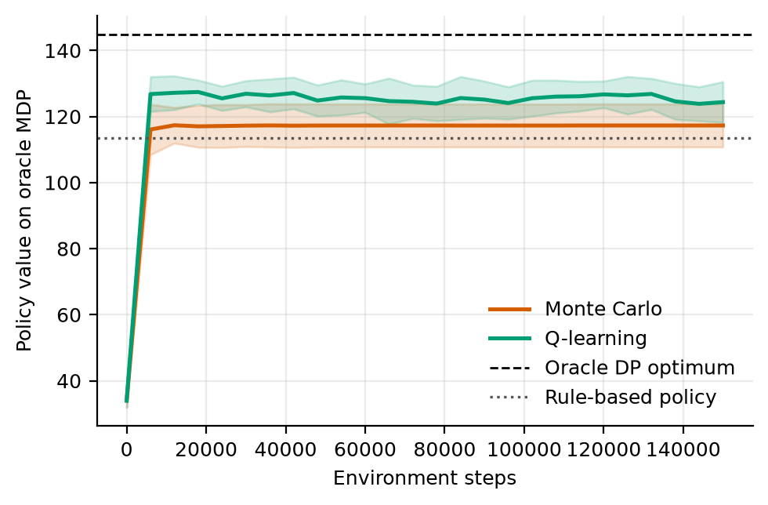
Figure 1. Learning curves on the oracle MDP (mean ± s.d. over 20 replicates). Dashed: oracle DP optimum; dotted: the overbooking rule.
Figure 1 shows the learning curves on the oracle model, which is the scale used for all efficiency metrics. Both learners start at 34.0 (the greedy policy of a value table of zeros). MC is within one model unit of its final value by step 12,000 and stays at 117.3; Q-learning peaks at 127.4 by step 18,000 and settles at 124.4 from step 48,000 of the 150,000. The mean DP policy value on the same model is 126.6, so Q-learning ends 2.3 below the DP solution of its fitted model and MC 9.3 below it. All three lie above the rule's 113.6 and far below the optimum 144.9. On this scale DP, MC and Q-learning are 13.0, 3.7 and 10.8 above the rule, and on the scoring sessions they are 19.5, 12.0 and 16.2 above it, so the two scales agree in sign and in the order of the learners; 9 of 60 replicate and learner cells have a model value below the rule's.
The model scale is still pessimistic. The oracle model treats a state and action pair seen fewer than 10 times as absorbing with the worst reward in the data, so a policy that chooses such an action is penalised on the model whatever it would do in the clinic. The return on the scoring sessions minus the oracle model value ranges from 28.7 to 45.5 over the six methods, and the data model's value of its own DP policy was 23.5 to 44.0 below the oracle model's value of the same policy in every replicate (mean optimism gap -33.5). We therefore use the model scale only to compare learning speed.
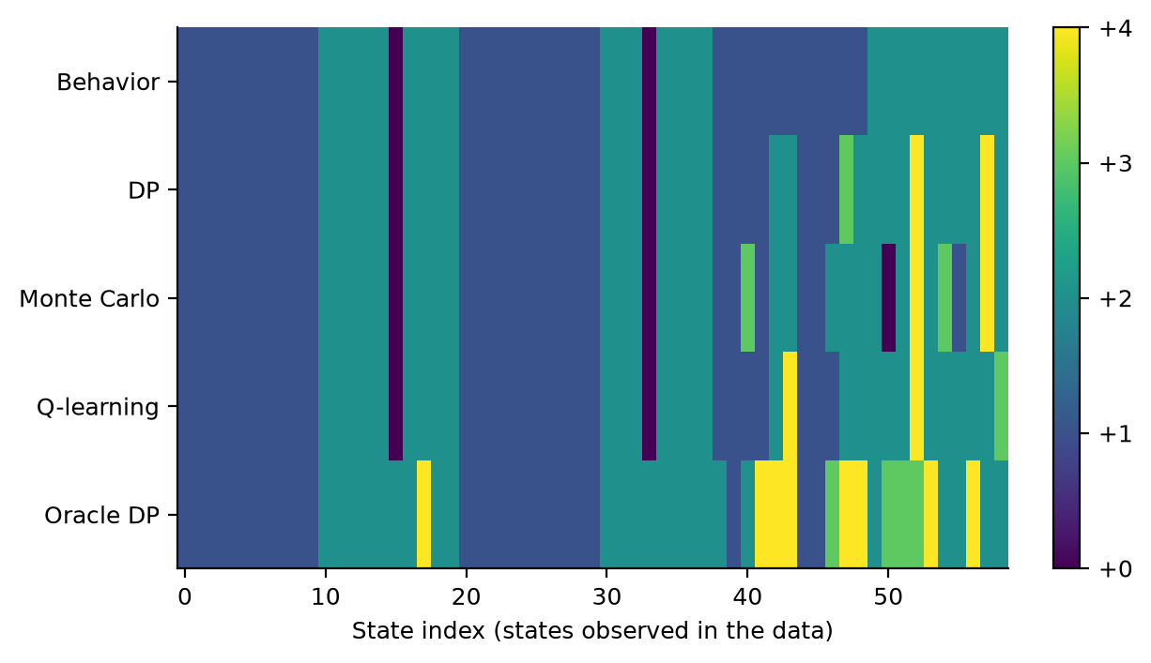
Figure 2. Extra bookings chosen in each state (replicate 0) by the behaviour policy, the three learners and the oracle, for the states observed in the oracle data.
Figure 2 compares the policies for replicate 0. The rule uses +1 in 30 states and +2 in 30, never anything else. The modal action behaviour policy differs from it in 3 states, and the learners in 9 (DP), 14 (MC) and 9 (Q-learning) of 60; they differ from the behaviour policy in 6, 11 and 6 states. The oracle differs from the rule in 13 states and uses +3 (4 states) or +4 (8 states); the learners use them in at most 4 states. This agrees with the support argument of Section 4.2: with 150 episodes the high overbooking actions are mostly unsupported, so the learners cannot adopt them. Q-learning agreed with DP in 89% and MC in 81% of the well visited states, averaged over replicates. Only replicate 0 is plotted, where DP scored 165.7.

7.2 Exploration schedules on the fitted model
Table 4. Exploration schedules: normalised area under the learning curve (AUC), normalised final value and the number of runs (of 12) reaching 90% of the optimal improvement. Values are on the scale of Eq. (4): 0 is the clinic's behaviour and 1 the oracle model optimum (6 replicates, 95% CI).
Schedule | Q-learning AUC | Q-learning final | MC AUC | MC final | Reached 90%
eps=0.1 const | 0.24 ± 0.12 | 0.37 ± 0.06 | 0.30 ± 0.08 | 0.41 ± 0.12 | 0/12
eps exp. decay | 0.29 ± 0.10 | 0.45 ± 0.14 | 0.11 ± 0.15 | 0.21 ± 0.16 | 0/12
GLIE 1/k | 0.26 ± 0.11 | 0.37 ± 0.14 | 0.07 ± 0.12 | 0.18 ± 0.12 | 0/12
Optimistic init | 0.13 ± 0.07 | 0.28 ± 0.07 | 0.24 ± 0.08 | 0.38 ± 0.08 | 0/12
Near-greedy (0.02) | -0.16 ± 0.15 | 0.34 ± 0.13 | 0.21 ± 0.15 | 0.31 ± 0.18 | 0/12

Table 4 is the central comparison of the schedule study. No run reached the 90% target in any of the 60 runs, so the steps to 90% metric is undefined for every schedule; the best mean final value was 0.446 (Q-learning, eps exp. decay), so the 0.9 target is about 2 times larger. The reason is visible in Figure 1: the learners plateau near the value of the DP solution of the fitted model (126.6), well below the oracle optimum (144.9), so even a perfect solver of that model cannot approach 1. Unlike the target, the improvement over the behaviour policy is clear: all 10 final values stay above zero once the intervals are widened to t intervals, from 0.18 to 0.45. The AUC values range from -0.16 to 0.29 for Q-learning and from 0.07 to 0.30 for MC. A part of every AUC is a common offset: the first checkpoint (step 0) has v = -2.54, which contributes -0.098 to the mean over 26 checkpoints in every run, so the offset is the same for all schedules and does not affect comparisons.
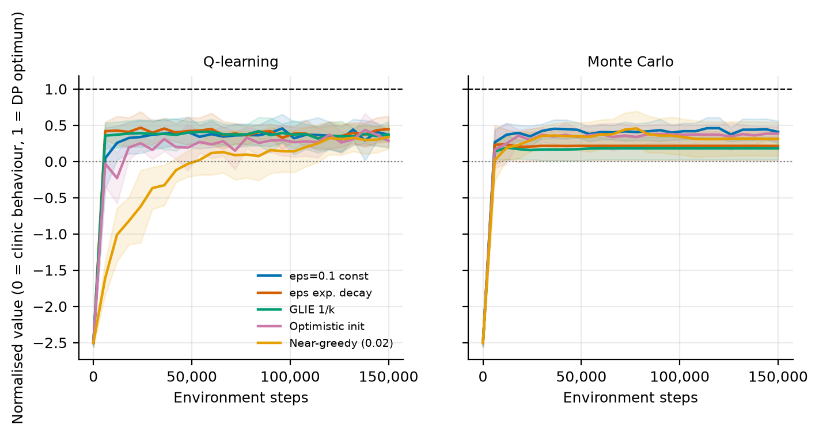
Figure 3. Normalised learning curves by exploration schedule (mean ± s.d. over 6 replicates). 0 is the clinic's behaviour and 1 the oracle model optimum.
Figure 3 shows what separates the schedules: mostly the first steps and, for the near greedy schedule, a slow climb. For Q-learning the near greedy schedule has an AUC of -0.16 ± 0.15, against 0.29 ± 0.10 for the best schedule (eps exp. decay); its t widened interval is separated from 4 of the other 4 schedules. This is the most robust schedule effect in the study, and it is the textbook one: a learner that explores little needs many more steps to learn the values of actions it rarely tries. The same schedule for MC (AUC 0.21 ± 0.15) is separated from 0 of the other 4 schedules, so for MC the evidence does not distinguish it from the rest. Among the other four schedules for Q-learning the AUC differences are between 0.02 and 0.15, and 0 of these 6 pairs are separated by the t widened intervals. Optimistic initialisation (q0 = 164, ε = 0.02) gives AUC 0.13 for Q-learning against 0.24 for constant ε, and 0.24 against 0.30 for MC. Seen from the offline RL angle the absence of large effects is unsurprising, because exploration inside a fitted model cannot reveal pairs absent from the logs: once the supported part of the model is sampled enough, every schedule converges towards the same solution, and the schedule mainly changes how soon.

7.3 Does the model scale metric predict true return?
Learning efficiency is measured on the model scale, but what matters is the return on the scoring sessions. For each learner we ranked the five schedules by their AUC and by the return of the final policy at the nominal rate (Table 5). For MC the two rankings agree exactly (Spearman correlation +1.00 over five schedules); for Q-learning they mostly agree (+0.70). With only five points no p-value is reported and the numbers are descriptive. The best schedule by return is eps exp. decay for Q-learning (169.5) and eps=0.1 const for MC (169.7), and the worst is Optimistic init (165.2) and GLIE 1/k (161.7). The exponential decay schedule is the best for Q-learning but ranks 4 of 5 for MC, and across the five schedules the ranks of the two learners have a correlation of -0.80.
How much of this is signal? The same learner with the exponential schedule also appears in the benchmark, with different data draws (seeds 1000 to 1019 against 700 to 705) and more scoring episodes (1,000 against 120): Q-learning scored 167.0 there and 169.5 here (+2.5), and MC 162.8 there and 162.6 here (-0.2). Differences of about 2.5 units therefore arise from the data draws and the scoring sample alone. The spread of returns across schedules is 4.3 for Q-learning and 8.0 for MC, 1.7 and 3.3 times that discrepancy, so the schedule may change the final return of MC by a few units, while for Q-learning the evidence is weak; the opposite orderings of the two learners argue against reading either ranking as general.

7.4 Robustness to a change in the no-show rate
Table 5. Return on the scoring sessions of the final policies under a shifted no-show rate (Eq. 6). Entries for Q-learning and MC are means over 6 replicates (120 scoring episodes each); the rule is scored on 300 episodes and DP on one replicate and 300 episodes. Section 7.7 gives intervals for every policy of the benchmark.
Policy | Nominal | No-show +0.08 | No-show -0.05 | Change, +0.08 | Change, -0.05
Overbooking rule | 150.5 | 129.3 | 156.8 | -21.2 | +6.3
DP (replicate 0) | 167.5 | 158.1 | 166.0 | -9.5 | -1.5
Q-learning: eps=0.1 const | 165.9 | 152.4 | 165.7 | -13.6 | -0.2
Q-learning: eps exp. decay | 169.5 | 156.0 | 169.2 | -13.5 | -0.3
Q-learning: GLIE 1/k | 169.4 | 154.5 | 170.2 | -14.9 | +0.9
Q-learning: Optimistic init | 165.2 | 154.2 | 163.8 | -11.0 | -1.4
Q-learning: Near-greedy (0.02) | 167.6 | 153.4 | 167.9 | -14.2 | +0.2
Monte Carlo: eps=0.1 const | 169.7 | 157.0 | 169.0 | -12.8 | -0.7
Monte Carlo: eps exp. decay | 162.6 | 148.8 | 163.2 | -13.8 | +0.6
Monte Carlo: GLIE 1/k | 161.7 | 146.6 | 163.5 | -15.1 | +1.8
Monte Carlo: Optimistic init | 166.7 | 156.5 | 164.5 | -10.2 | -2.2
Monte Carlo: Near-greedy (0.02) | 165.0 | 153.8 | 163.7 | -11.2 | -1.2

Table 5 reports returns when the no-show rate is higher or lower than in the scoring weeks. On real attendance the exposed direction is a rise in no-shows: the rule loses 21.2 units, DP 9.5, and the learners between 10.2 and 15.1, because a booking made for the nominal rate leaves more slots idle. The learned policies lose less than the rule: all 10 of 10 learner and schedule cells are above the rule at +0.08, by 17.4 to 27.7 units (mean 24.1), against 10 of 10 at the nominal rate (by 11.2 to 19.2; mean 15.9). A fall in no-shows helps the rule, which gains 6.3 because its cautious booking now fills more slots, while the learned policies, which already book more, change by -2.2 to +1.8; all 10 cells stay above the rule, by a smaller mean margin of 9.3.
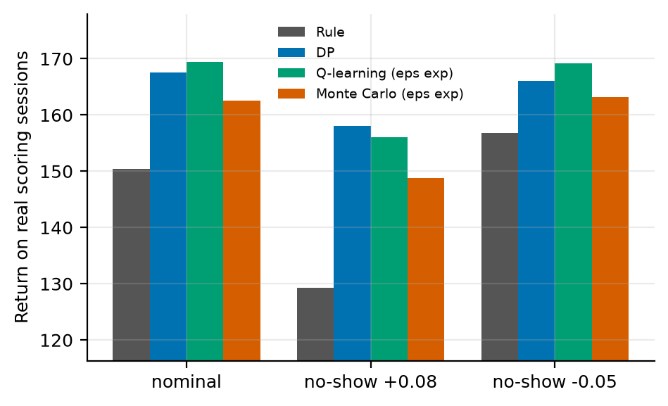
Figure 4. Return on the scoring sessions under the nominal and shifted no-show rates for the rule, DP and the exponentially decaying schedule of each learner.
Figure 4 shows the same for the four policies that the figure includes. Two caveats limit the shift study. First, the shift changes recorded outcomes at random and leaves the predicted risks unchanged, so it tests a change that the classifier has not seen; a real change in patient behaviour may also change who is booked. Second, the rule is a single policy with no learning noise while the learned entries average over replicates, so the comparison is not symmetric. Section 7.7 repeats the study with intervals for every policy, including the oracle.

7.5 The structured model and baselines from published work
Table 6. All methods on the real scoring sessions. Columns as in Table 3; utilisation is the share of the 10 regular slots in use (20 replicates, 95% CI; the rule, the three baselines and the oracle are single policies).
Method | Return (mean ± 95% CI) | Shows | Overtime | Idle | Waiting | Utilisation
Guideline rule | 150.8 ± 0.0 | 363.6 | 8.0 | 44.3 | 211.0 | 88.9%
Threshold double booking (θ = 0.25) | 164.5 ± 0.0 | 422.8 | 40.9 | 18.1 | 70.6 | 95.5%
Fixed booking (k = 2) | 174.6 ± 0.0 | 380.4 | 14.9 | 34.4 | 98.2 | 91.4%
Single session optimiser | 182.0 ± 0.0 | 395.8 | 20.6 | 24.8 | 73.1 | 93.8%
DP on estimated MDP | 170.3 ± 1.0 | 377.3 | 15.6 | 38.3 | 98.3 | 90.4%
Monte Carlo control | 162.8 ± 2.3 | 371.9 | 15.2 | 43.2 | 114.6 | 89.2%
Q-learning | 167.0 ± 2.1 | 377.3 | 16.9 | 39.6 | 101.2 | 90.1%
Oracle DP (10x data) | 173.6 ± 0.0 | 387.4 | 21.5 | 34.2 | 68.8 | 91.5%
Monte Carlo control, structured model | 169.3 ± 1.7 | 395.5 | 25.9 | 30.4 | 79.8 | 92.4%
Q-learning, structured model | 175.2 ± 1.0 | 395.0 | 23.7 | 28.6 | 72.4 | 92.8%
Structured model DP (ours) | 182.5 ± 0.0 | 396.6 | 21.4 | 24.7 | 66.9 | 93.8%

Sections 7.1 to 7.4 show that the learners are held back by the support of the logged data. Table 6 adds the structured model of Section 5.2 and the baselines of Section 6.3. With the same 150 logged days per replicate, DP on the structured model scored 182.54 ± 0.01: +12.25 ± 0.99 above DP on the estimated MDP, +15.49 ± 2.11 above Q-learning and +19.74 ± 2.25 above MC (all p < 0.001, ahead in 20 of 20 replicates against each), and +8.92 above the oracle fitted to ten times as much data (p < 0.001, paired over 1,000 episodes). Its interval of ±0.01 shows that the policy hardly depends on the data draw. Of the baselines from published work, threshold double booking scored 164.53, a fixed booking of 2 extra patients 174.61 and the single session optimiser 182.03; the structured model is ahead of them by +18.01, +7.92 and +0.51 ± 0.22 (p < 0.001, paired over 1,000 episodes). The last margin is 0.3% of the return.
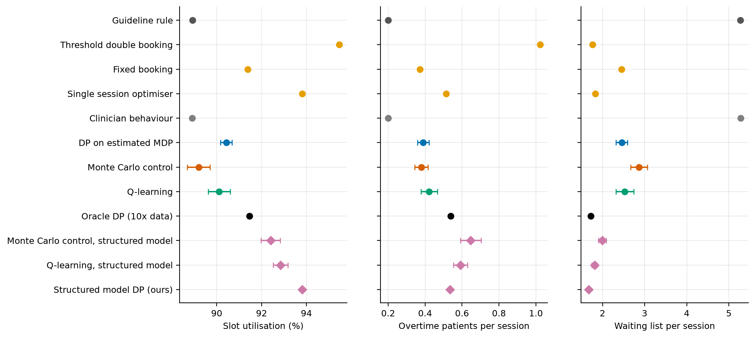
Figure 5. Utilisation of the regular slots, overtime patients and waiting list per session for every method (95% CI over 20 replicates; single policies have no interval). Orange: baselines from published work; diamonds: policies on the structured model.
The single session optimiser is a strong baseline: it uses each booked patient's own predicted risk, while the structured model sees only the band of the session's mean risk. The structured model is ahead because it also values the waiting list it leaves for later sessions, which the optimiser counts only through the 0.3 per patient drawn today; Section 7.8 shows that this matters more when the waiting list is under pressure. Figure 5 shows the operational side. Threshold double booking uses the most regular slots (95.5%) at the cost of 40.9 overtime patients per episode; the structured model uses 93.8% of the slots with 21.4 overtime patients, about as many as the oracle (21.5), and has the shortest waiting list of all methods (66.9 per episode against 73.1 for the single session optimiser and 211.0 for the rule). The classifier was fitted before the drift described in Section 4.1: its mean predicted no-show probability for the test weeks is 22.0% against 19.8% observed, so the structured model plans with risks that are slightly too high; we did not test how much a recalibrated classifier would add.

7.6 How much logged data is needed
Table 7. Return on the scoring sessions of DP on the estimated MDP and on the structured model for different amounts of logged data (10 replicates per size, 95% CI; differences paired over replicates).
Logged days | DP on estimated MDP | Structured model DP | Difference (paired)
25 | 149.32 ± 0.37 | 182.55 ± 0.02 | +33.23 ± 0.38 (p < 0.001)
50 | 156.96 ± 4.14 | 182.53 ± 0.02 | +25.56 ± 4.14 (p < 0.001)
150 | 170.83 ± 1.57 | 182.53 ± 0.01 | +11.70 ± 1.58 (p < 0.001)
500 | 172.79 ± 1.38 | 182.53 ± 0.01 | +9.74 ± 1.37 (p < 0.001)
1,500 | 173.52 ± 1.60 | 182.53 ± 0.01 | +9.01 ± 1.60 (p < 0.001)

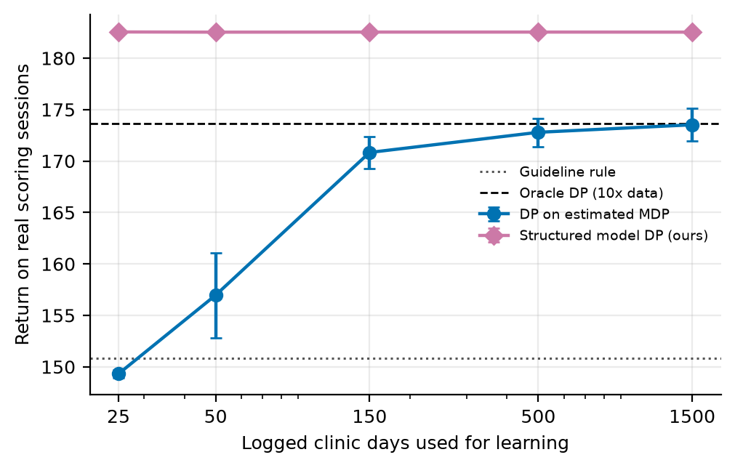
Figure 6. Return on the scoring sessions against the number of logged clinic days (log scale; 95% CI over 10 replicates). Dotted: guideline rule; dashed: oracle DP of Table 3.
Table 7 and Figure 6 vary the number of logged days. DP on the estimated MDP rises from 149.32 with 25 days, below the rule's 150.82, to 170.83 with 150 and 173.52 with 1,500, which is the data coverage effect anticipated in Section 4.2; since the logged days are drawn from the same 506 learning sessions, more days here mean more of the rarely logged actions, not new patients. DP on the structured model scores 182.55 with 25 days and 182.53 with 1,500: the quantities it estimates are already precise with 25 days. Even with 1,500 days the estimated MDP remains 9.01 ± 1.60 behind (p < 0.001).

7.7 The structured model under a shifted no-show rate
Table 8. Return on the scoring sessions under a shifted no-show rate (Eq. 6) for every policy of Table 6, trained at the nominal rate (20 replicates, 1,000 scoring episodes each, 95% CI; single policies have no interval).
Policy | Nominal | No-show +0.08 | No-show -0.05 | Change, +0.08 | Change, -0.05
Guideline rule | 150.8 ± 0.0 | 129.3 ± 0.0 | 157.4 ± 0.0 | -21.5 | +6.6
Threshold double booking (θ = 0.25) | 164.5 ± 0.0 | 171.0 ± 0.0 | 149.4 ± 0.0 | +6.5 | -15.2
Fixed booking (k = 2) | 174.6 ± 0.0 | 159.8 ± 0.0 | 175.5 ± 0.0 | -14.8 | +0.8
Single session optimiser | 182.0 ± 0.0 | 172.0 ± 0.0 | 176.8 ± 0.0 | -10.0 | -5.2
DP on estimated MDP | 170.3 ± 1.0 | 155.6 ± 1.6 | 171.5 ± 1.2 | -14.7 | +1.2
Monte Carlo control | 162.8 ± 2.3 | 147.7 ± 3.0 | 165.6 ± 1.8 | -15.1 | +2.8
Q-learning | 167.0 ± 2.1 | 153.4 ± 3.0 | 168.1 ± 1.9 | -13.6 | +1.0
Oracle DP (10x data) | 173.6 ± 0.0 | 164.1 ± 0.0 | 171.5 ± 0.0 | -9.5 | -2.2
Monte Carlo control, structured model | 169.3 ± 1.7 | 163.2 ± 1.6 | 164.0 ± 2.7 | -6.1 | -5.3
Q-learning, structured model | 175.2 ± 1.0 | 167.6 ± 1.2 | 169.8 ± 1.7 | -7.6 | -5.3
Structured model DP (ours) | 182.5 ± 0.0 | 173.2 ± 0.0 | 177.4 ± 0.0 | -9.3 | -5.1

Table 8 repeats the shift study of Section 7.4 for every policy, with 20 replicates and 1,000 scoring episodes. The structured model is ahead of every other policy at all three rates: 173.21 at +0.08 against 172.03 for the next best, and 177.40 at -0.05 against 176.78. It loses 9.3 when no-shows rise, less than the rule (21.5) and DP on the estimated MDP (14.7), and 5.1 when they fall, which is consistent with it booking more extra patients than any learner (+4 in 43 of 60 states in replicate 0), so that fewer no-shows turn some of them into overtime. Threshold double booking is the one policy that gains when no-shows rise (+6.5), since it books the most, but it stays below the structured model. As in Section 7.4, the predicted risks do not change, so no policy can see the shift in its state; a classifier recalibrated on the shifted weeks would let the structured model adjust, which we did not test.

7.8 When planning across sessions matters
Table 9. Return on the scoring sessions when the waiting list is under more pressure (10 replicates, 500 scoring episodes; 95% CI for the two DP methods, the other policies are single policies). The first row is the setting of Table 6.
Waiting cost | New patients per session | DP on estimated MDP | Best fixed booking | Single session optimiser | Structured model DP | Gain over single session optimiser
0.4 | 1.5 | 170.6 ± 1.6 | 174.5 | 181.6 | 182.0 ± 0.0 | +0.2%
1.0 | 1.5 | 144.0 ± 1.6 | 149.2 | 155.3 | 157.9 ± 0.1 | +1.7%
0.4 | 2.5 | 111.8 ± 3.0 | 160.1 | 160.0 | 168.4 ± 0.4 | +5.3%
1.0 | 2.5 | 42.3 ± 11.3 | 110.7 | 94.6 | 126.1 ± 0.1 | +33.3%

Table 9 varies the two quantities that make the waiting list costly. In the setting of Table 6 the structured model is 0.2% ahead of the single session optimiser (with 500 scoring episodes instead of 1,000). The gain grows to 1.7% when waiting costs 1.0 per patient, to 5.3% with 2.5 new patients per session, and to 33.3% with both. In that last setting the single session optimiser (94.57) falls below the best fixed booking (110.66), DP on the estimated MDP falls to 42.27, and the structured model scores 126.05. When the waiting list grows quickly or costs more, today's booking decides how long the list will be in later sessions, and only a policy that plans across sessions can weigh that.

7.9 Convergence of Monte Carlo and Q-learning
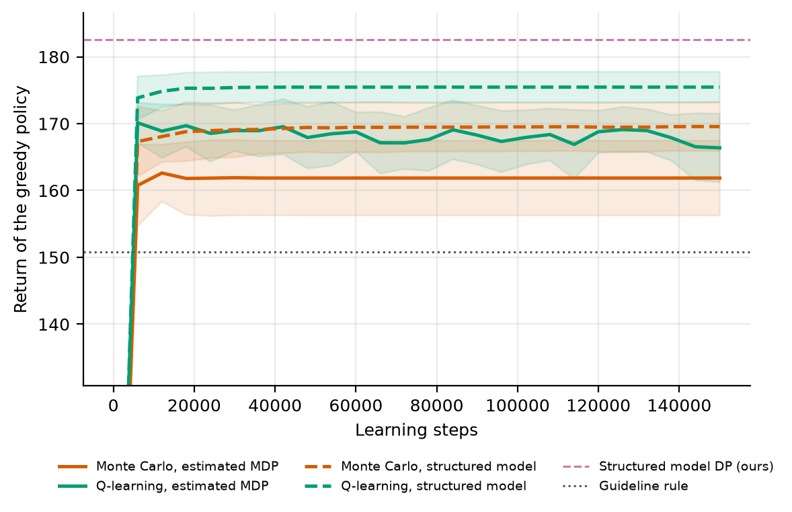
Figure 7. Return on the scoring sessions of the greedy policy during learning (mean ± s.d. over 20 replicates; 60 scoring episodes per checkpoint). Solid: learners on the estimated MDP; dashed: on the structured model; pink dashed: DP on the structured model; dotted: guideline rule. The axis is cut below, so the value at step 0 is not shown.
Figure 7 shows how MC control and Q-learning converge when their greedy policies are scored on the scoring sessions rather than on the oracle model. On the estimated MDP, Q-learning peaks at 170.1 after 6,000 steps and ends at 166.4, and MC ends at 161.9. On the structured model Q-learning ends at 175.5 and MC at 169.6. In the final scores of Table 6, Q-learning on the structured model is ahead of Q-learning on the estimated MDP by +8.11 ± 2.08 (p < 0.001) and MC by +6.53 ± 3.45 (p = 0.001). Neither reaches DP on the same model within 150,000 steps (182.54), so on this problem the model matters more than the learner, and on both models Q-learning ends closer to the DP solution than MC (by 5.84 on the structured model and 4.25 on the estimated MDP). A plausible reason, not tested separately, is that MC learns from the return of whole episodes of 40 sessions, whose variance is large compared with the differences between bookings (Section 3), while Q-learning updates each value from the next step.

8. Discussion
What the study shows. (1) On real attendance, learners trained on 150 episodes are well ahead of the overbooking rule, by +12.0 to +19.5 units (all p < 0.001), because the rule books too few patients for a no-show rate near 19%; a model fitted to ten times the data is ahead by +22.8, and Section 7.6 shows the estimated MDP improving with more logged days, which points to data coverage as what keeps the learners short of the oracle. (2) On the fitted model every schedule ends above the behaviour policy, and none reaches 90% of the possible improvement (0 of 60 runs). (3) The most clearly resolved schedule effect is that a near greedy Q-learner learns more slowly. (4) The learned policies lose less than the rule when no-shows rise (mean margin 24.1 against 15.9; all 10 of 10 configurations), and stay ahead when no-shows fall, by less (9.3). (5) The coverage barrier can be removed without more data: with the clinic's rules known and only patient behaviour learned, 25 logged days gave 182.5, more than the oracle DP (173.6). (6) The structured model is ahead of every method in Table 6, by 12.25 over DP on the estimated MDP and by 0.51 over the strongest baseline from published work, and stays ahead at both shifted rates. (7) That margin is small in the default setting and grows to 33% when the waiting list is under pressure (Table 9). (8) Q-learning ends closer to the DP solution than MC on both models.
What it does not show. It does not show that exploration schedules matter much for final performance: the differences across schedules are a few units, of the order of the discrepancy between data draws for the same configuration. It does not show that the model scale metric is a reliable proxy for the return on real sessions; it agreed in sign here, and its schedule ranking agreed for MC (+1.00) and less for Q-learning (+0.70), but the model undervalues every policy by 29 to 46 units. It does not show that a clinic knows its own rules as exactly as the structured model assumes: the slot count, the reward weights and the way extra bookings empty the waiting list are inputs, not estimates. It does not show a benefit to patients: attendance is recorded, but the decisions are generated and the waiting list is simulated. And the small margin over the single session optimiser in the default setting means that, in a quiet clinic, a good prediction model with a decision for one session at a time captures most of the gain.
Practical use. Because exploration inside a fitted model does not collect new data, practitioners should spend effort on what generates the log. A behaviour policy with deliberate variation in the number of extra bookings, run at low stakes, would give the learner support for the actions the optimum uses; the exploration schedule of the learner cannot substitute for that. A second way to reach those actions is to estimate less: whatever the clinic knows about its own rules need not be learned from the log. For deployment the shift study suggests a cheap check: score a learned policy against the existing rule under plausible no-show shifts and report the range, not the nominal value alone.

9. Limitations and threats to validity
- Generated decisions and a simulated waiting list. The table records attendance only. The decisions in the logs come from the behaviour policy of Table 1, and the waiting list, its 1.5 new patients per session and the reward weights (3 for overtime, 0.4 for waiting) are assumptions; Section 7.8 varies two of them.
- Few distinct days. The table covers 26 weekdays. Logged days are runs drawn from 506 learning sessions, so larger logs repeat the same patients, and the scoring weeks are a single period of 592 sessions.
- Sessions from neighbourhood days. A session is all appointments of one neighbourhood on one day; only 9% of these have fewer than 10 bookings, so the slots filled band rarely changes and adds little to the state.
- Shift by changed outcomes. The shift study flips recorded outcomes at random and keeps the predicted risks, so it tests one kind of change; a real change in patient behaviour may also change who is booked and the waiting list inflow.
- Drift and calibration. The classifier was calibrated before the no-show rate fell, so it overstates the risk in the scoring weeks (Section 7.5).
- Few replicates in the schedule study. It uses 6 replicates (t interval factor 1.31) and 120 scoring episodes per run; the benchmark and the schedule study use different data seeds.
- A model scale metric. Learning efficiency is measured on the oracle model, which is pessimistic by construction for pairs with fewer than 10 observations. The ranking of schedules on this scale need not match the ranking in the clinic.
- Exploration inside a model. The schedules sample from the fitted MDP and cannot reveal unlogged state and action pairs, so the study cannot say anything about exploration in a real clinic, where trying an action has a cost.
- Known clinic rules. The structured model takes the number of slots, the reward weights and the way extra bookings empty the waiting list as known; if these are wrong, its policy is optimal for a different clinic.
- Baselines. The baselines from published work are simplified implementations, not the authors' code, and their threshold and k were chosen on the scoring sessions.
- Wait time. Waiting is measured by the length of the waiting list; the table records no times within a day, so the time patients spend waiting in the clinic cannot be measured.
- Fixed horizon episodes treated as stationary. Episodes end after a fixed number of steps but the state does not contain the clock, so the estimated model treats termination as a constant hazard. This distorts absolute model values (not returns on the scoring sessions) and is why model based value estimates are compared only on a common oracle model.
- Hand set hyperparameters. ε schedules, step sizes and the support threshold were fixed in advance and not tuned.

10. Ethical considerations and future work
Ethics. The study uses a public appointment table [17] in which patients appear only as numeric identifiers; it was used as published, was not linked to any other source, and is not redistributed with the code. If the method were used for real bookings, three safeguards would be essential: de-identification and governance approval of the source data; a clinician-in-the-loop design in which the learned policy is advisory, with hard guardrails on unsafe actions; and prospective, randomised or at least carefully monitored evaluation before any deployment. Reinforcement learning from logs inherits the biases of the clinicians who produced them, and may under-serve groups that are under-represented in the data; subgroup performance should be reported alongside averages, including the waiting times of groups with a higher predicted no-show risk, on whom overbooking decisions may fall more often.
Future work. (1) Add a behaviour policy that deliberately varies the extra bookings and test whether the learners then close the gap to the oracle; (2) evaluate a policy trained on shifted data, to measure the cost of a stale model; (3) compare against a pessimistic penalty in the supported part of the space; (4) measure overtime and waiting from visit timestamps, which the table lacks; (5) estimate the reward weights and the waiting list dynamics from clinic records instead of assuming them; (6) let the structured model use each booked patient's own predicted risk at decision time, together with the value of the next state, and recalibrate the classifier as the no-show rate drifts; (7) test the structured model in a clinic that records its overbooking decisions.

11. Conclusion
On clinic sessions rebuilt from the Medical Appointment No Shows table, DP, MC and Q-learning trained on 150 logged days scored 170.3, 162.8 and 167.0 against 150.8 for a conservative overbooking rule and 173.6 for DP trained on ten times as much data. Five exploration schedules gave learning curves that ended above the behaviour policy but short of 90% of the possible improvement (0 of 60); only the near greedy Q-learner was clearly slower, and the ordering of schedules on return differed between learners. The learned policies lost less than the rule when no-shows rose by 0.08 (all 10 of 10 configurations were ahead) and stayed ahead when they fell by 0.05.
The limit is the coverage of the logged data. A structured model that learns only patient behaviour and takes the clinic's rules as known scored 182.5, 12.3 to 19.7 above the three learners and 8.9 above the oracle, reached that level with 25 logged days, and was ahead of the best baseline from published work (182.0) at the nominal and both shifted rates, by a margin that grew from 0.2% to 33.3% as the waiting list came under pressure. Q-learning came closer to the DP solution than MC. Attendance in these results is recorded, but the decisions are generated and the waiting list is simulated, so they are not evidence about real clinics.

Appendix A. Anticipated reviewer questions
The following questions are the ones a reviewer or examiner is most likely to raise. Each answer is tied to a number or figure produced by the code.
Q1. Why does no schedule reach 90% of the optimum?
The learners solve a fitted model whose DP solution is worth about 126.6 on the oracle model, against a rule value of 113.6 and an optimum of 144.9. They end near that solution (Q-learning 124.4, MC 117.3), so the target is out of reach for any schedule; the limit is the support of the logged data, not exploration.
Q2. If exploration matters little, why is near greedy Q-learning slower?
Near greedy Q-learning has a mean AUC of -0.16 against 0.29 for the best schedule, and a plausible reason (not tested separately) is that it tries few actions early and needs many steps to correct its initial values. That is a speed effect within a fixed model; its final value is within the range of the other schedules.
Q3. Why are the learners so far ahead of the rule on real data?
The rule books one or two extra patients, and with about 19% of patients not coming that leaves 44.3 idle slots per episode and a summed waiting list of 211. The learners book more in some states and cut the waiting list to 98 to 115.
Q4. Can we conclude that exponential decay is best for Q-learning?
No. Its return in the schedule study (169.5) differs by 2.5 from the same configuration in the benchmark (167.0), which is comparable to the 4.3 unit spread across all five Q-learning schedules, and the same schedule ranks 4 of 5 for MC.
Q5. Is the robustness result a reason to deploy the learned policy?
No. It is a change of a single quantity made by flipping recorded outcomes, scored on one period of real sessions. It shows that the learned policies lose less than the rule when no-shows rise, in all 10 of 10 configurations, and nothing more.
Q6. Why does the oracle score more than the learners?
With 1,500 episodes the high overbooking actions are supported (about 50 visits per pair against 5.0), and the oracle uses +3 or +4 in 12 states. The learners use them in at most 4.
Q7. Why does the structured model score more than the oracle fitted to ten times as much data?
The oracle still estimates P(s' | s, a) pair by pair, so with 1,500 days some pairs that the optimum uses remain below the support threshold and the rest carry sampling error. The structured model estimates 26 numbers that every logged session informs and computes the rest from the clinic's rules; its return varies by ±0.01 over 20 data draws.
Q8. Is the comparison fair to the learners?
They receive the same logged days, the same solver for DP and the same scoring episodes. What the structured model has in addition is the clinic's rules, which Section 9 lists as a limitation: a clinic that cannot state them cannot use it.
Q9. Why is the margin over the single session optimiser so small?
In the default setting the waiting list stays short under both policies (1.83 and 1.67 patients per session), so little is left to plan for, and the optimiser uses each patient's own risk while the structured model uses a band. When the waiting list is under pressure the margin reaches 33.3% (Table 9).
Q10. Which parts of the results are real?
Attendance is real: every patient in a scored session is a recorded appointment and comes exactly when the table says so, and the scoring weeks are never used for learning. The overbooking decisions in the logs, the waiting list and the reward weights are not in the table and are generated or assumed (Section 6.1).

Appendix B. Reproducibility
All results in this paper are produced by `python run_real.py` (shared library: rl_core.py, common.py, ideas.py; data and models: noshow_data.py, real_clinic.py, planner.py), which reads the table from data/KaggleV2-May-2016.csv. Random seeds are fixed in the code, so a rerun reproduces every table and figure. Figure files generated by the script: fig_learning, fig_policies, fig_schedules, fig_shift, fig_metrics, fig_datasize, fig_convergence and fig_demand; `python run_real.py --figures` redraws them from the stored results.

Appendix C. Source code of the experiment
For completeness the exact source of the clinic built from real sessions, the experiment functions and the structured model is reproduced below; it is the same code that produced every number and figure in this paper (the shared solvers value_iteration, mc_control and q_learning are in rl_core.py and are delivered with the code package).

real_clinic.RealClinic
class RealClinic(Domain):
name = "real clinic"
nA, gamma, max_steps, CAP = 5, 0.97, 40, 10
nS = 3 * 4 * 5
info_keys = ["shows", "overtime", "idle", "wait", "booked", "drawn", "p_reg_mean"]
action_labels = [f"+{k}" for k in range(5)]

def __init__(self, sessions, pool, risk_edges, lam=1.5, wait_cost=0.4):
self.sessions, self.pool, self.RE = sessions, pool, np.asarray(risk_edges)
self.lam, self.wait_cost = lam, wait_cost

# ----------------------------------------------------------------- state
def _draw(self, rng):
"""pick today's real session and the real patients who would come off the waiting list"""
d = self.t % 5
p, y = self.sessions[d][rng.integers(len(self.sessions[d]))]
o = rng.permutation(len(p))[:self.CAP]
self.p_reg, self.y_reg = p[o], y[o] # regular slots (up to 10)
pp, yy = self.pool[d]
e = rng.integers(len(pp), size=self.nA - 1)
self.p_ext, self.y_ext = pp[e], yy[e] # up to 4 extra patients
self.n_reg = len(o)

def _s(self):
sb = band(self.n_reg, SLOT_E)
rb = int(np.searchsorted(self.RE, self.p_reg.mean(), side="right"))
return (sb * 4 + rb) * 5 + band(self.w, WAIT_E)

@staticmethod
def decode(s):
sb, rest = divmod(s, 20)
rb, wb = divmod(rest, 5)
return sb, rb, wb

# ----------------------------------------------------------------- dynamics
def reset(self, rng):
self.t, self.w = 0, int(rng.integers(0, 6))
self._draw(rng)
return self._s()

def step(self, k, rng):
shows = int((1 - self.y_reg).sum() + (1 - self.y_ext[:k]).sum())
over, idle = max(0, shows - self.CAP), max(0, self.CAP - shows)
drawn = min(self.w, k)
r = 1.0 * shows - 3.0 * over - 0.5 * idle - self.wait_cost * self.w + 0.3 * drawn
self.w = int(np.clip(self.w - drawn + rng.poisson(self.lam), 0, 12))
self.t += 1
info = dict(shows=shows, overtime=over, idle=idle, wait=self.w, booked=self.n_reg + k, drawn=drawn,
p_reg_mean=float(self.p_reg.mean()))
self._draw(rng)
return self._s(), r, self.t >= self.max_steps, info, 1

def rule(self, s):
"""the overbooking rule of domains.Clinic, read on this state: +1 when predicted no-shows are low, otherwise +2"""
return 1 if self.decode(s)[1] <= 1 else 2

run_real: shift, benchmark and schedule study
def flip_outcomes(sessions, pool, delta, seed):
"""move the no-show rate by delta: a random share of recorded shows become no-shows (delta > 0) or of recorded
no-shows become shows (delta < 0); predicted risks are left as they are"""
rng = np.random.default_rng(seed)
rate = float(np.concatenate([pool[d][1] for d in pool]).mean())
def flip(y):
y = y.copy(); u = rng.random(len(y))
if delta > 0:
y[(y == 0) & (u < delta / (1 - rate))] = 1
else:
y[(y == 1) & (u < -delta / rate)] = 0
return y
s2 = {d: [(p, flip(y)) for p, y in sessions[d]] for d in sessions}
p2 = {d: (pool[d][0], flip(pool[d][1])) for d in pool}
return s2, p2

def benchmark(Dp, Df, SH, c):
"""common.standard_benchmark with the logs drawn from the learning sessions and every policy scored on the scoring
sessions; adds our structured model (DP, MC, Q-learning), the baselines from published work and the shift scores"""
n, S = CFG["n_eval"], CFG["seeds"]
q_extra = c["q_extra"]
d_or = rollout(Dp, Dp.behavior, np.random.default_rng(9999), CFG["n_oracle"])
m_or = build_mdp(d_or, Dp)
pi_or = fill_policy(value_iteration(m_or)[0], m_or, behavior_mode(d_or, Dp))
rule = np.array([Dp.rule(s) for s in range(Dp.nS)])
res = {"methods": {}, "curves": {"Monte Carlo": [], "Q-learning": []}, "policies": {},
"agree": {"Monte Carlo": [], "Q-learning": []}, "optimism_gap": [], "pi_equals_vi": [],
"true_curves": {k: [] for k in ("Monte Carlo|sir", "Q-learning|sir", "Monte Carlo|ours", "Q-learning|ours")},
"shift": {"nominal": {}, **{k: {} for k in SH}}, "ep_mean": {}}
eps = {}

def record(name, pol, seed_idx):
r, inf = score(Df, pol, n)
e = res["methods"].setdefault(name, {"J": [], "Jor": [], "info": {}})
e["J"].append(float(r.mean()))
e["Jor"].append(J(m_or, pol) if isinstance(pol, np.ndarray) else float("nan"))
for k, v in inf.items():
e["info"].setdefault(k, []).append(float(v.mean()))
eps.setdefault(name, []).append(r)
res["shift"]["nominal"].setdefault(name, []).append(float(r.mean()))
for k, sim in SH.items():
res["shift"][k].setdefault(name, []).append(float(score(sim, pol, n)[0].mean()))
if seed_idx == 0 and isinstance(pol, np.ndarray):
res["policies"][name] = np.asarray(pol).tolist()

record("Rule", rule, 0)
record("Oracle DP", pi_or, 0)
# baselines from published work (single policies; threshold and k chosen on the scoring sessions)
thr = {th: float(score(Df, pl.threshold_policy(th), n)[0].mean()) for th in (0.2, 0.25, 0.3, 0.35)}
fixed = {k: float(score(Df, np.full(Df.nS, k), n)[0].mean()) for k in range(Df.nA)}
best_th, best_k = max(thr, key=thr.get), max(fixed, key=fixed.get)
record("Single session optimiser", pl.one_session_optimiser(q_extra), 0)
record("Threshold double booking", pl.threshold_policy(best_th), 0)
record("Fixed booking", np.full(Df.nS, best_k), 0)
res["baselines"] = dict(threshold={str(k): v for k, v in thr.items()}, fixed={str(k): v for k, v in fixed.items()},
best_threshold=best_th, best_k=best_k)
log("benchmark: single policies scored")

true_J = lambda pi: float(eval_policy(Df, pi, seed=777, n_eps=CFG["ckpt_eps"])[0].mean())
for sd in range(S):
d = rollout(Dp, Dp.behavior, np.random.default_rng(1000 + sd), CFG["n_logged"])
m = build_mdp(d, Dp)
bm = behavior_mode(d, Dp)
pi_dp, V, Q = value_iteration(m)
pi_pi, _ = policy_iteration(m)
res["pi_equals_vi"].append(bool(abs(J(m, pi_dp) - J(m, pi_pi)) < 1e-6))
pi_dp = fill_policy(pi_dp, m, bm)
side = {"Monte Carlo": [], "Q-learning": []}

def cf(p, key, m=m, bm=bm):
fp = fill_policy(p, m, bm)
side[key].append(true_J(fp))
return J(m_or, fp)
pi_mc, _, c_mc = mc_control(m, np.random.default_rng(2000 + sd), CFG["steps"], ckpt_fn=lambda p: cf(p, "Monte Carlo"))
pi_q, _, c_q = q_learning(m, np.random.default_rng(3000 + sd), CFG["steps"], ckpt_fn=lambda p: cf(p, "Q-learning"))
res["optimism_gap"].append(float(J(m, pi_dp) - J(m_or, pi_dp)))
res["curves"]["Monte Carlo"].append(c_mc.tolist()); res["curves"]["Q-learning"].append(c_q.tolist())
res["true_curves"]["Monte Carlo|sir"].append([[float(x), v] for x, v in zip(c_mc[:, 0], side["Monte Carlo"])])
res["true_curves"]["Q-learning|sir"].append([[float(x), v] for x, v in zip(c_q[:, 0], side["Q-learning"])])
pi_mc, pi_q = fill_policy(pi_mc, m, bm), fill_policy(pi_q, m, bm)
vis = m.visits >= 5
for nm, p in (("Monte Carlo", pi_mc), ("Q-learning", pi_q)):
res["agree"][nm].append(float((p[vis] == pi_dp[vis]).mean()) if vis.any() else 1.0)
record("Behavior", bm, sd); record("DP", pi_dp, sd)
record("Monte Carlo", pi_mc, sd); record("Q-learning", pi_q, sd)
# our structured model, from the same logs
ms = pl.real_model(d, Dp, q_extra)
record("Ours: DP", value_iteration(ms)[0], sd)
p, _, cv = mc_control(ms, np.random.default_rng(2000 + sd), CFG["steps"], ckpt_fn=true_J)
record("Ours: Monte Carlo", p, sd); res["true_curves"]["Monte Carlo|ours"].append(cv.tolist())
p, _, cv = q_learning(ms, np.random.default_rng(3000 + sd), CFG["steps"], ckpt_fn=true_J)
record("Ours: Q-learning", p, sd); res["true_curves"]["Q-learning|ours"].append(cv.tolist())
log(f"benchmark seed {sd}: DP {res['methods']['DP']['J'][-1]:.2f} ours {res['methods']['Ours: DP']['J'][-1]:.2f}")
res["ep_mean"] = {k: np.mean(v, 0).tolist() for k, v in eps.items()}
res["J_oracle_model"] = {"Oracle DP": J(m_or, pi_or), "Rule": J(m_or, rule)}
res["n_states"], res["n_actions"] = Dp.nS, Dp.nA
res["config"] = dict(n_eps=CFG["n_logged"], n_oracle=CFG["n_oracle"], steps=CFG["steps"], seeds=S, n_eval=n)
res["m_or"] = m_or
return res

def schedule_study(Dp, Df, SH):
T = CFG["steps"]
qopt = 14.0 * (1 - Dp.gamma ** 40) / (1 - Dp.gamma)
SCH = {"eps=0.1 const": (lambda k, t: 0.1, 0.0), "eps exp. decay": (eps_exp, 0.0),
"GLIE 1/k": (lambda k, t: max(0.02, (t / 50.0) / (t / 50.0 + k)), 0.0),
"Optimistic init": (lambda k, t: 0.02, 0.5 * qopt), "Near-greedy (0.02)": (lambda k, t: 0.02, 0.0)}
d_or = rollout(Dp, Dp.behavior, np.random.default_rng(9999), CFG["n_oracle"]); m_or = build_mdp(d_or, Dp)
pi_or, _, _ = value_iteration(m_or); J_opt = J(m_or, pi_or)
J_beh = J(m_or, behavior_mode(d_or, Dp))
sh = {"nominal": Df, **SH}
CUR = {a: {s: [] for s in SCH} for a in ("Q-learning", "Monte Carlo")}
FIN = {a: {s: {k: [] for k in sh} for s in SCH} for a in CUR}
for sd in range(CFG["sched_seeds"]):
data = rollout(Dp, Dp.behavior, np.random.default_rng(700 + sd), CFG["n_logged"])
m = build_mdp(data, Dp); bm = behavior_mode(data, Dp)
cf = (lambda p, m=m, bm=bm: J(m_or, fill_policy(p, m, bm)))
for sn, (ef, q0) in SCH.items():
for an, fn in (("Q-learning", q_learning), ("Monte Carlo", mc_control)):
p, _, c = fn(m, np.random.default_rng([sd, list(SCH).index(sn), 1]), T, eps_fn=ef, q0=q0, ckpt_fn=cf)
CUR[an][sn].append(c.tolist())
p = fill_policy(p, m, bm)
for k, sim in sh.items():
FIN[an][sn][k].append(float(eval_policy(sim, p, n_eps=CFG["sched_eval"])[0].mean()))
log(f"schedule study seed {sd}")
t90 = {a: {} for a in CUR}; auc = {a: {} for a in CUR}; fin = {a: {} for a in CUR}
for a in CUR:
for sn in SCH:
cs = CUR[a][sn]
t90[a][sn] = steps_to_fraction(cs, J_beh + 0.9 * (J_opt - J_beh))
auc[a][sn] = [float(np.mean([(v[1] - J_beh) / (J_opt - J_beh) for v in c])) for c in cs]
fin[a][sn] = [float((c[-1][1] - J_beh) / (J_opt - J_beh)) for c in cs]
rule = np.array([Dp.rule(s) for s in range(Dp.nS)])
d700 = rollout(Dp, Dp.behavior, np.random.default_rng(700), CFG["n_logged"]); m700 = build_mdp(d700, Dp)
dp_pol = fill_policy(value_iteration(m700)[0], m700, rule)
shift_res = {}
for k, sim in sh.items():
shift_res[k] = {}
for nm, p in (("Rule", rule), ("DP", dp_pol)):
shift_res[k][nm] = float(eval_policy(sim, p, n_eps=CFG["shift_ref_eval"])[0].mean())
for a in CUR:
shift_res[k][a + " (eps exp)"] = float(np.mean(FIN[a]["eps exp. decay"][k]))
return dict(schedules=list(SCH), J_opt=J_opt, J_beh=J_beh, curves=CUR,
t90={a: {s: [None if np.isnan(x) else float(x) for x in t90[a][s]] for s in SCH} for a in CUR},
auc={a: {s: dict(mean=float(np.mean(auc[a][s])), ci=ci95(auc[a][s]), per_seed=auc[a][s]) for s in SCH} for a in CUR},
final={a: {s: dict(mean=float(np.mean(fin[a][s])), ci=ci95(fin[a][s])) for s in SCH} for a in CUR},
shift={a: {s: {k: float(np.mean(FIN[a][s][k])) for k in sh} for s in SCH} for a in CUR}, shift_ref=shift_res,
reach_rate={a: {s: float(np.mean(~np.isnan(t90[a][s]))) for s in SCH} for a in CUR})

planner: structured model
def session_value(q_reg, k, q_ext, cap=10):
"""expected shows - 3 x overtime - 0.5 x idle for one session.
q_reg: show-up probabilities of the booked patients; k extra patients each showing with prob q_ext.
Exact (Poisson-binomial) distribution of the number of patients who show."""
dist = np.array([1.0])
for q in np.concatenate([np.asarray(q_reg, float), np.full(k, q_ext)]):
dist = np.convolve(dist, [1 - q, q])
n = np.arange(len(dist))
return float((dist * (n - 3 * np.maximum(0, n - cap) - 0.5 * np.maximum(0, cap - n))).sum())

def waiting_list_model(data, wmax=12):
"""from the logged waiting-list lengths: arrival rate per session and which exact lengths sit in each band"""
ep, a, wait = data["ep"], data["a"], data["wait"].astype(int)
prev = np.full(len(a), -1)
same = np.r_[False, ep[1:] == ep[:-1]]
prev[same] = wait[:-1][same[1:]]
ok = (prev >= 0) & (wait < wmax) # skip the first session and capped lists
lam = float(np.mean(wait[ok] - (prev[ok] - np.minimum(prev[ok], a[ok]))))
Pw = np.zeros((5, wmax + 1))
for w in prev[prev >= 0]:
Pw[band(w, WAIT_E), w] += 1
for b in range(5): # bands never seen: spread evenly over their lengths
if Pw[b].sum() == 0:
Pw[b, [w for w in range(wmax + 1) if band(w, WAIT_E) == b]] = 1
return lam, Pw / Pw.sum(1, keepdims=True)

def waiting_step(Pw_row, k, lam, wait_cost, wmax=12):
"""expected waiting-list part of the reward and the distribution of the next waiting band,
given the distribution of the current exact length (Pw_row) and k extra bookings"""
pois = stats.poisson.pmf(np.arange(30), lam); pois[-1] += 1 - pois.sum()
r, nxt = 0.0, np.zeros(5)
for w, pw in enumerate(Pw_row):
if pw == 0:
continue
dr = min(w, k)
r += pw * (-wait_cost * w + 0.3 * dr)
for A, pa in enumerate(pois):
nxt[band(min(wmax, w - dr + A), WAIT_E)] += pw * pa
return r, nxt

def real_model(data, dom, q_extra):
"""structured model of the real-data clinic (state = slots filled x risk band x waiting band).
Session part: from the classifier's predicted risk of the patients logged in each (slots, risk) cell.
Next session: today's session does not change tomorrow's patients, so the next (slots, risk) cell is
drawn from the logged frequencies; the waiting band follows the waiting-list model."""
nS, nA = dom.nS, dom.nA
sb_, rest = np.divmod(data["s"], 20)
rb_ = rest // 5
cell = sb_ * 4 + rb_
n_reg, p_mean = data["booked"] - data["a"], data["p_reg_mean"]
freq = np.bincount(cell, minlength=12).astype(float) + 0.5
freq /= freq.sum()
sess = np.zeros((12, nA))
for c in range(12):
idx = np.flatnonzero(cell == c)
if len(idx) == 0: # unseen cell: use every logged session
idx = np.arange(len(cell))
idx = idx[:400]
for k in range(nA):
sess[c, k] = np.mean([session_value(np.full(int(n_reg[i]), 1 - p_mean[i]), k, q_extra) for i in idx])
lam, Pw = waiting_list_model(data)
R = np.zeros((nS + 1, nA)); P = np.zeros((nS + 1, nA, nS + 1))
for s in range(nS):
c, wb = divmod(s, 5)
for k in range(nA):
rw, wnext = waiting_step(Pw[wb], k, lam, dom.wait_cost)
R[s, k] = sess[c, k] + rw
P[s, k, :nS] = np.outer(freq, wnext).ravel()
m = _finish(P, R, nS, nA, dom.gamma, _start_dist(data, nS))
m.est = dict(arrivals=lam, q_extra=q_extra, cell_freq=freq.tolist())
m.lam, m.Pw, m.freq = lam, Pw, freq
return m

noshow_data: classifier and sessions
def fit_predictor(df):
"""gradient-boosted trees + isotonic calibration; returns the test part with a column p (predicted no-show)"""
fit, cal, test = df[df.AD < CAL_START], df[(df.AD >= CAL_START) & (df.AD < TEST_START)], df[df.AD >= TEST_START].copy()
clf = HistGradientBoostingClassifier(max_iter=300, learning_rate=0.05,
categorical_features=[FEATURES.index("nb")], random_state=0)
clf.fit(fit[FEATURES], fit["y"])
iso = IsotonicRegression(out_of_bounds="clip").fit(clf.predict_proba(cal[FEATURES])[:, 1], cal["y"])
raw = clf.predict_proba(test[FEATURES])[:, 1]
test["p"] = iso.predict(raw)
info = dict(n_fit=len(fit), n_cal=len(cal), n_test=len(test),
auc_test=float(roc_auc_score(test["y"], raw)),
mean_pred=float(test["p"].mean()), mean_obs=float(test["y"].mean()),
brier=float(np.mean((test["p"] - test["y"]) ** 2)))
return test, info

def build_sessions(test, min_size=5):
"""sessions[d] = list of (p, y) arrays for every neighbourhood-day on weekday d with >= min_size appointments;
pool[d] = (p, y) of all appointments on weekday d (patients pulled in from the waiting list are drawn from it)"""
sessions, pool = {d: [] for d in range(5)}, {}
for (nb, ad), g in test.groupby(["Neighbourhood", "AD"]):
if len(g) >= min_size:
sessions[ad.dayofweek].append((g["p"].to_numpy(), g["y"].to_numpy()))
for d in range(5):
g = test[test.dow == d]
pool[d] = (g["p"].to_numpy(), g["y"].to_numpy())
return sessions, pool

rl_core: shared solvers
def build_mdp(data, dom, weights=None, chan=None, min_n=10, term_prior=1.0):
"""Empirical (maximum-likelihood) MDP from logged transitions.
(s,a) pairs observed fewer than min_n times are completed pessimistically: they go
to the absorbing terminal state with the worst reward seen in the data."""
nS, nA = dom.nS, dom.nA
T = nS
w = np.ones(len(data["s"])) if weights is None else np.asarray(weights, float)
s, a = data["s"], data["a"]
s2 = np.where(data["done"] > 0, T, data["s2"])
N = np.zeros((nS + 1, nA, nS + 1))
np.add.at(N, (s, a, s2), w)
n = N.sum(2)
Rsum = np.zeros((nS + 1, nA))
np.add.at(Rsum, (s, a), w * data["r"])
Gsum = np.zeros((nS + 1, nA, nS + 1))
np.add.at(Gsum, (s, a, s2), w * dom.gamma ** data["dur"])
m = MDP()
m.nS, m.nA, m.gamma = nS, nA, dom.gamma
m.n = n
m.N = N
seen = n >= min_n # support constraint: thinly observed (s,a) are completed pessimistically
n_eff = n + term_prior # one pseudo-observation of absorption guards against 'immortal' loops
P = np.zeros_like(N)
P[seen] = N[seen] / n_eff[seen][:, None]
P[seen, T] += term_prior / n_eff[seen]
G = np.full_like(N, dom.gamma)
nz = N > 0
G[nz] = Gsum[nz] / N[nz]
R = np.zeros((nS + 1, nA))
R[seen] = Rsum[seen] / n_eff[seen]
rmin = float(data["r"].min())
m.rmin, m.rmax = rmin, float(data["r"].max())
P[~seen, T] = 1.0
R[~seen] = rmin
P[T, :, :] = 0.0
P[T, :, T] = 1.0
R[T, :] = 0.0
m.P, m.G, m.R = P, G, R
m.PG = P * G
# reward channels
m.Rc = {}
for c in (chan if chan is not None else dom.chan):
cs = np.zeros((nS + 1, nA))
np.add.at(cs, (s, a), w * data[c])
cr = np.zeros((nS + 1, nA))
cr[seen] = cs[seen] / n_eff[seen]
m.Rc[c] = cr
# start distribution = first state of every episode
first = data["t"] == 0
mu = np.bincount(data["s"][first], minlength=nS + 1).astype(float)
m.mu = mu / mu.sum()
m.visits = (n * seen).sum(1)[:nS]
m.seen = seen
m.Rsum = Rsum
return m

def value_iteration(m, R=None, mask=None, tol=1e-9, max_iter=20000, penalty=None):
R = m.R if R is None else R
if penalty is not None:
R = R - penalty
V = np.zeros(m.nS + 1)
for _ in range(max_iter):
Q = _q(m, V, R)
if mask is not None:
Q = np.where(mask, Q, -1e18)
Vn = Q.max(1)
Vn[m.nS] = 0.0
if np.abs(Vn - V).max() < tol:
V = Vn
break
V = Vn
Q = _q(m, V, R)
if mask is not None:
Q = np.where(mask, Q, -1e18)
pi = Q.argmax(1)[:m.nS]
return pi, V, Q

def q_learning(m, rng, steps, eps_fn=eps_exp, alpha0=1.0, alpha_min=0.02,
q0=0.0, mask=None, n_ckpt=25, max_len=200, ckpt_fn=None):
nS, nA = m.nS, m.nA
ckpt_fn = ckpt_fn or (lambda p: J(m, p))
Q = np.full((nS + 1, nA), q0)
Q[nS] = 0.0
cnt = np.zeros((nS + 1, nA))
smp = Sampler(m, rng)
ck = np.unique(np.linspace(0, steps, n_ckpt + 1).astype(int))
curve = []
s, ep_t = smp.start(), 0
ci = 0
for k in range(steps + 1):
if ci < len(ck) and k == ck[ci]:
pi = np.array([_greedy(Q, x, mask) for x in range(nS)])
curve.append((k, ckpt_fn(pi)))
ci += 1
if k == steps:
break
if rng.random() < eps_fn(k, steps):
a = _explore(rng, s, nA, mask)
else:
a = _greedy(Q, s, mask)
s2, r, g = smp.step(s, a)
tgt = r + (0.0 if s2 == nS else g * Q[s2].max() if mask is None
else g * np.where(mask[s2], Q[s2], -1e18).max())
cnt[s, a] += 1
al = max(alpha_min, alpha0 / (1.0 + cnt[s, a] ** 0.7))
Q[s, a] += al * (tgt - Q[s, a])
ep_t += 1
if s2 == nS or ep_t >= max_len:
s, ep_t = smp.start(), 0
else:
s = s2
pi = np.array([_greedy(Q, x, mask) for x in range(nS)])
return pi, Q, np.array(curve)

def mc_control(m, rng, steps, eps_fn=eps_exp, q0=0.0, mask=None, n_ckpt=25,
max_len=200, ckpt_fn=None):
"""first-visit Monte Carlo control with epsilon-soft behaviour policy and
incremental-average updates."""
nS, nA = m.nS, m.nA
ckpt_fn = ckpt_fn or (lambda p: J(m, p))
Q = np.full((nS + 1, nA), q0)
Q[nS] = 0.0
N = np.zeros((nS + 1, nA))
smp = Sampler(m, rng)
ck = np.unique(np.linspace(0, steps, n_ckpt + 1).astype(int))
curve = []
used, ci = 0, 0
while True:
while ci < len(ck) and used >= ck[ci]:
pi = np.array([_greedy(Q, x, mask) for x in range(nS)])
curve.append((ck[ci], ckpt_fn(pi)))
ci += 1
if used >= steps:
break
s = smp.start()
traj = []
for _ in range(max_len):
if rng.random() < eps_fn(used + len(traj), steps):
a = _explore(rng, s, nA, mask)
else:
a = _greedy(Q, s, mask)
s2, r, g = smp.step(s, a)
traj.append((s, a, r, g))
s = s2
if s2 == nS:
break
used += len(traj)
# returns, backwards; first-visit
Gret = 0.0
rets = []
for (s_, a_, r_, g_) in reversed(traj):
Gret = r_ + g_ * Gret
rets.append(Gret)
rets.reverse()
seen = set()
for (s_, a_, _, _), G_ in zip(traj, rets):
if (s_, a_) in seen:
continue
seen.add((s_, a_))
N[s_, a_] += 1
Q[s_, a_] += (G_ - Q[s_, a_]) / N[s_, a_]
pi = np.array([_greedy(Q, x, mask) for x in range(nS)])
return pi, Q, np.array(curve)

References
[1] Gupta, D. and Denton, B. Appointment scheduling in health care: challenges and opportunities. IIE Transactions 40(9):800-819, 2008.
[2] Zacharias, C. and Pinedo, M. Appointment scheduling with no-shows and overbooking. Production and Operations Management 23(5):788-801, 2014.
[3] Sutton, R. S. and Barto, A. G. Reinforcement Learning: An Introduction, 2nd ed. MIT Press, 2018.
[4] Singh, S., Jaakkola, T., Littman, M. L. and Szepesvari, C. Convergence results for single-step on-policy reinforcement-learning algorithms. Machine Learning 38(3):287-308, 2000.
[5] Brafman, R. I. and Tennenholtz, M. R-max - a general polynomial time algorithm for near-optimal reinforcement learning. Journal of Machine Learning Research 3:213-231, 2002.
[6] Topuz, K., Urban, T. L., Russell, R. A. and Yildirim, M. B. Decision support system for appointment scheduling and overbooking under patient no-show behavior. Annals of Operations Research 342(1):845-873, 2024.
[7] Amalina, N. N. and An, H. Adaptive double-booking strategy for outpatient scheduling using multi-objective reinforcement learning. arXiv:2603.07270, 2026.
[8] Watkins, C. J. C. H. and Dayan, P. Q-learning. Machine Learning 8(3-4):279-292, 1992.
[9] Even-Dar, E. and Mansour, Y. Learning rates for Q-learning. Journal of Machine Learning Research 5:1-25, 2003.
[10] Levine, S., Kumar, A., Tucker, G. and Fu, J. Offline reinforcement learning: tutorial, review, and perspectives on open problems. arXiv:2005.01643, 2020.
[11] Jin, Y., Yang, Z. and Wang, Z. Is pessimism provably efficient for offline RL? Proceedings of the 38th International Conference on Machine Learning (ICML), 2021.
[12] Kumar, A., Zhou, A., Tucker, G. and Levine, S. Conservative Q-learning for offline reinforcement learning. Advances in Neural Information Processing Systems 33, 2020.
[13] Boutilier, C., Dearden, R. and Goldszmidt, M. Stochastic dynamic programming with factored representations. Artificial Intelligence 121(1-2):49-107, 2000.
[14] Bellman, R. Dynamic Programming. Princeton University Press, 1957.
[15] Puterman, M. L. Markov Decision Processes: Discrete Stochastic Dynamic Programming. Wiley, 1994.
[16] Singh, S. P. and Sutton, R. S. Reinforcement learning with replacing eligibility traces. Machine Learning 22:123-158, 1996.
[17] Hoppen, J. Medical appointment no shows. Kaggle dataset, kaggle.com/datasets/joniarroba/noshowappointments, 2016.
[18] Friedman, J. H. Greedy function approximation: a gradient boosting machine. Annals of Statistics 29(5):1189-1232, 2001.
[19] Zadrozny, B. and Elkan, C. Transforming classifier scores into accurate multiclass probability estimates. Proceedings of the 8th ACM SIGKDD International Conference on Knowledge Discovery and Data Mining (KDD), 2002.
[20] Pedregosa, F. et al. Scikit-learn: machine learning in Python. Journal of Machine Learning Research 12:2825-2830, 2011.

