Granularity and Pessimism in Offline Sepsis Policy Learning: Where the Support Constraint Does the Work
[Author names] | [Department, Institution] | [Corresponding e-mail]
Abstract. Reinforcement-learning policies for sepsis treatment are usually learned offline from retrospective intensive-care records, after the continuous patient state has been discretised, and they are often regularised to avoid actions the data barely support. Two design choices therefore shape the result: how finely to discretise, and how pessimistic to be. We study both on a simulated sepsis simulator with a three-dimensional state (blood pressure, lactate, organ-failure score) and nine fluid-and-vasopressor actions, whose variables mirror public ICU sepsis tables (the Kaggle site was unreachable, HTTP 403, so no real file was used). We sweep bins per variable (2, 3, 5, 8) against the strength kappa of a count-based pessimism penalty (0, 0.05, 0.1, 0.25, 0.5, 1.0) with 5 replicates and score every policy in the true simulator against the guideline-style rule defined on the same discretisation. With the model-based dynamic programming (DP) policy and no penalty, the gain over the rule shrinks as bins get finer: +13.4, +7.1, +2.4 and +0.02 return units for 2, 3, 5 and 8 bins, as the share of states with supported data falls from 95% to 13%; at 8 bins the learned policy is the rule. Pessimism did not help: the penalty at kappa = 0.25 was no better than none for any granularity (-0.98 at 2 bins, -6.98 at 3 bins, -2.54 at 5 bins, -0.33 at 8 bins, paired over replicates), and larger kappa pushed returns below the rule at the coarsest and finest settings. This is consistent with the built-in support threshold already providing the pessimism, so that a second penalty double-counts it. On the 27-state benchmark, DP, Monte Carlo and Q-learning were within noise of one another (75.0, 73.9, 75.7) and above the rule (69.8), but far below an oracle fitted to 5,000 episodes (86.1). All results are simulated and carry no clinical meaning.
Keywords: sepsis; intensive care; fluids and vasopressors; offline reinforcement learning; state discretisation; pessimism; Markov decision process

1. Introduction
Sepsis, a life-threatening response to infection, is managed in intensive care with intravenous fluids and vasopressors, and its definition and severity scoring are well codified [1]. The choice of dose at each step is uncertain and varies across clinicians, which makes sepsis a favourite test case for reinforcement learning (RL) from retrospective records. The AI Clinician learned a policy from a large ICU database by discretising patient state into clusters and actions into dose bins [2], and subsequent work moved to continuous state spaces with deep networks [3]. Public data challenges make such records widely available [4]. Guidelines for the field emphasise that conclusions depend on design choices and on how the learned policy is evaluated [5,6].
Two of those choices are the subject of this paper. The first is granularity: a tabular policy needs a finite state set, and the analyst chooses how finely to cut each vital sign. Finer cuts represent patients more faithfully but spread a fixed dataset over more states, so most (state, action) pairs are seen rarely or never. The second is pessimism: in offline RL, value estimates for rarely observed actions are unreliable and optimisation exploits that unreliability, so many methods penalise or forbid actions that are poorly supported [7,8,9,10]. It is natural to assume that the two choices should be tuned together, and that more pessimism is safer when granularity is fine. We test that assumption directly.
Contributions. (i) A transparent ICU simulator whose state can be discretised at four granularities, with a guideline-style rule defined on each, so that gain over the rule is measurable at every granularity. (ii) A pessimism family, a count-based reward penalty with strength kappa, added to a support threshold that is already present in the pipeline, with a short argument for its functional form (Eq. 3 to 5). (iii) A full granularity-by-pessimism sweep (4 x 6 settings, 5 replicates each) scored exactly in the simulator, with coverage, agreement-with-rule, mortality and model-value diagnostics. (iv) A benchmark of DP, Monte Carlo (MC) control and Q-learning at the middle granularity. (v) Candid negative results: pessimism beyond the support threshold never improved on none, and the finest granularity was safe only because it collapsed to the rule.
Scope and honesty. The Kaggle site could not be reached from the build environment (HTTP 403), so no real ICU table was analysed. The simulator mirrors the variables of sepsis tables (blood pressure, lactate, organ-failure score, fluid and vasopressor doses, outcome) with made-up dynamics. Findings concern algorithms, not patients, and no clinical claim is made.

2. Related work
RL for sepsis. The AI Clinician is the best-known tabular example [2]; it clusters physiology into a fixed number of discrete states and actions into dose bins and evaluates by off-policy methods. Deep RL variants use continuous states [3]. Our sweep asks, in a controlled setting with a known ground truth, how the number of states changes what a tabular learner can deliver.
Offline RL and pessimism. Offline RL has to avoid actions absent from the data. Policy constraints keep the learner close to the behaviour policy [8], value-penalty methods lower the value of uncertain actions [9], and theory shows that pessimism is what makes offline learning provably efficient under limited coverage [10]; reviews summarise the field [7]. Our penalty follows the confidence-bound idea and uses the Hoeffding-type form [11].
Evaluation in healthcare. Surveys stress that offline learned policies are hard to evaluate and that recommendations should be reported with their uncertainty [5,6]. A simulator is not a substitute for clinical evidence, but it supplies exact policy values, which lets us measure what offline estimators cannot.

3. Preliminaries: Markov decision processes and the three solution families
A finite Markov decision process (MDP) is a tuple (S, A, P, R, γ) with a finite state set S, a finite action set A, a transition kernel P(s' | s, a), an expected reward R(s, a) and a discount factor γ in [0, 1). A deterministic policy π maps each state to an action. Its value V^π(s) is the expected discounted return obtained by starting in s and following π; the optimal value V*(s) satisfies the Bellman optimality equation [12,13,14]
V*(s) = max_a [ R(s,a) + γ Σ_{s'} P(s'|s,a) V*(s') ] (1)
Dynamic programming (DP). When P and R are known, V* is the unique fixed point of the contraction in Eq. (1). Value iteration repeatedly applies the right-hand side until the sup-norm change is below a tolerance; policy iteration alternates exact policy evaluation (solving the linear system (I − γP_π)V = R_π) with greedy improvement and terminates in a finite number of steps. We implement both and verify on every run that they return policies of identical value, which acts as a built-in correctness test of the solver.
Monte Carlo (MC) control. Without a model, MC control estimates the action-value Q(s,a) as the average return observed after first visits to (s,a) within complete episodes, and improves an ε-soft policy that is greedy with respect to Q [12,15]. It makes no bootstrapping assumption, so it is unbiased but has high variance and must wait until an episode ends before learning anything.
Q-learning. Tabular Q-learning is a model-free temporal-difference method that bootstraps from its own estimates [16]:
Q(s,a) ← Q(s,a) + α [ r + γ max_{a'} Q(s',a') − Q(s,a) ] (2)
It converges to Q* if every (s,a) is visited infinitely often and the step sizes satisfy the usual stochastic-approximation conditions. In practice the speed at which it spreads reward information backwards is its main advantage over MC, and its bias from bootstrapping off noisy estimates is its main weakness.
Empirical MDPs from logged data. Clinical data are logged, not simulated: we observe transitions (s, a, r, s') generated by clinicians. Counts N(s,a,s') give the maximum-likelihood model P̂(s'|s,a) = N(s,a,s')/N(s,a) and R̂(s,a) as the mean observed reward. Solving the MDP (P̂, R̂) by DP gives a plug-in policy; MC and Q-learning can be run against samples drawn from (P̂, R̂), which is how "learning from experience" is realised without touching patients. Two safeguards are used throughout because plug-in planning is notoriously exploited by estimation error [7,9,10]: (i) a support constraint: a pair (s,a) observed fewer than 10 times is completed pessimistically (it transitions to an absorbing terminal state with the worst reward in the data), and (ii) a terminal pseudo-count: one pseudo-observation of absorption is added to every supported pair so that no state is estimated to be immortal.

4. Problem formulation: a sepsis simulator with adjustable discretisation
A simulated patient has three continuous variables: mean arterial pressure (MAP, mmHg), lactate (mmol/L) and an organ-failure score (SOFA-like, 0 to 20; higher is worse [1]). At admission MAP is normal with mean 62 and standard deviation 8 (clipped to [40, 100]), lactate is lognormal with median 2.8 (log-sd 0.4), and the score is uniform on [3, 9]. At each of up to 24 decision steps the agent chooses one of three fluid levels (0 to 2) and one of three vasopressor levels (0 to 2), giving nine actions. MAP relaxes halfway toward a target that falls with the score and rises with vasopressor (+7 per level) and fluid (+2.5 per level) and carries Gaussian noise (sd 3). Lactate relaxes 40% of the way toward a source term that grows with the score and with low MAP, and is further raised by the highest vasopressor level. The score rises when lactate is above 3.5 or MAP below 60, falls when MAP is at least 68 with lactate below 2.5, and is raised by the highest fluid level in patients who are already sick (score at least 8). The episode ends with a reward of −100 if the score reaches 14 or MAP falls below 42 (death), +100 if the score is at most 2 with lactate below 2.0 (recovery), and otherwise after 24 steps with reward 40 − 5 × score. Every other step costs 0.1.
Table 1. The sepsis MDP. Only the discretisation g changes between the settings of the sweep; the simulator is identical.
Element | Definition
State | MAP band × lactate band × score band, g bins each (g in [2, 3, 5, 8]; 8, 27, 125, 512 states). For g = 3 the MAP cut points are 62.7, 77.3 mmHg, lactate 1.65, 3.40 mmol/L, score 5.7, 9.3
Actions (9) | fluid level (0, 1, 2) × vasopressor level (0, 1, 2); labelled f0v0 ... f2v2
Reward | −0.1 per step; −100 on death (score ≥ 14 or MAP < 42); +100 on recovery (score ≤ 2 and lactate < 2.0); at step 24: 40 − 5 × score
Discount, horizon | γ = 0.99; up to 24 decision steps
Guideline-style rule | vasopressor level from the MAP band (highest level in the lowest band); fluid level from the lactate band (highest level in the top band); defined for every g by the band's fractional position
Behaviour policy | the rule with ε = 0.25: with probability 0.25 a uniform random one of the nine actions
Dataset mirrored | ICU sepsis tables (PhysioNet/CinC 2019, eICU demo): MAP, lactate, SOFA, fluids, vasopressors, outcome

Two properties of this design matter for the analysis. First, the rule is a function of the banded state, so it changes with g: a two-bin rule is crude (a patient is either low or high on each variable) and an eight-bin rule is nearly continuous. Its true return is therefore 65.9, 69.8, 77.3, 82.4 for 2, 3, 5, 8 bins (simulated mortality 14.3%, 8.7%, 4.0%, 3.0%). The gain of a learned policy over the rule on the same discretisation is the quantity we report, because absolute return confounds the quality of the state representation with the quality of the learner. Second, the number of state-action cells grows as 9 g³: 72, 243, 1,125, 4,608 for 2, 3, 5, 8 bins, while the dataset is fixed at 500 logged episodes, so data per cell collapses as g increases.

5. Method: support-aware pessimism and a granularity sweep
The learner builds an empirical MDP from logged transitions with two safeguards already present in the pipeline: a pair (s, a) observed fewer than 10 times is treated as unsupported and sent to an absorbing state with the worst observed reward, and one pseudo-observation of absorption is added to supported pairs. On top of this we add a graded, count-based pessimism: the reward in the Bellman backup is reduced by a penalty that shrinks as the pair is observed more often. With n(s, a) the number of observations and Δr the range of rewards in the data,
Q_κ(s, a) = R̂(s, a) − κ Δr / √n(s, a) + γ Σ_{s'} P̂(s' | s, a) V_κ(s') (3)
and the policy is greedy with respect to Q_κ, with V_κ(s) = max_a Q_κ(s, a); κ = 0 recovers the unpenalised planner.
The form follows from a Hoeffding-type bound [11]: for rewards in an interval of width Δr, the estimate R̂ built from n independent observations is within Δr √(ln(2/δ) / (2n)) of the truth with probability at least 1 − δ. Equating the penalty to this half-width gives
κ(δ) = √( ln(2/δ) / 2 ), (4)
which is 1.36 for δ = 0.05, so even the largest strength tested (1.0) is weaker than a 95% lower confidence bound on each reward would require. The bound covers reward error only; error in P̂ also contributes and is not penalised. Because the penalty is subtracted at every step, it behaves as an extra negative step reward. In an episodic task with absorbing outcomes this has a side effect worth stating: when the penalty at the best-supported action exceeds the expected improvement from continuing, a planner prefers actions that end the episode sooner. We return to this in Section 7.3.
Granularity and coverage. Let c(g) be the fraction of states with at least one supported action. As g grows, c(g) falls, and in every unsupported state the deployed policy falls back to the rule. The learned policy therefore interpolates between an unconstrained plug-in planner when c is close to one and the rule itself when c is close to zero. We define the gain over the rule,
Gain(g, κ) = J_true(π_{g,κ}) − J_true(rule_g), (5)
with both terms measured in the true simulator on the same discretisation, and report it with a 95% interval over replicates (the rule is a single deterministic policy, so its return has no replicate variation). The sweep uses DP on the penalised model only; MC and Q-learning are compared at g = 3 with no penalty.
Algorithm 1 Granularity x pessimism sweep
for g in {2,3,5,8}: # bins per variable
dom <- Sepsis(g); rule_g <- guideline-style rule on the g-bin state; J_rule <- evaluate(rule_g) in the true simulator
for replicate in 1..5:
D <- 500 episodes from the epsilon-noisy rule; M <- empirical MDP (support threshold n >= 10, absorption pseudo-count)
for kappa in {0, 0.05, 0.1, 0.25, 0.5, 1.0}:
pen(s,a) <- kappa * (r_max - r_min) / sqrt(n(s,a)) if n(s,a) > 0 else 0
pi <- value_iteration(M, reward = R - pen); pi[unseen states] <- rule_g
record J_true(pi) (300 episodes), mortality, J_model(pi) - J_true(pi), agreement(pi, rule_g) on states with >= 5 visits
coverage c(g) <- share of states with at least one supported action
report Gain(g,kappa) = J_true(pi) - J_rule with 95% CI over replicates

6. Experimental protocol

6.1 Simulators that mirror the named Kaggle datasets
Important disclosure. The Kaggle website could not be reached from the environment in which this study was built (all requests returned HTTP 403), so no Kaggle file was downloaded. Instead every experiment is run on a transparent, hand-specified stochastic simulator whose recorded variables mirror the columns of the dataset named in the paper. The simulator plays two roles: it generates a logged dataset by running an ε-noisy clinician-like behaviour policy (the stand-in for the Kaggle table), and it is the ground truth against which every learned policy is scored. Using a simulator is a methodological choice with a real benefit (true policy value is measurable, which is impossible with a static table) and a real cost (the numbers are not clinical evidence). The accompanying code includes a data adapter that converts a real Kaggle CSV into the same transition format so that the identical pipeline can be re-run on the real file; the results below should be read as a method study, not as a finding about patients.

6.2 Data, solvers and scoring
Table 2. Experimental configuration.
Item | Setting
Simulator | sepsis MDP; MAP, lactate, score; 9 fluid-vasopressor actions; up to 24 steps
Benchmark (g = 3) | 27 states; 500 logged episodes per replicate; oracle MDP from 5,000 episodes; 5 replicates; 300 evaluation episodes
Learners (benchmark) | DP (value iteration and policy iteration, which agreed in all replicates: yes), first-visit MC, Q-learning; 150,000 steps
Sweep | g in [2, 3, 5, 8] x kappa in [0, 0.05, 0.1, 0.25, 0.5, 1.0]; 500 logged episodes; 5 replicates; 300 evaluation episodes per policy
Data seeds | sweep data use seeds 100-104; the benchmark uses seeds 1000-1004, so the g = 3, kappa = 0 cell of the sweep is an independent draw
Statistics | 95% CI = 1.96 standard errors over replicates; paired one-sample t-tests on per-replicate differences

- Learners. MC control and Q-learning each receive 150,000 environment steps drawn from the estimated MDP, with an exponentially decaying ε-greedy schedule (ε from 1.0 to about 0.05) and a visit-count step size α = max(0.02, 1/(1 + n^0.7)) for Q-learning.
- Replicates. 5 independent data draws (each with its own logged dataset and learner seeds). Intervals are 95% t-style intervals over replicates; paired differences are tested with a one-sample t-test on the per-replicate differences.
- Scoring. Each final policy is run for 300 episodes in the true simulator using common random numbers (episode e of every policy starts from the same random stream), and the mean discounted return is recorded. Learning curves are scored exactly on a large 'oracle' MDP estimated from ten or more times as much logged data.
- Fallback. In states never observed in the (supported) data a learned policy defers to the clinician's modal logged action, so that unsupported states cannot be exploited.
In the sweep the fallback in unsupported states is the guideline-style rule of the same granularity, not the modal logged action.

7. Results

7.1 The three solvers at the middle granularity
Table 3. Benchmark at g = 3 (27 states). True-simulator return and per-episode outcomes (5 replicates, 95% CI; rule and oracle are single deterministic policies).
Method | Return (mean ± 95% CI) | Death rate | Fluid levels | Vasopressor levels
Clinician behaviour (modal logged action) | 69.77 ± 0.00 | 0.09 | 11.09 | 2.55
Guideline rule | 69.77 ± 0.00 | 0.09 | 11.10 | 2.55
DP on estimated MDP | 75.04 ± 5.03 | 0.07 | 7.30 | 7.70
Monte Carlo control | 73.92 ± 5.22 | 0.09 | 10.17 | 5.57
Q-learning | 75.74 ± 5.41 | 0.07 | 8.56 | 8.22
Oracle DP (10x data) | 86.10 ± 0.00 | 0.02 | 9.62 | 10.87

Table 3 shows that all three learners improve on the rule on average, with wide intervals: DP 75.0 ± 5.0, MC 73.9 ± 5.2 and Q-learning 75.7 ± 5.4 against 69.8. Paired over replicates the differences from the rule are +5.3 ± 5.0 (p = 0.109) for DP, +4.2 ± 5.2 (p = 0.194) for MC and +6.0 ± 5.4 (p = 0.096) for Q-learning. The improvement is therefore not conclusively established for any solver with 5 replicates, and the replicate-level picture explains why: DP beat the rule in 4 of 5 replicates, but replicate 2 scored 64.8, below the rule. The ranking among the solvers is not resolved (their intervals overlap almost entirely). The oracle DP, fitted to 5,000 episodes, reaches 86.1, 16.3 above the rule, with a death rate of 0.020 against 0.087; it achieves this with much more vasopressor (10.9 dose-levels per episode against 2.5) and slightly less fluid (9.6 against 11.1). Headroom is large, and 500 episodes capture only a fraction of it.
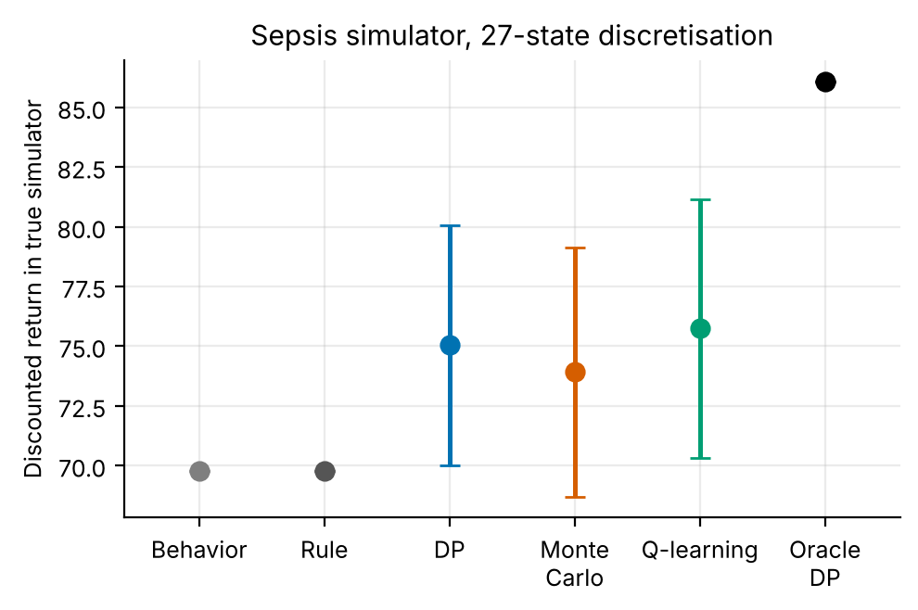
Figure 1. True-simulator return per method at g = 3 (points: mean; bars: 95% CI over 5 replicates).
Figure 1 displays the same comparison. The behaviour policy and the rule coincide, the three learners sit 4.2 to 6.0 points above them, and the oracle sits far above. The lower ends of the plotted intervals are above the rule's value for 2 of the three learners, but these intervals use 1.96 standard errors, which with 5 replicates are narrower than a t-interval by a factor of 1.42; with t-intervals all three would include the rule's value, which is what the paired tests above say. The pattern is that of an estimator whose variance is large relative to any systematic gain: more episodes would shrink the intervals, while a better state representation would raise the ceiling.
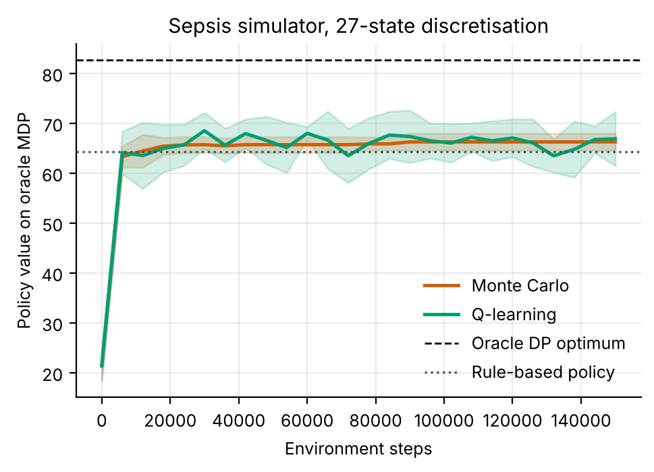
Figure 2. Learning curves on the oracle MDP (mean ± s.d. over 5 replicates). Dashed: oracle DP optimum; dotted: rule.
Figure 2 shows Q-learning and MC rising from near 21 to about 64 (Q-learning) and 63 (MC) by the first checkpoint at 6,000 steps and then creeping up; averaged over the last ten checkpoints Q-learning sits at 66.1 and MC ends at 66.3, a few points above the rule (64.4 on the oracle model) and far below the oracle optimum (82.7). Training longer does not close the gap, because the limit is the information in 500 logged episodes. Of the 27 states, the learned policies differ from the rule in 5 (DP), 7 (MC) and 5 (Q-learning), whereas the oracle differs in 9 (33% of states; Figure 3).
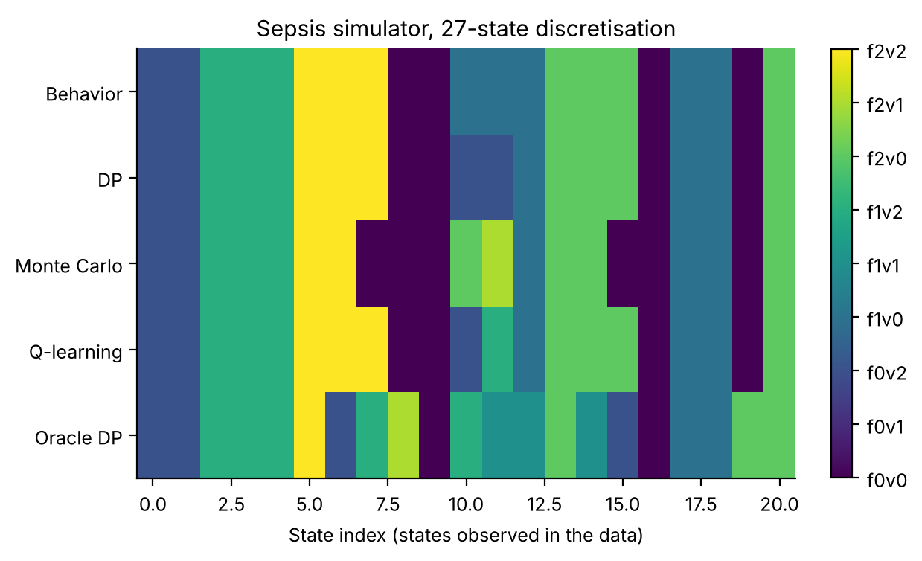
Figure 3. Action chosen in each state observed in the oracle data (colours: fluid and vasopressor levels). The learned policies stay close to the behaviour policy; the oracle departs from it in many states.
Figure 3 makes the same point state by state. The learners change the rule in only a handful of states, and different learners change different ones (MC and Q-learning disagree with DP and with each other in the middle columns), while the oracle rewrites the policy in a much larger part of the table. Q-learning agreed with DP in 92% of well-visited states and MC in 76%; MC's lower agreement is consistent with its higher variance. The model value of the DP policy minus its true value (optimism gap) was negative in 4 of 5 replicates, so the estimated model was usually pessimistic, not optimistic. We return to this in Section 7.3.

7.2 Granularity: finer states mean less to learn and a policy that collapses to the rule
Table 4. Effect of granularity with no penalty (kappa = 0): data coverage, and the learned policy's return, gain over the same-granularity rule and agreement with it (5 replicates).
Bins g | States | State-action cells | States with support | Median n per observed cell | Rule return (mortality) | DP, kappa = 0 | Gain over rule | Agreement with rule
2 | 8 | 72 | 95% | 18.1 | 65.9 (14.3%) | 79.3 ± 7.6 | +13.40 ± 7.61 | 74%
3 | 27 | 243 | 67% | 4.0 | 69.8 (8.7%) | 76.9 ± 4.5 | +7.12 ± 4.53 | 88%
5 | 125 | 1,125 | 29% | 3.0 | 77.3 (4.0%) | 79.7 ± 1.3 | +2.38 ± 1.27 | 94%
8 | 512 | 4,608 | 13% | 2.0 | 82.4 (3.0%) | 82.4 ± 0.0 | +0.02 ± 0.03 | 99%

Table 4 is the central result. As the number of bins per variable rises from 2 to 8, the state-action space grows from 72 to 4,608 cells while the data stay fixed; the share of states with any supported action falls from 95% to 13%, and the median count among observed cells falls from 18.1 to 2.0, which is below the support threshold of 10. The gain over the rule falls in step: +13.40 ± 7.61, +7.12 ± 4.53, +2.38 ± 1.27 and +0.02 ± 0.03. With t-based intervals the first three all exclude zero, though the g = 2 and g = 3 intervals are wide; the last is positive by a hair and means nothing: at 8 bins the learned policy agrees with the rule in 99% of well-visited states, and in the remaining states it is the rule by construction. Agreement with the rule rises from 74% to 99% over the same range, which is the signature of a planner that has little to say. Mortality moves with the gain, from 5.0% (learned) against 14.3% (rule) at 2 bins to 3.0% against 3.0% at 8 bins.
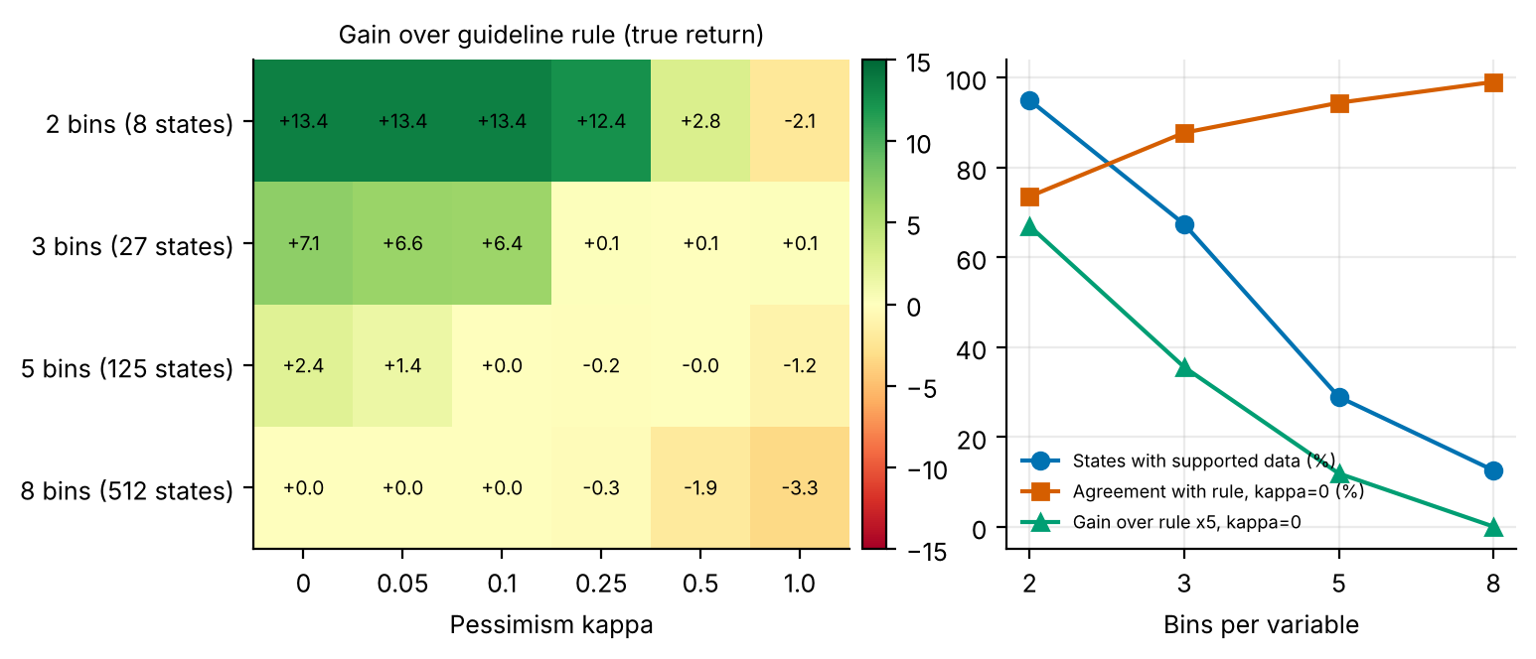
Figure 4. Left: gain over the same-granularity rule for each (bins, kappa) setting (green: better than the rule). Right: coverage, agreement with the rule at kappa = 0, and gain at kappa = 0 (multiplied by 5 for visibility).
Figure 4 (left) shows the whole sweep, and the right panel shows the mechanism. The blue line (coverage) and the green line (gain) fall together while the orange line (agreement with the rule) rises. In other words, granularity does not make learning harder in an abstract sense; it turns the learned policy into the rule, state by state, because the data no longer support any deviation. The finest granularity has the highest absolute return of the sweep (82.4 at g = 8, kappa = 0), but that value is the rule's own (the rule at 8 bins scores 82.4); no learning is involved. A reader comparing absolute returns across granularities, which range only from 76.9 to 82.4 at kappa = 0 even though the rule alone ranges from 65.9 to 82.4, would wrongly conclude that fine bins are best for learning. A second caution is that the coarsest setting offers the largest gain (+13.4) because the two-bin rule is poor, not because two bins is a good representation: its mortality (14.3% for the rule) is the highest of all rules.

7.3 Pessimism: a graded penalty on top of a hard support threshold does not help
Table 5. Gain over the same-granularity rule, by granularity and pessimism strength (mean ± 95% CI over 5 replicates). An asterisk marks cells whose t-based 95% interval (the ± value multiplied by 1.42) excludes zero.
Bins | kappa = 0 | kappa = 0.05 | kappa = 0.1 | kappa = 0.25 | kappa = 0.5 | kappa = 1.0
2 | +13.40* ± 7.61 | +13.44* ± 7.63 | +13.44* ± 7.63 | +12.41* ± 7.63 | +2.81 ± 5.52 | -2.14* ± 1.09
3 | +7.12* ± 4.53 | +6.55* ± 4.36 | +6.38* ± 4.19 | +0.14 ± 1.06 | +0.05 ± 0.13 | +0.13 ± 0.15
5 | +2.38* ± 1.27 | +1.41* ± 0.79 | +0.04 ± 0.08 | -0.16 ± 0.14 | -0.04 ± 0.36 | -1.16* ± 0.49
8 | +0.02 ± 0.03 | +0.01 ± 0.03 | +0.00 ± 0.00 | -0.31* ± 0.01 | -1.95* ± 0.74 | -3.32* ± 1.21

Table 5 is the pessimism result. Reading across any row, the gain never rises materially as kappa increases. Of the 20 (granularity, kappa > 0) settings, the penalised policy had a higher mean return than the unpenalised one in only 2, and by at most 0.05 return units, which is far inside the replicate intervals. For 3 bins the gain collapses between kappa = 0.1 (+6.38) and kappa = 0.25 (+0.14), after which the learned policy is the rule; for 5 bins the gain reaches zero at kappa = 0.1; for 2 bins it persists until kappa = 0.25 (+12.4) and then vanishes. At the largest strengths the policies are worse than the rule: -2.1 at 2 bins and -3.3 at 8 bins for kappa = 1.0 (5 of the 7 negative cells have t-based intervals that exclude zero). The worst cell in the table is 8 bins at kappa = 1.0.
Table 6. Paired test of moderate pessimism (kappa = 0.25) against none, and the gap between the DP model's value of the chosen policy and its true value.
Bins | Return, kappa = 0 | Return, kappa = 0.25 | Paired difference (kappa 0.25 minus 0) | Model value minus true value, kappa = 0 | Same, kappa = 0.25
2 | 79.3 ± 7.6 | 78.3 ± 7.6 | -0.98 ± 1.49 (p = 0.267) | -0.1 | -0.2
3 | 76.9 ± 4.5 | 69.9 ± 1.1 | -6.98 ± 3.58 (p = 0.019) | -8.9 | -7.8
5 | 79.7 ± 1.3 | 77.1 ± 0.1 | -2.54 ± 1.33 (p = 0.020) | -49.8 | -48.8
8 | 82.4 ± 0.0 | 82.1 ± 0.0 | -0.33 ± 0.03 (p < 0.001) | -121.6 | -121.6

Table 6 gives the paired comparison. Moderate pessimism (kappa = 0.25) is not better than none at any granularity, and is significantly worse in 3 of 4 (3 bins, 5 bins, 8 bins): -0.98 (p = 0.267) at 2 bins, -6.98 (p = 0.019) at 3 bins, -2.54 (p = 0.020) at 5 bins, -0.33 (p < 0.001) at 8 bins. The right-hand columns explain why a penalty is redundant. The model value of the chosen policy is below its true value in every one of the 24 sweep settings (the table shows the replicate mean at kappa = 0 and 0.25), and by a large margin as granularity increases (-49.8 at 5 bins and -121.6 at 8). The reason is that unsupported pairs are completed with the worst observed reward and an absorbing state, which is already a strong form of pessimism. When most pairs are unsupported the model undervalues almost every policy, and a second penalty only moves the planner further toward the best-observed action. The right measure of danger in this setting is therefore not over-optimism (the model is already pessimistic) but pessimism so severe that the planner has nothing to choose among.
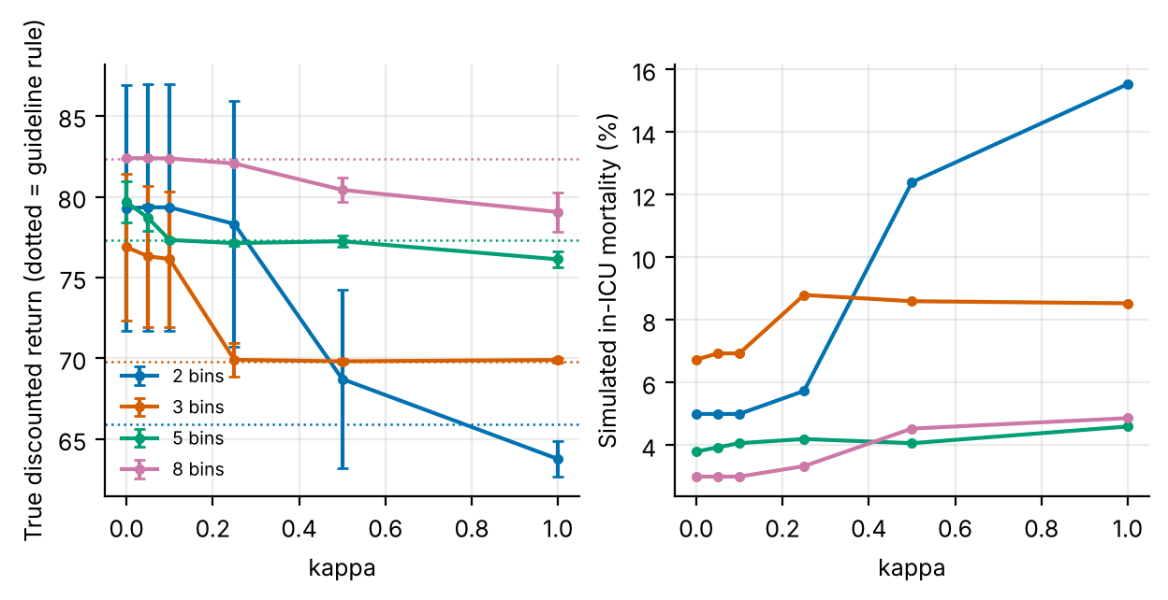
Figure 5. Left: true return against kappa for each granularity (dotted lines: the rule at that granularity; bars: 95% CI). Right: simulated in-ICU mortality against kappa.
Figure 5 shows the same sweep on the return scale and adds mortality. For 3 bins the return drops from about 77 at kappa = 0 to about 70 at kappa = 0.25 and then stays flat at the rule's level; mortality moves from 6.7% to 8.8%. For 2 bins the line is flat until kappa = 0.1, falls to 68.7 at kappa = 0.5 and to 63.8 at kappa = 1.0, below the rule (65.9), and its mortality climbs from 5.0% to 15.5%, above the rule's 14.3%. A penalty that is large relative to the +100 and −100 terminal rewards (the penalty at n = 10 is about 0.32 × kappa × Δr, which is of order 60 × kappa when Δr = 200) can make ending the episode quickly attractive, and the rising mortality at 2 bins is consistent with that mechanism; we did not test it directly, so it remains a hypothesis. The tight intervals at 5 and 8 bins show how little variation a mostly unsupported model produces.
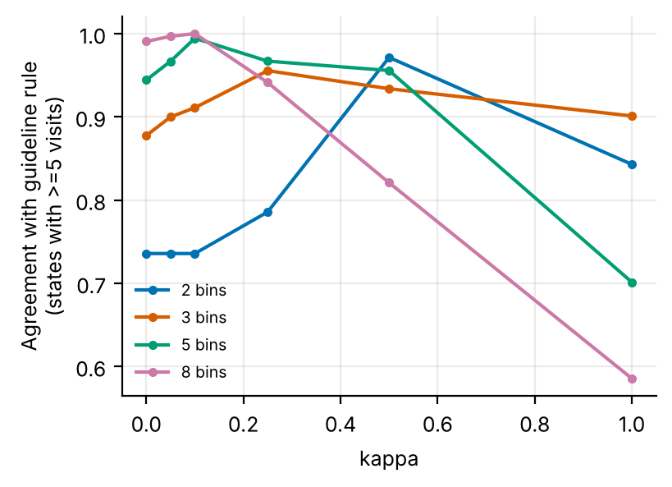
Figure 6. Agreement of the learned policy with the rule (states with at least 5 visits) as kappa grows, by granularity.
Figure 6 traces how pessimism changes the learned policy's resemblance to the rule. For 2 bins agreement rises from 74% (kappa = 0) to 97% (kappa = 0.5), as expected of a penalty that favours the most observed action, which under an ε-noisy rule is the rule's. At 8 bins agreement is already 99% at kappa = 0 and then falls to 59% at kappa = 1.0, and at 5 bins from 99% at kappa = 0.1 to 70%. A pessimism penalty is supposed to move a policy toward the behaviour policy, and it does so only when the penalty is moderate and coverage is reasonable; at fine granularity and large kappa it moves the policy away from the rule, possibly toward whichever action in the few supported cells has the largest count, which need not be the rule's. We did not investigate this further.

8. Discussion
What the sweep says about granularity. The tabular analyst's choice of bins is a choice of how much of the data to waste. At two bins nearly every state is supported and the learner can find improvements over a crude rule, but the representation is so coarse that the policy cannot be good (the rule's mortality is 14.3%, while the oracle at three bins reaches 2.0%). At eight bins the representation is richer and the rule is better, but the dataset cannot support a single departure from it. In between, the gain is distinguishable from zero at 2, 3 and 5 bins but shrinks steadily with granularity (+13.4, +7.1, +2.4), and the largest gains are where the rule is weakest. Practical advice: report the share of supported states and the agreement with the behaviour or rule policy next to any learned sepsis policy, since agreement near 100% is a warning that the policy is the clinician's and not the learner's.
What the sweep says about pessimism. The hard support threshold already implements the conservative principle that offline RL aims at, so a further penalty adds nothing here and, with a per-step form, risks distortions. This is a statement about this pipeline: algorithms without a hard threshold (for example neural Q-learning with a continuous state) have no such safeguard and would need a penalty. The practical lesson is to count the pessimism that is already present before adding more. The model-value gap (negative at every setting) is a cheap diagnostic: an estimated value that is far below the true value of the same policy means the model is too pessimistic to rank policies reliably, in which case estimated values should not be used to choose kappa. We could choose kappa here only because the simulator supplies true values.
The solvers. At the middle granularity DP, MC and Q-learning are indistinguishable. The replicate variability of MC (± 5.2) is similar to that of DP (± 5.0) and Q-learning (± 5.4); we did not test why it is not larger on this 24-step task. Agreement of MC with DP is lower (76%) than that of Q-learning (92%), in line with MC's higher variance, but it does not translate into a return difference.

9. Limitations and threats to validity
- One discretisation scheme. Bins are equal-width in MAP and score and geometric in lactate. Data-driven clustering, as in clinical work [2], may support different conclusions at the same number of states.
- DP only in the sweep. The pessimism sweep uses DP on a penalised model; MC control and Q-learning with a penalty were not tested and might react differently.
- Penalty form. Only one functional form (1/√n on the reward) was tested. Penalties on transition uncertainty or on the value of the behaviour policy are different and were not tested.
- Five replicates. Several intervals are wide (for example 7.6 at 2 bins) and the 1.96-standard-error intervals are narrower than t-intervals by a factor of 1.42; differences between nearby kappa values are not resolved, and only the kappa = 0.25 comparison has a paired test.
- Rule on each granularity. The rule is constructed from the band's fractional position and is not a validated clinical guideline; the size of the gain depends on how good it is.
- Simulated, not clinical, evidence. All numbers come from stylised simulators written for this study. They demonstrate how the algorithms behave when the ground truth is known; they say nothing about the safety or benefit of any treatment in people.
- State aggregation. Continuous physiology is discretised into bands. Banding makes the process only approximately Markov, and part of the gap between the DP policy on the estimated model and the true optimum is a modelling gap rather than a sampling gap.
- Fixed-horizon episodes treated as stationary. Episodes end after a fixed number of steps but the state does not always contain the clock, so the estimated model treats termination as a constant hazard. This distorts absolute model values (not true-simulator scores) and is why model-based value estimates are compared only on a common oracle model.
- Behaviour policy. The logged data come from a single ε-noisy rule. Coverage of non-rule actions is therefore thin, which is exactly the offline-RL situation, and results depend on that coverage.
- Hand-set hyper-parameters. ε schedules, step sizes and the support threshold were fixed in advance and not tuned per paper.

10. Ethical considerations and future work
Ethics. No human data were used, so no consent or privacy issues arise in this study. If the method were applied to real records, three safeguards would be essential: de-identification and governance approval of the source data; a clinician-in-the-loop design in which the learned policy is advisory, with hard guardrails on unsafe actions; and prospective, randomised or at least carefully monitored evaluation before any deployment. Reinforcement learning from logs inherits the biases of the clinicians who produced them, and may under-serve groups that are under-represented in the data; subgroup performance should be reported alongside averages.
Future work. (1) Replace equal-width bins by clusters learned from the data and repeat the sweep at matched numbers of states; (2) test penalties on transition uncertainty and a per-episode (not per-step) penalty that cannot reward early termination; (3) run MC control and Q-learning in the sweep; (4) report the support share and agreement with the clinician alongside any learned sepsis policy and use them to choose granularity; (5) apply the adapter to a real ICU table and compare model-based value estimates with importance-sampling estimates on a held-out split.

11. Conclusion
In a simulated sepsis task, a tabular learner's gain over a same-granularity rule falls from +13.4 at 2 bins per variable to +0.02 at 8, as the share of supported states falls from 95% to 13% and the learned policy converges to the rule. A count-based pessimism penalty improved on no setting by more than 0.05 return units, was significantly harmful at moderate strength in 3 of 4 granularities, and made the policy worse than the rule at the extremes; this is consistent with the hard support threshold already supplying the pessimism, as the negative model-value gaps indicate. At the middle granularity the three solvers were within noise of each other (75.0, 73.9, 75.7) and of the rule (69.8) and well below the oracle (86.1). All findings are from a simulator and are method evidence, not clinical evidence.

Appendix A. Anticipated reviewer questions
The following questions are the ones a reviewer or examiner is most likely to raise. Each answer is tied to a number or figure produced by the code.
Q1. Is it meaningful to call a policy better than the rule when the intervals are so wide?
Only where the (t-based) interval excludes zero, and Table 5 marks those cells. At g = 3 the gain at kappa = 0 is +7.12 ± 4.53, which excludes zero on that basis, but the benchmark comparison at the same granularity is +5.3 ± 5.0 (p = 0.109) for DP. We draw conclusions about trends across settings, not about any single cell.
Q2. Why is the finest granularity not the best, when it has the highest absolute return?
Because its return is the rule's. At 8 bins the learned policy agrees with the rule in 99% of well-visited states and the gain over the rule is +0.021 (Table 4). The rule is better at finer granularity, and learning has nothing to add.
Q3. Does your result mean pessimism is useless in offline RL?
No. It means that in this pipeline a hard support threshold is already in place, and the model values are already below the true values in every setting (Table 6). Methods without such a threshold would need a penalty. We also tested only one penalty form and only DP.
Q4. Why does a larger penalty make the policy worse than the rule?
The data show that it does (Table 5); the mechanism is a hypothesis. A per-step penalty is an extra negative reward and can make early termination attractive; at 2 bins mortality rises to 15.5% at kappa = 1.0, above the rule's 14.3%, which is consistent with that mechanism but does not prove it.
Q5. What would you need to run this on real data?
Map the table to (MAP, lactate, score, dose, reward) rows, discretise with the same bins, and call the adapter in the code package. A real table has no simulator, so the headline measure, true gain over the rule, would have to be replaced by held-out importance-sampling estimates, which have their own variance problems; the support share and agreement with the clinician can be computed without a simulator and are the first things to report.

Appendix B. Reproducibility
All results in this paper are produced by `python ideas.py 2` (shared library: rl_core.py, domains.py, common.py). Random seeds are fixed in the code, so a re-run reproduces every table and figure. Figure files generated by the script: fig_bars, fig_learning, fig_policies, fig_agreement, fig_heatmaps, fig_kappa, fig_agreement_rule. To repeat the study on a real Kaggle table, convert it with kaggle_adapter.transitions_from_dataframe, then call build_mdp, value_iteration, mc_control and q_learning exactly as the script does; because a real table has no simulator, report model-based estimates on a held-out split and label them as estimates.

Appendix C. Source code of the experiment
For completeness the exact source of the simulator and the experiment function is reproduced below; it is the same code that produced every number and figure in this paper (the shared solvers value_iteration, mc_control and q_learning are in rl_core.py and are delivered with the code package).

Sepsis
class Sepsis(Domain):
name = "sepsis"
nA, gamma, max_steps = 9, 0.99, 24
info_keys = ["died", "survived", "fluid", "vaso"]
behavior_eps = 0.25
action_labels = [f"f{f}v{v}" for f in range(3) for v in range(3)]

def __init__(self, gran=3):
self.gran = gran
g = gran
self.me = np.linspace(48, 92, g + 1)[1:-1]
self.le = np.geomspace(0.8, 7.0, g + 1)[1:-1]
self.se = np.linspace(2, 13, g + 1)[1:-1]
self.nS = g ** 3

def _s(self):
g = self.gran
return (band(self.map, self.me) * g + band(self.lac, self.le)) * g + band(self.sofa, self.se)

def reset(self, rng):
self.map = float(np.clip(rng.normal(62, 8), 40, 100))
self.lac = float(np.clip(rng.lognormal(np.log(2.8), 0.4), 0.6, 12))
self.sofa = float(rng.uniform(3, 9))
self.t = 0
return self._s()

def step(self, a, rng):
f, v = divmod(a, 3)
tgt = 74 - 1.6 * self.sofa + 7 * v + 2.5 * f
mp = self.map + 0.5 * (tgt - self.map) + rng.normal(0, 3)
mp = float(np.clip(mp, 30, 110))
ls = 0.8 + 0.25 * self.sofa + 0.08 * max(65 - mp, 0) + 0.25 * (v == 2)
lc = float(max(0.4, self.lac + 0.4 * (ls - self.lac) + rng.normal(0, 0.25)))
sf = self.sofa + 0.5 * (lc > 3.5) + 0.3 * (mp < 60) - 0.45 * (mp >= 68 and lc < 2.5) \
- 0.2 * (mp >= 65) + 0.5 * (f == 2 and self.sofa >= 8) + rng.normal(0, 0.3)
sf = float(np.clip(sf, 0, 20))
self.map, self.lac, self.sofa, self.t = mp, lc, sf, self.t + 1
r, done = -0.1, False
died = survived = 0.0
if sf >= 14 or mp < 42:
r, done, died = -100.0, True, 1.0
elif sf <= 2 and lc < 2.0:
r, done, survived = 100.0, True, 1.0
elif self.t >= self.max_steps:
r, done = 40 - 5 * sf, True
survived = float(sf < 6)
info = dict(died=died, survived=survived, fluid=float(f), vaso=float(v))
return self._s(), r, done, info, 1

def rule(self, s):
g = self.gran
mb = s // (g * g)
lb = (s // g) % g
mfrac = mb / max(g - 1, 1)
lfrac = lb / max(g - 1, 1)
v = 2 if mfrac < 0.2 else (1 if mfrac < 0.5 else 0)
f = 2 if lfrac >= 0.85 else (1 if lfrac >= 0.5 else 0)
return f * 3 + v

ideas.idea2
def idea2():
I = 2; d = odir(I)
res = standard_benchmark(Sepsis(3), n_eps=500, n_oracle=5000, steps=150000, seeds=5)
standard_figs(res, Sepsis(3), I, title="Sepsis simulator, 27-state discretisation")
GR = [2, 3, 5, 8]; KS = [0, 0.05, 0.1, 0.25, 0.5, 1.0]
SEEDS = 5
Jt = np.zeros((len(GR), len(KS), SEEDS)); gap = np.zeros_like(Jt); mort = np.zeros_like(Jt)
agree = np.zeros_like(Jt); rule_J = []; cover = []
for gi, g in enumerate(GR):
dom = Sepsis(g)
rule = np.array([dom.rule(s) for s in range(dom.nS)])
r, inf = eval_policy(dom, rule, n_eps=300)
rule_J.append((float(r.mean()), float(inf["died"].mean())))
for sd in range(SEEDS):
data = rollout(dom, dom.behavior, np.random.default_rng(100 + sd), 500)
m = build_mdp(data, dom)
cover.append((g, float((m.visits > 0).mean()), float(np.median(m.n[m.n > 0]))))
rng_ = m.rmax - m.rmin
pen = np.where(m.n > 0, rng_ / np.sqrt(np.maximum(m.n, 1)), 0.0)
for ki, k in enumerate(KS):
pi, _, _ = value_iteration(m, penalty=k * pen)
pi = fill_policy(pi, m, rule)
r, inf = eval_policy(dom, pi, n_eps=300)
Jt[gi, ki, sd] = r.mean(); mort[gi, ki, sd] = inf["died"].mean()
gap[gi, ki, sd] = J(m, pi) - r.mean()
vis = m.visits >= 5
agree[gi, ki, sd] = (pi[vis] == rule[vis]).mean() if vis.any() else np.nan
print("idea2 gran", g, np.round(Jt[gi].mean(1), 1), flush=True)
# gain over the clinician rule (rule is evaluated on the same discretisation)
rJ = np.array([x[0] for x in rule_J])
Gain = Jt - rJ[:, None, None]
cov_g = {g: np.mean([c for gg, c, _ in cover if gg == g]) for g in GR}
med_n = {g: np.mean([mm for gg, _, mm in cover if gg == g]) for g in GR}
fig, axs = plt.subplots(1, 2, figsize=(8.2, 3.2), gridspec_kw=dict(width_ratios=[1.25, 1]))
M = Gain.mean(2)
im = axs[0].imshow(M, aspect="auto", cmap="RdYlGn", vmin=-15, vmax=15); axs[0].grid(False)
axs[0].set_xticks(range(len(KS))); axs[0].set_xticklabels(KS); axs[0].set_yticks(range(len(GR)))
axs[0].set_yticklabels([f"{g} bins ({g**3} states)" for g in GR]); axs[0].set_xlabel("Pessimism kappa")
axs[0].set_title("Gain over guideline rule (true return)", fontsize=9)
for i in range(M.shape[0]):
for j in range(M.shape[1]):
axs[0].text(j, i, f"{M[i, j]:+.1f}", ha="center", va="center", fontsize=7)
fig.colorbar(im, ax=axs[0], fraction=0.046, pad=0.02)
xs = np.arange(len(GR))
axs[1].plot(xs, [100 * cov_g[g] for g in GR], marker="o", color="#0072B2", label="States with supported data (%)")
axs[1].plot(xs, [100 * np.nanmean(agree[i, 0]) for i in range(len(GR))], marker="s", color="#D55E00", label="Agreement with rule, kappa=0 (%)")
axs[1].plot(xs, [Gain[i, 0].mean() * 5 for i in range(len(GR))], marker="^", color="#009E73", label="Gain over rule x5, kappa=0")
axs[1].set_xticks(xs); axs[1].set_xticklabels([f"{g}" for g in GR]); axs[1].set_xlabel("Bins per variable"); axs[1].legend(fontsize=6.5)
fig.savefig(f"{d}/fig_heatmaps.png"); plt.close(fig)
fig, axs = plt.subplots(1, 2, figsize=(7.2, 3.0))
for gi, g in enumerate(GR):
axs[0].errorbar(KS, Jt[gi].mean(1), yerr=[ci95(Jt[gi, k]) for k in range(len(KS))], marker="o", ms=3, capsize=2, label=f"{g} bins", color=OKABE[gi])
axs[1].plot(KS, 100 * mort[gi].mean(1), marker="o", ms=3, label=f"{g} bins", color=OKABE[gi])
axs[0].axhline(rule_J[gi][0], color=OKABE[gi], ls=":", lw=0.9)
axs[0].set_xlabel("kappa"); axs[0].set_ylabel("True discounted return (dotted = guideline rule)")
axs[1].set_xlabel("kappa"); axs[1].set_ylabel("Simulated in-ICU mortality (%)")
axs[0].legend(fontsize=7)
fig.savefig(f"{d}/fig_kappa.png"); plt.close(fig)
fig, ax = plt.subplots(figsize=(4.2, 3.0))
for gi, g in enumerate(GR):
ax.plot(KS, np.nanmean(agree[gi], 1), marker="o", ms=3, label=f"{g} bins", color=OKABE[gi])
ax.set_xlabel("kappa"); ax.set_ylabel("Agreement with guideline rule\n(states with >=5 visits)"); ax.legend(fontsize=7)
fig.savefig(f"{d}/fig_agreement_rule.png"); plt.close(fig)
best = np.unravel_index(np.argmax(Jt.mean(2)), Jt.shape[:2])
out = dict(GR=GR, KS=KS, gain=Gain.mean(2), gain_ci=np.array([[ci95(Gain[i, j]) for j in range(len(KS))] for i in range(len(GR))]), cov=cov_g, med_n=med_n, J=Jt.mean(2), J_ci=np.array([[ci95(Jt[i, j]) for j in range(len(KS))] for i in range(len(GR))]),
gap=gap.mean(2), mort=mort.mean(2), agree=np.nanmean(agree, 2), rule=rule_J, cover=cover,
best=dict(gran=GR[best[0]], kappa=KS[best[1]], J=float(Jt.mean(2)[best])),
pess_vs_naive={str(g): paired(Jt[gi, 3], Jt[gi, 0]) for gi, g in enumerate(GR)},
best_pess_vs_naive_gap={str(g): [float(gap[gi, 0].mean()), float(gap[gi, 3].mean())] for gi, g in enumerate(GR)})
save_json(I, "results", dict(out, standard=summarize(res), extra=drop_models(res)))
return out

rl_core: shared solvers
def build_mdp(data, dom, weights=None, chan=None, min_n=10, term_prior=1.0):
"""Empirical (maximum-likelihood) MDP from logged transitions.
(s,a) pairs observed fewer than min_n times are completed pessimistically: they go
to the absorbing terminal state with the worst reward seen in the data."""
nS, nA = dom.nS, dom.nA
T = nS
w = np.ones(len(data["s"])) if weights is None else np.asarray(weights, float)
s, a = data["s"], data["a"]
s2 = np.where(data["done"] > 0, T, data["s2"])
N = np.zeros((nS + 1, nA, nS + 1))
np.add.at(N, (s, a, s2), w)
n = N.sum(2)
Rsum = np.zeros((nS + 1, nA))
np.add.at(Rsum, (s, a), w * data["r"])
Gsum = np.zeros((nS + 1, nA, nS + 1))
np.add.at(Gsum, (s, a, s2), w * dom.gamma ** data["dur"])
m = MDP()
m.nS, m.nA, m.gamma = nS, nA, dom.gamma
m.n = n
m.N = N
seen = n >= min_n # support constraint: thinly observed (s,a) are completed pessimistically
n_eff = n + term_prior # one pseudo-observation of absorption guards against 'immortal' loops
P = np.zeros_like(N)
P[seen] = N[seen] / n_eff[seen][:, None]
P[seen, T] += term_prior / n_eff[seen]
G = np.full_like(N, dom.gamma)
nz = N > 0
G[nz] = Gsum[nz] / N[nz]
R = np.zeros((nS + 1, nA))
R[seen] = Rsum[seen] / n_eff[seen]
rmin = float(data["r"].min())
m.rmin, m.rmax = rmin, float(data["r"].max())
P[~seen, T] = 1.0
R[~seen] = rmin
P[T, :, :] = 0.0
P[T, :, T] = 1.0
R[T, :] = 0.0
m.P, m.G, m.R = P, G, R
m.PG = P * G
# reward channels
m.Rc = {}
for c in (chan if chan is not None else dom.chan):
cs = np.zeros((nS + 1, nA))
np.add.at(cs, (s, a), w * data[c])
cr = np.zeros((nS + 1, nA))
cr[seen] = cs[seen] / n_eff[seen]
m.Rc[c] = cr
# start distribution = first state of every episode
first = data["t"] == 0
mu = np.bincount(data["s"][first], minlength=nS + 1).astype(float)
m.mu = mu / mu.sum()
m.visits = (n * seen).sum(1)[:nS]
m.seen = seen
m.Rsum = Rsum
return m

def value_iteration(m, R=None, mask=None, tol=1e-9, max_iter=20000, penalty=None):
R = m.R if R is None else R
if penalty is not None:
R = R - penalty
V = np.zeros(m.nS + 1)
for _ in range(max_iter):
Q = _q(m, V, R)
if mask is not None:
Q = np.where(mask, Q, -1e18)
Vn = Q.max(1)
Vn[m.nS] = 0.0
if np.abs(Vn - V).max() < tol:
V = Vn
break
V = Vn
Q = _q(m, V, R)
if mask is not None:
Q = np.where(mask, Q, -1e18)
pi = Q.argmax(1)[:m.nS]
return pi, V, Q

def q_learning(m, rng, steps, eps_fn=eps_exp, alpha0=1.0, alpha_min=0.02,
q0=0.0, mask=None, n_ckpt=25, max_len=200, ckpt_fn=None):
nS, nA = m.nS, m.nA
ckpt_fn = ckpt_fn or (lambda p: J(m, p))
Q = np.full((nS + 1, nA), q0)
Q[nS] = 0.0
cnt = np.zeros((nS + 1, nA))
smp = Sampler(m, rng)
ck = np.unique(np.linspace(0, steps, n_ckpt + 1).astype(int))
curve = []
s, ep_t = smp.start(), 0
ci = 0
for k in range(steps + 1):
if ci < len(ck) and k == ck[ci]:
pi = np.array([_greedy(Q, x, mask) for x in range(nS)])
curve.append((k, ckpt_fn(pi)))
ci += 1
if k == steps:
break
if rng.random() < eps_fn(k, steps):
a = _explore(rng, s, nA, mask)
else:
a = _greedy(Q, s, mask)
s2, r, g = smp.step(s, a)
tgt = r + (0.0 if s2 == nS else g * Q[s2].max() if mask is None
else g * np.where(mask[s2], Q[s2], -1e18).max())
cnt[s, a] += 1
al = max(alpha_min, alpha0 / (1.0 + cnt[s, a] ** 0.7))
Q[s, a] += al * (tgt - Q[s, a])
ep_t += 1
if s2 == nS or ep_t >= max_len:
s, ep_t = smp.start(), 0
else:
s = s2
pi = np.array([_greedy(Q, x, mask) for x in range(nS)])
return pi, Q, np.array(curve)

def mc_control(m, rng, steps, eps_fn=eps_exp, q0=0.0, mask=None, n_ckpt=25,
max_len=200, ckpt_fn=None):
"""first-visit Monte Carlo control with epsilon-soft behaviour policy and
incremental-average updates."""
nS, nA = m.nS, m.nA
ckpt_fn = ckpt_fn or (lambda p: J(m, p))
Q = np.full((nS + 1, nA), q0)
Q[nS] = 0.0
N = np.zeros((nS + 1, nA))
smp = Sampler(m, rng)
ck = np.unique(np.linspace(0, steps, n_ckpt + 1).astype(int))
curve = []
used, ci = 0, 0
while True:
while ci < len(ck) and used >= ck[ci]:
pi = np.array([_greedy(Q, x, mask) for x in range(nS)])
curve.append((ck[ci], ckpt_fn(pi)))
ci += 1
if used >= steps:
break
s = smp.start()
traj = []
for _ in range(max_len):
if rng.random() < eps_fn(used + len(traj), steps):
a = _explore(rng, s, nA, mask)
else:
a = _greedy(Q, s, mask)
s2, r, g = smp.step(s, a)
traj.append((s, a, r, g))
s = s2
if s2 == nS:
break
used += len(traj)
# returns, backwards; first-visit
Gret = 0.0
rets = []
for (s_, a_, r_, g_) in reversed(traj):
Gret = r_ + g_ * Gret
rets.append(Gret)
rets.reverse()
seen = set()
for (s_, a_, _, _), G_ in zip(traj, rets):
if (s_, a_) in seen:
continue
seen.add((s_, a_))
N[s_, a_] += 1
Q[s_, a_] += (G_ - Q[s_, a_]) / N[s_, a_]
pi = np.array([_greedy(Q, x, mask) for x in range(nS)])
return pi, Q, np.array(curve)

References
[1] Singer, M. et al. The Third International Consensus Definitions for Sepsis and Septic Shock (Sepsis-3). JAMA 315(8):801-810, 2016.
[2] Komorowski, M., Celi, L. A., Badawi, O., Gordon, A. C. and Faisal, A. A. The Artificial Intelligence Clinician learns optimal treatment strategies for sepsis in intensive care. Nature Medicine 24:1716-1720, 2018.
[3] Raghu, A., Komorowski, M., Celi, L. A., Szolovits, P. and Ghassemi, M. Continuous state-space models for optimal sepsis treatment: a deep reinforcement learning approach. Machine Learning for Healthcare (MLHC), 2017.
[4] Reyna, M. A. et al. Early prediction of sepsis from clinical data: the PhysioNet/Computing in Cardiology Challenge 2019. Critical Care Medicine 48(2):210-217, 2020.
[5] Gottesman, O. et al. Guidelines for reinforcement learning in healthcare. Nature Medicine 25:16-18, 2019.
[6] Yu, C., Liu, J., Nemati, S. and Yin, G. Reinforcement learning in healthcare: a survey. ACM Computing Surveys 55(1):1-36, 2021.
[7] Levine, S., Kumar, A., Tucker, G. and Fu, J. Offline reinforcement learning: tutorial, review, and perspectives on open problems. arXiv:2005.01643, 2020.
[8] Fujimoto, S., Meger, D. and Precup, D. Off-policy deep reinforcement learning without exploration. Proceedings of the 36th ICML, 2019.
[9] Kumar, A., Zhou, A., Tucker, G. and Levine, S. Conservative Q-learning for offline reinforcement learning. Advances in Neural Information Processing Systems 33, 2020.
[10] Jin, Y., Yang, Z. and Wang, Z. Is pessimism provably efficient for offline RL? Proceedings of the 38th International Conference on Machine Learning (ICML), 2021.
[11] Hoeffding, W. Probability inequalities for sums of bounded random variables. Journal of the American Statistical Association 58(301):13-30, 1963.
[12] Sutton, R. S. and Barto, A. G. Reinforcement Learning: An Introduction, 2nd ed. MIT Press, 2018.
[13] Bellman, R. Dynamic Programming. Princeton University Press, 1957.
[14] Puterman, M. L. Markov Decision Processes: Discrete Stochastic Dynamic Programming. Wiley, 1994.
[15] Singh, S. P. and Sutton, R. S. Reinforcement learning with replacing eligibility traces. Machine Learning 22:123-158, 1996.
[16] Watkins, C. J. C. H. and Dayan, P. Q-learning. Machine Learning 8(3-4):279-292, 1992.

