Lagrangian Dynamic Programming for Chronic Kidney Disease Care: Benefit-Burden Frontiers and Safety Margins for Burden Budgets
[Author names] | [Department, Institution] | [Corresponding e-mail]
Abstract. Managing chronic kidney disease (CKD) means choosing, at each visit, how intensively to treat: more intensive care slows the loss of kidney function but adds burden for the patient and the health system. We study this trade-off as a constrained Markov decision process on a simulated CKD cohort whose variables mirror public CKD tables (the Kaggle site was unreachable, HTTP 403, so no real file was used). We learn from 800 logged patient trajectories with dynamic programming (DP), Monte Carlo (MC) control and Q-learning, add a Lagrange multiplier that prices burden to trace a benefit-burden frontier, and propose a safety margin that tightens the budget used in planning to protect against under-predicted burden. At unit price, DP, Q-learning and MC scored 13.97, 13.60 and 13.15 against 11.80 for a nephrologist-style rule, but a constant 'always enhanced' policy scored 13.83, so the improvement is largely available without learning. Across eight prices the frontier is monotone (burden from 6.23 to 0.21, benefit from 18.4 to 12.1, simulated kidney-failure rate from 7.5% to 35.8%), but the 'always enhanced' policy lies above it (17.36 versus 16.99 at the same burden), and for prices of 2 to 8 the policy trained at a given price was not the best at that price in the true simulator. Planning to a burden budget with no margin exceeded the budget in 26 of 30 replicate-budget runs (realised burden was 1.27 to 1.49 times the model's prediction); a 50% margin reduced exceedances to 3 at a cost of 0.58 to 0.86 benefit units. All results are simulated and carry no clinical meaning.
Keywords: chronic kidney disease; constrained Markov decision process; Lagrangian relaxation; Pareto frontier; treatment burden; safety margin; dynamic programming

1. Introduction
CKD is a progressive loss of kidney function, usually tracked by the estimated glomerular filtration rate (eGFR) and by markers such as proteinuria; clinical guidelines tie monitoring and treatment intensity to the stage of disease [1]. Intensifying care, for example with tighter blood-pressure control [2], more frequent review, or additional drugs, can slow decline, but each step adds burden: clinic time, side effects, cost. A treatment policy is therefore a sequence of decisions that trade a health benefit against a cost, and a policymaker may reasonably say not 'maximise a weighted sum' but 'maximise benefit within a burden budget'.
Sequential decision problems with resource constraints are the subject of constrained Markov decision processes (CMDPs) [3]; safe reinforcement learning has built methods around them [4]. A classical route is Lagrangian relaxation: price the constrained resource by a multiplier and solve an ordinary MDP for the combined reward. This is attractive for tabular health problems because the inner solver is plain dynamic programming and the outcome, a frontier of efficient policies, is easy to inspect. The difficulty in healthcare is that the model is estimated from logs, so the burden of a candidate policy is itself an estimate, and a budget that is met in the model may be broken in practice.
Contributions. (i) A transparent CKD simulator with competing risks, a benefit channel (kidney function, with a large failure penalty) and a burden channel (treatment intensity). (ii) A Lagrangian DP pipeline that sweeps the burden price over 8 values and, by bisection, finds the price that meets a model-predicted burden budget (Eq. 3 to 5). (iii) A safety-margin rule that plans to a tightened budget, with an empirical calibration ratio that says how large the margin must be (Eq. 6). (iv) Benchmarks of DP, MC and Q-learning on the scalarised problem and comparison with three constant policies and a clinical-style rule. (v) Negative results: a constant policy matches the learned policy at unit price; the learned frontier is partly dominated by that constant policy; and the policy trained at a high price is not the best at that price.
Scope and honesty. The Kaggle site could not be reached from the build environment (all requests returned HTTP 403), so no real CKD table was analysed. The simulator mirrors the variables of CKD tables (eGFR, proteinuria, treatment intensity, outcome) with made-up dynamics. Findings concern algorithms, not patients, and no clinical claim is made.

2. Related work
CKD care and guidelines. Guidelines classify CKD by eGFR and albuminuria and recommend monitoring frequency and treatment according to risk [1]; blood-pressure targets are set by hypertension guidelines [2]. Our rule, intensive care below an eGFR threshold, enhanced care at intermediate eGFR and routine care above, is a stylised version of this stratification and is not a guideline.
Constrained MDPs and safe RL. Altman's monograph develops CMDPs, including the Lagrangian dual and the fact that optimal constrained policies may need randomisation [3]. Surveys of safe RL describe the Lagrangian and other approaches [4], and shielding enforces safety by blocking unsafe actions [5]. We use the plain dual with deterministic policies.
Offline RL. Learning from logs requires caution because models are wrong where data are thin [6,7,8]. In this paper the same fact appears as a calibration problem: the model under-predicts the burden of the policy it chooses.

3. Preliminaries: Markov decision processes and the three solution families
A finite Markov decision process (MDP) is a tuple (S, A, P, R, γ) with a finite state set S, a finite action set A, a transition kernel P(s' | s, a), an expected reward R(s, a) and a discount factor γ in [0, 1). A deterministic policy π maps each state to an action. Its value V^π(s) is the expected discounted return obtained by starting in s and following π; the optimal value V*(s) satisfies the Bellman optimality equation [9,10,11]
V*(s) = max_a [ R(s,a) + γ Σ_{s'} P(s'|s,a) V*(s') ] (1)
Dynamic programming (DP). When P and R are known, V* is the unique fixed point of the contraction in Eq. (1). Value iteration repeatedly applies the right-hand side until the sup-norm change is below a tolerance; policy iteration alternates exact policy evaluation (solving the linear system (I − γP_π)V = R_π) with greedy improvement and terminates in a finite number of steps. We implement both and verify on every run that they return policies of identical value, which acts as a built-in correctness test of the solver.
Monte Carlo (MC) control. Without a model, MC control estimates the action-value Q(s,a) as the average return observed after first visits to (s,a) within complete episodes, and improves an ε-soft policy that is greedy with respect to Q [9,12]. It makes no bootstrapping assumption, so it is unbiased but has high variance and must wait until an episode ends before learning anything.
Q-learning. Tabular Q-learning is a model-free temporal-difference method that bootstraps from its own estimates [13]:
Q(s,a) ← Q(s,a) + α [ r + γ max_{a'} Q(s',a') − Q(s,a) ] (2)
It converges to Q* if every (s,a) is visited infinitely often and the step sizes satisfy the usual stochastic-approximation conditions. In practice the speed at which it spreads reward information backwards is its main advantage over MC, and its bias from bootstrapping off noisy estimates is its main weakness.
Empirical MDPs from logged data. Clinical data are logged, not simulated: we observe transitions (s, a, r, s') generated by clinicians. Counts N(s,a,s') give the maximum-likelihood model P̂(s'|s,a) = N(s,a,s')/N(s,a) and R̂(s,a) as the mean observed reward. Solving the MDP (P̂, R̂) by DP gives a plug-in policy; MC and Q-learning can be run against samples drawn from (P̂, R̂), which is how "learning from experience" is realised without touching patients. Two safeguards are used throughout because plug-in planning is notoriously exploited by estimation error [6,7,8]: (i) a support constraint: a pair (s,a) observed fewer than 10 times is completed pessimistically (it transitions to an absorbing terminal state with the worst reward in the data), and (ii) a terminal pseudo-count: one pseudo-observation of absorption is added to every supported pair so that no state is estimated to be immortal.

4. Problem formulation: a CKD care simulator
A patient has a continuous eGFR (mL/min/1.73 m²) and a binary proteinuria flag. At entry eGFR is uniform on [25, 85] and 40% of patients have proteinuria. At each of up to 60 visits the clinician chooses one of three intensities: routine, enhanced or intensive. eGFR then falls by a base amount (0.45 without proteinuria, 1.1 with it) multiplied by (1 − r), where r = 0, 0.25 or 0.5 is the reduction due to the chosen intensity, multiplied by 1.4 if eGFR is already below 30, plus Gaussian noise with standard deviation 0.6. Proteinuria, if present, resolves with probability 0.04 + 0.1 × (intensity index) per visit; if absent it appears with probability 0.05 − 0.015 × (intensity index). The episode ends in kidney failure when eGFR falls below 15, on competing mortality (1.5% per visit, 2.5% when eGFR is below 30), or at the horizon.
Table 1. The CKD care MDP.
Element | Definition
State (120) | eGFR band (20 bands with cut points every 4 units from 15 to 87) × proteinuria (2) × previous intensity (3)
Actions (3) | routine, enhanced, intensive (eGFR-decline reduction 0, 25%, 50%)
Benefit channel c1 | eGFR / 60 per visit, minus 20 in the visit when kidney failure occurs
Burden channel c2 | 0.0, 0.15 and 0.5 per visit for routine, enhanced and intensive
Scalar reward | c1 − λ c2; λ = 1 for the benchmark; λ varied for the frontier
Discount, horizon | γ = 0.98; up to 60 visits
Nephrologist-style rule | intensive if the eGFR band midpoint is below 45, enhanced if below 60, otherwise routine
Behaviour policy | the rule with ε = 0.25 random actions
Dataset mirrored | Chronic Kidney Disease table (eGFR, proteinuria, treatment, outcome)

Two features of this design deserve attention. First, intensive care carries a burden of 0.5 per visit against 0.15 for enhanced care, so over a long episode intensive care is expensive, and the price of burden determines which intensity is worth giving. Second, because the rule is intensive for low eGFR and routine for high eGFR, the logged data contain few intensive visits at high eGFR and few routine visits at low eGFR, which limits what a learner can discover about those combinations; this will matter in the results.

5. Method: Lagrangian DP and safety margins
Let J_b(π) and J_c(π) be the expected discounted benefit and burden of a policy π. The constrained problem for a budget B is
max_π J_b(π) subject to J_c(π) ≤ B. (3)
Relaxing the constraint with a multiplier λ ≥ 0 gives the scalarised problem max_π [J_b(π) − λ J_c(π)], an ordinary MDP with reward c1 − λ c2, which we solve by value iteration on the estimated model. Let π_λ be its solution and C(λ) = J_c(π_λ). A standard exchange argument shows that C(λ) is non-increasing in λ and that, if π_λ and π_λ' are both optimal at their own prices, the exchange rate between them satisfies
λ ≤ [J_b(π_λ) − J_b(π_λ')] / [J_c(π_λ) − J_c(π_λ')] ≤ λ' for λ < λ'. (4)
Equation (4) is a testable property: the realised benefit lost per unit of burden saved between neighbouring frontier points must lie between their prices. Because C(λ) is monotone, the price that meets a budget can be found by bisection. Deterministic policies reach only the vertices of the achievable set, so the budget is met approximately (a randomised mixture of two adjacent policies would be needed to meet it exactly).
The burden is predicted from the estimated model, and the model can be wrong about it. In this pipeline pairs with fewer than 10 observations are treated as unsupported and absorbing; the model assigns them no burden channel reward, while the deployed policy falls back to the rule in states it has not seen, and the rule incurs real burden. A policy chosen to meet a predicted budget can therefore exceed it. The safety margin m plans to a tightened budget,
find the smallest λ such that Ĵ_c(π_λ) ≤ B / (1 + m). (5)
If the realised burden is a roughly constant multiple ρ of the predicted burden, the realised burden is ρ B / (1 + m), which meets the budget if
1 + m ≥ ρ, ρ = J_c(π_λ) / Ĵ_c(π_λ). (6)
The calibration ratio ρ can be estimated by comparing predicted and realised burden at m = 0. We report it together with the exceedance counts.
Algorithm 1 Lagrangian DP with a burden budget and safety margin
input : logged episodes, budget B, margin m, price grid, bisection tolerance
1. build the empirical MDP (supported pairs n >= 10; unsupported pairs absorbing) with channels c1, c2
2. burden(lam): pi <- value_iteration(reward = c1 - lam * c2); return mu . V_pi[c2] (model-predicted discounted burden)
3. target <- B / (1 + m)
4. if burden(0) <= target: lam <- 0
else: lo <- 0, hi <- 64; repeat 25 times: mid <- (lo + hi) / 2; if burden(mid) > target: lo <- mid else hi <- mid; lam <- hi
5. pi <- value_iteration(reward = c1 - lam * c2); in unsupported states use the rule's action
6. evaluate pi in the true simulator: realised benefit, burden, kidney-failure rate

6. Experimental protocol

6.1 Simulators that mirror the named Kaggle datasets
Important disclosure. The Kaggle website could not be reached from the environment in which this study was built (all requests returned HTTP 403), so no Kaggle file was downloaded. Instead every experiment is run on a transparent, hand-specified stochastic simulator whose recorded variables mirror the columns of the dataset named in the paper. The simulator plays two roles: it generates a logged dataset by running an ε-noisy clinician-like behaviour policy (the stand-in for the Kaggle table), and it is the ground truth against which every learned policy is scored. Using a simulator is a methodological choice with a real benefit (true policy value is measurable, which is impossible with a static table) and a real cost (the numbers are not clinical evidence). The accompanying code includes a data adapter that converts a real Kaggle CSV into the same transition format so that the identical pipeline can be re-run on the real file; the results below should be read as a method study, not as a finding about patients.

6.2 Data, solvers and scoring
Table 2. Experimental configuration.
Item | Setting
Simulator | CKD care MDP; 120 states; 3 actions; up to 60 visits
Benchmark (lambda = 1) | 800 logged episodes; oracle MDP from 6,000 episodes; 5 replicates; 400 evaluation episodes
Learners (benchmark) | DP (value and policy iteration agreed in all replicates: yes), first-visit MC, Q-learning; 200,000 steps
Frontier | 8 prices [0, 0.25, 0.5, 1, 2, 4, 8, 16]; 10 replicates (data seeds 300-309); 300 evaluation episodes
Budgets and margins | burden budgets [2, 4, 6] (discounted units) x margins [0, 25, 50]%; 10 replicates; bisection on [0, 64]
Constant policies | always routine, always enhanced, always intensive and the rule; 600 evaluation episodes each
Statistics | 95% CI = 1.96 standard errors over replicates; where a significance statement is made the interval is widened to a t-interval (factor 1.42 for 5 replicates, 1.15 for 10)

- Learners. MC control and Q-learning each receive 200,000 environment steps drawn from the estimated MDP, with an exponentially decaying ε-greedy schedule (ε from 1.0 to about 0.05) and a visit-count step size α = max(0.02, 1/(1 + n^0.7)) for Q-learning.
- Replicates. 5 independent data draws (each with its own logged dataset and learner seeds). Intervals are 95% t-style intervals over replicates; paired differences are tested with a one-sample t-test on the per-replicate differences.
- Scoring. Each final policy is run for 400 episodes in the true simulator using common random numbers (episode e of every policy starts from the same random stream), and the mean discounted return is recorded. Learning curves are scored exactly on a large 'oracle' MDP estimated from ten or more times as much logged data.
- Fallback. In states never observed in the (supported) data a learned policy defers to the clinician's modal logged action, so that unsupported states cannot be exploited.
In the frontier and budget sweeps unsupported states fall back to the nephrologist-style rule.

7. Results

7.1 Benchmark at unit price
Table 3. Benchmark at lambda = 1 (120 states). Return is discounted benefit minus discounted burden; benefit, burden and the kidney-failure fraction per episode are also shown (5 replicates, 95% CI; rule and oracle are single policies).
Method | Return (mean ± 95% CI) | Benefit | Burden | Failure rate
Clinician behaviour (modal logged action) | 11.80 ± 0.00 | 18.66 | 6.86 | 0.04
Guideline rule | 11.80 ± 0.00 | 18.66 | 6.86 | 0.04
DP on estimated MDP | 13.97 ± 0.15 | 17.15 | 3.18 | 0.12
Monte Carlo control | 13.15 ± 0.38 | 17.50 | 4.35 | 0.09
Q-learning | 13.60 ± 0.19 | 17.16 | 3.56 | 0.12
Oracle DP (10x data) | 13.91 ± 0.00 | 15.93 | 2.02 | 0.19

Table 3 shows that all three learners beat the rule at unit price: DP 13.97 ± 0.15, Q-learning 13.60 ± 0.19 and MC 13.15 ± 0.38 against 11.80. Paired over replicates the differences from the rule are +2.17 ± 0.15 (p < 0.001) for DP, +1.80 ± 0.19 (p < 0.001) for Q-learning and +1.34 ± 0.38 (p = 0.002) for MC. The solvers are ranked DP above Q-learning (paired difference +0.37 ± 0.23, p = 0.033) above MC (DP minus MC +0.82 ± 0.48, p = 0.028). The gain is bought by trading burden for failures: the learners cut burden from 6.86 to 3.18 (DP) but raise the simulated kidney-failure rate from 4.0% to 11.6%. Whether that is a good trade depends entirely on the price λ = 1, which is a modelling choice, so the improvement is real only relative to that price. The constant 'always enhanced' policy, evaluated on 600 episodes, scores 13.83 at this price (always routine 11.72, always intensive 8.14), so a learned policy that is statistically ahead of the rule is not clearly ahead of the best constant policy. The oracle DP, fitted to 6,000 episodes, scored 13.91, which is within 0.06 of DP fitted to 800 episodes; the tabular representation, not data volume, limits performance here (the oracle model's own value for its policy is 16.86, 3.0 above its true value; we did not diagnose the cause, which may be state aggregation or the stationary treatment of the horizon).
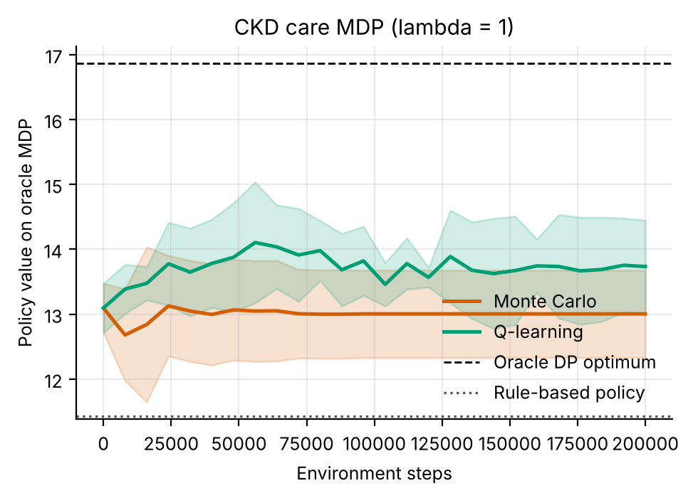
Figure 1. Learning curves on the oracle MDP (mean ± s.d. over 5 replicates). Dashed: oracle DP optimum; dotted: rule.
Figure 1 shows that both learners start near 13.1 on the oracle model, already above the rule's 11.4, and finish at 13.7 (Q-learning, last ten checkpoints) and 13.0 (MC), far below the oracle optimum (16.9). Little learning is visible in the curves: the start is above the rule because the initial greedy policy (we did not inspect it, but the curve at step 0 is its value) already scores well on this model, and the improvement afterwards is at most about 0.6 units. The learned policies differ from the rule in 25 (DP), 26 (MC) and 24 (Q-learning) of 120 states, and the oracle in 55; Q-learning agreed with DP in 91% of well-visited states and MC in 77% (Figure 2). The DP policy's model value minus its true value (optimism gap) was positive in 2 of 5 replicates, so on average the model is not systematically optimistic about the policy it picks, in contrast to its optimism about the oracle's.
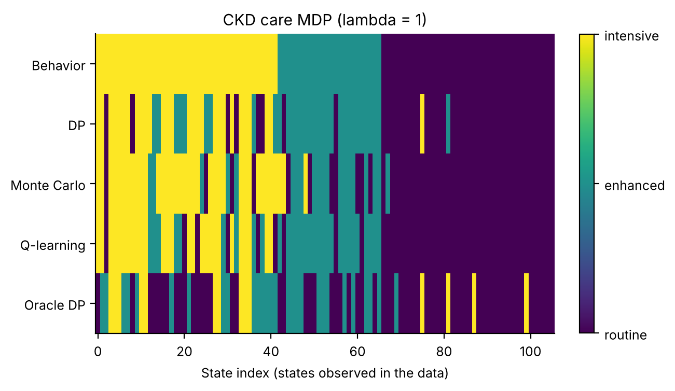
Figure 2. Action in each state observed in the data (routine, enhanced, intensive). The learned policies follow the structure of the behaviour policy and change many individual states; the oracle differs most.
Figure 2 shows that the learners keep the behaviour policy's coarse structure (intensive at low eGFR, routine at high eGFR) and change many individual cells. Because the cells are sorted by eGFR band, the striping reveals that the changes depend on proteinuria and previous action, as the state encodes, but also that many are isolated single cells, which look like noise from thin data. Over all 120 states the oracle policy uses routine care in 78, enhanced in 28 and intensive in 14, against 48, 24 and 48 for the rule: it gives much less intensive care than the rule, which is what a unit price on burden rewards, and it departs from the rule far more than the learners do (28 intensive states for DP).

7.2 The benefit-burden frontier
Table 4. Lagrangian DP frontier: true-simulator discounted benefit and burden and the kidney-failure fraction by burden price (10 replicates, 95% CI). The last column is the realised exchange rate between consecutive points.
Price λ | Benefit | Burden | Kidney failure | Benefit lost per burden saved vs previous λ
0 | 18.39 ± 0.15 | 6.23 ± 0.38 | 7.5% | -
0.25 | 17.83 ± 0.16 | 5.00 ± 0.35 | 10.2% | 0.45
0.5 | 17.47 ± 0.15 | 4.12 ± 0.25 | 11.5% | 0.42
1 | 16.52 ± 0.21 | 2.94 ± 0.22 | 16.3% | 0.80
2 | 15.15 ± 0.19 | 1.63 ± 0.12 | 22.7% | 1.05
4 | 13.77 ± 0.40 | 0.85 ± 0.11 | 28.8% | 1.77
8 | 12.52 ± 0.18 | 0.34 ± 0.07 | 34.2% | 2.45
16 | 12.14 ± 0.22 | 0.21 ± 0.07 | 35.8% | 2.80

Table 4 is the frontier. As the price rises from 0 to 16, burden falls from 6.23 to 0.21, benefit falls from 18.39 to 12.14, and the kidney-failure fraction rises from 7.5% to 35.8%; all three are strictly monotone in the price, as theory predicts. At the top price the policy is nearly the always-routine policy (benefit 11.72, burden 0.00, failure 38.5%). The exchange rate in the last column increases overall with the price (from 0.45 to 2.80), which is the signature of a concave frontier: the first units of burden saved are cheap in benefit and the last are expensive. Equation (4) requires each rate to lie between the two prices that bound it; it does for 3 of the 7 pairs, and fails for 0 to 0.25 (0.45, above the upper price), 2 to 4 (1.77, below the lower price), 4 to 8 (2.45, below the lower price), 8 to 16 (2.80, below the lower price). At the high-price end, where the realised rate falls short of the price, the learned policy at the higher price is not optimal for the lower price in the true simulator.
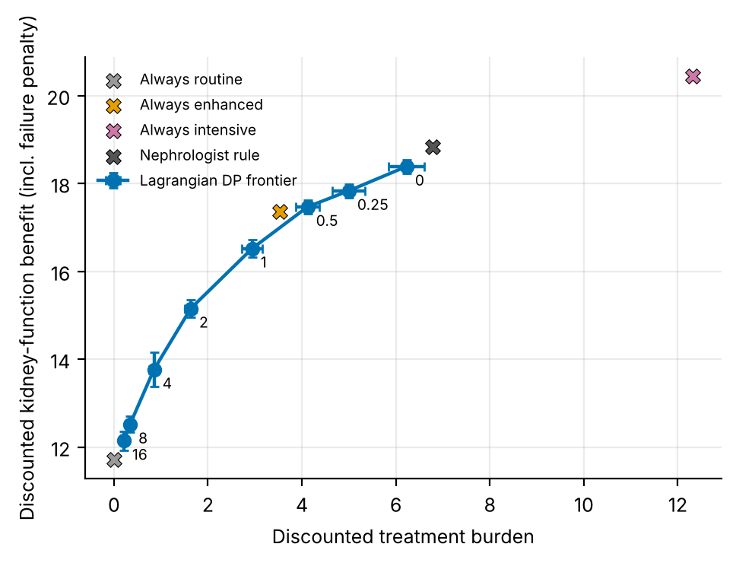
Figure 3. Benefit against burden: the Lagrangian DP frontier (points labelled by price; bars: 95% CI over 10 replicates) and the four reference policies.
Figure 3 puts the frontier next to the fixed policies. The 'always enhanced' policy sits above the frontier: it achieves benefit 17.36 at burden 3.53, whereas linear interpolation between learned points gives 16.99 at that burden, a shortfall of 0.37, larger than the frontier's own interval widths (0.15 to 0.21 at the neighbouring prices). The nephrologist-style rule lies beyond the right end of the frontier: it has burden 6.79 against 6.23 for the most benefit-seeking learned policy (λ = 0), and higher benefit (18.84 against 18.39) and a lower failure rate (3.5% against 7.5%). 'Always intensive' reaches benefit 20.45 at burden 12.31, far above anything the learner explores. In other words, the learned frontier is limited by the support of the logs: with λ = 0 a benefit-maximising planner would give intensive care everywhere, but it can do so only in states where the logs contain enough intensive visits, and those are the low-eGFR states where the rule already does it. That reading is a hypothesis about the mechanism, supported by the behaviour policy's structure (Figure 2) but not tested separately.
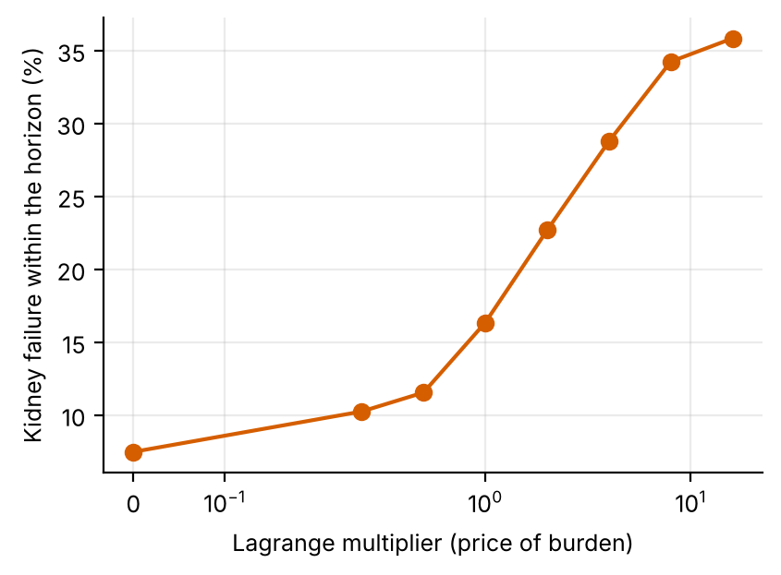
Figure 4. Simulated kidney-failure fraction against the burden price (symmetric-log axis).
Figure 4 shows the safety cost of pricing burden. The failure fraction rises slowly from 7.5% at λ = 0 to 11.5% at λ = 0.5, then steeply to 28.8% at λ = 4 and flattens near 35.8%, close to the always-routine rate (38.5%). A failure costs 20 benefit units, comparable to the whole discounted benefit of a surviving patient (Table 4), so this curve is the part of the frontier that a clinician would worry about: a price of 1 already multiplies the failure rate by 2.2 relative to λ = 0 (16.3% versus 7.5%), and the rule's 3.5% is below every learned point (the lowest is 7.5%).
Table 5. Price-consistency check from the sweep means: at each price λ, the true scalarised value (benefit − λ × burden) of the policy trained at λ, compared with the best policy among the eight trained.
Price λ | Best-trained price at this evaluation price | Value of the policy trained at λ | Value of the best policy | Shortfall
0 | 0 | 18.39 | 18.39 | 0.00
0.25 | 0 | 16.58 | 16.83 | 0.25
0.5 | 0.5 | 15.41 | 15.41 | 0.00
1 | 1 | 13.58 | 13.58 | 0.00
2 | 4 | 11.88 | 12.06 | 0.18
4 | 16 | 10.36 | 11.31 | 0.95
8 | 16 | 9.78 | 10.48 | 0.69
16 | 16 | 8.81 | 8.81 | 0.00

Table 5 tests whether the policy trained at a price is the best at that price in the true simulator. It is for 4 of 8 prices (λ = 0, 0.5, 1, 16), and not for the others. For λ = 2, 4, 8 the best policy is one trained at a higher price (λ = 4, 16, 16), by margins of up to 0.95. This is the same finding as the failure of Eq. (4) at the high end, seen from the other side: at high prices the learned policy underestimates how valuable it is to save burden or overestimates how much benefit it gives up, so it saves too little burden for its price. A different reading is that those policies are noisy (the estimated model is least reliable far from the logged behaviour). The data cannot separate the two.

7.3 Burden budgets and safety margins
Table 6. Burden-budget planning: price chosen by bisection, model-predicted and realised burden, number of replicates (of 10) whose realised burden exceeded the budget, benefit and failure fraction. An asterisk marks a mean realised burden above the budget with a t-based 95% interval that excludes it.
Budget | Margin | Mean price λ | Predicted burden | Realised burden | Realised / predicted | Exceed budget? | Benefit | Failure
2 | 0% | 1.05 | 1.91 | 2.65 ± 0.20 | 1.39 | 10/10 * | 16.33 | 17.5%
2 | 25% | 1.41 | 1.53 | 2.12 ± 0.12 | 1.39 | 8/10 | 15.80 | 19.9%
2 | 50% | 1.80 | 1.24 | 1.85 ± 0.13 | 1.49 | 3/10 | 15.47 | 21.3%
4 | 0% | 0.24 | 3.83 | 4.87 ± 0.18 | 1.27 | 10/10 * | 17.81 | 10.3%
4 | 25% | 0.51 | 2.97 | 3.99 ± 0.19 | 1.34 | 5/10 | 17.36 | 12.1%
4 | 50% | 0.71 | 2.54 | 3.46 ± 0.14 | 1.36 | 0/10 | 17.01 | 13.7%
6 | 0% | 0.00 | 4.91 | 6.23 ± 0.38 | 1.27 | 6/10 | 18.39 | 7.5%
6 | 25% | 0.07 | 4.57 | 5.81 ± 0.17 | 1.27 | 3/10 | 18.20 | 8.6%
6 | 50% | 0.24 | 3.83 | 4.87 ± 0.18 | 1.27 | 0/10 | 17.81 | 10.3%

Table 6 is the safety-margin result. With no margin the model-predicted burden is on target by construction (it is at or below the budget) but the realised burden is higher in every cell: the ratio of realised to predicted is 1.27 to 1.39 at m = 0 and 1.27 to 1.49 over all cells. Consequently the budget was exceeded in 10, 10 and 6 of 10 replicates for budgets of 2, 4 and 6. (For the budget of 6 and no margin the model's unconstrained policy already satisfies the budget, so the price is 0, and the realised burden still exceeds it in 6 of 10 replicates.) A 25% margin brought exceedances to 8, 5 and 3, and a 50% margin to 3, 0 and 0. The calibration rule of Eq. (6) predicts that a margin of at least ρ − 1, that is 39%, 27%, 27% for budgets 2, 4 and 6 (from the m = 0 row), is needed on average; this fits the counts, since 25% was insufficient and 50% was sufficient or nearly so for every budget.
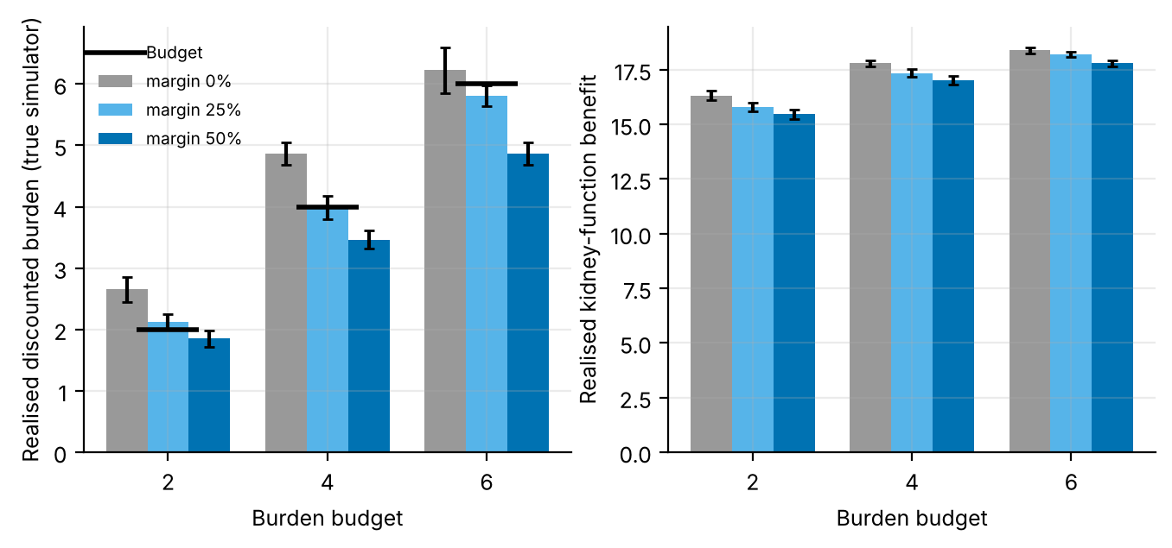
Figure 5. Realised burden (left; black bars: budget) and benefit (right) by budget and margin (10 replicates; 95% CI).
Figure 5 shows the same in the true-simulator units. The mean realised burden shrinks with the margin: at a 25% margin it is 2.12, 3.99 and 5.81 for budgets 2, 4 and 6, and at 50% it is 1.85, 3.46 and 4.87. A mean at or just under the budget still leaves many replicates above it, because replicates scatter around the mean (the error bars), which is why exceedances persist at 25%. The price of safety is visible on the right: a 50% margin instead of none costs 0.86, 0.79 and 0.58 units of benefit and raises the kidney-failure fraction by 3.8, 3.5 and 2.8 percentage points at budgets 2, 4 and 6. Looser budgets are cheaper to protect than tight ones, consistent with a concave frontier: the same proportional tightening removes a smaller slice of benefit where the frontier is flatter.
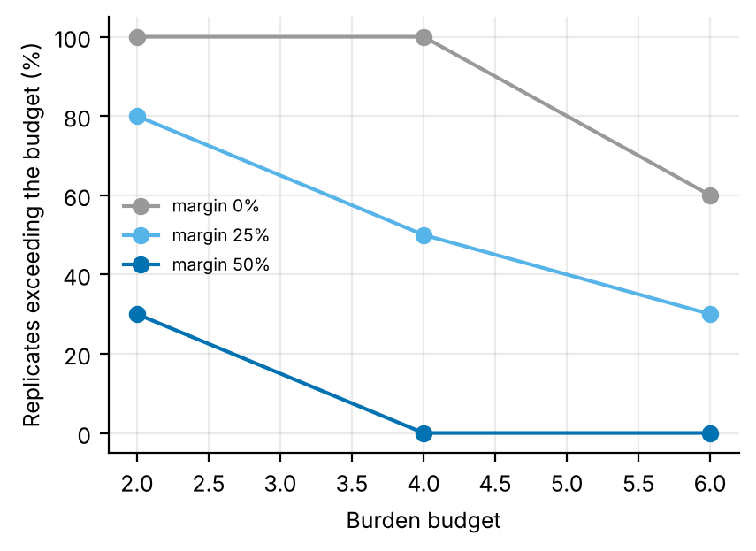
Figure 6. Share of replicates whose realised burden exceeded the budget, by budget and margin (10 replicates).
Figure 6 summarises the exceedance rates as percentages. With 10 replicates each point has a granularity of 10 percentage points and a wide binomial interval, so the figure should be read as monotone evidence (more margin, fewer violations) and not as a precise rate. Even with a 50% margin the budget of 2 was exceeded in 3 of 10 replicates, which a user who needs a hard guarantee would not accept; a distribution-free guarantee would require a conformal-style or hold-out calibration, which we did not do.

8. Discussion
What the study shows. Three findings are well supported. (1) A burden price traces a monotone, concave benefit-burden frontier whose failure cost rises steeply beyond a price of about 0.5 to 1 (Table 4, Figure 4). (2) Planning to a burden budget in the estimated model under-delivers: realised burden was 1.27 to 1.49 times the prediction in every cell, so a budget needs a margin. (3) The margin can be calibrated from the predicted-versus-realised ratio, and the required size (39%, 27%, 27%) matches the observed exceedance counts.
What it does not show. The learned policy is not clearly better than a trivial one. At unit price 'always enhanced' scored 13.83 against DP's 13.97 (benchmark) and 13.58 (sweep, price 1), with a rule-evaluation noise of 0.25 between 400 and 600 evaluation episodes; differences of that size cannot be resolved. Along the frontier, 'always enhanced' beats the learned points at its burden. The learned Lagrangian is therefore not an improvement on simple constant policies in this simulator, although it is the only one of these that can meet an arbitrary budget. The reason is likely that the logged data are too narrow to discover that intensive care is valuable outside the region where the rule already uses it (Figure 3); we did not test it by changing the behaviour policy.
Practical use. A deployment would report the frontier, the calibration ratio and the exceedance rates together, choose the margin from the ratio, and compare with the best constant policy before claiming a learned benefit. It would also check the price-consistency property (Table 5) as a diagnostic on the model; a failure at high prices is a sign that the model is unreliable there and that policies at those prices should not be trusted.

9. Limitations and threats to validity
- Linear scalarisation of failure. Kidney failure enters the benefit channel as a −20 term, so the 'benefit' conflates slowing decline and avoiding failure. A hard constraint on failure rate would be a different problem.
- Deterministic policies and approximate budgets. Randomised policies are needed to meet a budget exactly; we use bisection on deterministic policies and accept the discretisation gap.
- Margin by calibration on the same data. The ratio ρ is estimated in the same replicates in which exceedances are counted, so the agreement between the required margin and the counts is partly circular; no held-out calibration was done.
- Few replicates. Ten replicates give exceedance rates in steps of 10 percentage points; the benchmark uses 5 replicates and 1.96-standard-error intervals that are narrower than t-intervals by a factor of 1.42.
- Evaluation noise. The same rule is scored differently with 400 and 600 evaluation episodes; small differences between policies are not resolved.
- Simulated, not clinical, evidence. All numbers come from stylised simulators written for this study. They demonstrate how the algorithms behave when the ground truth is known; they say nothing about the safety or benefit of any treatment in people.
- State aggregation. Continuous physiology is discretised into bands. Banding makes the process only approximately Markov, and part of the gap between the DP policy on the estimated model and the true optimum is a modelling gap rather than a sampling gap.
- Fixed-horizon episodes treated as stationary. Episodes end after a fixed number of steps but the state does not always contain the clock, so the estimated model treats termination as a constant hazard. This distorts absolute model values (not true-simulator scores) and is why model-based value estimates are compared only on a common oracle model.
- Behaviour policy. The logged data come from a single ε-noisy rule. Coverage of non-rule actions is therefore thin, which is exactly the offline-RL situation, and results depend on that coverage.
- Hand-set hyper-parameters. ε schedules, step sizes and the support threshold were fixed in advance and not tuned per paper.

10. Ethical considerations and future work
Ethics. No human data were used, so no consent or privacy issues arise in this study. If the method were applied to real records, three safeguards would be essential: de-identification and governance approval of the source data; a clinician-in-the-loop design in which the learned policy is advisory, with hard guardrails on unsafe actions; and prospective, randomised or at least carefully monitored evaluation before any deployment. Reinforcement learning from logs inherits the biases of the clinicians who produced them, and may under-serve groups that are under-represented in the data; subgroup performance should be reported alongside averages.
Future work. (1) Compare the learned frontier with the best constant and randomised mixtures of constant policies at each burden; (2) widen the logged behaviour (more exploration at high eGFR) and test whether the frontier then overtakes 'always enhanced'; (3) calibrate the margin on held-out episodes and report a distribution-free guarantee; (4) solve the CMDP with randomised policies by linear programming and compare; (5) apply the adapter to a real CKD table, where burden would have to be defined from visit counts and costs.

11. Conclusion
On a simulated CKD cohort, Lagrangian dynamic programming traces a monotone benefit-burden frontier (burden 6.23 to 0.21; kidney-failure fraction 7.5% to 35.8%) and, at unit price, DP, Q-learning and MC all beat a nephrologist-style rule (13.97, 13.60, 13.15 versus 11.80). The gain is mostly available from a constant 'always enhanced' policy (13.83), which also lies above the learned frontier at its burden. Planning to a budget in the estimated model under-delivers by a factor of 1.27 to 1.49, and a safety margin sized from the predicted-to-realised ratio (about 27% to 39%) is needed to meet it, at a cost of 0.58 to 0.86 units of benefit for a 50% margin. These are simulator results, not clinical evidence.

Appendix A. Anticipated reviewer questions
The following questions are the ones a reviewer or examiner is most likely to raise. Each answer is tied to a number or figure produced by the code.
Q1. Is a learned policy that merely matches 'always enhanced' worth having?
Not on this evidence. At unit price the benchmark DP scored 13.97 and 'always enhanced' 13.83, within the evaluation noise of 0.25 that we measured on the rule, and at its burden the constant policy is above the learned frontier by 0.37. What the Lagrangian approach adds is the ability to meet a stated budget, which constant policies cannot do.
Q2. Why does the realised burden exceed the model's prediction?
The code shows a plausible mechanism: unsupported state-action pairs carry zero burden in the model and are absorbing, while in deployment the rule is used in unseen states and incurs burden. The measured ratio (Table 6) is evidence that the bias exists and is of order 27% to 49%; we did not isolate the mechanism by experiment.
Q3. Is a 50% margin the right choice?
It is the largest margin we tried. It removed exceedances at budgets 4 and 6 (0 and 0 of 10) but not at 2 (3 of 10), where the calibration ratio (1.39) is largest. The margin should be sized from ρ, per budget.
Q4. Why does the policy trained at a high price fail the consistency check?
Table 5 shows the policy trained at λ = 4 is beaten, at price 4, by the policy trained at 16 (shortfall 0.95). Either the model mis-prices burden saving at high prices or those policies are noisy; the results do not separate the explanations.
Q5. Can the results be used to choose a treatment intensity?
No. The simulator's dynamics, burden values and failure penalty are invented; the study is about how a Lagrangian planner behaves and how it should be protected against its own model error.

Appendix B. Reproducibility
All results in this paper are produced by `python ideas.py 6` (shared library: rl_core.py, domains.py, common.py). Random seeds are fixed in the code, so a re-run reproduces every table and figure. Figure files generated by the script: fig_bars, fig_learning, fig_policies, fig_agreement, fig_pareto, fig_failure, fig_budget, fig_violation. To repeat the study on a real Kaggle table, convert it with kaggle_adapter.transitions_from_dataframe, then call build_mdp, value_iteration, mc_control and q_learning exactly as the script does; because a real table has no simulator, report model-based estimates on a held-out split and label them as estimates.

Appendix C. Source code of the experiment
For completeness the exact source of the simulator and the experiment function is reproduced below; it is the same code that produced every number and figure in this paper (the shared solvers value_iteration, mc_control and q_learning are in rl_core.py and are delivered with the code package).

CKD
class CKD(Domain):
name = "ckd"
nA, gamma, max_steps = 3, 0.98, 60
info_keys = ["c1", "c2", "failure"]
chan = ["c1", "c2"]
GE = list(range(15, 88, 4))
RED = [0.0, 0.25, 0.5]
BUR = [0.0, 0.15, 0.5]
nS = (len(GE) + 1) * 2 * 3
action_labels = ["routine", "enhanced", "intensive"]

def _s(self):
return (band(self.egfr, self.GE) * 2 + self.prot) * 3 + self.last

def reset(self, rng):
self.egfr = float(rng.uniform(25, 85))
self.prot = int(rng.random() < 0.4)
self.last, self.t = 0, 0
return self._s()

def step(self, a, rng):
base = 0.45 if self.prot == 0 else 1.1
acc = 1.4 if self.egfr < 30 else 1.0
self.egfr = float(self.egfr - base * (1 - self.RED[a]) * acc + rng.normal(0, 0.6))
if self.prot == 1:
self.prot = int(not (rng.random() < 0.04 + 0.1 * a))
else:
self.prot = int(rng.random() < 0.05 - 0.015 * a)
self.last, self.t = a, self.t + 1
c1 = self.egfr / 60.0
c2 = self.BUR[a]
fail = self.egfr < 15
if fail: c1 -= 20.0
died = (not fail) and rng.random() < (0.015 + 0.01 * (self.egfr < 30)) # competing mortality
info = dict(c1=c1, c2=c2, failure=float(fail))
return self._s(), c1 - c2, fail or died or self.t >= self.max_steps, info, 1

def rule(self, s):
gb = s // 6
mid = 0.0 if gb == 0 else self.GE[gb - 1] + 2.0
if mid < 45: return 2
if mid < 60: return 1
return 0

ideas.idea6
def idea6():
I = 6; d = odir(I)
dom = CKD()
res = standard_benchmark(dom, n_eps=800, n_oracle=6000, steps=200000, seeds=5, n_eval=400)
standard_figs(res, dom, I, title="CKD care MDP (lambda = 1)")
rule = np.array([dom.rule(s) for s in range(dom.nS)])
LAMS = [0, 0.25, 0.5, 1, 2, 4, 8, 16]; SEEDS = 10
BUD = [2, 4, 6]; MARG = [0.0, 0.25, 0.5]
B = np.zeros((len(LAMS), SEEDS)); C = np.zeros_like(B); F = np.zeros_like(B)
shp = (len(MARG), len(BUD), SEEDS)
Bb, Cb, Pred, Fb, Lm = (np.zeros(shp) for _ in range(5))
for sd in range(SEEDS):
data = rollout(dom, dom.behavior, np.random.default_rng(300 + sd), 800)
m = build_mdp(data, dom)
R1, R2 = m.Rc["c1"], m.Rc["c2"]
for li, lam in enumerate(LAMS):
p, _, _ = value_iteration(m, R=R1 - lam * R2); p = fill_policy(p, m, rule)
r, inf = eval_policy(dom, p, n_eps=300)
B[li, sd] = inf["d_c1"].mean(); C[li, sd] = inf["d_c2"].mean(); F[li, sd] = inf["failure"].mean()

def burden(lam):
p, _, _ = value_iteration(m, R=R1 - lam * R2)
return float(m.mu @ policy_value(m, p, R2)), p

for mi_, marg in enumerate(MARG):
for bi, bud in enumerate(BUD):
target = bud / (1.0 + marg)
lo_, hi_ = 0.0, 64.0
if burden(0.0)[0] <= target: lam = 0.0
else:
for _ in range(25):
mid = 0.5 * (lo_ + hi_)
if burden(mid)[0] > target: lo_ = mid
else: hi_ = mid
lam = hi_
pred, p = burden(lam); p = fill_policy(p, m, rule)
r, inf = eval_policy(dom, p, n_eps=300)
Bb[mi_, bi, sd] = inf["d_c1"].mean(); Cb[mi_, bi, sd] = inf["d_c2"].mean()
Pred[mi_, bi, sd] = pred; Fb[mi_, bi, sd] = inf["failure"].mean(); Lm[mi_, bi, sd] = lam
print("idea6 seed", sd, flush=True)
fx = {}
for nm, p in (("Always routine", fixed_policy(dom, 0)), ("Always enhanced", fixed_policy(dom, 1)), ("Always intensive", fixed_policy(dom, 2)), ("Nephrologist rule", rule)):
r, inf = eval_policy(dom, p, n_eps=600)
fx[nm] = dict(benefit=float(inf["d_c1"].mean()), burden=float(inf["d_c2"].mean()), failure=float(inf["failure"].mean()))
fig, ax = plt.subplots(figsize=(5.4, 3.6))
ax.errorbar(C.mean(1), B.mean(1), xerr=[ci95(C[i]) for i in range(len(LAMS))], yerr=[ci95(B[i]) for i in range(len(LAMS))], marker="o", color="#0072B2", lw=1.6, capsize=2, label="Lagrangian DP frontier")
for i, l in enumerate(LAMS): ax.annotate(f"{l:g}", (C.mean(1)[i], B.mean(1)[i]), textcoords="offset points", xytext=(4, -9), fontsize=7)
for (nm, v), c in zip(fx.items(), ("#999999", "#E69F00", "#CC79A7", "#555555")):
ax.scatter(v["burden"], v["benefit"], color=c, s=50, marker="X", edgecolor="k", lw=0.4, label=nm)
ax.set_xlabel("Discounted treatment burden"); ax.set_ylabel("Discounted kidney-function benefit (incl. failure penalty)")
ax.legend(fontsize=7); fig.savefig(f"{d}/fig_pareto.png"); plt.close(fig)
fig, ax = plt.subplots(figsize=(4.6, 3.2))
ax.plot(LAMS, 100 * F.mean(1), marker="o", color="#D55E00"); ax.set_xscale("symlog", linthresh=0.25)
ax.set_xlabel("Lagrange multiplier (price of burden)"); ax.set_ylabel("Kidney failure within the horizon (%)")
fig.savefig(f"{d}/fig_failure.png"); plt.close(fig)
fig, axs = plt.subplots(1, 2, figsize=(8.0, 3.2))
x = np.arange(len(BUD)); w = 0.26
for mi_, (marg, c) in enumerate(zip(MARG, ("#999999", "#56B4E9", "#0072B2"))):
axs[0].bar(x + (mi_ - 1) * w, Cb[mi_].mean(1), w, yerr=[ci95(Cb[mi_, i]) for i in range(len(BUD))], color=c, capsize=2, label=f"margin {int(100 * marg)}%")
axs[1].bar(x + (mi_ - 1) * w, Bb[mi_].mean(1), w, yerr=[ci95(Bb[mi_, i]) for i in range(len(BUD))], color=c, capsize=2)
axs[0].plot(x, BUD, "k_", ms=26, mew=2, label="Budget")
for ax in axs: ax.set_xticks(x); ax.set_xticklabels(BUD); ax.set_xlabel("Burden budget")
axs[0].set_ylabel("Realised discounted burden (true simulator)"); axs[1].set_ylabel("Realised kidney-function benefit"); axs[0].legend(fontsize=7)
fig.savefig(f"{d}/fig_budget.png"); plt.close(fig)
viol = np.array([[float((Cb[mi_, bi] > BUD[bi] + 1e-9).mean()) for bi in range(len(BUD))] for mi_ in range(len(MARG))])
fig, ax = plt.subplots(figsize=(4.6, 3.2))
for mi_, (marg, c) in enumerate(zip(MARG, ("#999999", "#56B4E9", "#0072B2"))):
ax.plot(BUD, 100 * viol[mi_], marker="o", color=c, label=f"margin {int(100 * marg)}%")
ax.set_xlabel("Burden budget"); ax.set_ylabel("Replicates exceeding the budget (%)"); ax.legend(fontsize=7)
fig.savefig(f"{d}/fig_violation.png"); plt.close(fig)
out = dict(LAMS=LAMS, benefit=B.mean(1), burden=C.mean(1), failure=F.mean(1),
benefit_ci=[ci95(B[i]) for i in range(len(LAMS))], burden_ci=[ci95(C[i]) for i in range(len(LAMS))],
fixed=fx, BUD=BUD, MARG=MARG,
realised=Cb.mean(2), realised_ci=[[ci95(Cb[m_, b_]) for b_ in range(len(BUD))] for m_ in range(len(MARG))],
predicted=Pred.mean(2), benefit_b=Bb.mean(2), failure_b=Fb.mean(2), lam_b=Lm.mean(2), violation=viol,
standard=summarize(res))
save_json(I, "results", dict(out, extra=drop_models(res)))
return out

rl_core: shared solvers
def build_mdp(data, dom, weights=None, chan=None, min_n=10, term_prior=1.0):
"""Empirical (maximum-likelihood) MDP from logged transitions.
(s,a) pairs observed fewer than min_n times are completed pessimistically: they go
to the absorbing terminal state with the worst reward seen in the data."""
nS, nA = dom.nS, dom.nA
T = nS
w = np.ones(len(data["s"])) if weights is None else np.asarray(weights, float)
s, a = data["s"], data["a"]
s2 = np.where(data["done"] > 0, T, data["s2"])
N = np.zeros((nS + 1, nA, nS + 1))
np.add.at(N, (s, a, s2), w)
n = N.sum(2)
Rsum = np.zeros((nS + 1, nA))
np.add.at(Rsum, (s, a), w * data["r"])
Gsum = np.zeros((nS + 1, nA, nS + 1))
np.add.at(Gsum, (s, a, s2), w * dom.gamma ** data["dur"])
m = MDP()
m.nS, m.nA, m.gamma = nS, nA, dom.gamma
m.n = n
m.N = N
seen = n >= min_n # support constraint: thinly observed (s,a) are completed pessimistically
n_eff = n + term_prior # one pseudo-observation of absorption guards against 'immortal' loops
P = np.zeros_like(N)
P[seen] = N[seen] / n_eff[seen][:, None]
P[seen, T] += term_prior / n_eff[seen]
G = np.full_like(N, dom.gamma)
nz = N > 0
G[nz] = Gsum[nz] / N[nz]
R = np.zeros((nS + 1, nA))
R[seen] = Rsum[seen] / n_eff[seen]
rmin = float(data["r"].min())
m.rmin, m.rmax = rmin, float(data["r"].max())
P[~seen, T] = 1.0
R[~seen] = rmin
P[T, :, :] = 0.0
P[T, :, T] = 1.0
R[T, :] = 0.0
m.P, m.G, m.R = P, G, R
m.PG = P * G
# reward channels
m.Rc = {}
for c in (chan if chan is not None else dom.chan):
cs = np.zeros((nS + 1, nA))
np.add.at(cs, (s, a), w * data[c])
cr = np.zeros((nS + 1, nA))
cr[seen] = cs[seen] / n_eff[seen]
m.Rc[c] = cr
# start distribution = first state of every episode
first = data["t"] == 0
mu = np.bincount(data["s"][first], minlength=nS + 1).astype(float)
m.mu = mu / mu.sum()
m.visits = (n * seen).sum(1)[:nS]
m.seen = seen
m.Rsum = Rsum
return m

def value_iteration(m, R=None, mask=None, tol=1e-9, max_iter=20000, penalty=None):
R = m.R if R is None else R
if penalty is not None:
R = R - penalty
V = np.zeros(m.nS + 1)
for _ in range(max_iter):
Q = _q(m, V, R)
if mask is not None:
Q = np.where(mask, Q, -1e18)
Vn = Q.max(1)
Vn[m.nS] = 0.0
if np.abs(Vn - V).max() < tol:
V = Vn
break
V = Vn
Q = _q(m, V, R)
if mask is not None:
Q = np.where(mask, Q, -1e18)
pi = Q.argmax(1)[:m.nS]
return pi, V, Q

def q_learning(m, rng, steps, eps_fn=eps_exp, alpha0=1.0, alpha_min=0.02,
q0=0.0, mask=None, n_ckpt=25, max_len=200, ckpt_fn=None):
nS, nA = m.nS, m.nA
ckpt_fn = ckpt_fn or (lambda p: J(m, p))
Q = np.full((nS + 1, nA), q0)
Q[nS] = 0.0
cnt = np.zeros((nS + 1, nA))
smp = Sampler(m, rng)
ck = np.unique(np.linspace(0, steps, n_ckpt + 1).astype(int))
curve = []
s, ep_t = smp.start(), 0
ci = 0
for k in range(steps + 1):
if ci < len(ck) and k == ck[ci]:
pi = np.array([_greedy(Q, x, mask) for x in range(nS)])
curve.append((k, ckpt_fn(pi)))
ci += 1
if k == steps:
break
if rng.random() < eps_fn(k, steps):
a = _explore(rng, s, nA, mask)
else:
a = _greedy(Q, s, mask)
s2, r, g = smp.step(s, a)
tgt = r + (0.0 if s2 == nS else g * Q[s2].max() if mask is None
else g * np.where(mask[s2], Q[s2], -1e18).max())
cnt[s, a] += 1
al = max(alpha_min, alpha0 / (1.0 + cnt[s, a] ** 0.7))
Q[s, a] += al * (tgt - Q[s, a])
ep_t += 1
if s2 == nS or ep_t >= max_len:
s, ep_t = smp.start(), 0
else:
s = s2
pi = np.array([_greedy(Q, x, mask) for x in range(nS)])
return pi, Q, np.array(curve)

def mc_control(m, rng, steps, eps_fn=eps_exp, q0=0.0, mask=None, n_ckpt=25,
max_len=200, ckpt_fn=None):
"""first-visit Monte Carlo control with epsilon-soft behaviour policy and
incremental-average updates."""
nS, nA = m.nS, m.nA
ckpt_fn = ckpt_fn or (lambda p: J(m, p))
Q = np.full((nS + 1, nA), q0)
Q[nS] = 0.0
N = np.zeros((nS + 1, nA))
smp = Sampler(m, rng)
ck = np.unique(np.linspace(0, steps, n_ckpt + 1).astype(int))
curve = []
used, ci = 0, 0
while True:
while ci < len(ck) and used >= ck[ci]:
pi = np.array([_greedy(Q, x, mask) for x in range(nS)])
curve.append((ck[ci], ckpt_fn(pi)))
ci += 1
if used >= steps:
break
s = smp.start()
traj = []
for _ in range(max_len):
if rng.random() < eps_fn(used + len(traj), steps):
a = _explore(rng, s, nA, mask)
else:
a = _greedy(Q, s, mask)
s2, r, g = smp.step(s, a)
traj.append((s, a, r, g))
s = s2
if s2 == nS:
break
used += len(traj)
# returns, backwards; first-visit
Gret = 0.0
rets = []
for (s_, a_, r_, g_) in reversed(traj):
Gret = r_ + g_ * Gret
rets.append(Gret)
rets.reverse()
seen = set()
for (s_, a_, _, _), G_ in zip(traj, rets):
if (s_, a_) in seen:
continue
seen.add((s_, a_))
N[s_, a_] += 1
Q[s_, a_] += (G_ - Q[s_, a_]) / N[s_, a_]
pi = np.array([_greedy(Q, x, mask) for x in range(nS)])
return pi, Q, np.array(curve)

References
[1] KDIGO CKD Work Group. KDIGO 2012 clinical practice guideline for the evaluation and management of chronic kidney disease. Kidney International Supplements 3(1):1-150, 2013.
[2] Whelton, P. K. et al. 2017 ACC/AHA guideline for the prevention, detection, evaluation, and management of high blood pressure in adults. Hypertension 71(6):e13-e115, 2018.
[3] Altman, E. Constrained Markov Decision Processes. Chapman and Hall/CRC, 1999.
[4] Garcia, J. and Fernandez, F. A comprehensive survey on safe reinforcement learning. Journal of Machine Learning Research 16:1437-1480, 2015.
[5] Alshiekh, M., Bloem, R., Ehlers, R., Konighofer, B., Niekum, S. and Topcu, U. Safe reinforcement learning via shielding. Proceedings of the AAAI Conference on Artificial Intelligence, 2018.
[6] Levine, S., Kumar, A., Tucker, G. and Fu, J. Offline reinforcement learning: tutorial, review, and perspectives on open problems. arXiv:2005.01643, 2020.
[7] Jin, Y., Yang, Z. and Wang, Z. Is pessimism provably efficient for offline RL? Proceedings of the 38th International Conference on Machine Learning (ICML), 2021.
[8] Kumar, A., Zhou, A., Tucker, G. and Levine, S. Conservative Q-learning for offline reinforcement learning. Advances in Neural Information Processing Systems 33, 2020.
[9] Sutton, R. S. and Barto, A. G. Reinforcement Learning: An Introduction, 2nd ed. MIT Press, 2018.
[10] Bellman, R. Dynamic Programming. Princeton University Press, 1957.
[11] Puterman, M. L. Markov Decision Processes: Discrete Stochastic Dynamic Programming. Wiley, 1994.
[12] Singh, S. P. and Sutton, R. S. Reinforcement learning with replacing eligibility traces. Machine Learning 22:123-158, 1996.
[13] Watkins, C. J. C. H. and Dayan, P. Q-learning. Machine Learning 8(3-4):279-292, 1992.

