Surge-Aware Replanning for Hospital Capacity Control: Recency-Weighted Dynamic Programming and the Adaptation-Regret Frontier
[Author names] | [Department, Institution] | [Corresponding e-mail]
Abstract. Hospital capacity decisions - admit, accelerate discharge, or divert - are sequential, uncertain and non-stationary: a policy tuned on last year's admissions can fail when demand surges. We study how a policy learned from logged data should be updated when only a few weeks of post-surge data exist. We model the daily decision as a Markov decision process, estimate it from logs, and compare dynamic programming (DP), first-visit Monte Carlo control and Q-learning, and we propose recency-weighted replanning: DP on a model whose counts from the new regime are up-weighted by a factor omega. A short precision-weighting argument gives a closed-form guide, omega* = 1 + N_old Δ² / σ². On a stylised hospital simulator mirroring a Kaggle length-of-stay table (the Kaggle site was unreachable, so no real file was used), learning does not beat a good occupancy rule under baseline demand: DP matches it (DP 99.5 vs rule 100.5), while Q-learning (96.3) and Monte Carlo (86.4) fall below it. Under a 30% demand surge, the baseline-trained policy collapses to -9.9 while a surge-trained oracle reaches 28.3. With 20 surge episodes, recency-weighted replanning recovers -1.8 (+8.1, p = 0.007, uncorrected, 6 replicates), still far below the oracle, whereas training on the surge data alone does not help (-11.4, nominally worse than not adapting, not significant). The price is a measurable regret under the original demand (4.3 points at 80 surge episodes). The results are a method study on simulated data, not clinical evidence.
Keywords: hospital capacity; Markov decision process; dynamic programming; Monte Carlo control; Q-learning; non-stationarity; replanning

1. Introduction
A hospital manager makes a capacity decision every morning. Beds are occupied, a queue of patients waits for admission, and today's arrivals are uncertain. The manager may admit everyone the unit can hold, accelerate some discharges to free beds, or divert incoming ambulances to a neighbouring hospital. Each choice changes tomorrow's occupancy and queue, so the problem is sequential. It is also non-stationary: respiratory seasons, epidemics, holidays and local events change arrival rates from one month to the next. A policy that is excellent in a stable regime can be badly mismatched in the next one, and the data that would re-tune it - post-change days - are scarce precisely when they matter most.
Markov decision processes (MDPs) are the natural language for such decisions [1,2], and reinforcement learning has been applied to many clinical and operational problems [3,4]. Hospitals, however, do not experiment; they log the consequences of their existing practice. This is the offline setting, in which a model or value function is learned from data generated by a different (behaviour) policy and in which distribution shift is the central difficulty [5]. Three questions follow. First, if one estimates an MDP from logged operations, how much does planning on it - by dynamic programming (DP) - or learning on it - by Monte Carlo (MC) control or Q-learning - actually improve on a sensible occupancy rule? Second, what happens when demand shifts after deployment? Third, given only a few post-shift weeks, how should old and new data be combined?
Contributions. (i) We formulate daily capacity control as a 490-state, 3-action MDP and benchmark DP, MC and Q-learning on it with exact, simulator-based scoring. (ii) We propose recency-weighted replanning: weighted maximum-likelihood counts followed by DP, a one-parameter family that interpolates between 'ignore the new data' and 'use only the new data'. (iii) We give a precision-weighting argument that yields a closed-form guide omega* = 1 + N_old Δ² / σ² for the weight. (iv) We map the adaptation-regret frontier: how much return is gained under the surge versus lost if demand returns to normal. (v) We report honest negative results: at baseline demand learning does not beat a good rule, MC is unstable, and re-estimating from the few surge episodes alone does not beat doing nothing (it is nominally worse, but the difference is not significant), and even the best adaptation recovers only a minority of the gap to a surge-trained oracle.
Scope and honesty. The Kaggle site could not be reached from the build environment, so the 'dataset' is a transparent hospital simulator whose recorded variables (admissions, occupancy, queue, discharges) mirror those of public length-of-stay tables. All claims concern the behaviour of the algorithms, not any real hospital.

2. Related work
Healthcare operations as MDPs. Dynamic programming has long been used for sequential decisions in health care, from treatment timing to resource allocation [1,6]. Appointment and capacity problems in particular are classical applications of stochastic optimisation [7]. Our contribution is not a new operations model but a study of what happens when such a model must be learned from logs and then re-learned after a regime change.
Reinforcement learning in health. Surveys document the growth of RL in clinical decision support and its pitfalls, notably evaluation without a simulator and distribution shift [3,4]. Landmark applications such as sepsis treatment policies [8] illustrate how a tabular MDP estimated from records can yield interpretable policies; they also illustrate why careful off-policy evaluation matters. Here the simulator supplies exact evaluation, which isolates algorithmic behaviour from evaluation error.
Offline RL and pessimism. When data are logged by another policy, value estimates for poorly covered actions are unreliable and are routinely exploited by the optimiser. Remedies include constraining the policy to the data's support [9] and penalising uncertain values [10,11]. We use the simplest member of this family, a count threshold, and show that it interacts decisively with adaptation: thin new-regime data fall below the threshold.
Adapting to change. Combining a large old sample with a small new sample is an instance of precision weighting, the same logic that underlies shrinkage estimators [12]. We make it explicit for the transition counts of an MDP and test it against exact ground truth.

3. Preliminaries: Markov decision processes and the three solution families
A finite Markov decision process (MDP) is a tuple (S, A, P, R, γ) with a finite state set S, a finite action set A, a transition kernel P(s' | s, a), an expected reward R(s, a) and a discount factor γ in [0, 1). A deterministic policy π maps each state to an action. Its value V^π(s) is the expected discounted return obtained by starting in s and following π; the optimal value V*(s) satisfies the Bellman optimality equation [1,2,13]
V*(s) = max_a [ R(s,a) + γ Σ_{s'} P(s'|s,a) V*(s') ] (1)
Dynamic programming (DP). When P and R are known, V* is the unique fixed point of the contraction in Eq. (1). Value iteration repeatedly applies the right-hand side until the sup-norm change is below a tolerance; policy iteration alternates exact policy evaluation (solving the linear system (I − γP_π)V = R_π) with greedy improvement and terminates in a finite number of steps. We implement both and verify on every run that they return policies of identical value, which acts as a built-in correctness test of the solver.
Monte Carlo (MC) control. Without a model, MC control estimates the action-value Q(s,a) as the average return observed after first visits to (s,a) within complete episodes, and improves an ε-soft policy that is greedy with respect to Q [2,14]. It makes no bootstrapping assumption, so it is unbiased but has high variance and must wait until an episode ends before learning anything.
Q-learning. Tabular Q-learning is a model-free temporal-difference method that bootstraps from its own estimates [15]:
Q(s,a) ← Q(s,a) + α [ r + γ max_{a'} Q(s',a') − Q(s,a) ] (2)
It converges to Q* if every (s,a) is visited infinitely often and the step sizes satisfy the usual stochastic-approximation conditions. In practice the speed at which it spreads reward information backwards is its main advantage over MC, and its bias from bootstrapping off noisy estimates is its main weakness.
Empirical MDPs from logged data. Clinical data are logged, not simulated: we observe transitions (s, a, r, s') generated by clinicians. Counts N(s,a,s') give the maximum-likelihood model P̂(s'|s,a) = N(s,a,s')/N(s,a) and R̂(s,a) as the mean observed reward. Solving the MDP (P̂, R̂) by DP gives a plug-in policy; MC and Q-learning can be run against samples drawn from (P̂, R̂), which is how "learning from experience" is realised without touching patients. Two safeguards are used throughout because plug-in planning is notoriously exploited by estimation error [5,10,11]: (i) a support constraint: a pair (s,a) observed fewer than 10 times is completed pessimistically (it transitions to an absorbing terminal state with the worst reward in the data), and (ii) a terminal pseudo-count: one pseudo-observation of absorption is added to every supported pair so that no state is estimated to be immortal.

4. Problem formulation: daily capacity control
The simulator represents a 40-bed unit. Each day the following happens in order: arrivals are drawn from a Poisson distribution whose mean depends on the weekday (9.5, 9.0, 8.5, 8.5, 9.0, 7.0, 6.5 patients, Monday to Sunday) multiplied by a demand factor; if the action is *divert*, half of the arrivals are sent elsewhere; the rest join a queue (capped at 15, with overflow lost); patients are admitted while beds are free; and each occupied bed is vacated with probability 0.20 (0.28 under *early-discharge*). The decision maker observes only a coarse summary.
Table 1. The capacity-control MDP.
Element | Definition
State (490) | weekday (7) × occupancy bucket, 3 beds wide (14) × queue band {0, 1-2, 3-5, 6-9, 10+} (5)
Actions (3) | admit; early-discharge (accelerate discharges); divert (turn away about half of arrivals)
Reward | +1 per admission − 0.3 per queued patient − 5 per overflow − 2 per diverted patient − 1.6 per excess early discharge
Discount, horizon | γ = 0.97; episodes of 28 days
Behaviour policy | occupancy rule (divert if ≥35 beds and queue ≥3; early-discharge if ≥30 beds; otherwise admit), randomised with ε = 0.25
Dataset mirrored | Hospital length-of-stay / healthcare-analytics tables on Kaggle (admissions, occupancy, stay length)

The reward encodes the usual tension. Admitting patients earns throughput; keeping them waiting, losing them to overflow or sending them away costs; and pushing patients out early frees beds but is penalised because it raises the risk of bounce-backs. Because the occupancy rule is hand-built and sensible, there is limited room for improvement at baseline demand, which makes the question of what learning adds a fair one rather than a foregone conclusion.

5. Method: recency-weighted replanning
Let D_old be the logged transitions from the baseline regime (here 800 episodes, 22,400 days) and D_new the transitions observed after the surge. For a weight ω ≥ 0 the weighted counts and mean rewards are
N_ω(s,a,s') = N_old(s,a,s') + ω N_new(s,a,s'), R̂_ω(s,a) = [ Σ_old r + ω Σ_new r ] / [ N_old(s,a) + ω N_new(s,a) ] (3)
and the replanned policy is obtained by DP on (P̂_ω, R̂_ω), with the support constraint applied to the weighted count. ω = 0 ignores the new data (the *static* policy), ω = 1 pools the data naively, and ω → ∞ approaches estimation from the new data alone. No parameters of any network are retrained, which makes the procedure cheap enough to rerun every day.

5.1 A precision-weighting guide for ω
Consider a single transition probability. Under the old regime its true value is p_o, under the new regime p_n = p_o + Δ, and a Bernoulli observation has variance σ² (at most 1/4). The pooled estimator is p̂ = q p̂_o + (1 − q) p̂_n with q = N_old / (N_old + ω N_new). Relative to the *new* regime its bias is −qΔ and its variance is approximately q² σ²/N_old + (1 − q)² σ²/N_new, so
MSE(q) = q² Δ² + q² σ²/N_old + (1 − q)² σ²/N_new. (4)
Setting the derivative to zero gives q* = (σ²/N_new) / (Δ² + σ²/N_old + σ²/N_new), and converting q* back to a weight yields
ω* = 1 + N_old Δ² / σ². (5)
Two features deserve emphasis. The weight grows with the amount of old data: the more evidence the old regime carries, the harder the new data must be up-weighted to overrule it. It also grows with the squared size of the shift. If nothing has changed (Δ = 0) the guide returns ω* = 1, i.e. plain pooling. In practice Δ is unknown and differs across state-action pairs, so ω is treated as a single tunable constant and Eq. (5) is used only to indicate its order of magnitude: with, say, N_old = 50 observations of a state-action pair, σ² = 0.25 and a 10-point shift, ω* ≈ 3; with 200 observations ω* ≈ 9.
Algorithm 1 Recency-weighted replanning
input: old logs D_old, new logs D_new, weight omega, support threshold n_min
1: for each logged transition (s,a,r,s') with weight w = 1 (old) or omega (new):
2: N[s,a,s'] += w ; Rsum[s,a] += w * r
3: n[s,a] = sum_s' N[s,a,s']
4: for (s,a) with n[s,a] >= n_min: P[s,a,.] = (N[s,a,.] + pseudo-absorption) / (n[s,a] + 1); R[s,a] = Rsum / (n+1)
5: for (s,a) with n[s,a] < n_min: complete pessimistically (absorb with worst observed reward)
6: pi <- value_iteration(P, R, gamma); in unsupported states use the clinician's modal action
7: return pi

6. Experimental protocol

6.1 Simulators that mirror the named Kaggle datasets
Important disclosure. The Kaggle website could not be reached from the environment in which this study was built (all requests returned HTTP 403), so no Kaggle file was downloaded. Instead every experiment is run on a transparent, hand-specified stochastic simulator whose recorded variables mirror the columns of the dataset named in the paper. The simulator plays two roles: it generates a logged dataset by running an ε-noisy clinician-like behaviour policy (the stand-in for the Kaggle table), and it is the ground truth against which every learned policy is scored. Using a simulator is a methodological choice with a real benefit (true policy value is measurable, which is impossible with a static table) and a real cost (the numbers are not clinical evidence). The accompanying code includes a data adapter that converts a real Kaggle CSV into the same transition format so that the identical pipeline can be re-run on the real file; the results below should be read as a method study, not as a finding about patients.

6.2 Data, solvers and scoring
Table 2. Experimental configuration.
Item | Setting
Simulator | 40-bed unit, Poisson arrivals with weekday profile, 28-day episodes
States / actions | 490 / 3 (weekday × occupancy bucket × queue band)
Logged baseline data | 800 episodes (22,400 transitions) from the ε-noisy occupancy rule
Oracle model | 6,000 baseline episodes (for exact learning-curve scoring)
Stage 1 (baseline) | 5 replicates; 300 evaluation episodes per policy
Stage 2 (surge) | demand × 1.3; 0, 5, 10, 20, 40, 80 surge episodes from the same behaviour rule; 6 replicates; 200 evaluation episodes
Stage 3 (ω sweep) | ω in {1, 3, 10, 30, 100}; 10, 20, 40 surge episodes; both regimes scored
Surge-trained oracle | DP on 6,000 surge episodes

- Learners. MC control and Q-learning each receive 150,000 environment steps drawn from the estimated MDP, with an exponentially decaying ε-greedy schedule (ε from 1.0 to about 0.05) and a visit-count step size α = max(0.02, 1/(1 + n^0.7)) for Q-learning.
- Replicates. 5 independent data draws (each with its own logged dataset and learner seeds). Intervals are 95% t-style intervals over replicates; paired differences are tested with a one-sample t-test on the per-replicate differences.
- Scoring. Each final policy is run for 300 episodes in the true simulator using common random numbers (episode e of every policy starts from the same random stream), and the mean discounted return is recorded. Learning curves are scored exactly on a large 'oracle' MDP estimated from ten or more times as much logged data.
- Fallback. In states never observed in the (supported) data a learned policy defers to the clinician's modal logged action, so that unsupported states cannot be exploited.
Four replanning variants are compared in Stage 2: Static (baseline data only), Pooled, equal weight (ω = 1), Pooled, recency ×10 (ω = 10) and Surge data only (ω → ∞ with the baseline data removed).

7. Results

7.1 Baseline demand: learning does not beat a good rule
Table 3. Baseline demand. Discounted return over a 28-day episode and mean episode counts (5 replicates; true simulator).
Method | Return (mean ± 95% CI) | Admitted | Overflow | Diverted | Early d/c
Clinician behaviour (modal logged action) | 100.41 ± 0.10 | 229.01 | 4.02 | 0.96 | 30.97
Guideline rule | 100.51 ± 0.00 | 229.01 | 3.99 | 0.99 | 31.02
DP on estimated MDP | 99.49 ± 0.87 | 228.50 | 3.97 | 1.49 | 31.09
Monte Carlo control | 86.41 ± 3.48 | 220.29 | 3.06 | 10.67 | 30.57
Q-learning | 96.26 ± 2.08 | 226.96 | 3.63 | 3.47 | 32.13
Oracle DP (7.5x data) | 99.81 ± 0.00 | 226.31 | 3.93 | 3.69 | 25.99

Table 3 shows that planning on the estimated MDP essentially reproduces the occupancy rule: DP scores 99.5 ± 0.9 against 100.5 for the rule, and even the oracle DP (7.5 times more data) scores 99.8. This is not a failure of the solver - the DP and policy-iteration solutions agreed in every replicate - but a property of the problem: the rule was written by someone who understood it, so a policy that is optimal for the estimated, state-aggregated model has little left to find. Q-learning is below the rule (96.3 ± 2.1). Monte Carlo is clearly worse (86.4 ± 3.5); its policies divert about 10.7 patients per episode against 1.0 for the rule, presumably because diversion has a high-variance, rarely-observed outcome that the episode-level returns estimate noisily.
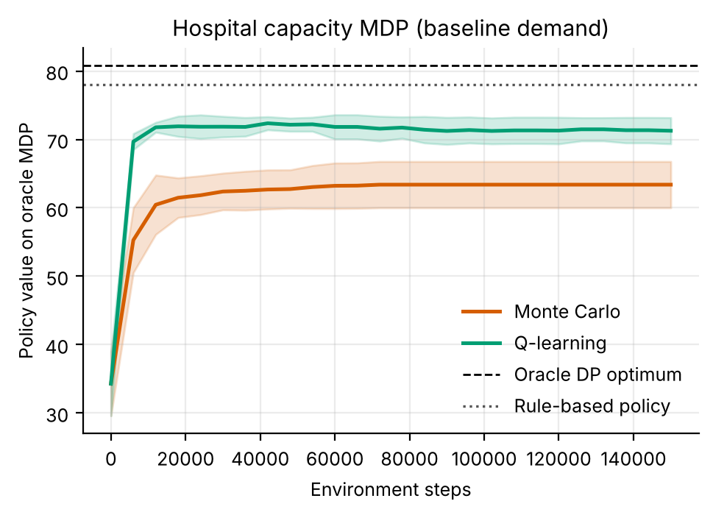
Figure 1. Learning curves on the oracle MDP (mean ± s.d. over 5 replicates). Q-learning rises within about 10,000 steps and plateaus below the DP optimum (dashed); Monte Carlo plateaus lower and wider.
Figure 1 explains the ranking. Q-learning's bootstrapping spreads reward information through the 490-state chain quickly; MC must wait for entire 28-day episodes and averages a long, noisy return into every update, so its plateau is both lower and more variable between replicates. Neither method reaches the DP optimum on the oracle MDP (Q-learning plateaus near 72 and Monte Carlo near 63, against 81 for the oracle DP and 78 for the rule); both learn from the same finite log that DP uses, and here the price of not solving the model exactly is not small. Averaged over replicates, Q-learning agreed with the DP policy in 96% of well-visited states and Monte Carlo in 87%.
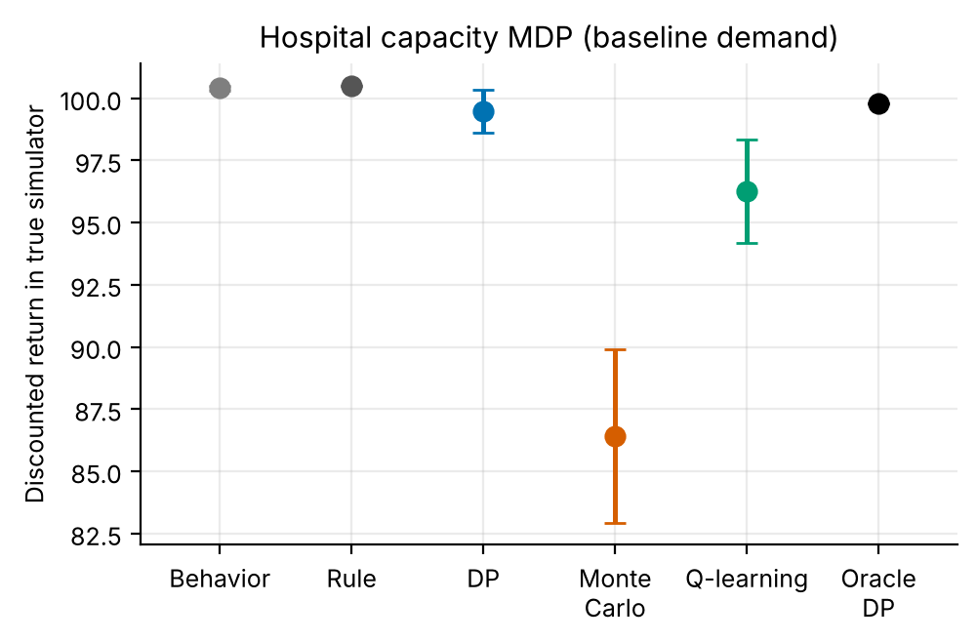
Figure 2. True-simulator return by method under baseline demand (error bars: 95% CI over replicates).
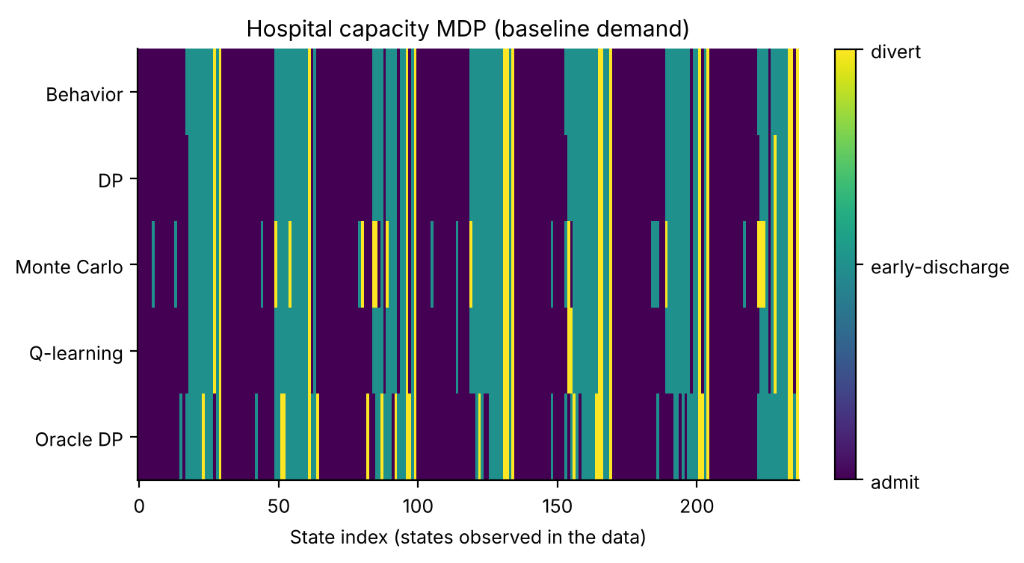
Figure 3. Action chosen by each method in every state observed in the oracle data (colours: admit / early-discharge / divert). The learned policies DP and Q-learning largely reproduce the behaviour rule; Monte Carlo and the oracle DP deviate in scattered states, Monte Carlo including many low-occupancy ones.

7.2 Demand surge: every baseline-trained policy fails
We now raise arrivals by 30% without changing anything else. Table 4 (below) shows that a policy trained on baseline data - or the occupancy rule itself - collapses: the static policy's return falls from 98.5 (baseline) to -9.9 ± 1.4 under surge, and the rule scores -10.5. A policy trained on an abundance of surge data (6,000 episodes) obtains 28.3. The gap of about 38 points is the value of knowing the regime; it is also an upper bound on what any adaptation scheme can recover from a few weeks of data.
Table 4. Return under the +30% surge, by replanning variant and number of surge episodes available (mean ± 95% CI, 6 replicates). Surge-trained oracle: 28.3; occupancy rule: -10.5.
Surge episodes | 0 | 5 | 10 | 20 | 40 | 80
Static (baseline only) | -9.9 ± 1.4 | -9.9 ± 1.4 | -9.9 ± 1.4 | -9.9 ± 1.4 | -9.9 ± 1.4 | -9.9 ± 1.4
Pooled, equal weight | -9.9 ± 1.4 | -9.9 ± 1.8 | -9.5 ± 2.1 | -9.4 ± 1.8 | -6.5 ± 1.3 | -2.9 ± 1.4
Pooled, recency x10 | -9.9 ± 1.4 | -6.5 ± 3.0 | -6.4 ± 3.8 | -1.8 ± 4.6 | -0.1 ± 4.4 | 3.8 ± 4.9
Surge data only | -9.9 ± 1.4 | -11.4 ± 0.0 | -11.4 ± 0.0 | -11.4 ± 0.0 | -12.0 ± 0.7 | -12.7 ± 1.4

7.3 Adaptation: how much surge data, and how to use it
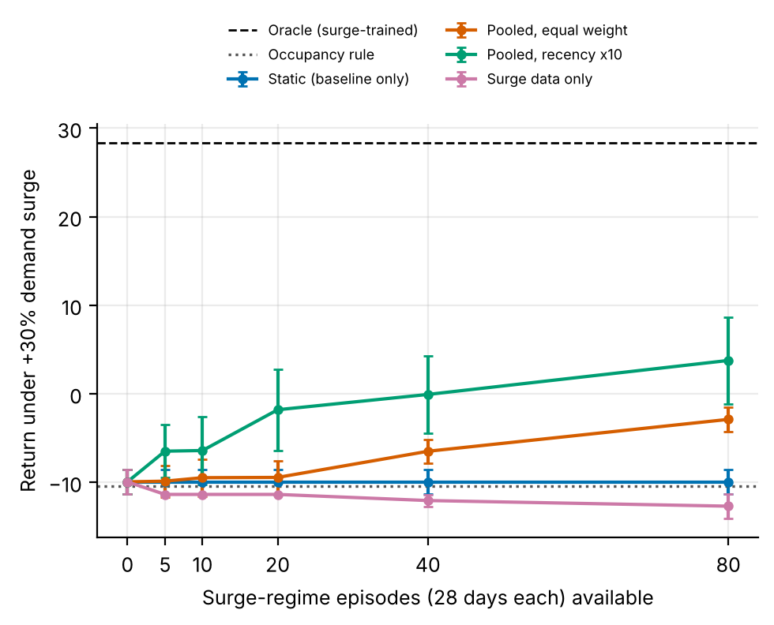
Figure 4. Return under surge as surge episodes accumulate. Recency-weighted pooling (ω = 10) improves with more data, though noisily; equal-weight pooling needs many more episodes; using surge data alone does not help (nominally below the static policy). Error bars: 95% CI over 6 replicates.
Figure 4 is the central result. Four observations follow. (1) Recency weighting works. With ω = 10 the return improves from -9.9 to -6.5 after only 5 surge episodes (140 days) and to -1.8 after 20; at 20 episodes the improvement over the static policy is 8.1 ± 3.6 (p = 0.007, paired over replicates). At 80 episodes it reaches 3.8, although the confidence interval (± 4.9) is wide. (2) Equal-weight pooling is slow. The 800 baseline episodes swamp the new data; with ω = 1 nothing changes until 40 episodes (-6.5) and the return is still -2.9 at 80. (3) Surge data alone does not help. With ω → ∞ and the old data removed, the return is -11.4 at 5 episodes and -12.7 at 80, nominally below the static policy (-9.9); the paired difference at 20 episodes is -1.4 ± 1.4 (p = 0.106), so we cannot call it harmful, only not helpful. At 5 episodes the recency-weighted variant beats it by 4.9 ± 3.0 (p = 0.024). The surge-only return is identical across replicates at 5, 10 and 20 episodes (zero spread), which suggests that the support threshold leaves almost all of the 1,470 state-action pairs unsupported so that the policy falls back to the clinician rule (we did not verify this directly); its baseline return is also not reduced (99.3), consistent with that reading. (4) The remaining gap is large. Even at 80 episodes, adaptation recovers only about 36% of the 38-point gap to the oracle (and about 21% at 20 episodes); the oracle used 75 times more surge data.
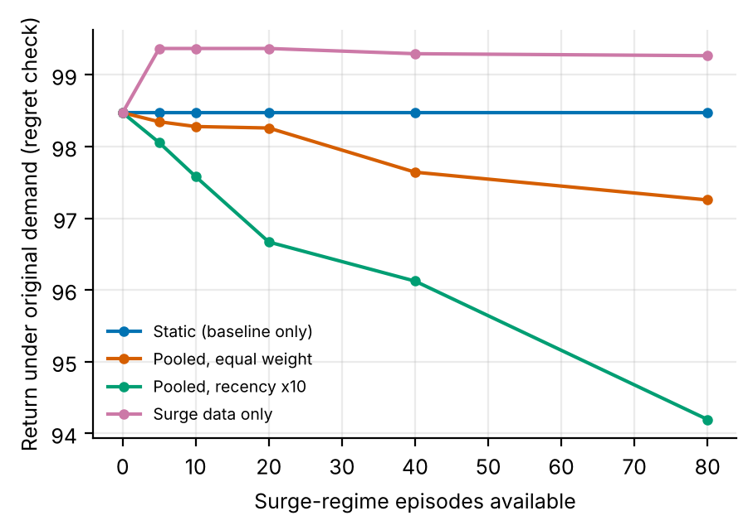
Figure 5. Regret check: return under the original demand for the same policies. Recency-weighted replanning gives up some baseline performance as it forgets the old regime.
Figure 5 shows the price of adapting. If demand returns to normal, the recency-weighted policy built from 80 surge episodes scores 94.2 instead of 98.5, a regret of 4.3. Equal-weight pooling loses less (97.3), which is the mirror image of its slower adaptation, and surge-only replanning loses nothing here. The regret curves have no error bars (means of 6 replicates). The two figures together define a frontier: more weight on new data buys return under the surge and costs return in the old regime.

7.4 The adaptation-regret frontier
Table 5. Recency-weight sweep: return under surge / return under baseline demand (6 replicates).
ω | 10 episodes: surge / baseline | 20 episodes: surge / baseline | 40 episodes: surge / baseline
1 | -9.5 / 98.3 | -9.4 / 98.3 | -6.5 / 97.6
3 | -9.3 / 97.8 | -6.8 / 97.9 | -0.4 / 96.8
10 | -6.4 / 97.6 | -1.8 / 96.7 | -0.1 / 96.1
30 | -6.8 / 94.6 | -3.1 / 92.8 | 0.0 / 92.9
100 | -6.8 / 92.6 | -4.1 / 86.6 | -1.2 / 86.1

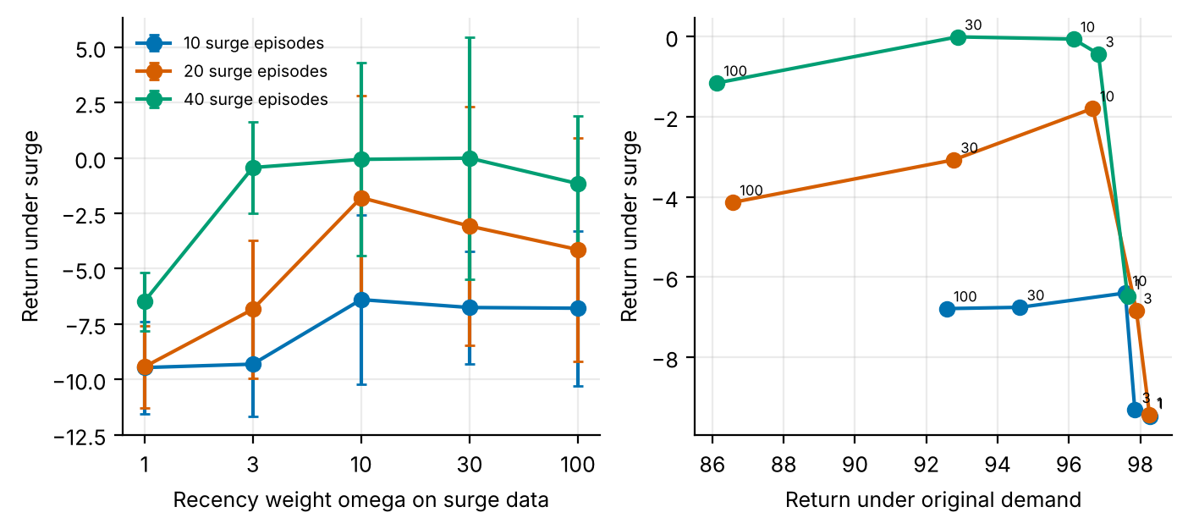
Figure 6. Left: surge return versus the recency weight ω for 10, 20 and 40 surge episodes. Right: the same points traced on the surge-versus-baseline plane; moving right-to-left along a curve trades baseline return for surge return.
Figure 6 shows that the surge return rises with ω and then saturates or declines, while baseline return falls monotonically. With 10 surge episodes the best surge return (-6.4) is obtained at ω = 10. With 20 surge episodes the best surge return (-1.8) is obtained at ω = 10. With 40 surge episodes the best surge return (0.0) is obtained at ω = 30. The differences among ω = 10, 30 and 100 are small relative to the confidence intervals (several intervals span 5 points or more), so the location of the optimum is not resolved; what is resolved is that ω = 1 is clearly worse than ω ≥ 3 at 40 episodes (nominally also at 20, where the intervals overlap) and that baseline return keeps falling as ω grows. The closed-form guide in Eq. (5) predicts that the optimal weight should be of order one to a few tens for the per-cell counts in this problem, which is roughly consistent in order of magnitude with the sweep (the sweep favours somewhat larger values than the worked examples of Eq. (5)); because the shift Δ differs between cells, the sweep is a more reliable guide than the formula, which should be read as an explanation of the trend (heavier weight on new data when the old sample is large or the shift is big) rather than as a prescription.

8. Discussion
What a hospital would take from this. If the occupancy rule is already sensible, learning a policy from logs buys little in stable times; the benefit appears when the world changes. In that case the cheapest effective action is not to relearn from scratch but to keep the large historical model and up-weight the recent weeks. Relearning only from recent data is the intuitive response; in this simulator it gave no benefit when the recent sample was small.
DP, MC and Q-learning. DP is the reference: when a model is estimated it is exact and fast (fast for 1,470 state-action pairs). Q-learning approaches it from experience alone and is the better of the two model-free methods here. Monte Carlo's weakness is structural. It averages complete returns, so rare, high-variance events (diversions, overflows) contaminate every state on the path; with 28-day episodes this variance dominates. The practical lesson is that for long-horizon operational problems with sparse costly events, bootstrapping methods are preferable to episode-return averaging unless many more samples are available.
Why surge-only does not help. Our reading, not directly tested here, is that this is a support effect. A threshold on the number of observations per state-action pair is a sensible safeguard against exploiting noise, but it means that estimates built from a few weeks of data cover very little of the state space. The recency-weighted variant avoids this because the large historical count keeps most cells supported while the weight lets the new regime dominate the cells where it has spoken. The advantage over surge-only at 5 episodes was significant in a paired test, but this is one simulator with six replicates.
Choosing ω. The frontier suggests an operational rule: choose ω in the range where surge return has plateaued (here about 10 to 30) and no larger, since beyond it the surge return does not improve while the baseline regret keeps growing. Because the regret is incurred only if demand returns to normal, a hospital that expects the surge to persist (an epidemic season) can accept the upper end of that range, and one that expects it to be transient should choose a smaller one. A natural extension is to detect the regime change and set ω from the detected shift size using Eq. (5).

9. Limitations and threats to validity
- Uniform surge. The surge multiplies all arrival rates by 1.3 and leaves length of stay unchanged. Real surges change case mix, and therefore the discharge process, as well.
- Replanning data come from the old rule. The surge episodes are generated by the baseline occupancy rule, so exploration of surge-appropriate actions is thin. Active data collection could change the conclusions.
- One weight for all cells. Eq. (5) says the optimal weight varies across state-action pairs; a single global ω is a simplification.
- Small replicate counts. Six replicates keep the computation modest; several intervals are wide (for example at 80 surge episodes) and differences between ω values near the optimum are not statistically resolved.
- Simulated, not clinical, evidence. All numbers come from stylised simulators written for this study. They demonstrate how the algorithms behave when the ground truth is known; they say nothing about the safety or benefit of any treatment in people.
- State aggregation. Continuous physiology is discretised into bands. Banding makes the process only approximately Markov, and part of the gap between the DP policy on the estimated model and the true optimum is a modelling gap rather than a sampling gap.
- Fixed-horizon episodes treated as stationary. Episodes end after a fixed number of steps but the state does not always contain the clock, so the estimated model treats termination as a constant hazard. This distorts absolute model values (not true-simulator scores) and is why model-based value estimates are compared only on a common oracle model.
- Behaviour policy. The logged data come from a single ε-noisy rule. Coverage of non-rule actions is therefore thin, which is exactly the offline-RL situation, and results depend on that coverage.
- Hand-set hyper-parameters. ε schedules, step sizes and the support threshold were fixed in advance and not tuned per paper.

10. Ethical considerations and future work
Ethics. No human data were used, so no consent or privacy issues arise in this study. If the method were applied to real records, three safeguards would be essential: de-identification and governance approval of the source data; a clinician-in-the-loop design in which the learned policy is advisory, with hard guardrails on unsafe actions; and prospective, randomised or at least carefully monitored evaluation before any deployment. Reinforcement learning from logs inherits the biases of the clinicians who produced them, and may under-serve groups that are under-represented in the data; subgroup performance should be reported alongside averages.
Future work. (1) Sweep the support threshold and the surge size, and use more replicates so that the omega comparisons near the optimum can be resolved; (2) detect the regime change online and set omega from the estimated shift using Eq. (5); (3) collect surge-appropriate exploratory data actively; (4) run the adapter on a real admissions log and compare model-based estimates with a held-out period.

11. Conclusion
On a hospital-capacity MDP, model-based learning from logs (DP) matches a good occupancy rule at baseline demand and model-free learners fall below it, and none protects against a surge: the baseline-trained policy (like the rule itself) falls to -9.9 against 28.3 for a surge-trained oracle. Recency-weighted replanning - DP on counts that up-weight recent data - improves on the static policy with a few weeks of post-surge logs (-1.8 after 20 episodes, p = 0.007 versus static) but closes only a minority of the gap to the oracle, while using the surge data alone gave no benefit. The adaptation-regret frontier makes the trade-off explicit. All results are from a simulator, so the contribution is a tested recipe and a set of measured trade-offs, to be re-examined on real admission logs with the accompanying adapter.

Appendix A. Anticipated reviewer questions
The following questions are the ones a reviewer or examiner is most likely to raise. Each answer is tied to a number or figure produced by the code.
Q1. Why does DP not beat the occupancy rule at baseline demand?
Because the rule is already near-optimal for the discretised problem. Oracle DP, with 7.5 times more data, scores 99.8 against 100.5 for the rule. The honest conclusion is that learning adds little in a stable regime; its value shows up under change.
Q2. Is a 30% surge realistic, and does the conclusion depend on it?
Surges of this order are plausible for seasonal peaks, but the number is a stress-test parameter, not an estimate. The qualitative conclusions (static policies fail, recency weighting helps, surge-only does not) rely on the surge being large enough to change the optimal action in some states; we expect, but did not test, that a smaller surge would shrink the gaps.
Q3. Why not simply retrain on the new data?
That is the surge-only variant, and it did not beat not adapting (-11.4 versus -9.9 at 20 episodes; p = 0.106 for the difference), probably because thin data leave most state-action pairs unsupported.
Q4. Could the results be an artefact of the support threshold?
The threshold determines how much of the model is trusted, so it matters for the surge-only variant. It is a standard offline-RL safeguard rather than a tuned parameter, and the main conclusion (old data must be retained) is the same direction as the pessimism literature [10,11]. A sensitivity sweep of the threshold is the obvious extension and is easy to run with the code provided.
Q5. What is needed to run this on the real Kaggle file?
Map the table to (day, occupancy, queue, action, reward) rows, discretise with the same bins, and call kaggle_adapter.transitions_from_dataframe. Because a real file has no simulator, report model-based value estimates on held-out days and label them as estimates.

Appendix B. Reproducibility
All results in this paper are produced by `python ideas.py 3` (shared library: rl_core.py, domains.py, common.py). Random seeds are fixed in the code, so a re-run reproduces every table and figure. Figure files generated by the script: fig_learning, fig_bars, fig_policies, fig_agreement, fig_adaptation, fig_regret, fig_omega. To repeat the study on a real Kaggle table, convert it with kaggle_adapter.transitions_from_dataframe, then call build_mdp, value_iteration, mc_control and q_learning exactly as the script does; because a real table has no simulator, report model-based estimates on a held-out split and label them as estimates.

Appendix C. Source code of the experiment
For completeness the exact source of the simulator and the experiment function is reproduced below; it is the same code that produced every number and figure in this paper (the shared solvers value_iteration, mc_control and q_learning are in rl_core.py and are delivered with the code package).

Hospital
class Hospital(Domain):
name = "hospital"
nA, gamma, max_steps = 3, 0.97, 28
info_keys = ["admitted", "overflow", "diverted", "early_dc", "queue"]
CAP = 40
LAM = np.array([9.5, 9.0, 8.5, 8.5, 9.0, 7.0, 6.5])
W = 3 # occupancy bucket width (beds)
QE = [1, 3, 6, 10]
action_labels = ["admit", "early-discharge", "divert"]

def __init__(self, surge=1.0):
self.surge = surge
self.nOB = 40 // self.W + 1
self.nQ = len(self.QE) + 1
self.nS = 7 * self.nOB * self.nQ

def _s(self):
return (self.dow * self.nOB + min(self.occ // self.W, self.nOB - 1)) * self.nQ + band(self.q, self.QE)

def reset(self, rng):
self.occ = int(rng.integers(20, 40))
self.q = int(rng.integers(0, 5))
self.dow = int(rng.integers(7))
self.t = 0
return self._s()

def step(self, a, rng):
arr = int(rng.poisson(self.LAM[self.dow] * self.surge))
div = int(rng.binomial(arr, 0.5)) if a == 2 else 0
self.q += arr - div
over = max(0, self.q - 15)
self.q -= over
adm = min(self.q, self.CAP - self.occ)
self.q -= adm
occ_mid = self.occ + adm
rate = 0.28 if a == 1 else 0.2
dis = int(rng.binomial(occ_mid, rate))
early = max(0, dis - int(round(0.2 * occ_mid))) if a == 1 else 0
self.occ = occ_mid - dis
r = 1.0 * adm - 0.3 * self.q - 5.0 * over - 2.0 * div - 1.6 * early
self.dow = (self.dow + 1) % 7
self.t += 1
info = dict(admitted=adm, overflow=over, diverted=div, early_dc=early, queue=self.q)
return self._s(), r, self.t >= self.max_steps, info, 1

def rule(self, s):
occb = (s // self.nQ) % self.nOB
qb = s % self.nQ
occ = occb * self.W
if occ >= 35 and qb >= 2: return 2
if occ >= 30: return 1
return 0

ideas.idea3
def idea3():
I = 3; d = odir(I)
base = Hospital(1.0); surge = Hospital(1.3)
res = standard_benchmark(base, n_eps=800, n_oracle=6000, steps=150000, seeds=5)
standard_figs(res, base, I, title="Hospital capacity MDP (baseline demand)")
NEW = [0, 5, 10, 20, 40, 80]; SEEDS = 6
variants = ["Static (baseline only)", "Pooled, equal weight", "Pooled, recency x10", "Surge data only"]
Js = {v: np.zeros((len(NEW), SEEDS)) for v in variants}
Jb = {v: np.zeros((len(NEW), SEEDS)) for v in variants}
ov = []
rule = np.array([base.rule(s) for s in range(base.nS)])
# oracle for surge
ds = rollout(surge, surge.behavior, np.random.default_rng(555), 6000)
mo = build_mdp(ds, surge); po, _, _ = value_iteration(mo); po = fill_policy(po, mo, behavior_mode(ds, surge))
r_or, _ = eval_policy(surge, po, n_eps=300); r_rule, _ = eval_policy(surge, rule, n_eps=300)
for sd in range(SEEDS):
d0 = rollout(base, base.behavior, np.random.default_rng(10 + sd), 800)
dn_all = rollout(surge, surge.behavior, np.random.default_rng(20 + sd), max(NEW))
for ni, n in enumerate(NEW):
if n == 0:
dd = d0; wlist = {v: None for v in variants}
for v in variants:
if n == 0:
comb, w = d0, None
else:
sub = {k: val[dn_all["ep"] < n] for k, val in dn_all.items()}
if v == "Static (baseline only)": comb, w = d0, None
elif v == "Surge data only": comb, w = sub, None
else:
comb = concat_data(d0, sub)
wnew = 1.0 if v == "Pooled, equal weight" else 10.0
w = np.concatenate([np.ones(len(d0["s"])), np.full(len(sub["s"]), wnew)])
if v == "Surge data only" and n == 0:
comb = d0
m = build_mdp(comb, base, weights=w)
p, _, _ = value_iteration(m); p = fill_policy(p, m, rule)
r, _ = eval_policy(surge, p, n_eps=200); Js[v][ni, sd] = r.mean()
r2, _ = eval_policy(base, p, n_eps=200); Jb[v][ni, sd] = r2.mean()
print("idea3 seed", sd, flush=True)
fig, ax = plt.subplots(figsize=(5.4, 3.4))
for i, v in enumerate(variants):
ax.errorbar(NEW, Js[v].mean(1), yerr=[ci95(Js[v][k]) for k in range(len(NEW))], marker="o", ms=3.5, capsize=2, color=OKABE[i], label=v)
ax.axhline(r_or.mean(), color="k", ls="--", lw=1, label="Oracle (surge-trained)")
ax.axhline(r_rule.mean(), color="#555555", ls=":", lw=1.2, label="Occupancy rule")
ax.set_xlabel("Surge-regime episodes (28 days each) available"); ax.set_ylabel("Return under +30% demand surge")
ax.set_xticks(NEW); ax.legend(fontsize=6.5, loc="upper center", bbox_to_anchor=(0.5, 1.28), ncol=2)
fig.savefig(f"{d}/fig_adaptation.png"); plt.close(fig)
fig, ax = plt.subplots(figsize=(5.0, 3.2))
for i, v in enumerate(variants):
ax.plot(NEW, Jb[v].mean(1), marker="o", ms=3.5, color=OKABE[i], label=v)
ax.set_xlabel("Surge-regime episodes available"); ax.set_ylabel("Return under original demand (regret check)")
ax.legend(fontsize=7)
fig.savefig(f"{d}/fig_regret.png"); plt.close(fig)
# cost-structure plot for the two heads
fig, ax = plt.subplots(figsize=(4.8, 3.0))
labs = ["Static", "Pooled x10 (20 eps)", "Surge-only (20 eps)", "Oracle"]
vals = [Js[variants[0]][0].mean(), Js[variants[2]][3].mean(), Js[variants[3]][3].mean(), r_or.mean()]
errs = [ci95(Js[variants[0]][0]), ci95(Js[variants[2]][3]), ci95(Js[variants[3]][3]), ci95(r_or)]
ax.bar(labs, vals, yerr=errs, color=[OKABE[0], OKABE[2], OKABE[3], "k"], capsize=3)
ax.set_ylabel("Return under surge"); ax.set_xticklabels(labs, fontsize=7, rotation=12)
lo = min(vals) - 15; ax.set_ylim(lo, max(vals) + 10)
fig.savefig(f"{d}/fig_surge_bars.png"); plt.close(fig)
# ---- recency-weight sweep: the adaptation / regret frontier
OM = [1, 3, 10, 30, 100]; NN = [10, 20, 40]
Jo = {(n, w): ([], []) for n in NN for w in OM}
for sd in range(SEEDS):
d0 = rollout(base, base.behavior, np.random.default_rng(10 + sd), 800)
dn_all = rollout(surge, surge.behavior, np.random.default_rng(20 + sd), max(NN))
for n in NN:
sub = {k: val[dn_all["ep"] < n] for k, val in dn_all.items()}
comb = concat_data(d0, sub)
for w_ in OM:
wt = np.concatenate([np.ones(len(d0["s"])), np.full(len(sub["s"]), float(w_))])
m = build_mdp(comb, base, weights=wt)
p, _, _ = value_iteration(m); p = fill_policy(p, m, rule)
Jo[(n, w_)][0].append(float(eval_policy(surge, p, n_eps=200)[0].mean()))
Jo[(n, w_)][1].append(float(eval_policy(base, p, n_eps=200)[0].mean()))
print("idea3 omega seed", sd, flush=True)
fig, axs = plt.subplots(1, 2, figsize=(8.0, 3.2))
for i, n in enumerate(NN):
axs[0].errorbar(range(len(OM)), [np.mean(Jo[(n, w_)][0]) for w_ in OM], yerr=[ci95(Jo[(n, w_)][0]) for w_ in OM], marker="o", capsize=2, color=OKABE[i], label=f"{n} surge episodes")
axs[1].plot([np.mean(Jo[(n, w_)][1]) for w_ in OM], [np.mean(Jo[(n, w_)][0]) for w_ in OM], marker="o", color=OKABE[i], label=f"{n} surge episodes")
for w_ in OM: axs[1].annotate(f"{w_}", (np.mean(Jo[(n, w_)][1]), np.mean(Jo[(n, w_)][0])), fontsize=6, xytext=(3, 3), textcoords="offset points")
axs[0].set_xticks(range(len(OM))); axs[0].set_xticklabels(OM); axs[0].set_xlabel("Recency weight omega on surge data"); axs[0].set_ylabel("Return under surge"); axs[0].legend(fontsize=7)
axs[1].set_xlabel("Return under original demand"); axs[1].set_ylabel("Return under surge")
fig.savefig(f"{d}/fig_omega.png"); plt.close(fig)
omega = {str(n): {str(w_): dict(surge=float(np.mean(Jo[(n, w_)][0])), surge_ci=ci95(Jo[(n, w_)][0]), base=float(np.mean(Jo[(n, w_)][1]))) for w_ in OM} for n in NN}
out = dict(omega=omega, OM=OM, NN=NN, NEW=NEW, variants=variants,
J_surge={v: dict(mean=Js[v].mean(1), ci=[ci95(Js[v][k]) for k in range(len(NEW))]) for v in variants},
J_base={v: dict(mean=Jb[v].mean(1)) for v in variants},
oracle_surge=float(r_or.mean()), rule_surge=float(r_rule.mean()),
static_vs_pooled10_20=paired(Js[variants[2]][3], Js[variants[0]][0]),
surgeonly_vs_static_20=paired(Js[variants[3]][3], Js[variants[0]][0]),
pooled10_vs_surgeonly_5=paired(Js[variants[2]][1], Js[variants[3]][1]))
save_json(I, "results", dict(out, standard=summarize(res), extra=drop_models(res)))
return out

rl_core: shared solvers
def build_mdp(data, dom, weights=None, chan=None, min_n=10, term_prior=1.0):
"""Empirical (maximum-likelihood) MDP from logged transitions.
(s,a) pairs observed fewer than min_n times are completed pessimistically: they go
to the absorbing terminal state with the worst reward seen in the data."""
nS, nA = dom.nS, dom.nA
T = nS
w = np.ones(len(data["s"])) if weights is None else np.asarray(weights, float)
s, a = data["s"], data["a"]
s2 = np.where(data["done"] > 0, T, data["s2"])
N = np.zeros((nS + 1, nA, nS + 1))
np.add.at(N, (s, a, s2), w)
n = N.sum(2)
Rsum = np.zeros((nS + 1, nA))
np.add.at(Rsum, (s, a), w * data["r"])
Gsum = np.zeros((nS + 1, nA, nS + 1))
np.add.at(Gsum, (s, a, s2), w * dom.gamma ** data["dur"])
m = MDP()
m.nS, m.nA, m.gamma = nS, nA, dom.gamma
m.n = n
m.N = N
seen = n >= min_n # support constraint: thinly observed (s,a) are completed pessimistically
n_eff = n + term_prior # one pseudo-observation of absorption guards against 'immortal' loops
P = np.zeros_like(N)
P[seen] = N[seen] / n_eff[seen][:, None]
P[seen, T] += term_prior / n_eff[seen]
G = np.full_like(N, dom.gamma)
nz = N > 0
G[nz] = Gsum[nz] / N[nz]
R = np.zeros((nS + 1, nA))
R[seen] = Rsum[seen] / n_eff[seen]
rmin = float(data["r"].min())
m.rmin, m.rmax = rmin, float(data["r"].max())
P[~seen, T] = 1.0
R[~seen] = rmin
P[T, :, :] = 0.0
P[T, :, T] = 1.0
R[T, :] = 0.0
m.P, m.G, m.R = P, G, R
m.PG = P * G
# reward channels
m.Rc = {}
for c in (chan if chan is not None else dom.chan):
cs = np.zeros((nS + 1, nA))
np.add.at(cs, (s, a), w * data[c])
cr = np.zeros((nS + 1, nA))
cr[seen] = cs[seen] / n_eff[seen]
m.Rc[c] = cr
# start distribution = first state of every episode
first = data["t"] == 0
mu = np.bincount(data["s"][first], minlength=nS + 1).astype(float)
m.mu = mu / mu.sum()
m.visits = (n * seen).sum(1)[:nS]
m.seen = seen
m.Rsum = Rsum
return m

def value_iteration(m, R=None, mask=None, tol=1e-9, max_iter=20000, penalty=None):
R = m.R if R is None else R
if penalty is not None:
R = R - penalty
V = np.zeros(m.nS + 1)
for _ in range(max_iter):
Q = _q(m, V, R)
if mask is not None:
Q = np.where(mask, Q, -1e18)
Vn = Q.max(1)
Vn[m.nS] = 0.0
if np.abs(Vn - V).max() < tol:
V = Vn
break
V = Vn
Q = _q(m, V, R)
if mask is not None:
Q = np.where(mask, Q, -1e18)
pi = Q.argmax(1)[:m.nS]
return pi, V, Q

def q_learning(m, rng, steps, eps_fn=eps_exp, alpha0=1.0, alpha_min=0.02,
q0=0.0, mask=None, n_ckpt=25, max_len=200, ckpt_fn=None):
nS, nA = m.nS, m.nA
ckpt_fn = ckpt_fn or (lambda p: J(m, p))
Q = np.full((nS + 1, nA), q0)
Q[nS] = 0.0
cnt = np.zeros((nS + 1, nA))
smp = Sampler(m, rng)
ck = np.unique(np.linspace(0, steps, n_ckpt + 1).astype(int))
curve = []
s, ep_t = smp.start(), 0
ci = 0
for k in range(steps + 1):
if ci < len(ck) and k == ck[ci]:
pi = np.array([_greedy(Q, x, mask) for x in range(nS)])
curve.append((k, ckpt_fn(pi)))
ci += 1
if k == steps:
break
if rng.random() < eps_fn(k, steps):
a = _explore(rng, s, nA, mask)
else:
a = _greedy(Q, s, mask)
s2, r, g = smp.step(s, a)
tgt = r + (0.0 if s2 == nS else g * Q[s2].max() if mask is None
else g * np.where(mask[s2], Q[s2], -1e18).max())
cnt[s, a] += 1
al = max(alpha_min, alpha0 / (1.0 + cnt[s, a] ** 0.7))
Q[s, a] += al * (tgt - Q[s, a])
ep_t += 1
if s2 == nS or ep_t >= max_len:
s, ep_t = smp.start(), 0
else:
s = s2
pi = np.array([_greedy(Q, x, mask) for x in range(nS)])
return pi, Q, np.array(curve)

def mc_control(m, rng, steps, eps_fn=eps_exp, q0=0.0, mask=None, n_ckpt=25,
max_len=200, ckpt_fn=None):
"""first-visit Monte Carlo control with epsilon-soft behaviour policy and
incremental-average updates."""
nS, nA = m.nS, m.nA
ckpt_fn = ckpt_fn or (lambda p: J(m, p))
Q = np.full((nS + 1, nA), q0)
Q[nS] = 0.0
N = np.zeros((nS + 1, nA))
smp = Sampler(m, rng)
ck = np.unique(np.linspace(0, steps, n_ckpt + 1).astype(int))
curve = []
used, ci = 0, 0
while True:
while ci < len(ck) and used >= ck[ci]:
pi = np.array([_greedy(Q, x, mask) for x in range(nS)])
curve.append((ck[ci], ckpt_fn(pi)))
ci += 1
if used >= steps:
break
s = smp.start()
traj = []
for _ in range(max_len):
if rng.random() < eps_fn(used + len(traj), steps):
a = _explore(rng, s, nA, mask)
else:
a = _greedy(Q, s, mask)
s2, r, g = smp.step(s, a)
traj.append((s, a, r, g))
s = s2
if s2 == nS:
break
used += len(traj)
# returns, backwards; first-visit
Gret = 0.0
rets = []
for (s_, a_, r_, g_) in reversed(traj):
Gret = r_ + g_ * Gret
rets.append(Gret)
rets.reverse()
seen = set()
for (s_, a_, _, _), G_ in zip(traj, rets):
if (s_, a_) in seen:
continue
seen.add((s_, a_))
N[s_, a_] += 1
Q[s_, a_] += (G_ - Q[s_, a_]) / N[s_, a_]
pi = np.array([_greedy(Q, x, mask) for x in range(nS)])
return pi, Q, np.array(curve)

References
[1] Puterman, M. L. Markov Decision Processes: Discrete Stochastic Dynamic Programming. Wiley, 1994.
[2] Sutton, R. S. and Barto, A. G. Reinforcement Learning: An Introduction, 2nd ed. MIT Press, 2018.
[3] Yu, C., Liu, J., Nemati, S. and Yin, G. Reinforcement learning in healthcare: a survey. ACM Computing Surveys 55(1):1-36, 2021.
[4] Gottesman, O. et al. Guidelines for reinforcement learning in healthcare. Nature Medicine 25:16-18, 2019.
[5] Levine, S., Kumar, A., Tucker, G. and Fu, J. Offline reinforcement learning: tutorial, review, and perspectives on open problems. arXiv:2005.01643, 2020.
[6] Schaefer, A. J., Bailey, M. D., Shechter, S. M. and Roberts, M. S. Modeling medical treatment using Markov decision processes. In Operations Research and Health Care, Kluwer, 2005.
[7] Gupta, D. and Denton, B. Appointment scheduling in health care: challenges and opportunities. IIE Transactions 40(9):800-819, 2008.
[8] Komorowski, M., Celi, L. A., Badawi, O., Gordon, A. C. and Faisal, A. A. The Artificial Intelligence Clinician learns optimal treatment strategies for sepsis in intensive care. Nature Medicine 24:1716-1720, 2018.
[9] Fujimoto, S., Meger, D. and Precup, D. Off-policy deep reinforcement learning without exploration. Proceedings of the 36th ICML, 2019.
[10] Kumar, A., Zhou, A., Tucker, G. and Levine, S. Conservative Q-learning for offline reinforcement learning. Advances in Neural Information Processing Systems 33, 2020.
[11] Jin, Y., Yang, Z. and Wang, Z. Is pessimism provably efficient for offline RL? Proceedings of the 38th International Conference on Machine Learning (ICML), 2021.
[12] Efron, B. and Morris, C. Stein's paradox in statistics. Scientific American 236(5):119-127, 1977.
[13] Bellman, R. Dynamic Programming. Princeton University Press, 1957.
[14] Singh, S. P. and Sutton, R. S. Reinforcement learning with replacing eligibility traces. Machine Learning 22:123-158, 1996.
[15] Watkins, C. J. C. H. and Dayan, P. Q-learning. Machine Learning 8(3-4):279-292, 1992.

