Overbooking Clinic Appointments with Reinforcement Learning: Exploration Schedules, Learning Efficiency and Robustness to Shifts in the No-Show Rate
[Author names] | [Department, Institution] | [Corresponding e-mail]
Abstract. Patients who miss appointments leave clinic slots empty, and booking more patients than slots recovers capacity at the risk of overtime and long waits. We model a clinic that decides before each session how many extra patients to book as a 100-state, 5-action Markov decision process on a simulator whose variables mirror the public 'Medical Appointment No Shows' table, and we rebuild real clinic sessions from that table to test the methods on recorded attendance. From 150 logged clinic days we learn policies with dynamic programming (DP), Monte Carlo (MC) control and Q-learning, compare five exploration schedules (constant epsilon, exponential decay, a 1/k decay, optimistic initialisation, near-greedy), and score the final policies in the true simulator, including two shifts of the no-show rate. In the true simulator DP, MC and Q-learning scored 162.2, 166.6 and 164.4 against 160.3 for the overbooking rule, a gain of +1.9 (p = 0.324), +6.3 (p = 0.036) and +4.1 (p = 0.060) over 5 replicates, whereas a DP policy fitted to ten times as much data scored 179.0. On the fitted model no schedule reached 90% of the optimal improvement in any of 60 runs, and the schedule differences that can be resolved are small: the near-greedy schedule was clearly slowest for Q-learning (normalised area under the learning curve -0.54 against -0.05 for the best schedule), but for MC it could not be separated from the others. The ranking of schedules by final true return differed between the two algorithms (rank correlation -0.90 over five schedules). When the no-show rate fell by 0.05, all 10 learned configurations scored above the rule, by 8.0 units on average against 4.8 at nominal rates; when it rose by 0.08, they were within 0.8 units of it. The limit is the coverage of the logged data, and a structured model that learns only patient behaviour and takes the clinic's rules as known removes it: solved by DP, it scored 184.1 with the same 150 days (+19.6 over DP on the estimated MDP, p < 0.001, 20 replicates) and 184.0 with 25 days. On 592 real clinic sessions it scored 182.5 against 150.8 for the rule, 170.3 for DP on the estimated MDP and 182.0 for a single session optimiser, with a margin over the latter that grows to 33% when waiting is costlier, and Q-learning came closer to its DP solution than MC. No clinical claims are made.
Keywords: appointment scheduling; no-show; overbooking; exploration schedule; epsilon-greedy; optimistic initialisation; learning curves; distribution shift; structured model; real appointment data

1. Introduction
Missed appointments are costly: a slot reserved for a patient who does not come is lost capacity, and clinics have long responded by overbooking, that is, giving more appointments than slots. Overbooking trades the value of filled slots against the cost of overtime when everyone arrives and of waiting for those who are not seen [1,2]. The right amount depends on the no-show rate, which varies with the weekday, the season and the patient mix and drifts over time.
Reinforcement learning (RL) can learn an overbooking rule from logged clinic data without an explicit model of no-show behaviour [3]. Three practical questions follow. First, how quickly and how reliably do standard learners converge, and does the exploration schedule matter? The textbook answer is that it does, because an agent that never tries an action cannot learn its value [3,4,5]. Second, a policy learned from a log is deployed in a clinic whose no-show rate may differ from that of the log, so how robust is it? Third, if the logs are the limit, can they be used more efficiently, and do the answers hold on real appointments? This paper studies the first two in a transparent simulator and the third both in the simulator and on clinic sessions rebuilt from a real appointment table.
A feature of the offline setting changes the first question. When the learner is trained on a model fitted from logs, its exploration happens inside that model, and a state-action pair that the logs never contain cannot be discovered by exploring harder. The exploration schedule then governs how fast the fitted model is solved rather than what information is collected. Part of our contribution is to measure how much the schedule matters under that condition and to report the answer even when it is small. The same condition points to a remedy: if the clinic's own rules are known, only patient behaviour has to be learned, and every logged session informs the same few quantities.
Contributions. (i) A clinic overbooking MDP with a weekday cycle, a no-show state, a waiting list and an operational reward (Section 4.1), and clinic sessions rebuilt from a real appointment table (Section 4.2). (ii) A normalised learning-efficiency metric, the area under the learning curve and the steps to 90% of the optimal improvement, defined against the clinic's own behaviour and the oracle optimum (Eq. 3 to 5). (iii) A controlled comparison of 5 exploration schedules for two learners with 6 replicates each. (iv) A shift study that evaluates the trained policies when the no-show rate is higher or lower than in the log (Eq. 6). (v) Candid negative results: no schedule reaches 90%, the fitted-model metric does not agree with true return, and schedule effects on true return are of the same size as the run-to-run noise. (vi) A structured model in which only patient behaviour is learned (Section 5.2); it removes the data coverage limit in the simulator, and on real sessions it is ahead of the learners and of baselines from published work (Sections 7.5 to 7.10), where we also compare the convergence of MC and Q-learning.
Scope and honesty. The Kaggle site could not be reached when the simulator study was built (all requests returned HTTP 403), so Sections 7.1 to 7.4 analyse no real appointment table. The simulator mirrors the variables of such a table (appointment day, no-show indicator, waiting time) with made-up dynamics. The table was obtained later and is used to rebuild real clinic sessions (Section 4.2); those sessions keep a simulated waiting list and reward. Findings concern algorithms, not clinics, and no clinical claim is made.

2. Related work
Appointment scheduling and overbooking. Operations research has studied appointment systems extensively, including no-shows, overbooking and the trade-off between patient waiting and provider overtime [1]; analytical results for overbooking with no-shows are given by Zacharias and Pinedo [2]. Predicted no-show probabilities have been combined with overbooking decisions for a single session, for example by marginal analysis [6], and fixed risk thresholds for double booking serve as the baseline for learned policies [7]. Our contribution is not a better scheduling model but a study of how RL learners behave on one, and of how much they gain from a model that knows the clinic's rules.
Exploration in RL. Epsilon-greedy exploration, decaying schedules and optimistic initial values are the textbook devices [3]. Convergence of on-policy methods needs schedules that are greedy in the limit with infinite exploration (GLIE) [4]; Q-learning converges under visit-count conditions on the step size [8,9]. Model-based methods such as R-max make optimism explicit [5]. Our schedules are the simple ones a practitioner would try; the 'GLIE-style' schedule here has a floor and is therefore not strictly GLIE.
Offline RL and shift. Learning from logs is limited by data coverage and is sensitive to model error, which motivates pessimism and support constraints [10,11,12]. Robustness to a change in the environment after deployment is a related but different concern, and we treat it with the simplest possible experiment: re-evaluating the trained policies in simulators with a shifted no-show rate. Known structure is an alternative to more data: in a factored MDP the transition model is assembled from separately specified parts of the state [13], which is the idea behind the structured model of Section 5.2.

3. Preliminaries: Markov decision processes and the three solution families
A finite Markov decision process (MDP) is a tuple (S, A, P, R, γ) with a finite state set S, a finite action set A, a transition kernel P(s' | s, a), an expected reward R(s, a) and a discount factor γ in [0, 1). A deterministic policy π maps each state to an action. Its value V^π(s) is the expected discounted return obtained by starting in s and following π; the optimal value V*(s) satisfies the Bellman optimality equation [3,14,15]
V*(s) = max_a [ R(s,a) + γ Σ_{s'} P(s'|s,a) V*(s') ] (1)
Dynamic programming (DP). When P and R are known, V* is the unique fixed point of the contraction in Eq. (1). Value iteration repeatedly applies the right-hand side until the sup-norm change is below a tolerance; policy iteration alternates exact policy evaluation (solving the linear system (I − γP_π)V = R_π) with greedy improvement and terminates in a finite number of steps. We implement both and verify on every run that they return policies of identical value, which acts as a built-in correctness test of the solver.
Monte Carlo (MC) control. Without a model, MC control estimates the action-value Q(s,a) as the average return observed after first visits to (s,a) within complete episodes, and improves an ε-soft policy that is greedy with respect to Q [3,16]. It makes no bootstrapping assumption, so it is unbiased but has high variance and must wait until an episode ends before learning anything.
Q-learning. Tabular Q-learning is a model-free temporal-difference method that bootstraps from its own estimates [8]:
Q(s,a) ← Q(s,a) + α [ r + γ max_{a'} Q(s',a') − Q(s,a) ] (2)
It converges to Q* if every (s,a) is visited infinitely often and the step sizes satisfy the usual stochastic-approximation conditions. In practice the speed at which it spreads reward information backwards is its main advantage over MC, and its bias from bootstrapping off noisy estimates is its main weakness.
Empirical MDPs from logged data. Clinical data are logged, not simulated: we observe transitions (s, a, r, s') generated by clinicians. Counts N(s,a,s') give the maximum-likelihood model P̂(s'|s,a) = N(s,a,s')/N(s,a) and R̂(s,a) as the mean observed reward. Solving the MDP (P̂, R̂) by DP gives a plug-in policy; MC and Q-learning can be run against samples drawn from (P̂, R̂), which is how "learning from experience" is realised without touching patients. Two safeguards are used throughout because plug-in planning is notoriously exploited by estimation error [10,11,12]: (i) a support constraint: a pair (s,a) observed fewer than 10 times is completed pessimistically (it transitions to an absorbing terminal state with the worst reward in the data), and (ii) a terminal pseudo-count: one pseudo-observation of absorption is added to every supported pair so that no state is estimated to be immortal.

4. Problem formulation: a clinic overbooking simulator and real clinic sessions

4.1 The simulator
A clinic runs 40 sessions per episode, each with 10 regular slots. Before a session the clinic books 10 + k patients, where k in {0, 1, 2, 3, 4} is the number of extra bookings. Each booked patient shows up independently with probability 1 − p, where p is the current no-show rate. The number who show is binomial. Overtime is the number of patients above 10, idle is the number of unused slots, and a waiting list of length w (0 to 12) grows by a Poisson(1.5) number of patients per session and shrinks by min(w, k), the number of extra bookings drawn from it. The no-show rate starts near 0.18 (normal with standard deviation 0.03) and relaxes towards a weekday-specific mean: p moves to 0.8 p + 0.2 μ_d plus Gaussian noise with standard deviation 0.02, where the means for the five weekdays are 0.22, 0.17, 0.17, 0.18, 0.20. The reward per session is shows − 3 × overtime − 0.5 × idle − 0.4 × waiting-list length + 0.3 × (patients drawn from the waiting list). Rewards are discounted with γ = 0.97.
Table 1. The clinic overbooking MDP.
Element | Definition
State (100) | weekday (5) × no-show band (4: p below 0.12, 0.12 to 0.18, 0.18 to 0.24, above 0.24) × waiting-list band (5: lengths 0, 1-2, 3-5, 6-8, 9 or more)
Actions (5) | book 10 + k patients, k = 0 to 4 (labels +0, +1, +2, +3, +4)
Reward per session | shows − 3 overtime − 0.5 idle − 0.4 waiting list + 0.3 drawn from waiting list
Discount, horizon | γ = 0.97; 40 sessions per episode
Overbooking rule | book one extra patient when the no-show band is 0 or 1 (p below 0.18), otherwise two extra
Behaviour policy | the rule with ε = 0.25 uniformly random actions
Dataset mirrored | Medical Appointment No Shows (appointment date, no-show flag, wait)

Three design features matter for what follows. First, the rule only ever uses k = 1 or 2, and the behaviour policy picks each of the other actions with probability ε / 5 = 0.05 per session, so the logs contain few examples of overbooking by 3 or 4. If visits were spread evenly over the 100 states, a given off-rule state-action pair would be seen about 3.0 times in 150 logged episodes and about 30 times in 1,500; since pairs seen fewer than 10 times are treated as unsupported, the small dataset cannot support most of the actions the optimum uses, while the large one can. (Visits are not spread evenly, so this is an order-of-magnitude argument.) Second, the waiting list rewards overbooking beyond the show-rate trade-off, because extra bookings drain it. Third, the no-show band is part of the state, so a policy can in principle adapt to a shifted no-show rate if it has learned what each band calls for.

4.2 Real clinic sessions from the Medical Appointment No Shows table
The simulator of Section 4.1 has invented dynamics. To test the methods on recorded attendance, the same decision problem is also rebuilt from the Medical Appointment No Shows table [17], whose variables the simulator mirrors. The table lists 110,527 medical appointments in Brazil, one row per appointment, with the day the appointment was booked, the day it took place, the patient's age, sex and neighbourhood, an SMS reminder flag, enrolment in a welfare programme, flags for hypertension, diabetes, alcoholism and disability, and whether the patient came. After removing one row with a negative age and the 39 appointments on Saturdays, 110,487 appointments of 62,277 patients in 81 neighbourhoods remain, on 26 weekdays between 29 April and 8 June 2016; 20.2% of them were missed.
The table records whether each patient came, but no overbooking decision and no waiting list, so it does not contain the transitions (s, a, r, s') of Section 3. It is used in two other ways. First, a classifier predicts the no-show probability of each appointment from what is known when it is booked: the days between booking and appointment, the patient's age, sex, SMS flag, welfare flag and the four condition flags, the weekday, the numbers of the patient's earlier appointments and earlier no-shows in the table, and the neighbourhood. The classifier is a gradient boosting model [18] fitted on the 24,187 appointments before 9 May 2016, calibrated by isotonic regression [19] on the 21,683 appointments from 9 to 15 May, and applied to the 64,617 appointments from 16 May onwards; both steps use scikit-learn [20]. On these appointments its area under the ROC curve is 0.728, its Brier score 0.144, and its mean predicted no-show probability 22.0% against 19.8% observed. No information from later weeks enters the classifier.
Second, the appointments from 16 May onwards are grouped into clinic sessions, one for each neighbourhood and day with at least 5 appointments. The first min(10, n) appointments of a session fill its regular slots, patients for extra bookings are drawn from all appointments on the same weekday of the same period, and each patient shows up exactly when the table says so. Sessions from 16 to 25 May (506) are used only for learning and sessions from 30 May to 8 June (592) only for scoring. The no-show rate fell from 21.2% in the first period to 18.5% in the second, a real shift in the direction that Section 7.4 found hardest for overbooking policies.
The state combines the three quantities that matter for the booking decision: the number of regular slots filled (3 bands: 5 to 7, 8 or 9, all 10), the predicted no-show risk of the booked patients (4 bands, the quartiles of the session mean of the predicted probabilities in the learning period, with cut points 0.175, 0.215 and 0.257) and the waiting list band of Table 1 (5 bands), giving 60 states. Actions, reward, discount and horizon are those of Table 1, and the overbooking rule reads the risk band as Table 1 reads the no-show band: one extra booking in the two lower bands, otherwise two. The table has no waiting list, so the waiting list of Section 4.1 is kept, with Poisson(1.5) new patients per session; this part of the clinic is assumed, and Section 7.9 varies it. Only 9% of the learning sessions have fewer than 10 bookings, so the slots filled band rarely changes.

5. Method: exploration schedules, shift evaluation and a structured model

5.1 Exploration schedules, normalised learning efficiency and shift evaluation
Both learners are trained on a model fitted to the logged episodes and sample experience from that model (never from the simulator). Let k be the step count and T the budget (150,000 steps). The five schedules are
constant: ε_k = 0.1; exponential: ε_k = 0.05 + 0.95 exp(−5k/T); 1/k-type: ε_k = max(0.02, c / (c + k)), c = T / 50; near-greedy: ε_k = 0.02, (3)
and the optimistic-initialisation schedule uses ε_k = 0.02 together with an initial action value q0 = 0.5 × 14 × (1 − γ^H) / (1 − γ) = 164.3, where 14 is an assumed upper bound on the reward per session and H = 40. With c = 3,000 the 1/k-type schedule equals 0.5 at k = c and reaches its floor only near the end of the budget; because of the floor it is not strictly GLIE [4]. MC control uses first-visit returns with incremental averaging; Q-learning uses a visit-count step size [8,9].
Learning curves are measured by recording, at 26 evenly spaced checkpoints, the value of the greedy policy on a large 'oracle' model (Section 7.1 explains what that value means). The raw values depend on the scale of the problem, so we normalise them against the clinic's own behaviour and against the optimum of the same model:
v(π) = [J(π) − J_beh] / [J_opt − J_beh], (4)
so that v = 0 is the behaviour policy and v = 1 the model optimum. We summarise a learning curve by its mean over the checkpoints and by the first checkpoint reaching 90% of the possible improvement:
AUC = (1 / K) Σ_j v(π_{t_j}), t90 = min { t_j : v(π_{t_j}) ≥ 0.9 }, K = 26. (5)
The AUC rewards fast learning and penalises a slow start, and t90 asks whether the optimum is approached at all. The evaluation under shift is a re-simulation in which the no-show rate is displaced by δ at the start of an episode and in every weekday mean:
p_0 ← p_0 + δ, μ_d ← μ_d + δ, δ ∈ { 0, +0.08, −0.05 }. (6)
The policy, trained on nominal data, is not changed. Because the state contains the no-show band, a shift moves the visited states towards other bands, some of which are rarely seen in the log.
Algorithm 1 Exploration-schedule study
input : logged clinic days D (150 episodes), schedule list, learners {Q-learning, MC}, budget T, shift list
1. fit the MDP from D (pairs seen < 10 times are unsupported; unsupported pairs are absorbing with the worst reward)
2. for each schedule and each learner:
run the learner for T steps in the fitted MDP with eps_k (and q0); every T/25 steps record J(greedy policy) on the oracle MDP
fill unobserved states with the logged modal action; evaluate the final policy in each shifted simulator (120 episodes)
3. normalise curves with Eq. (4); compute AUC and t90 with Eq. (5)
4. repeat over independent data draws; report means and 95% intervals

5.2 A structured model of the clinic solved by DP
Section 4.1 explains what limits any learner that works on the empirical MDP of Section 3: it estimates P(s' | s, a) separately for each of the 500 pairs (s, a), and the pairs that the optimum uses are rarely logged. A structured model estimates far fewer quantities. The clinic's own rules are taken as known: the 10 regular slots, the reward of Table 1, and the fact that k extra bookings take min(w, k) patients off a waiting list of length w. Only patient behaviour is learned from the logs: the probability q_b that a booked patient comes when the no-show band is b, the probability T_d(b' | b) that the band moves from b to b' after a session on weekday d, and the mean number λ of patients who join the waiting list in a session. A model assembled in this way from separately specified parts of the state is a factored MDP [13]; here 98 numbers are estimated, against 50,500 transition probabilities in the empirical MDP.
From the logged sessions, q̂_b is the number of patients who came divided by the number booked, over all sessions in band b whatever the action; T̂_d(b' | b) is a count with 0.25 added to every cell; λ̂ is the mean of w_{t+1} − (w_t − min(w_t, k_t)) over consecutive sessions in which the list did not reach its cap of 12; and π(w | v), the share of each exact list length w among the logged sessions in waiting list band v, links the band to the length. With (x)⁺ = max(0, x), the expected reward of booking k extra patients in state s = (d, b, v) is
R̃(s, k) = E[ N − 3 (N − 10)⁺ − 0.5 (10 − N)⁺ ] + E_w[ 0.3 min(w, k) − 0.4 w ], (7)
where N, the number of patients who come, is a sum of independent Bernoulli variables, one for each booked patient, each with attendance probability q̂_b; its distribution is computed exactly by convolution. The second expectation is over the list length w drawn from π(w | v). The next state s' = (d + 1 mod 5, b', v') follows from the same parts:
P̃(s' | s, k) = T̂_d(b' | b) Pr[ band(min(12, w − min(w, k) + A)) = v' ], (8)
with w drawn from π(w | v) and the number of new patients A drawn from Poisson(λ̂).
In comparison B the state is (slots filled, risk band, waiting list band). The first term of Eq. (7) is then averaged over the logged sessions of the same slots and risk cell (up to 400), each represented by its number of booked patients and their mean predicted attendance probability from the classifier of Section 4.2; extra patients come with probability 0.778, one minus the mean predicted risk in the learning period. Tomorrow's patients do not depend on today's booking, so in Eq. (8) T̂_d(b' | b) is replaced by the logged frequency of each slots and risk cell (with 0.5 added to every cell), there is no weekday, and the waiting list part is unchanged.
Eq. (7) and (8) give a reward and a transition for every pair (s, k), whether or not the logs contain it, so no pair is unsupported and no fallback is needed. The model is solved with value iteration (Eq. 1), the solver of Section 3. The same model can also be given to MC control and Q-learning in place of the empirical MDP, which separates the effect of the model from that of the learner.
Algorithm 2 Structured model DP (extension)
input : logged clinic days D; the clinic's rules (10 slots, reward of Table 1, waiting list emptied by extra bookings)
1. estimate patient behaviour from D: q_b for each no-show band, T_d(b'|b), the arrival rate λ and π(w|v)
(comparison B: attendance probabilities from the calibrated classifier of Section 4.2)
2. for every state s and every k = 0 to 4 compute R(s,k) with Eq. (7) and P(s'|s,k) with Eq. (8)
3. solve the model by value iteration (Eq. 1) and use the greedy policy in every state
4. optionally, train MC control or Q-learning on the same model instead of step 3

6. Experimental protocol

6.1 Data: a simulator and real clinic sessions
Important disclosure. The Kaggle website could not be reached from the environment in which the simulator study was built (all requests returned HTTP 403), so Sections 7.1 to 7.4 run on a transparent, hand-specified stochastic simulator whose recorded variables mirror the columns of the dataset named in the paper. The simulator plays two roles: it generates a logged dataset by running an ε-noisy clinician-like behaviour policy (the stand-in for the Kaggle table), and it is the ground truth against which every learned policy is scored. Using a simulator is a methodological choice with a real benefit (true policy value is measurable, which is impossible with a static table) and a real cost (the numbers are not clinical evidence). The table was obtained later. It records no overbooking decisions, so the data adapter of the accompanying code, which converts a table of logged decisions into the same transition format, does not apply to it; Section 4.2 uses it instead to rebuild real clinic sessions, on which Sections 7.8 to 7.10 score every policy. All results should be read as a method study, not as a finding about patients.

6.2 Data, solvers and scoring
Table 2. Experimental configuration.
Item | Setting
Simulator | clinic overbooking MDP; 100 states; 5 actions; 40 sessions per episode
Benchmark | 150 logged episodes; oracle MDP from 1,500 episodes; 5 replicates; 300 evaluation episodes; 150,000 steps
Learners | DP (value and policy iteration agreed in all replicates: yes), first-visit MC, Q-learning
Schedule study | 5 schedules × 2 learners × 6 replicates (data seeds 700-705); 150,000 steps; 26 checkpoints; reference values J_beh = 125.60, J_opt = 150.03 on the oracle MDP
Shift study | no-show offsets 0, +0.08, -0.05; 120 evaluation episodes per run (300 for the rule and the DP policy)
Statistics | 95% CI = 1.96 standard errors over replicates; where a significance statement is made the interval is widened to a t-interval (factor 1.42 for 5 replicates, 1.31 for 6)
Structured model | DP, MC and Q-learning on the model of Section 5.2; 20 replicates (data seeds 1000 to 1019); 300 evaluation episodes
Real sessions | 506 learning and 592 scoring sessions (Section 4.2); 1,000 scoring episodes; three baselines from published work (Section 6.3)

- Learners. MC control and Q-learning each receive 150,000 environment steps drawn from the estimated MDP, with an exponentially decaying ε-greedy schedule (ε from 1.0 to about 0.05) and a visit-count step size α = max(0.02, 1/(1 + n^0.7)) for Q-learning.
- Replicates. 5 independent data draws (each with its own logged dataset and learner seeds). Intervals are 95% t-style intervals over replicates; paired differences are tested with a one-sample t-test on the per-replicate differences.
- Scoring. Each final policy is run for 300 episodes in the true simulator using common random numbers (episode e of every policy starts from the same random stream), and the mean discounted return is recorded. Learning curves are scored exactly on a large 'oracle' MDP estimated from ten or more times as much logged data.
- Fallback. In states never observed in the (supported) data a learned policy defers to the clinician's modal logged action, so that unsupported states cannot be exploited.
In the schedule study the standard benchmark's exponential schedule is one of the five. Final policies in the schedule study use the logged modal action in states with no data.

6.3 Comparisons, baselines and scoring
Sections 7.5 to 7.10 make two comparisons. Comparison A repeats the benchmark of Section 7.1 in the same simulator and adds the structured model; comparison B builds the clinic of Section 4.2 from real sessions and adds three baselines from published work. All other settings are those of Table 2.
- Replicates. Comparison A uses 20 data draws with data seeds 1000 to 1019; the first 5 are those of Table 3 and reproduce it exactly, and the other 15 narrow the intervals. Comparison B uses 20 logged datasets of 150 episodes, generated in the learning sessions by the behaviour policy of Table 1.
- Scoring. Comparison A scores every policy on 300 episodes of the true simulator, as in Section 6.2. Comparison B scores every policy on 1,000 episodes of 40 sessions drawn from the scoring sessions, with common random numbers, so that episode e brings the same patients and the same attendance for every policy.
- Baselines from published work (comparison B). (i) A single session optimiser books the k that maximises the expected reward of the current session, computed from each booked patient's predicted risk; this is marginal analysis of the kind used for overbooking under predicted no-shows [6]. (ii) Threshold double booking fills empty regular slots and books one extra patient for every booked patient whose predicted risk is at least θ, the fixed threshold rule against which learned double booking policies are compared [7]. (iii) A fixed number k of extra bookings in every session. The threshold θ (0.20, 0.25, 0.30 or 0.35) and the fixed k (0 to 4) were chosen on the scoring sessions, which favours these baselines.
- Data volume and demand. Comparison A repeats DP on the estimated MDP and on the structured model with 25, 50, 150, 500 and 1,500 logged days (10 replicates each). Comparison B repeats both with a waiting cost of 0.4 or 1.0 per patient and 1.5 or 2.5 new patients per session (10 replicates, 500 scoring episodes).
- Convergence. MC control and Q-learning run for 150,000 steps on the empirical MDP and on the structured model, with the schedule and step size of Section 6.2; at 26 checkpoints the true return of the greedy policy is measured on 60 episodes of the clinic used for scoring.
- Statistics. Intervals are 95% intervals over replicates. Differences between two learned policies are tested with a t test on the paired differences over replicates; differences from a single policy in comparison B are also tested over the 1,000 paired scoring episodes.

7. Results

7.1 Benchmark in the true simulator
Table 3. Benchmark in the true simulator (100 states). Return is discounted; shows, overtime, idle slots and the summed waiting-list length are totals per 40-session episode (5 replicates, 95% CI; rule and oracle are single policies).
Method | Return (mean ± 95% CI) | Shows | Overtime | Idle | Waiting
Clinician behaviour (modal logged action) | 160.3 ± 0.1 | 375.9 | 9.9 | 34.1 | 194.6
Guideline rule | 160.3 ± 0.0 | 375.9 | 9.9 | 34.0 | 194.8
DP on estimated MDP | 162.2 ± 3.3 | 377.5 | 11.1 | 33.6 | 181.4
Monte Carlo control | 166.6 ± 4.0 | 379.9 | 12.9 | 32.9 | 154.0
Q-learning | 164.4 ± 3.1 | 378.1 | 11.6 | 33.5 | 169.2
Oracle DP (10x data) | 179.0 ± 0.0 | 394.3 | 21.5 | 27.1 | 72.3

Table 3 shows that the learners are ahead of the rule on average but not by much, and not consistently. DP scored 162.19 ± 3.34, MC 166.57 ± 3.99 and Q-learning 164.36 ± 3.08 against 160.27 for the rule. Paired over replicates the differences from the rule are +1.92 ± 3.34 (p = 0.324; ahead in 4 of 5) for DP, +6.30 ± 3.99 (p = 0.036; 5 of 5) for MC and +4.09 ± 3.08 (p = 0.060; 5 of 5) for Q-learning. With 5 replicates a t-interval is 1.42 times wider than the 1.96-standard-error interval shown, so the p-values (which use the t distribution) are the safer guide: only MC is below 0.05, Q-learning is borderline, and DP is not distinguishable from the rule. Among the learners no difference is resolved either (DP minus Q-learning -2.17 ± 2.03, p = 0.105; DP minus MC -4.38 ± 5.92, p = 0.220; MC minus Q-learning +2.21 ± 4.22, p = 0.363). The replicate-to-replicate standard deviations are 3.5 for Q-learning and 4.6 for MC, which is the scale of the noise to keep in mind below. In 1 of 5 replicates the DP policy scored exactly as the logged modal-action policy (160.30), consistent with it having reproduced the behaviour policy there.
The oracle DP, fitted to 1,500 episodes, scored 179.01, which is 18.7 above the rule and 12.4 above the best learner. This is the opposite of the finding in a problem where data volume does not matter: here the headroom is large and the learners trained on 150 episodes capture only part of it (34% for MC, 22% for Q-learning, 10% for DP). The operational columns show how the oracle gets there: it books more patients (394 shows per episode against 376 for the rule), accepts about 2.2 times as much overtime (21.5 against 9.9), has fewer idle slots (27.1 against 34.0) and, above all, a much shorter waiting list (72 against 195). The learners move in the same direction but only a little: MC reduces the summed waiting list to 154 and Q-learning to 169, with overtime of 12.9 and 11.6.
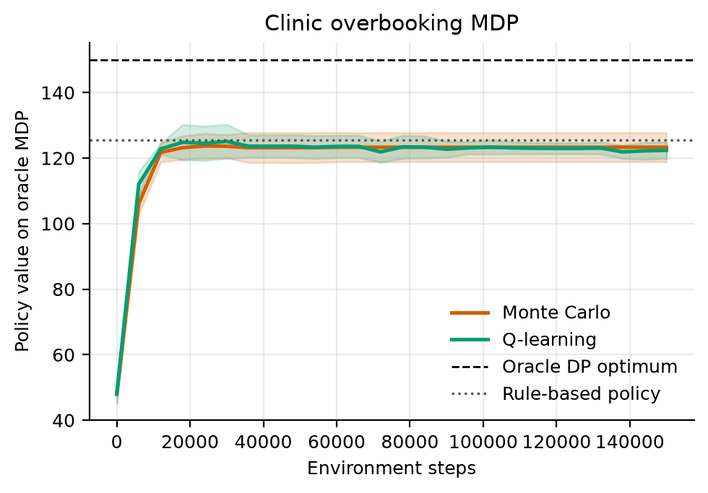
Figure 1. Learning curves on the oracle MDP (mean ± s.d. over 5 replicates). Dashed: oracle DP optimum; dotted: rule-based (modal behaviour) policy.
Figure 1 shows the learning curves on the oracle model, which is the scale used for all efficiency metrics. Both learners start at 48.0 (the greedy policy of an all-zero value table) and rise to within one model unit of their final value by step 12,000 (Q-learning) and 18,000 (MC) of the 150,000, then stay flat at 122.4 and 123.3. These plateaus match the mean DP policy value on the same model (122.7) to within 0.6, as expected when learning in a fitted model converges to its solution. They lie below the rule's 125.6 and far below the optimum 150.0. The model-scale and true-simulator pictures therefore disagree in sign: on the model DP, MC and Q-learning are 2.9, 2.3 and 3.2 below the rule, while in the true simulator they are 1.9, 6.3 and 4.1 above it. In 12 of 15 replicate-learner cells the model value is below the rule's.
Understanding why requires looking at what the model-scale value measures. The oracle model treats a state-action pair seen fewer than 10 times as absorbing with the worst reward in the data, so a policy that chooses such an action is penalised on the model whatever it would do in the clinic. All the model-scale values are far below their true values: the true return minus the oracle-model value ranges from 29.0 to 43.3 over the six methods, and the data model's value of its own DP policy was 28.0 to 41.9 below the oracle model's value of the same policy in every replicate (mean optimism gap -37.2). This is a code-level reading, not a tested explanation, but it implies that the model scale is a pessimistic and distorted version of the true scale; we use it only to compare learning speed.
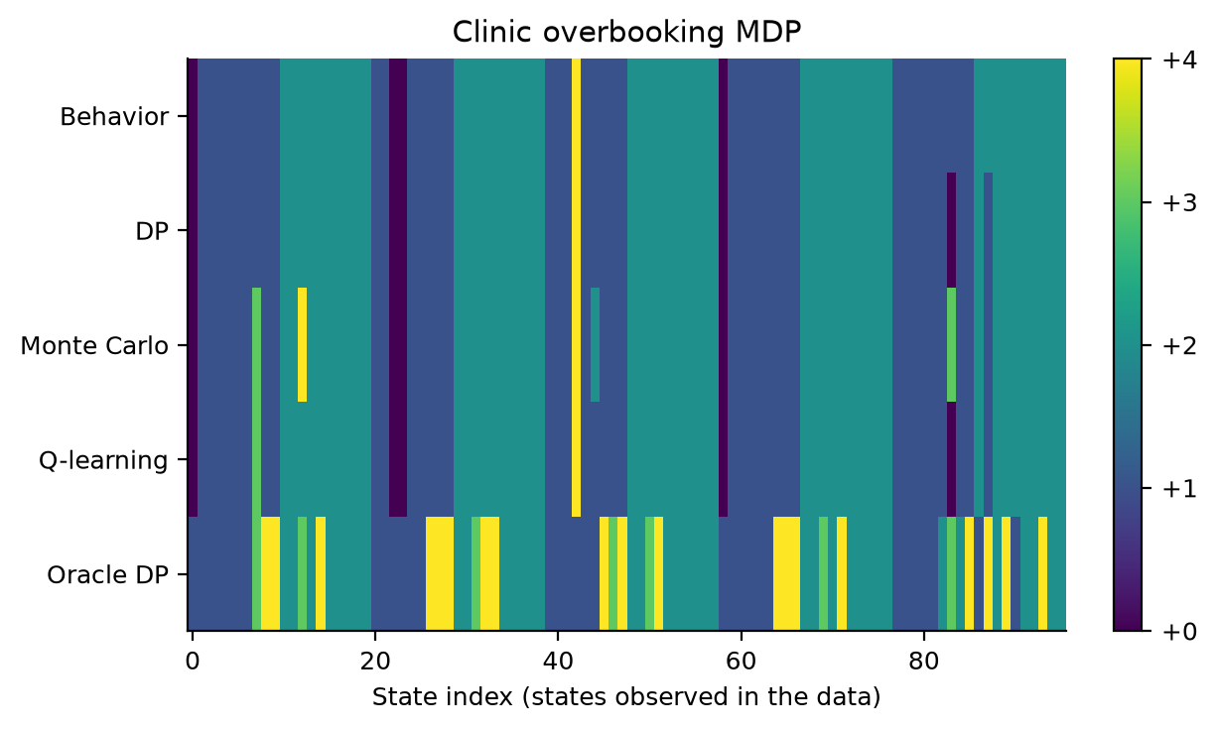
Figure 2. Extra bookings chosen in each state (replicate 0) by the behaviour policy, the three learners and the oracle. States are sorted by weekday, then no-show band, then waiting-list band.
Figure 2 compares the policies for replicate 0. The rule uses +1 in 50 states and +2 in 50, never anything else. The modal-action behaviour policy differs from it in 6 states, and the learners in 8 (DP), 11 (MC) and 9 (Q-learning) of 100; they differ from the behaviour policy in only 2, 5 and 3 states. The oracle differs from the rule in 30 states and is the only policy that uses +3 (7 states) or +4 (19 states) with any frequency; the learners use them in at most 4 states. Action 0 appears in 5 states of the behaviour policy, which is consistent with the default action for states absent from the data (default is 0), although we did not check that directly. This pattern agrees with the support argument of Section 4: with 150 episodes the high-overbooking actions are mostly unsupported, so the learners cannot adopt them, and the benchmark gains of +2 to +6 come from changes to a handful of states. Q-learning agreed with DP in 98% and MC in 93% of the well-visited states, averaged over replicates. Because only replicate 0 is plotted and DP in that replicate scored 156.8, below the rule's 160.3, the figure should not be read as showing the policies that earned the averages in Table 3.

7.2 Exploration schedules on the fitted model
Table 4. Exploration schedules: normalised area under the learning curve (AUC), normalised final value and the number of runs (of 12) reaching 90% of the optimal improvement. Values are on the scale of Eq. (4): 0 is the clinic's behaviour and 1 the oracle-model optimum (6 replicates, 95% CI).
Schedule | Q-learning AUC | Q-learning final | MC AUC | MC final | Reached 90%
eps=0.1 const | -0.20 ± 0.10 | -0.01 ± 0.09 | -0.16 ± 0.09 | -0.06 ± 0.13 | 0/12
eps exp. decay | -0.05 ± 0.12 | 0.11 ± 0.10 | -0.29 ± 0.09 | -0.13 ± 0.11 | 0/12
GLIE 1/k | -0.12 ± 0.11 | 0.09 ± 0.13 | -0.16 ± 0.14 | -0.03 ± 0.14 | 0/12
Optimistic init | -0.17 ± 0.09 | -0.03 ± 0.11 | -0.25 ± 0.18 | -0.07 ± 0.20 | 0/12
Near-greedy (0.02) | -0.54 ± 0.08 | -0.11 ± 0.11 | -0.35 ± 0.14 | -0.06 ± 0.15 | 0/12

Table 4 is the central comparison of the schedule study. No run reached the 90% target in any of the 60 runs, so the steps-to-90% metric is undefined for every schedule (the left panel of the efficiency figure in the code output is empty for this reason); the best mean final value was +0.107 (Q-learning, eps exp. decay), so the 0.9 target is about 8 times larger. The reason is visible in Figure 1: the learners plateau at the value of the DP solution of the fitted model, which on the model scale is slightly below the rule's, so even a perfect solver of that model cannot approach 1. The AUC values are all negative, from -0.54 to -0.05 for Q-learning and from -0.35 to -0.16 for MC. A part of every AUC is a common offset: the first checkpoint (step 0) has v = -3.18, which contributes -0.122 to the mean over 26 checkpoints in every run, so the offset is the same for all schedules and does not affect comparisons but does make the absolute AUC look worse than the learning actually is. No final value differs from zero once the intervals are widened to t-intervals (0 of 10 do), so after 150,000 steps all schedules end at about the behaviour policy's model value, with the largest positive mean being +0.107.
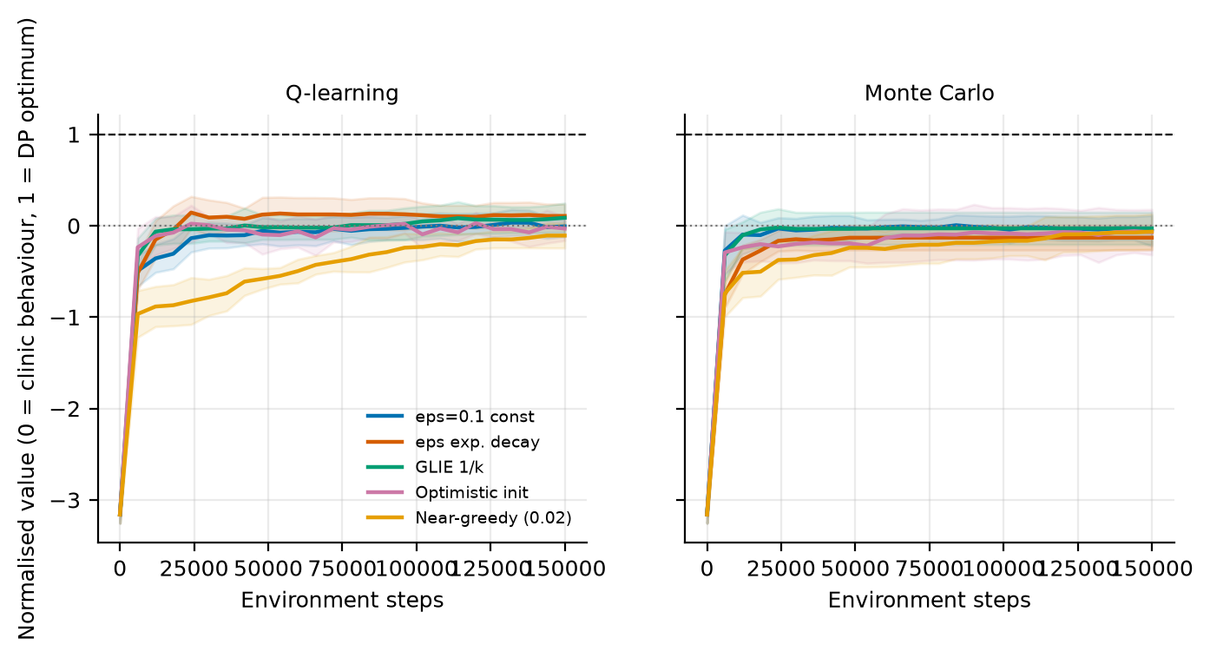
Figure 3. Normalised learning curves by exploration schedule (mean ± s.d. over 6 replicates). 0 is the clinic's behaviour and 1 the oracle-model optimum.
Figure 3 shows what separates the schedules: almost entirely the first steps and, for the near-greedy schedule, a slow climb. For Q-learning the near-greedy schedule has an AUC of -0.54 ± 0.08, against -0.05 ± 0.12 for the best schedule (eps exp. decay); its t-widened interval is separated from 4 of the other 4 schedules. This is the one robust schedule effect in the study, and it is the textbook one: a learner that explores little needs many more steps to learn the values of actions it rarely tries. The same schedule for MC (AUC -0.35 ± 0.14) is separated from 0 of the other 4 schedules, so for MC the evidence does not distinguish it from the rest. Among the other four schedules for Q-learning the AUC differences are between 0.03 and 0.15, and none of these pairs is separated by the t-widened intervals. Optimistic initialisation (q0 = 164, ε = 0.02) gives AUC -0.17 for Q-learning against -0.20 for constant ε, and -0.25 against -0.16 for MC; with intervals of ±0.09 to ±0.18 these do not separate. Seen from the offline-RL angle this is unsurprising, because exploration inside a fitted model cannot reveal pairs absent from the logs: once the supported part of the model is sampled enough, every schedule converges to the same solution, and the schedule only changes how soon.

7.3 Does the model-scale metric predict true return?
Learning efficiency is measured on the model scale, but what matters is true return. For each learner we ranked the five schedules by their AUC and by the true return of the final policy on nominal data (Table 5). For Q-learning the two rankings agree exactly (Spearman correlation +1.00 over five schedules); for MC they hardly agree (+0.30). With only five points no p-value is reported and the numbers are descriptive. The best schedule by true return is eps exp. decay for Q-learning (true return 169.5) and eps=0.1 const for MC (167.8), and the worst is Near-greedy (0.02) (161.2) and eps exp. decay (161.4). The exponential decay schedule is the best for Q-learning and the worst for MC, and across the five schedules the true-return ranks of the two learners have a correlation of -0.90.
How much of this is signal? The same learner with the exponential schedule also appears in the benchmark, with different data draws (seeds 1000 to 1004 against 700 to 705) and more evaluation episodes (300 against 120): Q-learning scored 164.4 there and 169.5 here (+5.1), and MC 166.6 there and 161.4 here (-5.2). Based on the code these are the same configuration, so differences of about 5 units arise from the data draws and the evaluation sample alone. The spread of true returns across schedules is 8.3 for Q-learning and 6.5 for MC, which is 1.6 and 1.2 times that discrepancy, so the data do not establish that any schedule changes true return, and the opposite orderings of the two learners are consistent with noise.

7.4 Robustness to a change in the no-show rate
Table 5. True return of the final policies under a shifted no-show rate. Entries for Q-learning and MC are means over 6 replicates (120 evaluation episodes each); the rule is evaluated on 300 episodes and DP on one replicate and 300 episodes. No confidence intervals were stored for these entries.
Policy | Nominal | No-show +0.08 | No-show -0.05 | Change, -0.05 vs nominal
Overbooking rule | 160.3 | 166.0 | 136.7 | -23.5
DP (replicate 0) | 167.8 | 166.3 | 147.4 | -20.4
Q-learning: eps=0.1 const | 162.9 | 166.5 | 139.9 | -22.9
Q-learning: eps exp. decay | 169.5 | 166.7 | 151.1 | -18.4
Q-learning: GLIE 1/k | 169.1 | 166.5 | 150.3 | -18.8
Q-learning: Optimistic init | 164.4 | 166.5 | 143.0 | -21.4
Q-learning: Near-greedy (0.02) | 161.2 | 166.0 | 138.9 | -22.3
Monte Carlo: eps=0.1 const | 167.8 | 166.7 | 147.1 | -20.7
Monte Carlo: eps exp. decay | 161.4 | 165.4 | 142.4 | -18.9
Monte Carlo: GLIE 1/k | 163.7 | 166.1 | 143.6 | -20.1
Monte Carlo: Optimistic init | 165.2 | 166.2 | 144.5 | -20.7
Monte Carlo: Near-greedy (0.02) | 165.8 | 166.2 | 146.7 | -19.1

Table 5 reports true returns when the no-show rate is higher or lower than in the log. Lower no-show rates are worse for everyone: the rule falls by 23.5 units, DP by 20.4, and the learners by between 18.4 and 22.9. A fall in no-shows means that the booking made for the nominal rate produces more overtime, so this is the direction in which overbooking policies are exposed. The learned policies lose less than the rule: all 10 of 10 learner-schedule cells are above the rule at -0.05, by 2.2 to 14.4 units, compared with 10 of 10 at nominal rates (by 1.0 to 9.2); the mean margin over the rule is 8.0 at -0.05 against 4.8 at nominal, so the margin grows when no-shows fall, although part of the margin already exists without any shift. At +0.08 the picture is different: the rule gains 5.7, and every learned configuration lies within 0.8 units of it (all entries between 165.4 and 166.7), so the learned policies have no visible advantage or disadvantage when there are more no-shows.
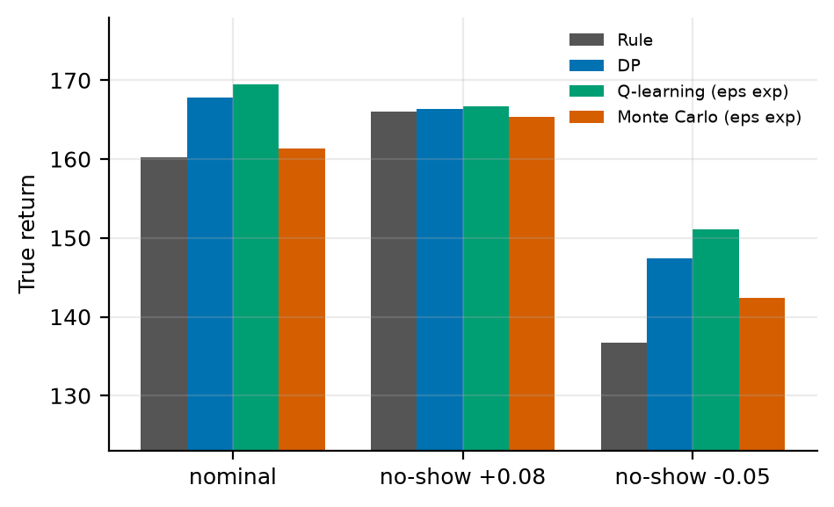
Figure 4. True return under the nominal and shifted no-show rates for the rule, DP and the exponentially decaying schedule of each learner.
Figure 4 shows the same for the four policies that the figure includes. The advantage of the learned policies at -0.05 is the largest result of the shift study (+14.4 for Q-learning, +10.7 for DP and +5.7 for MC relative to the rule), and it is consistent across all ten configurations, which gives some confidence it is not an accident of one schedule. Two caveats limit it. First, no intervals were stored, and the benchmark noise gauge above (about 5 units) is comparable to some of the advantages; the 10 of 10 count is the more reliable evidence than any individual difference. Second, the rule is a single policy with no learning noise while the learned entries average over replicates, so the comparison is not symmetric. We did not evaluate the oracle under shift, so we cannot say how far any of these policies is from the best possible policy in the shifted clinics, and we did not identify which states produce the advantage; the learned policies differ from the rule in only 8 to 11 states in replicate 0 (Figure 2), so the effect must come from a small set of cells that the shift makes more frequent, which is a hypothesis.

7.5 The structured model in the true simulator
Table 6. Comparison A: the benchmark of Table 3 with the structured model added. Return is discounted; shows, overtime, idle slots and the summed waiting list length are totals per episode of 40 sessions, and utilisation is the share of the 10 regular slots in use (20 replicates, 95% CI; rule and oracle are single policies).
Method | Return (mean ± 95% CI) | Shows | Overtime | Idle | Waiting | Utilisation
Guideline rule | 160.3 ± 0.0 | 375.9 | 9.9 | 34.0 | 194.8 | 91.5%
DP on estimated MDP | 164.5 ± 1.4 | 379.1 | 12.0 | 32.9 | 167.8 | 91.8%
Monte Carlo control | 165.5 ± 2.2 | 380.2 | 12.9 | 32.7 | 159.7 | 91.8%
Q-learning | 166.0 ± 1.5 | 379.8 | 12.5 | 32.7 | 159.5 | 91.8%
Oracle DP (10x data) | 179.0 ± 0.0 | 394.3 | 21.5 | 27.1 | 72.3 | 93.2%
Monte Carlo control, structured model | 166.3 ± 1.8 | 396.8 | 25.7 | 28.9 | 99.9 | 92.8%
Q-learning, structured model | 176.3 ± 0.6 | 392.7 | 21.3 | 28.6 | 80.1 | 92.8%
Structured model DP (ours) | 184.1 ± 0.0 | 396.7 | 20.8 | 24.1 | 65.9 | 94.0%

Sections 7.1 to 7.4 show that the learners are held back by the support of the logged data. Table 6 shows the benchmark of Table 3 with the structured model added. With the same 150 logged days per replicate, DP on the structured model scored 184.10 ± 0.01, against 164.53 ± 1.35 for DP on the estimated MDP, 165.46 ± 2.23 for MC and 166.02 ± 1.47 for Q-learning. Paired over 20 replicates it is ahead of the three learners by +19.56 ± 1.35, +18.64 ± 2.23 and +18.08 ± 1.47 (all p < 0.001), in 20 of 20 replicates against each, and +5.09 ahead of the oracle DP fitted to ten times as much data (p < 0.001). Its interval of ±0.01 shows that the policy hardly depends on the data draw. Over the first 5 replicates the three learners score exactly as in Table 3 (162.19, 166.57 and 164.36); over all 20 they are within 1.5 of each other, so the added replicates do not change the picture of Section 7.1.
The operational columns show that the structured model goes further along the route of the oracle: 396.7 patients seen per episode against 375.9 for the rule and 379.1 for DP on the estimated MDP, 94.0% of the regular slots in use against 91.5% and 91.8%, and a summed waiting list of 65.9 against 194.8 and 167.8. The price is overtime: 20.8 patients per episode against 9.9 for the rule and 12.0 for DP on the estimated MDP, slightly below the oracle's 21.5. The estimated arrival rate was 1.46 patients per session on average over replicates, against 1.5 in the simulator, and the estimated attendance probabilities fell from 0.89 in the lowest no-show band to 0.74 in the highest.

7.6 How much logged data is needed
Table 7. True return of DP on the estimated MDP and on the structured model for different amounts of logged data (10 replicates per size, 95% CI; differences paired over replicates).
Logged days | DP on estimated MDP | Structured model DP | Difference (paired)
25 | 158.52 ± 0.31 | 184.04 ± 0.05 | +25.51 ± 0.29 (p < 0.001)
50 | 159.68 ± 0.21 | 184.09 ± 0.02 | +24.41 ± 0.20 (p < 0.001)
150 | 163.61 ± 1.89 | 184.10 ± 0.01 | +20.49 ± 1.89 (p < 0.001)
500 | 175.23 ± 0.97 | 184.10 ± 0.01 | +8.87 ± 0.97 (p < 0.001)
1,500 | 177.12 ± 0.80 | 184.10 ± 0.01 | +6.98 ± 0.80 (p < 0.001)

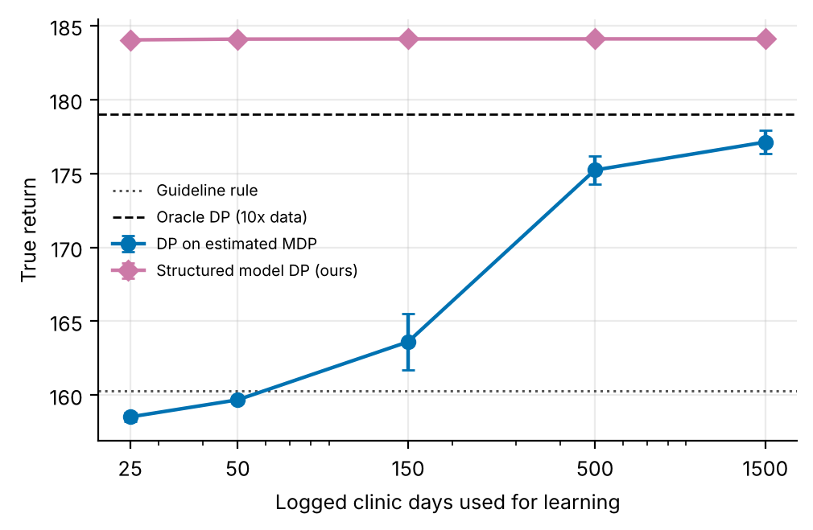
Figure 5. True return against the number of logged clinic days (log scale; 95% CI over 10 replicates). Dotted: guideline rule; dashed: oracle DP of Table 3.
Table 7 and Figure 5 vary the number of logged days. DP on the estimated MDP rises from 158.52 with 25 days, below the rule's 160.27, to 163.61 with 150, 175.23 with 500 and 177.12 with 1,500, which is the data coverage effect anticipated in Section 4: more days bring more of the pairs that the optimum uses above the support threshold. DP on the structured model scores 184.04 with 25 days and 184.10 with 1,500; the quantities it estimates are already precise with 25 days, and further data change its return by less than 0.1. Even with 1,500 days the estimated MDP remains 6.98 ± 0.80 behind (p < 0.001).

7.7 Robustness to a change in the no-show rate
Table 8. True return under a shifted no-show rate for every policy of Table 6, trained on nominal data (20 replicates, 300 evaluation episodes each, 95% CI; rule and oracle are single policies).
Policy | Nominal | No-show +0.08 | No-show -0.05 | Change, -0.05 vs nominal
Guideline rule | 160.3 ± 0.0 | 166.0 ± 0.0 | 136.7 ± 0.0 | -23.5
DP on estimated MDP | 164.5 ± 1.4 | 165.9 ± 0.2 | 142.3 ± 2.1 | -22.2
Monte Carlo control | 165.5 ± 2.2 | 165.4 ± 0.4 | 144.4 ± 2.9 | -21.1
Q-learning | 166.0 ± 1.5 | 165.7 ± 0.3 | 145.4 ± 2.6 | -20.6
Oracle DP (10x data) | 179.0 ± 0.0 | 169.0 ± 0.0 | 173.8 ± 0.0 | -5.2
Monte Carlo control, structured model | 166.3 ± 1.8 | 162.9 ± 1.9 | 161.8 ± 1.9 | -4.4
Q-learning, structured model | 176.3 ± 0.6 | 168.5 ± 2.3 | 171.7 ± 0.9 | -4.6
Structured model DP (ours) | 184.1 ± 0.0 | 179.2 ± 0.0 | 182.8 ± 0.1 | -1.3

Table 8 repeats the shift study of Section 7.4 for every policy of Table 6, now with 20 replicates and intervals. When the no-show rate falls by 0.05, the rule loses 23.5, the oracle 5.2 and the three learners 20.6 to 22.2, while DP on the structured model loses 1.3 (182.81 ± 0.11 against 184.10); in the shifted clinic it is 8.96 ahead of the oracle and 40.51 ahead of DP on the estimated MDP. When the rate rises by 0.08, it scores 179.24 ± 0.01 against 165.99 for the rule and 165.86 ± 0.23 for DP on the estimated MDP. The policy is not retrained; a plausible reason for the small loss, not tested separately, is that the no-show band is part of the state and Eq. (7) and (8) value every band and every k, including bands that the nominal logs rarely visit, so the policy already specifies what to book when no-shows are fewer.

7.8 Real clinic sessions
Table 9. Comparison B: real clinic sessions from the scoring period (30 May to 8 June 2016). Columns as in Table 6; 20 replicates of the logged data, 1,000 scoring episodes, 95% CI; the rule, the three baselines and the oracle are single policies.
Method | Return (mean ± 95% CI) | Shows | Overtime | Idle | Waiting | Utilisation
Guideline rule | 150.8 ± 0.0 | 363.6 | 8.0 | 44.3 | 211.0 | 88.9%
Threshold double booking (θ = 0.25) | 164.5 ± 0.0 | 422.8 | 40.9 | 18.1 | 70.6 | 95.5%
Fixed booking (k = 2) | 174.6 ± 0.0 | 380.4 | 14.9 | 34.4 | 98.2 | 91.4%
Single session optimiser | 182.0 ± 0.0 | 395.8 | 20.6 | 24.8 | 73.1 | 93.8%
DP on estimated MDP | 170.3 ± 1.0 | 377.3 | 15.6 | 38.3 | 98.3 | 90.4%
Monte Carlo control | 162.8 ± 2.3 | 371.9 | 15.2 | 43.2 | 114.6 | 89.2%
Q-learning | 167.0 ± 2.1 | 377.3 | 16.9 | 39.6 | 101.2 | 90.1%
Oracle DP (10x data) | 173.6 ± 0.0 | 387.4 | 21.5 | 34.2 | 68.8 | 91.5%
Monte Carlo control, structured model | 169.3 ± 1.7 | 395.5 | 25.9 | 30.4 | 79.8 | 92.4%
Q-learning, structured model | 175.2 ± 1.0 | 395.0 | 23.7 | 28.6 | 72.4 | 92.8%
Structured model DP (ours) | 182.5 ± 0.0 | 396.6 | 21.4 | 24.7 | 66.9 | 93.8%

Table 9 reports comparison B. The rule scored 150.82. The learners of Section 3, trained on 150 logged days of real sessions, scored 170.28 ± 0.99 (DP), 162.80 ± 2.26 (MC) and 167.05 ± 2.11 (Q-learning), and the oracle 173.62. Of the baselines from published work, threshold double booking scored 164.53, a fixed booking of 2 extra patients 174.61 and the single session optimiser 182.03. DP on the structured model scored 182.54 ± 0.01: +31.72 above the rule, +12.25 ± 0.99 above DP on the estimated MDP (p < 0.001, paired over replicates), +7.92 above the best fixed booking and +0.51 ± 0.22 above the single session optimiser (p < 0.001, paired over 1,000 episodes). The last margin is 0.3% of the return.
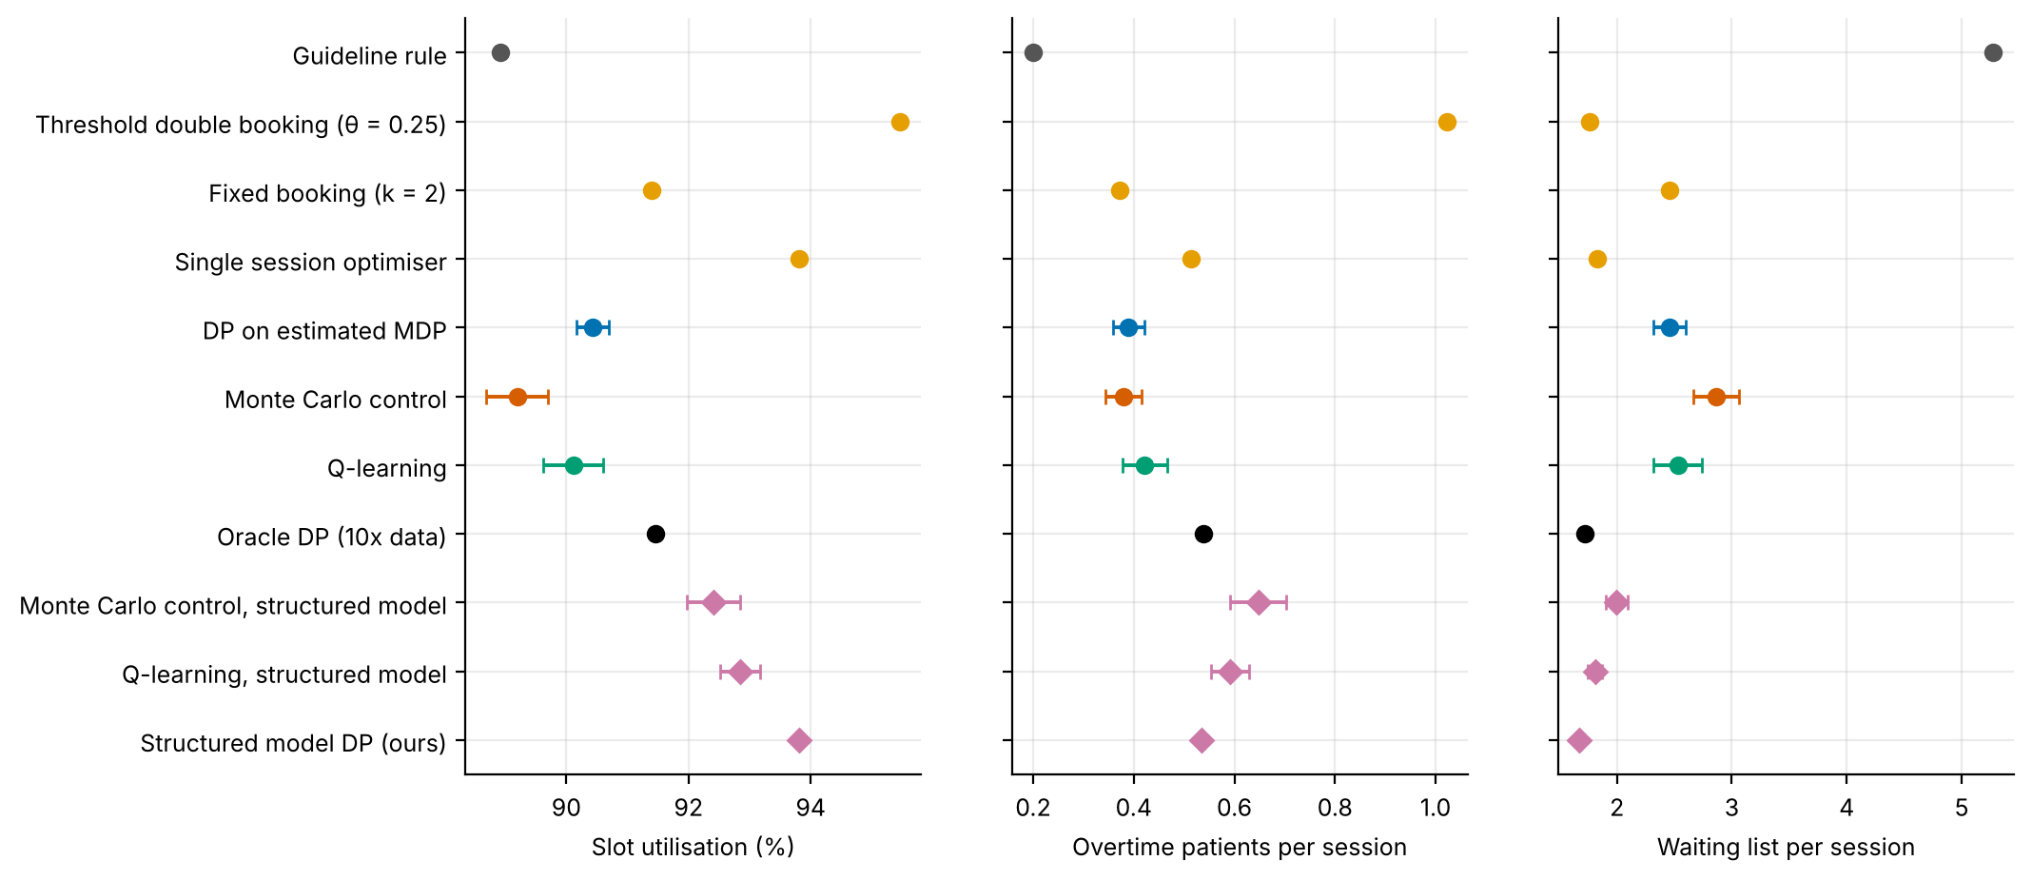
Figure 6. Utilisation of the regular slots, overtime patients and waiting list per session in comparison B (95% CI over 20 replicates; single policies have no interval). Orange: baselines from published work; diamonds: policies on the structured model.
The single session optimiser is a strong baseline: it uses each booked patient's own predicted risk, while the structured model sees only the band of the session's mean risk. The structured model is ahead because it values the waiting list it leaves for later sessions, which the optimiser counts only through the 0.3 per patient drawn today; Section 7.9 shows that this matters more when the waiting list is under pressure. Figure 6 shows the operational side. Threshold double booking uses the most regular slots (95.5%) at the cost of 40.9 overtime patients per episode, 1.6 times the next highest; the structured model uses 93.8% of the slots with 21.4 overtime patients and has the shortest waiting list of all methods (66.9 per episode against 73.1 for the single session optimiser and 211.0 for the rule).
The classifier was fitted before the drift described in Section 4.2: its mean predicted no-show probability for the test weeks is 22.0% against 19.8% observed, and the scoring sessions have 18.5%. The structured model therefore plans with risks that are slightly too high, yet it is ahead of every other method; we did not test how much a recalibrated classifier would add.

7.9 When planning across sessions matters
Table 10. True return in comparison B when the waiting list is under more pressure (10 replicates, 500 scoring episodes; 95% CI for the two DP methods, the other policies are single policies). The first row is the setting of Table 9.
Waiting cost | New patients per session | DP on estimated MDP | Best fixed booking | Single session optimiser | Structured model DP | Gain over single session optimiser
0.4 | 1.5 | 170.6 ± 1.6 | 174.5 | 181.6 | 182.0 ± 0.0 | +0.2%
1.0 | 1.5 | 144.0 ± 1.6 | 149.2 | 155.3 | 157.9 ± 0.1 | +1.7%
0.4 | 2.5 | 111.8 ± 3.0 | 160.1 | 160.0 | 168.4 ± 0.4 | +5.3%
1.0 | 2.5 | 42.3 ± 11.3 | 110.7 | 94.6 | 126.1 ± 0.1 | +33.3%

Table 10 varies the two quantities that make the waiting list costly. In the setting of Table 9 the structured model is 0.2% ahead of the single session optimiser (with 500 scoring episodes instead of 1,000). The gain grows to 1.7% when waiting costs 1.0 per patient, to 5.3% with 2.5 new patients per session, and to 33.3% with both. In that last setting the single session optimiser (94.57) falls below the best fixed booking (110.66), DP on the estimated MDP falls to 42.27 ± 11.27, and the structured model scores 126.05 ± 0.13. When the waiting list grows quickly or costs more, today's booking decides how long the list will be in later sessions, and only a policy that plans across sessions can weigh that.

7.10 Convergence of Monte Carlo and Q-learning
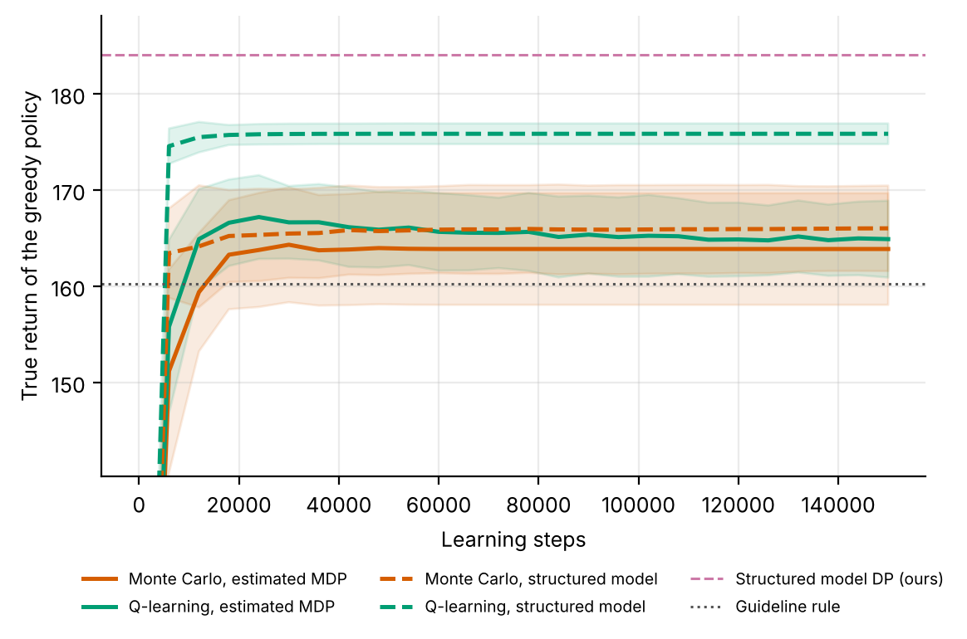
Figure 7. Comparison A: true return of the greedy policy during learning (mean ± s.d. over 20 replicates; 60 evaluation episodes per checkpoint). Solid: learners on the estimated MDP; dashed: on the structured model; pink dashed: DP on the structured model; dotted: guideline rule. The axis is cut below, so the value at step 0 is not shown.
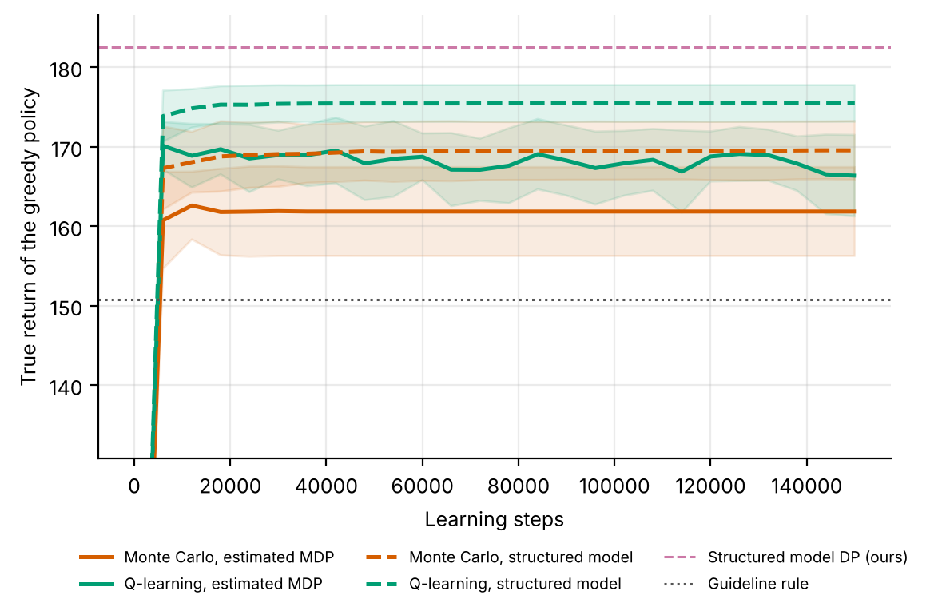
Figure 8. Comparison B: the same as Figure 7 on real clinic sessions.
Figures 7 and 8 show how MC control and Q-learning converge, on the estimated MDP and on the structured model. On the estimated MDP of comparison A, Q-learning peaks at 167.2 after 24,000 steps and ends at 164.9, and MC ends at 163.9. On the structured model Q-learning is within one unit of its final value 175.9 after 12,000 steps, while MC ends at 166.0. Comparison B shows the same order: on the structured model Q-learning ends at 175.5 and MC at 169.6, on the estimated MDP at 166.4 and 161.9. In the final scores of Tables 6 and 9, Q-learning on the structured model is ahead of Q-learning on the estimated MDP by +10.23 ± 1.60 in comparison A (p < 0.001) and +8.11 ± 2.08 in comparison B (p < 0.001). For MC the gain is +6.53 ± 3.45 in comparison B (p = 0.001) but only +0.84 ± 2.91 in comparison A (p = 0.578).
Neither learner reaches DP on the same model within 150,000 steps (184.10 in comparison A, 182.54 in comparison B), so on this problem the model matters more than the learner, and on the structured model Q-learning ends closer to the DP solution than MC in both comparisons (by 9.95 in A and 5.84 in B). A plausible reason, not tested separately, is that MC learns from the return of whole episodes of 40 sessions, whose variance is large compared with the differences between bookings (Section 3), while Q-learning updates each value from the next step.

8. Discussion
What the study shows. (1) Learners trained on 150 episodes are ahead of the overbooking rule in the true simulator by +1.9 to +6.3 units on average, with only MC clearly so (p = 0.036), while a model fitted to ten times the data is ahead by +18.7, which points to data coverage rather than the learner as the main barrier (Section 7.6 confirms it by varying the data volume). (2) On the fitted model every schedule converges to about the same value, and none reaches 90% of the possible improvement (0 of 60 runs). (3) The one clearly resolved schedule effect is that a near-greedy Q-learner learns more slowly. (4) The learned policies are ahead of the rule at the nominal rate and by a larger average margin when no-shows fall (8.0 against 4.8; all 10 of 10 configurations), and level with it when no-shows rise. (5) The coverage barrier can be removed without more data: with the clinic's rules known and only patient behaviour learned, 25 logged days gave 184.0, more than the oracle DP fitted to 1,500 days (179.0; Table 7). (6) The gain carries over to real patients: on sessions rebuilt from the Medical Appointment No Shows table the structured model is ahead of every method in Table 9, by 12.25 over DP on the estimated MDP and by 0.51 over the strongest baseline from published work. (7) That margin is small in the default setting and grows to 33% when the waiting list is under pressure (Table 10). (8) On the structured model Q-learning ends closer to the DP solution than MC in both comparisons.
What it does not show. It does not show that exploration schedules matter for final performance: the final model-scale values are all within 0.13 of the behaviour policy's, and the true-return differences across schedules are comparable to the run-to-run discrepancy for the same configuration. It does not show that the model-scale metric is a good proxy for true return; its sign disagrees with the true comparison, and its schedule ranking correlates with true return for Q-learning (+1.00) but hardly for MC (+0.30). It does not show which states drive the robustness result of Section 7.4. It does not show that a clinic knows its own rules as exactly as the structured model assumes: the slot count, the reward weights and the way extra bookings empty the waiting list are inputs, not estimates. It does not show a benefit to real patients: the real sessions replay recorded attendance, but the waiting list and the reward are still simulated. And the small margin over the single session optimiser in the default setting means that, in a quiet clinic, a good prediction model with a decision for one session at a time captures most of the gain.
Practical use. Because exploration inside a fitted model does not collect new data, practitioners should spend effort on what generates the log. A behaviour policy with deliberate variation in the number of extra bookings, run at low stakes, would give the learner support for the actions the optimum uses; the exploration schedule of the learner cannot substitute for that. A second way to reach the actions the optimum uses is to estimate less: whatever the clinic knows about its own rules need not be learned from the log. For deployment the shift study suggests a cheap sanity check: re-evaluate a learned policy against the existing rule under plausible no-show shifts and report the range, not the nominal value alone.

9. Limitations and threats to validity
- Few replicates and no intervals for shift. The schedule study uses 6 replicates (t-interval factor 1.31) and the shift table stores no intervals; the DP entry is one replicate.
- Unequal evaluation sizes. Rule and DP in the shift table use 300 evaluation episodes, the learners 120 per run; the benchmark and the schedule study use different data seeds.
- A model-scale metric. Learning efficiency is measured on the oracle model, which is pessimistic by construction for pairs with fewer than 10 observations; the AUC also contains a common step-0 offset of -0.122. The ranking of schedules on this scale need not match the ranking in the clinic.
- Exploration inside a model. The schedules sample from the fitted MDP and cannot reveal unlogged state-action pairs, so the study cannot say anything about exploration in the real environment, where a clinic would face costs of trying.
- Assumed no-show structure. The shift is a constant offset to the no-show rate; real shifts also change who is booked and the waiting-list inflow. The simulator's reward weights (3 for overtime, 0.4 for waiting) are invented.
- Known clinic rules. The structured model takes the number of slots, the reward weights and the way extra bookings empty the waiting list as known; if these are wrong, its policy is optimal for a different clinic.
- Assumed waiting list. The table has no waiting list, so the real sessions use a simulated one with the arrival rate and reward weights of Table 1; Table 10 varies two of these values, and others were not tested.
- Sessions from neighbourhood days. A session is all appointments of one neighbourhood on one day; only 9% of these have fewer than 10 bookings, so the slots filled band rarely changes and adds little to the state.
- Drift and calibration. The classifier was calibrated before the no-show rate fell, so it overstates the risk in the scoring weeks (Section 7.8).
- Baselines. The baselines from published work are simplified implementations, not the authors' code, and their threshold and k were chosen on the scoring sessions.
- Wait time. Waiting is measured by the length of the waiting list; the table records no times within a day, so the time patients spend waiting in the clinic cannot be measured.
- Simulated, not clinical, evidence. All numbers come from stylised simulators written for this study, and on real sessions from a simulation built from recorded appointments with an assumed waiting list and reward. They demonstrate how the algorithms behave when the ground truth is known; they say nothing about the safety or benefit of any treatment in people.
- State aggregation. Continuous physiology is discretised into bands. Banding makes the process only approximately Markov, and part of the gap between the DP policy on the estimated model and the true optimum is a modelling gap rather than a sampling gap.
- Fixed-horizon episodes treated as stationary. Episodes end after a fixed number of steps but the state does not always contain the clock, so the estimated model treats termination as a constant hazard. This distorts absolute model values (not true-simulator scores) and is why model-based value estimates are compared only on a common oracle model.
- Behaviour policy. The logged data come from a single ε-noisy rule. Coverage of non-rule actions is therefore thin, which is exactly the offline-RL situation, and results depend on that coverage.
- Hand-set hyper-parameters. ε schedules, step sizes and the support threshold were fixed in advance and not tuned per paper.

10. Ethical considerations and future work
Ethics. The simulator study used no human data. The real sessions come from a public appointment table [17] in which patients appear only as numeric identifiers; it was used as published, was not linked to any other source, and is not redistributed with the code. If the method were used for real bookings, three safeguards would be essential: de-identification and governance approval of the source data; a clinician-in-the-loop design in which the learned policy is advisory, with hard guardrails on unsafe actions; and prospective, randomised or at least carefully monitored evaluation before any deployment. Reinforcement learning from logs inherits the biases of the clinicians who produced them, and may under-serve groups that are under-represented in the data; subgroup performance should be reported alongside averages, including the waiting times of groups with a higher predicted no-show risk, on whom overbooking decisions may fall more often.
Future work. (1) Add an exploration-aware behaviour policy that deliberately varies the extra bookings and test whether the learners then close the gap to the oracle; (2) store per-replicate learning curves and shift results to attach intervals and paired tests; (3) evaluate the oracle and a DP policy under shift, and a policy trained on shifted data, to measure the cost of a stale model; (4) compare against a model-based safeguard such as a pessimistic penalty in the supported part of the space; (5) measure overtime and waiting from visit timestamps, which the table lacks; (6) estimate the reward weights and the waiting list dynamics from clinic records instead of assuming them; (7) let the structured model use each booked patient's own predicted risk at decision time, together with the value of the next state; (8) test the structured model in a clinic that records its overbooking decisions, where the empirical MDP and the structured model can be compared on the same real data.

11. Conclusion
On a simulated clinic, DP, MC and Q-learning trained on 150 logged days scored 162.2, 166.6 and 164.4 against 160.3 for a conservative overbooking rule and 179.0 for DP trained on ten times as much data. Five exploration schedules gave learning curves that all plateaued at the same model value: none reached 90% of the possible improvement (0 of 60), only the near-greedy Q-learner was clearly slower, and the ordering of schedules on true return differed between learners and was comparable in size to the seed-to-seed discrepancy. The learned policies lost less than the rule when no-shows fell by 0.05 (all 10 of 10 configurations were ahead) and matched it when they rose by 0.08.
The limit is the coverage of the logged data. A structured model that learns only patient behaviour and takes the clinic's rules as known scored 184.1 in the same simulator, 18.1 to 19.6 above the three learners and 5.1 above the oracle, and reached that level with 25 logged days. On clinic sessions rebuilt from the Medical Appointment No Shows table it scored 182.5 against 150.8 for the rule, 170.3 for DP on the estimated MDP and 182.0 for the best baseline from published work, and its margin over that baseline grew from 0.2% to 33.3% as the waiting list came under pressure. Q-learning came closer to the DP solution of the structured model than MC in both comparisons. These are results from a simulator and from a simulation built from real records, not evidence about real clinics.

Appendix A. Anticipated reviewer questions
The following questions are the ones a reviewer or examiner is most likely to raise. Each answer is tied to a number or figure produced by the code.
Q1. Why does no schedule reach 90% of the optimum?
The learners solve a fitted model whose DP solution is worth about 122.7 on the oracle model, against a rule value of 125.6 and an optimum of 150.0. They converge to that solution (plateaus 122.4 and 123.3), so the target is out of reach for any schedule; the limit is the support of the logged data, not exploration.
Q2. If exploration does not matter, why is near-greedy Q-learning slower?
Near-greedy Q-learning has a mean AUC of -0.54 against -0.05 for the best schedule, and a plausible reason (not tested separately) is that it tries few actions early and needs many steps to correct its initial values. That is a speed effect within a fixed model; it disappears from the final values, which are all indistinguishable from zero.
Q3. Why do the model-scale and true-simulator comparisons disagree?
The model treats rarely logged pairs as absorbing with the worst reward, so it undervalues every policy by 29 to 43 units and penalises choices the data do not support. On that scale the learners are 2.3 to 3.2 below the rule, while in the true simulator they are ahead of it. The model scale is useful for learning speed, not for deciding which policy is better.
Q4. Can we conclude that exponential decay is best for Q-learning?
No. Its true return in the schedule study (169.5) differs by 5.1 from the same configuration in the benchmark (164.4), which is comparable to the 8.3-unit spread across all five Q-learning schedules, and the same schedule is the worst for MC.
Q5. Is the robustness result a reason to deploy the learned policy?
No. It is a simulated shift of a single parameter, with no intervals, evaluated on a policy that differs from the rule in few states. It shows that the learned policies do not lose more than the rule when no-shows fall, in all 10 of 10 configurations, and nothing more.
Q6. Why does the oracle score so much more than the learners?
With 1,500 episodes the high-overbooking actions are supported (about 30 visits per pair against 3.0), and the oracle uses +3 or +4 in 26 states. The learners use them in at most 4.
Q7. Why does the structured model score more than the oracle fitted to ten times as much data?
The oracle still estimates P(s' | s, a) pair by pair, so with 1,500 days some pairs that the optimum uses remain below the support threshold and the rest carry sampling error. The structured model estimates 98 numbers that every logged session informs and computes the rest from the clinic's rules; its return varies by ±0.01 over 20 data draws.
Q8. Is the comparison fair to the learners of Section 7.1?
They receive the same logged days, the same solver for DP and the same scoring episodes. What the structured model has in addition is the clinic's rules, which Section 9 lists as a limitation: a clinic that cannot state them cannot use it.
Q9. Why is the margin over the single session optimiser so small?
In the default setting the waiting list stays short under both policies (1.83 and 1.67 patients per session), so little is left to plan for, and the optimiser uses each patient's own risk while the structured model uses a band. When the waiting list is under pressure the margin reaches 33.3% (Table 10).
Q10. Why does Q-learning come closer to the DP solution than MC?
On the structured model Q-learning ends 9.95 above MC in comparison A and 5.84 in comparison B, and in comparison A MC gains only 0.84 from the better model (p = 0.578). A plausible reason, not tested separately, is the variance of whole episode returns in MC (Section 3); DP on the same model shows that the model itself supports 184.10.
Q11. Are the outcomes in comparison B real?
Attendance is real: every patient in a scored session is a recorded appointment and comes exactly when the table says so. The waiting list, its arrivals and the reward weights are simulated, so comparison B is a simulation built from real records.

Appendix B. Reproducibility
All results of Sections 7.1 to 7.4 are produced by `python ideas.py 7` (shared library: rl_core.py, domains.py, common.py). Random seeds are fixed in the code, so a re-run reproduces every table and figure. Figure files generated by the script: fig_bars, fig_learning, fig_policies, fig_agreement, fig_schedules, fig_efficiency, fig_shift. To repeat the simulator study on a real table of logged decisions, convert it with kaggle_adapter.transitions_from_dataframe, then call build_mdp, value_iteration, mc_control and q_learning exactly as the script does; because a real table has no simulator, report model-based estimates on a held-out split and label them as estimates.
Sections 4.2, 5.2, 6.3 and 7.5 to 7.10 are produced by `python run_topic7.py` (new modules noshow_data.py, real_clinic.py and planner.py), which reuses rl_core.py, domains.py, common.py and ideas.py unchanged and reads the table from data/KaggleV2-May-2016.csv. Random seeds are fixed in the code, so a rerun reproduces every number of those sections. Figure files used here: fig_A_datasize, fig_B_metrics, fig_A_convergence, fig_B_convergence; `python run_topic7.py --figures` redraws them from the stored results.

Appendix C. Source code of the experiment
For completeness the exact source of the simulator, the experiment function and the structured model is reproduced below; it is the same code that produced every number and figure in this paper (the shared solvers value_iteration, mc_control and q_learning are in rl_core.py, and the experiment script of Sections 7.5 to 7.10, run_topic7.py, is delivered with the code package).

Clinic
class Clinic(Domain):
name = "clinic"
nA, gamma, max_steps = 5, 0.97, 40
info_keys = ["shows", "overtime", "idle", "wait"]
CAP = 10
NE = [0.12, 0.18, 0.24]
nS = 5 * 4 * 5
action_labels = [f"+{k}" for k in range(5)]
MU = np.array([0.22, 0.17, 0.17, 0.18, 0.20])

def __init__(self, shift=0.0):
self.shift = shift

def _s(self):
return (self.t % 5 * 4 + band(self.p, self.NE)) * 5 + band(self.w, [1, 3, 6, 9])

def reset(self, rng):
self.p = float(np.clip(0.18 + self.shift + rng.normal(0, 0.03), 0.02, 0.6))
self.w, self.t = int(rng.integers(0, 6)), 0
return self._s()

def step(self, k, rng):
booked = self.CAP + k
shows = int(rng.binomial(booked, 1 - self.p))
over = max(0, shows - self.CAP)
idle = max(0, self.CAP - shows)
drawn = min(self.w, k)
r = 1.0 * shows - 3.0 * over - 0.5 * idle - 0.4 * self.w + 0.3 * drawn
self.w = int(np.clip(self.w - drawn + rng.poisson(1.5), 0, 12))
mu = self.MU[self.t % 5] + self.shift
self.p = float(np.clip(0.8 * self.p + 0.2 * mu + rng.normal(0, 0.02), 0.02, 0.6))
self.t += 1
info = dict(shows=shows, overtime=over, idle=idle, wait=self.w)
return self._s(), r, self.t >= self.max_steps, info, 1

def rule(self, s):
pb = (s // 5) % 4 # conservative practice: overbook by one, or two at high no-show rates
return 1 if pb <= 1 else 2

ideas.idea7
def idea7():
I = 7; d = odir(I)
dom = Clinic()
res = standard_benchmark(dom, n_eps=150, n_oracle=1500, steps=150000, seeds=5)
standard_figs(res, dom, I, title="Clinic overbooking MDP")
T = 150000
qopt = 14.0 * (1 - dom.gamma ** 40) / (1 - dom.gamma)
SCH = {"eps=0.1 const": (lambda k, t: 0.1, 0.0), "eps exp. decay": (eps_exp, 0.0),
"GLIE 1/k": (lambda k, t: max(0.02, (t / 50.0) / (t / 50.0 + k)), 0.0),
"Optimistic init": (lambda k, t: 0.02, 0.5 * qopt), "Near-greedy (0.02)": (lambda k, t: 0.02, 0.0)}
SEEDS = 6
d_or = rollout(dom, dom.behavior, np.random.default_rng(9999), 1500); m_or = build_mdp(d_or, dom)
pi_or, _, _ = value_iteration(m_or); J_opt = J(m_or, pi_or)
J_beh = J(m_or, behavior_mode(d_or, dom))
sh = {"nominal": Clinic(0.0), "no-show +0.08": Clinic(0.08), "no-show -0.05": Clinic(-0.05)}
CUR = {a: {s: [] for s in SCH} for a in ("Q-learning", "Monte Carlo")}
FIN = {a: {s: {k: [] for k in sh} for s in SCH} for a in CUR}
for sd in range(SEEDS):
data = rollout(dom, dom.behavior, np.random.default_rng(700 + sd), 150)
m = build_mdp(data, dom); bm = behavior_mode(data, dom)
cf = (lambda p, m=m, bm=bm: J(m_or, fill_policy(p, m, bm)))
for sn, (ef, q0) in SCH.items():
for an, fn in (("Q-learning", q_learning), ("Monte Carlo", mc_control)):
p, _, c = fn(m, np.random.default_rng([sd, list(SCH).index(sn), 1]), T, eps_fn=ef, q0=q0, ckpt_fn=cf)
CUR[an][sn].append(c.tolist())
p = fill_policy(p, m, bm)
for k, sim in sh.items():
r, _ = eval_policy(sim, p, n_eps=120)
FIN[an][sn][k].append(float(r.mean()))
print("idea7 seed", sd, flush=True)
t90 = {a: {} for a in CUR}; auc = {a: {} for a in CUR}; fin = {a: {} for a in CUR}
for a in CUR:
for sn in SCH:
cs = CUR[a][sn]
tgt = J_beh + 0.9 * (J_opt - J_beh)
t90[a][sn] = steps_to_fraction(cs, tgt)
auc[a][sn] = [float(np.mean([(v[1] - J_beh) / (J_opt - J_beh) for v in c])) for c in cs]
fin[a][sn] = [float((c[-1][1] - J_beh) / (J_opt - J_beh)) for c in cs]
fig, axs = plt.subplots(1, 2, figsize=(8.0, 3.2), sharey=True)
for ax, a in zip(axs, CUR):
for i, sn in enumerate(SCH):
arr = np.array(CUR[a][sn]); x = arr[0, :, 0]
y = (arr[:, :, 1] - J_beh) / (J_opt - J_beh)
ax.plot(x, y.mean(0), color=OKABE[i], label=sn, lw=1.6)
ax.fill_between(x, y.mean(0) - y.std(0, ddof=1), y.mean(0) + y.std(0, ddof=1), color=OKABE[i], alpha=0.12)
ax.axhline(1, color="k", ls="--", lw=0.8); ax.axhline(0, color="#777777", ls=":", lw=0.8)
ax.set_title(a, fontsize=9); ax.set_xlabel("Environment steps")
axs[0].set_ylabel("Normalised value (0 = clinic behaviour, 1 = DP optimum)"); axs[0].legend(fontsize=7)
fig.savefig(f"{d}/fig_schedules.png"); plt.close(fig)
fig, axs = plt.subplots(1, 2, figsize=(8.0, 3.0))
for ai, a in enumerate(CUR):
v = [np.nanmean(t90[a][s]) / 1000 for s in SCH]
axs[0].bar(np.arange(len(SCH)) + (ai - 0.5) * 0.38, v, 0.38, color=COL[a], label=a)
axs[1].bar(np.arange(len(SCH)) + (ai - 0.5) * 0.38, [np.mean(auc[a][s]) for s in SCH], 0.38, yerr=[ci95(auc[a][s]) for s in SCH], color=COL[a], capsize=2)
for ax in axs: ax.set_xticks(range(len(SCH))); ax.set_xticklabels(list(SCH), rotation=25, ha="right", fontsize=7)
axs[0].set_ylabel("Steps (thousands) to reach 90% of optimum\n(NaN-safe mean over seeds that reach it)"); axs[1].set_ylabel("Area under learning curve (normalised)")
axs[0].legend(fontsize=7); fig.savefig(f"{d}/fig_efficiency.png"); plt.close(fig)
# shift robustness (best schedule per algorithm = eps exp)
fig, ax = plt.subplots(figsize=(5.2, 3.2))
dp_pol = fill_policy(value_iteration(build_mdp(rollout(dom, dom.behavior, np.random.default_rng(700), 150), dom))[0],
build_mdp(rollout(dom, dom.behavior, np.random.default_rng(700), 150), dom), np.array([dom.rule(s) for s in range(dom.nS)]))
rule = np.array([dom.rule(s) for s in range(dom.nS)])
shift_res = {}
for k, sim in sh.items():
shift_res[k] = {}
for nm, p in (("Rule", rule), ("DP", dp_pol)):
r, _ = eval_policy(sim, p, n_eps=300); shift_res[k][nm] = float(r.mean())
for a in CUR:
shift_res[k][a + " (eps exp)"] = float(np.mean(FIN[a]["eps exp. decay"][k]))
ks = list(sh); w = 0.2
for i, nm in enumerate(["Rule", "DP", "Q-learning (eps exp)", "Monte Carlo (eps exp)"]):
ax.bar(np.arange(len(ks)) + (i - 1.5) * w, [shift_res[k][nm] for k in ks], w, label=nm, color=[COL["Rule"], COL["DP"], COL["Q-learning"], COL["Monte Carlo"]][i])
ax.set_xticks(range(len(ks))); ax.set_xticklabels(ks); ax.set_ylabel("True return"); ax.legend(fontsize=7)
lo = min(v for k in ks for v in shift_res[k].values()); ax.set_ylim(lo * 0.9, None)
fig.savefig(f"{d}/fig_shift.png"); plt.close(fig)
out = dict(schedules=list(SCH), J_opt=J_opt, J_beh=J_beh,
t90={a: {s: [None if np.isnan(x) else float(x) for x in t90[a][s]] for s in SCH} for a in CUR},
auc={a: {s: dict(mean=float(np.mean(auc[a][s])), ci=ci95(auc[a][s])) for s in SCH} for a in CUR},
final={a: {s: dict(mean=float(np.mean(fin[a][s])), ci=ci95(fin[a][s])) for s in SCH} for a in CUR},
shift={a: {s: {k: float(np.mean(FIN[a][s][k])) for k in sh} for s in SCH} for a in CUR}, shift_ref=shift_res,
reach_rate={a: {s: float(np.mean(~np.isnan(t90[a][s]))) for s in SCH} for a in CUR}, standard=summarize(res))
save_json(I, "results", dict(out, extra=drop_models(res)))
return out

rl_core: shared solvers
def build_mdp(data, dom, weights=None, chan=None, min_n=10, term_prior=1.0):
"""Empirical (maximum-likelihood) MDP from logged transitions.
(s,a) pairs observed fewer than min_n times are completed pessimistically: they go
to the absorbing terminal state with the worst reward seen in the data."""
nS, nA = dom.nS, dom.nA
T = nS
w = np.ones(len(data["s"])) if weights is None else np.asarray(weights, float)
s, a = data["s"], data["a"]
s2 = np.where(data["done"] > 0, T, data["s2"])
N = np.zeros((nS + 1, nA, nS + 1))
np.add.at(N, (s, a, s2), w)
n = N.sum(2)
Rsum = np.zeros((nS + 1, nA))
np.add.at(Rsum, (s, a), w * data["r"])
Gsum = np.zeros((nS + 1, nA, nS + 1))
np.add.at(Gsum, (s, a, s2), w * dom.gamma ** data["dur"])
m = MDP()
m.nS, m.nA, m.gamma = nS, nA, dom.gamma
m.n = n
m.N = N
seen = n >= min_n # support constraint: thinly observed (s,a) are completed pessimistically
n_eff = n + term_prior # one pseudo-observation of absorption guards against 'immortal' loops
P = np.zeros_like(N)
P[seen] = N[seen] / n_eff[seen][:, None]
P[seen, T] += term_prior / n_eff[seen]
G = np.full_like(N, dom.gamma)
nz = N > 0
G[nz] = Gsum[nz] / N[nz]
R = np.zeros((nS + 1, nA))
R[seen] = Rsum[seen] / n_eff[seen]
rmin = float(data["r"].min())
m.rmin, m.rmax = rmin, float(data["r"].max())
P[~seen, T] = 1.0
R[~seen] = rmin
P[T, :, :] = 0.0
P[T, :, T] = 1.0
R[T, :] = 0.0
m.P, m.G, m.R = P, G, R
m.PG = P * G
# reward channels
m.Rc = {}
for c in (chan if chan is not None else dom.chan):
cs = np.zeros((nS + 1, nA))
np.add.at(cs, (s, a), w * data[c])
cr = np.zeros((nS + 1, nA))
cr[seen] = cs[seen] / n_eff[seen]
m.Rc[c] = cr
# start distribution = first state of every episode
first = data["t"] == 0
mu = np.bincount(data["s"][first], minlength=nS + 1).astype(float)
m.mu = mu / mu.sum()
m.visits = (n * seen).sum(1)[:nS]
m.seen = seen
m.Rsum = Rsum
return m

def value_iteration(m, R=None, mask=None, tol=1e-9, max_iter=20000, penalty=None):
R = m.R if R is None else R
if penalty is not None:
R = R - penalty
V = np.zeros(m.nS + 1)
for _ in range(max_iter):
Q = _q(m, V, R)
if mask is not None:
Q = np.where(mask, Q, -1e18)
Vn = Q.max(1)
Vn[m.nS] = 0.0
if np.abs(Vn - V).max() < tol:
V = Vn
break
V = Vn
Q = _q(m, V, R)
if mask is not None:
Q = np.where(mask, Q, -1e18)
pi = Q.argmax(1)[:m.nS]
return pi, V, Q

def q_learning(m, rng, steps, eps_fn=eps_exp, alpha0=1.0, alpha_min=0.02,
q0=0.0, mask=None, n_ckpt=25, max_len=200, ckpt_fn=None):
nS, nA = m.nS, m.nA
ckpt_fn = ckpt_fn or (lambda p: J(m, p))
Q = np.full((nS + 1, nA), q0)
Q[nS] = 0.0
cnt = np.zeros((nS + 1, nA))
smp = Sampler(m, rng)
ck = np.unique(np.linspace(0, steps, n_ckpt + 1).astype(int))
curve = []
s, ep_t = smp.start(), 0
ci = 0
for k in range(steps + 1):
if ci < len(ck) and k == ck[ci]:
pi = np.array([_greedy(Q, x, mask) for x in range(nS)])
curve.append((k, ckpt_fn(pi)))
ci += 1
if k == steps:
break
if rng.random() < eps_fn(k, steps):
a = _explore(rng, s, nA, mask)
else:
a = _greedy(Q, s, mask)
s2, r, g = smp.step(s, a)
tgt = r + (0.0 if s2 == nS else g * Q[s2].max() if mask is None
else g * np.where(mask[s2], Q[s2], -1e18).max())
cnt[s, a] += 1
al = max(alpha_min, alpha0 / (1.0 + cnt[s, a] ** 0.7))
Q[s, a] += al * (tgt - Q[s, a])
ep_t += 1
if s2 == nS or ep_t >= max_len:
s, ep_t = smp.start(), 0
else:
s = s2
pi = np.array([_greedy(Q, x, mask) for x in range(nS)])
return pi, Q, np.array(curve)

def mc_control(m, rng, steps, eps_fn=eps_exp, q0=0.0, mask=None, n_ckpt=25,
max_len=200, ckpt_fn=None):
"""first-visit Monte Carlo control with epsilon-soft behaviour policy and
incremental-average updates."""
nS, nA = m.nS, m.nA
ckpt_fn = ckpt_fn or (lambda p: J(m, p))
Q = np.full((nS + 1, nA), q0)
Q[nS] = 0.0
N = np.zeros((nS + 1, nA))
smp = Sampler(m, rng)
ck = np.unique(np.linspace(0, steps, n_ckpt + 1).astype(int))
curve = []
used, ci = 0, 0
while True:
while ci < len(ck) and used >= ck[ci]:
pi = np.array([_greedy(Q, x, mask) for x in range(nS)])
curve.append((ck[ci], ckpt_fn(pi)))
ci += 1
if used >= steps:
break
s = smp.start()
traj = []
for _ in range(max_len):
if rng.random() < eps_fn(used + len(traj), steps):
a = _explore(rng, s, nA, mask)
else:
a = _greedy(Q, s, mask)
s2, r, g = smp.step(s, a)
traj.append((s, a, r, g))
s = s2
if s2 == nS:
break
used += len(traj)
# returns, backwards; first-visit
Gret = 0.0
rets = []
for (s_, a_, r_, g_) in reversed(traj):
Gret = r_ + g_ * Gret
rets.append(Gret)
rets.reverse()
seen = set()
for (s_, a_, _, _), G_ in zip(traj, rets):
if (s_, a_) in seen:
continue
seen.add((s_, a_))
N[s_, a_] += 1
Q[s_, a_] += (G_ - Q[s_, a_]) / N[s_, a_]
pi = np.array([_greedy(Q, x, mask) for x in range(nS)])
return pi, Q, np.array(curve)

planner: structured model
def session_value(q_reg, k, q_ext, cap=10):
"""expected shows - 3 x overtime - 0.5 x idle for one session.
q_reg: show-up probabilities of the booked patients; k extra patients each showing with prob q_ext.
Exact (Poisson-binomial) distribution of the number of patients who show."""
dist = np.array([1.0])
for q in np.concatenate([np.asarray(q_reg, float), np.full(k, q_ext)]):
dist = np.convolve(dist, [1 - q, q])
n = np.arange(len(dist))
return float((dist * (n - 3 * np.maximum(0, n - cap) - 0.5 * np.maximum(0, cap - n))).sum())

def waiting_list_model(data, wmax=12):
"""from the logged waiting-list lengths: arrival rate per session and which exact lengths sit in each band"""
ep, a, wait = data["ep"], data["a"], data["wait"].astype(int)
prev = np.full(len(a), -1)
same = np.r_[False, ep[1:] == ep[:-1]]
prev[same] = wait[:-1][same[1:]]
ok = (prev >= 0) & (wait < wmax) # skip the first session and capped lists
lam = float(np.mean(wait[ok] - (prev[ok] - np.minimum(prev[ok], a[ok]))))
Pw = np.zeros((5, wmax + 1))
for w in prev[prev >= 0]:
Pw[band(w, WAIT_E), w] += 1
for b in range(5): # bands never seen: spread evenly over their lengths
if Pw[b].sum() == 0:
Pw[b, [w for w in range(wmax + 1) if band(w, WAIT_E) == b]] = 1
return lam, Pw / Pw.sum(1, keepdims=True)

def waiting_step(Pw_row, k, lam, wait_cost, wmax=12):
"""expected waiting-list part of the reward and the distribution of the next waiting band,
given the distribution of the current exact length (Pw_row) and k extra bookings"""
pois = stats.poisson.pmf(np.arange(30), lam); pois[-1] += 1 - pois.sum()
r, nxt = 0.0, np.zeros(5)
for w, pw in enumerate(Pw_row):
if pw == 0:
continue
dr = min(w, k)
r += pw * (-wait_cost * w + 0.3 * dr)
for A, pa in enumerate(pois):
nxt[band(min(wmax, w - dr + A), WAIT_E)] += pw * pa
return r, nxt

def clinic_model(data, dom, wait_cost=0.4):
"""structured model of the Clinic simulator (state = weekday x no-show band x waiting band), from the logs only"""
nS, nA = dom.nS, dom.nA
d_, rest = np.divmod(data["s"], 20)
pb_ = rest // 5
pb2 = (data["s2"] % 20) // 5
booked = 10 + data["a"]
q = np.array([data["shows"][pb_ == b].sum() / max(booked[pb_ == b].sum(), 1) for b in range(4)])
Tp = np.full((5, 4, 4), 0.25) # weak prior: a quarter pseudo-count per cell
np.add.at(Tp, (d_, pb_, pb2), 1.0)
Tp /= Tp.sum(2, keepdims=True)
lam, Pw = waiting_list_model(data)
sess = {(b, k): session_value(np.full(10, q[b]), k, q[b]) for b in range(4) for k in range(nA)}
R = np.zeros((nS + 1, nA)); P = np.zeros((nS + 1, nA, nS + 1))
for s in range(nS):
d, rest = divmod(s, 20)
pb, wb = divmod(rest, 5)
nd = (d + 1) % 5
for k in range(nA):
rw, wnext = waiting_step(Pw[wb], k, lam, wait_cost)
R[s, k] = sess[(pb, k)] + rw
P[s, k, nd * 20: nd * 20 + 20] = np.outer(Tp[d, pb], wnext).ravel()
m = _finish(P, R, nS, nA, dom.gamma, _start_dist(data, nS))
m.est = dict(show_up=q.tolist(), arrivals=lam)
return m

def real_model(data, dom, q_extra):
"""structured model of the real-data clinic (state = slots filled x risk band x waiting band).
Session part: from the classifier's predicted risk of the patients logged in each (slots, risk) cell.
Next session: today's session does not change tomorrow's patients, so the next (slots, risk) cell is
drawn from the logged frequencies; the waiting band follows the waiting-list model."""
nS, nA = dom.nS, dom.nA
sb_, rest = np.divmod(data["s"], 20)
rb_ = rest // 5
cell = sb_ * 4 + rb_
n_reg, p_mean = data["booked"] - data["a"], data["p_reg_mean"]
freq = np.bincount(cell, minlength=12).astype(float) + 0.5
freq /= freq.sum()
sess = np.zeros((12, nA))
for c in range(12):
idx = np.flatnonzero(cell == c)
if len(idx) == 0: # unseen cell: use every logged session
idx = np.arange(len(cell))
idx = idx[:400]
for k in range(nA):
sess[c, k] = np.mean([session_value(np.full(int(n_reg[i]), 1 - p_mean[i]), k, q_extra) for i in idx])
lam, Pw = waiting_list_model(data)
R = np.zeros((nS + 1, nA)); P = np.zeros((nS + 1, nA, nS + 1))
for s in range(nS):
c, wb = divmod(s, 5)
for k in range(nA):
rw, wnext = waiting_step(Pw[wb], k, lam, dom.wait_cost)
R[s, k] = sess[c, k] + rw
P[s, k, :nS] = np.outer(freq, wnext).ravel()
m = _finish(P, R, nS, nA, dom.gamma, _start_dist(data, nS))
m.est = dict(arrivals=lam, q_extra=q_extra, cell_freq=freq.tolist())
m.lam, m.Pw, m.freq = lam, Pw, freq
return m

real_clinic.RealClinic
class RealClinic(Domain):
name = "real clinic"
nA, gamma, max_steps, CAP = 5, 0.97, 40, 10
nS = 3 * 4 * 5
info_keys = ["shows", "overtime", "idle", "wait", "booked", "drawn", "p_reg_mean"]
action_labels = [f"+{k}" for k in range(5)]

def __init__(self, sessions, pool, risk_edges, lam=1.5, wait_cost=0.4):
self.sessions, self.pool, self.RE = sessions, pool, np.asarray(risk_edges)
self.lam, self.wait_cost = lam, wait_cost

# ----------------------------------------------------------------- state
def _draw(self, rng):
"""pick today's real session and the real patients who would come off the waiting list"""
d = self.t % 5
p, y = self.sessions[d][rng.integers(len(self.sessions[d]))]
o = rng.permutation(len(p))[:self.CAP]
self.p_reg, self.y_reg = p[o], y[o] # regular slots (up to 10)
pp, yy = self.pool[d]
e = rng.integers(len(pp), size=self.nA - 1)
self.p_ext, self.y_ext = pp[e], yy[e] # up to 4 extra patients
self.n_reg = len(o)

def _s(self):
sb = band(self.n_reg, SLOT_E)
rb = int(np.searchsorted(self.RE, self.p_reg.mean(), side="right"))
return (sb * 4 + rb) * 5 + band(self.w, WAIT_E)

@staticmethod
def decode(s):
sb, rest = divmod(s, 20)
rb, wb = divmod(rest, 5)
return sb, rb, wb

# ----------------------------------------------------------------- dynamics
def reset(self, rng):
self.t, self.w = 0, int(rng.integers(0, 6))
self._draw(rng)
return self._s()

def step(self, k, rng):
shows = int((1 - self.y_reg).sum() + (1 - self.y_ext[:k]).sum())
over, idle = max(0, shows - self.CAP), max(0, self.CAP - shows)
drawn = min(self.w, k)
r = 1.0 * shows - 3.0 * over - 0.5 * idle - self.wait_cost * self.w + 0.3 * drawn
self.w = int(np.clip(self.w - drawn + rng.poisson(self.lam), 0, 12))
self.t += 1
info = dict(shows=shows, overtime=over, idle=idle, wait=self.w, booked=self.n_reg + k, drawn=drawn,
p_reg_mean=float(self.p_reg.mean()))
self._draw(rng)
return self._s(), r, self.t >= self.max_steps, info, 1

def rule(self, s):
"""the overbooking rule of domains.Clinic, read on this state: +1 when predicted no-shows are low, otherwise +2"""
return 1 if self.decode(s)[1] <= 1 else 2

noshow_data: classifier and sessions
def fit_predictor(df):
"""gradient-boosted trees + isotonic calibration; returns the test part with a column p (predicted no-show)"""
fit, cal, test = df[df.AD < CAL_START], df[(df.AD >= CAL_START) & (df.AD < TEST_START)], df[df.AD >= TEST_START].copy()
clf = HistGradientBoostingClassifier(max_iter=300, learning_rate=0.05,
categorical_features=[FEATURES.index("nb")], random_state=0)
clf.fit(fit[FEATURES], fit["y"])
iso = IsotonicRegression(out_of_bounds="clip").fit(clf.predict_proba(cal[FEATURES])[:, 1], cal["y"])
raw = clf.predict_proba(test[FEATURES])[:, 1]
test["p"] = iso.predict(raw)
info = dict(n_fit=len(fit), n_cal=len(cal), n_test=len(test),
auc_test=float(roc_auc_score(test["y"], raw)),
mean_pred=float(test["p"].mean()), mean_obs=float(test["y"].mean()),
brier=float(np.mean((test["p"] - test["y"]) ** 2)))
return test, info

def build_sessions(test, min_size=5):
"""sessions[d] = list of (p, y) arrays for every neighbourhood-day on weekday d with >= min_size appointments;
pool[d] = (p, y) of all appointments on weekday d (patients pulled in from the waiting list are drawn from it)"""
sessions, pool = {d: [] for d in range(5)}, {}
for (nb, ad), g in test.groupby(["Neighbourhood", "AD"]):
if len(g) >= min_size:
sessions[ad.dayofweek].append((g["p"].to_numpy(), g["y"].to_numpy()))
for d in range(5):
g = test[test.dow == d]
pool[d] = (g["p"].to_numpy(), g["y"].to_numpy())
return sessions, pool

References
[1] Gupta, D. and Denton, B. Appointment scheduling in health care: challenges and opportunities. IIE Transactions 40(9):800-819, 2008.
[2] Zacharias, C. and Pinedo, M. Appointment scheduling with no-shows and overbooking. Production and Operations Management 23(5):788-801, 2014.
[3] Sutton, R. S. and Barto, A. G. Reinforcement Learning: An Introduction, 2nd ed. MIT Press, 2018.
[4] Singh, S., Jaakkola, T., Littman, M. L. and Szepesvari, C. Convergence results for single-step on-policy reinforcement-learning algorithms. Machine Learning 38(3):287-308, 2000.
[5] Brafman, R. I. and Tennenholtz, M. R-max - a general polynomial time algorithm for near-optimal reinforcement learning. Journal of Machine Learning Research 3:213-231, 2002.
[6] Topuz, K., Urban, T. L., Russell, R. A. and Yildirim, M. B. Decision support system for appointment scheduling and overbooking under patient no-show behavior. Annals of Operations Research 342(1):845-873, 2024.
[7] Amalina, N. N. and An, H. Adaptive double-booking strategy for outpatient scheduling using multi-objective reinforcement learning. arXiv:2603.07270, 2026.
[8] Watkins, C. J. C. H. and Dayan, P. Q-learning. Machine Learning 8(3-4):279-292, 1992.
[9] Even-Dar, E. and Mansour, Y. Learning rates for Q-learning. Journal of Machine Learning Research 5:1-25, 2003.
[10] Levine, S., Kumar, A., Tucker, G. and Fu, J. Offline reinforcement learning: tutorial, review, and perspectives on open problems. arXiv:2005.01643, 2020.
[11] Jin, Y., Yang, Z. and Wang, Z. Is pessimism provably efficient for offline RL? Proceedings of the 38th International Conference on Machine Learning (ICML), 2021.
[12] Kumar, A., Zhou, A., Tucker, G. and Levine, S. Conservative Q-learning for offline reinforcement learning. Advances in Neural Information Processing Systems 33, 2020.
[13] Boutilier, C., Dearden, R. and Goldszmidt, M. Stochastic dynamic programming with factored representations. Artificial Intelligence 121(1-2):49-107, 2000.
[14] Bellman, R. Dynamic Programming. Princeton University Press, 1957.
[15] Puterman, M. L. Markov Decision Processes: Discrete Stochastic Dynamic Programming. Wiley, 1994.
[16] Singh, S. P. and Sutton, R. S. Reinforcement learning with replacing eligibility traces. Machine Learning 22:123-158, 1996.
[17] Hoppen, J. Medical appointment no shows. Kaggle dataset, kaggle.com/datasets/joniarroba/noshowappointments, 2016.
[18] Friedman, J. H. Greedy function approximation: a gradient boosting machine. Annals of Statistics 29(5):1189-1232, 2001.
[19] Zadrozny, B. and Elkan, C. Transforming classifier scores into accurate multiclass probability estimates. Proceedings of the 8th ACM SIGKDD International Conference on Knowledge Discovery and Data Mining (KDD), 2002.
[20] Pedregosa, F. et al. Scikit-learn: machine learning in Python. Journal of Machine Learning Research 12:2825-2830, 2011.

