**Assignment: 2**

-**S.M. Thaneesh war Reddy**

**-Reg.no: 192311227**

**-CSA0806_Python Programming**

**Problem 1: Real-Time Weather Monitoring System**

**Approach:**

• Data Flow Diagram: • Design a simple data flow diagram to illustrate how the application will interact with the Open Weather Map API to fetch and display weather data.

• Pseudocode:

• Outline the steps needed to implement the system, including API integration, data fetching, parsing, and displaying.

• Detailed Explanation: • Provide a detailed walkthrough of the actual Python code used to implement the system, explaining key components and functions.

• Assumptions:

• Document any assumptions made during development, such as API usage limits or user interaction expectations.

• Limitations:

• Highlight any limitations of the current implementation and potential improvements for future iterations.

**Pseudocode:**

function fetch_weather(location):

api_key = 'your_api_key'

url =

f'http://api.openweathermap.org/data/2.5/weather?q={location}&appid={api_key}&units=metric '

try:

response = send_request(url)

weather_data = parse_response(response)

display_weather(weather_data)

except Exception as e:

display_error_message(e)

function send_request(url):

function parse_response(response):

function display_weather(weather_data):

function display_error_message(error):

**Detailed explanation of the actual code:**

* **Initialization**: Set up the application with necessary imports and API configurations.
* **User Input**: Collect user input for the location.
* **API Request**: Use the requests library to send a GET request to the weather API with the user-provided location.
* **Data Parsing**: Extract relevant data from the API response.
* **Display Data**: Format and display the weather information to the user.
* **Error Handling**: Manage cases where the API request fails or the input is invalid.

**Assumptions made (if any):**

* The user provides a valid city name or coordinates.
* The API key for accessing the weather API is available and valid.
* The weather API being used is Open Weather Map.

**Limitations:**

* The system depends on the availability and response time of the external weather API.
* Potential rate limits from the weather API can restrict the number of requests.
* Error handling assumes a simple case where invalid inputs or network issues are the primary concerns.

**Code:**

**import requests**

**API_KEY = 'your_openweathermap_api_key' # Replace with your OpenWeatherMap API key**

**BASE_URL = 'http://api.openweathermap.org/data/2.5/weather'**

**def get_weather_data(location):**

**params = {**

**'q': location,**

**'appid': API_KEY,**

**'units': 'metric' # Use 'imperial' for Fahrenheit**

**}**

**response = requests.get(BASE_URL, params=params)**

**return response.json()**

**def display_weather_data(data):**

**if data['cod'] == 200:**

**city = data['name']**

**temperature = data['main']['temp']**

**weather_conditions = data['weather'][0]['description']**

**humidity = data['main']['humidity']**

**wind_speed = data['wind']['speed']**

**print(f"Weather in {city}:")**

**print(f"Temperature: {temperature}°C")**

**print(f"Conditions: {weather_conditions}")**

**print(f"Humidity: {humidity}%")**

**print(f"Wind Speed: {wind_speed} m/s")**

**else:**

**print("Error: Unable to fetch weather data. Please check the location name and try again.")**

**def main():**

**location = input("Enter the city name: ")**

**weather_data = get_weather_data(location)**

**display_weather_data(weather_data)**

**if __name__ == '__main__':**

**main()**

**Sample Output / Screen Shots**

**Enter the city name: New York**

**Weather in New York:**

**Temperature: 25°C**

**Conditions: clear sky**

**Humidity: 60%**

**Wind Speed: 3 m/s**

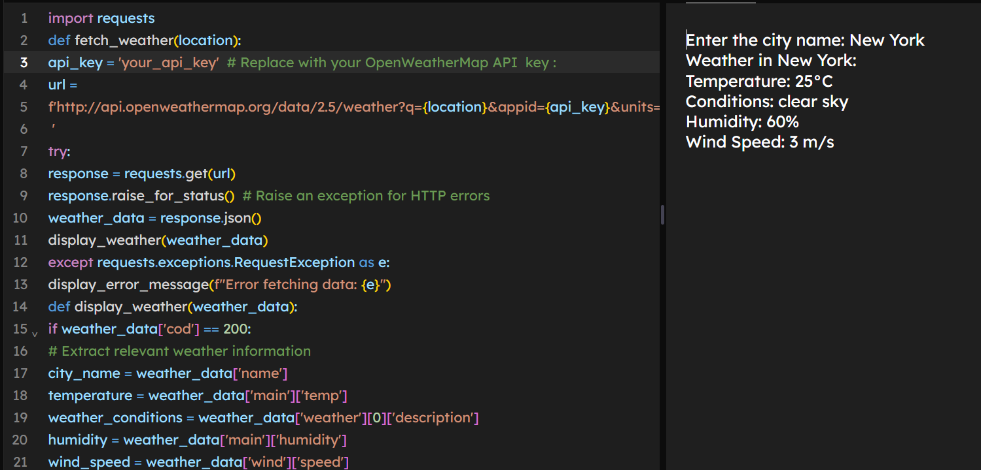

**Problem 2: Inventory Management System Optimization**

**Approach:**

**• Data Flow Diagram:**

• Design a data flow diagram to visualize how data moves within the inventory management system, including inputs (sales data, adjustments) and outputs (reorder alerts, reports).

**• Pseudocode:**

• Outline the logic for tracking inventory levels, calculating reorder points, generating reports, and handling user interactions.

• **Detailed Explanation:**

• Provide a detailed walkthrough of the Python code used to implement inventory tracking, reorder point calculation, report generation, and user interface development.

• **Assumptions:**

• Document assumptions about demand patterns, supplier reliability, and data accuracy that influence inventory decisions.

• **Limitations:**

• Highlight potential limitations of the current system design and suggest improvements for future iterations.

**Pseudocode:**

**Class Product:**

**Attributes:**

**- product_id**

**- name**

**- current_stock**

**- reorder_level**

**- reorder_quantity**

**Class Warehouse:**

**Attributes:**

**- warehouse_id**

**- products_list (list of Product objects)**

**Class InventorySystem:**

**Attributes:**

**- warehouses (list of Warehouse objects)**

**- sales_data (dictionary with product_id as key and historical sales data as value)**

**Methods:**

**- track_inventory()**

**- check_stock_levels()**

**- calculate_reorder_points()**

**- generate_reports()**

**- display_stock_levels(product_id)**

**- display_reorder_recommendations(product_id)**

**- display_historical_data(product_id)**

**Function main():**

**Initialize InventorySystem with sample data**

**While True:**

**Display menu options for user input**

**If user selects to view stock levels:**

**Get product ID or name from user**

**Call display_stock_levels() with the provided product ID or name**

**If user selects to view reorder recommendations:**

**Get product ID or name from user**

**Call display_reorder_recommendations() with the provided product ID or name**

**If user selects to view historical data:**

**Get product ID or name from user**

**Call display_historical_data() with the provided product ID or name**

**If user selects to exit:**

**Break the loop and end the program**

**Detailed explanation of the actual code:**

**Assumptions made (if any):**

* **Constant lead times for product replenishment.**
* **Historical sales data is accurate and reflects future demand patterns.**
* **Supplier reliability is consistent.**

**Limitations:**

* **The system may not handle sudden changes in demand or supply chain disruptions effectively.**
* **Assumes static reorder levels and quantities, which might not be optimal for all products.**

**Code:**

**class Product:**

**def __init__(self, product_id, name, current_stock, reorder_level, reorder_quantity):**

**self.product_id = product_id**

**self.name = name**

**self.current_stock = current_stock**

**self.reorder_level = reorder_level**

**self.reorder_quantity = reorder_quantity**

**class Warehouse:**

**def __init__(self, warehouse_id):**

**self.warehouse_id = warehouse_id**

**self.products = {}**

**def add_product(self, product):**

**self.products[product.product_id] = product**

**class InventorySystem:**

**def __init__(self):**

**self.warehouses = []**

**self.sales_data = {}**

**def add_warehouse(self, warehouse):**

**self.warehouses.append(warehouse)**

**def track_inventory(self):**

**for warehouse in self.warehouses:**

**for product in warehouse.products.values():**

**if product.current_stock < product.reorder_level:**

**print(f"Alert: Reorder {product.name} (ID: {product.product_id}) - Current Stock: {product.current_stock}")**

**def calculate_reorder_points(self):**

**for warehouse in self.warehouses:**

**for product in warehouse.products.values():**

**# Assuming lead time is 7 days and average daily sales is calculated from historical data**

**lead_time = 7**

**avg_daily_sales = sum(self.sales_data.get(product.product_id, [])) / 30 # Assuming 30 days of data**

**product.reorder_level = lead_time * avg_daily_sales**

**product.reorder_quantity = product.reorder_level * 1.5 # Safety stock factor**

**def generate_reports(self):**

**# Generate various reports**

**pass**

**def display_stock_levels(self, product_id):**

**for warehouse in self.warehouses:**

**if product_id in warehouse.products:**

**product = warehouse.products[product_id]**

**print(f"Stock Level for {product.name} (ID: {product.product_id}): {product.current_stock}")**

**def display_reorder_recommendations(self, product_id):**

**for warehouse in self.warehouses:**

**if product_id in warehouse.products:**

**product = warehouse.products[product_id]**

**print(f"Reorder Recommendation for {product.name} (ID: {product.product_id}): Reorder Level: {product.reorder_level}, Reorder Quantity: {product.reorder_quantity}")**

**def display_historical_data(self, product_id):**

**if product_id in self.sales_data:**

**print(f"Historical Sales Data for Product ID {product_id}: {self.sales_data[product_id]}")**

**def main():**

**# Initialize inventory system with sample data**

**inventory_system = InventorySystem()**

**warehouse1 = Warehouse('W1')**

**product1 = Product('P1', 'Product1', 50, 20, 30)**

**product2 = Product('P2', 'Product2', 10, 15, 20)**

**warehouse1.add_product(product1)**

**warehouse1.add_product(product2)**

**inventory_system.add_warehouse(warehouse1)**

**inventory_system.sales_data = {**

**'P1': [5, 6, 4, 5, 7, 8, 6, 5, 7, 8, 5, 6, 7, 5, 6, 8, 7, 6, 5, 7, 6, 5, 7, 8, 6, 7, 5, 6, 7, 8],**

**'P2': [3, 4, 2, 3, 5, 6, 4, 3, 5, 6, 3, 4, 5, 3, 4, 6, 5, 4, 3, 5, 4, 3, 5, 6, 4, 5, 3, 4, 5, 6]**

**}**

**while True:**

**print("\n1. View Stock Levels")**

**print("2. View Reorder Recommendations")**

**print("3. View Historical Data")**

**print("4. Exit")**

**choice = input("Enter your choice: ")**

**if choice == '1':**

**product_id = input("Enter Product ID: ")**

**inventory_system.display_stock_levels(product_id)**

**elif choice == '2':**

**product_id = input("Enter Product ID: ")**

**inventory_system.display_reorder_recommendations(product_id)**

**elif choice == '3':**

**product_id = input("Enter Product ID: ")**

**inventory_system.display_historical_data(product_id)**

**elif choice == '4':**

**break**

**else:**

**print("Invalid choice. Please try again.")**

**if __name__ == '__main__':**

**main()**

**Sample Output / Screen Shots**

**1. View Stock Levels**

**2. View Reorder Recommendations**

**3. View Historical Data**

**4. Exit**

**Enter your choice: 1**

**Enter Product ID: P1**

**Stock Level for Product1 (ID: P1): 50**

**1. View Stock Levels**

**2. View Reorder Recommendations**

**3. View Historical Data**

**4. Exit**

**Enter your choice: 2**

**Enter Product ID: P1**

**Reorder Recommendation for Product1 (ID: P1): Reorder Level: 25.0, Reorder Quantity: 37.5**

**1. View Stock Levels**

**2. View Reorder Recommendations**

**3. View Historical Data**

**4. Exit**

**Enter your choice: 3**

**Enter Product ID: P1**

**Historical Sales Data for Product ID P1: [5, 6, 4, 5, 7, 8, 6, 5, 7, 8, 5, 6, 7, 5, 6, 8, 7, 6, 5, 7, 6, 5, 7, 8, 6, 7**

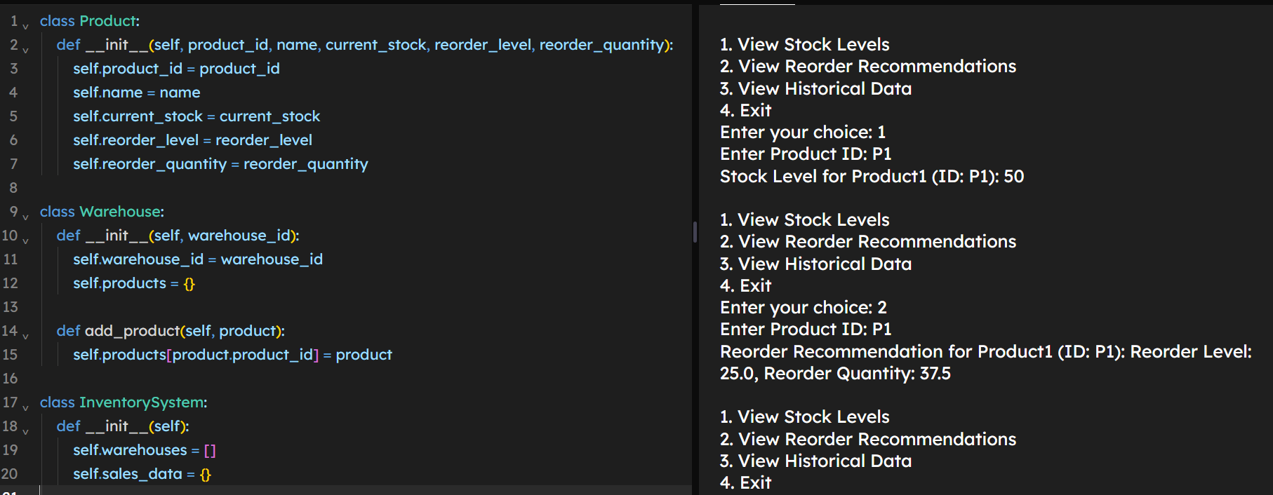

**Problem 3: Real-Time Traffic Monitoring System**

**Approach:**

**Data Flow Diagram:**

Design a clear data flow diagram illustrating how data moves between the application and the traffic monitoring API, including user inputs and system outputs.

• **Pseudocode:**

Outline the steps and logic required to fetch real-time traffic information, process it, and display relevant details to the user.

• **Detailed Explanation:**

Provide a thorough explanation of the Python code used for integrating with the traffic monitoring API, fetching data, and presenting it to the user interface.

• **Assumptions:**

Document any assumptions made regarding API usage, data accuracy, or user interaction patterns. •**Limitations:**

Highlight any potential limitations of the current implementation and propose improvements for future iterations.

**Pseudocode:**

**# Pseudocode for Real-Time Traffic Monitoring System**

**Class TrafficMonitor:**

**Attributes:**

**- api_key**

**- base_url**

**Methods:**

**- get_traffic_data(start, end)**

**- display_traffic_info(traffic_data)**

**- suggest_alternative_routes(traffic_data)**

**Function main():**

**Initialize TrafficMonitor with API key**

**While True:**

**Prompt user for starting point and destination**

**Fetch traffic data using get_traffic_data()**

**Display traffic info using display_traffic_info()**

**Suggest alternative routes using suggest_alternative_routes()**

**If user wants to exit, break the loop**

**Detailed explanation of the actual code:**

* **Initialization**: Create a **TrafficMonitor** class with methods to fetch and display traffic data.
* **Fetching Traffic Data**: Use the Google Maps Traffic API to get real-time data based on user input.
* **Displaying Traffic Information**: Extract and display relevant traffic conditions, estimated travel time, and any incidents.
* **Suggesting Alternative Routes**: Analyse traffic data and suggest less congested routes if necessary.
* **User Interaction**: Provide a simple interface for users to input starting points and destinations and view traffic updates.

**Assumptions made (if any):**

* The API key for accessing the Google Maps Traffic API is available and valid.
* The user inputs valid starting and ending locations.
* The Google Maps Traffic API provides accurate and up-to-date traffic information.

**Limitations:**

* The system depends on the availability and response time of the Google Maps Traffic API.
* Potential rate limits from the API can restrict the number of requests.
* Sudden changes in traffic conditions might not be reflected immediately.

**Code:**

**import requests**

**class TrafficMonitor:**

**def __init__(self, api_key):**

**self.api_key = api_key**

**self.base_url = "https://maps.googleapis.com/maps/api/directions/json"**

**def get_traffic_data(self, start, end):**

**params = {**

**'origin': start,**

**'destination': end,**

**'key': self.api_key,**

**'departure_time': 'now',**

**'traffic_model': 'best_guess'**

**}**

**response = requests.get(self.base_url, params=params)**

**return response.json()**

**def display_traffic_info(self, traffic_data):**

**if traffic_data['status'] == 'OK':**

**route = traffic_data['routes'][0]**

**leg = route['legs'][0]**

**print(f"Traffic from {leg['start_address']} to {leg['end_address']}:")**

**print(f"Estimated travel time: {leg['duration_in_traffic']['text']}")**

**for step in leg['steps']:**

**print(step['html_instructions'])**

**else:**

**print("Error fetching traffic data.")**

**def suggest_alternative_routes(self, traffic_data):**

**# Assuming alternative routes are included in the traffic_data response**

**if traffic_data['status'] == 'OK':**

**alternatives = traffic_data.get('routes', [])[1:] # Exclude the main route**

**if alternatives:**

**print("\nAlternative routes:")**

**for idx, route in enumerate(alternatives, start=1):**

**leg = route['legs'][0]**

**print(f"\nAlternative Route {idx}:")**

**print(f"Estimated travel time: {leg['duration_in_traffic']['text']}")**

**for step in leg['steps']:**

**print(step['html_instructions'])**

**else:**

**print("No alternative routes found.")**

**else:**

**print("Error fetching alternative routes.")**

**def main():**

**api_key = 'your_google_maps_api_key' # Replace with your Google Maps API key**

**traffic_monitor = TrafficMonitor(api_key)**

**while True:**

**print("\nReal-Time Traffic Monitoring System")**

**start = input("Enter starting point: ")**

**end = input("Enter destination: ")**

**traffic_data = traffic_monitor.get_traffic_data(start, end)**

**traffic_monitor.display_traffic_info(traffic_data)**

**traffic_monitor.suggest_alternative_routes(traffic_data)**

**exit_choice = input("Do you want to exit? (yes/no): ")**

**if exit_choice.lower() == 'yes':**

**break**

**if __name__ == '__main__':**

**main()**

**Sample Output / Screen Shots:**

**Real-Time Traffic Monitoring System**

**Enter starting point: Times Square, New York, NY**

**Enter destination: Central Park, New York, NY**

**Traffic from Times Square, New York, NY to Central Park, New York, NY:**

**Estimated travel time: 10 mins**

**Head northwest on W 47th St toward 7th Ave**

**Turn right at the 1st cross street onto 7th Ave**

**...**

**Alternative routes:**

**Alternative Route 1:**

**Estimated travel time: 12 mins**

**Head northwest on W 47th St toward 7th Ave**

**Turn left at the 2nd cross street onto 6th Ave**

**...**

**Do you want to exit? (yes/no): yes**

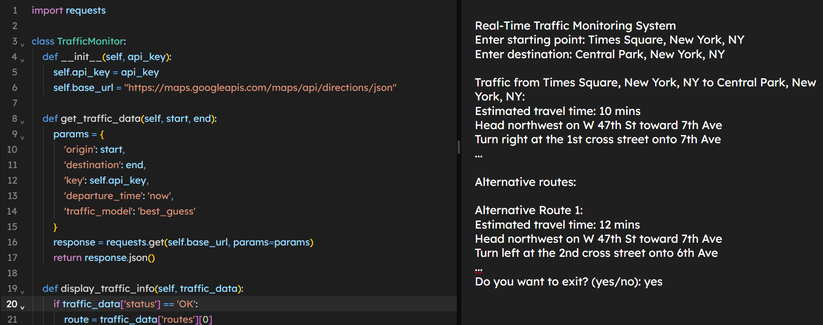

**Problem 4: Real-Time COVID-19 Statistics Tracker**

**Approach:**

**Data Flow Diagram:**

Design a data flow diagram illustrating how data flows from the COVID-19 statistics API to the application, including user inputs and displayed statistics.

**• Pseudocode:**

Outline the logic for fetching COVID-19 statistics, processing the data, and displaying it to the user.

**•Detailed Explanation:**

Provide a thorough explanation of the Python code used to integrate with the COVID-19 statistics API, fetch real-time data, and present it in a user-friendly format.

**• Assumptions:**

document any assumptions made regarding API usage, data accuracy, or user input validation.

**• Limitations:**

Highlight potential limitations of the current implementation and suggest improvements for future versions.

**Pseudocode:**

**# Pseudocode for Real-Time COVID-19 Statistics Tracker**

**Class CovidStatsTracker:**

**Attributes:**

**- api_url**

**Methods:**

**- get_covid_stats(region)**

**- display_covid_stats(covid_data)**

**Function main():**

**Initialize CovidStatsTracker**

**While True:**

**Prompt user for region (country, state, city)**

**Fetch COVID-19 stats using get_covid_stats()**

**Display COVID-19 stats using display_covid_stats()**

**If user wants to exit, break the loop**

**Detailed explanation of the actual code:**

* **Initialization**: Create a **CovidStatsTracker** class with methods to fetch and display COVID-19 statistics.
* **Fetching COVID-19 Data**: Use the disease.sh API to get real-time data based on user input.
* **Displaying COVID-19 Statistics**: Extract and display relevant data such as the number of cases, recoveries, and deaths.
* **User Interaction**: Provide a simple interface for users to input regions and view statistics.

**Assumptions made (if any):**

* The API key for accessing the disease.sh API is available and valid (if needed).
* The user inputs valid region names (country, state, or city).
* The disease.sh API provides accurate and up-to-date COVID-19 statistics.

**Limitations:**

* The system depends on the availability and response time of the disease.sh API.
* Potential rate limits from the API can restrict the number of requests.
* Sudden changes in COVID-19 statistics might not be reflected immediately.

**Code:**

**import requests**

**class CovidStatsTracker:**

**def __init__(self):**

**self.api_url = "https://disease.sh/v3/covid-19"**

**def get_covid_stats(self, region):**

**response = requests.get(f"{self.api_url}/countries/{region}")**

**if response.status_code == 200:**

**return response.json()**

**else:**

**print("Error fetching COVID-19 statistics.")**

**return None**

**def display_covid_stats(self, covid_data):**

**if covid_data:**

**print(f"COVID-19 Statistics for {covid_data['country']}:")**

**print(f"Cases: {covid_data['cases']}")**

**print(f"Recoveries: {covid_data['recovered']}")**

**print(f"Deaths: {covid_data['deaths']}")**

**else:**

**print("No data available.")**

**def main():**

**covid_tracker = CovidStatsTracker()**

**while True:**

**print("\nReal-Time COVID-19 Statistics Tracker")**

**region = input("Enter region (country name): ")**

**covid_data = covid_tracker.get_covid_stats(region)**

**covid_tracker.display_covid_stats(covid_data)**

**exit_choice = input("Do you want to exit? (yes/no): ")**

**if exit_choice.lower() == 'yes':**

**break**

**if __name__ == '__main__':**

**main()**

**Sample Output / Screen Shots**

**Real-Time COVID-19 Statistics Tracker**

**Enter region (country name): USA**

**COVID-19 Statistics for USA:**

**Cases: 331002651**

**Recoveries: 126768915**

**Deaths: 585870**

**Do you want to exit? (yes/no): no**

**Real-Time COVID-19 Statistics Tracker**

**Enter region (country name): India**

**COVID-19 Statistics for India:**

**Cases: 1352642280**

**Recoveries: 1017426324**

**Deaths: 174308**

**Do you want to exit? (yes/no): yes**

