Jenkins task-01

1.Install Jenkins and run Jenkins on port number 8081.
Step -1 install Jenkins
Sudo su -
sudo wget -O /etc/yum.repos.d/jenkins.repo \
https://pkg.jenkins.io/redhat-stable/jenkins.repo
sudo rpm --import https://pkg.jenkins.io/redhat-stable/jenkins.io-2023.key
sudo yum upgrade
# Add required dependencies for the jenkins package
sudo yum install fontconfig java-21-openjdk
sudo yum install Jenkins
sudo systemctl start Jenkins
sudo systemctl status jenkins
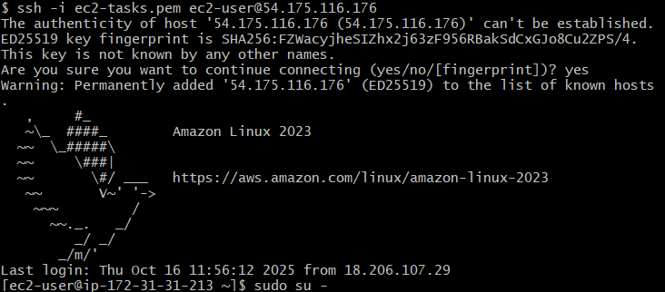
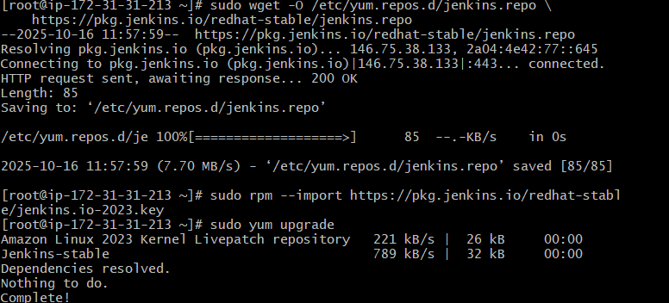
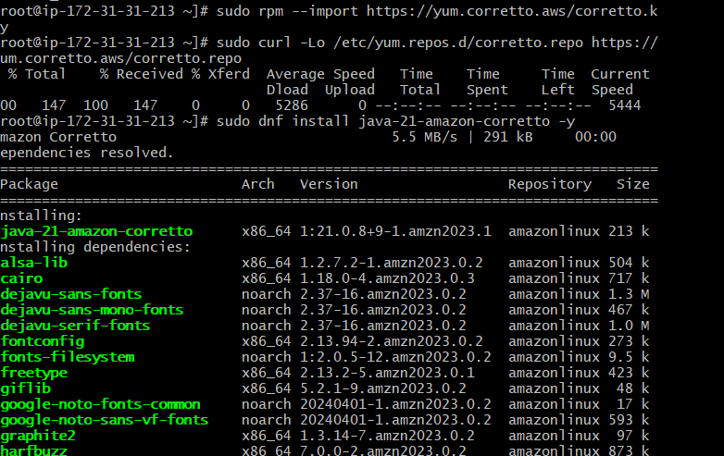
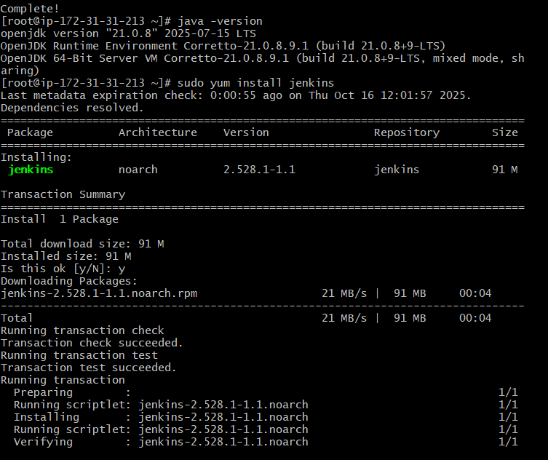
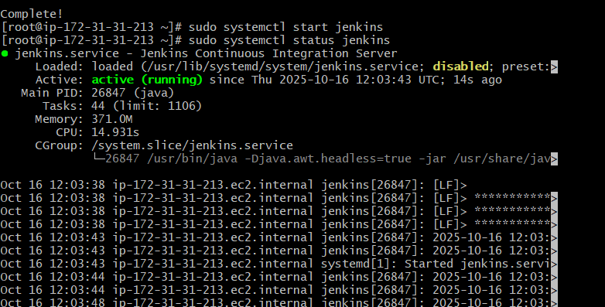
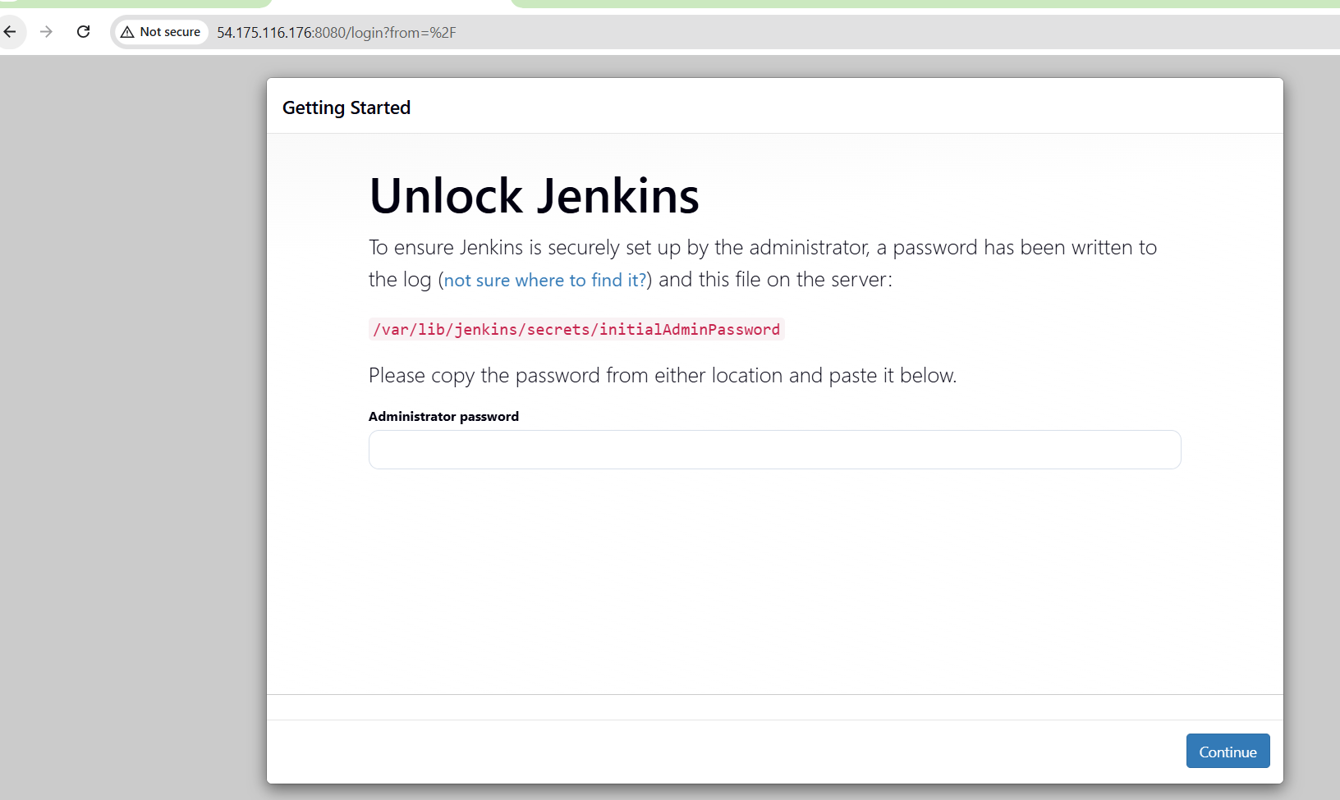
Step-2 open the configuration file using these command
sudo vi /usr/lib/systemd/system/jenkins.service
and change the port number from 8080 to 8081.
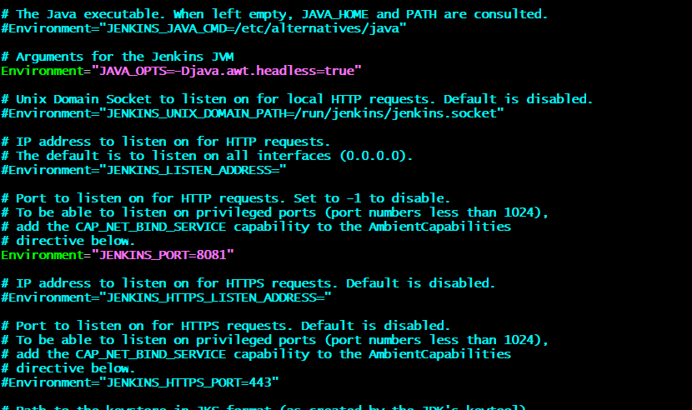
sudo systemctl daemon-reload
sudo systemctl restart jenkins
sudo systemctl status Jenkins
step-3: go to browser and check
https:54.172.116.176:8081
cat /var/lib/Jenkins/secrets/initialadminpassword.
And enter the password .
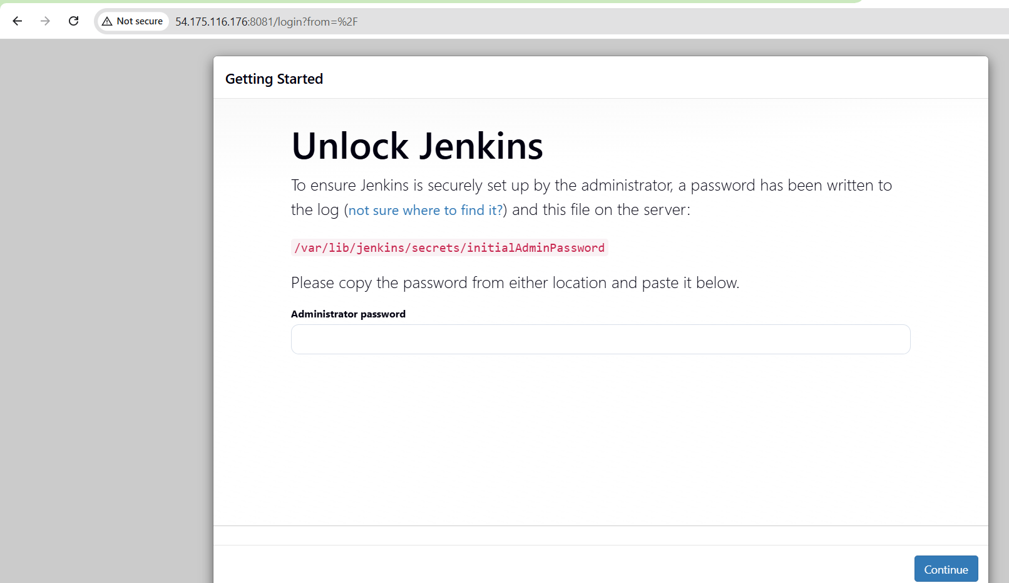
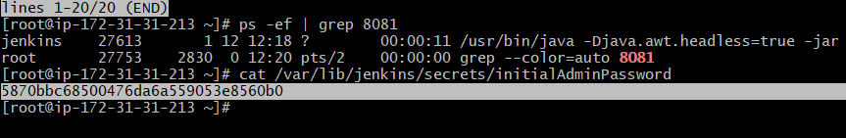
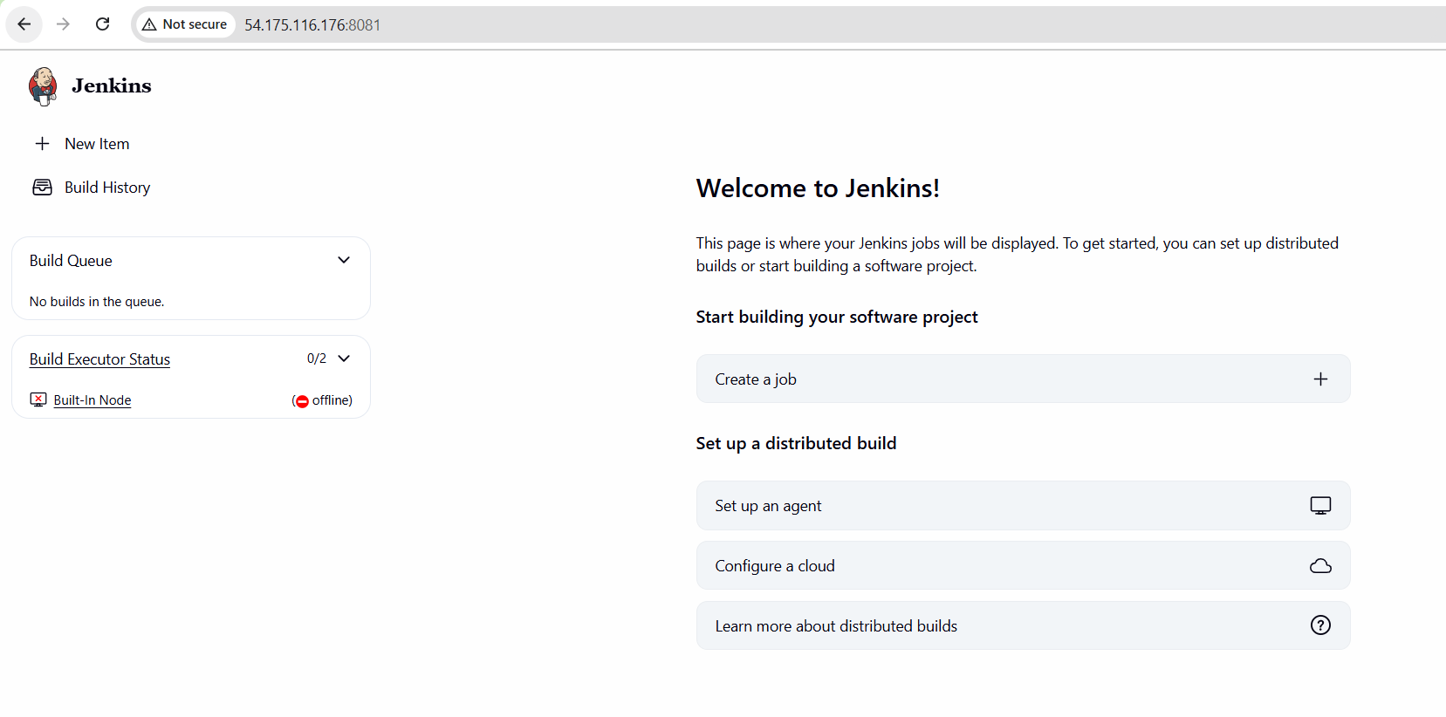
2.Secure Jenkins server.
Go to Jenkinssecurityand replace the old password with new password and click on save.
And also remove the initialadminpassword.
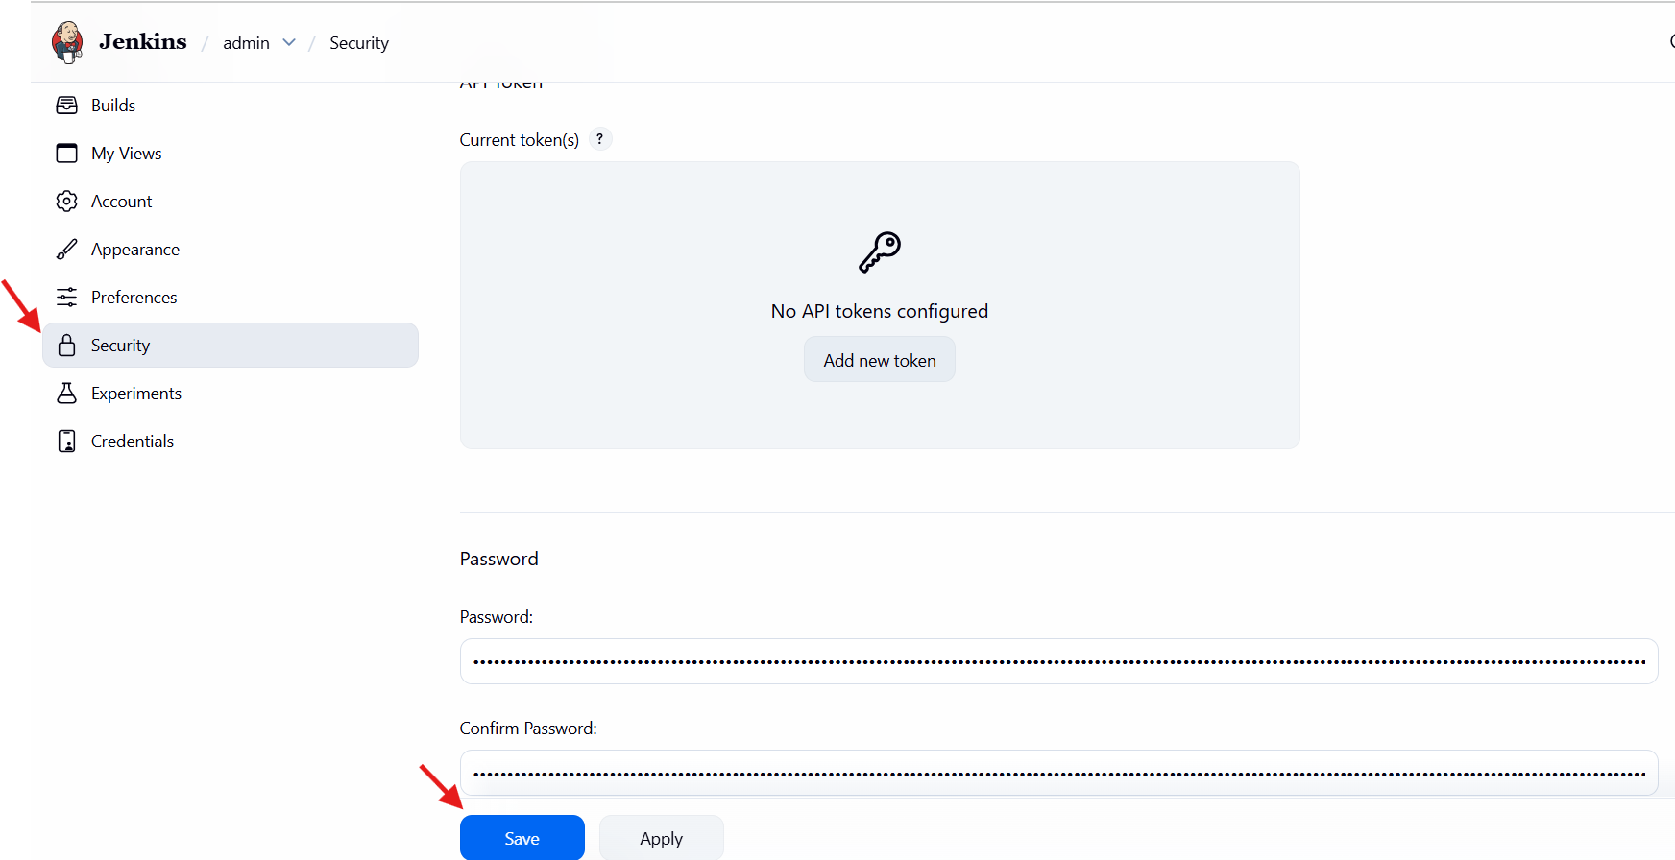
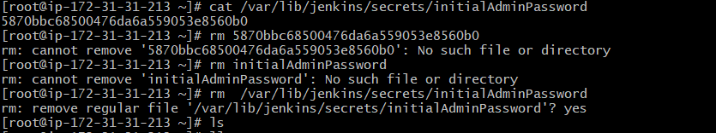
3.Create users called DevOps, Testing in Jenkins with Limited access.
Step-1: install role plugin
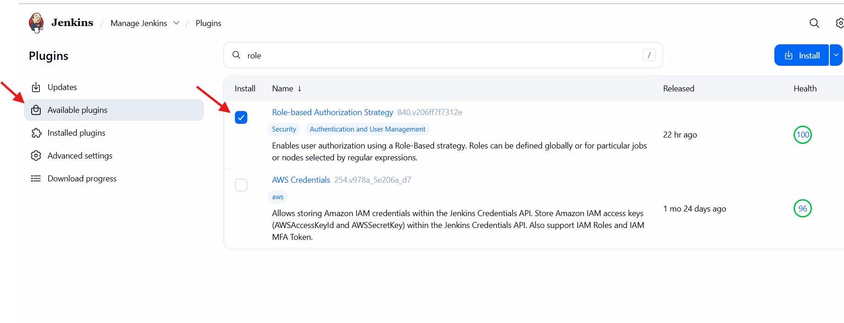
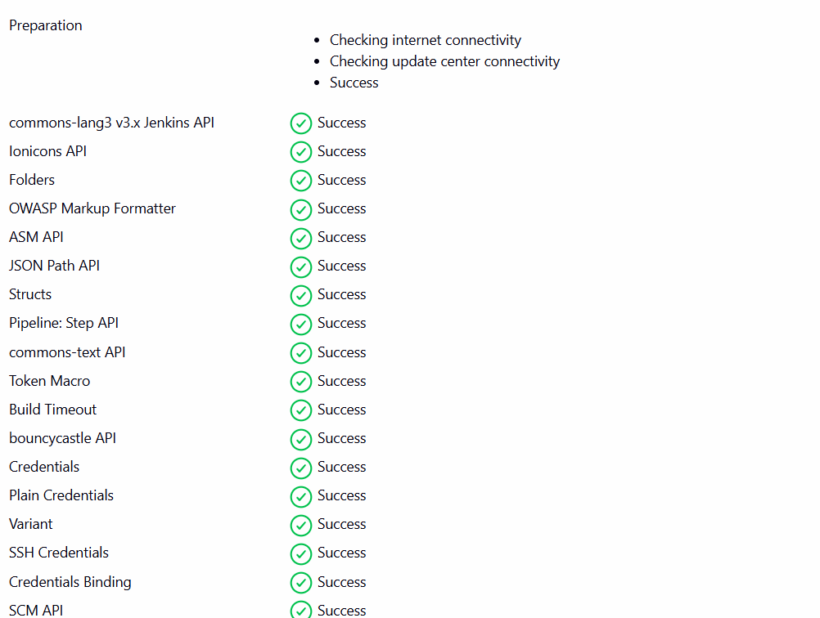
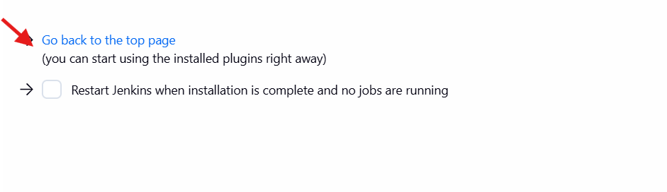
Step-2:Jenkinsmanage Jenkinsuserscreate user.
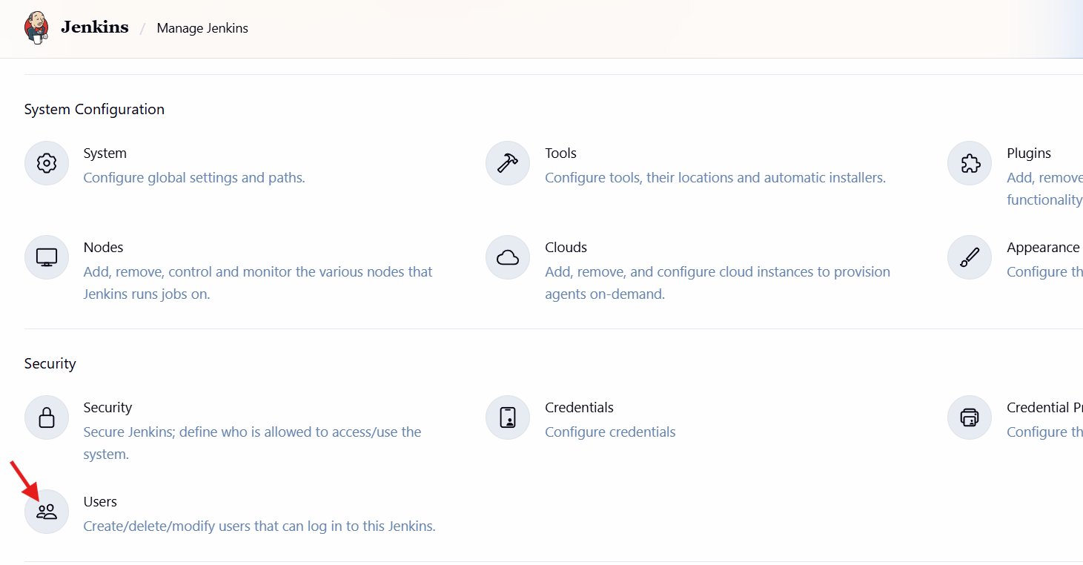

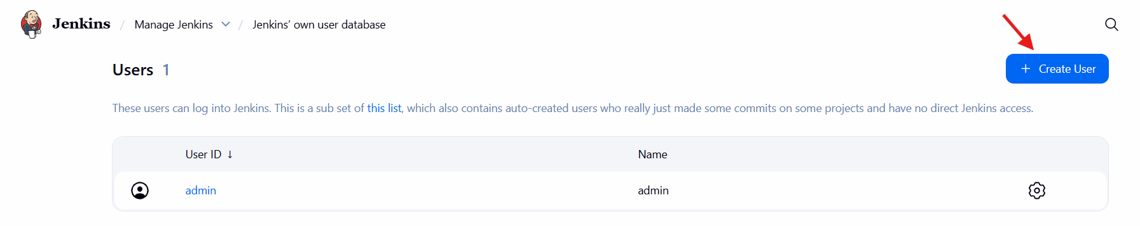
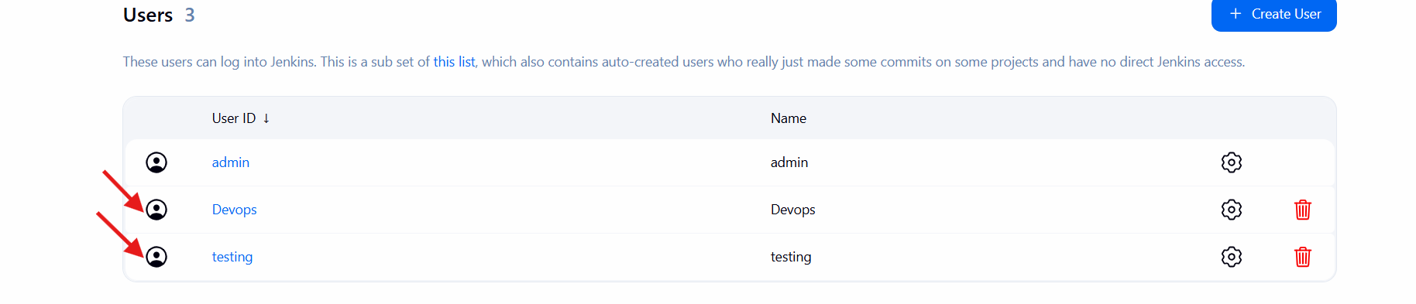
Step-3 : Jenkinsmanage Jenkinssecurity.
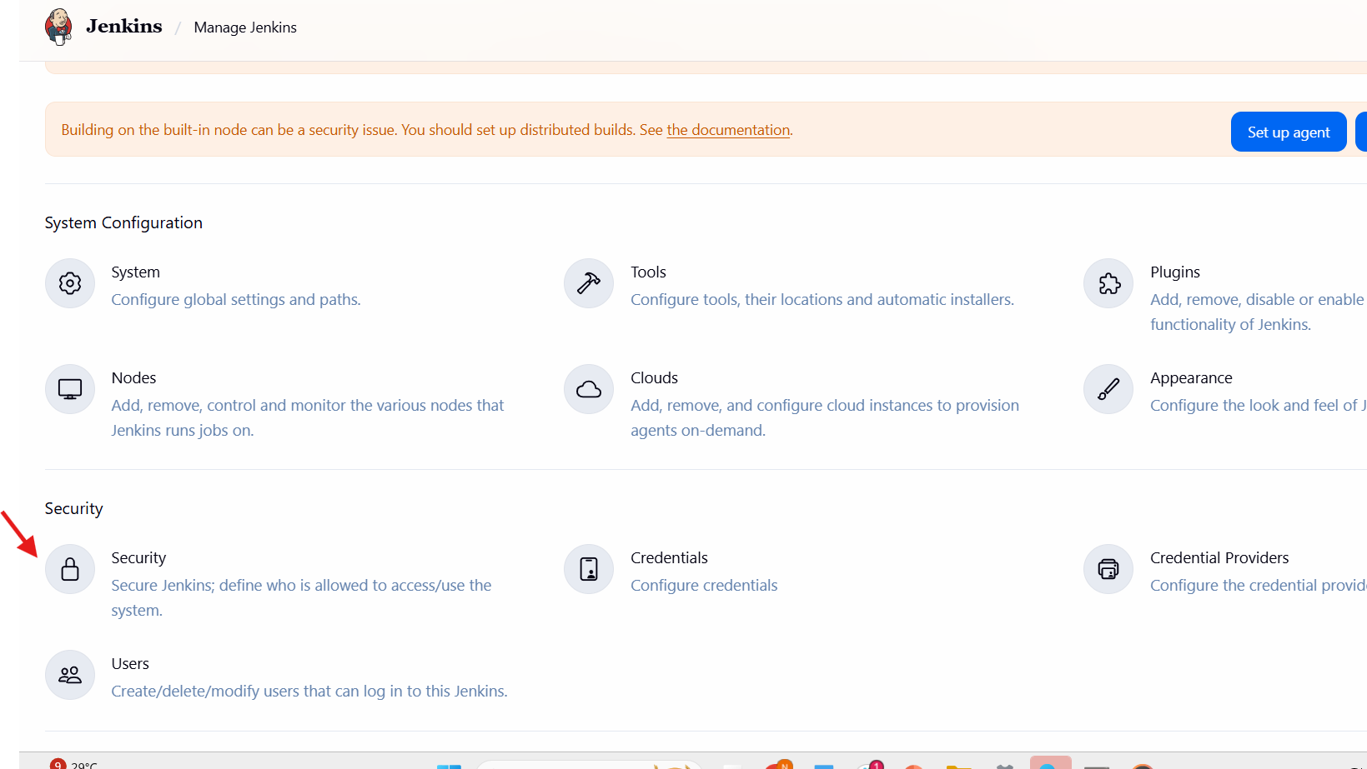
And select Jenkins own user database and select project-based matrix authorization strategy and give limited access.
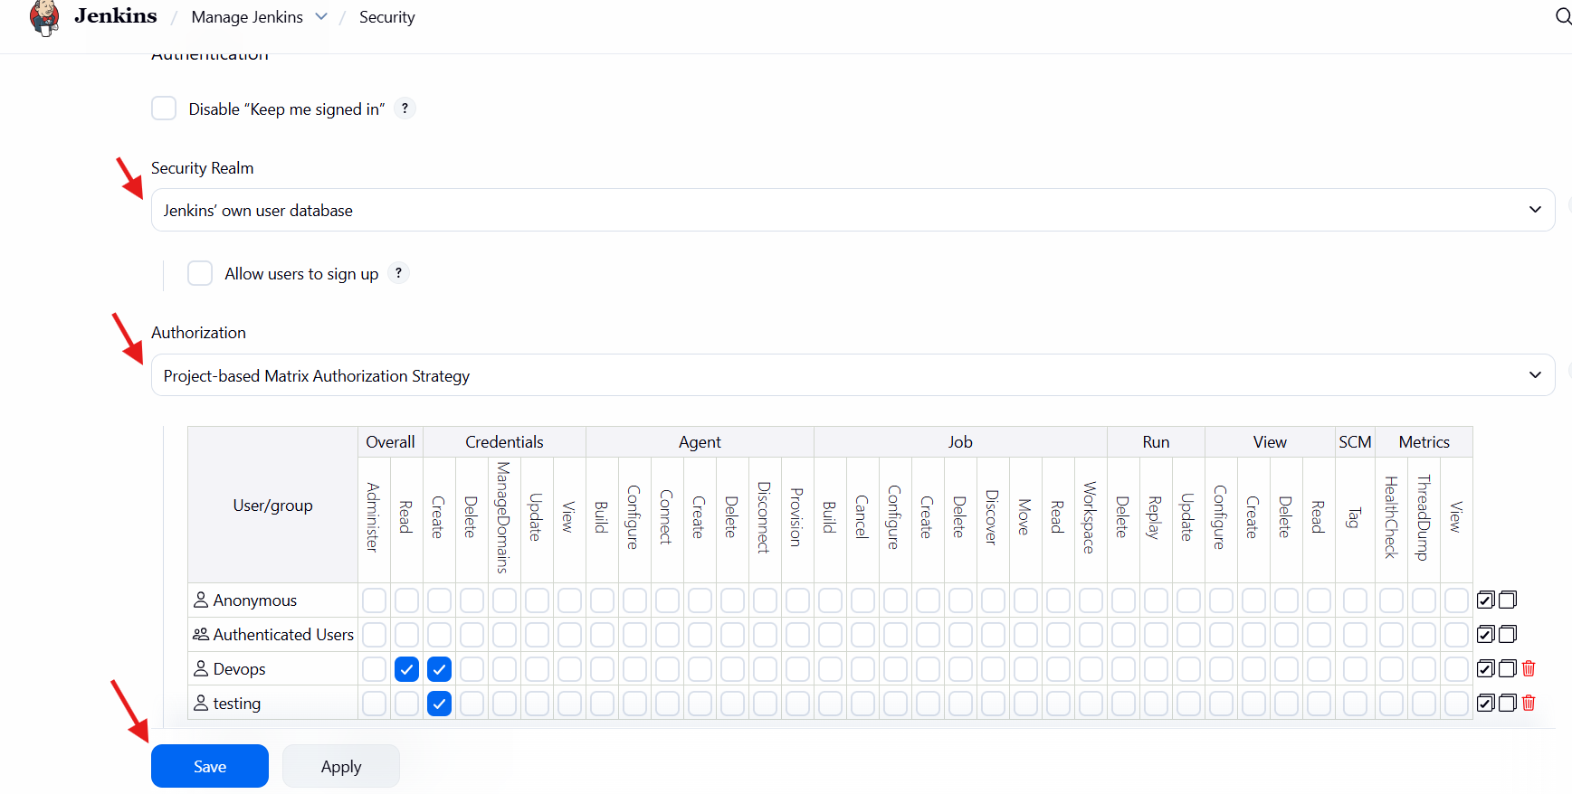
4.Configure labels and restrict the jobs to execute based on label only.
Step-1: Go to manage Jenkinsclick on pluginsselect node and label parameterinstall.
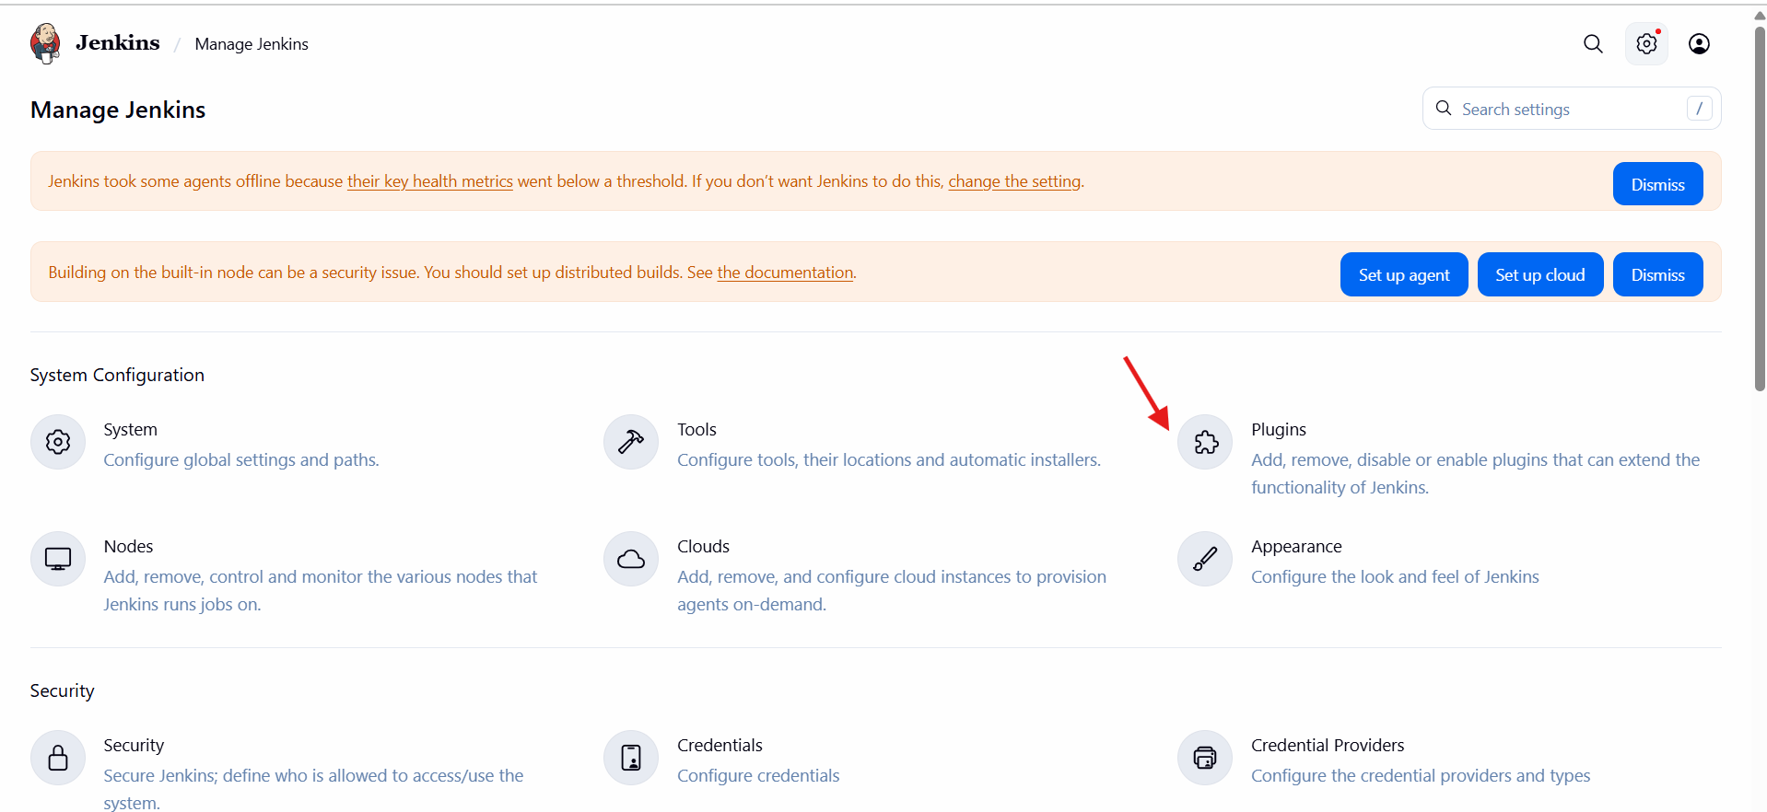
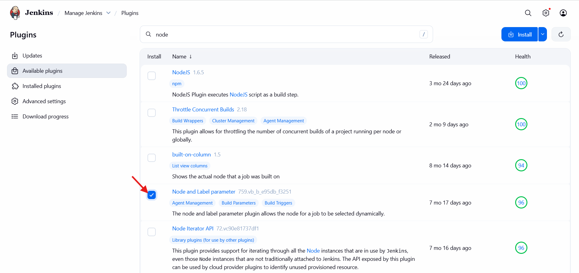
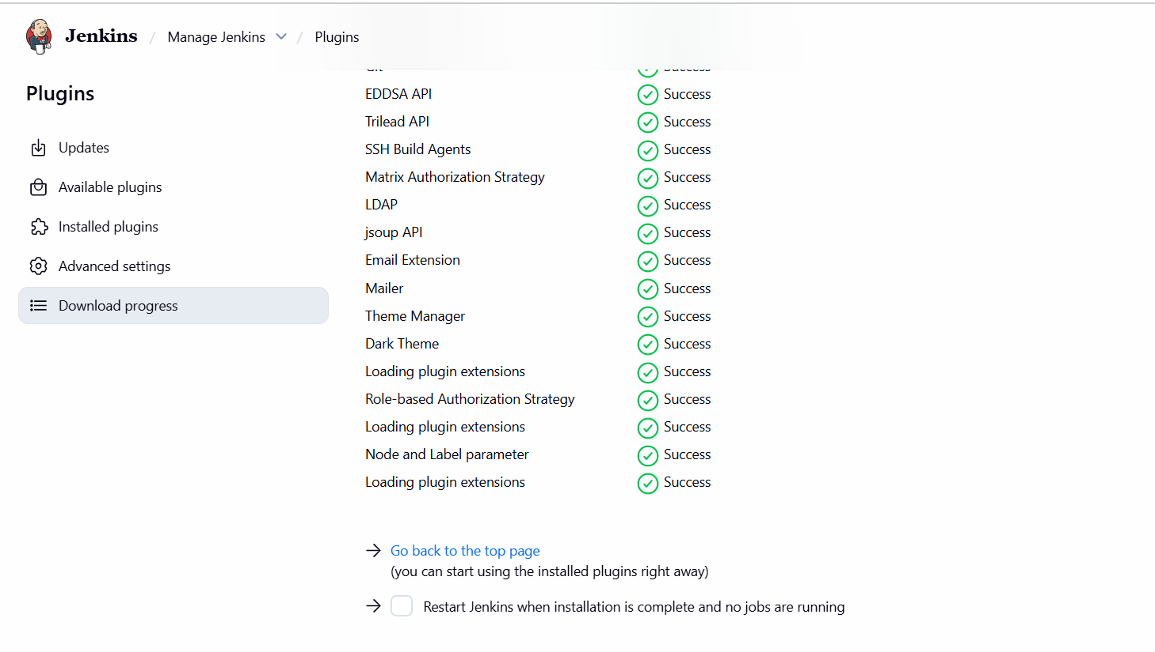
Step-2:make a new item select a free style projectconfigurelabels(master) select restrict where this project can runadd git url save.
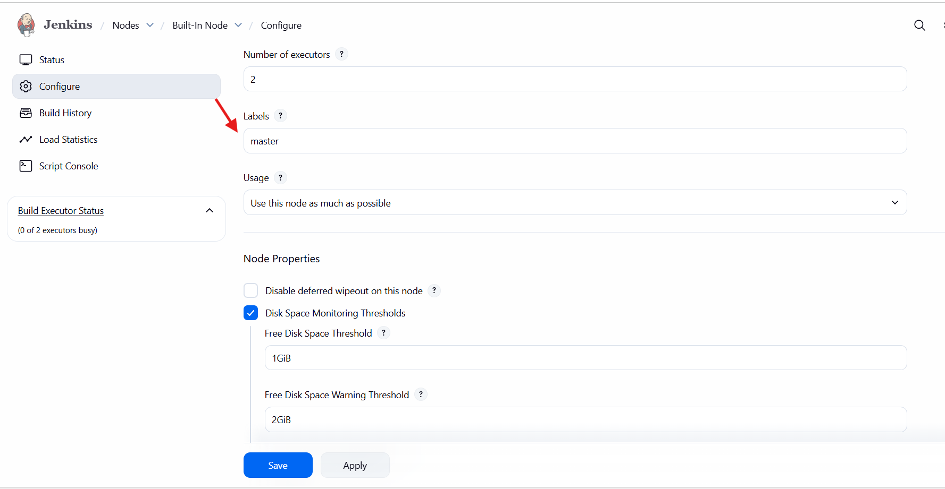
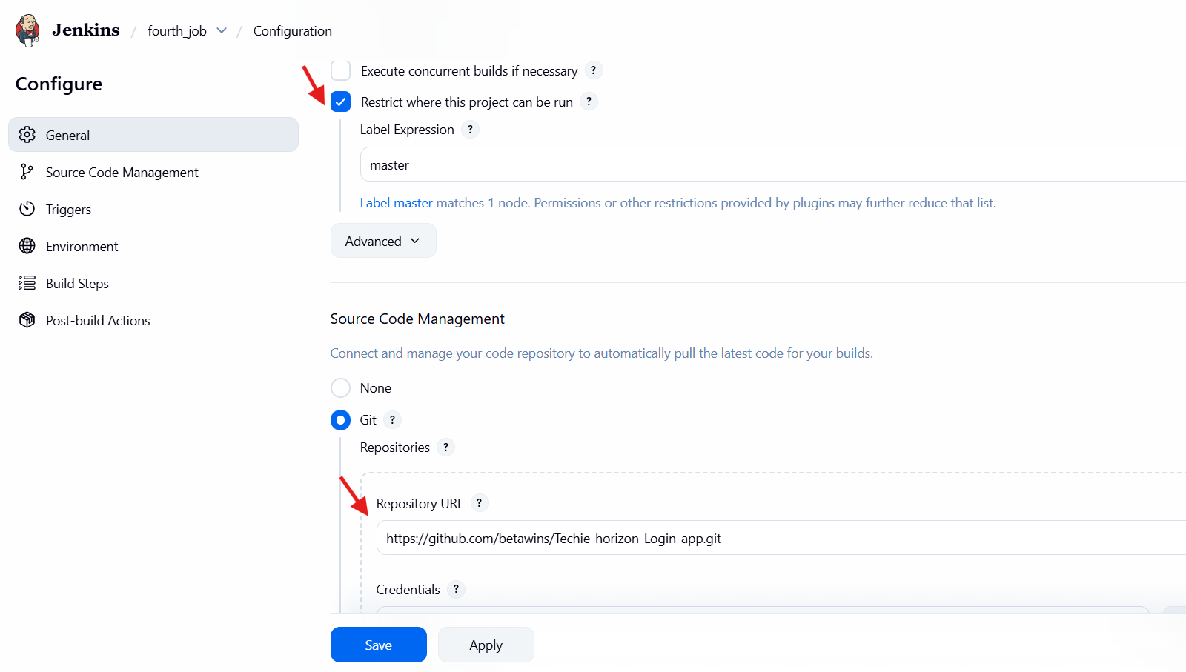
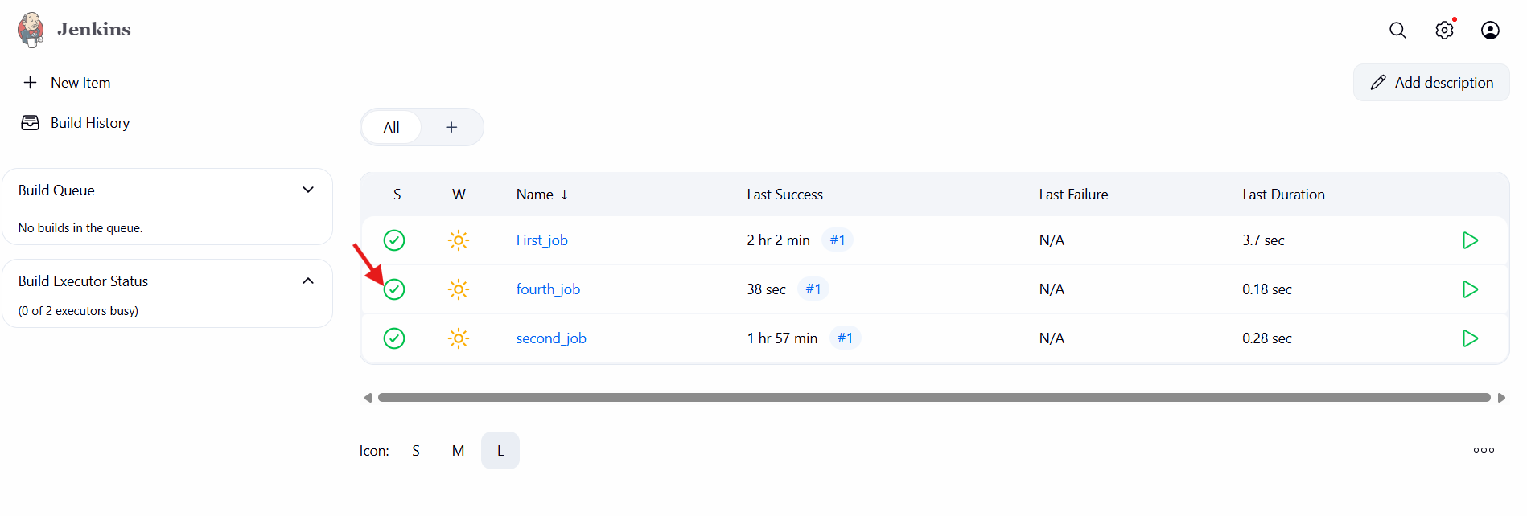

5.Create Three sample jobs using the below URL. https://github.com/betawins/Techie_horizon_Login_app.git
Step-1: go to Jenkins dashboardcreate a jobselect free style projectclick on ok.
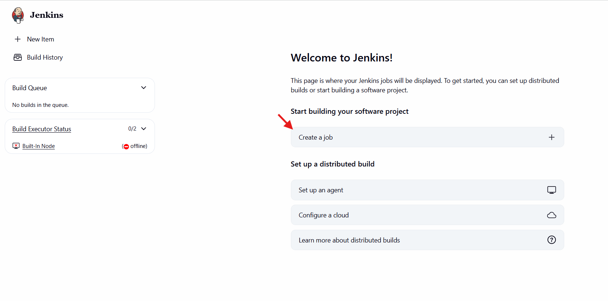
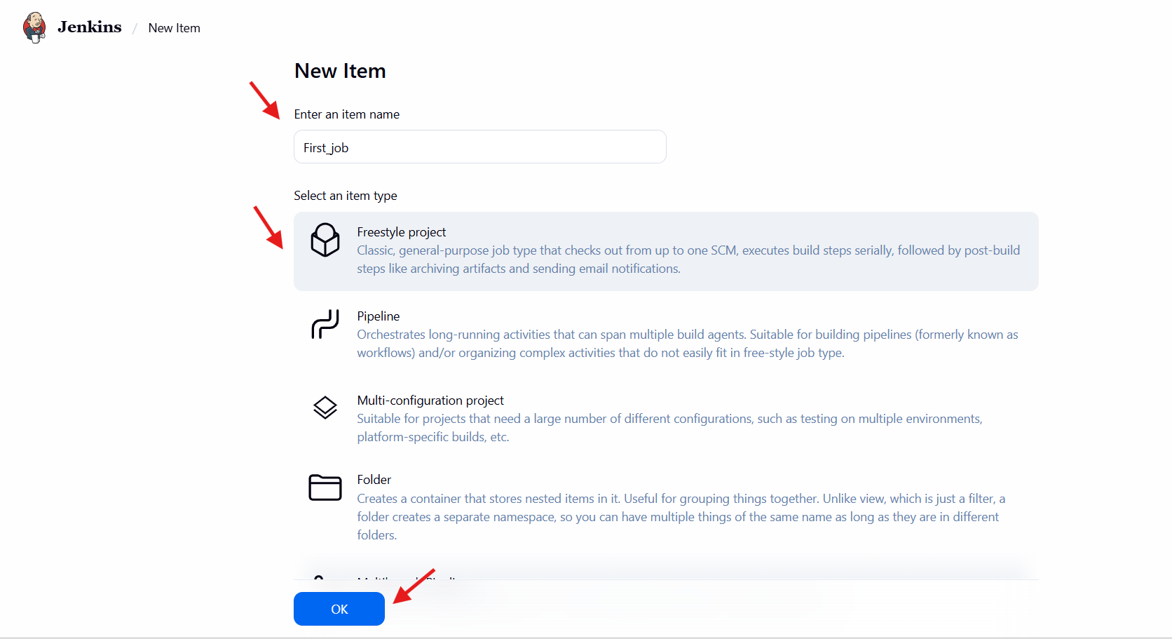
Step-2:Go to generaladd descriptionadd github urlsave.
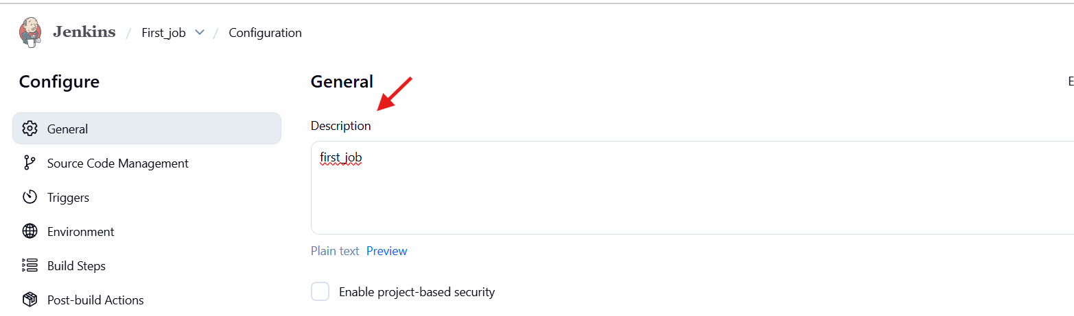
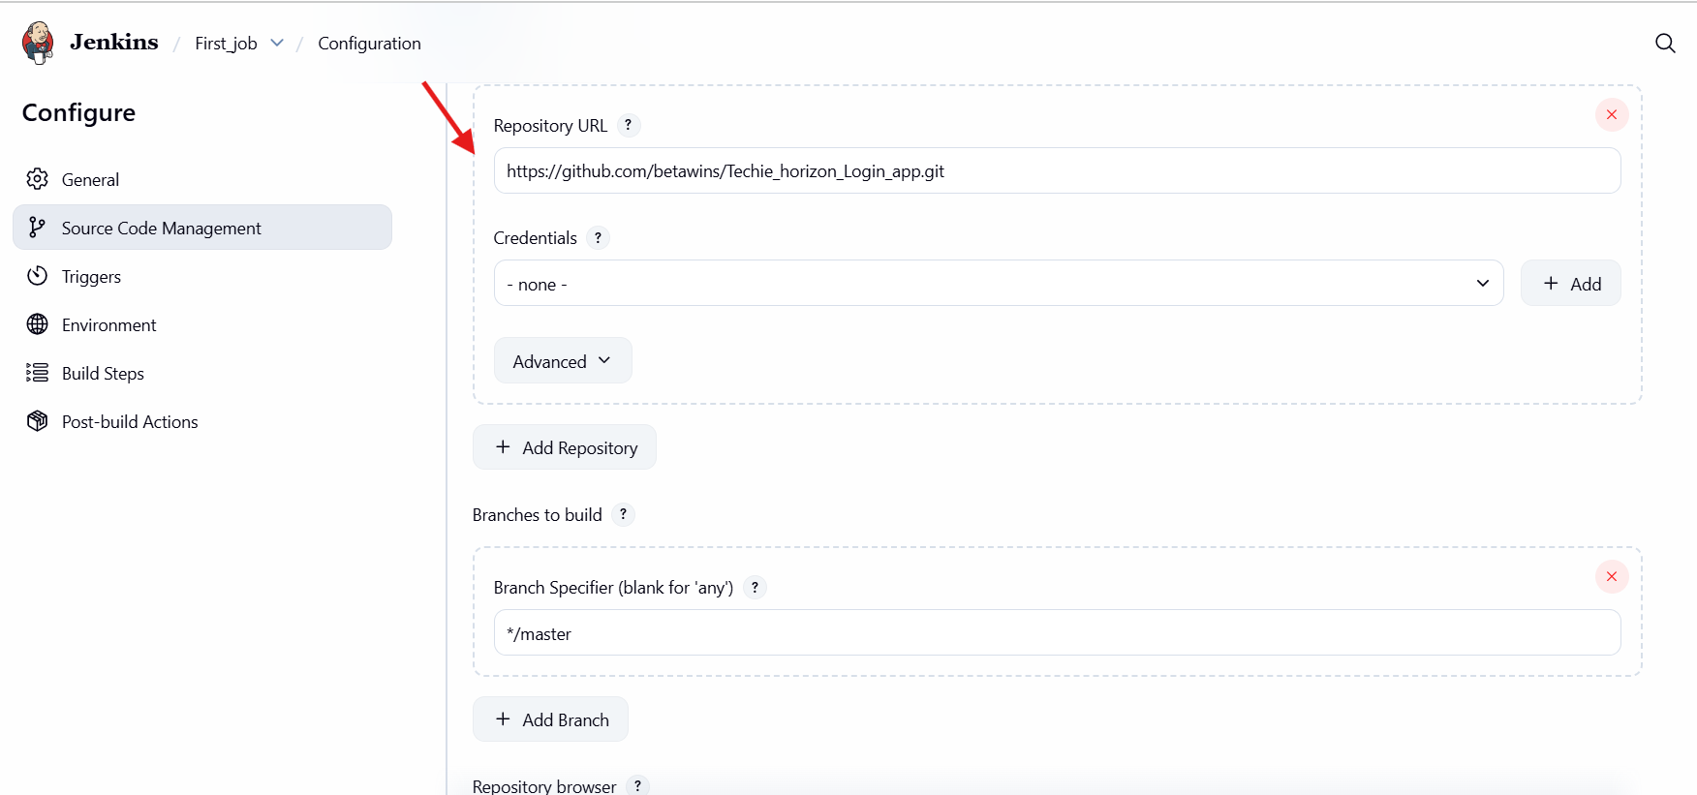
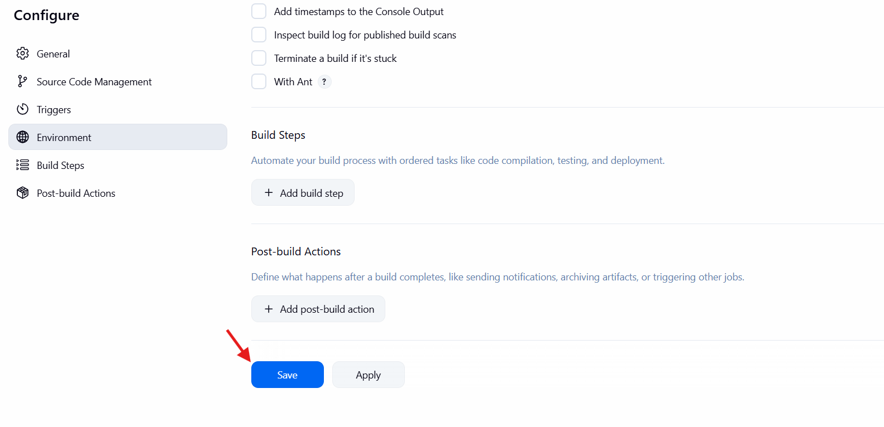
Step-3: click on build now.
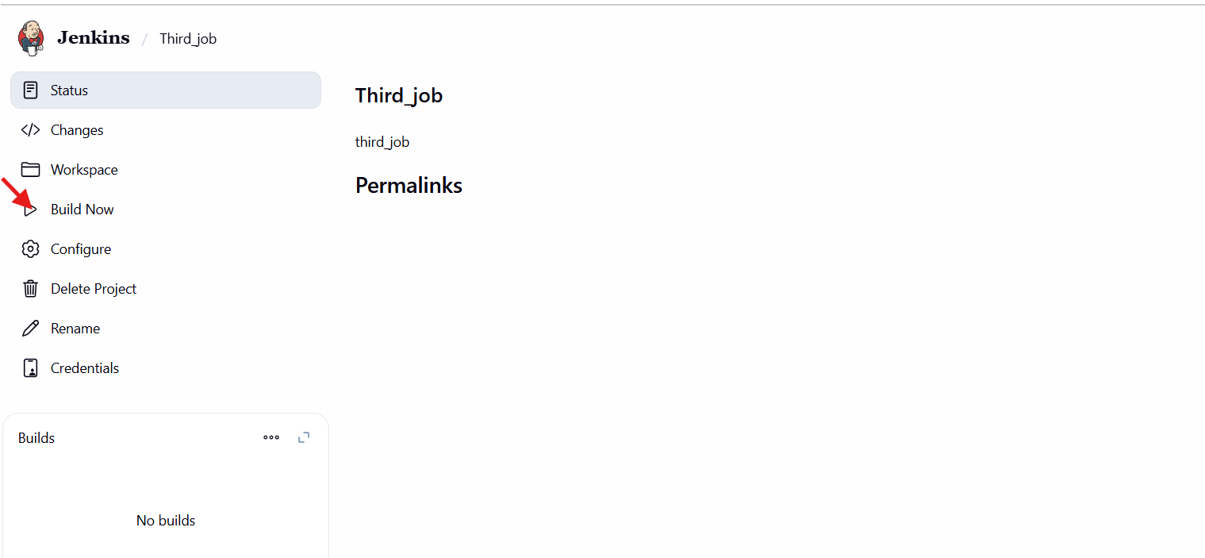
Here, we can see the results.
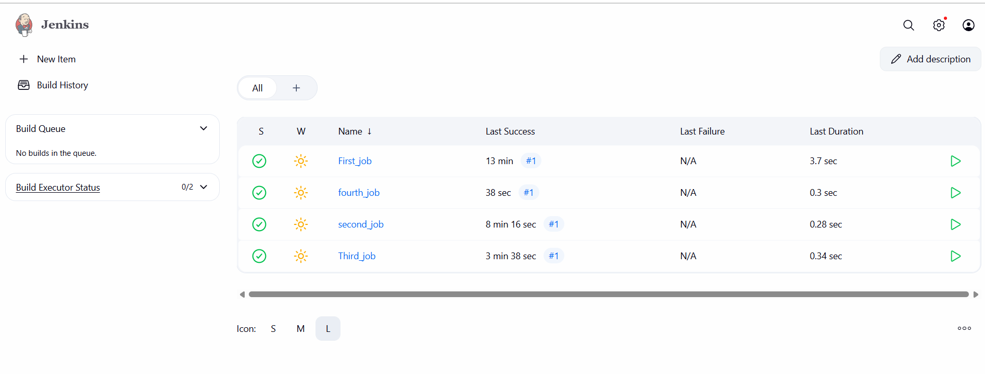
6.Create one Jenkins job using git hub Private repository

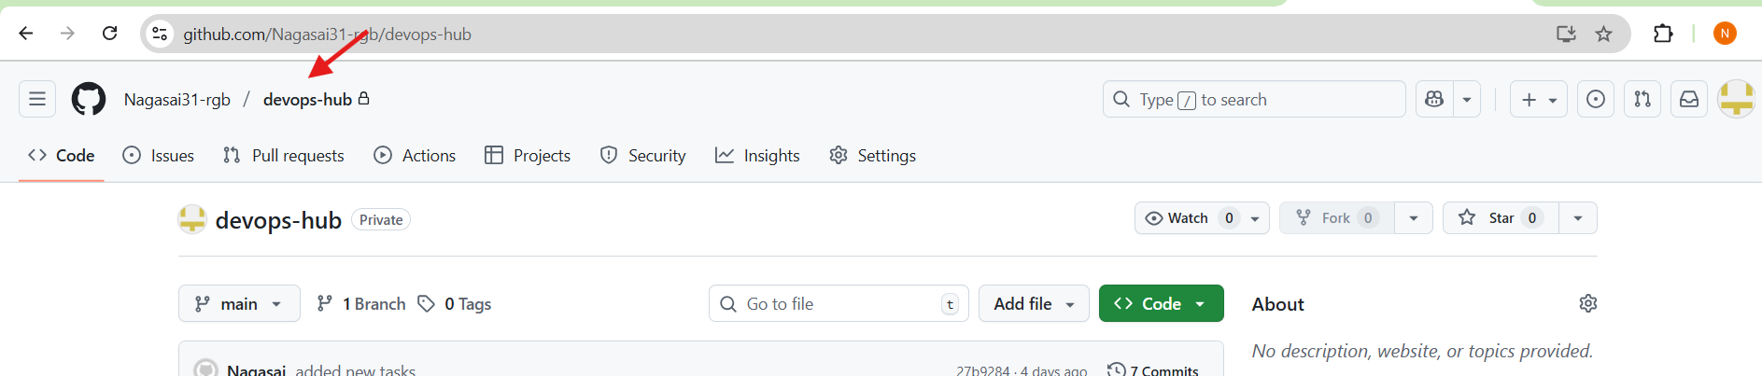
Step-1:Go to GitHub → Settings → Developer settings → Personal access tokens → Tokens (classic)
Click “Generate new token”
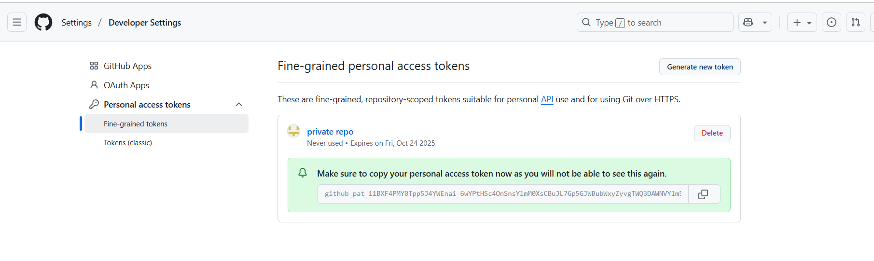
Step2:Jenkins Dashboard → Manage Jenkins → Credentials → Global → Add Credentials
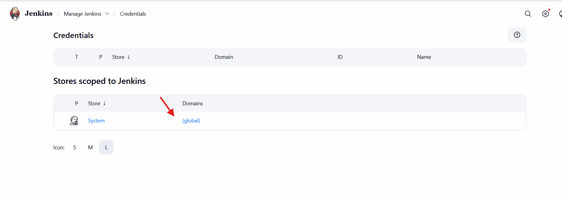
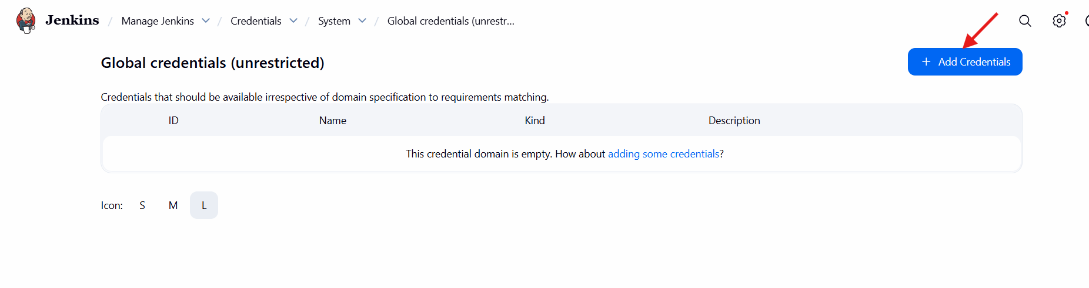
Step-3:we can configure the username and password(taken from github) and create.
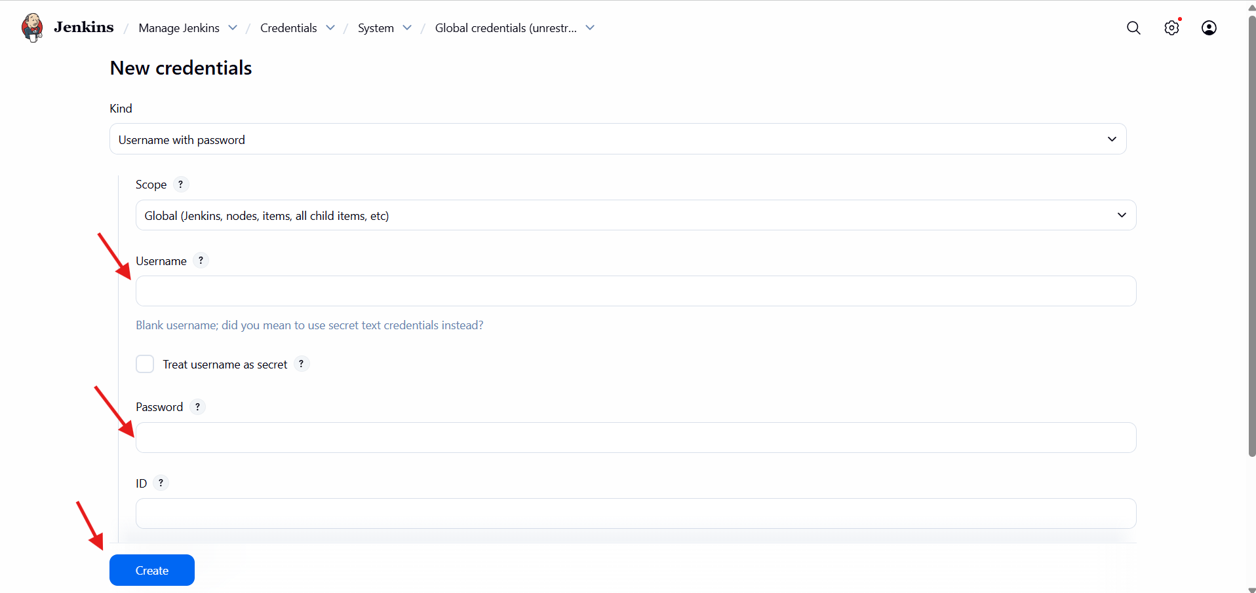
Step-4: Go to Jenkinsselect a new itemselect freestyle projectconfigurationadd git hub urlcredentialssave.
