**Challenge Assignment -1**

1) Launched one aws ec2 and installed Jenkins

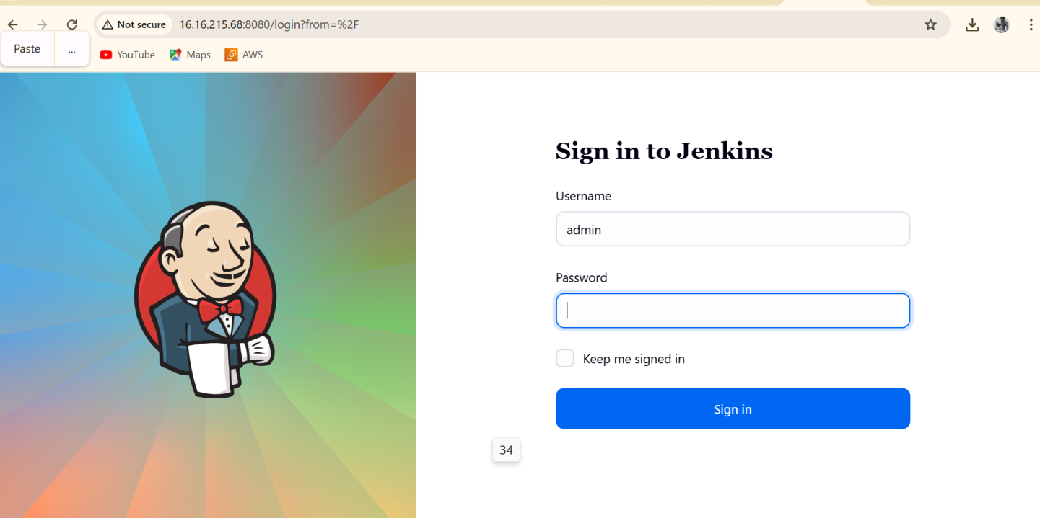

2. Installed and Set up Apache Tomcat on an Ubuntu Virtual Machine

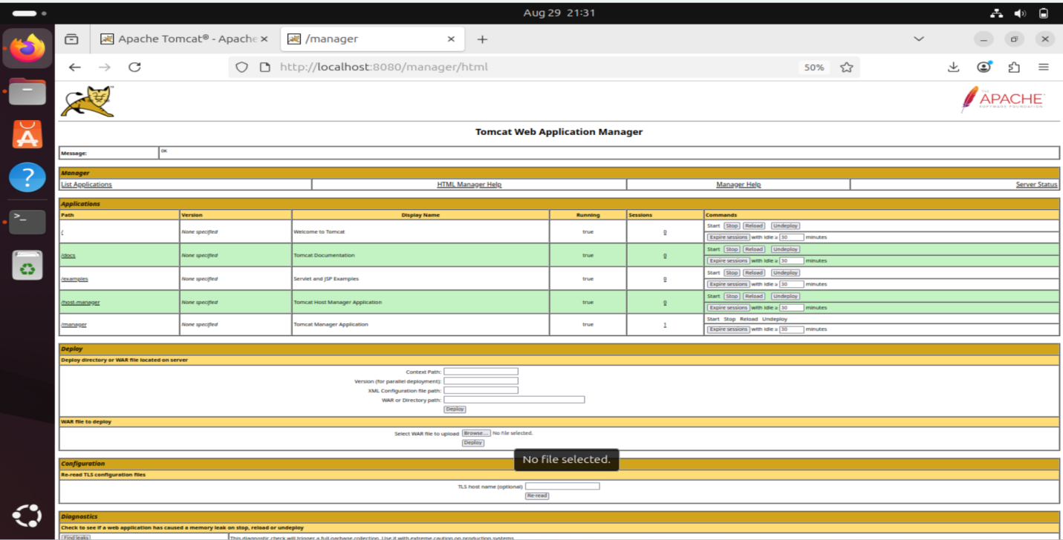

3. Docker desktop is installed on my windows

