**GLUT ACM Practice Summary**

**班级:2016级计算机6班 2017年11月6日**

**姓名:杨易 学号:3162052051639**

**实验题目:POJ：Palindromes**

This summary was auto generated by python, you could found it at [**https://github.com/cthulhujk/glut_acm_practice**](https://github.com/cthulhujk/glut_acm_practice).

**1.Lab Topic**

* POJ：Palindromes

A regular palindrome is a string of numbers or letters that is the same forward as backward. For example, the string "ABCDEDCBA" is a palindrome because it is the same when the string is read from left to right as when the string is read from right to left.A mirrored string is a string for which when each of the elements of the string is changed to its reverse (if it has a reverse) and the string is read backwards the result is the same as the original string. For example, the string "3AIAE" is a mirrored string because "A" and "I" are their own reverses, and "3" and "E" are each others' reverses.

**2.Requirement Analysis**

输入N个字符串，输出字符串是否为回文字符串;对字符串进行操作和根据题目进行计算

**3.APIs Design**

///////////////////////////////////////////////////////////////////////

/// Public Interface: Note that these interfaces were even not actually

/// APIs which could be called by other functions.

///////////////////////////////////////////////////////////////////////

//@summary No public APIs provided

//@param void none

//@return void none

static void NoneExportedAPI(void);

**4.Detail Design**

回文字处理，使用硬编码直接将题目要求的回文数字/字符写入代码，方便后面计算；特殊天气计算按照题目描述计算即可，由于缺少其他情况，故程序不完全符合题目要求。

///////////////////////////////////////////////////////////////////////

/// Pseudocode implementations: implementation details of program

/// described by pseudocode. Its syntax was familiar to Python.

///////////////////////////////////////////////////////////////////////

//no pseudocode provided

**5.Building and running**

I have A LOT free time to do uesless work. Obviously this project can easily use g++/clang compiled for all, but I still write a cmake rules to make it more engineered and modernization, even in previous you could see manual makefile. Notice that this project was licensed under [MIT License](https://github.com/cthulhujk/glut_acm_practice/blob/master/public/LICENSE), which means you can do almost everything you want with it. Anyway, I just want to make it more fun :-)

Prerequisite:

* unix make
* g++ version >= 4.8.4
* git
* cmake >= 3.5.0

For linux users:

$ git clone https://github.com/NagaseMinato/glut_acm_practice.git

$ cd glut_acm_practice/build

$ cmake .. -G"Unix Makefiles"

$ make -j8

$ ../bin/poj_1590_33percentAC # try to run a built program

$ make clean

There are more details about each programs in testsuites, you can run it to see more if you had been installed valgrindtoolchain:

$ sudo apt-get install valgrind

$ make test # run testsuite

For windows users:

> git clone https://github.com/NagaseMinato/glut_acm_practice.git

> cd glut_acm_practice/build

> cmake .. -G"Visual Studio 15 2017"

Then double-click glut_acm_practice.sln, select a sub project and build it, enjoy it!

**6.Test Output**

A regular palindrome is a string of numbers or letters that is the same forward as backward. For example, the string "ABCDEDCBA" is a palindrome because it is the same when the string is read from left to right as when the string is read from right to left.A mirrored string is a string for which when each of the elements of the string is changed to its reverse (if it has a reverse) and the string is read backwards the result is the same as the original string. For example, the string "3AIAE" is a mirrored string because "A" and "I" are their own reverses, and "3" and "E" are each others' reverses.  
[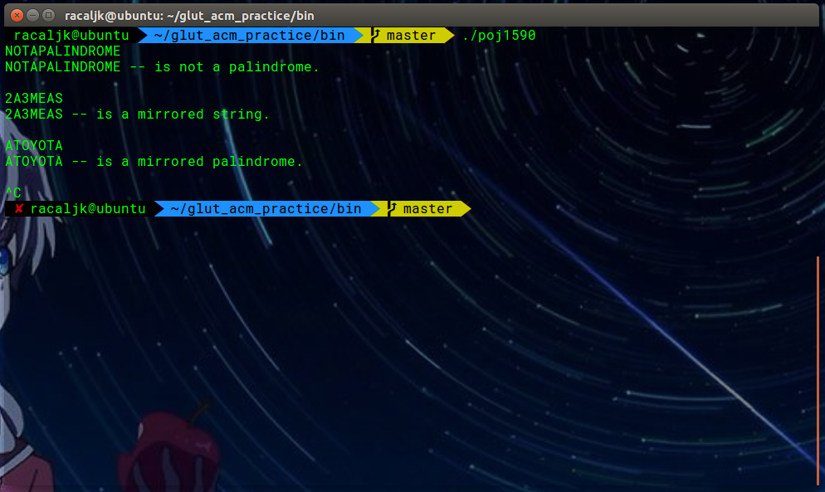](https://github.com/cthulhujk/glut_acm_practice/blob/master/public/poj_1590_33percentAC.png)

**7.Appendix**

* All programs had been passed my own test cases, you can add/modify/delete testcases into corresponding test/*.data file. For me, I eliminated all warnings and memory leaking using [valgrind](http://valgrind.org/)
* For more information about how to run these test, see # 5.Usage section

Test project /home/racaljk/Desktop/glut_acm_practice/build

Start 1: test_running__01pack_v1.0

1/16 Test #1: test_running__01pack_v1.0 ............ Passed 0.01 sec

Start 2: test_running__8queen

2/16 Test #2: test_running__8queen ................. Passed 0.00 sec

Start 3: test_running__poj3299_WA

3/16 Test #3: test_running__poj3299_WA ............. Passed 0.00 sec

Start 4: test_running__poj_1007_40percentAC

4/16 Test #4: test_running__poj_1007_40percentAC ... Passed 0.01 sec

Start 5: test_running__poj_1590_33percentAC

5/16 Test #5: test_running__poj_1590_33percentAC ... Passed 0.00 sec

Start 6: test_running__poj_2386_49percentAC

6/16 Test #6: test_running__poj_2386_49percentAC ... Passed 0.00 sec

Start 7: test_running__poj_2538_47percentAC

7/16 Test #7: test_running__poj_2538_47percentAC ... Passed 0.00 sec

Start 8: test_running__poj_3278_31percentAC

8/16 Test #8: test_running__poj_3278_31percentAC ... Passed 0.00 sec

Start 9: test_running__poj_3979_30percentAC

9/16 Test #9: test_running__poj_3979_30percentAC ...***Failed 0.13 sec

Start 10: test_running__solution1

10/16 Test #10: test_running__solution1 .............. Passed 0.00 sec

Start 11: test_running__solution2

11/16 Test #11: test_running__solution2 .............. Passed 0.00 sec

Start 12: test_running__solution3

12/16 Test #12: test_running__solution3 .............. Passed 0.00 sec

Start 13: test_running__solution4

13/16 Test #13: test_running__solution4 .............. Passed 0.00 sec

Start 14: test_running__solution5

14/16 Test #14: test_running__solution5 .............. Passed 0.00 sec

Start 15: test_running__solution6

15/16 Test #15: test_running__solution6 .............. Passed 0.00 sec

Start 16: test_running__solution8

16/16 Test #16: test_running__solution8 .............. Passed 0.00 sec

94% tests passed, 1 tests failed out of 16

Total Test time (real) = 0.19 sec