SOFTWARE REQUIREMENTS SPECIFICATION (SRS)
Student Record System (EduTrack) - Academic Performance, Attendance & Lifecycle Management Platform
Standards Compliance: IEEE 830-1998 Recommended Practice | Deliverables Part-1 Baseline

Project Name | Student Record System (EduTrack)
Specification Document | 1_SRS_StudentRecordSystem.docx (IEEE 830)
Document Version | 1.0 - Official Baseline
Date | October 2026
Repository | https://github.com/Nagashri2304/student-record-system
Project Team & Roles | Nagashree R Patil (@Nagashri2304) - Lead Architect & Core Security  Nidhi L (@nidhilokesh1) - Frontend Engineering & UI  Kushitha K (@Kushitha30) - Backend API & Services  Monika PM (@Monikapm19) - Database & Quality Assurance

1. Introduction

1.1 Purpose
This Software Requirements Specification (SRS) document details the complete functional, non-functional, and interface specifications for the Student Record System (EduTrack), developed under IEEE 830-1998 guidelines. The system serves as an enterprise academic administration platform designed to centralize student profiling, continuous daily attendance tracking, automated threshold warning notifications, continuous assessment and examination mark recording, letter grade and SGPA/CGPA evaluation, formal grade card generation, and academic grievance processing.

1.2 Document Conventions
This document follows standard IEEE 830 nomenclature. Requirement identifiers use standard prefixes:
• FR-xx: Functional Requirements (Numbered FR-01 through FR-15)
• NFR-xx: Non-Functional Requirements (Numbered NFR-01 through NFR-08)
• UC-xx: UML Use Cases (Numbered UC-01 through UC-12)
Priorities are classified as Critical (P1), High (P2), or Medium (P3).

1.3 Intended Audience and Reading Suggestions
This document is authored for the academic evaluation committee, software engineering development team (Frontend, Backend, Database), independent verification & validation (IV&V) test engineers, and academic institutional stakeholders. It provides a formal contract defining the precise system boundaries and behavioral constraints.

1.4 Product Scope
EduTrack eliminates manual paper registries, error-prone spreadsheet mark sheets, and delayed attendance notices. The web-based system delivers strict role-based access control (RBAC), ensuring students and parents access only authorized academic records while empowering instructors with automated grading engines and administrators with immutable audit logging.

2. Overall Description

2.1 Product Perspective
EduTrack operates as a self-contained, 3-tier distributed web application comprising a modern Single Page Application (SPA) client layer (React.js), a stateless RESTful business API service layer (Python Django / Node.js Express), and an ACID-compliant relational data store (PostgreSQL 15+). The system integrates with external email/SMS gateways for automated threshold alerting and cryptographic PDF engines for transcript creation.

2.2 User Classes and Characteristics
User Role | Technical Acumen | Primary Responsibilities | Access Privilege
Administrator | High (IT Staff) | User provisioning, department/course catalog setup, security policies, audit trail inspection | Full System (Superuser)
Faculty / Instructor | Moderate (Academic) | Course session attendance logging, continuous assessment marks entry, grievance review | Course-Scoped Read/Write
Student | Moderate (Learner) | View own timetable, check attendance percentages, inspect grades/GPA, submit grievance, download PDF cards | Self-Record Read-Only
Parent / Guardian | Basic / General | Monitor linked student attendance percentages, receive shortage alerts, view published semester grade cards | Linked Child Read-Only

2.3 Operating Environment
• Client Platform: Standard modern web browsers (Chrome >= 110, Edge >= 110, Firefox >= 115, Safari >= 16) with responsive viewport support (320px to 4K).
• Server OS: Linux (Ubuntu 22.04 LTS / Debian 12) or Containerized Alpine Linux environments.
• Database Environment: PostgreSQL 15.x with UTF-8 encoding and connection pooling.
• Network: Standard HTTPS (TLS 1.3) over TCP port 443.

2.4 Design & Implementation Constraints
• Security: Mandatory password hashing using Bcrypt (cost factor >= 12), JWT-based stateless authentication with 15-minute token expiry.
• Regulatory: Compliance with Family Educational Rights and Privacy Act (FERPA) standards ensuring strict data segregation.
• Zero-Trust Role Isolation: Broken Object-Level Authorization (IDOR) prevention enforced at the database query level on every API request.

3. Specific Functional Requirements (FR-01 to FR-15)
The following requirements specify the exact behavioral capabilities of EduTrack. All items have been verified against institutional academic regulations.
Req ID | Feature Name | Functional Description & Processing | Output | Priority
FR-01 | Multi-Factor Authentication | Validates username/email and Bcrypt-hashed password. Emits short-lived JWT access token (15 min) and secure HttpOnly refresh token with role claim. | JWT Session Tokens | Critical (P1)
FR-02 | Student Profile CRUD | Enables Administrators to register, update, archive, and query student biographical, departmental, and guardian records with unique USN/Roll constraint. | Persisted Student Profile | Critical (P1)
FR-03 | Course Catalog Management | Enables creation of academic courses, credit definitions, semester assignment, and prerequisite mapping. | Course Catalog Registry | High (P2)
FR-04 | Faculty-Batch Enrollment | Assigns faculty instructors to specific course batches and enrolls eligible students for the active academic term. | Enrollment Roster | High (P2)
FR-05 | Session Attendance Marking | Enables assigned faculty to log daily attendance (Present, Absent, Excused) with date, period, and topic timestamped. | Attendance Session Log | Critical (P1)
FR-06 | Attendance Aggregator | Computes cumulative and course-wise attendance percentages in real-time using formula: (Attended / Conducted) * 100. | Calculated Attendance % | Critical (P1)
FR-07 | Automated Shortage Alerts | Monitors when student attendance drops below statutory 75% threshold. Automatically dispatches warning email/SMS to student and parent. | Automated Alert Dispatch | High (P2)
FR-08 | Continuous Internal Marks | Allows instructors to input marks for continuous internal assessments (quizzes, lab assignments, mid-terms) with max marks validation. | Internal Assessment Record | High (P2)
FR-09 | End-Semester Examination | Accepts final exam scores, validates against scaling rules, and locks marks from modification once submitted by department head. | Locked Semester Score | Critical (P1)
FR-10 | Grade & GPA Engine | Applies institutional 10-point relative/absolute grading scale to calculate Letter Grade (O, A+, A, B, C, F), Grade Points, and SGPA/CGPA. | Official Letter Grade & GPA | Critical (P1)
FR-11 | Tamper-Resistant PDF Card | Generates digitally signed, printable PDF Grade Cards containing QR verification hash, semester breakdown, and institutional seal watermark. | Secure PDF Grade Card | High (P2)
FR-12 | Grade Grievance Workflow | Provides students an interface to submit re-evaluation/grievance requests with reason text. Faculty review and approve/reject with audit justification. | Grievance Ticket Status | Medium (P3)
FR-13 | Parent Guardian Portal | Restricts parent view exclusively to linked children's attendance stats, subject-wise scores, and official teacher notices. | Filtered Child Dashboard | High (P2)
FR-14 | Immutable Audit Logging | Records all administrative changes, grade modifications, and authentication attempts in an append-only audit trail table with actor ID and IP. | Immutable Audit Log Entry | Critical (P1)
FR-15 | Database Backup & Config | Provides administrative interface for automated database snapshots, academic year rollover, and grade boundary configuration. | Configuration Snapshot | Medium (P3)

4. UML Use Case Modeling (draw.io Integrated)
The system behavioral specifications are formally captured via UML Use Case modeling. The complete diagram was designed and rendered using the open industry standard draw.io (diagrams.net). The native diagram source file is version-controlled at `docs/use_case_diagram.drawio` to allow full architectural modification and team collaboration.

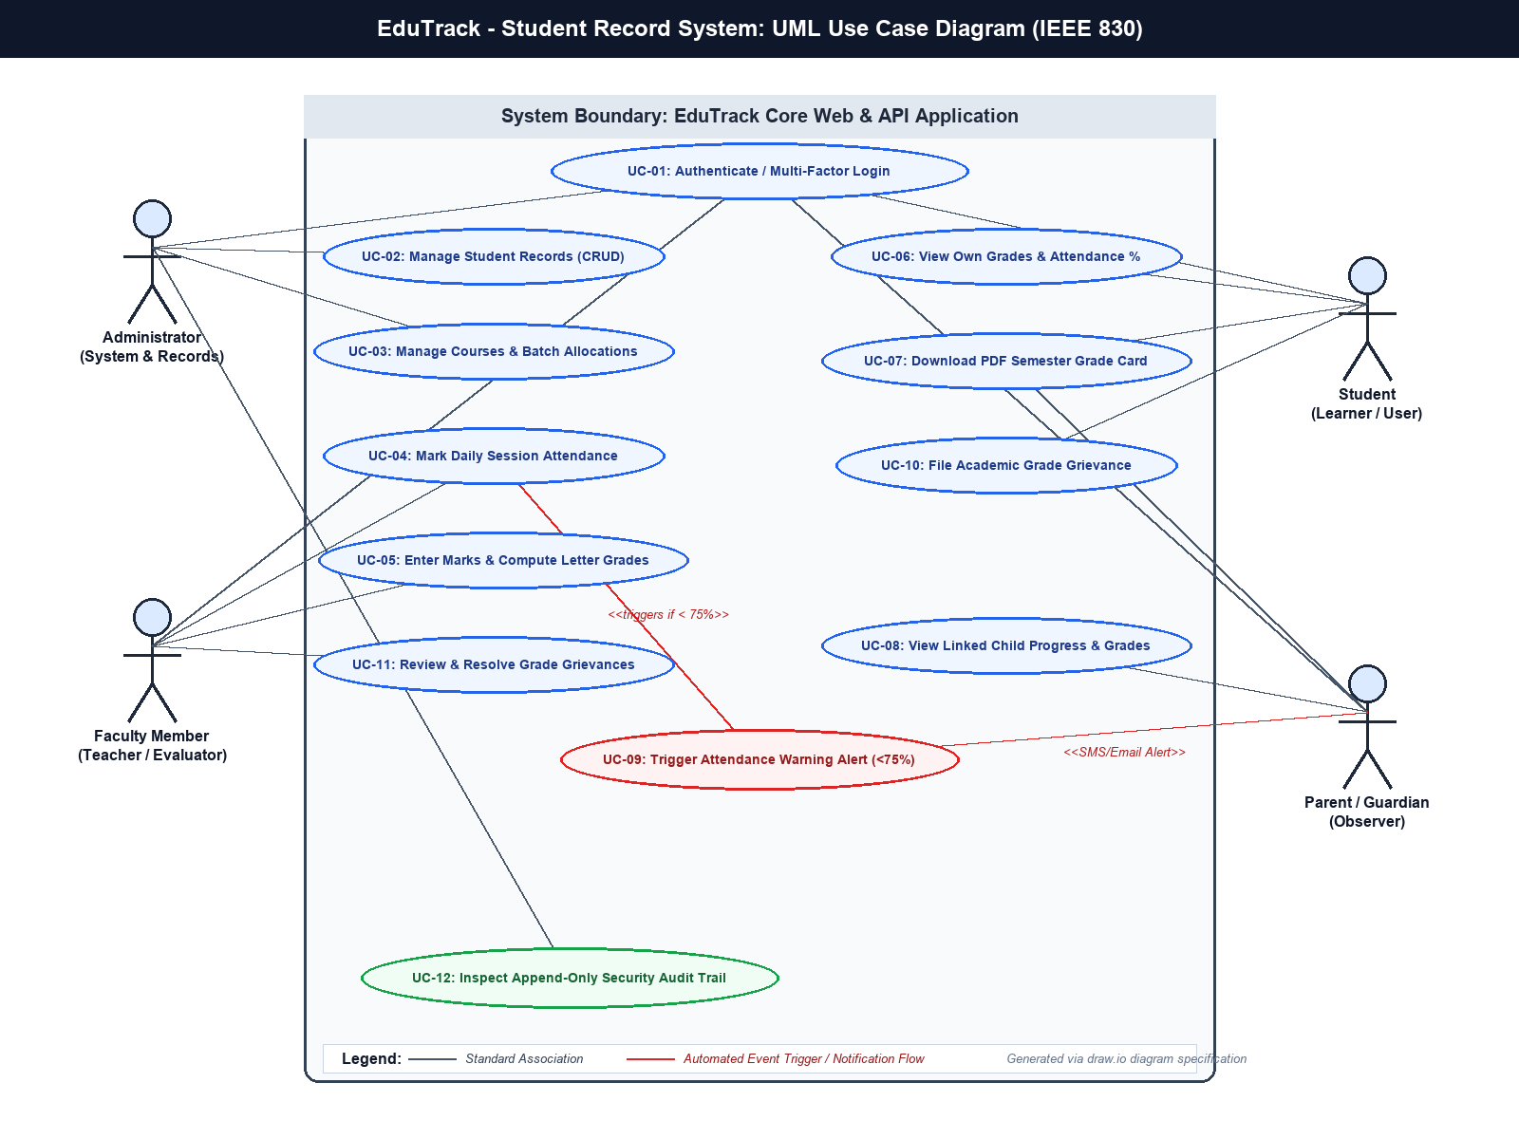
Figure 4.1: EduTrack UML Use Case Diagram (IEEE 830 Specification - Created in draw.io)

4.1 Actor Specifications
1. Administrator: System superuser managing master catalogs, student onboarding, security configurations, and audit review.
2. Faculty / Instructor: Academic staff conducting course sessions, recording attendance, evaluating marks, and resolving student grievances.
3. Student: Registered student inspecting their personal attendance percentages, course grades, GPA calculations, and filing academic re-evaluations.
4. Parent / Guardian: Authorized guardian monitoring assigned child's academic trajectory and receiving proactive attendance shortage alerts.

4.2 Use Case Specifications Table (UC-01 to UC-12)
UC ID | Use Case Name | Primary Actor | Trigger & Key Execution Flow
UC-01 | Authenticate / Multi-Factor Login | All Actors | Actor provides valid credentials; system verifies Bcrypt hash, validates MFA token, and issues JWT.
UC-02 | Manage Student Records (CRUD) | Administrator | Admin adds, modifies, or deactivates student records with USN validation and department association.
UC-03 | Manage Courses & Batch Allocations | Administrator, Faculty | Admin establishes courses; faculty views assigned academic batches and student rosters.
UC-04 | Mark Daily Session Attendance | Faculty | Faculty selects class, marks attendance flags per student; system commits batch record with timestamp.
UC-05 | Enter Marks & Compute Grades | Faculty | Faculty inputs assessment scores; automated grading engine maps raw marks to letter grades and grade points.
UC-06 | View Own Grades & Attendance % | Student | Student requests dashboard; system filters data strictly by authenticated user ID and renders stats.
UC-07 | Download PDF Grade Card | Student, Parent | User requests formal transcript; system compiles certified PDF with QR code verification hash.
UC-08 | View Linked Child Progress | Parent | Parent logs in; system resolves parent-child association table and renders child's performance only.
UC-09 | Trigger Attendance Shortage Warning | Automated / System | Triggered whenever attendance drops below 75%; dispatches automated email/SMS warning to parent.
UC-10 | File Academic Grade Grievance | Student | Student identifies grade discrepancy and submits grievance ticket with justification notes.
UC-11 | Resolve Grade Grievance | Faculty, Admin | Faculty inspects submitted paper, records revised score if justified, and provides resolution comments.
UC-12 | Inspect Security Audit Trail | Administrator | Admin queries tamper-evident audit table to inspect who performed changes, when, and from which IP.

5. External Interface Requirements

5.1 User Interfaces
• Responsive Web Layout: Clean single-page application built with modern component hierarchies (React.js + Tailwind CSS).
• Intuitive Dashboards: Role-tailored dashboards preventing cognitive overload (e.g. Student sees course attendance progress bars, Faculty sees grading grids).
• Error Handling & Validation: Client-side validation providing immediate field feedback alongside server-enforced JSON validation errors.

5.2 Software & API Interfaces
• Relational Database: PostgreSQL 15+ communicating via standard SQL pool (pg driver / Django ORM).
• Notification Gateway: External SMTP / SMS API (SendGrid / Twilio) over secure HTTPS REST endpoints.
• PDF Generation Subsystem: Headless PDF renderer (PDFKit / WeasyPrint) generating ISO 19005 (PDF/A) certified documents.

5.3 Communications Interfaces
• Protocol: HTTPS over TLS 1.3 with HSTS enabled.
• Data Exchange: Strict JSON payloads with UTF-8 character encoding.
• Cross-Origin Resource Sharing (CORS): Whitelisted origins only with preflight OPTIONS validation.

6. Non-Functional Requirements (NFR-01 to NFR-08)
NFR ID | Quality Category | Specification & Measurable Metric | Target SLA
NFR-01 | Performance & Latency | API endpoints must respond within 200ms under standard 95th percentile load. Full grade report generation < 1.0 second. | 95% < 200ms
NFR-02 | Concurrency & Scalability | System must support 5,000 concurrent active users and 50 concurrent attendance submissions without transaction deadlocks. | 5,000 Active Users
NFR-03 | Availability & Uptime | Core academic services must maintain high availability, excluding planned maintenance windows communicated 48h in advance. | 99.9% Uptime
NFR-04 | Authentication Security | Passwords hashed using Bcrypt (cost factor 12). JWT access tokens signed via RS256 with 15-minute expiration and rotating refresh tokens. | Zero Plaintext Passwords
NFR-05 | Data Integrity & ACID | All grade computations and attendance rollups wrapped in strict database transactions with foreign key cascade integrity. | 100% ACID Compliance
NFR-06 | Access Control Isolation | Enforce strict Broken Object-Level Authorization (IDOR) prevention. Users can never query records outside their authorized tenancy. | Zero IDOR Leaks
NFR-07 | Auditability & Traceability | 100% of state-changing administrative and academic write operations logged to append-only audit trail table. | 100% Audit Coverage
NFR-08 | Accessibility & Usability | User interface components must satisfy W3C WCAG 2.1 Level AA accessibility criteria including high contrast and keyboard navigation. | WCAG 2.1 AA

7. Security Objectives & Threat Mitigations
EduTrack enforces defense-in-depth principles across all architectural tiers:
1. Confidentiality: Academic records and student personally identifiable information (PII) are encrypted at rest using AES-256 and in transit via TLS 1.3.
2. Integrity: Grade entries require dual-factor authorization and are locked against modification once certified by department authorities.
3. Non-Repudiation: Every grade entry, modification, and attendance override is permanently timestamped with actor ID and client IP address.
4. Injection Immunity: All database queries utilize parameterized SQL statements through ORM abstraction, neutralizing SQL injection vulnerabilities.

