Student Record System
Software Architecture & Design Specification
Deliverable 3 of 4 - Mini-Project Part 1
Prepared following IEEE 1016-2009 (Software Design Descriptions) and IEEE 42010 (Architecture Description)
Document ID: SADS-SRSYS-01 | Version 1.0 | 28 September 2026
TEAM-E12
Team Members
Monika PM - PES1UG24CS275
Kushita K - PES1UG24CS247
Nagashree R Patil - PES1UG24CS289
Nidhi L - PES1UG24CS298

Software Engineering Mini-Project - Part 1

Table of Contents
Part A - Architecture: 1. Introduction 2. Architecture Pattern 3. Component View & Description 4. Traceability to Requirements 5. Security Architecture 6. Deployment View 7. Data Architecture | Part B - Design: 8. Sequence Diagrams 9. API Design 10. Error Handling 11. Database Design 12. Design Constraints & Decisions

Revision History
Version | Date | Description | Author
1.0 | 28 September 2026 | Initial Architecture & Design Specification for Mini-Project Part 1. | TEAM-E12 (all members)

PART A - ARCHITECTURE

1. Introduction

1.1 Purpose and Scope
This document describes the software architecture and detailed design of the Student Record System, building on the requirements in SRS-SRSYS-01. It is intended for the development team (as an implementation blueprint) and the evaluator (as evidence of architectural and design reasoning).

1.2 Architectural Goals and Drivers
- Separation of concerns across presentation, application and data tiers, so that the four actor-specific UIs, the business logic and the storage layer can evolve independently (supports NFR-07, Maintainability).
- Centralised, defence-in-depth security enforcement at a single middleware layer rather than scattered per-endpoint checks (supports SEC-01 to SEC-09).
- Stateless application servers (session state carried in the JWT, not in server memory) so that the API tier can be scaled horizontally if load increases (supports NFR-01, NFR-03).

2. Architecture Pattern
The system follows a layered (n-tier) client-server architecture with three tiers - Presentation, Application and Data - further organised internally using a Model-View-Controller-like separation within the Application tier, and a Service-Oriented decomposition of the business logic into cohesive services (Auth, Student/Course, Grade, Attendance, Report, Notification, Grievance, Audit).
- Presentation tier: a React single-page application (SPA) that renders role-specific views and communicates only through the REST API - no direct database access.
- Application tier: a stateless REST API server (Node.js/Express, or an equivalent framework) that hosts an API Gateway/Router, a Security Middleware layer, and eight independent domain services.
- Data tier: a relational database (PostgreSQL/MySQL) for structured, transactional data, a temporary file store for generated reports, and an external e-mail/SMS gateway for notifications.
This pattern was chosen over a monolithic single-layer design because it lets the security middleware (SEC-01 to SEC-09) apply uniformly to every service, it keeps each domain service small enough for one team member to own, and it maps cleanly onto the SRS's actor/use-case structure (each dashboard in the Presentation tier talks to a small, predictable set of services).

3. Component View and Description
Figure 2 shows the components of the system, grouped by tier, with the interfaces between them.
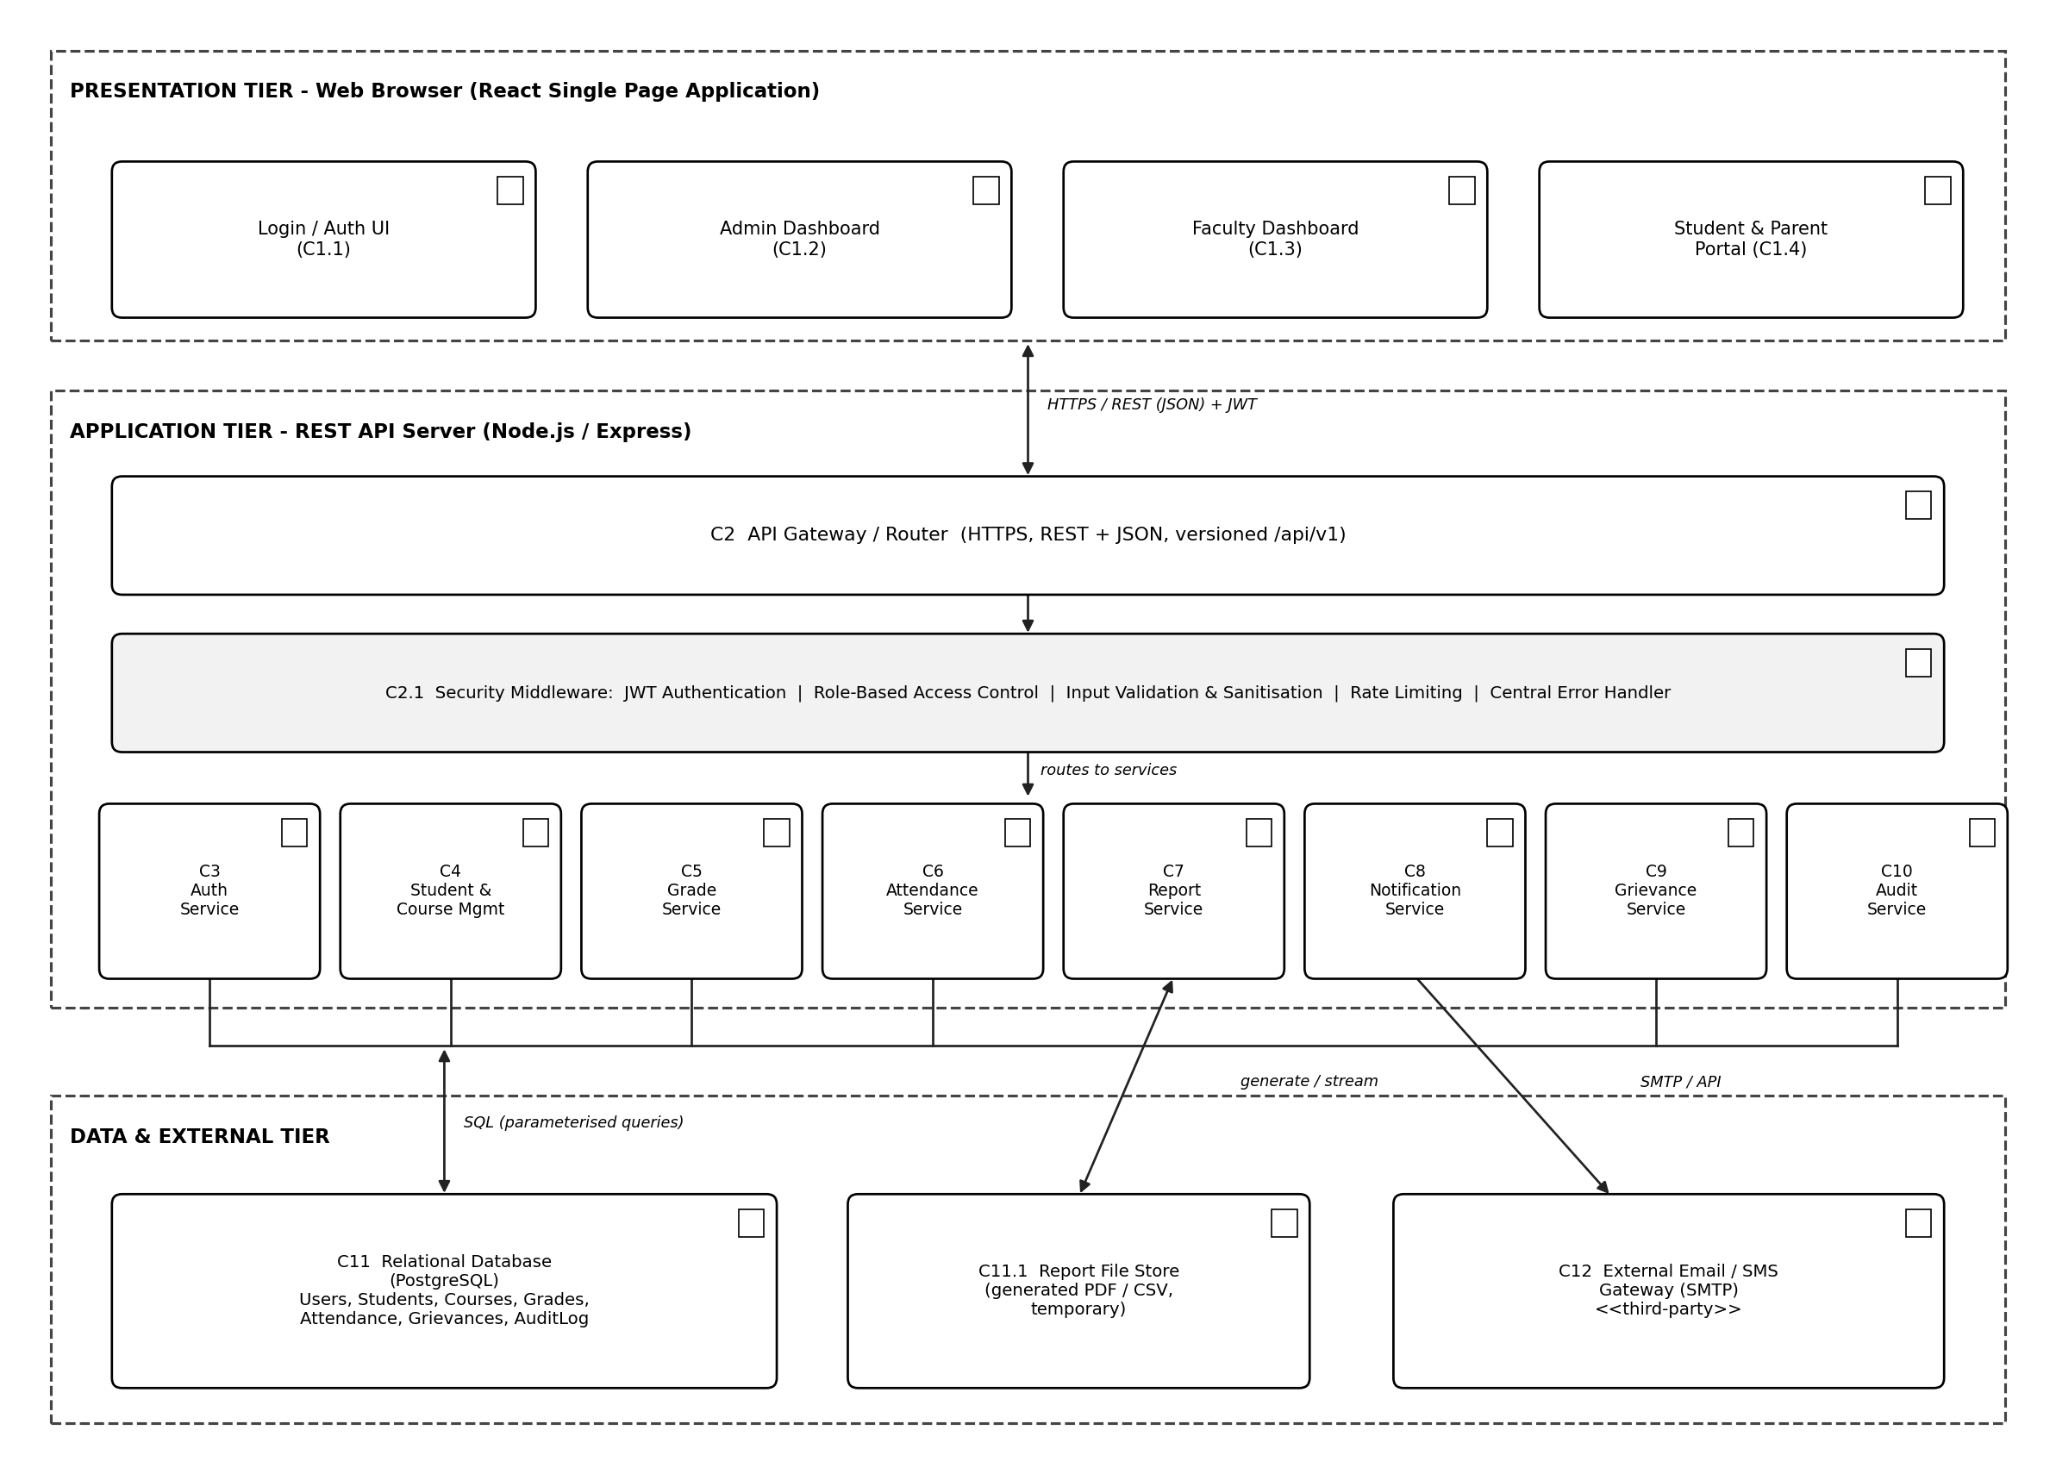
Figure 2: Component Diagram - Student Record System

3.1 Component Descriptions
Component | Responsibility
C1.1-C1.4 UI components | Render the Login screen and the Admin, Faculty, and Student/Parent dashboards; call the REST API; hold no business logic.
C2 API Gateway / Router | Single entry point for all HTTP requests; routes requests to the correct service by URL/verb; terminates TLS.
C2.1 Security Middleware | Verifies JWTs, enforces role-based access control, validates/sanitises input, applies rate limiting, and formats errors centrally (see Section 5, 10).
C3 Auth Service | Validates credentials, issues/refreshes JWTs, manages account lockout and password change.
C4 Student & Course Mgmt Service | CRUD for student, faculty and course records; enrolment management.
C5 Grade Service | Records and corrects marks; computes letter grades; enforces the faculty-course assignment check.
C6 Attendance Service | Records per-session attendance; computes attendance percentage; raises the low-attendance event consumed by C8.
C7 Report Service | Aggregates grade and attendance data into class-wise/student-wise reports and report-card PDFs.
C8 Notification Service | Listens for low-attendance and grievance events and dispatches e-mail/SMS via C12.
C9 Grievance Service | Manages grievance lifecycle: raised, in review, resolved.
C10 Audit Service | Writes an immutable audit entry for every state-changing call made through C2.1.
C11 / C11.1 Data stores | Relational database for all persistent entities; temporary file store for generated report files.
C12 External Gateway | Third-party SMTP/SMS provider used only by C8.

4. Traceability to Requirements
Every functional, non-functional and security requirement from the SRS is realised by one or more components identified above. This closes the loop from requirement to design element (and, via the Test Plan, to a verifying test case).
Requirement ID | Realising Component(s)
FR-01 | C1.1, C2, C2.1, C3
FR-02 | C1.2, C4, C11
FR-03 | C1.2, C4, C11
FR-04 | C1.2, C3, C4
FR-05 | C1.2, C4
FR-06 | C1.3, C5, C11
FR-07 | C1.3, C5, C10
FR-08 | C1.3, C6, C11
FR-09 | C6
FR-10 | C1.4, C5, C6
FR-11 | C1.4, C7, C11.1
FR-12 | C1.4, C3, C5, C6
FR-13 | C6, C8, C12
FR-14 | C1.2, C1.3, C7, C11.1
FR-15 | C1.3, C1.4, C9, C8
FR-16 | C10, C11
FR-17 | C1.4, C4
NFR-01 | C2, C11 (indexes, connection pool)
NFR-02 | C7, C11
NFR-03 | C11 (indexes, pagination)
NFR-04 | Deployment (process manager, monitoring)
NFR-05 | C1
NFR-06 | C1
NFR-07 | All (modular services, OpenAPI)
NFR-08 | C11 (scheduled backup)
NFR-09 | C5, C6, C11 (transactions)
NFR-10 | C1
SEC-01 | C3
SEC-02 | C2.1
SEC-03 | C2 (TLS termination)
SEC-04 | C2.1, C3
SEC-05 | C3
SEC-06 | C2.1, all services
SEC-07 | C10, C11
SEC-08 | C2.1, C5, C6
SEC-09 | C2.1

5. Security Architecture

5.1 Defence-in-Depth Layers
- Network layer: HTTPS/TLS 1.2+ termination at the API Gateway (C2); no plaintext HTTP is served (SEC-03).
- Access layer: Security Middleware (C2.1) authenticates every request via JWT and enforces role-based and object-level access control before a request reaches any service (SEC-02, SEC-04, SEC-08).
- Application layer: each service validates and sanitises its own inputs in addition to the middleware's generic checks, and uses parameterised queries exclusively (SEC-06).
- Data layer: the audit service (C10) writes to an append-only table for which the application's database role has no UPDATE/DELETE grant (SEC-07); passwords are stored only as bcrypt hashes (SEC-01).
- Perimeter layer: rate limiting at the middleware protects against brute-force and application-level denial-of-service (SEC-05, SEC-09).

5.2 Authentication and Session Flow
Figure 3 (Section 8, SD-1) shows the authentication sequence in detail: credential submission, server-side validation, JWT issuance with a 30-minute expiry, and per-request verification by the Security Middleware on every subsequent call.

5.3 Threat Model (Summary)
Threat (STRIDE) | Mitigating Component / Control
Spoofing identity | C3 Auth Service - hashed passwords, account lockout (SEC-01, SEC-05)
Tampering with data | C2.1 parameterised queries, input validation; C10 immutable audit log (SEC-06, SEC-07)
Repudiation | C10 Audit Service records who did what and when (SO-4)
Information disclosure | C2.1 object-level authorisation restricting Student/Parent to own/linked records (SEC-08)
Denial of service | C2.1 rate limiting (SEC-09)
Elevation of privilege | C2.1 role-based access control checked on every route (SEC-02)

6. Deployment View
For the mini-project, all components are deployed as: (a) the React build served as static files (e.g. via Nginx or a CDN); (b) the Node.js/Express API server as a single process (with the option to run multiple instances behind a load balancer, since the design is stateless); (c) a managed or self-hosted PostgreSQL/MySQL instance; (d) a third-party SMTP/SMS provider reached over the internet. A daily automated backup job satisfies NFR-08.

7. Data Architecture
Primary entities and their relationships (detailed schema in Section 11): User (1) --- (0..1) Student; User (1) --- (0..1) Faculty; Course (1) --- (n) Enrolment (n) --- (1) Student; Faculty (1) --- (n) Course; Enrolment/Course (1) --- (n) Grade; Enrolment/Course (1) --- (n) AttendanceRecord; Student (1) --- (n) Grievance; every write to Grade/Attendance/Student produces (1) AuditLogEntry; Parent (1) --- (n) Student via a ParentLink table.

PART B - DESIGN

8. Sequence Diagrams
Three representative sequence diagrams are given below (exceeding the minimum of 2 requested), covering authentication, a core write operation, and a core read/export operation.
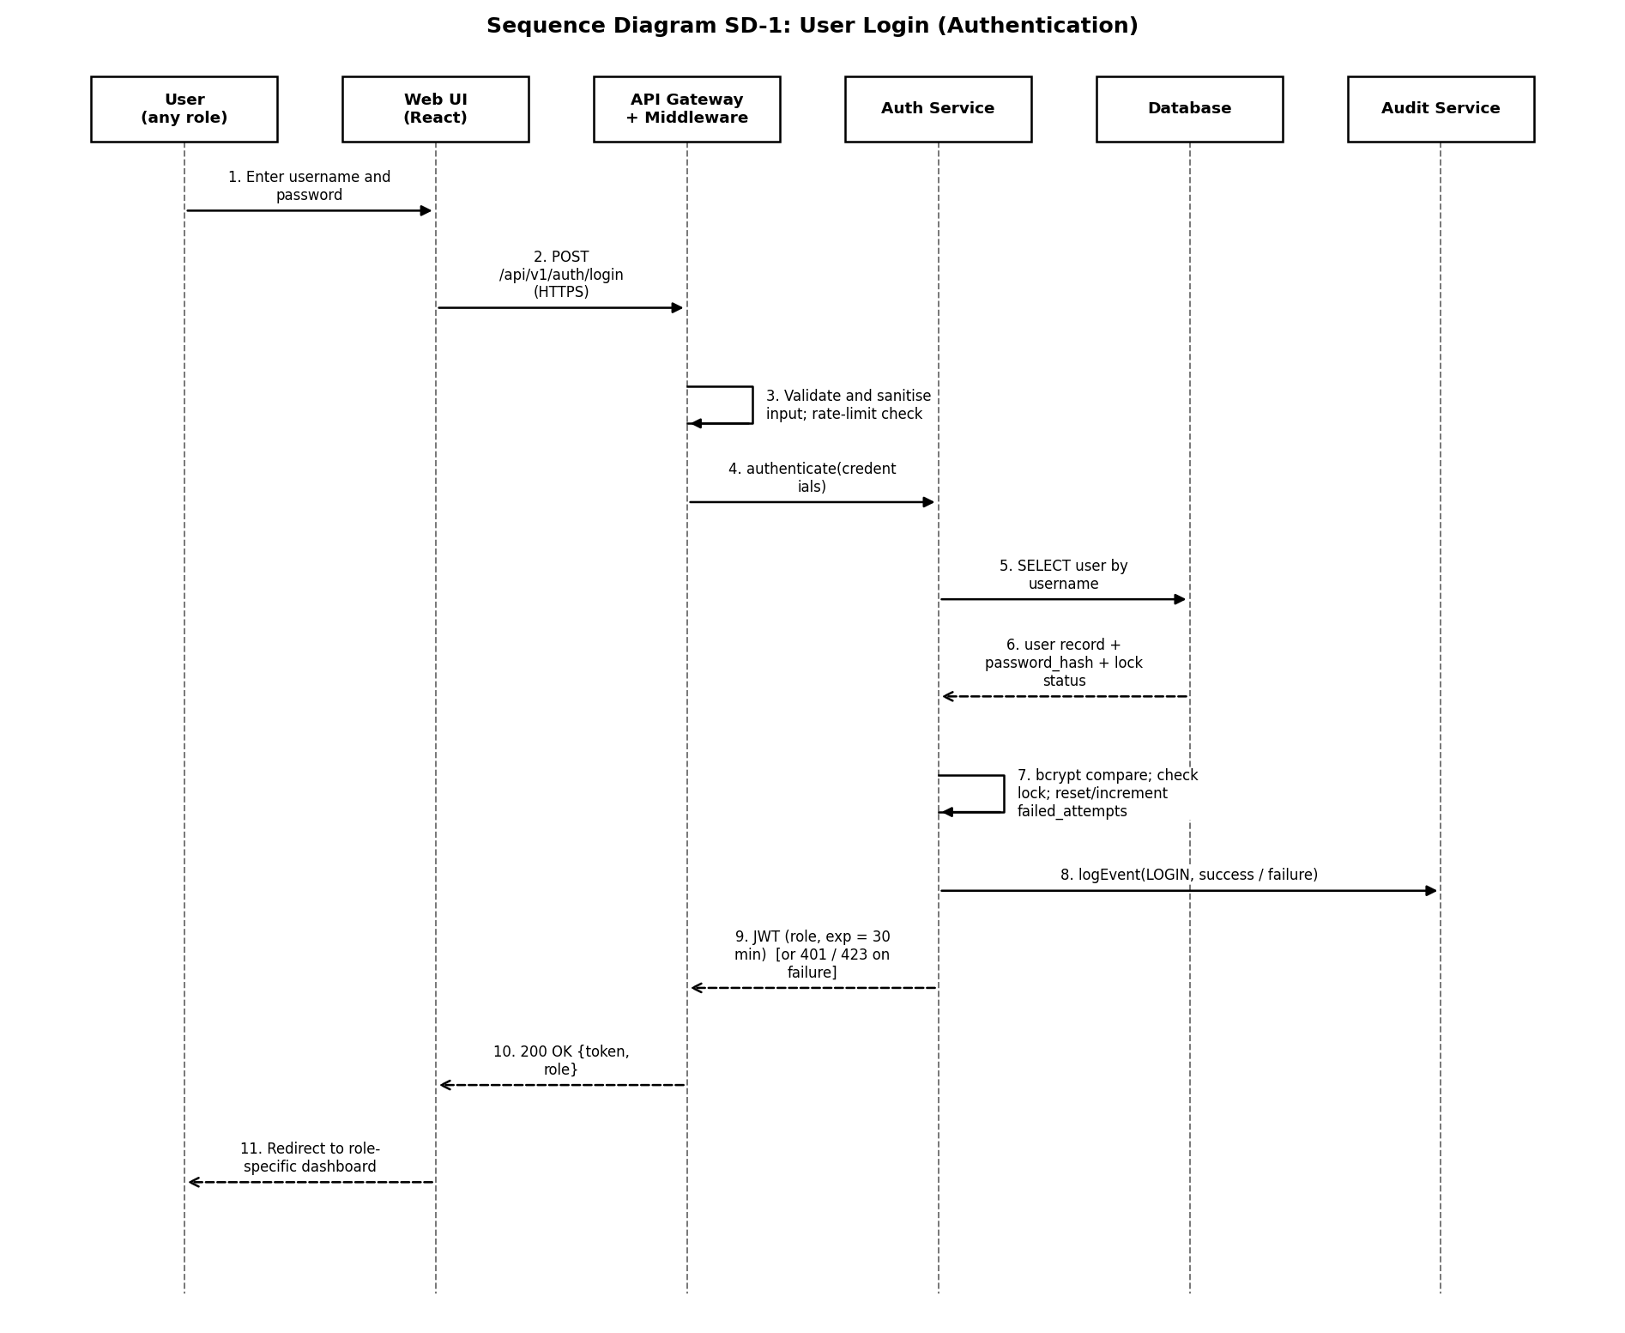
Figure 3 (SD-1): User Login (Authentication) - realises FR-01, SEC-01, SEC-04, SEC-05
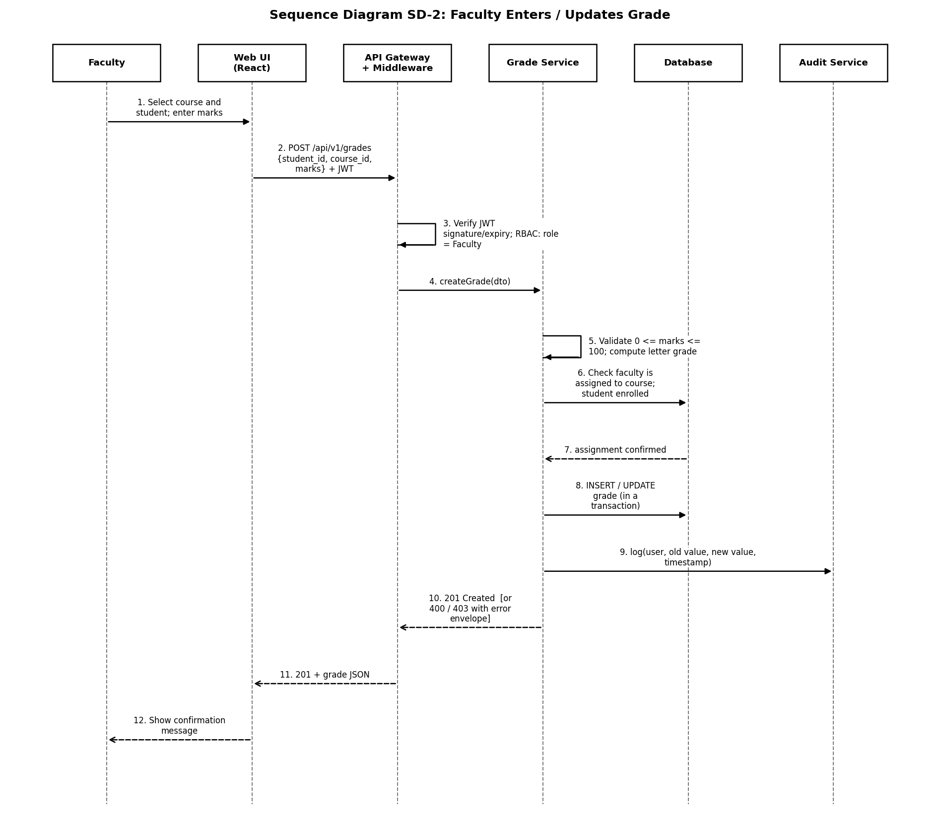
Figure 4 (SD-2): Faculty Enters/Updates a Grade - realises FR-06, FR-07, SEC-02, SEC-06
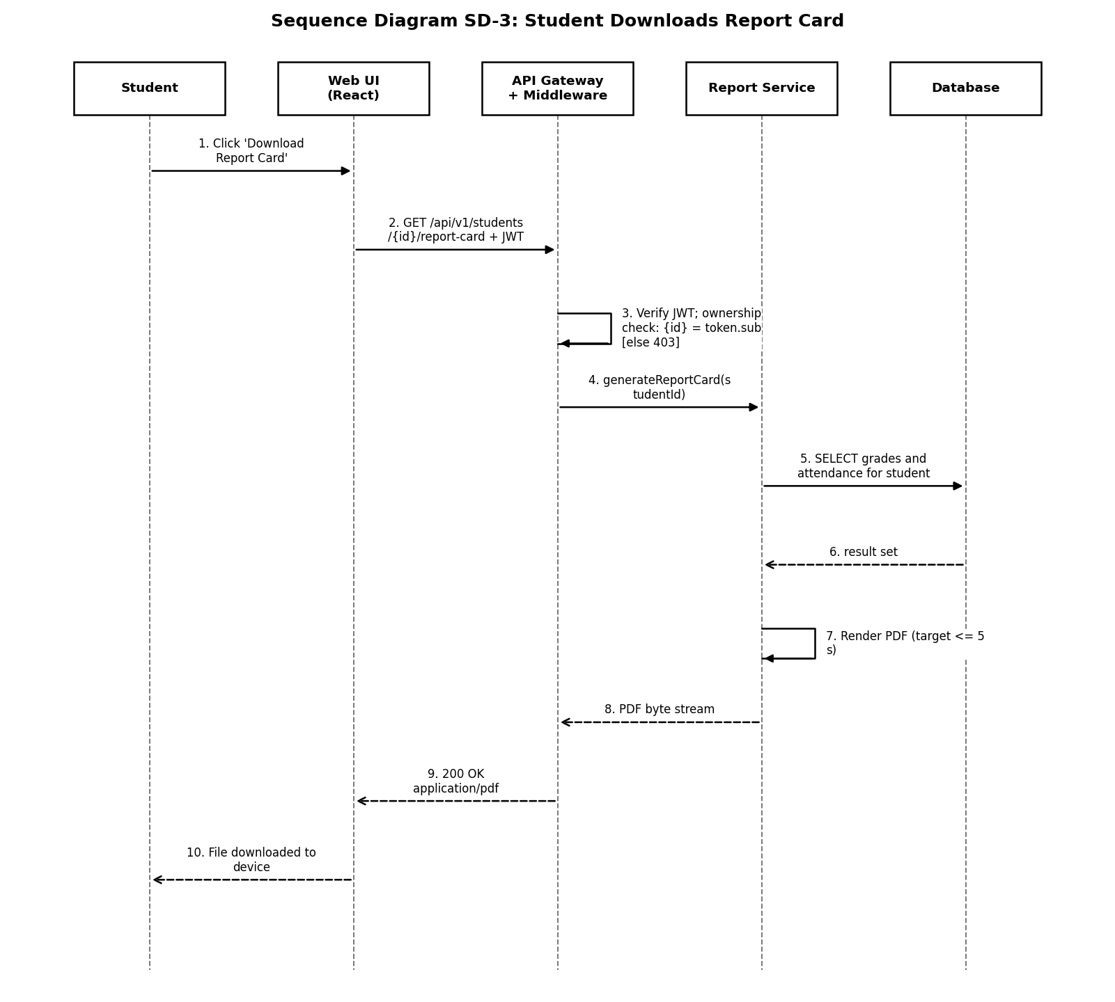
Figure 5 (SD-3): Student Downloads Report Card - realises FR-11, SEC-08

9. API Design
The API is a versioned REST interface (/api/v1) using JSON request/response bodies, HTTPS only, and a Bearer JWT in the Authorization header for every endpoint except login. Representative endpoints:
Method & Path | Auth / Role | Description | Realises
POST /api/v1/auth/login | None (public) | Authenticate and receive a JWT. | FR-01, SEC-01, SEC-04, SEC-05
GET /api/v1/students/{id} | Admin; or Student/Parent (own/linked only) | Retrieve a student record. | FR-02, FR-10, FR-12, SEC-08
POST /api/v1/students | Admin | Create a student record. | FR-02
PUT /api/v1/students/{id} | Admin | Update a student record. | FR-03, FR-17 (self-service subset)
POST /api/v1/courses/{id}/grades | Faculty (assigned to course) | Enter or correct a grade. | FR-06, FR-07, SEC-02
POST /api/v1/courses/{id}/attendance | Faculty (assigned to course) | Mark attendance for a session. | FR-08, FR-09
GET /api/v1/students/{id}/report-card | Student (self); Admin; Parent (linked) | Generate/download report card PDF. | FR-11, SEC-08
GET /api/v1/reports/class/{courseId} | Admin; Faculty (own course) | Class-wise performance report. | FR-14
POST /api/v1/grievances | Student | Raise a grievance on a grade/attendance entry. | FR-15
PATCH /api/v1/grievances/{id} | Faculty | Respond to / resolve a grievance. | FR-15
GET /api/v1/audit-logs | Admin (read-only) | View the audit trail. | FR-16, SEC-07

9.1 Standard Response Envelope
Every response uses a consistent envelope so the front end can handle success and error uniformly:
{
"success": true,
"data": { ... },
"meta": { "timestamp": "2026-09-28T10:00:00Z" }
}
Error responses follow the same shape with success:false and an error object (see Section 10).

10. Error Handling
All errors are caught by a single central error handler in the Security Middleware (C2.1) so that no stack trace or internal detail is ever leaked to the client, satisfying part of SEC-06.
HTTP Status | Meaning | Example Trigger
400 Bad Request | Input failed validation | Marks outside 0-100; missing mandatory field
401 Unauthorized | Missing, invalid or expired JWT | Expired session (Section 5, SEC-04)
403 Forbidden | Authenticated but not authorised for this resource | Faculty editing another Faculty's course grade (SEC-02, SEC-08)
404 Not Found | Resource does not exist / is deactivated | Roll number not found
409 Conflict | Duplicate or state conflict | Duplicate roll number on student creation (FR-02)
423 Locked | Account temporarily locked | 5 consecutive failed logins (SEC-05)
429 Too Many Requests | Rate limit exceeded | More than 100 requests/minute from one client (SEC-09)
500 Internal Server Error | Unexpected server fault | Logged internally with a correlation ID; generic message returned to client

{
"success": false,
"error": { "code": "VALIDATION_ERROR", "message": "marks must be between 0 and 100" }
}
Every 4xx/5xx response is also written to the audit/error log with a correlation ID (linking front-end error reports to server-side logs) without exposing that ID's internal detail to the end user.

11. Database Design (Key Tables, Simplified)
Table | Key Columns
users | id (PK), username, password_hash, role, failed_attempts, locked_until
students | id (PK), user_id (FK), roll_no (unique), name, dob, department, semester, is_active
faculty | id (PK), user_id (FK), name, department
courses | id (PK), code, name, semester, faculty_id (FK)
enrolments | id (PK), student_id (FK), course_id (FK)
grades | id (PK), enrolment_id (FK), marks, letter_grade, updated_by (FK), updated_reason
attendance_records | id (PK), enrolment_id (FK), session_date, status, marked_by (FK), marked_at
grievances | id (PK), student_id (FK), reference_id, status, raised_at, resolved_at
parent_links | id (PK), parent_user_id (FK), student_id (FK)
audit_log | id (PK), user_id (FK), action, entity, old_value, new_value, timestamp (append-only)

12. Design Constraints and Decisions
- Chosen a relational database over NoSQL because student/course/grade/attendance data is inherently relational with strong integrity constraints (foreign keys, uniqueness), which maps directly to NFR-09 (ACID transactions).
- Chosen JWT-based stateless authentication over server-side sessions to keep the Application tier horizontally scalable without a shared session store (supports NFR-01/NFR-03).
- Chosen a single shared Security Middleware over per-service auth checks to reduce the chance that a new endpoint is added without the required access control (a common real-world security defect class).
- Report generation is asynchronous-capable (temporary file store, C11.1) so that PDF generation for larger classes does not block the API Gateway.

