|  |  |
| --- | --- |
| Date | 7th April 2023 |
| Team ID | NM2023TMID06742 |
| Project Name | The Tragedy of Flight: A Comprehensive Crash Analysis |
| Maximum marks | 5 marks |

Airplane is the safest way to travel. It is nineteen times safer than in a car. It makes people more comfortable.

People say that it is a very reliable transportation and it has no physical limits. We can fly everywhere.



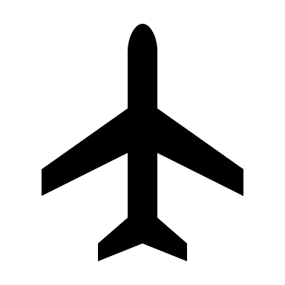**Think and feel**

The number of civil aviation deaths increased from 349 in 2020 to 376 in 2021.

**ATLANTA**- Hartsfield Jackson Atlanta International Airport be the busiest airport in the world.

**Hear See**

**Say and do**

Don’t climb and jump over the seats while the travelling

Follow the instructions that the aerosters provided.

**Pain Gain**

Roughly 10000 flights take off and land everyday all over the globe. Nowadays most of the people prefer airplane to travel.

37% of accidents occur while descent and landing. There are 1,622 airplane crashes per year.