AI Assistant Coding
Assignment 4.1.2
Name : P.Nagasri HT. No : 2303A52456 Batch: 32

Q1.
A company receives a large number of customer emails every day and wants to automatically classify them into the following
categories:
• Billing
• Technical Support
• Feedback
• Others
Instead of training a new machine learning model, the company decides to use prompt engineering techniques with an existing large language model.
Tasks
1. Prepare five short sample emails, each belonging to one of the above categories.
2. Write a zero-shot prompt to classify a given email into one of the categories without providing any examples.
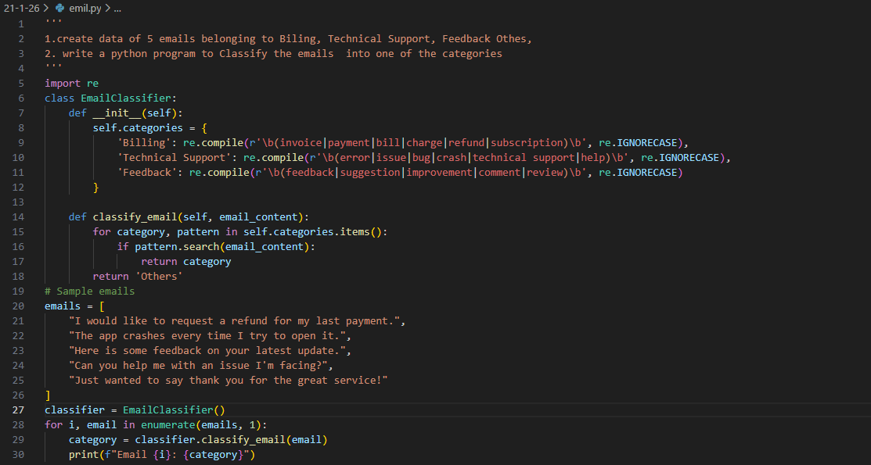
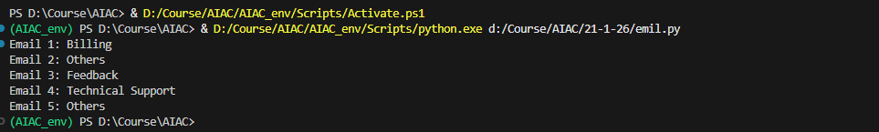
3. Write a one-shot prompt by including one labeled email example and ask the model to classify a new email.
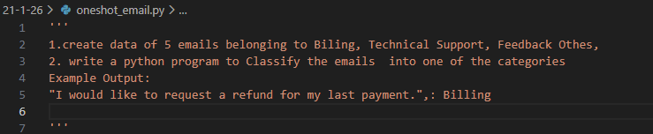
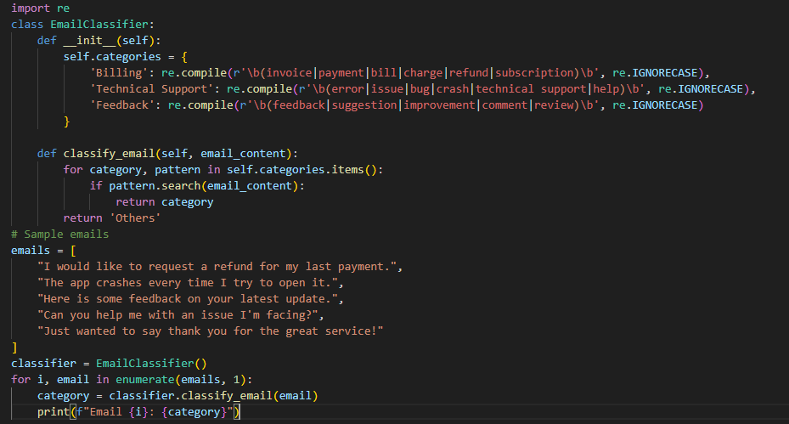
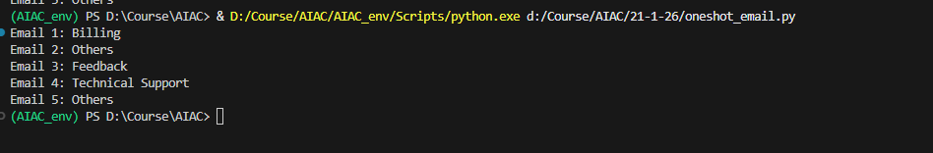
4. Write a few-shot prompt by including two or three labelled email examples and ask the model to classify a new email.
5. Compare the outputs obtained using zero-shot, one-shot, and few-shot prompting techniques and briefly comment on their effectiveness
Using zero Shot,one shot, few shot there is no changes in code just a slight improve

Q2.
A company wants to deploy a chatbot to handle customer queries. Each query must be classified into one of the following intents: Account Issue, Order Status, Product Inquiry, or General Question using prompt engineering techniques.
Tasks to be Completed
1. Prepare Sample Data Create 6 short chatbot user queries, each mapped to one of the four intents.
2. Zero-shot Prompting Design a prompt that asks the LLM to classify a user query into the given intent categories without examples.
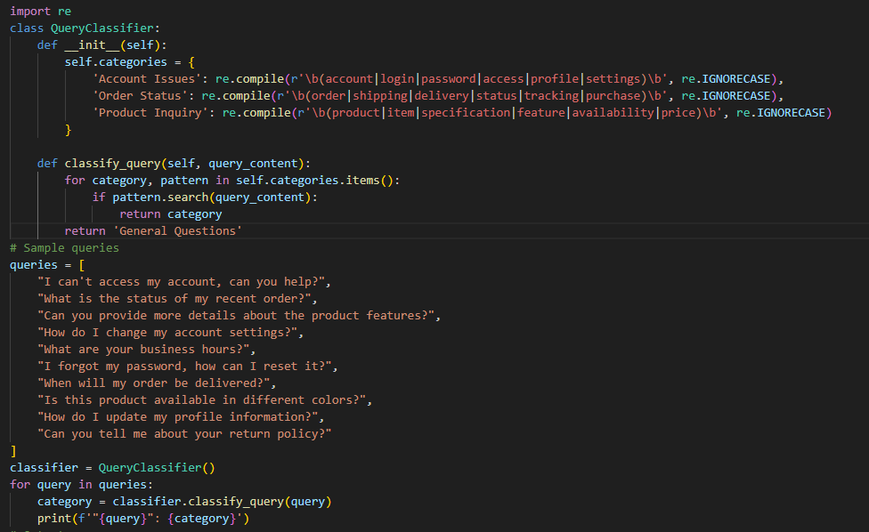
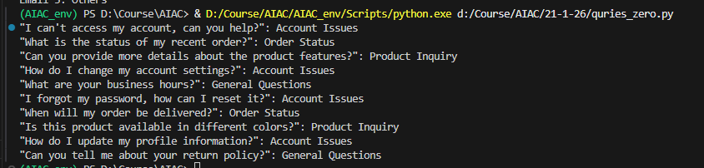

3. One-shot Prompting Provide one labeled query in the prompt before classifying a new query.
4. Few-shot Prompting Include 3–5 labeled intent examples to guide the LLM before classifying a new query.
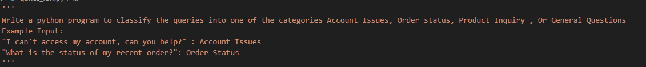
5. Evaluation Apply all three techniques to the same set of test queries and document differences in performance.
For all the test cases the out put is same as there is no change in code

Q3.
A university collects student feedback and wants to categorize comments as Positive, Negative, or Neutral.
Questions:
- Write a Zero-shot prompt to classify feedback sentiment.
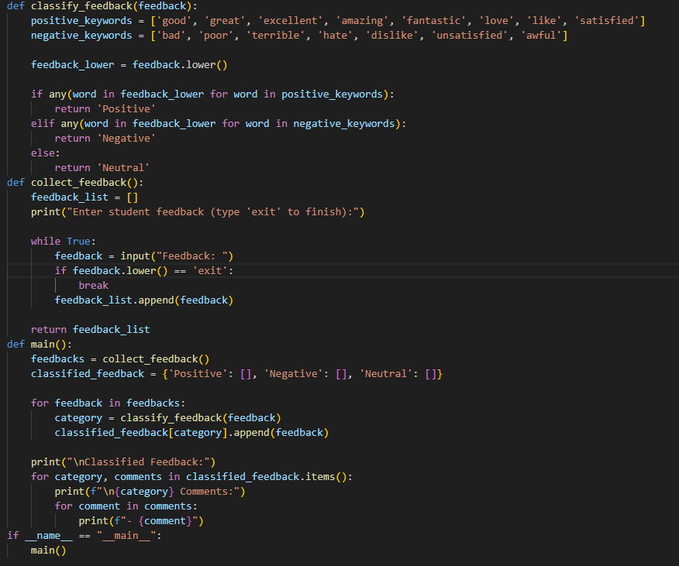
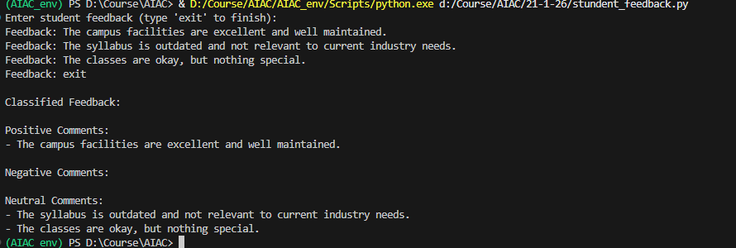
- Provide a One-shot prompt with one feedback example.
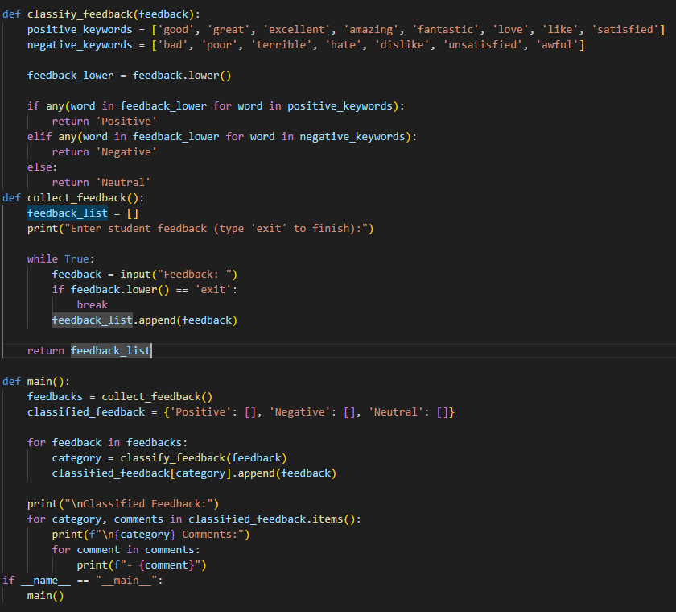
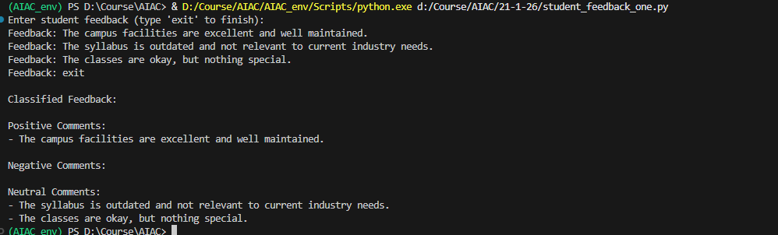
- Create a Few-shot prompt using multiple labeled feedback samples.
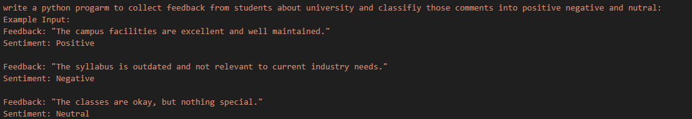
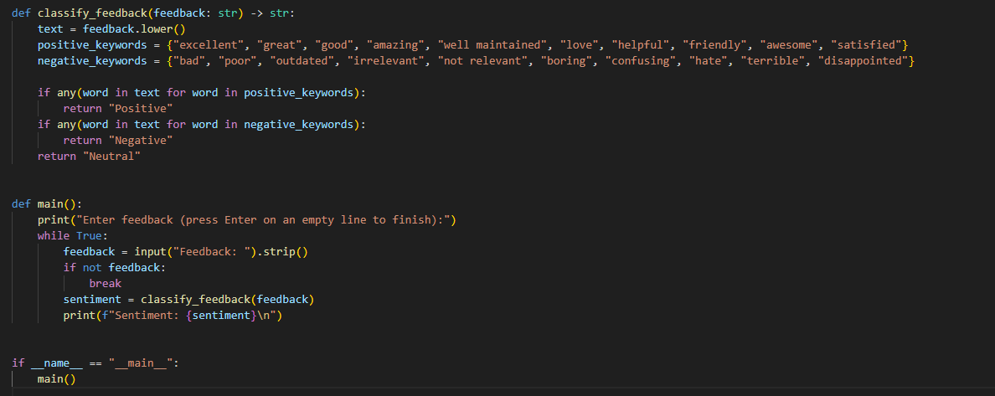
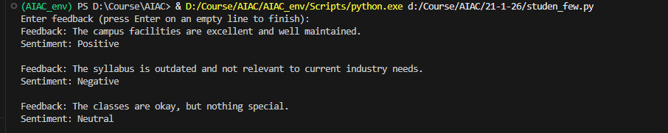
d) Explain how examples improve sentiment classification accuracy.
The Examples help the AI to add more keywords in code to classify the queries

Q4.
An online learning platform wants to recommend courses by classifying learner queries into Beginner, Intermediate, or Advanced levels.
Questions:
- Write a Zero-shot prompt to classify learner queries.
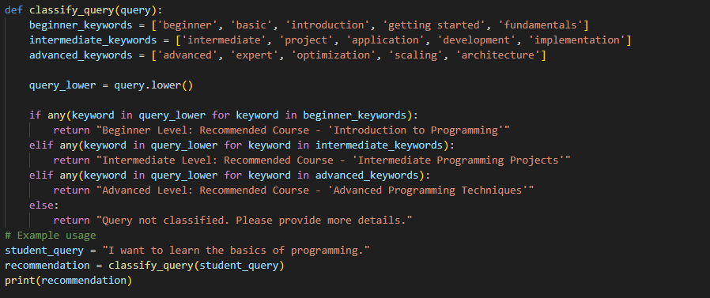
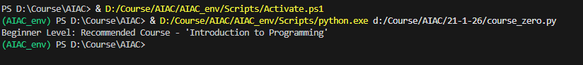
- Create a One-shot prompt with one example query.
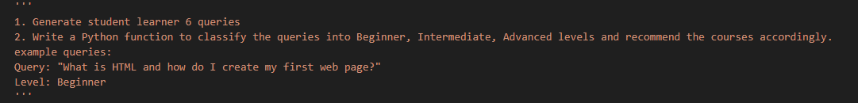
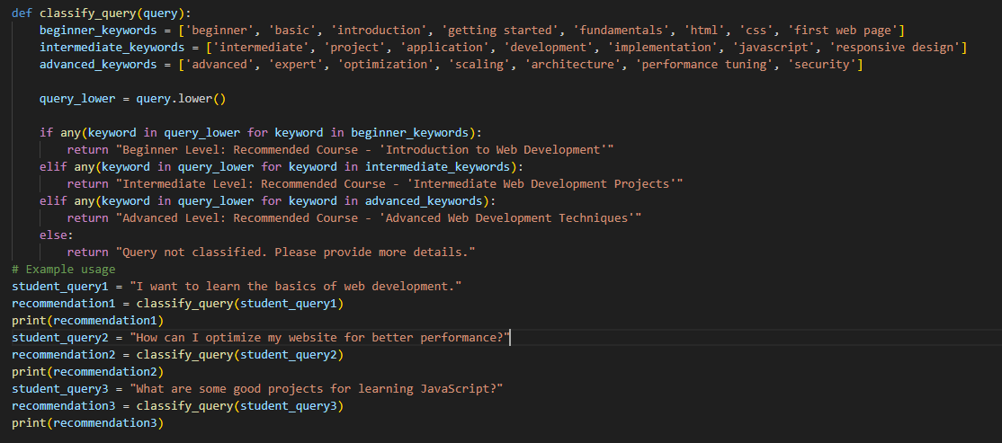
- Develop a Few-shot prompt with multiple labeled queries.
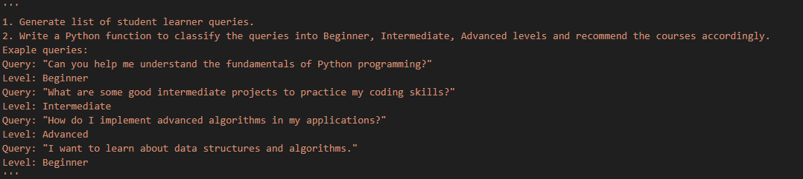
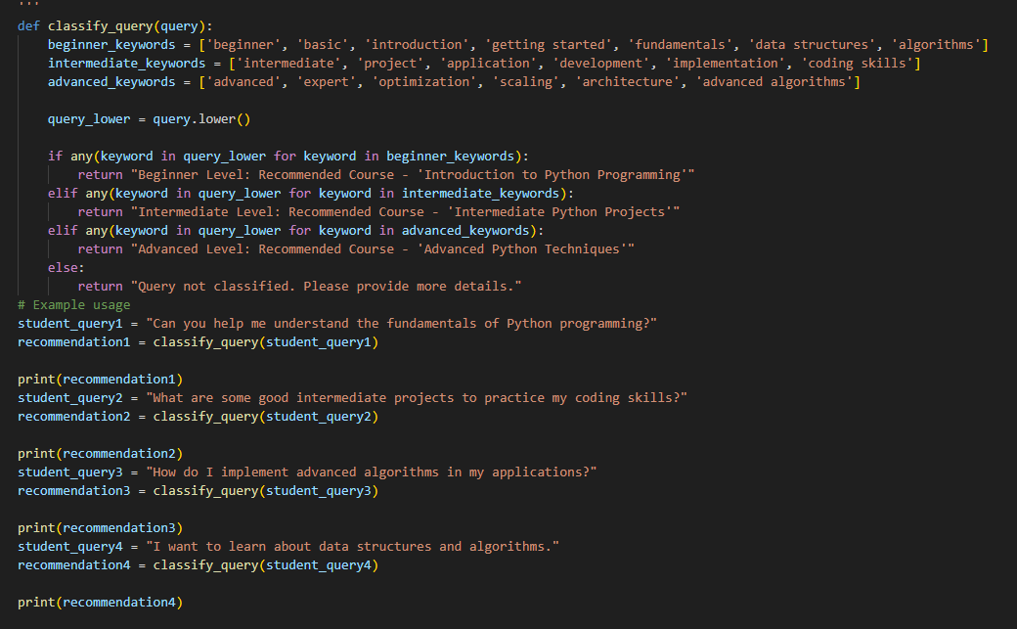
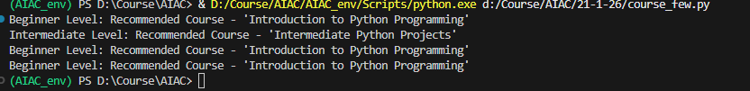
d) Discuss how Few-shot prompting improves recommendation quality
Few Shot Prompting to help the AI to add more keywords which help to classify the queries

Q5. A social media platform wants to classify posts into Acceptable, Offensive, or Spam.
Questions:
- Write a Zero-shot prompt for post moderation.
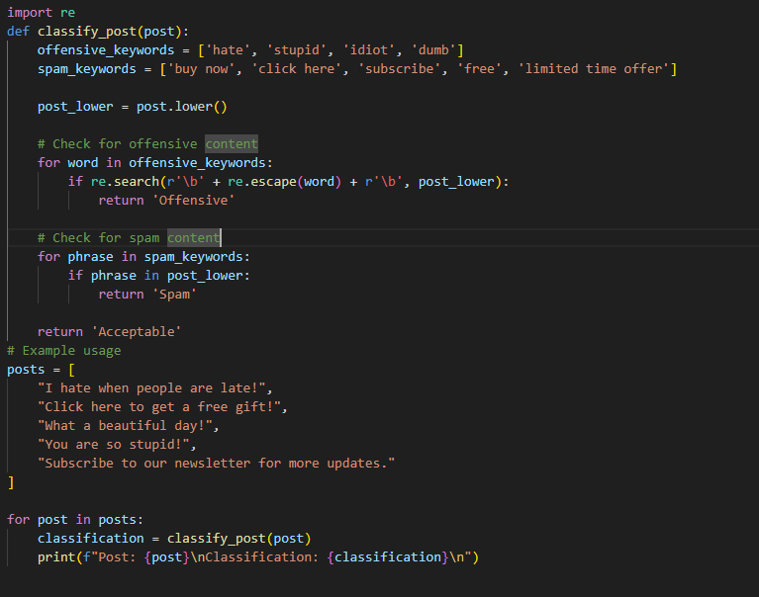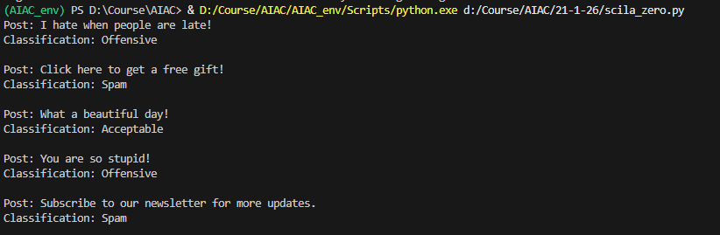
- Convert it into a One-shot prompt.
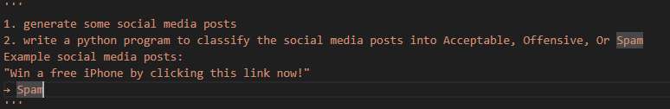
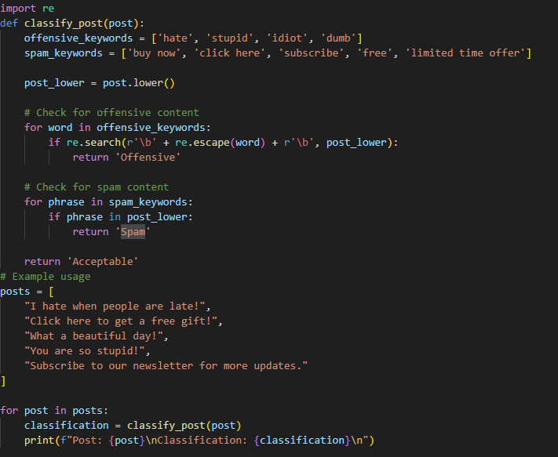
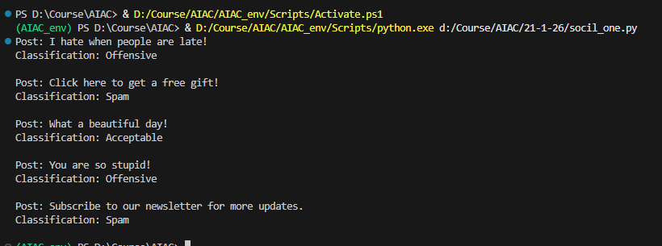
- Design a Few-shot prompt using multiple examples.
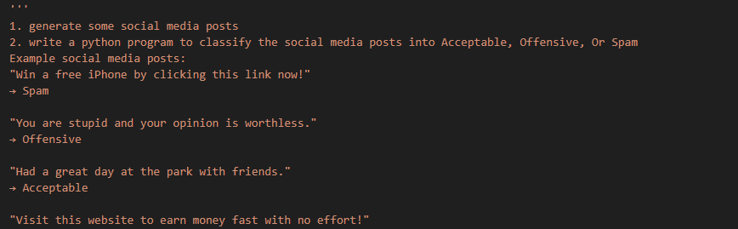
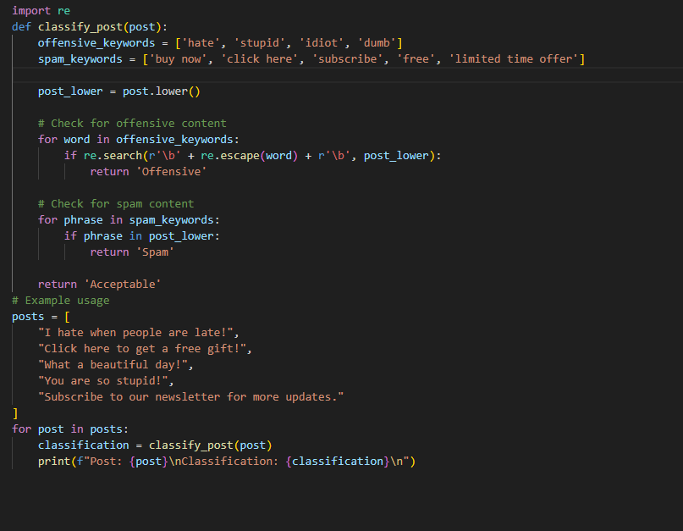
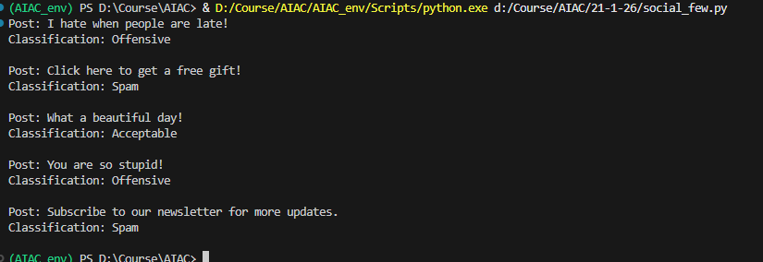
- Explain the challenges of Zero-shot prompting in content moderation.
Limitations in keywords which cant classify all the pots

