ASSIGNMENT-1
Domain:
The domain selected is Student Exam Scores, which commonly follow a Normal Distribution. A normal distribution is a symmetric, bell-shaped curve where most values cluster around the average, and fewer values appear at the extremes.
In exam results, the majority of students score near the mean (average marks), while only a few students score very low or very high marks. This makes student performance a suitable real-world example of a normal distribution.
According to the Empirical Rule (68–95–99.7 rule):
- About 68% of students score within one standard deviation of the mean.
- About 95% of students fall within two standard deviations.
- Nearly 99.7% of students fall within three standard deviations.
This rule helps teachers understand overall performance and identify outliers such as toppers or weak performers.
The distribution can also be represented using:
- Histogram – shows frequency of marks
- Normal curve – shows smooth bell shape
- Skewed distributions – show easier or harder exams
- Mean, Median, Mode comparison – shows data symmetry
Understanding this distribution helps in grading systems, performance analysis, and academic decision-making.
We will assume:
- Mean (μ) = 70 marks
- Standard Deviation (σ) = 10 marks
This is a common real-world domain where data follows a Normal Distribution (Bell Curve).
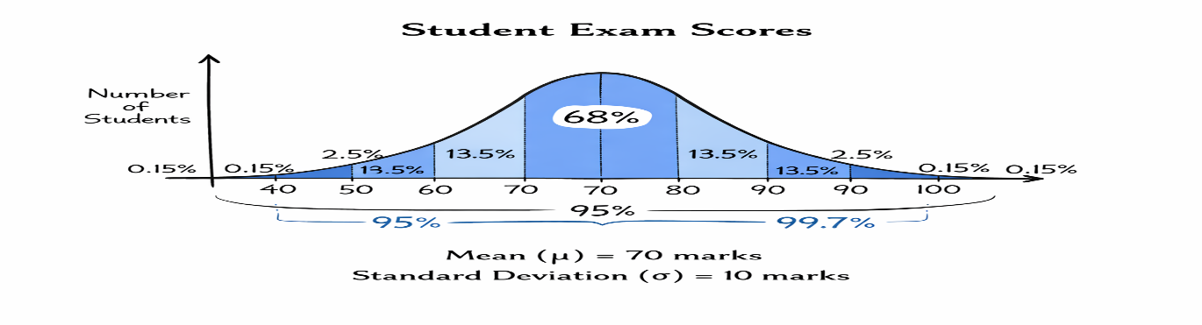

Normal Distribution Graph Explanation
The graph is a bell-shaped curve with:
- Center = Mean (70)
- Spread determined by standard deviation
Axis:
- X-axis → Marks
- Y-axis → Number of Students (Frequency)
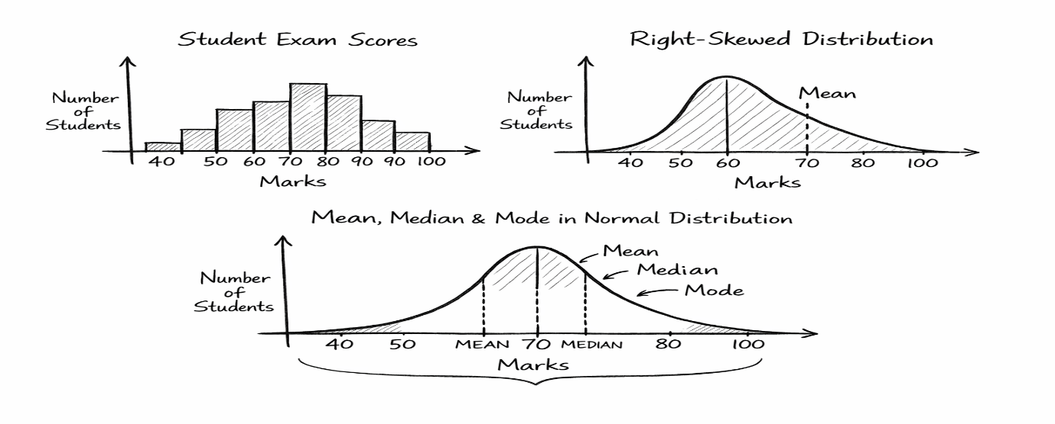

📐 Empirical Rule (68–95–99.7 Rule)
This rule explains how data is distributed in a normal curve.
🔹 1 Standard Deviation (μ ± 1σ)
- Range: 60 to 80
- Covers: 68% of students
➡ Most students score between 60–80 marks.

🔹 2 Standard Deviations (μ ± 2σ)
- Range: 50 to 90
- Covers: 95% of students
➡ Almost all students fall in this range.

🔹 3 Standard Deviations (μ ± 3σ)
- Range: 40 to 100
- Covers: 99.7% of students
➡ Very few students score below 40 or above 100.
Range | Marks | Percentage
μ ± 1σ | 60–80 | 68%
μ ± 2σ | 50–90 | 95%
μ ± 3σ | 40–100 | 99.7%

Conclusion
student exam scores follow a normal distribution where most values lie near the mean. The empirical rule helps understand how marks are spread across standard deviations. This is useful for analyzing student performance and identifying exceptional cases.

