**1) Total Seats**

SELECT DISTINCT COUNT(Parliament_Constituency) from constituencywise_results;

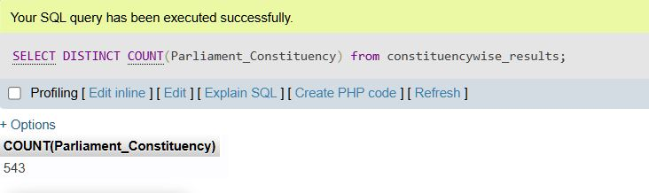

**2)What is the toal number of seats available for electins in each state.**

SELECT

s.State AS State_name,

COUNT(cr.Parliament_Constituency) AS sum_seats

FROM

constituencywise_results cr

INNER JOIN

statewise_results sr ON cr.Parliament_Constituency = sr.Parliament_Constituency

INNER JOIN

states s ON sr.State_ID = s.State_id

GROUP BY

s.State

ORDER BY

s.State

SELECT

'Total' AS State_name,

COUNT(cr.Parliament_Constituency) AS sum_seats

FROM

constituencywise_results cr;

**3)total seats won by NDA alince**

SELECT

SUM( CASE

WHEN party IN (

'Bharatiya Janata Party - BJP',

'Asom Gana Parishad - AGP',

'Telugu Desam - TDP',

'Janata Dal (United) - JD(U)',

'Shiv Sena - SHS',

'AJSU Party - AJSUP',

'Apna Dal (Soneylal) - ADAL',

'Hindustani Awam Morcha (Secular) - HAMS',

'Janasena Party - JnP',

'Janata Dal (Secular) - JD(S)',

'Lok Janshakti Party(Ram Vilas) - LJPRV',

'Nationalist Congress Party - NCP',

'Rashtriya Lok Dal - RLD',

'Sikkim Krantikari Morcha - SKM'

) THEN Won

ELSE 0 END

) AS NDA_Total_Seats_Won

FROM partywise_results;

**4)seats won by nda aliance parties**

select

party as Party_Name,

Won as Seats_Won

from partywise_results

where

party in(

'Bharatiya Janata Party - BJP',

'Asom Gana Parishad - AGP',

'Telugu Desam - TDP',

'Janata Dal (United) - JD(U)',

'Shiv Sena - SHS',

'AJSU Party - AJSUP',

'Apna Dal (Soneylal) - ADAL',

'Hindustani Awam Morcha (Secular) - HAMS',

'Janasena Party - JnP',

'Janata Dal (Secular) - JD(S)',

'Lok Janshakti Party(Ram Vilas) - LJPRV',

'Nationalist Congress Party - NCP',

'Rashtriya Lok Dal - RLD',

'Sikkim Krantikari Morcha - SKM'

)

order by Seats_won DESC

**4)seats won by I.N.D.I.A aliance**

SELECT

SUM( CASE

WHEN party IN (

'Aam Aadmi Party - AAAP',

'All India Trinamool Congress - AITC',

'Communist Party of India - CPI',

'Communist Party of India (Marxist-Leninist) (Liberation) - CPI(ML)(L)',

'Communist Party of India (Marxist) - CPI(M)',

'Dravida Munnetra Kazhagam - DMK',

'Indian National Congress - INC',

'Indian Union Muslim League - IUML',

'Jammu & Kashmir National Conference - JKN',

'Jharkhand Mukti Morcha - JMM',

'Kerala Congress - KEC',

'Marumalarchi Dravida Munnetra Kazhagam - MDMK',

'Rashtriya Janata Dal - RJD',

'Revolutionary Socialist Party - RSP',

'Samajwadi Party - SP',

'Viduthalai Chiruthaigal Katchi - VCK',

'Rashtriya Loktantrik Party - RLTP',

'Bharat Adivasi Party - BHRTADVSIP',

'Nationalist Congress Party Sharadchandra Pawar - Ncpsp',

'Shiv Sena (Uddhav Balasaheb Thackrey) - SHSUBT'

) THEN Won

ELSE 0

END

) AS NDA_Total_Seats_Won

FROM

partywise_results;

**5)seats won by I.N.D.I.A. Alliance Parties**

SELECT

party,

won from partywise_results

WHERE party IN (

'Aam Aadmi Party - AAAP',

'All India Trinamool Congress - AITC',

'Communist Party of India - CPI',

'Communist Party of India (Marxist-Leninist) (Liberation) - CPI(ML)(L)',

'Communist Party of India (Marxist) - CPI(M)',

'Dravida Munnetra Kazhagam - DMK',

'Indian National Congress - INC',

'Indian Union Muslim League - IUML',

'Jammu & Kashmir National Conference - JKN',

'Jharkhand Mukti Morcha - JMM',

'Kerala Congress - KEC',

'Marumalarchi Dravida Munnetra Kazhagam - MDMK',

'Rashtriya Janata Dal - RJD',

'Revolutionary Socialist Party - RSP',

'Samajwadi Party - SP',

'Viduthalai Chiruthaigal Katchi - VCK',

'Rashtriya Loktantrik Party - RLTP',

'Bharat Adivasi Party - BHRTADVSIP',

'Nationalist Congress Party Sharadchandra Pawar - Ncpsp',

'Shiv Sena (Uddhav Balasaheb Thackrey) - SHSUBT'

)

order by won DESC

**6)Add new column field in table partywise_results to get the party allianz as NDA, I.N.D.I.A. and OTHER**

alter table partywise_results add party_alliance varchar(50) ;

update partywise_results

set party_alliance='I.N.D.I.A.'

WHERE party in (

'Aam Aadmi Party - AAAP',

'All India Trinamool Congress - AITC',

'Communist Party of India - CPI',

'Communist Party of India (Marxist-Leninist) (Liberation) - CPI(ML)(L)',

'Communist Party of India (Marxist) - CPI(M)',

'Dravida Munnetra Kazhagam - DMK',

'Indian National Congress - INC',

'Indian Union Muslim League - IUML',

'Jammu & Kashmir National Conference - JKN',

'Jharkhand Mukti Morcha - JMM',

'Kerala Congress - KEC',

'Marumalarchi Dravida Munnetra Kazhagam - MDMK',

'Rashtriya Janata Dal - RJD',

'Revolutionary Socialist Party - RSP',

'Samajwadi Party - SP',

'Viduthalai Chiruthaigal Katchi - VCK',

'Rashtriya Loktantrik Party - RLTP',

'Bharat Adivasi Party - BHRTADVSIP',

'Nationalist Congress Party Sharadchandra Pawar - Ncpsp',

'Shiv Sena (Uddhav Balasaheb Thackrey) - SHSUBT'

)

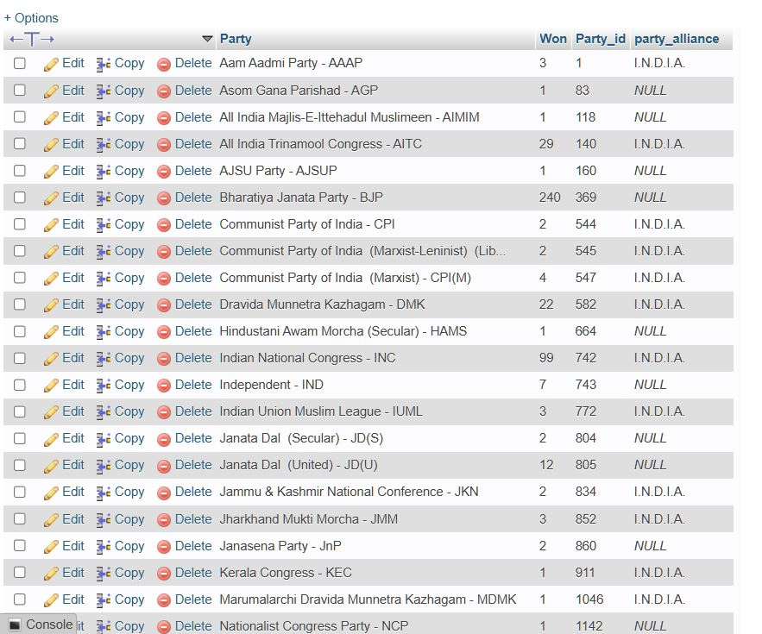

# NDA

update partywise_results

set party_alliance='N.D.A'

WHERE party in (

'Bharatiya Janata Party - BJP',

'Asom Gana Parishad - AGP',

'Telugu Desam - TDP',

'Janata Dal (United) - JD(U)',

'Shiv Sena - SHS',

'AJSU Party - AJSUP',

'Apna Dal (Soneylal) - ADAL',

'Hindustani Awam Morcha (Secular) - HAMS',

'Janasena Party - JnP',

'Janata Dal (Secular) - JD(S)',

'Lok Janshakti Party(Ram Vilas) - LJPRV',

'Nationalist Congress Party - NCP',

'Rashtriya Lok Dal - RLD',

'Sikkim Krantikari Morcha - SKM'

)

# OTHER

UPDATE partywise_results set party_alliance='OTHER ' where party_alliance is null

**7)Which party alliance (NDA, I.N.D.I.A, or OTHER) won the most seats across all states?**

SELECT

p.party_alliance,

COUNT(cr.Constituency_ID) AS Seats_Won

FROM

constituencywise_results cr

JOIN

partywise_results p ON cr.Party_ID = p.Party_ID

WHERE

p.party_alliance IN ('NDA', 'I.N.D.I.A', 'OTHER')

GROUP BY

p.party_alliance

ORDER BY

Seats_Won DESC;

**8)Winning candidate's name, their party name, total votes, and the margin of victory for a specific state and constituency?**

SELECT cr.Winning_Candidate, p.Party, p.party_alliance, cr.Total_Votes, cr.Margin, cr.Constituency_Name, s.State

FROM constituencywise_results cr

JOIN partywise_results p ON cr.Party_ID = p.Party_ID

JOIN statewise_results sr ON cr.Parliament_Constituency = sr.Parliament_Constituency

JOIN states s ON sr.State_ID = s.State_ID

WHERE s.State = 'GUJARAT' AND cr.Constituency_Name = 'RAJKOT';



**9)What is the distribution of EVM votes versus postal votes for candidates in a specific constituency?**

SELECT

cd.Candidate,

cd.Party,

cd.EVM_Votes,

cd.Postal_Votes,

cd.Total_Votes,

cr.Constituency_Name

FROM

constituencywise_details cd

JOIN

constituencywise_results cr ON cd.Constituency_ID = cr.Constituency_ID

WHERE

cr.Constituency_Name = 'RAJKOT'

ORDER BY cd.Total_Votes DESC;

**10) Which parties won the most seats in s State, and how many seats did each party win?**

SELECT

p.Party,

SUM(p.won) AS Seats_Won

FROM

constituencywise_results cr

JOIN

partywise_results p ON cr.Party_ID = p.Party_ID

JOIN

statewise_results sr ON cr.Parliament_Constituency = sr.Parliament_Constituency

JOIN states s ON sr.State_ID = s.State_ID

WHERE

s.state = 'GUJARAT'

GROUP BY

p.Party

ORDER BY

Seats_Won DESC;

**11)what is the total number of seats won by each party alliance (NDA, I.N.D.I.A, AND OTHER) in each state for the india elections 2024**

SELECT

s.State AS State_Name,

SUM(CASE WHEN pr.party_alliance = 'N.D.A' THEN 1 ELSE 0 END) AS NDA_Seats_Won,

SUM(CASE WHEN pr.party_alliance = 'I.N.D.I.A.' THEN 1 ELSE 0 END) AS INDIA_Seats_Won,

SUM(CASE WHEN pr.party_alliance = 'OTHER' THEN 1 ELSE 0 END) AS OTHER_Seats_Won

FROM

constituencywise_results cr

JOIN

partywise_results pr ON cr.Party_ID = pr.Party_ID

JOIN

statewise_results sr ON cr.Parliament_Constituency = sr.Parliament_Constituency

JOIN

states s ON sr.State_ID = s.State_ID

GROUP BY

s.State

**12)which candidate received the highest number of EVM votes in each constituency(Top 10)?**

SELECT

cr.Constituency_Name,

cd.Constituency_ID,

cd.Candidate,

cd.EVM_Votes

FROM

constituencywise_details cd

JOIN

constituencywise_results cr ON cd.Constituency_ID = cr.Constituency_ID

WHERE

cd.EVM_Votes = (

SELECT MAX(cd1.EVM_Votes)

FROM constituencywise_details cd1

WHERE cd1.Constituency_ID = cd.Constituency_ID

)

ORDER BY

cd.EVM_Votes DESC

LIMIT 10;

**13)which candidate won and which candidate was the runner-up in each consituency of state for the 2024 elecatons?**

WITH RankedCandidates AS (

SELECT

cd.Constituency_ID,

cd.Candidate,

cd.Party,

cd.EVM_Votes,

cd.Postal_Votes,

cd.EVM_Votes + cd.Postal_Votes AS Total_Votes,

ROW_NUMBER() OVER (PARTITION BY cd.Constituency_ID ORDER BY cd.EVM_Votes + cd.Postal_Votes DESC) AS VoteRank

FROM

constituencywise_details cd

JOIN

constituencywise_results cr ON cd.Constituency_ID = cr.Constituency_ID

JOIN

statewise_results sr ON cr.Parliament_Constituency = sr.Parliament_Constituency

JOIN

states s ON sr.State_ID = s.State_ID

WHERE s.State = 'Maharashtra'

)

SELECT

cr.Constituency_Name,

MAX(CASE WHEN rc.VoteRank = 1 THEN rc.Candidate END) AS Winning_Candidate,

MAX(CASE WHEN rc.VoteRank = 2 THEN rc.Candidate END) AS Runnerup_Candidate

FROM

RankedCandidates rc

JOIN

constituencywise_results cr ON rc.Constituency_ID = cr.Constituency_ID

GROUP BY

cr.Constituency_Name

ORDER BY

cr.Constituency_Name;

**14)for the state of Gujarat, what are the total number of seats,total number of candidatetotal number of parties, total votes(Including EVM and postal),and the breakdown of EVM and postal votes?**

SELECT

COUNT(DISTINCT cr.Constituency_ID) AS Total_Seats,

COUNT(DISTINCT cd.Candidate) AS Total_Candidates,

COUNT(DISTINCT p.Party) AS Total_Parties,

SUM(cd.EVM_Votes + cd.Postal_Votes) AS Total_Votes,

SUM(cd.EVM_Votes) AS Total_EVM_Votes,

SUM(cd.Postal_Votes) AS Total_Postal_Votes

FROM

constituencywise_results cr

JOIN

constituencywise_details cd ON cr.Constituency_ID = cd.Constituency_ID

JOIN

statewise_results sr ON cr.Parliament_Constituency = sr.Parliament_Constituency

JOIN

states s ON sr.State_ID = s.State_ID

JOIN

partywise_results p ON cr.Party_ID = p.Party_ID

WHERE

s.State = 'Gujarat';

