|  |  |  |  |  |  |  |  |  |  |
| --- | --- | --- | --- | --- | --- | --- | --- | --- | --- |
|  | | | | | | | | | |
|  | | | | | | | | | |
|  |  |  |  |  |  |  |  |  |  |
| **student handout**  **Assiciation rule mining – apriori algorithm**  **name: ……………………………………….…….. ID:………………..** | | | | | | | | | |

**1. Given the following database of transactions in a supermarket, find the association rules between purchases using the Apriori algorithm.**

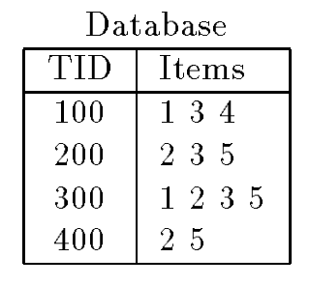

**2. Suppose that *L*3 is the list**

***{{a, b, c}, {a, b, d}, {a, c, d}, {b, c, d}, {b, c,w}, {b, c, x},***

***{p, q, r}, {p, q, s}, {p, q, t}, {p, r, s}, {q, r, s}}***

**Which itemsets are placed in *C*4 by the *join* step of the *Apriori-gen* algorithm?**

**Which are then removed by the *prune* step?**

**{1,2,3} -> ok**

**{1,2,5}->OK**

**{1,3,4}->OK**

**{1,3,5}->OK**

**{2,3,4}->Not OK**

**{2,3,5}->OK**

**C3 = {{1,2,3} , {1,2,5}, {1,3,4}, {1,3,5}, {2,3,5}}**

**{1,2,3} 1/4**

**{1,2,5} 1/4**

**{1,3,4} 1/4**

**{1,3,5} 1/4**

**{2,3,5} 2/4**

**L3 =**

**{1,2,3}**

**{1,2,5}**

**{1,3,4}**

**{1,3,5}**

**{2,3,5}**

**C4 =L3 join L3**

**L4 = {1,2,3,5}**

**L 🡪 R CONFIDENCE**

**1 🡪 235 1/2=0.5**

**2 🡪 135 1/3**

**3 🡪 125 1/3**

**5 🡪 123 1/3**

**12 🡪 35**

**13 🡪 25**

**15 🡪 23**

**23 🡪 15**

**25 🡪 13**

**35 🡪 12**

**123 🡪 5**

**125 🡪 3**

**135 🡪 2**

**235 🡪 1**